LESSON NOTE 5
PROBLEMS OF TRANSPORTATION
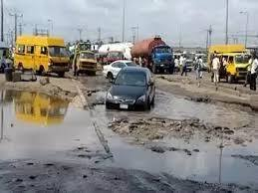
Physical problems.
1. Presence of highlands which limits construction of roads
2. Rivers and marshy areas creates problems and increase cost of transportation
Human problems
1. Attitude of road users who have no regard for traffic codes
2. Mismanagement of resources meant for developing transportation system.
Economic problems
1. There may be insufficient capital to develop transport system
2. The cost of purchasing and maintaining transportation means may be too high
SOLUTIONS
1. Physical problems can be reduced by building high quality roads and rail tracks to reduce the effect of erosion
2. Problem of capital can be reduced through loans from banks and savings by people.
3. Mismanagement can be improved through greater efficiency in management.
COMMUNICATION IN NIGERIA.

Communication is the process of transmission or exchange of meaningful information, opinions, feelings and ideas from one person to another. Some of the traditional means of communication include: town crier, smoke signal, wooden talking drums etc.
COMMUNICATION NETWORKS IN NIGERIA

The major communication networks in Nigeria are
Telecommunications, postal services, mass media, internet, satellite, courier services.
TELECOMMUNICATIONS
This is the technology used in sending signals, images and messages over long distance by telephone and satellite. It includes the use of services like;
Telephone: enables the sending and receiving of verbal messages between people
Telegram :written messages are sent quickly from one place to another
Telex:enables message transmitted or receiving of printed messages over telecomline
G.S.M provide telecommunications services from companies like mtn, 9mobile etc.
HOME WORK
Explain postal services, list and explain 3 types of postal services in Nigeria

LESSON NOTE 6
MASS MEDIA
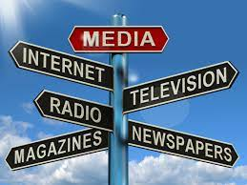
This is the transmission of messages through special media of communication to the public. It includes the use of radio, television, newspaper, film shows etc.
Types of mass media include: Electronic mass media and Print mass media
MERITS
- They may not require the presence of the operator
- Time wasting and stress involved in going round the audience are limited
- Pictures in electronic can easily be served as demonstrated aids
DEMERITS
- They are very expensive to control
- Media like newspaper and magazine are only useful to the educated audience.
- The audience may not be able to ask questions on matters which they do not understand.

INTERNET

This is referred to as the convergence of computer system worldwide with the assistance of telecommunication link which allows the exchange of information between computers with the communication link.
MERITS
- It reduces communication cost
- It facilitates commercial activities
- It facilitates banking activities.
DEMERITS
- Inadequate security
- There is no formal organization
- There is no clear guidelines on how the rules of the Internet should be established.

SATELLITE
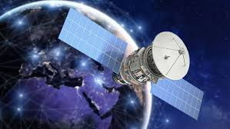
This is a communication equipment stationed in the space to send signals to different countries of the world. It provides the following functions
- Provides telephone and television links among nations
- Ensures the covering of live events and simultaneously watching all over the world
- Makes video conferencing meetings possible.
HOME WORK
- What is courier service
- List 5 functions of courier companies.

LESSON NOTE 7
IMPORTANCE OF COMMUNICATION

- Promotes commercial activities
- Creates awareness for goods and services
- Reduces cost and risk of travelling
- Enhances international trade

PROBLEMS OF COMMUNICATION IN NIGERIA
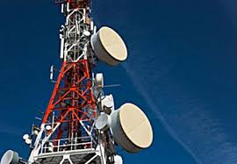
- Inadequate infrastructure like electricity to service communication elements
- Most communication companies render poor services
- Call failure is a prominent feature
- High tariff rate paid by subscriber.

SOLUTIONS
- Adequate infrastructure should be provides
- Efforts should be made by government to reduce tariff
- Service providers should ensure their equipment are in perfect working condition to prevent call failure.

LESSON NOTE 8
MANUFACTURING INDUSTRIES IN NIGERIA
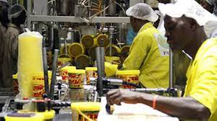
Manufacturing industry is defined as the turning of raw materials into new products by mechanical or chemical processes at home or in the factory.
TYPES OF INDUSTRIES
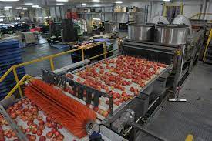
- PRIMARY INDUSTRY: they are concerned with the extraction of raw materials provided by nature. Eg. Mining, farming, fishing, livestock production.
- SECONDARY INDUSTRY: they turn raw into consumable or finished goods. E.g. textile, building and chemical industries
- TERTIARY INDUSTRY: they render services which could be direct or indirect. Eg. Banking, teaching, paramilitary, transportation etc.

MAJOR INDUSTRIAL ZONES IN NIGERIA
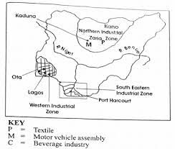
Nigeria can be divided into 4 industrial-urban conurbations. These are:
- THE WESTERN ZONE: located in the western part of Nigeria or west of republic of Niger. Common industrial products are constructional products, engineering products etc.
- THE NORTH CENTRAL ZONE: Located in the northern part of Nigeria or north of rivers Niger and Benue.
- THE SOUTH-EASTERN ZONE: important products include petroleum, minerals, boats etc.
- THE MID-WEST ZONE: located in the west of river Niger. Products include power and petroleum products

