RENEWABLE AND NON RENEWABLE ENERGY

Renewable energy is the energy that is obtained from a source that cannot be exhausted. Renewable energy their source can be replaced. Examples of renewable energy are
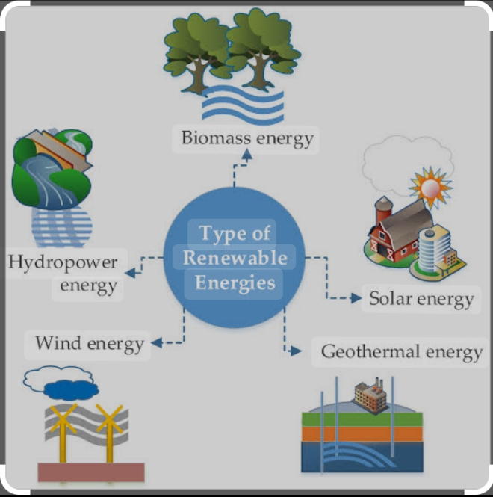
1. wind
2. Biomass
3.Solar
4.water
1. Biomass :it is a fuel itself but can be converted to other forms of energy, it is obtained from plants and animals. It contains energy which is absorbed from the sun. it is renewable because plants and animals can grow over and over again.
Water : when water is used for cooking washing bathing E.t.c when poured away it enters the water table the water cycle, the sun dries it up is collected as cloud and comes back to the earth as rain .
Geothermal energy: rocks within the earth generate great heatof energy of high temperature the heat can be converted to electricity .
Biogas :when garbage is left to rot or decompose another fear called biogas is released. Biodiesel: this is a renewable fuel made from vegetable oil , fat and greases.
features of renewable energy
1. It cannot be exhausted it can be recycled
2.It is very cheap and readily available
3.It does not cause pollution.
4. It does not contribute to global warming .
5.It produces little or no waste.

NON- RENEWABLE ENERGY
Non renewable energy Is the energy that cannot be replaced once it has been used up.It canot be replaced within a human life cycle because it has taken several hundreds of years to be formed and is obtained from sources that can be exhausted.
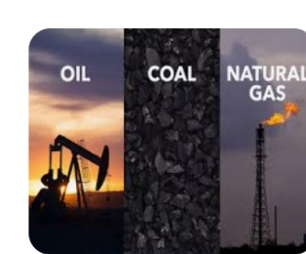
Examples of non- renewable energy are
1.coal
This is a dark hard substance and is the oldest fuel know.it is the largest source of fuel.however it cause great pollution as it contains elements like carbon ,hydrogen and oxygen.
2.Natural gas
This is another fuel found underground.it is odourless and cannot be seen with naked eyes.it is lighter Than air. It contains methane and it is highly flammable.
3.Crude oil Or petroleum
This is a thick black substance found in oil deposits located deep under the earth's surface.it can be refined through a process called FRACTIONAL DISTILLATION.petrol is one of the product obtained from the process.
4.other non- renewable energy sources includes distilates from petroleum like diesel,kerosene,aviation fuel,bitumen etc.these are all fuels and lubricants that can be exhausted.
Features of non renewable energy.
1.it can be exhausted
2.it can cuse pollution.
3.it is expensive.
4.it contribute to global warming.
5.it is easily transported and distributed.
Note:most non renewable energy sources are fossil fuel.
implications of the missuse of non renewable energy.
Non renewable energy must be carefully used since it can finish and once the source is dry it cannot be restored or replaced because it takes several millions of years for them to be formed.

Assignment
state 4 effect of energy on the society

FORCE
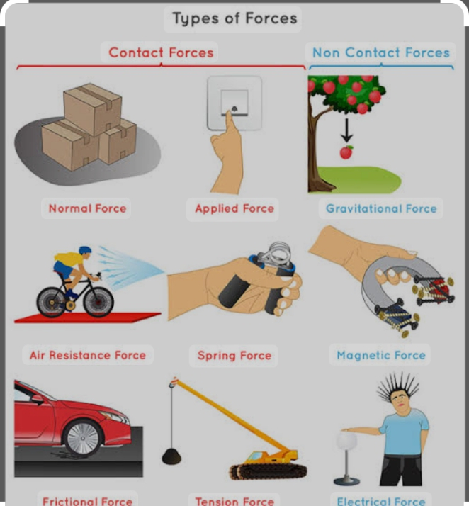
Force is that which changes the state of rest of a body of an object moving in a straight line in a particular direction. force moves an object in a direction of the applied force .
Force is a vector quantity that has magnitude and direction . the SI unit of force is Newton(N).
The force applied on an object can be calculated using the formula
force=mass x acceleration of the object
F=mxa
Generally force may simply be called a push or a pull .
Effect of force on a body
1.Force changes the shapevof a body
2. Force makes a body at rest to move.
3.it causes an object to change it speed
4.it makes a moving object to stop
5. it causes a moving object to change direction.
Types of force
we have two types of force
1. contact force and 2.Non-contact force
Contact Force : this is the type of force which becomes effective only when there is a physical contact ,touch or connection between the source of the force and the objects .Examples are push, pull and frictional Forces
Non contact Force or force field : this type of force does not require physical contact with the body before it acts .In force field the effect can be felt in an area that is covered by the force Field examples are magnetic field , electric field and gravitational force
Balanced and unbalanced forces
Balanced and unbalanced forces occur in pairs. They act together.
Balanced forces make bodies remain in equilibrium. Balanced forces are equal in
strength and act in opposite directions. Examples is found in a seasaw.
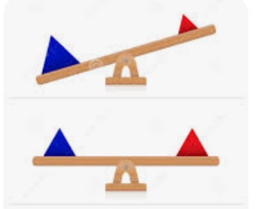
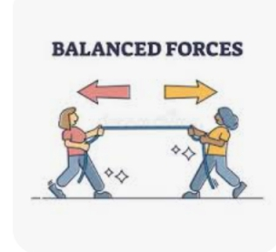

Unbalanced forces make a body not to be in equilibrium. The strength
of one of the forces is either bigger or smaller. An unbalanced force is responsible for motion.
example is found in tug of war

Friction is the force that prevents or opposes the motion of a body when two surfaces are in contact with each other. Friction is greater when the surfaces of the body in contact are rough than when they are smooth. Friction slows down things and acts in the opposite direction to the way they are moving.Friction is part of what makes life worthwhile.
Advantages of friction
1. Friction makes humans stand and walk without slipping on the floor, unlike what you experience on a polished floor.
2. Friction makes a moving vehicle come to a stop whenever the brakes are applied.
3. Friction makes sharpening of tools like cutlass possible.
4. It makes the use of belt possible in machines.
Disadvantages of friction
1. friction generates unwanted heat when parts of machines are rubbed together.
2. Friction causes wear and tear
3. Friction reduces the efficiency of machines.
Ways of reducing friction
1. Use of lubricants between the two surfaces in contact.lubricant like oil and grease
2. polishing or smoothening the surfaces in contact
3. the use of ball bearings or rollers reduces friction.
week 4
AIR
Air is a mixture of gases.Air is composed of mainly nitrogen,oxygen, carbon dioxide,noble gas and water vapour .
when air is moving is called wind.
percentage composition of air
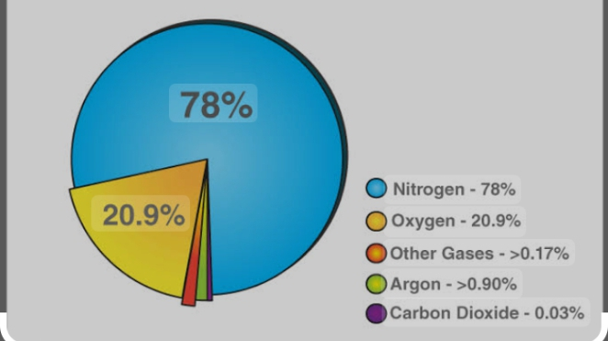
The percentage compositions of air by volume includes
I.Nitrogen 78%
2. Oxygen 21%
3. carbon dioxide 0.03%
4.Noble gas 1%
5. Water vapour (variable)
6. dust and others (variable)
properties of air
There are certain properties of gases like any other matter. Some common properties are as follows:

1. Colourless and Odourless:
Air generally has no colour or odour. It is an invisible matter that can only be felt. All living things breathe air for their survival. Moving air is called wind.
2. Occupy Space:
It is a mixture of different gases. Hence, like every other matter, they also occupy space. On blowing, a balloon expands because the air being blown into it fills up the empty space.

3. Air Exerts Pressure:
It has weight, and the pressure exerted by the weight of air is known as air pressure. Due to gravity, this mixture of gases near the surface is denser than at high altitudes. This is why the gaseous atmosphere in the mountains is thinner than that at the surface.

4. Expansion:
Another property is its expanding property. On heating, it expands and occupies more space. The more it expands, the thinner it becomes. Hence, the pressure of the warm wind is lower than that of cold wind
5. Air support life
6. Air is needed for burning.
ASSIGNMENT
Mention 5 uses of air.

