INTRODUCTION TO HYDROCARBONS

PETROLEUM CHEMISTRY
HYDROCARBON AND CRUDE OIL:
Hydrocarbon are very simple organic compound composed mainly of hydrogen and carbon only.
The sources of hydrocarbons are coal, natural gases and petroleum.
Hydrocarbon can be divided into two main classes:
1.Aliphatic hydrocarbon
2.Aromatic hydrocarbon

ALIPHATIC HYDROCARBON: They are further divided into three groups: Alkanes, Alkenes and Alkynes. The Aliphatic may be Acyclic or Cyclic. The acyclic hydrocarbons are the straight or branched chain hydrocarbon while the cyclic hydrocarbons consist of closed ring chain such as cycloalkane e.g. cyclopropane.
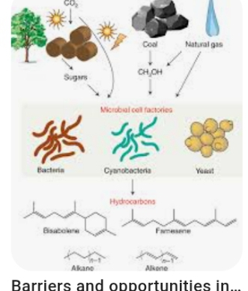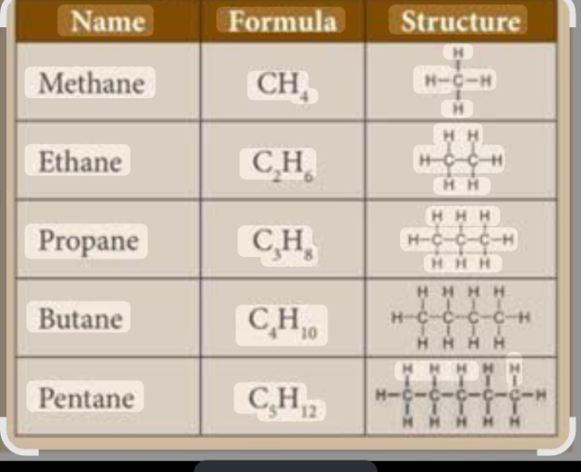

AROMATIC HYDROCARBON
Contain ring structure having non localized orbital e.g C₆H₆. Aromatic hydrocarbons are all cyclic hydrocarbons. The basic cyclic structure is the benzene ring.

PETROLEUM (CRUDE OIL)
Petroleum is the chief source of aliphatic hydrocarbon. It is a dark viscous liquid which is usually trapped or found under the ground or sea beds in certain part of the world e.g. Nigeria, Saudi Arabia, Iran, USA, Iraq and Russia. Petroleum is a mixture of Alkanes, alkenes, cyclo alkanes and aromatic hydrocarbons together with about 1 – 6% impurities consisting mainly of compounds of sulphur and minute quantity of H₂ and O₂ compounds. Natural gas consists mainly of methane.

Origin of Crude oil and Natural gas
Natural gas and petroleum are formed by the decomposition of vast quantities of organic material, undoubtedly of marine origin, buried in sediment. When these tiny aquatic organisms died, their remains gradually settled on the sea beds. Over the years, the remains became covered by mud, silt and other sediments. As the sediment piled up, their mass exerted a great pressure on the lower layers, changing them to hard sedimentary rocks. During this process, bacterial activity, heat and pressure probably changed the plants and animal remains into crude oil and natural gas. The oil and gas so formed slowly moved to other areas through the tiny holes or pores in the porous rocks around them. Since oil and gas are not dense, they tend to seep upwards until they meet a non- porous layer or rocks and are trapped under it, thus forming an oil trap.

REFINING OF PETROLEUM
The process of petroleum refining is basically that of converting crude oil into a range of products required to meet an economic market demand. How is this achieved? Crude oil consists of a very complex mixture of hydrocarbons, which individually, they exist as gas, liquid or solid at normal temperatures and pressures. The crude oil can be separated into fractions by comparatively simple distillation and for every given variety of crude oil; their relative proportions and properties are fixed. Modern competitive marketing conditions, however, demand that these fractions from crude oil are of such a quality that simple distillation is not enough.

Fractional distillation, necessitating more advanced refinery techniques is now adopted.
Crude oil (petroleum) is composed mainly of a complex mixture of hydrocarbons. By using fractional distillation, crude oil can be separated into fractions or groups of similar compounds. Each fraction contains several compounds all of which fall within a certain range of boiling points. These fractions can be differentiated from one another by their different volatility, odour texture and their relative rate of ignition and burning. The fractional distillation is carried out in a fractionating column of towers. The crude oil is passed into a fractionating column with a temperature ranging between 400⁰C at the bottom of the column of the steel pipe and 40⁰C at the top part of the column.

The fractionating column is divided into several compartments by perforated plates called trays, each of which is maintained within a specified range of temperature. The crude oil is first heated to about 400ºC so that all the components are vaporised. The vapour enters the bottom of the fractionating column. They rise up the column and cool. Those with high boiling points will soon condense to liquids and will not move far up the column, whereas those with low boiling points will have to cool considerably before they condense and so will move towards the top of the column. This means that substances with higher boiling points separated out in the trays on the lower part of the column, while those with lower boiling points separate out in the trays on the upper part of the column. The fractions are collected in horizontal trays at different heights on the column, redistilled to improve purity and then further treated to obtain different liquid fuels and petrol chemicals.

The petroleum fractions are gases, petrol, kerosene, diesel oil, lubricating oil and bitumen.

USES OF PETROLEUM FRACTION
1. Natural gas: The gas fractions consist mainly of hydrocarbon containing 1 – 4 carbon atoms per molecule and distilling around 40ºC. These are methane, ethane, ethane, propane and butane. Methane and ethane are usually burnt as fuel. The propane and butane are liquefied and distributed in high pressure gas cylinder or tank to the public for lighting and heating purposes in homes. They are also used for synthesising a large number of compound e.g. methanol, butadiene etc, They are also used for the manufacture of products like hydrogen, carbon(iv)sulphide, tetrachloromethane and ethyne.
2. Petrol or Motor gasoline: Petrol is the most important product derived from petroleum because of the rapid increase of the use of motor vehicles. Petrol is a complex mixture of volatile hydrocarbons containing C₆ – C₁₀ carbon atoms per molecule.(such as hexane, heptane and octane) distilling off between 50⁰C – 200⁰C. Petrol is used as a fuel for aeroplanes and vehicles. It is also a good solvent for paints, grease and stains etc. It is a volatile liquid. Since straight chains hydrocarbons making up the petrol fraction of petroleum usually cause engine knock and engine wear, they have to be reformed to branched chain hydrocarbons which are not prone to knocking.
3. Kerosene or paraffin oil: This is a mixture of hydrocarbons containing C₁₀ – C₁₆ carbon atoms per molecule and boiling between 170⁰C – 250⁰C. It is a fairly volatile liquid and is used as a fuel for lightning and heating. It is also used as a major fuel in jet engines, aeroplanes and tractors and gas turbines. It is a good solvent for grease and paints.
4. Gas Oil or Diesel oil: This is a mixture of hydrocarbons containing C₁₄ – C₁₈ carbon atoms per molecule and boiling between 300⁰C – 360⁰C.It is used in internal combustion of diesel engines of trains, lorries and tractors etc, They are also used as raw materials in the cracking process.
5. Lubricating oil, Grease and wax: It is a mixture of long chain hydrocarbons with more than 20 carbons atoms per molecule which distil over in the temperature range of 350⁰C – 500⁰C.They are viscous liquids used as a lubricant for moving parts of engines and machines and also for making Vaseline or petroleum jelly. Paraffin wax is used for making candles, water proof materials, polish, grease ointment and cream
6. Bitumen or Asphalt: It is a complex mixture of non soluble solids made of polycyclic hydrocarbons. It is used as a biding agent for roofing materials and in road surfacing as a protective coating.

Name of fraction Boiling Point Carbon atoms Uses
Range in ⁰C in molecules

1. Petroleum gas below 40 1 – 4 Fuel and manufacture of other

2. Petrol 40 – 200 4 – 12 Fuel in aeroplanes and motor vehicles
3. Kerosene 200 – 250 12-18 Fuel for lighting, heating and jet engine
4. Gas/diesel oil 250-350 12-25 Fuel for heating and diesel engine

Raw materials for cracking

5. Lubricating Oil 350– 500 more than 20 Lubricating moving parts of
machines, Making candles, creams &
hair care products
6. Bitumen Above 500 more than 35 Surfacing roads

CRACKING AND REFORMING
CRACKING: Cracking is the process use in breaking down large hydrocarbon molecules into two or more smaller hydrocarbon molecules. This is the method used in increasing the quantity of petrol. The fraction from which petrol is produced (C₆ – C₁₂) is small compare with other fractions with greater number of carbon atoms. The petroleum refineries find it difficult to cope with large demands of petrol from users, while on the other they are left with large surplus of the less volatile fractions like kerosene and diesel oil. They are therefore been forced to think of method of converting these less volatile fractions into petrol. This method is known as CRACKING.

There are two types of cracking in use in the petroleum industry:
1. THERMAL CRACKING: This involves vaporizing the oil fractions of long carbon chain (C₁₂ – C₁₈) and heating them for a short time to temperature around 600⁰C under very high pressure of about 300atoms.
2. CATALYTIC CRACKING: The long chain hydrocarbons are heated in the presence of a silica alumina or zeolite catalyst .The catalyst speeds up the process which requires less energy. The pressure needed is lower and high grades of petrol are produced by increasing the octane number of petrol. The temperature is still about 500⁰C. This catalytic cracking is more widely used. Catalytic cracking is better because:
(i) The process is more controllable; i.e. the conditions can be adjusted such that desirable products of certain chain lengths are obtained. This process thus yields a source of alkenes which serve as raw materials for great variety of organic chemicals.
(ii) The process does not only yield more petrol but also gives petrol a high quality. In fact, this petrol is a higher grade petrol than the one obtained directly from the petrol fractions during the distillation of crude oil.
C₁₆H₃₄ C₈H₁₈ + C₈H₁₆.
CH₃(CH₂)₈CH₃ CH₃C (CH₃)₂CH₂CH(CH ₃)CH₃ + C₂H₄
The overall benefits of the cracking process are:
(i)It increases the yield of petroleum
(ii)It provides a petrol mixture rich in branched chain hydrocarbons with an attendant increase in octane number.
(iii)It yields as by product, large quantity of ethane, propene, butane etc used for making plastics, synthetic rubber, detergent and many important chemicals like ethanol and phenol.

REFORMING: This is the process used in converting long chain hydrocarbons to shorter and branched chain molecules to improve its anti knock properties. The process usually takes place in the presence of catalysts such as oxides of silicon and aluminium at about 600⁰C and pressure between 8 and 15 atm in order to increase its octane number and to produce high grade petrol.

Cracking is a breaking down process while reforming is an isomerisation process (i.e. changing a compound into its isomers)

OCTANE NUMBER
The octane number of octane rating of petrol is a mixture of the proportion of branched chain hydrocarbons to the straight chain hydrocarbons in a given blend of gasoline (petrol).
Gasoline is composed of C7 – C9 hydrocarbons i.e. heptane, octane and nonane. These hydrocarbons are present in their straight chain or branched chain isomers. It has been shown that straight chain hydrocarbons (e.g. n – heptane) burn too rapidly in the car engine thus, causing irregular motion of the pistons which result in rattling noise.
The rattling noise is known as ‘KNOCKING’.

Petrol containing a higher percentage of straight chain hydrocarbons causes more knocking that petrol containing a higher percentage of branched-chain hydrocarbons
A straight chain alkanes like heptanes is assigned an octane number of O while a highly branched chain alkane like 2,2,4 trimethylpentane is assigned an octane number of 100 which burns very smoothly in engines. Therefore the quality of any petrol is rated according to its octane number, i.e. the percentage of heptanes to 2,2,4 – trimethylpentane in a mixture.
CH₃ – CH ₂– CH ₂– CH ₂– CH ₂– CH₂ – CH₃
Heptane octane number = 0

CH₃ CH₃ 2,2,4 – trimethylpentane (iso – octane)

CH₃ C CH₂ C CH₃ octane number = 100

CH₃ H
Octane number is a measure of the performance of the fuel in engines and the rating is given as the percentage of iso – octane (2,2,4 – trimethyl pentane) to straight chain hydrocarbon present. For e.g a gasoline with an octane rating of 94 is understood to contain 94% iso octane and 6% straight chain heptane. Similarly, a fuel with an octane number of 50 has a performance equivalent to 50 – 50 mixture of heptane and 2,2,4 – trimethylpentane.
When low grade petrol is used in some auto mobile engines, there is a tendency for the engine to knock. The difference in the grade of petrol is therefore, a difference in their octane numbers.

The motor car engines are known as petrol engines.

GRADE OF PETROL
Petrol can be graded as:
(a) Super or extra (b) Regular or Ordinary
Petrol which is graded as super or extra has an octane number closer to 100 than petrol that is graded as regular or ordinary.

The octane number of straight – chain hydrocarbons is related to their molecular mass, i.e. the lower the molecular mass of the hydrocarbon, the higher the octane number. Some fuels which are superior to 2,2,4 – trimethylpentane have an octane number greater than 100.

SYNTHETIC PETROL
Synthetic Petrol is made from materials such as coal, coke and hydrogen which do not occur in
crude petroleum. Synthetic petroleum can be gotten from two sources:
1. From Coal: When powdered coal is heated with hydrogen in the presence of Fe or Sn as catalyst at 500⁰C and 20 atmospheric pressure, it is converted into an oily mixture of hydrocarbons. The mixture is separated by distillation into a petrol fraction boiling at 200⁰C and heavy oil residue which can be further treated with fresh coal to obtain more petrol.
2. From Coke: When steam is passed over heated coke at 100⁰C, a mixture containing equal volumes of CO and hydrogen known as water gas is obtained.
C + H₂O CO + H₂
Water gas
The water gas can be hydrogenated to a mixture of hydrocarbons by adding hydrogen and passing it over finely divided nickel as catalysts at 200⁰C. About half of the product is petrol, the less volatile fraction being used as fuel for diesel engines.

PETROCHEMICALS
Petrochemicals are substances that are manufactured from the by – products of petroleum. These include plastics, synthetic rubber and fibres. Petroleum and natural gas are now used in increasing amounts to produce many inorganic compounds. Examples include ethanol, ethane, propane 1, 2, 3 – triol, benzene and toluene. These small molecules organic compounds are in turn used to make large – molecule organic compounds like plastic, synthetic rubber, insecticides, detergents and synthetic fibres like nylon and Dacron.
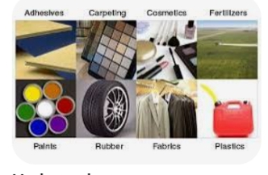

PROBLEMS OF PETROLEUM CHEMISTRY
1. The petrol produced is too small to meet the demand of the world
2. The quality of the petrol produced is too low and may result in knocking of the petrol engine

SOLUTION TO THE PROBLEMS
These problems can be solved by increasing the amount of petrol produced through
(a) Breaking down of larger hydrocarbon molecule into smaller hydrocarbon molecule (Pyrolysis)
C₁₀H₂₂ H₂ + C C₅H₁₂ + CH₃ – CH = CH – CH₃
But – 2 – ene (iso butene)
(b) By addition of lead – tetraethyl (known as ‘anti – knock’ compounds) to prevent knocking and thereby increases the octane number.
Note; Cracking, catalytic reforming and uses of additives (tetraethyl lead) are used to improve the yield and quality of petrol.

