Resources from living and non living things
Resources are materials in our environment which when processed or refined ,are useful to mankind. they can either be living or non living things.
Natural resources are valuable material that is found in nature and used by people to meet their needs. Some natural resources are air, water, plants and animals, metals soil and so on.
Resources are either renewable or non renewable.
Renewable resources are resources that are naturally replaced after use. Plants and animals are renewable resources because they can reproduce.
Non-renewable resources are resources that are not replaced after use. All mineral resources are non renewable.
Resources from living things include the resources from plants and animals.
RESOURCES FROM PLANTS
Resources gotten from plants include:
FOOD CROPS
These are crops cultivated only to feed man. They include the following.
i.Leafy vegetables (like bitter leaf, pumpkin, spinach) which provides us with minerals (like calcium and iron) and vitamins.
ii. Fruits (like orange, mango, pineapple etc) provide the body with essential vitamins and mineral salts.
iii.Grains and cereals (like rice, oat, millet, sorghum etc) which are rich in starch, oil and protein.
iv. Staples and tubers (like yam, cassava, potato etc) which are essentially rich in starch.
v.Oil plants (like oil palm, groundnut, coconut etc) from which we get oil. The oil is used domestically, for cooking.
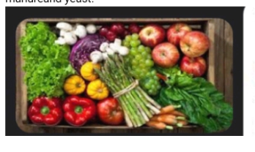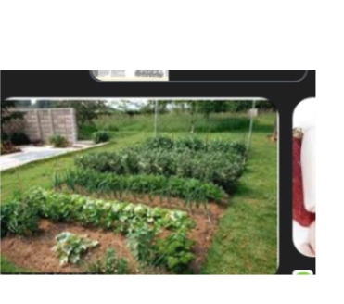

CASH CROPS
These are crops cultivated by the farmer for sale and to make profit. They include:
i.Fibre crops (like cotton, milkweed etc) are used in textile industries for making clothes. It is also used in making pulp for papers.
ii.Oil crops (like groundnut, oil palm, Shea-butter, coconut etc) sold to earn income.
iii.Beverage crops (like cocoa, coffee, tea etc) are also exported.
iv.Latex crops (like rubber, Arabic gum, raffia palm) used for making latex and exported.

MEDICINAL PLANTS
The bark leaves and roots of some plants are used for medicinal purposes. Examples include Dongoyaro, lemon grass, kolanut trees, tobacco etc.
TEXTILE CROPS
These are crops used in the manufacturing of clothes, dyes and other accessories. They are mainly fibrecrops like cotton and dyeplants like indigo plant.

WOODS
These are products from trees mainly used for building, furnitures, cooking etc. Examples of plants that provide us with wood include Mahogany, ebony, obeche, African walnut etc.
ORNAMENTAL PLANTS
These are plants that are used for beautifying the environment. Examples include: hisbiscus plant, Rose plant, Pride of Barbados etc.

COMPOST AND MANURE
When plants die or when their leaves fall to the ground, they decompose and add to the nutrient of the soil. Legumes also add to soil fertility when they are planted

RESOURCES FROM ANIMALS
Animals are reared by man to provide food and other essential resources. These resources include:
Food: Livestocks are reared to provide food in form of meat for man. Man obtain nutritional values like proteins, fat, vitamins and mineral salts from meat. E.g pork from pigs, chevon from goat, mutton from sheep, poultry meat, fish, prawn etc.
Eggs: Eggs laid by poultry birds are also important sources of protein. The fowls that are reared mainly for the production of eggs are called layers. Examples of poultry include: chicken, Turkey, duck etc.
Dairy products: Dairy deals with the production milk from livestocks especially cattle. Dairy products include milk, cheese, yoghurt etc.
Bones: Bones are the part of the body found within animals. Bones are used in the production of glues and ornamental decoration.
Horns: Horns are extension of the skull of some animals. Horns are used fir producing cattle, sheep, goat etc
Feathers: Feathers are coverings on the body of birds. Feathers are used for decoration.
Hide and skin: Hide from large animals and skin from small animals are used for making belts, bags, drums, purses. Hide and skin are gotten from goats, sheep, horse, camel, cattle etc.
Beast of burden: These are animals used for carrying loads and doing farm work. These animals include horses, donkey, camel, cows etc.
Animaldungs: Animal waste are used to produce manure which add to soil fertility and increase crop yield.
ECONOMIC IMPORTANCE OF RESOURCES FROM LIVING THINGS
i.They serve as source of food to man e.g beans, cassava, beans, cow, goat etc.
ii.They serve as raw materials for industries e.g Timber, tannin and hides for leather, milk etc.
iii.They provide drugs and antidotes.
ivPlants make oxygen available for us and purify our environment.
v.Animals are used for farming activities.
vi. Ornamental plants are used to decorate our environment.
vii.Animals that are used as pets helps to fight loneliness.
viii.They are sources of income generation for farmers.
ix.They provide employment for the people.
x. Animals in zoos and parks serve as centre for tourism.

RESOURCES FROM NONLIVING THINGS (SOLID MINERALS)

MINERAL RESOURCES
Mineral resources are resources deposited in the earth crust for the benefit of man. A mineral can exist as a single element or as a compound. It could also be deposited in a solid or liquid state. Often, solid minerals are deposited in the earth as ore. An ore is a compound of a useful element that is found deposited in the earth.
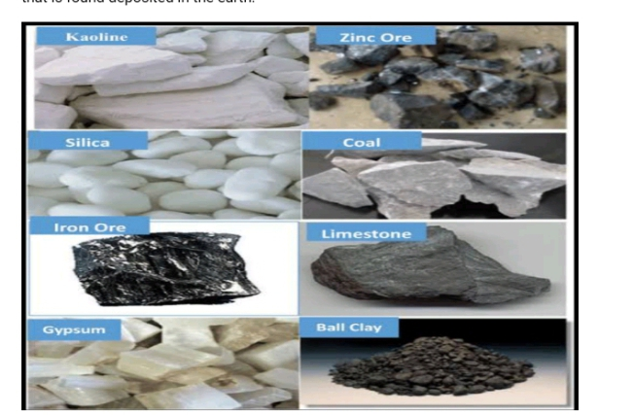

Some mineral resources, their location and their uses in Nigeria are given below
Mineral resources | Location | Uses
Gold | Bida(Niger), Ondo, katsina, kebbi, | Used for decoration and making jewellery, coinage, currency etc.
Limestone | Ogun, Gombe, Kaduna | Used for making cement. Used as filter in paints.
Kaolin | Kogi, Abia, Abuja, katsina | Used for making ceramics and plates
Iron ore | Plateau, Benue, Kogi, Anambra | For making iron and steel. Also used for making alloys for various uses
Zinc | Bauchi, Benue, Akwa-Ibom, Abia, Anambra | For making roofing sheets.
Coal | Enugu, Benue, kogi, Ondo | Used as fuel, used industrially to produce coal gas and iron.
Dolomite | Plateau, Oyo, Osun, Kwara | For refractory furnace, building materials.
Lead | Cross river, Benue, Bauchi, | Used for making battery.
Tin | Cross rivers, Kaduna, plateau, Kano | For making decorative lanterns, coating of lead and steel containers to prevent corrosion.
Bitumen | Ondo, Edo, Lagos. | It is used for tarring roads.
Quartz | Jigawa, katsina, kebbi, Niger, Osun, Oyo | It is used in making glass and silica bricks; paint scouring, saops, sand paper, porcelain, paint.
Mica | Plateau, Osun, Ogun, Kebbi, Cross river, Borno | Used as electrical insulator, telephone condensers. Used as filters in production of tyres and tubes
Clay | Almost all state of the federation. | Used for building bricks, flower pots, floor tiles, fencing brickss
Glass sand | Rivers, Niger, Ekiti, cross Rivers, Bayelsa, Abia | It is used for making bottles, synthetic Mable and other glass wares.

MINERAL RESOURCES AND THEIR LOCATION IN NIGERIA
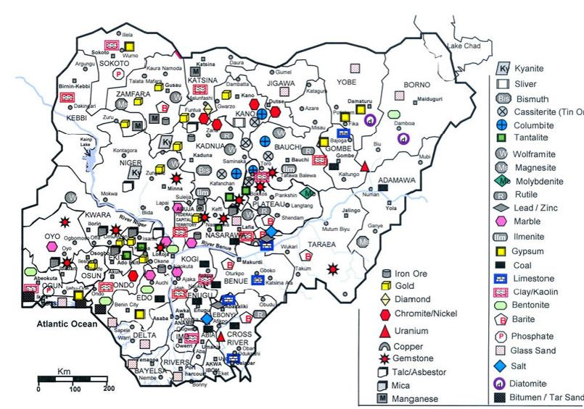

GENERAL IMPORTANCE OF MINERAL RESOURCE
i.It serve as a source of income for the state and country.
ii.They are raw materials for industries.
iii.They are required construction of roads e.g. bitumen.
iv.They are used as source of fuel. E.g. coal.
v. It brings about provision of employment and income for individuals.
vi.The availability of mineral resources makes life easier and more comfortable.
vii.The presence of mineral resources in a country brings fame to the country.

Week 2
Light ,sound and electrical energy.
Light can be defined as a form of energy which produces electromagnetic radiation capable of causing visual sensation. Light is a kind of electromagnetic wave (waves that can travel in vacuum). Light is the fastest substance known to man. Light travels at a speed of 3×10⁸ m/s (300,000,000 metres per second or 299,792.5 km/s). Light travels in a straight line in what is called Rectilinear propagation of light until it encounters an obstacle. When light cannot pass through an object, shadow is formed. An object that does not allow light to pass through it is an opaque object while those objects that allow light to pass through them are called transparent object.
An object that can produce light on it's own is called luminous e.g. sun, light bulb, fire. While an object that does not produce light but may reflect it is called non luminous e.g. the moon, mirror, stone, chair etc.
Light waves are also called light rays. A line with an arrowhead is used to represent a ray of light. A collection of light rays is called light beam.
There are there type of beam. They are:
i. Parallel beam: This is the type of beam in which the light rays are parallel to one another.
ii.Divergent beam: This is the type of beam in which the ray scatters from a point which is usually the source, a convex mirror or a concave lens.
iii.Convergent beam: This is the type of beam in which the rays converge or meet at a point called focus.
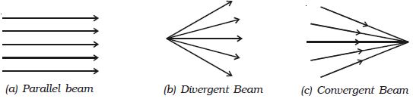
PROPERTIES OF LIGHT
Light has the following properties:
Reflection.
Refraction.
Diffraction.
Dispersion.
Interference.
Polarization.

REFLECTION OF LIGHT
Reflectionoflightis the change in the direction of light after dashing against a surfray. Reflection involves two rays of light: an incoming incident ray and an outgoing reflected ray.

LAW OF REFLECTION
The angle of incident ray, the normal and reflected ray at the point of incidence all lie on the same plane.
The angle of incidence (i) and the angle of reflection (r) are equal but on opposite sides of the normal. i = r
N.B: The normal is an imaginary line at right angle to the mirror at the point of incidence.

TYPES OF REFLECTION
Regular or specular reflection: This is when parallel beam of light is reflected in one direction. Such reflection takes place on smooth, polished surface such as a plane mirror.
Diffuse reflection: This is when a parallel beam of light is reflected in different directions. Such reflection takes place from a rough surface, such as water surface or paper surface.

REFRACTION
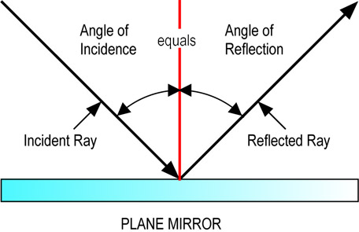
Refraction is the bending or change in the direction of wave when it moves from one medium to another where its speed is different. A medium is a material or space that allows wave pass through it. Refraction is responsible for image formation by lens and the eye.
When you dip your legs into a pool, it disappears bent in the pool. A fish in an aquarium seem to radically change position as it is being viewed from different view points. These are as a result of refraction.

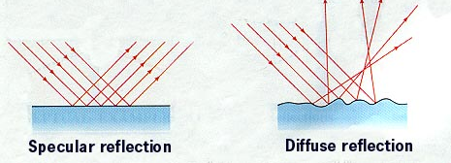
LAWS OF REFRACTION
The first law of refraction states that the incident ray, the refracted ray and the normal at the point of incidence all lie on the same plane.
The second law states that the sine of the angle of incidence (i) to the sine of the angle of refraction (r) is a constant for a given pair of media.
This is also known as Snell's law and the ratio of "I" to "r" is called the refractive index.

SOUND ENERGY

INTRODUCTION
Sound is a wave caused by vibration of matter. It is a property of vibrating objects. These objects may be solid, liquid or gases. If there is an elastic medium (i.e a medium which is capable of being compressed between the vibrating object and a suitable apparatus such as a microphone, ear of animals) noise or sound will be detected.
TRANSMISSION OF SOUND
This is the passage of sound from one point to another e.g. from one room in a building to another or from the street into a room in the building.
The transmission of natural vibration from the tuning fork to the water is called Resonance.
Sound is transmitted through matter such as air, water or solid metals. The matter or material through which sound is transmitted is called a medium. Sound travels faster in solid than in liquid and faster in liquid than in gases. The speed of sound in dry air is 332 m/s, 1484 m/s in water and 5,120 m/s in iron.

REFLECTION OF SOUND
When sound reflects off a special curved surface called a parabola, it will bounce out in a straight line no matter where it originally hits.

Many entertainment stages are designed as a parabola so that the sound will go directly into the audience instead of bouncing on the stage. If the parabola is closed off by another curve surface it is called an ellipse. Sound will travel from one focus to another no matter where it strikes the wall.
An echo is a sound that is reflected back to it source. While multiple overlapping echoes is called reverberation.
HEARING
Hearing is the ability to perceive sound by detecting vibrations, change in the pressure of the surrounding medium through an organ called the ear. The inability of the ear to hear is called deafness. There are three main components of the ear: the outer ear, the middle ear and the inner ear.

Electrical energy
Electrical energy is a form of energy that results
from the movement of charged particles, like electrons, through a conductor.
The faster the electrons the more electrical energy is created.
Conventional current flow in a circuit is from the positive terminal to the negative terminal.
circuit diagram
A circuit is a diagram representing the pathway of electric current when some electric materials are connected together.
the table below shows the symbols or signs used for electric materials in electric circuit
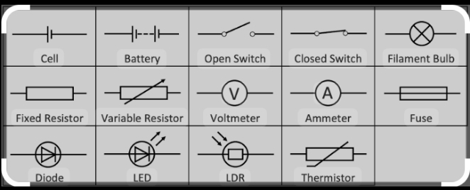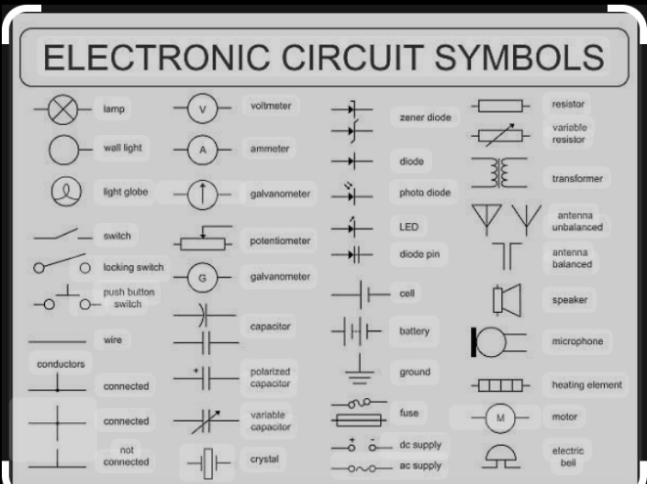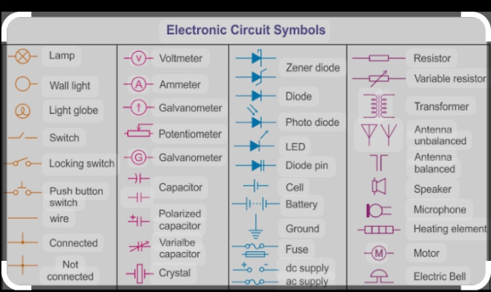

Series circuit and parallel circuits
A series circuit is a circuit where the components are connected end-to-end in a line.
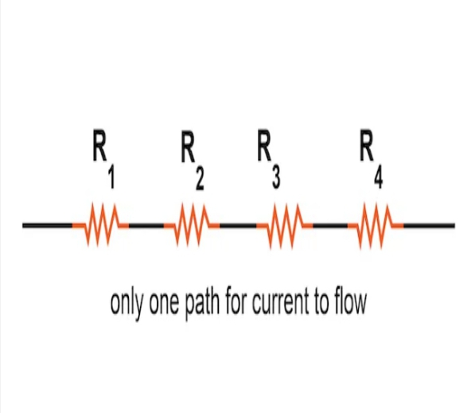

parallel circuit is a circuit where all components are connected in a branched manner across each other’s.
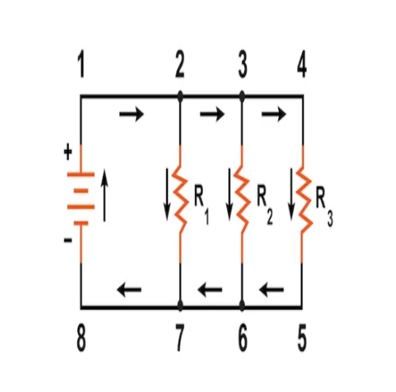
Ammeter and voltmeter
The ammeter measures the amount of current in a circuit. It is always connected in series.
The voltmeter measures the difference in electric potential between the positive and negative terminals. The positive terminal is always at a higher potential.
The voltmeter is arranged in parallel in a circuit.

Measuring AND BuYING electricity
Electric current is the flow of electric charge.
The unit of electric current is ampere/C/s
I = Q/t
Where Q= charge measured in coulombs(C)
t= time measured in seconds(s)
I=current and measured in Ampere
MEASURING ELECTRICITY
Electric current (I)is the rate of flow of electric charge (electrons) through a conductor. The unit of electric current is Ampere .(A)
Electric current= electric charge Q ÷Time (t)
Buying of electricity
Calculate the cost of electricity consumption when the reading from the meter is 22986 at 8:00am on Monday and 23465 at 7.00 am on Tuesday.

week 3
Meaning of Radioactivity
Radioactivity refers to the spontaneous but gradual disintegration observed in radioactive materials or Radioactivity is the sudden disintegration/decay of an unstable nucleus, leading to energy release and loss of nucleus particles. Anything that undergoes radioactivity is said to be radioactive.
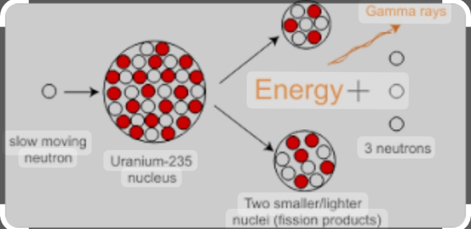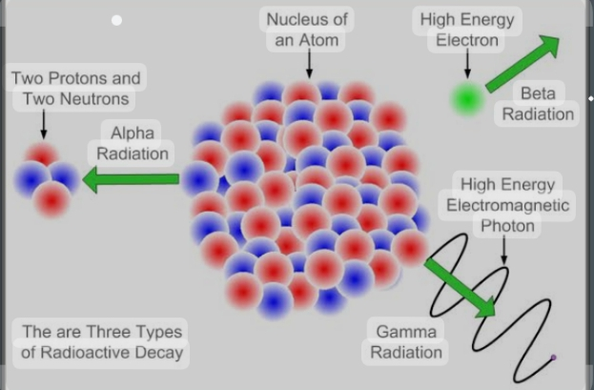
What are Radioactive elements?
Some elements of atomic nuclei are unstable because of the presence of excess nuclear charge inside it, so these nuclei undergo radioactive decay to form stable nuclei. These elements are called radioactive elements.Examples are Radon,radium, uranium, polonium e.t.c
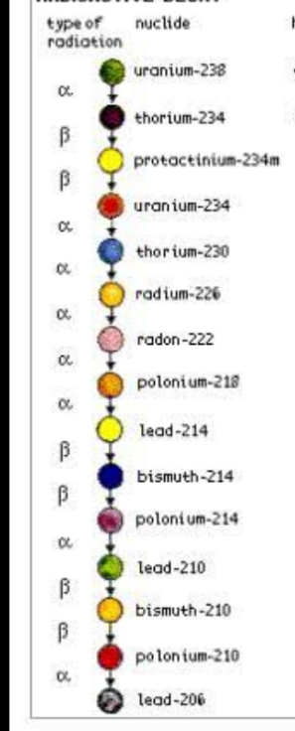
Types of radiation
1. Alpha particle
When an alpha particle emits its nucleus, the process is called alpha decay. The formula of alpha decay is given as:
The nucleus of helium is taken as the alpha particle which is very stable. It has a group of two protons and two neutrons. For example, the alpha decay of uranium-238 is shown below

238U92------------ 234Th90 + 4He2

An Alpha particle is composed of 2 protons and 2 neutrons.
It has symbols ⁴₂He
They have high ionisation energy power.
Alpha particle has low penetrating power
2. Beta Decay
A beta particle is often referred to as an electron, but it can also be a positron. If the reaction involves electrons, the nucleus sheds out neutrons one by one. Even the proton number increases accordingly. A beta decay process is shown below:

234Th90 → 234Pa91 + e⁻¹

Beta particles are electrons emitted from atomic nuclei
It has symbols e⁻¹
They have intermediate ionisation energy power.
The beta particle has intermediate penetrating power
3. Gamma Decay
The nucleus has orbiting electrons which indeed have some energy, and when an electron jumps from a level of high energy to a level of low energy, there is an emission of a photon. The same thing happens in the nucleus: whenever it rearranges into a lower energy level, a high-energy photon is shot out which is known as a gamma ray.

²³⁸₉₂U ---------²³⁴₉₀Th + ⁴₂He + γ

Gamma rays are electromagnetic radiation high-energy photons.
It has symbols γ
They have low ionization energy power.
Gamma rays have a high penetrating power.
Application of radioactive elements
Radioactive isotopes have many useful applications.
In medicine, it is used for cancer treatment and also used as tracers for diagnostic purposes as well as in research on metabolic processes
Gamma rays are used to kill cancerous cells and are hence used in radiotherapy.
Cobalt-60 is used to destroy carcinogenic cells.
I-131 is used for thyroid function tests and for treating thyroid cancer.
Sr-89, used for treating bone cancer, intravenous injection.
Gamma rays kill microbes present in food and prevent it from decaying by increasing the shelf life.
The age of the rocks can be studied using radioactive radiations by measuring the argon content present in the rock
Dangers of Radioactive Rays
Long-term or high-dose exposure to radiation can harm both living and nonliving things. 1.Radiation knocks electrons out of atoms and changes them to ions.
2.It also breaks bonds in DNA and other compounds in living things. One source of radiation that is especially dangerous to people is radon. Radon is a radioactive gas that forms in rocks underground.
3.It can seep into basements and get trapped inside buildings. Then it may build up and become harmful to people who breathe it. Long-term exposure to radon can cause lung cancer.

4.Exposure to higher levels of radiation can be very dangerous, even if the exposure is short-term. A single large dose of radiation can burn the skin and cause radiation sickness. Symptoms of this illness include extreme fatigue, destruction of blood cells, and loss of hair.

5.Nonliving things can also be damaged by radiation. For example, high levels of radiation can weaken metals by removing electrons. This is a problem in nuclear power plants and space vehicles because they are exposed to very high levels of radiation.
