Sulphur and its compounds
Sulphur is a non metallic chemical element belonging to the group 6 of the periodic table with six valence electrons.pure sulphur is a tasteless, odourless brittle solid that is pale yellow in colour.It is insoluble in water.it chemical nature was unknown until 1787 when Lavoisier recognized it as an element.it reacts readily with group 1 and 2 metals to form sulphide ion S2-.
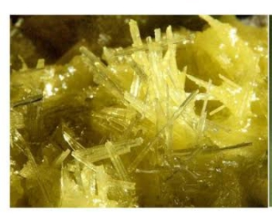
Allotropes of Sulphur
The main allotropes of sulphur are
1. Rhombic sulphur and
2.Monoclinic or prisimatic sulphur
Rhombic sulphur Free sulphur exists as rhombic sulphur in nature because it is the only stable allotrope at temperatures below 96°C. Crystals of rhombic sulphur are bright yellow and octahedral. They are made up of S8 molecules. Each S8 molecule consists of a ring of eight atoms.
Rhombic sulphur is prepared by allowing a saturated solution of sulphur in carbon(IV) sulphide to evaporate slowly. Octahedral crystals will gradually be deposited.


MONOCLINIC sulphur.
Monoclinic sulphur is the only stable allotrope at temperatures between 96°C and 119°C.The crystals are long, thin and needle-shaped, and consist of S8 molecules. At room temperature,
they slowly revert to rhombic sulphur crystals.Monoclinic sulphur is less dense than rhombic
sulphur. This is because the S8 molecules are more tightly packed in rhombic sulphur than in monoclinic sulphur.
The following relationship exists between rhombic and monoclinic sulphur.
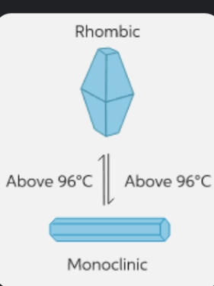
Physical properties of sulphur
1.sulphur is a yellow solid. It exists in two forms amorphous and crystalline.
2.It is insoluble in water but soluble in carbon(IV) sulphide and methyl benzene (toluene).
3.Sulphur is a bad conductor of heat and electricity.being that it is a non metal.
4 .Density depends on allotropic form.
5. It has a melting point of 119°C and a boiling point of 444°C.
Chemical properties of sulphur
1. Direct combination with other elements i e with metals, Oxygen, Hydrogen,Carbon and some other non metals. Fe (s) + S -------------->FeS (s)
O2(g) + S ---------------> SO2(g)
In plentiful supply of air .
H2 (g) + S(s) -----------

->H2S( g)
2.Sulphur acts as an oxidizing Acid.Sulphur is readily oxidized when warmed with concentrated tetraoxosulphate (VI) acid to form sulphur(IV) oxide. The acid itself is reduced to sulphur(IV) oxide.
2H2SO4(aq) + S(s)--------------> 2H20(l) + 3S02(g)
3.Action of hot concentrated alkalis:Sulphur will react with hot concentrated alkaline solutions to form a mixture of sulphides and trioxosulphates(IV), which, in the presence of excess sulphur, react to form a polysulphide and a trioxothiosulphate( VI) respectively.
Uses of sulphur
1.Sulphur is used to produce sulphur(IV) oxide for manufacturing tetraoxosulphate(VI) acid.
2.Sulphur is used in the vulcanization of rubber.
3. Sulphur and some of its products are used as fungicides and insecticides for spraying crops.
4.Sulphur is used to manufacture the bleaching agent used in the pulp and paper industry.
5.It is also used for the production of carbon(V) sulphide, skin ointments and dyes, and as sulphides in manufacturing matches, fireworks and gunpowder.

week 2
Compounds of sulphur
HYDROGEN SULPHIDE
Hydrogen sulphide is found in volcanic gases, sulphur springs, coal gas, and gases formed during the decay of organic matter containing sulphur.
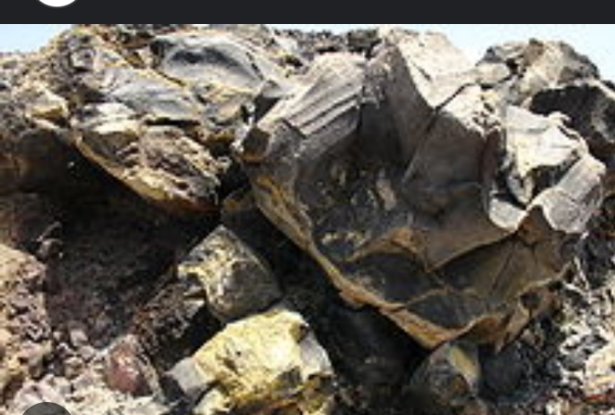
Preparation
Hydrogen sulphide is prepared both in the laboratory and commercially by the action of a dilute acid on a
metallic sulphide, like iron(ll) sulphide.
2HCI_{(aq)} + FeS_{(s)}-----------------> FeCl_{2(aq)} + H₂S_{(g)}
H₂SO_{4(aq)} + FeS_{(s)}------------> FeSO₄(aq) + H₂S(g)
The gas is easily liquefied and may be purchased in this form in steel cylinders.
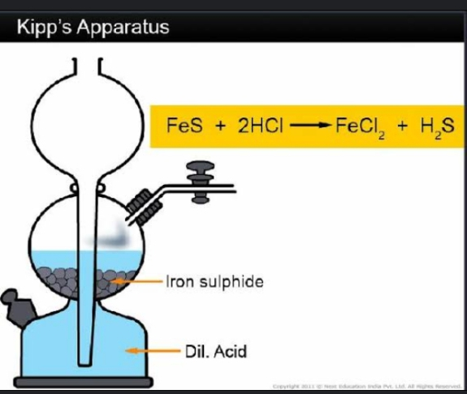

Physical Properties
1. It is very poisonous.
2. Hydrogen sulphide is a colourless gas with a repulsive smell like that of a rotten egg.
3. It is about 1.18 times denser than air.
4.It is moderately soluble in water.
5. It burns with a pale blue flame.
6. It has a boiling point of -6ºC
Chemical Properties
1. Hydrogen sulphide acts as an acid.Hydrogen sulphide ionizes slightly in water to form a weak, dibasic acid, which exhibits typical acidic properties.Hydrogen sulphide can react with sodium or Potassium hydroxide to form the corresponding acid salt, namely sodium or potassium hydrogensulphide
respectively.
2NaOH_{(aq)} + H₂S(g) -----------------> Na₂S_{(aq)} + 2H₂O
NaOH_{(aq)} + H₂S_{(g)} ---------------------->NaHS_{(aq)} + H₂0_{(l)}
2. As a precipitating agent: When hydrogen sulphide is bubbled through solutions of metallic salts, the metallic sulphide are precipitated.

ZnSO_{4 (aq)} + H₂S ------------->ZnS_{(s)} +H₂SO₄ _{(aq)}
3.Reaction with oxygen: Hydrogen sulphide does not support combustion but it burns in a plentiful supply of air with a bright blue flame to produce sulphur(IV) oxide. If the supply of oxygen is limited, a deposit of sulphur may form.
2H₂S _{(g)} +3O_{2 (g)}-----------> 2H₂O _{(l)} +2SO_{2 (g)}
Excess air
2H₂S _{(g)} +O_{2 (g)} --------------->2H₂O _{(l)} +2S _{(s)}
(iv) As a reducing agent: Hydrogen sulphide is a powerful reducing agent because the oxidation number of sulphur in this compound is -2, the lowest exhibited by
sulphur. During the redox process, hydrogen sulphide itself is oxidised to sulphur.
H₂S<===========> 2H⁺ + S²⁻
Test for hydrogen sulphide
With lead (II) trioxonitrate (v):Hydrogen sulphide turns filter paper that has been moistened with lead (II) trioxonitrate (v) solution to black due to the formation of black lead (II) sulphide.
Pb(NO₃)_{2 (aq)} + H₂S _{(g)}--------------> PbS (s) + 2HNO_{3(aq)}
Uses of hydrogen sulphide
1. Hydrogen sulphide is used in the detection of metals in qualitative analysis. The presence of a certain metal is often indicated by the colour of its sulphide.
Colour of some nmetallic sulphides
PbS, CuS, FeS, AgS, NiS, CoS black
ZnS is white
SnS₂ ,CdS is yellow
MnS is pink.
2. Sulphur(IV) oxide:Sulphur(iV) oxide is prepared by
1. the burming of sulphur or metallic sulphides.
(II) heating potasium or sodium trioxosulphate(IV) with dilute tetraoxosulphate(Vl) acid or hydrochloric acid. or (III) heating concentrated tetraoxosulphate( VI) with copper turnings.

It is an acidic gas with a smell of burning firecrackers; it dissolves in water to form trioxosulphate(iV)
Acid. H₂SO₃. It neutralizes bases;
it combines directly with certain metallic oxides: it acts as a strong
reuucing agent in redox reactions with oxidizing agents; it bleaches dyes by its reducing action: it can
aiso behavc as an oxIdizing agent in the presence of a stronger reducing agent like hydrogen sulphide.
test for sulphur( iV) oxide
Besides its characteristic smell, it
(i) bleaches straws, flowers and fabrics.
ii) it turns acidified potassium tetraoxomanganate(VII) from purple to colourless and acidified
potassium heptaoxochromate(VI) from orange to green.
Sulphur(Vi) oxide.
Sulphur(VI) oxide is prepared from sulphur(IV) oxide and oxygen in the presence of a heated catalyst
Iike platinized asbestos or vanadium(V) oxide. It is an acidic gas and dissolves exothermically in water
to form tetraoxosulphate(VI) acid, H₂SO₄
Trioxosulphate(IV) acid
Trioxosulphate(iV) acid is a weak dibasic acid, formed when sulphur([V) oxide dissolves in water. On Exposure to air. It slowly becomes tetraoxosulphate(VI) acid, H₂SO₄. The trioxosulphate(IV) ion, SO₃ in trioxosulphate(IV) acid is responsible for the reducing and bleaching action of sulphur(iV) oxide in aqueous solution.
Trioxosulphates(iV)
trioxosulphates(IV) are prepared by
(i) neutralizing alkalis with sulphur(lV) oxide,
(ii) precipitating them from a corresponding metallic salt solution by passing in sulphur(IV) oxide.
Only the trioxosutphates(iV) of ammonia, potassium, sodium and calcium are soluble in water.
Trioxosulphates(IV) liberate sulphur(iV) oxide when warmed with acids: and on expoosure to air they are converted to tetraoxosulphate( VI) ions, SO₄²⁻ slowly.
Tetraoxosulphate(VI) acid
Industrially, tetraoxosulphate( VI) acid is manufactured by the Contact process. This proces involves the
catalytic combination of sulphur([V) oxide and oxygen to form sulphur(VI) oxide which is then dissolved in
concentrated tetraoxosulphate(Vi) acid to form oleum. This is then diluted with water to produce 98%
tetraoxosulphate(VI)) acid.
Dilute tetraoxosulphate(VI) acid is a strong, dibasic acid. It neutralizes alkalis; liberates hydrogen with
Metals and releases carbon(IV) oxide from trioxocarbonates(IV) and hydrogentrioxocarbonates(IV).
Concentrated tetraoxosulphate( VI) acid is hygroscopic and behaves as a dehydrating agent.
Hot concentrated tetraoxosulphate(VI)) acid is a strong oxidizing agent. It oxidizes metals to the
tetraoxosulphate(VI) and is itself reduced to sulphur(IV) oxide: with non-metals, it produces the
corresponding oxides and sulphur(lV) oxide; and it also oxidizes reducing agents like hydrogen sulphide. Tetraoxosulphate(Vl) acid is used to manufacture fertilizers, pigments, textiles. plastics, detergents and
other chemicals. It is also used in many manufacturing processcs.
Tetraoxosulphates(Vi)
Tetraoxosulphates(VI) are normal salts prepared by the action of dilute tetraoxosulphate(VI) acid on
the metals or the oxides, hydroxides or trioxocarbonates(iV) of metals. Insoluble tetraoxosulphates(Vi)
are prepared by double deconposition of the appropriate salts or acids. Tetraoxosulphates(VI) form double salts or alums. The tetraoxosulphates(VI) of sodium, potassium and calcium are stable to heat but the tetraoxosulphates(VI) of metals lower down the electrochemical series
tend to decompose to the metallic oxides, sulphur(IV) oxide and sulphur(VI) oxide on heating.
Test for tetraoxosulphates(VI) With barium chloride, they form a white precipitate of barium tetraoxosulphate(VI), which is insoluble in excess hydrochloric acid.

week
OXIDATION AND REDUCTION
Redox is a short form for reduction and oxidation reactions. The two reactions are opposing and complementary and they occur simultaneously. Redox has the following definitions
Definition of Oxidation reactions with examples
In terms of addition of oxygen: Oxidation is the addition of oxygen or removal of hydrogen from a substance. Any reaction where there is addition of oxygen to a reactant is regarded as Oxidation.
Some examples are:
(i) 2Mg_{(s)} + O_{2(g)} ----------> 2MgO_{(s)} oxidation of magnesium
(ii) C_{(s)} + 2ZnO_{(s)} --------- > CO_{2 (g)} + 2Zn_{(s)}
In this reaction, oxygen (O) was added to carbon (C) to form Carbon (iv) oxide (CO₂). That is carbon was oxidized to Carbon (iv) oxide.
In terms of hydrogen removal: Oxidation is the removal of hydrogen from a compound e.g. (i) combustion of hydrogen sulphide
2H₂S_{(g)} + O_{2(g)} ------------> 2H₂O_{(l)} + 2S_{(s)}
H₂S_{(g)} + Cl_{2(g) ------------------->}2HCl_{2(g)} + S_{(s)}
In both reactions, hydrogen sulphide was oxidized to Sulphur. The second reaction shows that oxidation can occur without the involvement of oxygen
In terms of loss of electron: Oxidation is the loss of electron.
4Na_{(s)} + O_{2(g)} -----------> 2Na₂O_{(s)}
Na -------------> Na⁺ + e⁻ the loss of electron by sodium atom (Na) to form sodium ion (Na+) in sodium oxide
Definition of reduction with examples
Definitions of reduction are the opposites of the definitions of oxidation.
Removal of oxygen
E.g. Cu_{(s)} + ZnO_{(s)} ----------------> CuO_{(s)} + Zn_{(s)}
In this reaction zinc oxide was reduced to zinc
Addition of hydrogen
e.g. H₂S_{(g)} +Cl_{2(g)} ---------------> 2HCl _{(g)} + S_{(s)}
chlorine is reduced to hydrogen chloride.
Gain of electrons
e.g. 4Na_{(s)} + O_{2(g)} ----------> 2Na₂O_{(s}) i.e oxygen gained electron
0₂ + 4e⁻ --------------> 20²⁻
In terms Of Decrease In Oxidation Number
Zn_{(s)} + CuSO_{4(aq) -------------------->} ZnSO_{4(aq)} + Cu_{(s)}
The oxidation number of copper decreased from +2 in copper (ii) salt to zero in copper.
Reduction occurs when electro negative element is added
Redox Reaction And Electron Transfer: considering all the reactions used as examples so far, it would be seen that both oxidation and reactions occur together see illustration below:
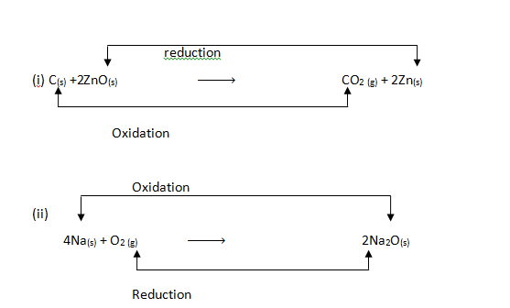
Because 2Na -----------> 2Na⁺ + 2e⁻ (loss of electron is oxidation)
O₂ + 4e^{- ------------------>} 2O²⁻ (gain of electron is reduction)
The above electron transfer equations can be written for most redox reactions.
More examples are
2KI + Fe₂(SO₄)_{3(aq)} --------------> I_{2(aq)} + K₂SO_{4(aq)} + 2FeSO_{4(aq)}
Ionically
2I⁻_{(aq)} -----------> I_{2 (aq)} + 2e⁻ (loss of electrons in oxidation)
The above equation is the redox reaction .Each half reaction cannot occur alone because an atom cannot receive or donate electron without another atom around that must donate or receive the electron.
Evidence of electron transfer in redox reactions can be proved using a simple electro chemical cell.

OXIDATION NUMBERS OF CENTRAL ELEMENTS SOME COMPOUNDS
Oxidation number is the electrical change assigned to an atom in accordance with some prescribed set of rules
RULES FOR DETERMING OXIDATION NUMBER
The following sets of rules are used to determine the oxidation state or number of substances.
1.The oxidation number of an element in an un-combined state is zero, for example the oxidation number of Hydrogen, Oxygen and Sodium atom in a free state or un-combined with another element is zero.
2. In most compounds containing hydrogen, the oxidation number of hydrogen is +1 except in hybrids where it is -1
Electrons shared between two unlike atoms are counted with the more electro negative atom. For example, in water molecule the electron are regarded as being with the more electronegative oxygen. Thus in H₂O, each hydrogen atom is in +1 oxidation state, and the oxygen atom is in -2 oxidation state.
3. The sum of all the oxidation numbers of elements in a compound is zero and with this simple relationship, the oxidation number of each element in a compound can be calculated.
Calculation of oxidation number
With the rules for determining oxidation numbers in our memory, it is possible to calculate the oxidation number of any given element in an ion or a compound.
Worked examples
Calculate the oxidation number of chromium in
Solution
This can be solved by simple linear equation by making the unknown subject of formula. We have 4 oxygen and its oxidation is -2
Let the unknown (oxidation number of Cr be x)
But = -2 (because the sign on the ion is -2)
x + (-24) = -2
x – 8 = -2
x = -2 + 8
x= +6
Thus the oxidation number of Cr in is +6
Note: oxidation number is never written as a neutral number, i.e. it is either written as a neutral number, i.e .It is either written as a positive or negative number.
Calculate the oxidation number of sulphur in H₂SO₄
Solution
The oxidation number (O.N) of hydrogen is +1 and the two hydrogen atoms will give+2. The four oxygen atoms will give (-2 x4) = -8, since -2 is the oxidation number (O, N) of an atom of oxygen
2×(+1) + x + (4 × -2) =0
2 + x + -8 =0
=0 +8 -2
=+8-2
=+6
CONNECTION OF OXIDATION NUMBERS WITH IUPAC NAMES
From all the examples considered so far, it can be seen that the names of most inorganic compounds reflect.
The oxidation numbers of the elements with variable oxidation numbers e.g. iron (ii) ion, in this, oxidation number of Fe is +2
the number of oxygen atoms in the compound e.g.
CO₃²⁺ is trioxo (i.e. three oxygen atoms)
SO₂⁴⁻ is tetraoxo (i.e. four oxygen atoms
Cr₂O₇²⁻ is heptaoxo (i.e. seven oxygen atoms)
Hence, if the formula of a substance is known, the IAUPAC name can be written by calculating the oxidation number of the central atom using the fixed oxidation numbers of the other atoms like oxygen, hydrogen and halogen.
For example:
KMnO₄ has oxidation number K= +1 and O₄= 4 × -2
i.e. +1+x + -8 = 0 where x is the oxidation number of Mn, therefore= 0 + 8 - 1 = +7. Therefore, the name is potassium tetraoxomaganate(VII)
The Following Prefixes and Suffixed Should Be Noted
PREFIX SUFFIX
1= mono- = sulphate (IV)
2= di- = sulphate (VI)
3.= tri - =maganate (VII)
4. =tetra- = phosphate(V)
5= penta =Chlorate(V)
6= hexa- = Carbonate(IV)
7= hepta – = dichromate (vi)
8. =octa- = nitrate (v)
9.= nona – BrO⁻ = bromate (i)
10. = deca IO⁻ =iodate (i)
- iodate (V)
. ClO⁻⁻ = Chlorate (V)
Worked examples
Calculate the oxidation number of manganese in KMnO₄ and hence name the compound in IUPAC nomenclature
Solution
Let unknown (oxidation number of Mn) = x
K= +1, O = -2
KMnO₄= 0
1 + x + (-2 x4) =0
1 + x -8 =0
X – 8 = -1
X= -1 +8
X= +7
The oxidation number of manganese is +7 and the name of the compound is potassium tetraoxomanganate(vii) . The tetraoxo means there are 4 oxygen atoms in the compound.
Calculate the oxidation state of chromium in and give its IUPAC name
Let the unknown = x
O= -2 and = -2
2x + (-2 x 7) = -2
2x – 14 =-2
2x = -2 +14
2x =+ 12
X=+6
The oxidation state of chromium is +6
There are two chromium atoms and there are seven oxygen atoms, there is a charge on the compound making it an ion. Thus, the name is heptaoxodichromate(VI) ion.

Assignment

What is the oxidation number of manganese in each of the following species? (i) MnCl₂ (b) MnO₂ (c) MnO₋₄
Determine the oxidation number of chromium in Cr₂O₇²⁻, then name in IUPAC.

OXIDIZING AND REDUCING AGENTS
Oxidising agent: This is a substance which adds oxygen or removes hydrogen form a substance or a substance which accepts electron, i.e. electron acceptor. Consider the following reactions.
Oxidation in terms of addition of oxygen: oxidizing agent will add oxygen to a substance e.g.
C_{(s)} +2ZnO_{(s)} -------------> CO_{2(g)} + 2Zn _{(s)}
ZnO is the oxidising agent because it added oxygen to (i.e. oxidise) carbon to form CO₂
Oxidation in term of removal of hydrogen: oxidizing agent will add oxygen to a substance e.g
2H₂S _{(g)} + O_{2 (g)} -------------------> 2H₂O _{(l)} + 2S_{(s)} or
H₂S _{(g)} + Cl_{2 (g)} ------------------> 2HCl _{(g)} + S_{(s)}
Oxygen and chlorine are the oxidizing agents because they removed hydrogen from H₂S to form sulphur
Oxidation in term of loss of electrons: oxidizing agent will gain electrons e.g
2FeCl_{2(s)} + Cl_{2 (g)} -----------------> 2FeCl_{3(s)}
Fe²⁺ ---------------- > Fe³⁺ + 2e⁻
Cl₂ + 2e⁻ ------------ > 2Cl⁻
The oxidizing agent is chlorine (Cl₂) because it gained electrons lost by Fe²⁺
Other means of identifying an oxidising agent is the substance.
(i) Which is reduced
(ii) Whose oxidation number has decreased
Reducing agent: This is a substance which adds hydrogen to another substance or removes oxygen from that substance or this substance which donates election, i.e. an electron donor.
Consider the following reactions
Adds hydrogen e.g hydrogen sulphide reduces chloride to hydrogen chloride in
H₂S_{(g)} + Cl_{2(g)} ----------------> 2HCl _{(g)} + 2S_{(s)}
Removes oxygen e.g. Carbon in
C_{(s)} + ZnO_{(s)} ------------------> CO_{2(g)} + 2Zn_{(s)}
Has its oxidation number increases e.g. in
Zn_{(s)} + CuSO_{4 (aq)} ----------------- > ZnSO_{4 (a q)} + Cu_{(s)}
Zinc is the reducing agent because its oxidation number increased from zero in zinc to +2 in zinc tetraoxosulphate (vi) that is, it was oxidized.
The Table below give some common reducing agent and oxidizing agents.
OXIDIZING AGENTS
Oxygen | O₂
Hydrogen peroxide | H₂O₂
Chlorine (and other halogen) | Cl₂
Acidified potassium tetraoxomanganate (viii) | KMnO₄
Acidified potassium heptaoxchromate (vi) | K₂Cr₂O₇
Hot concentrated tetraoxsulphate (vi) acid | H₂SO₄
Concentrated trioxonitrate(v) acid | HNO₃
Silver salt (and metals low in the series e.g cu) | Ag+

REDUCING AGENTS
Hydrogen | H₂
Carbon | C
Potassium | KI
Hydrogen sulphide | H₂S
Sulphur(iv) oxide | SO₂
Iron(II) salt | SO₂
Sodium (and other reactive metals) | Na
Ammonia | NH₃

Generally, metals that are highly electro positive e.g. Na, K and Mg lose electrons easily and so are good reducing agents (they release their electrons to another thus reducing it). Non-metals that are highly electro negative e.g. O, Cl and F are good oxidizing agents (they easily accept electrons from another thus oxidizing it).
TEST FOR OXIDIZING AGENTS
Strong reducing agents like iron (ii) salt and hydrogen sulphide are used.
Green aqueous solution of iron (ii) salt turns brown in the presence of an oxidising agent .
Fe^{2+ --------------------->} Fe³⁺ +e⁻
Blue brown
Note: Freshly prepared iron(II) salt is used.
(ii) Hydrogen sulphide forms deposit of sulphur when passed through the solution of an oxidising agent.
S²⁻ --------------------> 2S_{(s)} + 2e-
TEST FOR REDUCING AGENTS
Strong oxidizing agents like acidified potassium tetraoxomagnate(viii) and acidified potassium heptaoxo chromate (vi) are used
The purple colour of acidified potassium tetraoxomanganate (vii) is turned colourless in the presence of a reducing agent.
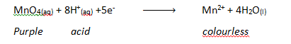

The orange colour of acidified potassium heptaoxodichromate(VI) is turned green in the presence of a reducing agent.
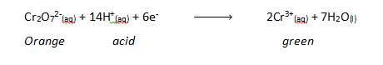
Assignment
1. define reducing agent in terms of oxidation number.
2. Identify the oxidizing and reducing agent in the reaction below:
Zn_{(s)} + CuSO_{4 (aq)} -----------------> ZnSO_{4 (a q)} + Cu_{(s)}

BALANCING IONIC (REDOX) EQUATION
In balancing ionic equations, the following steps can be taken.
Examine the given equation carefully
Balance the number of atoms first by adding the correct number of H⁺ and H₂O on the appropriate sides of the equation when an acid is involved.
Next, balance the number of charges by adding appropriate number of electrons on the right side of the equation.
Lastly, count the atoms on both sides of the equation. If they are equal, then the equation is balanced in atoms (or molecules); also check the charge; if equal, then it is balanced ironically too.
WORKED EXAMPLES
What is the value of n in the following equation
+ 8H⁺ + ne⁻ -------------> X²⁺ + 4H₂O
Solution
+ 8H⁺ + ne⁻ -------------------> X²⁺ + 4H₂O
In the given equation, the atoms are balanced but the charges are not. On the left of the equation, we have a net charge of
-1 on XO⁻₄ + 8H⁺ + ne⁻, i.e. -1 +8 =+7
On the right hand side, we have just +2 which is on X²⁺. Then, for these charges to be equal on both sides of the equation, we have to add 5electrons which will neutralize 5 positive charges from the +7, thereby reducing it to +2, which balances the equation below
The balanced equation is
+ 8H⁺ + 5e⁻ -------------------> X²⁺ + 4H₂O

Week 5
IONIC THEORY
Ionic theory was used to explain the behaviour of electrolytes when electric current is passed through their solution.
Arrhenius version of the ionic theory has been modified since the X-ray diffraction studies show that salts and strong alkalis consists of oppositely charged ions even in solid state. The modern theory of the proposes that ion in such solid state are pulled away from one another either as a result of heat energy applied when the solid melts or with the help of the solvent molecules when the solid dissolves.
MEANING OF ELECTROLYSIS
Electrolysis is the process whereby chemical decomposition occurs when an electric current is passed through an electrolyte.

TERMINOLOGIES
1. Electrode: Electrodes are conductors in the form of wires rods or plates through which an electric current enters or leaves the electrolyte. We have the cathode and the anode
Note: In an electrolytic cell, the negative electrode is known as the cathode while the positive electrode is known as the anode.
In an electrochemical cell, the negative electrode is the anode while the positive electrode is the cathode.
2. ELECTROLYTES
An electrolyte is a compound, in a molten or aqueous state which can conduct electricity and is decomposed in the process.
Electrolytes conduct electric currents by movement of ions. Examples of electrolytes include NaCl, CuCl₂, C_{U}SO₄, HCl, H₂SO₄ etc.
Electrolytes may be weak or strong:
(a) Strong electrolyte ionizes completely and can conduct large electric current since they are composed entirely of free moving ions. Examples are strong acids , strong bases and salts
(b) Weak electrolytes are partially ionized and conduct electricity poorly because the contain low concentration of ions. Examples are weak acids and weak bases
3. Non-electrolytes do not conduct electricity since they do not ionize. Examples are urea ethane, benzene, trichloromethane, cane sugar, ether, tetra chloromethane.
4. An electrolytic cell is an assembly of two electrodes in an electrolyte and is used for the electrolysis of a substance.
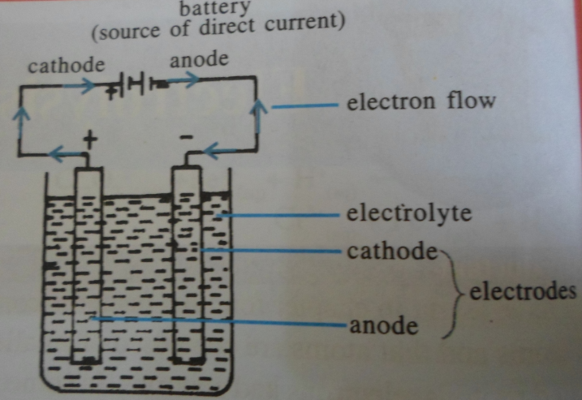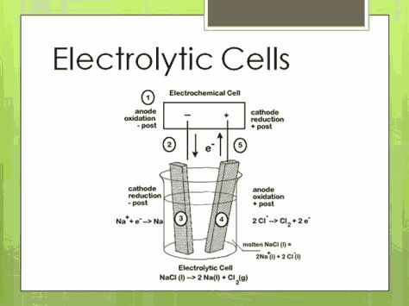

Assignment
Write short note on the following terms:
1. Electrolysis
2. Electrolyte
3. Electrodes
4. Weak electrolyte
5. Strong electrolyte
6. Non-electrolyte

COMPARISON OF ELECTROLYTIC CELLS AND ELECTROCHEMICAL CELLS AND PRINCIPLES OF ELECTROLYSIS
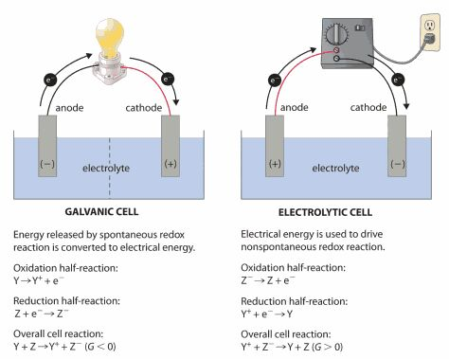
COMPARISON OF ELECTROLYTIC CELL AND ELECTROCHEMICAL CELL
 | ELETROLYTIC CELL | ELETROCHEICAL CELL
1. | Convert electrical energy to chemical energy i.e. electric current is required for the reaction to occur. | Convert chemical energy to electrical energy i.e. chemical reaction produces electrical energy.
2. | Electrons are forced or pushed by an outside source such as a battery. The process is non-spontaneous | Electrons are generated by oxidation at an electrode (anode). The process is spontaneous
3. | Cathode is the negative electrode while anode is the positive electrode | Cathode is the positive electrode while anode is the negative electrode
4. | Electrodes are in the same compartment | Electrodes are in separate compartments
5. | Salt bridge is not needed | Salt bridge is required
6. | Only one electrode is used | Two electrodes are used

PRINCIPLES OF ELECTROLYSIS
Cations and anions
An electrolyte composed of positive and negative ions.
During electrolysis, electrons move from the negative pole of the battery to the cathode, making it to be electron-rich and negatively charged. Hence, positive ions migrate to the cathode; and are called cations. The anode becomes electron-poor and positively charged. Hence, negatively charged ions migrate to the anode, and are called anions.

FACTORS AFFECTING THE DISCHARGES OF IONS/ PRODUCT OF ELECTROLYSIS
During electrolysis the ions in the electrolyte are positively and negatively charged. The negatively charge ion will migrate to the negative charged cathode. In order to know which of the ions will be preferentially discharged at the electrodes, the following factors must be taken into consideration.
The position of ions in the electrochemical series

CATIONS |  | ANIONES
K+ | If two cations are present in an electrolyte the cation below the other one in the electrochemical series will be preferentially discharged. | If two anions are present in electrolyte, the anions that is above the other one in the electrochemical series will be preferentially discharged | OH-
Na+ |  |  | I-
Ca²⁺ |  |  | Br-
Mg²⁺ |  |  | Cl-
Al³⁺ |  |  | Cl-
Zn²⁺ |  |  | Cl-
Fe²⁺ |  |  | NO₃
Sn²⁺ |  |  | NO₃
Sn²⁺ |  |  | SO₄²⁻
Pb²⁺ |  |  | SO₄²⁻
H+ |  |  | SO₄²⁻
H+ |  |  | F-
Cu²⁺ |  |  | F-
Hg²⁺ |  |  | F-
Ag+ |  |  | F-
AU⁺ |  |  | F-
Pt⁺ |  |  | F-

ELECTROLYSIS OF SODIUM CHLORIDE SOLUTION USING INERT ELECTRODES
Note: Inert electrodes are the electrodes that will tamper with the electrolysis. Examples are carbon (graphite) and platinum.

DIAGRAM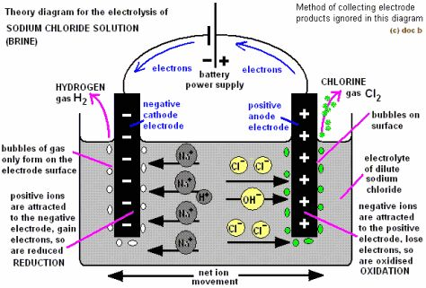

At the anode: Both OH⁻ and Cl⁻ will migrate to the anode where OH⁻ ions will be preferentially discharged because they are above Cl⁻ in the electrochemical.
Cathodic half reaction: 4OH⁻_{(aq)} → 2H₂O_{(l)} + O_{2(g)} + 4e⁻

At the cathode: Both Na⁺ ions and H⁺ ions migrate to the cathode where H+ ions are preferentially discharged because they are below Na+ ions in the electrochemical series.
Anodic half reaction: 4H+_{(aq)} + 4e⁻ → 2H_{2(g)}
Overall reaction: 4OH⁻_{(aq)} + 4H⁺_{(aq)} → 2H_{2(l)} + O_{2(g)} + 2H_{2(g).}
Products of electrolysis: Hydrogen gas is produced at the cathode and oxygen gas is produced at the anode.

Effect of electrolyte on the electrolysis: At the end of the electrolysis, the electrolyte will more concentrated since OH⁻ and H⁺ have been removed from the electrolyte.

2. CONCENTRATION OF IONS IN THE ELECTROLYTE e.g. electrolysis of concentrated NaCl _{(aq)} using inert electrodes. The electrolytic cell is the same as in number factor above, but the electrolyte is concentrated NaCl_{(aq)}
Ions in the electrolyte:
CATIONS ANIONS
Na⁺ OH⁻
H⁺ Cl⁻

At the anode: Both, Cl⁻ and OH⁻ will migrate to the anode where Cl⁻ ions will be preferentially discharged because they are more concentrated. (i.e they are more in concentration inside the electrolyte).
Anodic half reaction: 2Cl⁻_{(aq) →} Cl_{2(g)} + 2e⁻
At the cathode: Both the Na⁺ and H⁺ will migrate to the cathode where H⁺ will be preferentially discharged. This is because even though Na⁺ ions are more in concentration in the electrolyte, the distance between Na⁺ and H⁺ in the electrochemical series is very far.
Cathodic half reaction: 2H⁺_{(aq)} + 2e⁻ → H_{2(g)}

Overall reaction of electrolysis: Chlorine gas is produced at the anode and hydrogen gas at the cathode.

Effect of electrolysis on the electrolyte
At the end of the electrolysis, the electrolyte will become alkaline. H+ and Cl⁻ have been removed from the electrolyte remaining Na+ and OH- which forms NaOH solution.

3. EFFECT OF THE NATURE OF ELECTRODE e.g. Electrolysis of CuSO4 solution using copper anode. The cathode can be any electrode e.g. platinum, graphite or even copper.
The electrolysis cell is the same as above but the anode is copper and cathode is graphite
Ions in the electrolyte:
CATIONS ANIONS
Cu²⁺ SO₄²⁻
H⁺ OH⁻
At the anode: Both SO₄²⁻ and OH⁻ will migrate to the anode but none of them will be discharged. The reason is that, the anode (which is a copper metal) has the nature as the metallic ions (copper (II) ions) in the electrolyte.
Cu _{(s)} → Cu²⁺ _{(aq)} + 2e⁻
(From anode)
At the cathode: Both the Cu²⁺ ions and H⁺ ions will migrate to the cathode where Cu²⁺ ions will be preferentially discharged.
Cathode half reaction
Cu²⁺ _{(aq)} + 2e⁻ → Cu _{(s)}
Product of electrolysis: Since the normal electrolysis did not take place, the anode ionizes into the electrolyte. Copper metal get deposited on the surface of the cathode and the cathode becomes bigger in size.

ELECTROLYSIS OF ACIDIFIED WATER (DILUTE TETRAOXOSULPHATE (VI) ACID).
The equation of the reaction that is involved in this process is given as shown below:
H₂SO₄ 2H⁺ + SO₄² ⁻ (1)
H₂O ⇌ H⁺ + OH⁻ (2)
At the cathode: H+ ions migrate to the cathode and are reduced by gaining electrons to become neutral hydrogen atoms.
H⁺_{(aq)} + e⁻ H_{(g)} reduction.
The hydrogen atoms then combine in pairs to form diatomic hydrogen gas molecules
H_{g} + H_{(g)} H_{2(g)}.
At the Anode: SO₄²⁻ and OH⁻ anode. The ions migrate to the anode. The OH- ions being lower than SO₄²⁻ in the electrochemical series are preferentially discharged.
OH⁻_{(aq)} OH _{(g)} + e⁻.
The OH groups interact to form water and oxygen molecules;
OH + OH H₂O + O
O + O O₂
Overall half-equation
4OH⁻ O₂ + 2H₂0 + 4e⁻
The net result of the electrolysis is that two volumes of hydrogen are produced at the cathode and one volumes of oxygen is produced at the anode. The migration of SO₄²⁻ ions to the anode and the discharge of the H⁺ ions cause a decrease in the concentration of H₂SO₄ acid around the anode disturbs the ionic equilibrium of water. To reverse this, more water ionizes
H₂O_{(L)} ⇌ H⁺ + OH-_{(aq).}
This produces an access of H⁺ ions and with the incoming SO₄²⁻ ions, an increase in the concentration of H₂SO₄ acid is obtained at the anode. The overall result of the electrolysis is that the total amounts of the acid in the solution remain unchanged at the end of the electrolysis. Since two volumes of hydrogen are obtained at the cathode and one volume of oxygen is obtained at the anode, the entire process is equivalent to the electrolysis of water.

ELECTROLYSIS OF BRINE: Concentrated sodium chloride solution (ionic NaCl solution) Note that in this electrolysis, the cathode can be either platinum carbon to the anode must be carbon to resist attack by chloride.
The electrolysis ionizes thus:

NaCl _{(aq)} Na⁺_{(aq)} + Cl⁻_{(aq)}
H₂O _{(l)} ⇌ H⁺_{(aq)} + OH⁻_{(aq)}

When electric current is passed through the electrolytic solution Na⁺ and H⁺ ions migrate to the cathode, while Cl⁻ and OH⁻ ions move to the anode.
At Cathode: Na⁺ being lower than H⁺ in the electrochemical series is preferentially discharged. The H⁺ gains electrons from the cathode and is in turn liberated at the cathode
2H⁺ _{(aq)} + 2e⁻ H_{2(g)}
At Anode: Cl⁻ ions is preferentially discharged because its concentration is much higher than that of OH⁻ ions. The Cl⁻ ion loses an electron to the anode and becomes chloride atoms. The chlorine atoms then combine to form chlorine molecules.
Cl⁻ Cl + e⁻
Cl_{(g)} + Cl_{(g)} Cl_{2(g).}
The discharge of hydrogen ions and chloride ions causes the electrolyte to become basic.
ELECTROCHEMICAL SERIES
Electrochemical series also known as reactivity series is an arrangement of the standard electrolyte potentials of metal ions/metal half cells and those of non-metal/non-metal half cells in order of starting from the most negative to the most positive. Strongly electropositive series while strongly electronegative elements (usually non-metals and oxidizing agents) are at the bottom of the series.
Importance of electrochemical series
Predicting the preferential discharge of ions in electrolysis. Metal down the series is preferentially discharged to the one above it and the non-metal higher in the series is discharged in preference to the ones below it.
Chemical reactivity of elements: metals in the series are arranged in decreasing order of chemical reactivity except for calcium which is less reactive than sodium but is above sodium.
Natural occurrence: metals above hydrogen in the series do not occur in the free state instead, they exist as compounds e.g. chlorides, sulphides, oxides etc.
Displacement and redox reactions: the series shows at a glance the order in which element will displace another. Metals will displace metals which are below them I the series. For redox reactions, reducing power of elements decrease down the reactivity series while their oxidizing power increases down the series
Assignment
Distinguish between a conductor and an electrolyte
Distinguish between an electrolytic cell and an electrochemical cell.
How would you purify an impure copper metal
Distinguish between electrolyte and non-electrolyte.
Classify each of the following as strong/weak electrolyte: potassium chloride, sodium ethonoate, petrol, aqueous ammonia, cane sugar.
Explain why NaCl_{(s)} does not conduct electricity, but NaCl _{(aq)} does
(a) Define electrochemical series
Explain the factors affecting preferential discharge of ion
State the importance of the electrochemical series

