Week 5 - 6
MEASUREMENT
Measurement is the comparison of an unknown quantity with a known fixed quantity or Measurement is the assignment of a number to a characteristic of an object or event, which can be compared with other objects or events.
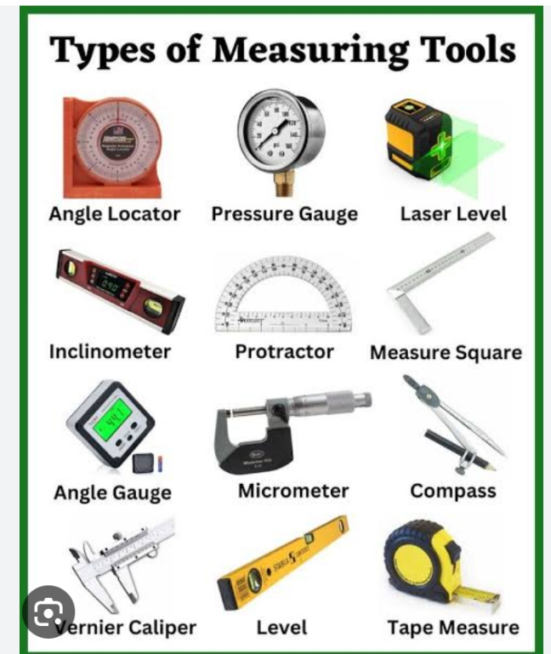
Density
Density, in simple terms, means how heavy a substance or an object is. But
density has to do with the mass and volume of the object; hence it is defined
as the mass per unit volume of the substance, i.e.
Density = mass/volume
The S.I. unit of density is kg/m³ or kgm.³.
The instrument for measuring density is the hydrometer
Calculation
The volume of a wooden box is 4 m³ and
its mass is 36 kg. Calculate the density of the wooden box.
Solution
Density= mass/volume
Density= 36/4
=9kg/m³

Length
Length is the measurement of the distance between two edges of an object or the measure of the extent of an object from end to end.
The units of length are centimetre(cm), decimetre (dm), kilometre (km),mile etc.
Some of the standard instruments used to measure length are a ruler, meter scale, measuring tape, vernier calliper, and screw gauge.
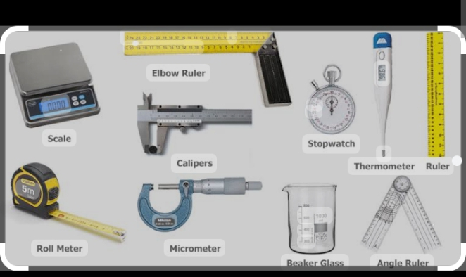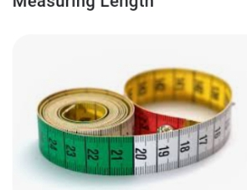
Time
Time is the ongoing sequence of event taking place. The time tells us the duration it takes an event to occur. The basic unit of time is the second. There are also minutes, hours, days, weeks, months and years.The usual measuring instruments for time are clocks and watches. For highly accurate measurement of time an atomic clock is used. Stop watches are also used to measure time in some sports.
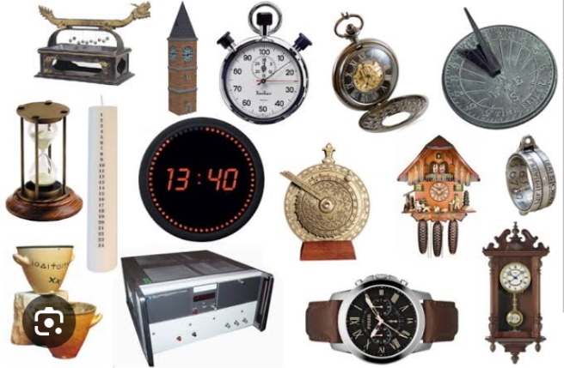
Mass and weight
Mass of a body is a measure of the amount (quantity) of matter in an object regardless of both its location the universe and the gravitational force applied to it. It is usually measured grams (g) or Kilograms (kg).
It is measured by chemical balance
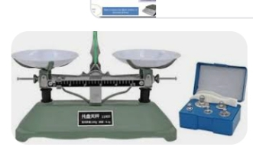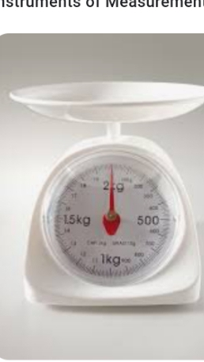

Weight of a body is the force exerted on the body by gravity.
Weight=Mass × gravity
W=mg
Volume
Volume is the quantity of space occupied by a liquid,solid or gas .common units used to express volume include litres, cubic meters (m), cubic centimetres (cm?) or cubic decimetres (dm).
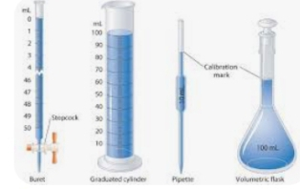
Temperature
Temperature is a measurement of how hot or cold an object is. It can be measured with a thermometer ora calorimeter. It is a means of determining the internal energy contained within a given system.
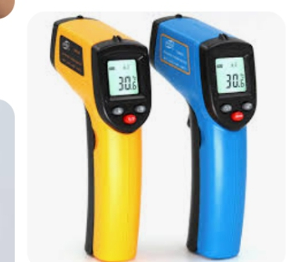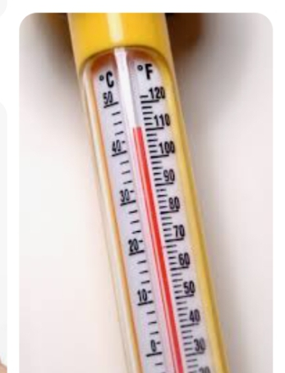
Force
Force is that which causes van object to move or tries to make it move.The instrument used to measure force is a spring balance
Force= mass x acceleration
The S.I unit of force is newton(N)
Pressure
Pressure is a force acting on an area.pressure = force/ area with N/m² as it unit.
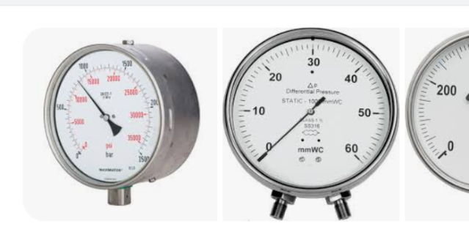
Types of pressure
1. Atmospheric pressure .it is measured using a barometer
2. Liquid pressure.it is measured using a manometer.
3. Gas pressure it is measured using manometer or gauge.

Week 7 - 9

The cell
The cell as the basic unit of life
cell is the structural and functional unit life, We cannot see the unit cells which make living things with the naked eyes because they are too small. However, cells can be seen with the aid of a microscope.
They are different organs that make up a cell.they are called the organelles of cell.
They include the following
1.The cell wall
2.The cell membrane
3. The vacuoles
4. The nucleus
5.The cytoplasm
6.chloroplast
7. Mitochondria
They are two types of cell
1. Animal cell and plant cell
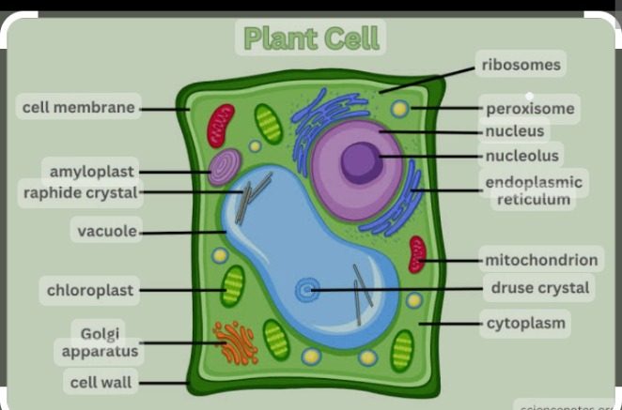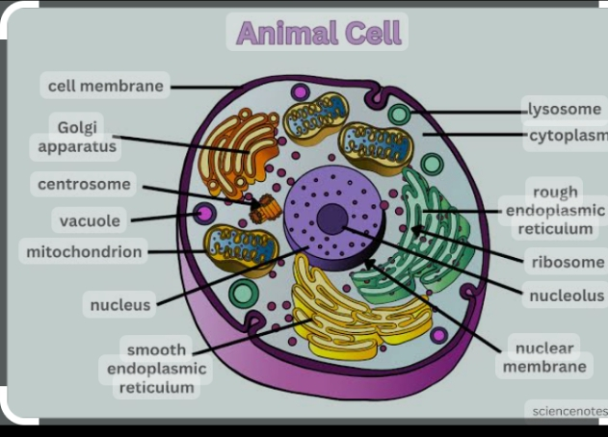
Animals are classified into groups based on
1. Size
2. Presence of backbone
Classification by size
1. Unicellular organisms (microorganisms): These are animals with one cell each. They cannot be seen with the naked eye because they are too small. They can only be seen with the aid of a microscope. Examples are bacteria, amoeba, etc.
2. Multicellular organisms (macroorganisms): These are animals with many cells. Marny are big enough to be seen with the naked eye e.g. man, dog, cat, fish, goat etc.
Classification by Presence of backbone
Animals can be grouped as
A. vertebrates these are organisms with backbones .They include fishes,amphibians, Reptiles, aves(Birds), mammals.
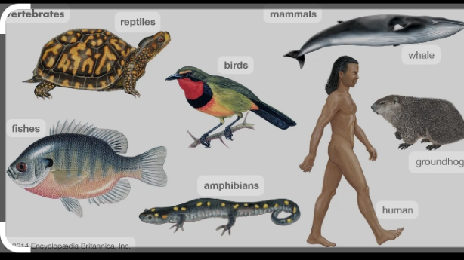

Mammals can be further classified based the type of food material they feed on.
i. Carnivoes: They are flesh-eating arnimal e.g. lion, cat etc.
ii. Herbivores: They feed mainly on grass and -goat, cow etc.
iii. Omnivores: They feed on plant and animal eg man and pig.
B. Invertebrates these are animals without backbones examples flukes ,hookworms, snails, earthworm,spider, butterfly, Scorpions,sea cucumber etc
