Types of chemical bond.
The following are the types of bond
Electrovalent (ionic) bond
Covalent bond
Dative bond
Hydrogen bond
Metallic bond

ELECTROVALENT (IONIC) BOND
Electrovalent bond is characterised by transfer of electrons from metallic atoms to non-metallic atoms during reaction. The metallic atom that donates electron becomes positively charged while the non-metallic atom that accepts electron becomes negatively charged. The strong electrostatic attraction that holds the oppositely charged ions together is called ionic bond.
Examples

ELECTRON DOT REPRESENTATION OF FORMATION OF IONIC COMPOUNDS
Formation of sodium chloride
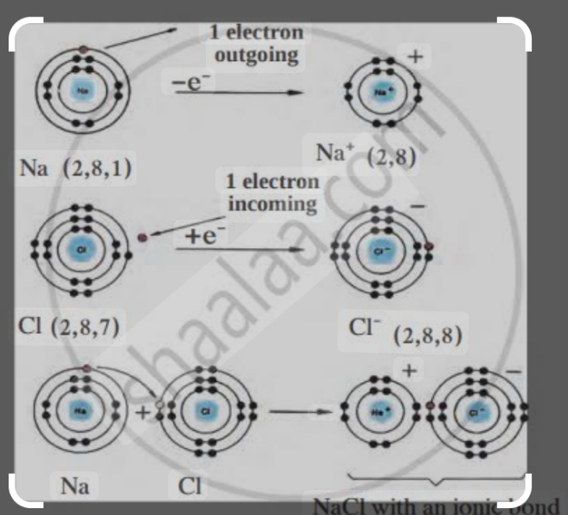

Formation of calcium oxide
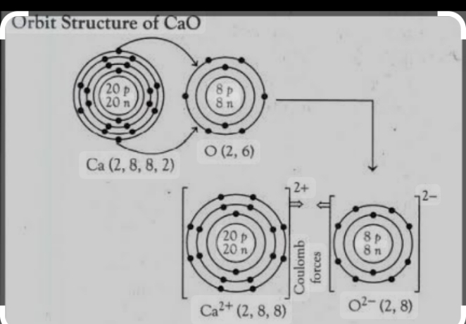

PROPERTIES OF SOME IONIC COMPOUNDS
1.They are solids at room temperature.
2.They contain oppositely charged ions.
3.They readily dissolve in water and other polar solvents like ethanol.
4.They have high melting and boiling points
5. They are good conductors of electricity when in molten or in aqueous form.

COVALENT BOND
This involves the sharing of a paired of electron between two reacting atoms. The shared electrons are each contributed by the reacting atoms and are called shared pair. A shared pair of electron in covalent bond is represented by a horizontal line
(----) between the two atoms

ELECTRON DOT REPRESENTATION OF FORMATION OF COVALENT COMPOUNDS
Formation of hydrogen molecule
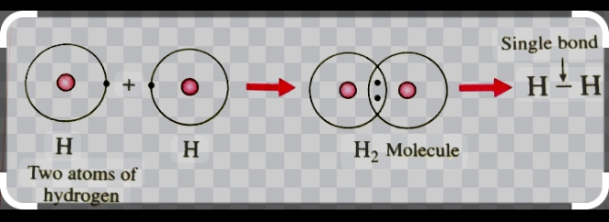
Formation of carbon (iv) oxide

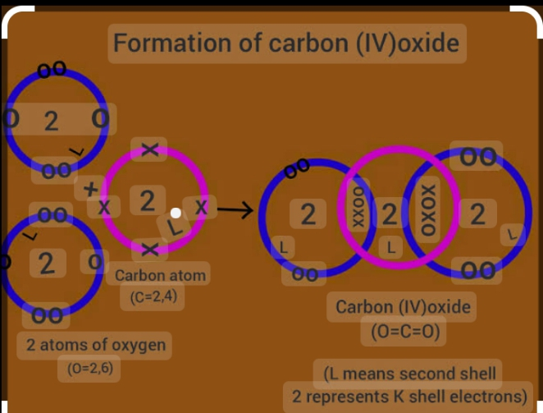

PROPERTIES OF COVALENT COMPOUNDS
1.They consist of molecules with definite shape.
2.They are gases or volatile liquids.
3.They readily dissolve is non-polar organic solvents
4.They have low melting and boiling points
5. They do not conduct electricity because the molecules do not contain charged particles.

COORDINATE COVALENT (DATIVE) BOND
In coordinate covalent bond, the shared pair of electrons is supplied by one of the combining atoms. Coordinate covalent bond is often formed in molecules that have a lone pair of electrons, i.e. a pair of electron not directly concerned in an existing bond.

ELECTRON DOT REPRESENTATION TO SHOW FORMATION OF DATIVE BOND
Formation of hydroxonium ion (H₃O⁺)
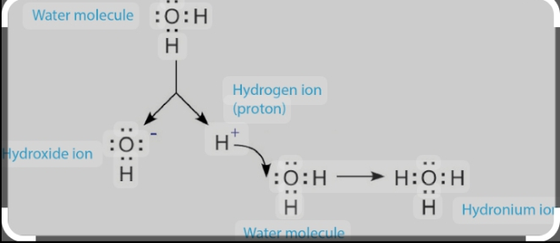

Formation of Ammonium ion (NH₄⁺)
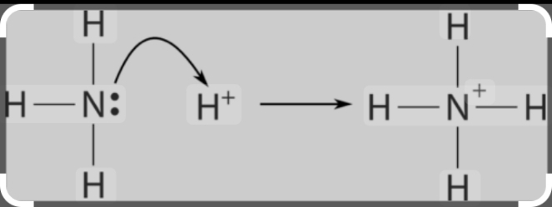

Compounds containing coordinate covalent bond are similar in properties to purely covalent compounds. Both do not conduct electricity, but the presence of coordinate covalent bond tends to make a compound less volatile.

HYDROGEN BOND
Hydrogen bond is a dipole-dipole intermolecular force of attraction which exists when hydrogen is covalently bonded to a highly electronegative element of small atomic size. The electronegative element can be N, O, F, Cl, Br or I.

The highly electronegative element has very strong affinity for electrons. Hence, they attract the shared pair of electrons in the covalent bond toward themselves, resulting in the formation of a dipole which leaves a partial positive charge on the hydrogen atom and a partial negative charge on the electronegative atom. An electrostatic attraction between two dipoles is set up when the positive pole of one molecule attracts the negative pole of the other. This attractive force is known as hydrogen bond.

IMPORTANCE OF HYDROGEN BOND
It accounts for the solubilities of some compounds containing O, N and F in certain hydrogen containing solvents such as water
The crystalline shape of solid water (ice) is due to hydrogen bond.

METALLIC BOND
Metal atoms are held together in solid crystal lattice by metallic bond. each metallic atom contributes its outer (valence) electron to the electron cloud, thus becoming positively charged. The resulting positively charged metallic ions tend to repel each other but are held together by the moving electron cloud and overlapping residual electron orbits. Thus, a metallic bond is a force of attraction between the positive metal ions and the free mobile electrons.

VAN DER WAALS’ FORCES
The attractive forces which make it possible for non-polar molecules like nitrogen and CO₂ molecules to form liquid and solid is called van der Waals’ force. This force though very weak when compared to ionic and covalent bond is important in the liquefaction of gases and in the formation of molecular lattices as in iodine and naphthalene crystals.

week 6- 9

KINETIC THEORY OF MATTER

STATES OF MATTER
The three states of matter: solid, liquid and gaseous states can be distinguished by the motion of particles they are made of and the attractive force between their particles.
SOLID | LIQUID | GASES
Have definite shape and volume | Have no definite shape but definite volume | Have no definite shape and volume
Very dense | Less dense | Least dense
Incompressible | Incompressible | Compressible
Fixed mass | Fixed mass | Fixed mass
Particle vibrate and rotate about a fixed point | Particles vibrate and move about within a restricted space | Particles move about constantly at great speed and at random
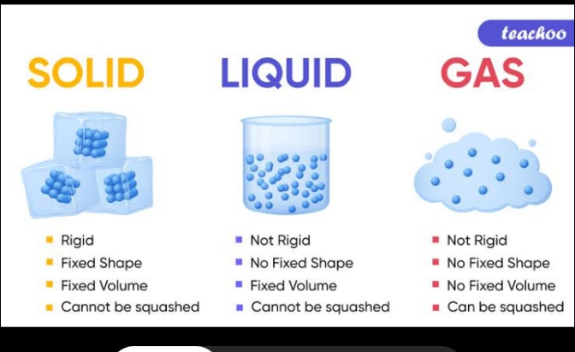

CHANGE OF STATE MELTING
Melting is the physical process where a substance changes from a solid to a liquid. When a solid is heated, the particles acquire greater kinetic energy and move violently. A point is reached when the forces of vibration overcome the cohesive forces holding the solid particles together and the crystalline structure collapses. The particles are no longer held in fixed positions but are free to move about and the liquid state is reached. The temperature at which this occurs is called the melting point of the solid.
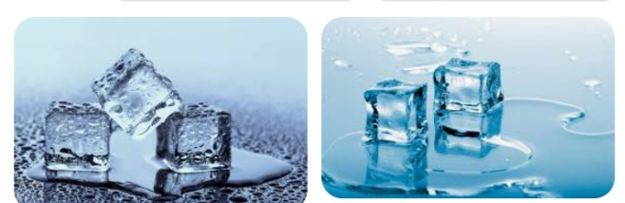

BOILING
When a liquid is heated, the rate of evaporation increases and the value of the saturated vapour pressure equal the prevailing atmospheric pressure. When this happens, the liquid is said to boil and the temperature at which this happen is known as the boiling point of the liquid.
The boiling point of a liquid change with change in atmospheric pressure. If the pressure is raised, the boiling point will increase and if the pressure is lowered the boiling point will decrease. Also, the presence of impurities increases the boiling point of a liquid.
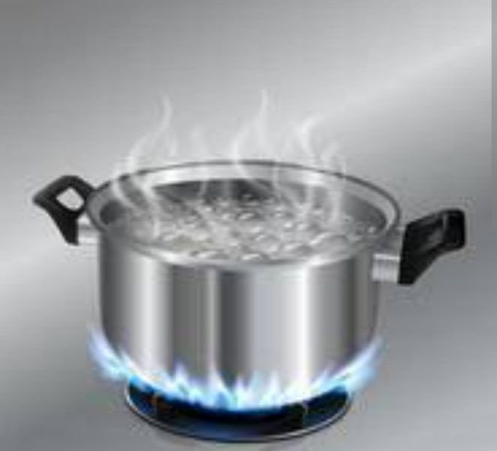
EVAPORATION
Evaporation is the process of vapourization of liquids at all temperatures. When the surface of a liquid is exposed, the molecules near the surface of the liquid will acquire extra kinetic energy, large enough to enable them break away from the cohesive force binding them to the neighbouring particles. Once free, they escape from the liquid surface to become molecules in the vapour state.

Evaporation results in decrease in the volume of liquid and lowering the temperature of the liquid, therefore it causes cooling. Also, it occurs at all temperature but increases with increase in temperature. In addition, it is slower in electrovalent liquids than in covalent liquids.
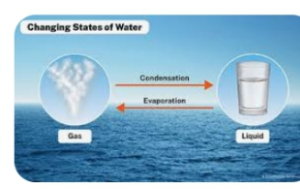

DIFFERENCES BETWWEEN EVAPORATION AND BOILING
EVAPORATION | BOILING
Takes place at the surface of the liquid | Involves the entire volume of the liquid
Takes place at all temperature | Takes place at a fixed temperature

CONDENSATION AND FREEZING
Condensation is a process whereby a vapour loses some of its kinetic energy to a colder body and changes into the liquid state.
When a liquid cools, it loses heat energy to its surroundings, causing its temperature to drop. If the cooling continues, the temperature of the liquid keeps dropping until it reaches the freezing point of the liquid. At this temperature, the liquid changes into solid.

KINETIC THEORY OF GASES
The theory postulates the following for an ideal or perfect gas:
Gas molecules are in constant, rapid, straight motion, colliding with one another and with the walls of the container.

The collision of gas molecules is perfectly elastic.
The total volume of the gas molecule is negligible compared to the volume of the container.
The force of attraction between the gas molecules is negligible.
The average kinetic energy of the molecule is a measure of the temperature of the gas molecules.

PHENOMENA SUPPORTING THE KINETIC THEORY OF GASES
Brownian motion: This is the constant, irregular movement of particles in a liquid or gas. It shows that gas molecules are in constant motion.
Diffusion: Diffusion is the movement of particles from a region of higher concentration to lower concentration. Diffusion is common in gases and it results from the random movement of particles of a gas.

GAS LAWS

Boyle’s law
Charles’ law
Ideal gas equation
Dalton’s law of partial pressure

BOYLE’S LAW
It states that the volume of a fixed mass of gas is inversely proportional to the pressure provided the temperature remains constant.

Mathematically,
V α 1/P
V = k/P
PV = k
Hence, P₁V₁ = P₂V₂
Boyle’s law can be represented graphically as shown below.
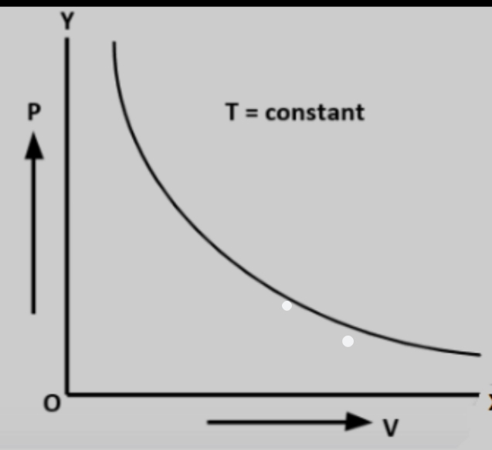

The graph shows that if the pressure is doubled, the volume is reduced to half its former value and if it is halved, the volume is doubled.

EXPLANATION OF BOYLE’S LAW USING THE KINETIC THEORY
When the volume of fixed mass of gas is decreased, the molecules of the gas will collide with each other more rapidly. This gives rise to an increase in pressure. However, if molecules are farther apart the number of collisions for unit time decreases, resulting in a decrease in pressure.
CHARLES’ LAW
Charles’ law states that the volume of a fixed mass of gas at constant pressure is directly proportional to its temperature in the Kelvin scale.
Mathematically,
V α T
V = k/T
V = k
T
Hence, V₁ = V₂
T₁ T₂
The graphical representation of Charles’ law is as shown below:
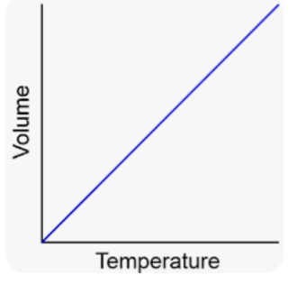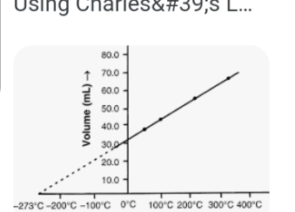

EXPLANATION OF CHARLES’ LAW USING THE KINETIC THEORY
When a given gas is heated at constant pressure, the molecules acquire more kinetic energy and move faster. They collide with one another and with the walls of the container more frequently. To maintain the same number of collisions on the walls of container (i.e. keep the pressure constant) the volume of the gas increases.

CALCULATIONS BASED ON BOYLE’S AND CHARLES’ LAW
1. 200cm3 of a gas has a pressure of 510mmHg. What will be its volume if pressure in increased to 780mmHg, assuming there is no change in temperature?
Solution:
V₁ = 200cm³, P₁ = 510mmHg, P₂ = 780mmHg V₂ = ?
Using the expression for Boyle’s law:
P₁V₁ = P₂V₂
V₂ = P₁V₁ = 510mmHg x 200cm³ = 130.769 = 131 cm³
P₂ 780mmHg

2. A certain mass of a gas occupies 300cm³ at 35ºC. At what temperature will it have its volume reduced by half assuming its pressure remains constant?
Solution:
V₁ = 300cm³, T₁ = 35ºC = (35 + 273)K = 308K, V₂ = V₁/2 = 300/2 = 150cm³, T₂ = ?
Using the formula for Charles’ law
V₁ = V₂
T₁ T₂
T₂ = V₂T₁ = 150cm³ x 308K = 154K
V₁ 300cm³

GENERAL GAS EQUATION
Boyle’s and Charles’ laws are combined into a single expression known as the general gas equation which can be expressed mathematically as
P₁V₁ = P₂V₂
T₁ T₂

IDEAL GAS EQUATION
This equation states that for an ideal gas PV/T is a constant.
That is, PV = R (R = molar gas constant)
T
PV = RT
That is, for n mole of a gas, the equation becomes
PV = nRT

CALCULATIONS
1. What is the volume at s.t.p of a fixed mass of a gas that occupies 700cm³ at 25ºC and 0.84 x 10⁵ Nm⁻²pressure?
Solution:
T₁ = 273K, P₁ = 1.01 x 10⁵Nm⁻², T₂ = 25ºC = (25 + 273) = 298K, P₂ = 0.84 x 10⁵Nm⁻²,
V₂ = 700cm³, V₁ =?
Using the general gas equation
P₁V₁ = P₂V₂
T₁ T₂
V₁ = P₂V₂T₁ = 0.84 x 10⁵Nm⁻² x 700cm³ x 273K = 533.337 =533cm³
P₁T₂ 1.01 x 10⁵Nm⁻² x 298K

2. Calculate the number of moles present in a certain mass of gas occupying 6.5dm³ at 3atm and 15ºC (R = 0.082atmdm³K⁻¹mol⁻¹)
Solution:
V = 6.5dm3, P = 3atm, T = 15ºC = (15 + 273)K = 288K, n =?
Using PV = nRT
n = PV = 3atm x 6.5dm3= 0.8257
RT 0.082atmdm³K⁻¹mol⁻¹ x 288K
Number of moles = 0.83 mole

DALTON’S LAW OF PARTIAL PRESSURE
This law state that in a mixture of gases which do not react chemically together, the total pressure exerted by the mixture of gases is equal to the sum of the partial pressure of the individual gases that make up the mixture.
Mathematically, the law can be expressed as:
P_{total} = P_{A} + P_{B} +P_{C.}.......P_{n}

Where P_{total} is the total pressure of the mixture and P_{A}, P_{B}, P_{C} are the partial pressure exerted separately by the individual gases A, B, C that make up the mixture.
The pressure each constituent gas exerts is called partial pressure and is expressed as
Partial pressure of gas A (P_{A}) = Number of moles of gas A x P_{total}
Total number of moles of gas in mixture

That is, P_{A} = n_{A} x P_{total}
n_{A} + n_{B} + n_{C}
If the gas is collected over water, it is likely to be saturated with water vapour and the total pressure becomes
P_{total} = P_{gas} + P_{water vapour}
P_{gas} = P_{total} – P_{water vapour}

CALCULATION ON THE LAW
A gaseous mixture containing 64g of O₂ and 70g of N₂ exerts a total pressure of 1.8oatm. What is the partial pressure exerted by oxygen in the mixture?
Solution:
Molar mass of O₂ = 16 x 2 = 32gmol⁻¹
Molar mass of N₂ = 14 x 2 = 28gmol⁻¹
Number of mole of O₂ = 64g = 2.0mole
32gmol⁻¹
Number of mole of O₂ = 70g = 2.5mole
28gmol⁻¹
Total number of moles of gases in mixture = 2.0 + 2.5 = 4.5 mole
Partial pressure of O₂ = 2.0 x 1.80 = 0.80atm
4.5

GAS LAWS
CONTENT
Avogadro’s law
Gay lussac’s law of combinig volumes
Graham’s law of diffusion

AVOGADRO’S LAW
This law states that equal volume of all gases at the same temperature and pressure contain the same number of molecules. This means that 1 mole of any gas at s.t.p has a volume of 22.4dm³.

GAY LUSSAC’S LAW OF COMBINING VOLUMES
It states that when gases react they do so in volumes which are simple ratios to one another and to the volumes of the products if gaseous, provided that the temperature and pressure remain constant.

CALCULATION ON THE LAW
Calculate the volume of oxygen required to burn 500cm³ of methane completely.
Solution:
The equation for the reaction is:
2CH_{4(g)} + 3O_{2(g)} → 2CO_{2(g)} + 2H₂O_{(g)}
By Gay Lussac’s law,
2 volumes of CH₄ requires 3 volumes of O₂ for complete combustion
Therefore, 2cm³ of CH₄ requires 3cm³ of O₂
500cm³ of CH₄ will require Xcm³ of O₂
Xcm³ of O₂ = 500cm³ x 3cm³ = 750cm³
2cm³
Thus, 750cm³ of O₂ is required

GRAHAM’S LAW OF DIFFUSION
It states that the rate of diffusion of a gas is inversely proportional to the square root of its density at constant temperature and pressure.
Mathematically,
R α 1/√d
R = k/√d where k is a constant
Comparing the rate of diffusion of two gases:
R₁ = √d₂
R₂ √d₁
In terms of relative molecular mass, M
R α 1/√M
For two gases,
R₁ = √M₂
R₂ √M₁
But rate of diffusion is reciprocal of time, R =1/t
That is,
R₁ = t₂
R₂ t₁
From the inverse relationship we can deduce that the less dense a gas is, the higher the rate of diffusion and vice versa.
CALCULATION
1. A given volume of SO₂ diffuses in 60 seconds. How long will it take the same volume of CH₄ to diffuse under the same condition (SO₂ = 64, CH₄ = 16)
Solution:
Using the expression:
t₁= √M₂
t₂ √M₁
t₂ = √M₂ x t₁ = √16 x 60seconds = 30seconds
√M₁ √64

