week 1- 2
TOPIC: WATER

WATER
Water is regarded as the universal solvent. It is a good solvent for many substances.
SOURCES OF WATER
The following are the sources of water:
Natural water:Rainwater, Well water, Spring water and Sea water
Treated water: Distilled water, Pipe – borne water and chlorinated water.

TYPES OF WATER
Water is of two types namely: soft water and hard water. Soft water forms lather with soap easily while hard water does not form lather readily with soap since it contains some dissolved salt in it.

STRUCTURE OF WATER
In a molecule of water, H₂O, the central atom is Oxygen. Oxygen has the following electronic configuration: 1s² 2s² 2p⁴.

The valence shell of oxygen has two lone pairs of electrons (2s²2p²) and two unpaired electrons (2p_{y}¹2p_{z}¹). Each unpaired electron forms a covalent bond with an electron from a hydrogen atom. The water molecule has two lone pairs and two bond pairs of electrons in the valence shell of its central atom, thereby satisfying the octet rule for stability.

Ideally, the four electron pairs should be directed towards corners of a tetrahedron. However, when lone pairs of electrons is located near another lone pair, the repulsion between them is so great that they squeeze the other two bond pairs of electrons closer together. As a result, the bond angle in water is compressed to approximately 105º, such that the structure of the water molecule is V-shaped or angular shape.
O

H H

LABORATORY PREPARATION OF WATER
To prepare water in laboratory, dry hydrogen gas is ignited in air. It burns with a faint blue flame to give steam, which will condense on contact with any cold surface to form water.

PHYSICAL PROPERTIES OF WATER
Water boils at 100ºC and freezes at 0ºC
It has a maximum density of 1gcm⁻³ at 4ºC
It is neutral to litmus.

CHEMICAL PROPERTIES
Water reacts with electropositive metals to form alkali and liberate hydrogen gas. E.g
Na_{(s)} + H₂O_{(aq)} NaOH_{(aq)} + H_{2(g)}
Mg & Zn react with steam
Cu, Au, Ag, Hg do not react with water to form alkaline solution
Non-metal like chlorine reacts with water to form acid solution.
H₂0_{(aq)} + Cl_{2(g)} HCl_{(aq)} + HOCl_{(aq)}

TEST FOR WATER
When few drops of water are added to
White anhydrous copper (II) tetraoxosulphate (VI), it turns blue.
Blue cobalt (II) chloride, it turns pink.
NOTE: These two tests are not specific for water. They only indicate the presence of water. Any aqueous solution or substance containing water will give a positive test for water.

HARDNESS OF WATER
Hard water is the water that does not form lather readily with soap.
Water acquired hardness when insoluble salts of CaSO₄, MgSO₄ and Ca(HCO₃)₂ dissolves in it from the soil which it flows through.

TYPES OF HARDNESS OF WATER
Temporary hard water
Permanent hard water

TEMPORARY HARDNESS: This is caused by the presences of Ca²⁺ and Mg²⁺ in the form of hydrogen trioxocarbonate IV i.e. Ca(HCO₃)₂

REMOVAL OF TEMPORARY HARDNESS
Physical method: By boiling
Ca(HCO₃)_{2(aq)}^{heat} CaCO_{3(s)} + H₂O_{(l)} + CO_{2(g)}
Chemical method: By using of slaked lime (calcium hydroxide solution)
Ca(HCO₃)_{2(aq)} + Ca(OH)_{2(aq)} 2CaCO_{3(s)}+ 2H₂O_{(l)}

EFFECTS OF TEMPORARY HARDNESS: It causes
Furring of kettles and boilers.
Stalagmite and stalactites in caves.

PERMANENT HARDNESS
Permanent hardness in water is caused by the presence of Calcium and Magnesium ions in the form of soluble tetraoxosulphate (VI) and chlorides (i.e. CaSO₄, MgSO₄, MgCl₂, CaCl₂)
Removal of permanent hardness: By chemical method only
1. Addition of washing soda
Na₂CO_{3(aq)} + CaSO_{4(aq)} CaCO_{3(s)} + Na₂SO_{4(aq)}
Addition of caustic soda
2NaOH_{(aq)} + CaSO_{4(aq)} Ca(OH)_{2(s)} + Na₂SO_{4(aq)}
3. Ion exchange resin
CaSO_{4(aq)} + Sodium zeolite Calcium zeolite + NaSO_{4(aq)}
(insoluble)
ADVANTAGES OF HARD WATER
It has better taste than soft water.
Calcium salts in it helps to build strong teeth and bones.
It provides CaCO₃, that crab and snail use to build their shells.
It does not dissolvelead, hence it can be supplied in lead pipes.

DISADVANTAGES OF HARD WATER
It causes furring of kettles and boilers.
It wastes soap.
It cannot be used in dying and tanning.
TREATMENT OF WATER FOR MUNICIPAL SUPPLY
The following are the processes of treating river water for town supply
Coagulation:Chemicals like potash alum, KAl(SO₄)₂, or sodium aluminate III, NaAlO₂ is added to water in a large settling tank.
Sedimentation: The coagulated solid particles or flocs are allowed to settle in the settling tank to form sediments at the bottom of the tank.
Filtration: The water above the sediment still contains some suspended particles. The water is passed through a filter bed to remove the remaining fine dirt particles.
Chlorination (Disinfection): Chemicals like chlorine is then added to the water to kill germs. Iodine and fluorine are also added as food supplements to prevent goiter and tooth decay respectively. The treated water is then stored in a reservoir and distributed to the town.

WEEK TWO
TOPIC: SOLUBILITY AND SOLUTIONS

SOLUTIONS
A solution is a uniform or homogenous mixture of two or more substances.
Solution = Solvent + Solute
A solute is a dissolved substance which may be a solid, liquid or gas.
A solvent is a substance (usually liquid) which dissolves a solute.

TYPES OF SOLUTIONS
Aqueous Solution: This is formed when a solute is dissolved in water.
Chemical Solution: This is the apparent solution of a solute in a solvent accompanied by a chemical change. For example, magnesium appears to dissolve in dilute hydrochloric acid, what actually happens is that the magnesium attacks the acid to form magnesium chloride, which dissolves in water present.

TRUE SOLUTION AND COLLOIDAL SOLUTION
A true solution is formed when solute particles dissolve such that they are able to get in between the solvent particles. Example of true solution is aqueous solution of sodium chloride and copper (II) tetraoxosulphate (VI).
A False or Colloidal solution is one in which the individual particles are larger than the particles of a true solution, but not large enough to be seen by the naked eye. Examples of colloids are starch and albumen.

TYPES OF COLLOIDS
Sols and Gels: These are colloids where solid particles are dispersed in liquid medium. Example: starch, glue, jelly, etc
Aerosols: In aerosols, liquid particles are dispersed in a gas. Fog, smoke, spray of insecticide is examples of aerosol.
Emulsion: For emulsions, a liquid is dispersedin another liquid. Examples of emulsions are milk, hair cream; cleaning action of detergents is due to their ability to form emulsion.

SOLUBILITY
The solubility of a solute (substance) in a solvent at a particular temperature is the maximum amount of solute in moles or grams that will dissolve in 1 dm³ of the solvent at that temperature.

The concentration in moldm⁻³ of a saturated solution is termed the solubility of the substance i.e. Solubility (moldm³) = Concentration in gdm³
Molar mass
Solubility in mol/dm³ can also be expressed as = mass x 1000
Molar mass volume
Solubility in g/dm³ = mass x 1000
volume 1
Solubility of a solid solute in a solvent increases with rise in temperature while solubility of gases decreases with rise in temperature.

DEFINITION OF TERMS
Saturated Solution: A saturated solution at a particular temperature is one which contains as much solute as it can dissolves at that temperature in the presence of undissolved solute particles.
Unsaturated solution: This is a solution which contains less of the solute than it can dissolve at a particular temperature.
Super saturated solution: This is a solution which contains more of the solute than it can dissolve at a particular temperature.

DETERMINATION OF SOLUBILITY
Solute: KCl, Solvent: water
Method
A saturated solution of KCl is prepared by dissolving excess of the solid in water in a beaker
Allow the solution in the beaker to settle down to obtain a clear saturated solution
Decant a portion of clear solution into another beaker and measures its temperature
Transfer the solution into a weighed evaporation dish and record the mass of the solution
Evaporate the solution to a complete dryness in a water bath
Allow the resulting solid to cool and reweigh the basin with content
Obtain mass of the dissolved salt and calculate the mass of the salt that would dissolve in 1dm³ of water at that temperature.

CALCULATION
Mass of basin = xg
Mass of basin + solution = yg
Mass of basin + salt = zg
Mass of solution = (y-x)g
Mass of salt = (z-x)g
Mass of water used = (y-z)g
:. (y – z)g H₂O dissolves (z – x)g salt
:. 100g H₂O dissolves (z – x)/(y – z) x 100g salt
[Density of water = 1gcm³]
:. No of moles of salt = 100(z – x)
(y-z) x M.M

:. Moles of salt dissolves in 1 dm³ water = 100(z-x)
(y-z) x M.M

FACTORS THAT AFFECT SOLUBILITY
1. Nature of solvent and solute
2. Temperature
3. Pressure (often neglected)

SOLUBILITY CURVES
These are the graphs of solubility against temperature. The graph provides useful source of information.

USES OF SOLUBILITY CURVES
1. It provides useful information about suitable solvent and temperature for solvent extraction from natural sources
2. It provides useful information about temperature for fractional crystallization of a mixture of soluble salts.
3. The curves enable pharmacists to determine the amount of solid drugs that must be dissolved in a given quantity of solvent to give a prescribed drug mixture.

CALCULATION ON SOLUBILITY
1. If 12.2g of Pb(NO₃)₂ were dissolved in 21cm³ of distilled water at 20ºC. Calculate the solubility of the solute in moldm⁻³

Solution:
Molar mass of Pb(NO₃)₂ = 331g
No of moles of Pb(NO₃)₂ = 12.2/331 = 0.037moles
If 21cm³ of water at 20⁰C dissolved 0.037mole salt
:. 1000cm³ of water at 20⁰C dissolves 0.037 x 1000/21
= 176moles Pb(NO₃) per dm³ H₂O

2. 1.0dm³ of an aqueous solution at 90ºC contains 404g of KNO₃ and 245g of KClO₃.
a. Determine which of the two salts will separate out when the solution is cooled to 60ºC
b. mass of salt that will separate out at 60ºC
(Solubility of KNO₃ in H₂O at 60ºC = 5.14moldm⁻³, solubility of KClO₃ in H₂O at 60ºC = 1.61moldm⁻³)

Solution:
No of moles of KNO₃ = 404/101 = 4.0moles dm⁻³
No of moles of KClO₃ = 245/122.5 = 2.0 moldm⁻³
The solubility of KClO₃ at 60ºC (5.14 moldm⁻³) is higher than the amount in solution (4.0 moldm⁻³), then KNO₃ will remain in solution while KClO₃ will crystallize out at 60ºC since the solubility at 60ºC is lower than the amount in solution.

b. Mass of salt that will separate out at 60ºC = 2.0 – 1.61 = 0.39mole
Mass of salt = Number of moles x Molar mass
= 0.39 x 122.5 = 47.78g

3. The solubility of KNO₃ is exactly 1800g per 1000g water at 83ºC and 700g per 1000g water at 40ºC. Calculate the mass of KNO₃ that will crystallize out of solution if 155g of the saturated solution at 83ºC is cooled to 40ºC.

Solution:
Saturated solution of KNO₃ at 83ºC = 1000 + 1800 = 2800g
Saturated solution of KNO₃ at 40ºC = 1000 + 700 = 1700g
Mass of solute deposited = 2800 – 1700 = 1100g
From 83ºC to 40ºC, 2800 of saturated solution deposited 1100g of solute
155g of saturated solution will deposit 1100 x 155/2800 = 60.80g of salt.
Assignment
Calculate the solubility of KCl in g/dm³ if 5g of the salt was dissolved in 50cm³ of water at 40ºC
If 50cm³ of a saturated solution of potassium chloride at 30ºC yielded 18.62g of dry salt, calculate the solubility of the salt in mol/dm³ at 30ºC
Define solubility
A certain mass of a gas occupies 300cm³ at 35ºC. At what temperature will it have its volume reduced by half, assuming its pressure remains constant?
A certain mass of hydrogen gas collected over water at 10oc and 760mm Hg pressure has a volume of 37cm³. Calculate the volume when it is dry at s.t.p. (Saturated vapour pressure of water at 10ºC = 9.2mmHg)

Week 3
Air and it's Composition
Air is a mixture of gases which makes up the Earth’s atmosphere. These gases are colorless and odorless and hence, we can’t see them but only feel them. The atmosphere is an ocean of these gases. It consists of 78% nitrogen, 21% oxygen and 1 % other gases and water vapour. The composition of air does not change as you travel through the layers of the atmosphere. What changes is the number of molecules. The air molecules decrease and become less. The moisture content varies from place to place. Arid regions have less moisture content as compared to wetlands.

The water vapour or moisture content of air varies. The maximum moisture carrying capacity of air depends primarily on temperature.
The composition of air is unchanged until the elevation of approximately 10,000 m.
The average air temperature diminishes at the rate of 0.6oC for each 100 m vertical height.
“One Standard Atmosphere” is defined as the pressure which is equal to that exerted by a 760 mm column of mercury at 0°C sea level and at standard gravity (32.174 ft/sec2).
Composition of Air
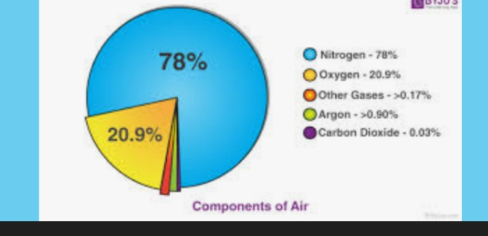
The mixture of gases that makes up the Earth’s atmosphere is known as air. Nitrogen makes up 78 % of this gas, which is mixed with oxygen (21%), water vapour (variable), argon (0.9 %), carbon dioxide (0.04%), and trace gases. There is no apparent scent or colour in pure air. Dust, pollen, and spores are common contaminants in the air; additional contaminants are referred to as “air pollution.” Because there is no air in space, the so-called air on another planet, such as Mars, would have a different composition.

Components of air
We all know that air surrounds us everywhere on this planet. One cannot imagine the existence of life without air. Ever wondered what is air made up of? Is it a mixture or a pure substance? In ancient times, the air was thought to be a pure substance but was later found to be a mixture of many gases. The composition of air is not constant and changes from place to place. For example: in polluted areas, since emissions of carbon dioxide are very high therefore, they have the higher percentage of carbon dioxide. The main components of air are explained below:

Water vapour: We know that water present in oceans and rivers evaporates during summer and escapes into the air. Thus water vapour is one of the components of the air. It occupies very less percentage of the earth’s atmosphere.

Oxygen: Have you ever tried to burn a candle in absence of air? If you would try you would notice that it doesn’t burn in absence of air. Air contains some matter which supports combustion. This substance is oxygen. Oxygen is one of the major components of air around us. Air comprises almost 21% oxygen.

Nitrogen: When you blow over a burning candle you notice that it extinguishes. This means air contains incombustible gases (gases which don’t support combustion) too. This is majorly due to the presence of nitrogen. Nitrogen occupies nearly 78% of the earth’s atmosphere and is the most abundant gas on our planet.

Carbon dioxide: Carbon dioxide is mainly produced due to respiration by plants and animals or the burning of fuel. It occupies 0.038% of the earth’s atmosphere. Its occupancy keeps on changing from one place to another in our atmosphere.

Smoke and dust particles: Smoke is present in our atmosphere due to the burning of fuels. Its occupancy varies from place to place. It is a mixture of gases and is often harmful. Apart from these, dust particles are also present in our atmosphere which we observe when we see a ray of light in a dark room. Smoke and dust particles occupy less than 1% of earth’s atmosphere.

Properties of Air
Some common properties are as follows:

Colourless and Odourless:
Air generally has no colour or odour. It is an invisible matter that can only be felt. All living things breathe air for their survival. Moving air is called wind.

Occupy Space:
It is a mixture of different gases. Hence, like every other matter, they also occupy space. On blowing, a balloon expands because the air being blown into it fills up the empty space.

What is a Flame?
The word “flame’ itself comes from the Latin word “flamma”. Very simply put flames are the visible part of a combustion reaction. During combustion, the fuel reacts with the oxygen and produces a huge amount of heat energy. Due to this heat, the atoms of the reactants get superheated. And as these atoms are leaving the combustion zone they bleed of this excess energy in form of light.
When you light a candle a combustion reaction takes place with the wax of the candle which is the fuel and the air which contains oxygen. The flames are the are in which this combustion reaction is taking place. The release of heat and light energy from this exothermic reaction happens through the flame.
There are three distinct colors in the flames. This helps us to classify the parts of a flame which are as following:
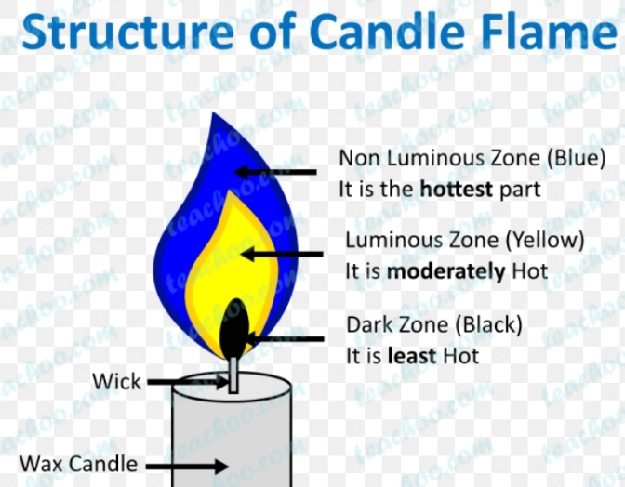

Inner Part: This is the innermost part of the flame. It is the part closest to the wick. You might assume that this is the hottest part of the flame. However, it is the least hot. This is the black part of the flames that contains unburnt particles of the carbon from the wick i.e. unburnt fuel.
Middle Part: This is the biggest part of the flame. The colors in this are varying shades of yellow and orange. This is the luminous flame because it emits light. This part is also not extremely hot. This is because this part gets a limited supply of oxygen. So incomplete combustion takes place here. Which is why it burns orange and is luminous.
Outer Part: this is the hottest part of the flame. This part has an unlimited supply of oxygen. So complete combustion takes place here. Hence it is the hottest part of the flame. Also, this part of the flames burns with a blue color. It is the non-luminous, i.e. does not emit light
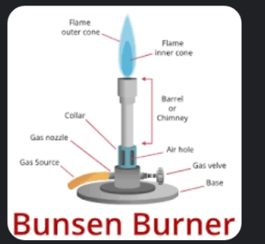
Week 4 note
Hydrogen
In 1766, Henry Cavendish did the first important work on hydrogen.It was Antoine Lavoisier, a Frenchman, who showed that hydrogen is an element and actually named
the element hydrogen. The word hydrogen means water former and is a reference to the fact that hydrogen burns in air to form water. Hydrogen is the lightest of the elements.
Hydrogen occupies a unique or special position in the periodic table. The hydro-
gen atom has only one electron in its single shell, and so, it is like the alkali metals which also have only one electron in their outermost shells so it can be grouped as group 1. On the other hand, the hydrogen atom can be considered as belonging to the Group VII elements, i.e. those elements with one electron less than their noble gas neighbours. In this respect, hydrogen could be grouped with the halogens
Hydrogen has three known isotopes. The mass numbers of hydrogen’s isotopes are 1, 2, and 3, the most abundant being the mass 1 isotope generally called hydrogen (symbol H, or 1H) but also known as protium. The mass 2 isotope, which has a nucleus of one proton and one neutron and has been named deuterium, or heavy hydrogen (symbol D, or 2H), constitutes 0.0156 percent of the ordinary mixture of hydrogen. Tritium (symbol T, or 3H), with one proton and two neutrons in each nucleus, is the mass 3 isotope and constitutes about 10−15 to 10−16 percent of hydrogen
Laboratory preparation of hydrogen
The laboratory preparation of hydrogen gas usually involves the action of dilute sulphuric acid or dilute hydrochloric acid on zinc granules.
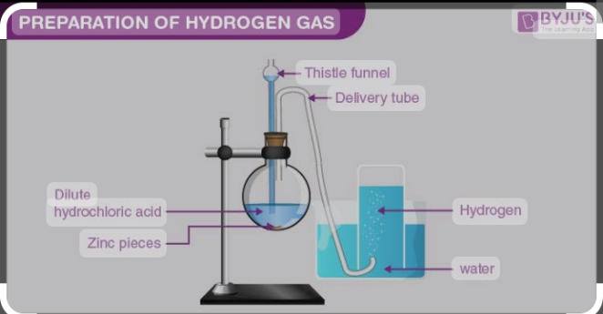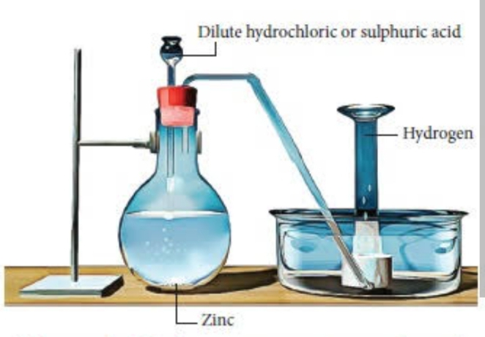
preparation of hydrogen gas via this method are listed below.
1.Action of zinc on an acid.no heating is required.
With Hydrochloric Acid: Zn(s) + 2HCl(aq) ----------->ZnCl2(aq) + H2(g)
With Sulphuric Acid: Zn(s) + H2SO4(aq)------------> ZnSO4(aq) + H2(g)
2.Action of sodium on cold water Sodium liberates hydrogen from cold water. This reaction n is very vigorous and should be carried out with extreme care using only a small piece of sodium.
2Na_{(s)} + 2H₂0(1)----------> 2NaOH(aq) + H_{2(g)}
3. Action of iron on steam Iron, at red heat liberates hydrogen from steam. Iron(II) diiron(III); oxide, Fe₃O₄ is formed at the, same time. This reaction is reversible.
3Fe(s) + 4H₂0_{(g)}------------> Fe₃0_{4(s)} + 4H_{2(g)}
Industrial preparation
Hydrogen is prepared commercially by a variety of methods.
1. From water gas
2. From methane
3.By electrolytic method

Physical Properties
1.Hydrogen is a colourless, odourless and tasteless gas.
2. It is neutral to moist litmus paper.
3. It is relatively insoluble in water. Only 2 cm²of it will dissolve in 100 cm² of water at s.t.p.
4. Hydrogen is the lightest known substance. It is 14.4 times less dense than air.
5. It has a very low boiling point of -253 °C.
Chemical properties of hydrogen
1. Combination reactions
Hydrogen combines with certain metals and non- metals to form electrovalent and covalent hydrides respectively.
2Na_{( s)} + H_{2 (g)} ----------> NaH (s)
2H2 (g) + O2----------->2H₂O _{(g)}
Cl2 (g) + H_{2 (g)}------>2HCl_{(g)}
2.Reducing action
Hydrogen is a strong reducing agent. It reduces the Oxides of copper, lead, iron and zinc to the respective metals when they are heated in a stream of the gas. At the same time, the hydrogen itself is oxidized to form water.
CuO_{(s)} + H_{2(g)}---------> Cu_{(s)} + H₂0_{(g)}
Fe₂O_{3(s)} + 3H_{2(g)}-----------> 2Fe_{(s)} + 3H₂0_{(g)}
Test for hydrogen
Insert a lighted splinter into a test-tube containing the unknown gas. If the gas is hydrogen, it will burn with a pop sound, since it will invariably mix with the air as soon as the test-tube is unstoppered. This test should only be carried out with small quantities of the gas.
Uses
1.Hydrogen is used in the manufacture of ammonia hydrochloric acid and methanol.
2. Hydrogen is used to make margarine or as lard and in the manufacture of soap and candles.
3.Hydrogen is used for filling balloons.
4 . Hydrogen is a constituent of many gaseous fuels such as water gas and coal gas. Liquid hydrogen is also used as a rocket fuel.
5. Hydrogen gives out a lot of heat when it burns

Hydrides
Hydrides is any of a class of chemical compounds in which hydrogen is combined with another element.in a hydride hydrogen has a -1 oxidation state.Akali and alkali earth metals like sodium and calcium form ionic hydrides with hydrogen.

Week 5 note
OXYGEN AND ITS COMPOUNDS
Oxygen is the most abundant element on earth. It constitutes 21% by volume of atmospheric air.Occurrence: It occurs as free elements in nature and in combined states.

GENERAL PROPERTIES OF OXYGEN FAMILY
Elements in group VI include: Oxygen (O), Sulphur (S), Selenium (Se), Tellurium (Te), and Polonium (Po).their properties are as follows:
i. They are non-metals and exist as solid at room temperature except for oxygen
ii. They are electron acceptors and oxidizing in nature.
iii. They do not react with water in any form. But oxygen and sulphur combine directly with hydrogen to yield water and hydrogen sulphide respectively.

ELECTRONIC STRUCTURE AND BONDING IN OXYGEN
Oxygen has an atomic number of 8; hence its electronic configuration is 1s²2s²2p⁴. This shows that oxygen needs two electrons in order to attain an octet configuration.

Oxygen atom has six valence electrons and can acquire a stable octet configuration by:
Accepting two electrons from electropositive elements like metals to form negative oxide ion, O²⁻. Example
Ca²⁺ + O²⁻ --------->CaO
Entering into covalent bond formation with non-metals by covalently sharing two out of its six outer electrons. Example formation of carbon (IV) oxide molecule.
O ---- C ----- O
Forming covalent bond with itself.
O= O

LABORATORY PREPARATION OF OXYGEN
1. By the thermal decomposition of potassium trioxochlorate (V) in the presence of MnO₂ as catalyst
2KClO_{3(s)}^{heat}---------> 2KCl_{2(s)} + 3O_{2(g)}
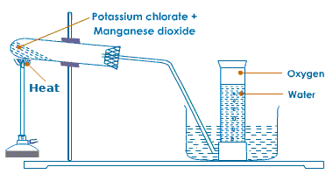
2. By decomposition of hydrogen peroxide, H₂O₂ in the presence of MnO₂ as catalyst
2H₂O_{2(aq)} ^{heat} ---------> 2H₂O_{(l)} + O_{2(g)}
Hydrogen peroxide also reacts with acidified KMnO₄ in the cold to produce oxygen
5H₂O_{2(aq)} + 2KMnO_{4(aq)} + 3H₂SO_{4(aq)} ---------> K₂SO_{4(aq)} + 2MnSO_{4(aq)} + 8H₂O_{(l)} + 50_{2(g)}
NOTE: If the gas is required dry, it is passed through anhydrous calcium chloride or concentrated tetraoxosulphate (VI) acid and collected over mercury.

INDUSTRIAL PREPARATION
1.Electrolysis of water
2. Fractional distillation of liquid air: This preparation involves two main processes:
Liquefaction of air
i.Air is first passed through caustic Soda, NaOH_{(aq)} to remove CO₂. It is then subjected through series of compressions, expansions and cooling until liquid air is obtained at -200ºC.
2. Fractional distillation of liquid air
The liquid air is led to a fractional distillation column. On distillation, nitrogen with a lower boiling point of -196⁰C is evolved first, leaving behind liquid oxygen. Further heating converts the liquid oxygen to a gas at -183⁰C

PHYSICAL PROPERTIES
1.It is colourless , odorless and tasteless diatomic gas
2. It is neutral to litmus
3.It is slightly soluble in water
4.Gaseous oxygen is denser than air
5. Gaseous oxygen liquefies at -183⁰C

CHEMICAL PROPERTIES
1. Reaction with metals: Oxygen combines directly with most metals to form basic oxides
2Ca + O₂ ---------> 2CaO
4K + O₂ ---------> K₂O
The oxides of very electropositive metals, K, Na, Ca dissolves in water to form alkalis
2 K₂O + 2 H₂O ---------> 4KOH
2. Reaction with non-metals: Non-metals burn in oxygen to acidic oxides. These are known as acid anhydrides as they dissolve in water to form acids.
S_{(s)} + O_{2(g)} ---------> SO_{2(g)}
SO_{2(g)} + H₂O_{(l)} ---------> H₂SO_{3(aq)}
P_{4(s)} + O_{2(g)} ---------> P₄O_{6(g)}
P₄O₆ + H₂O_{(l)} --------->4H₃PO_{3(aq)}
3. Most hydrocarbon and compounds of carbon, hydrogen and oxygen burn in oxygen to give CO₂ and H₂O
C₂H₅OH_{(l)} + 3O_{4(g)} ---------> 2CO_{2(g)} + 3H₂O_{(l)}

USES OF OXYGEN
1.It is used in oxy-ethylene flame
2.It is required for respiration
3.It is used in steel industry for the removal of C, S and P impurities from pig iron
4.Liquid oxygen and fuel are used as propellant for space rockets
5. Oxygen is used in the manufacturer of tetraoxosulphate (VI), trioxonitrate (VI) acid and ethanoic acid.

TEST FOR OXYGEN
When a glowing splinter is inserted into a gas jar containing an unknown gas and the glowing splinter is rekindled, then the gas is likely oxygen gas or dinitrogen (I) oxide gas.
If the gas is colourless and reacts with nitrogen (II) oxide to produce reddish-brown fumes of nitrogen (IV) oxide, then the gas is confirmed to be oxygen gas.

OXIDES
Oxides are binary compounds formed when oxygen combines with other elements
Types of oxides (classification)
1. Basic Oxides: These are oxides of metals e.g. Na₂O, K₂O, MgO, CaO etc. They react with acids to form salt and water only. Example
Na₂O_{(s)} + 2HCl_{(aq)} ---------> 2NaCl_{(s)} + H₂O_{(l)}
2. Acidic Oxides: These are oxides of non-metals which dissolves in water to form acids e.g. CO₂, SO₂, NO₂ etc. They react with alkali to form a salt and water only e.g. CO_{2(g)} + 2NaOH_{(aq)} Na₂CO_{3(aq)} + H₂O_{(l)}
3. Amphoteric Oxides: These are oxides of metals which can react with both acids and alkalis to form salt and water only. They include the oxides of Al, Zn, Pb and Sn. Example
ZnO_{(s)} + H₂SO₄ ---------> ZnSO_{4(aq)} + H₂O_{(l)}
ZnO(s) + 2NaOH_{(aq)} + H₂O ---------> Na₂Zn(OH)_{4(aq)}
4. Neutral Oxides: These are oxides of non-metals which are neither acidic nor basic. They are neutral to litmus. They include CO₂H₂O and N₂O
5. Peroxides: These are oxides which contain higher proportion of oxygen than ordinary oxides e.g Na₂O₂, CaO₂ and BaO₂. They react with dilute acid to produce hydrogen peroxide, H₂O₂

Week 6
HALOGENS
Halogens (salt formers) are found in group VII of the periodic table. They are the most reactive nonmetals. They have seven valence electrons, they exist as diatomic molecules, and they are coloured and ionizes to form univalent negative ions. They form electrovalent compounds with metals. In the group are chlorine, fluorine, bromine, iodine and astatine.
ELECTRONIC CONFIGURATION OF HALOGENS
The halogens meaning salt makers are found in group VII of the periodic table. The
electronic configuration of the halogens is one electron short of the noble gas structure (i.e. contains seven electrons on their outermost shells), and the chemistry of the group is dominated by the tendency to complete the octet arrangement by receiving an electron. The electronic configurations of the halogens are shown below:
Fluorine = 9: 1s² 2s² 2p⁵
Chlorine = 17: 1s² 2s² 2p⁶ 3s² 3p⁵
Bromine = 35: 1s² 2s² 2p⁶ 3s² 3p⁶ 3d¹⁰ 4s² 4p⁵
Iodine = 53: 1s² 2s² 2p⁶ 3s² 3p⁶ 3d¹⁰ 4s² 4p⁶ 4d¹⁰ 5s² 5p⁵

PHYSICAL PROPERTIES OF THE HALOGENS
They are usually univalent, and easily accept one electron from other atoms to form ionic compounds (especially from metals e.g Na & K). They also share electrons with themselves or with non-metals to form covalent compounds.
They exist in their natural states as non-polar diatomic molecules.
Fluorine and chlorine are gases, bromine is a liquid and iodine is a solid.
The halogens are coloured, with typical penetrating odour. The colours deepen down the group. Fluorine is pale-yellow, chlorine is greenish- yellow, bromine is red and iodine is violet.
They are volatile substances. Their volatility decreases down the group.
All the halogens except fluorine, dissolve to some extent in water, fluorine reacts with water to give oxygen and hydrogen fluoride.

CHEMICAL PROPERTIES OF THE HALOGENS
1.The halogens are very reactive elements. Their reactivity decreases down the group. Fluorine is the most reactive halogen. They are also strongly electronegative. Their Electronegativity decreases down the group.
2. As oxidizing agents. Halogens are strong oxidizing agent. They do so by accepting electrons and forming halide ions especially in the reaction with metals. The oxidizing power decreases down a group.
3. Reaction with metals: Halogens react with metals to form ionic compounds.
2Na_{(s)} + F_{2(g)} --------->2NaF_{(s)}
4. Reaction with hydrogen: Fluorine explodes with hydrogen even in the dark, chlorine reacts slowly in the dark but explode in bright sunlight, bromine reacts with hydrogen in the presence of platinum catalyst; while iodine reacts partially with hydrogen on heating. Example
H_{2(g)} + Cl_{2(g)} --------->2HCl_{(g)}
Stability of the hydrogen halides decreases down the group. Hydrogen fluoride is a liquid with a boiling point of 19^{O}C. The other hydrogen halides are gases.
5. Reaction with water: Fluorine reacts vigorously with water to give off oxygen gas. Chlorine reacts very slowly with water to give a mixture of hydrochloric acid and oxochlorate (I) acid which later decomposes to give hydrochloric acid and oxygen gas. The oxygen gas given off by the oxochlorate (I) acid is responsible for the bleaching action of moist chlorine gas and chlorine water.
H₂O_{(g)} + Cl_{2(g)} ---------> HCl_{(aq)} + HOCl_{(aq)}

CHLORINE
Chlorine is the most important element in the halogen family. It does not occur as free element in nature because it is too reactive. It is usually found in combined state as chlorides.

LABORATORY PREPARATION OF CHLORINE
By the oxidation of concentrated HCl with strong oxidizing agent such as MnO₂ or KMnO₄
MnO_{2(s)} + 4HCl_{(aq)} --------->MnCl_{2(aq)} + 2H₂O_{(l)} + Cl_{2(g)}

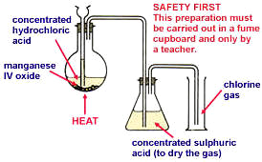

2. By heating concentrated H₂SO₄ with a mixture of NaCl and MnO₂
2NaCl_{(s)} + MnO_{2(s)} + 2H₂SO_{4(aq)} ---------> Na₂SO_{4(aq)} + MnSO_{4(aq)} + H₂O_{(l)} + Cl_{2(g)}

INDUSTRIAL PREPARATION
Chlorine is manufactured industrially by the electrolysis of brine and molten NaCl, MgCl₂ or CaCl_{2.}
PHYSICAL PROPERTIES
1. Chlorine is a greenish-yellow gas with unpleasant chocking smell.
2. It is a poisonous gas.
3. It is about 2.5 times denser than air.
4.It can be liquefied under a pressure of about 6atm.
5. It is moderately soluble in water.

CHEMICAL PROPERTIES
1. It is very reactive and tends to attain stability by forming electrovalent compound with metals and a single covalent bond compounds with non-metals.
2Na_{(s)} + Cl_{2(g) ------------>} 2NaCl_{(s)}
Cl_{2(g)} + H_{2(g)} ----------> 2HCl_{(g)}
2. It displaces other halogens from solution of their acids and salts
Cl_{2(g)} + NaI_{(aq)} ---------> 2NaCl_{(aq)} + I_{2(g)}
3. It combines directly with other elements except oxygen, nitrogen carbon and the noble gases; to form chlorides
Ca_{(s)} + Cl_{2(g)} ---------> CaCl_{2(s)}
4. It has a very strong affinity for hydrogen; it removes hydrogen from its compounds.
C₁₀H_{12(l)} + 8Cl_{2(g)} ---------> 10C_{(s)} + 16HCl_{(g)}
5. It is a powerful oxidizing agent: it oxidizes green Fe²⁺ to yellow Fe³⁺
2FeCl_{2(aq)} + Cl₂ --------->2FeCl_{3(aq)}
6. It has a bleaching action: in the presence of water, chlorine bleaches most dyes and inks except printer’s ink. The bleaching action of chlorine is due to its ability to react with water to form oxochlorate (I) acid which decomposes to release oxygen which oxidizes the dye to form a colourless compound.
H₂O_{(l)} + Cl_{2(g)} ---------> HCl_{(aq)} + HOCl_{(aq)}
HOCl_{(aq)} ---------> HCl_{(aq)} + [O]
Dye + [O] --------->[Dye + O]
Coloured Colourless
7. It reacts with hot concentrated NaOH solution to give a mixture of trioxochlorate (V) and chloride of the metal.
6NaOH + 3Cl_{2(g)} --------->NaClO_{3(aq)} + NaCl_{(aq)} + H₂O_{(l)}
^{Sodium trioxochlorate (V)}
With cold dilute solution of NaOH, a pale yellowish mixture of oxochlorate (I) and chloride of the metal is formed.
2NaOH_{(aq)} + Cl_{2(g)} --------->NaOCl_{(aq)} + NaCl_{(aq)} + H₂O_{(l)}
It reacts with slaked lime solutions to produce bleaching powder
Ca(OH)_{2(aq)} + Cl_{2(g)} --------->CaOCl₂.H₂O_{(s)}
^{Bleaching powder}
TEST FOR CHLORINE
It turns damped blue litmus paper pink and then bleaches it. It is acidic gas.
It turns damped starch-iodide dark blue. Chlorine turns starch-iodide paper blue because it displaces iodine from the iodide. The iodine liberated then turns the starch blue.

USES OF CHLORINE
1.It is a powerful germicide [due to its oxidizing nature].
2.It is used as a bleaching agent for cotton, wool, pulp etc.
3.It is used in the manufacture of polyvinyl chloride (PVC) and synthetic rubber.
4.It is used in the manufacture of organic compound e.g CHCl₃, CCl_{4.}
5.It is used in producing KClO₃, for making matches and fireworks.
6.It is used for making NaClO_{3,} a weed killer.
7.It is used for making domestic antiseptics e.g acidified NaClO solution.
COMPOUNDS OF CHLORINE
HYDROGEN CHLORIDE
Hydrogen chloride (marine-acid gas) exists as a gas at room temperature. It dissolves in water to form hydrochloric acid. It occurs in traces in the air as industrial by-product and is considered as air pollutant; but it can be easily washed down as acid rain since it is very
soluble in water.

LABORATORY PREPARATION
The gas is prepared by the action of hot concentrated H₂SO₄ on any soluble chloride. Example 2NaCl_{(s)} + H₂SO_{4(aq)} --------->Na₂SO_{4(aq)} + 2HCl_{(g)}
Note: NaHSO₄ is first formed at a lower temperature and later at higher temperature HCl gas is formed. The gas is dried by passing it through concentrated H₂SO₄ in another flask and collected.
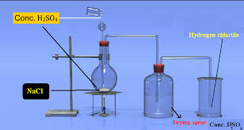
INDUSTRIAL PREPARATION
Pure HCl gas can be produced in large scale by direct combination of hydrogen and chloride gas obtained from the electrolysis of brine.
H_{2(g)} + Cl_{2(g)} ---------> 2HCl_{(g)}

PHYSICAL PROPERTIES
Pure HCl gas is colourless and has sharp irritating smell
It turns damp blue litmus paper red
It is about 1.25times denser than air
It is very soluble in water, forming aqueous HCl acid
It is readily dissolved in non-polar solvent like chloroform and toluene; but the solution does not conduct electricity and has no acidic properties because hydrogen chloride which is a covalent molecule does not ionize when it dissolve in non-polar solvents. But it dissolves in water and ionizes. The ions formed in aqueous solution are responsible for the acidic property and conductivity of its aqueous solution.
It forms misty fumes in moist air because it dissolves in the moisture to form tiny droplets of HCl acid.
It does not support combustion.

CHEMICAL PROPERTIES
1. It combines directly with NH₃ and produces a white fumes of ammonium chloride
HCl_{(g)} + NH_{3(g)} ---------> NH₄Cl_{(s)}
2. It reacts with various heated metals to form their respective chloride and hydrogen
Zn_{(s)} + 2HCl_{(g)} --------->ZnCl_{2(s)} + H_{2(g)}

TEST FOR HYDROGEN CHLORIDE
A gas rod that has been dipped in ammonia solution is brought near the gas jar containing the unknown gas, if there are dense white fumes on the glass rod, then the gas is hydrogen chloride gas.
Few drops of silver trioxonitrate (V) is added to the gas jar containing the unknown gas and shaken. If white precipitate of silver chloride is observed, then the gas is hydrogen chloride gas.

CHLORIDES
Chlorides are normal salts formed when metallic ion replace the hydrogen ion in hydrochloric acid. Chlorides are prepared by neutralization reaction. Chlorides are soluble in water with exception of few.

Soluble chlorides Insoluble chlorides
NaCl, NH₄Cl, KCl CuCl₂, AgCl, PbCl₂CaCl₂ etc

PROPERTIES
Chlorides are not decomposed by heat. They can only be recovered from solution by evaporation to dryness or sometimes by crystallization.
They react with hot concentrated tetraoxosulphate (VI) acid to produce hydrogen chloride gas.
2NaCl_{(s)} + H₂SO_{4(aq)} ---------> Na₂SO_{4(aq)} + 2HCl_{(g)}
On heating a chloride with concentrated tetraoxosulphate (VI) in the presence of a strong oxidizing agent, chlorine is produced.
ZnCl_{2(s)} + KMnO_{4(s)} + 2H₂SO_{4(aq)} ---------> ZnSO_{4(aq)} + K₂SO_{4(aq)} + 2MnO_{2(aq)} + 2H₂O_{(l)} + Cl_{2(g)}

TEST FOR CHLORIDES
The test solution is acidified with dilute trioxonitrate (V) acid to prevent precipitation of other salts. Few drops of AgNO_{3(aq)} is then added to the acidified solution in a test tube, a white precipitate of AgCl which readily dissolves in excess NH_{3(aq)} solution indicates the presence of a chloride.

Week 7 - 11

NITROGEN

GENERAL PROPERTIES OF NITROGEN FAMILY (GROUP VA ELEMENTS)
The group V elements include: Nitrogen, Phosphorus, Arsenic, Antimony and Bismuth. There are more differences than similarities between the elements in this group.
Nitrogen is a diatomic gas and does not exhibit allotropy. Phosphorus is a typical non-metal and exhibits allotropy. Arsenic and Antimony are metalloid; while bismuth is a metal.
Nitrogen is a colourless gas. Phosphorus exists in variety of allotropic forms like white and red phosphorus. Arsenic exists as a dull grey metallic solid. Antimony and bismuth is silvery-white solid.
Nitrogen is the most electronegative element in the group. It combines with metals and non-metals to form a variety of compounds.

ELECTRONIC CONFIGURATION
The electronic configuration of the group V elements is as follows:
Nitrogen = 7: 1s² 2s² 2p³
Phosphorus = 15: 1s² 2s² 2p⁶ 3s² 3p³
Arsenic = 33: 1s² 2s² 2p⁶ 3s² 3p⁶ 3d¹⁰ 4s² 4p³
Antimony = 51: 1s² 2s² 2p⁶ 3s² 3p⁶ 3d¹⁰ 4s² 4p⁶ 4d¹⁰ 5s² 5p³

NITROGEN
Nitrogen occurs chiefly as a free element in the air. It makes up 78% by volume of the atmosphere. It also exists in combined form in many compounds e.g ammonia, urea, proteins etc. 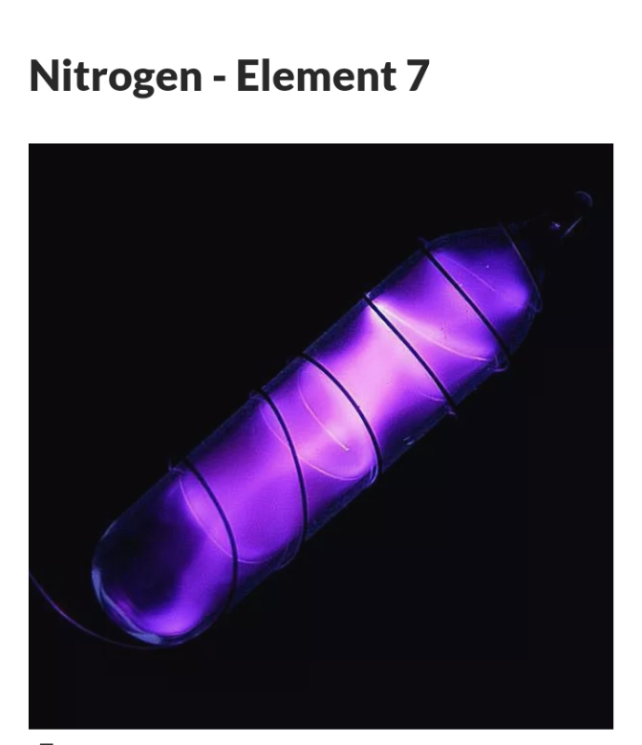

LABORATORY PREPARATION
From Air
It can be obtained from air by passing air through caustic soda to remove CO₂ and
overheated copper turnings to remove O₂ respectively. The nitrogen obtained is not pure, it contains 1% by volume of rare gases and it is denser than air.
Pure nitrogen is obtained in the laboratory by chemical method. The following chemicals are used to prepare nitrogen.
1. Thermal decomposition of ammonium dioxonitrate (III)
a. NaNO_{2(aq)} + NH₄Cl_{(aq)} ---------> NH₄NO_{2(aq)} +NaCl_{(aq)}
b. NH₄NO_{2(aq)} ---------> 2H₂O_{(l)} + N_{2(g)}
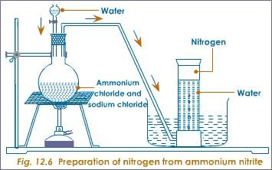

2. Thermal decomposition of ammonium heptaoxodichromate (VI)
(NH₄)₂Cr₂O_{7(s)} --------->Cr₂O_{3(s)} + 4H₂O_{(l)} + N_{2(g)}
3. Oxidation of ammonia by hot Copper (II) oxide
2NH_{3(g)} + 3CuO_{(s)} ---------> 3Cu_{(s)} + 3H₂O_{(g)} + N_{2(g)}
Reduction of dinitrogen (I) oxide by red-hot copper.
N₂O_{(g)} + Cu_{(s)} ---------> CuO_{(s)} + N_{2(g)}

INDUSTRIAL PREPARATION
Industrially, nitrogen is obtained by fractional distillation of liquid air.
PHYSICAL PROPERTIES
1. It is colourless, odourless and tasteless
2. Pure nitrogen is lighter than air.
3. Slightly soluble in water
4. Melting point – 210⁰C and boiling point is -196⁰C

CHEMICAL PROPERTIES
1. It reacts with very electropositive metals to form nitrides
3Mg_{(s)} + N_{2(g)} ---------> Mg₃N_{2(s)}
2. It reacts with non – metals like hydrogen and oxygen to form ammonia and oxides respectively.
N_{2(g)} + 3H_{2(g)} ---------> 3NH_{3(g)}
N_{2(g)} + 2O_{2(g)} ---------> 2N₂O_{(g)}

USES
1. It is used industrially to manufacture ammonia.
2. Liquid nitrogen is used as a cooling agent.
3. It is used as preservative in packaged foods to prevent rancidity.

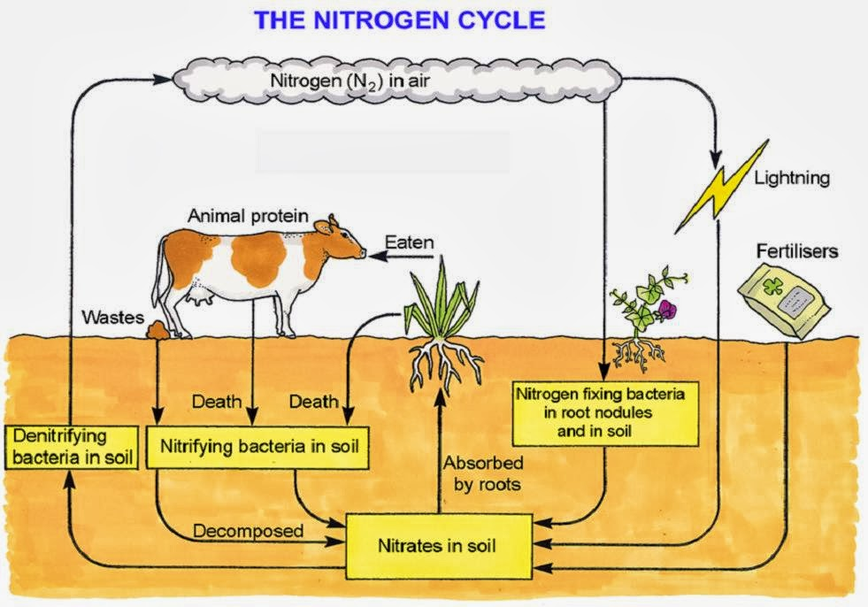
The stages in which atmospheric nitrogen is converted into soil nitrogen and back to free nitrogen occurs in the following ways:
Oxidation of atmospheric nitrogen: During lightning and thunderstorm, there is electrical discharge in the atmosphere which cause atmospheric nitrogen and oxygen combine to form oxides of nitrogen which can dissolve in rain water as dioxonitrate (III) and trioxonitrate (V) acids. These acids go into the soil and react with mineral salts in the soil to form trioxonitrate (V) salts which is absorbed by plants.
N_{2(g)} + O_{2(g)} ---------> 2NO_{(g)}
2NO_{(g)} + O_{2(g)} ---------> 2NO_{2(g)}
4NO_{(g)} + O_{2(g)} + 2H₂O_{(l)} ---------> 4HNO_{2(aq)}
4NO_{(g)} + O_{2(g)} + 2H₂O_{(l)} --------->4HNO_{3(aq)}
Action of nitrogen-fixing bacteria: Soil micro-organisms like Rhizobium living in root nodules of leguminous plants are able to convert atmospheric nitrogen into organic nitrogenous compounds which are used directly by the host plants. These compounds are released into the soil when these plants die. Other free living micro-organisms in the soil like Azotobacter and Clostridium are also able to convert atmospheric nitrogen directly into trioxonitrate (V) which is absorbed by plants. These processes are known as nitrogen fixation.
Decay of organic matter: When plants and animal die, putrefying bacteria and fungi in the soil converts organic nitrogenous compounds to ammonia. Nitrifying bacteria like Nitrosomonas and Nitrobacter convert the ammonia to trioxonitrate (V) which can again be absorbed by plants. These processes are known as nitrification.
Denitrification: Trioxonitrate (V) salt in the soil can be converted to gaseous nitrogen by denitrifying bacteria. The process is known as Denitrification. The nitrogen so formed escapes into the atmosphere, where it becomes atmospheric nitrogen. Denitrifying bacteria therefore reduces the quantity of trioxonitrate (V) in the soil.

COMPOUNDS OF NITROGEN
OXIDES OF NITROGEN
NITROGEN (I) OXIDE, N₂O
Nitrogen (I) oxide is known as laughing gas as it causes uncontrollable laughter when inhaled.

LABORATORY PREPARATION
The gas is prepared in the laboratory by thermal decomposition of ammonium trioxonitrate (V). Ammonium trioxonitrate (V) is not heated directly since the reaction is exothermic and may become uncontrollable leading to an explosion.
a. KNO_{3(s)} + NH₄Cl_{(s)} → KCl_{(s)} + NH₄NO_{3(s)}
b NH₄NO_{3(s)} → 2H₂O_{(g)} + N₂O_{(g)}
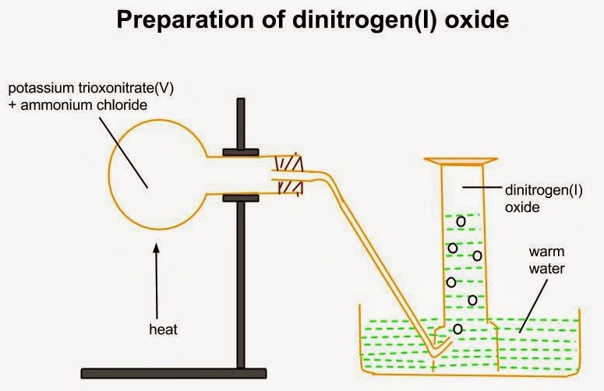
PHYSICAL PROPERTIES
1.It is a colourless gas with a faint pleasant sickly smell and it has a sweetish taste.
2. It is fairly soluble in cold water.
3. It is 1.5 times denser than air.
3.It is neutral to moist litmus paper.

CHEMICAL PROPERTIES
1. It decomposes on strong heating (about 600ºC) to form nitrogen and oxygen.
2N₂O_{(g)}---------> O_{2(g)} + 2N_{2(g)}
2. It supports the combustion of any burning substance which is hot enough to decompose it.
Mg_{(s)} + N₂O_{(g)} --------->MgO_{(s)} + N_{2(g)}
It is reduced to nitrogen by heated copper or iron
Cu_{(s)} + N₂O_{(g)} ---------> N_{2(g)} + CuO_{(s)}

TEST FOR N₂O
A glowing splinter is inserted into the gas jar containing the unknown gas. If the splinter is rekindled, the gas is either oxygen or nitrogen (I) oxide. If the gas has a pleasant smell and does not produce brown fumes with nitrogen (IV) oxide; then the gas is nitrogen (I) oxide.

USE: Nitrogen (I) oxide is used as anesthetic for minor surgical operations.
NITROGEN (II) OXIDE, NO
LABORATORY PREPARATION
Nitrogen (II) oxide is prepared by reacting 50% trioxonitrate (IV) acid with copper.
3Cu_{(s)} + 8HNO_{3(aq)} --------->3Cu(NO₃)_{2(aq)} + 4H₂O_{(l)} + 2NO_{(g)}
Some of the nitrogen (II) oxide gas reacts with oxygen in the flask to form brown fumes of nitrogen (IV) oxide which is dissolved in water as the gas is pass through water.

PHYSICAL PROPERTIES
1.It is a colourless and poisonous gas.
2.It is a almost insoluble in water.
3.It is slightly denser than air.
4.It is neutral to litmus.

CHEMICAL PROPERTIES
1. It reacts readily with oxygen to form brown fumes of nitrogen (IV) oxide
2NO_{(g)} + O_{2(g)} ---------> 2NO_{2(g)}
2. It decomposes on heating at high temperature to form equal volume of nitrogen and oxygen
2NO_{(s)} ---------> N_{2(g)} + O_{2(g)}
It is reduced to nitrogen by hot metals
2Cu_{(s)} + 2NO_{(g)} → 2CuO_{(g)} + N_{2(g)}
It acts as reducing agent decolourizing acidified potassium tetraoxomanganate (VI) slowly
3MnO₄⁻_{(aq)} + 4H⁺_{(aq)} + 5NO_{(g)} --------->3Mn²⁺_{(aq)} + 5NO₃⁻_{(aq)} + 2H₂O_{(l)}

TEST FOR NO
Using air: the gas jar containing the unknown gas is opened, if the gas turns reddish-brown, then the gas is NO.
Using iron (II) tetraoxosulphate (VI): A solution of FeSO₄ which has been acidified with a little dilute H₂SO₄ acid is poured into the gas jar containing the unknown gas. If the solution turns dark brown, then the gas is NO.
NITROGEN (IV) OXIDE, NO₂
LABORATORY PREPARATION
Nitrogen (IV) oxide is prepared by thermal decomposition of lead (II) trioxonitrate (V) because the nitrate does not contain water of crystallization which can interfere with the preparation.
Pb(NO₃)_{2(s)} --------->2PbO_{(s)} + O_{2(g)} + 4NO_{2(g)}
The gas mixture obtained is passed through a U- tube immersed in a freezing mixture. Nitrogen (IV) oxide liquefies as a green liquid (yellow if pure) in the tube while oxygen escapes out.
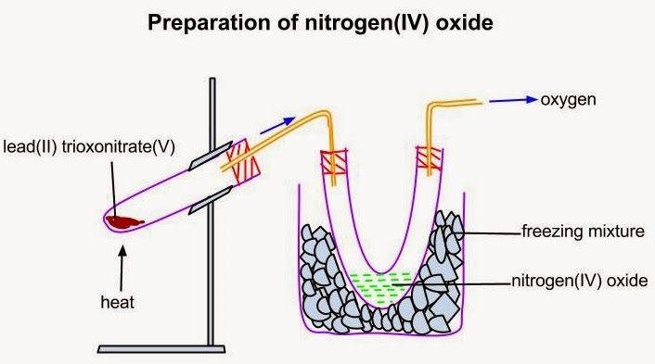
PHYSICAL PROPERTIES
1.It is a reddish – brown gas.
2.It has an irritating smell and is poisonous.
3.It turns damp blue litmus paper red and dissolves in water to form acidic solution.
4.It liquefies into yellow liquid at 21ºC.
5.It is much heavier than air.

CHEMICAL PROPERTIES
1. Nitrogen (IV) oxide exists mainly as dinitrogen (IV) oxide, N₂O₄ at low temperature. It decomposes on heating as follows.
N₂O_{4(g)} 2NO_{2(g)} ---------> 2NO_{(g)} + O_{2(g)}
Pale Reddish colourless
yellow brown
2. It supports combustion as it decomposes on heating to nitrogen and oxygen
2NO_{2(g)} ---------> N_{2(g)} + 2O_{2(g)}
3. It is reduced to nitrogen by reducing agent.
4CU_{(s)} + 2NO_{(g)} ---------> 4CuO_{(s)} + N_{2(g)}
4. It dissolves in water to form a mixture of dioxonitrate (III) and trioxonitrate (V) acids. It is a mixed acid anhydride.
H₂O_{(l)} + 2NO_{2(g)} --------->HNO_{2(aq)} + HNO_{3(aq)}
5. It reacts with alkalis to form mixture of dioxonitrate (III) and trioxonitrate (V) salts
2KOH_{(aq)} + 2NO_{2(g)} --------->KNO_{3(aq)} + KNO_{2(aq)} + H₂O_{(l)}

AMMONIA
Ammonia is a hydride of nitrogen. It is produced in nature when nitrogenous matter decays in the absence of air. Thus, traces of ammonia may be found in the atmosphere but being very soluble in water, it is dissolved by rain water and washed down into the soil.

LABORATORY PREPARATION OF AMMONIA
Ammonia is prepared in the laboratory by heating calcium hydroxide, Ca(OH)₂ (slaked lime) with ammonium chloride.
Ca(OH)_{2(s)}+ 2NH₄Cl_{(s)} ---------> CaCl_{2(s)} +2H₂O_{(l)}+2NH_{3(g)}.
Ammonia is dried using calcium oxide, CaO. Ammonia being alkaline cannot be dried using Conc. H₂SO₄ or fused CaCl₂, because they will react.
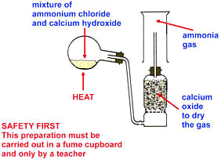

INDUSTRIAL PREPARATION
Ammonia is manufactured from nitrogen and hydrogen by the Haber process. It involves mixing nitrogen and hydrogen in ratio 1:3 by volume. The reaction is reversible so special conditions listed below are required for optional yield of ammonia.
Finely divided iron catalyst is used
Temperature of about 450^{O}c is used
Pressure of about 200atm is used.
The yield is about 15% under this condition
N_{2(g)} +3H_{2(g)} ---------> 2NH_{3(g)} + heat

PHYSICAL PROPERTIES
1.It is a colorless gas with a characteristic choking smell.
2.Ammonia in large quantity is poisonous as it affects respiratory muscles.
3.It is the only known alkaline gas.
4.It is about 1.7 times less dense than air.
5.Solid ammonia melts at -34.4^{O}C and the liquid boils at -77.7^{O}C.

CHEMICAL PROPERTIES
1.Ammonia burns readily in oxygen to form water vapor and nitrogen
4NH_{3(g)} + 3O_{2(g)} --------->6H₂O_{(g)} + 2N_{2(g)}
2. Ammonia reacts as reducing agents reacting with
i. Copper II oxide
3CuO_{(s)} + 2NH_{3(g)} --------->3Cu_{(s)} + 3H₂O_{(l)} + N_{2(g)}
Chlorine
3Cl_{2(g)} + 8NH_{3(g)} ---------> 6NH₄Cl_{(s)} + N_{2(g)}
3.Ammonia reacts with carbon IV oxide to form Urea and water vapour.
2NH_{3(g)} + CO_{2(g)} ---------> (NH₂)₂ CO_{(s)} + H₂O_{(l)}
^{urea}
4.Ammonia reacts with acid to form ammoniums salts.
2NH_{3(g)} + H₂SO_{4(g)} -----> (NH₄)₂SO_{4(s)}

TEST FOR AMMONIA
Ammonia has a choking smell. It can be confirmed using:
Litmus paper: Damped red litmus is dipped into the gas jar containing the unknown gas. If the litmus paper turns blue, then the gas is ammonia.
Hydrochloric acid: a glass rod is dipped in concentrated HCl and then inserted in the gas jar containing the unknown gas. If white fumes are observed on the glass rod, then the gas is ammonia.

USES OF AMMONIA
Ammonia is used in the manufacture of trioxonitrate (V) acid and Sodium trioxocarbonate (IV) by the Solvay process.
Liquid ammonia is used as a refrigerant.
Aqueous ammonia is used in softening temporary hard water.
Aqueous ammonia is also used in laundries as a solvent for removing grease and oil stains.

TRIOXONITRATE (V) ACID, HNO₃
LABORATORY PREPARATION
Trioxonitrate (V) acid is a volatile acid and it is prepared in the laboratory by its displacement from any trioxonitrate salt by concentrated H₂SO₄ which is less volatile. Trioxonitrate (V) of potassium or sodium is usually used because they are cheap.
KNO_{3(s)} + H₂SO_{4(aq)} ---------> KHSO_{4(aq)} + HNO_{3(aq)}

NOTE: An all glass apparatus must be used in this preparation because the hydrogen trioxonitrate (V) acid vapour will attack cork or rubber.
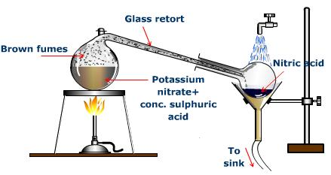
INDUSTRIAL PREPARATION
Trioxonitrate (V) acid is obtained by the catalytic oxidation of ammonia:
- Ammonia is treated with excess air using Platinum-rhodium catalyst at 700ºC to produce nitrogen (II) oxide (96% conversion of NH₃ is obtained)
4NH_{3(g)} + 5O_{2(g)} ---------> 4NO_{(g)} + 6H₂O_{(g)}
- Nitrogen (II) oxide formed is cooled and mixed with excess air to produce nitrogen (IV) oxide.
2NO_{(g)} + O_{2(g)} ------> 2NO₂(g)
- Nitrogen (IV) oxide formed is dissolved with excess air in hot water to yield trioxonitrate (V) acid solution of up to 50% concentration.
4NO_{2(g)} + 2H₂O_{(l)} + O_{2(g)} -------> 4HNO_{3(aq)}

PHYSICAL PROPERTIES
1.The pure acid is a colourless fuming liquid with sharp choking smell. The acid turns yellow due to its decomposition to nitrogen (IV) oxide which redissolves in the acid.
2.The pure acid boils at 86⁰C and melts at -47ºC
3.The density of the pure acid is 1.52 gcm⁻³
4.The pure acid is miscible with water in all properties and forms constant boiling mixture with it at 121ºC
5.The concentrated form of the acid is corrosive.
6.The dilute acid turns blue litmus red.

CHEMICAL PROPERTIES
1.As an acid it neutralizes bases and alkalis to form metallic trioxonitrate (V) and water only
NaOH_{(aq)} + HNO_{3(aq)} --------> NaNO_{3(aq)} + H₂O_{(l)}
2.As an acids it reacts with metallic trioxocarbonate (IV) to liberate
carbon (II) oxide
CaCO_{3(s)} + HNO_{3(aq)} --------->Ca(NO₃)_{2(aq)} + H₂O_{(l)} + CO_{2(g)}
Unlike other acids, it rarely gives out hydrogen with metals except when very dilute solution is reacted with Ca, Mg or Mn.
3.As an oxidizing agent, it reacts with non – metal to form the corresponding oxides of the non – metals.
S_{(s)} + 6HNO_{3(aq)} -------> H₂SO_{4(aq)} + 2H₂O_{(l)} + 6NO_{2(g)}
4.As an oxidizing agent, it oxidizes Cu, Pb, Hg and Ag to yield the
respective trioxonitrate (V) and nitrogen (IV) oxide if concentrated, but nitrogen (II) oxide if the concentration is moderate.
Aluminum and iron are not oxidized to their oxides by concentrated HNO_{3(aq)} due to formation of a surface coating of oxide which is passive do not allow further reaction with the metals. Aluminum or iron lined container can be used to transport concentrated HNO_{3(aq)}
As an oxidizing agent, it oxidizes hydrogen sulphide to sulphur
H₂S_{(g)} + 2HNO_{3(aq)} ------> S_{(s)} + 2H₂O_{(l)} + 2NO_{2(g)}
As an oxidizing agent, it oxidizes iron (II) salts to iron (III) salts
6Fe²⁺_{(aq)} + 8H⁺_{(aq)} + 2NO₃⁻_{(aq)} ----- > 6Fe³⁺_{(aq)} + 4H₂O_{(l)} + 2NO_{(g)}

USES
1.It is used as an acid, oxidizing agent and nitrating agent in the laboratory.
2.It is used in nylon production and Terylene.
3.It is used as rocket fuel.
4.It is used in production of fertilizers, dyes, drugs and explosives.

