Week 1
KINETIC THEORY
Kinetic theory of gases - states that gases consist of small particles in random motion. The kinetic particle THEORY explains the properties of the different states of matter. The particles in solids, liquids and gases have different amounts of energy. They are arranged differently and move in different ways.
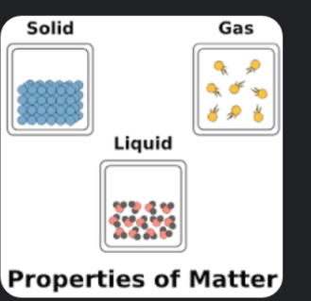

Solids
Properties of solids
They have a fixed shape and cannot flow
The particles cannot move from place to place
They cannot be compressed or squashed
The particles are close together and have no space to move into

Liquids
Properties of liquids
They flow and take the shape of their container
The particles can move around each other
They cannot be compressed or squashed
The particles are close together and have no space to move into

Gases
Gases are made up of molecules. What are molecules? Molecules are the smallest unit which behaves same as the sample, i.e. they have the same chemical properties as of the sample.

Properties of gases
They flow and completely fill their container
The particles can move quickly in all directions
They can be compressed or squashed
The particles are far apart and have space to move into

Changes of state
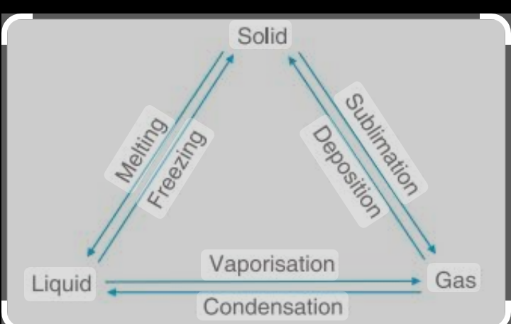

CHANGE OF STATE FROM SOLID TO LIQUID (MELTING)

According to the kinetic theory of matter, when a solid i s substance is heated, the particles vibrate more violently. The force of attraction gain kinetic energy and the particles begin to vibrate more violently. The force of attraction holding the particles together is broken, the particles loosen up and become mobile. The temperature at which the solid changes to liquid is called the melting point of the solid.
Change of state from liquid to gas (Boiling)

According to the kinetic theory of matter when a liquid substance is heated, the particles gain kinetic energy and begin to vibrate throughout the liquid. As the vibration increases (boiling), the molecules begin to escape from the surface of the liquid (vapourisation). At a particular temperature the vapour pressure becomes equal to the atmospheric pressure of the liquid.
The temperature at which the vapour pressure equals that of the atmospheric pressure is called the boiling point of the liquid.

SUBLIMATION
Solids can also lose particles from their surface to form a vapour. Sublimation is the direct change from solid to vapour (or vice versa) without going through the liquid stage. For example, naphthalene, dry ice of carbon(iv)oxide, Iodine crystals e.t.c
Assumptions of kinetic THEORY of gases:
1.All gases are made up of molecules which are constantly and persistently moving in random directions.
2.The separation between the molecules is much greater than the size of molecules.
3.When a gas sample is kept in a container, the molecules of the sample do not exert any force on the walls of the container during collision.
4.The time interval of collision between two molecules, and between a molecule and the wall is considered to be very small.
5.All the collisions between molecules and even between molecules and wall are considered to be elastic.
6.All the molecules in a certain gas sample obey the Newtons laws of motion.
If a gas sample is left for a sufficient time, it eventually comes to a steady state. The density of molecules and the distribution of molecules are independent of position, distance and time.

CHANGE OF STATE FROM LIQUID TO GAS (EVAPORATION)
A liquid is said to evaporate when it changes to gas (vapour) without its temperature reaching its boiling point. Evaporation is the breaking away of the particles
of a liquid in vapour form from the surface of a liquid.
According to the kinetic theory of matter, particles in a liquid are attracted to one
another but the particles at the surface of the liquid gain heat energy from the environment, which makes it possible for them to escape
from the surface of the liquid. The average kinetic energy of liquid is the same as a
temperature. The particles on the surface of liquid escape as vapour because they have a higher kinetic energy. As the particles continue to escape, the average kinetic energy of the liquid decreases and its temperature falls. Evaporation
therefore produces a cooling effect. Examples of substances that can evaporate are ether, alcohol, petrol, methylated spirit, perfumes, etc. These liquids are called volatile liquids because they have low boiling points.

Differences between EVAPORATION AND BOILING

BOILING
1. Boiling takes place throughout t the liquid.
2. Boiling takes place at a particular temperature of the liquid which is called the boiling point of the liquid
3. Boiling requires an external source of heat. Wind has no effect on boiling.
4. Boiling produces heat.
5. Boiling is a rapid process.

EVAPORATION
1.Evaporation takes place only on the surface of the liquid.
2. Evaporation takes place at any temperature
3.Evaporation can occur using the internal energy of the system.
4. Evaporation produces cooling effect.
5. Evaporation is a slow process.

Factors influencing the rate of evaporation

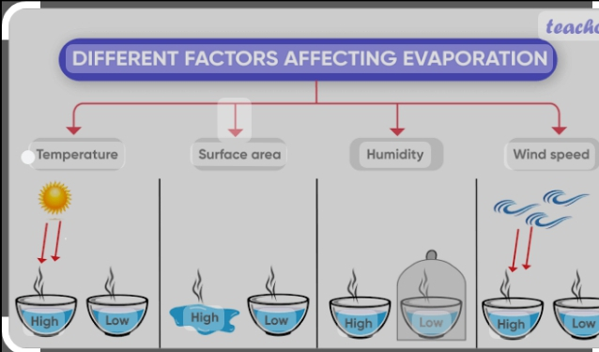

1. Temperature: If the temperature of a liquid increases, its kinetic energy also increases, making the particles more mobile, increase in temperature therefore increases the evaporation of the liquid.
2. Atmospheric pressure: If the atmospheric pressure increases, the rate of evaporation in a liquid increases because the particles that escaped as vapour will not be able to return into the liquid after bouncing off its surface.
3. Wind: As wind blows over the surface of a liquid, the particles gain kinetic energy and become more mobile and escape as vapour?
4 Surface area: If the surface area of a liquid is increased, more particles spread out and gain kinetic energy more easily. These particles become more mobile and escape as vapour.

Week 2
THERMAL ENERGY
Heat flow is the movement of heat (energy) from the interior of Earth to the surface. The source of most heat comes from the cooling of the Earths core and the radioactive heat generation in the upper 20 to 40 km of the Earths crust.

Energy flows into your body from the surrounding air, from surrounding objects, and from the sun when you're outside, or even light bulbs when you're inside. Energy also flows out of your body into the surrounding air, into the surrounding objects, and even into outer space, most notably if you are outside on a clear night. Heat flow moves energy from a higher temperature to a lower temperature. The bigger the difference in temperature between two objects, the faster heat flows between them. When temperatures are the same, there is no change in energy due to heat flow. Heat has the units of energy; heat flow has the units of power.

This type of energy transfer from one place to another place is driven by differences in temperature and is called heat flow
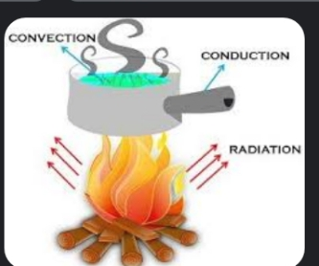

Way Heat Flows
There has to be a temperature difference. Energy only flows as heat if there is a temperature difference.
Energy as heat flows from a higher temperature to a lower temperature.
The greater or larger the difference in temperature, the faster the energy flows.

Temperature is a measure of the average amount of kinetic energy possessed by the
particles in a sample of matter. The more the particles vibrate, translate and rotate, the greater the temperature of the object. You have hopefully adopted an understanding of heat as a flow of energy from a higher temperature object to a lower temperature object. It is the temperature difference between the two neighboring objects that causes this heat transfer. Heat is transferred from the hot water to the cold water until both samples have the same temperature.

Conduction. involves the transfer of heat from one location to another in the absence of any material flow. The mechanism in which heat is transferred from one object to another object through particle collisions is known as conduction.

Applications
1.cooling a glass in an ice bucket
2.burning your hand on a hot tripod
3.holding the handle of a pan

Convection is the process of heat transfer from one location to the next by the movement of fluids. The moving fluid carries energy with it. The fluid flows from a high temperature location to a low temperature location. The two examples are heating water in a pot and heating air in a room.

Application
1.boiling water
2. hot air balloon rising
3.warm water on the surface of a lake and cold water at the bottom of the lake
4.air condition cooling a room
5.cooking rice in water

Radiation is the transfer of heat by means of electromagnetic waves. The transfer of heat by radiation involves the carrying of energy from an origin to the space surrounding it. The energy is carried by electromagnetic waves and does not involve the movement or the interaction of matter.

Application
1.Sun's light warming the Earth
2.feeling warm when you sit in sunlight
3.a pan above the stove burner
4.Barbeque meat with charcoal

Week 3
LESSON NOTE

WORK, ENERGY AND POWER
Work
Work results when a force acts upon an object to cause a displacement (or a motion) or, in some instances, to hinder a motion. Three variables are of importance in this definition - force, displacement, and the extent to which the force causes or hinders the displacement. Each of these three variables find their way into the equation for work. 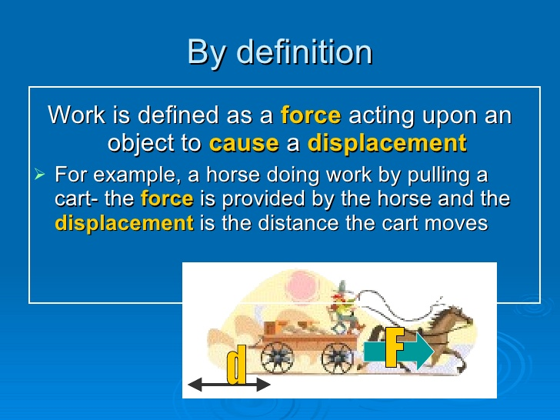

That equation is:
Work = Force × Displacement
W = F × d

Since the standard metric unit of force is the Newton and the standard metric unit of displacement is
the meter, then the standard metric unit of work is a Newtonmeter, defined as a Joule and abbreviated with a J.
Worked examples
Calculate the work done when a box of 2 k kg is raised through a vertical | height of 5 m. (Acceleration due
to gravity= 10 m/s?)
Solution
mass = 2 kg, acceleration = 10 m/s?.
distance =5 m
work done = m x axd
work = 2 x 10 x 5
work = 20 x5
work = 100 J
2. A truck of 8 kg was raised vertically through a height of 10.3 m, what will be the work done? (acceleration due to gravity = 10m/s)
Solution
W=Fxd,
F=ma
W=mxa xd, m=5 kg a = 10
d=7.5 m
W=8x 10 x 10.3=824 J

Week 4
LESSON NOTE

Energy
Energy is defined as the amount of work a physical system is capable of performing. Energy, can neither be created nor consumed or destroyed.
Energy is measured in Joules (J)


Concepts of work, energy and power

Virtually every day we see people carry out various task such as pulling or pushing objects towards a distance. It is observed that force is applied when carrying out the aforementioned activities .It is also pertinent to note that many activities which involve human fatigue do not necessarily, imply that mechanical work is done. For instance, if a man carries a heavy load on his head or his hands , no work is being done if the load is kept stationary.

POTENTIAL AND KINETIC ENERGY
Kinetic energy is energy possessed by a body by virtue of its movement. Potential energy is the energy possessed by a body by virtue of its position or state. While kinetic energy of an object is relative to the state of other objects in its environment, potential energy is completely independent of its environment. Hence the acceleration of an object is not evident in the movement of one object, where other objects in the same environment are also in motion. For example, a bullet whizzing past a person who is standing possesses kinetic energy, but the bullet has no kinetic energy with respect to a train moving alongside.

INTERCONVERSION OF KINETIC AND POTENTIAL ENERGY
The law of conservation of energy states that energy cannot be destroyed but can only be transformed from one form into another. Take a classic example of a simple pendulum. As the pendulum swings the suspended body moves higher and due to its position potential energy increases and reaches a maximum at the top. As the pendulum begins its downward swing, the stored potential energy is converted into kinetic energy.

CALCULATING KINETIC AND POTENTIAL ENERGY
For moving objects, we can easily calculate kinetic energy using the formula:
KE = (mass x velocity2)/2 or 1/2 mv²

Although mass and velocity both have great effects on kinetic energy, it is velocity more significantly determines kinetic energy.
Sample Problem
What is the kinetic energy of a 45 kg object moving at 13 m/sec?
First we identify the information we are given in the problem:
mass = 45 kg
velocity = 13 m/sec
Next, we place this information into the kinetic energy formula:
KE = 1/2 mv2
KE = 1/2 (45 kg)(13 m/sec)2
Solving the equation gives a kinetic energy value of 3802.5 J
Note: the unit for energy is the same as for work: the Joule (J)

Worked examples
1. If a ball of 50 kg falls from a height 20 m to the ground. Calculate the P.E (g = 10 m/s?).
Solution
h= 20, m= 50 kg, g=10 m/s?
P.E = mgh = 50 x 10 x 20
= 10,000J
2. If a bucket of water with a mass of 15 kg was lifted through a vertical
height of 5 m, calculate the potential energy (g = 10m/s?)
Solution
P.E = mgh
m = 15kg, g= 10, h= 5m
P.E= 15 x 10 x 5 = 750 J

Week 5
LESSON NOTE

Power
Electrical power is usually measured in watt (W), kilowatt (kW), megawatt (MW), etc. Power is energy transfer per unit of time or It is the rate of doing work

Power may be measured at any point in time, whereas energy has to be measured during a certain period, e.g. a second, an hour, or a year. If a wind turbine has a rated power or nameplate power of 1000 kW, that tells you that the wind turbine will produce 1000 kilowatt hours (kWh) of energy per hour of operation, when running at its maximum performance (i.e. at high winds above, say, 15 metres per second (m/s)).

The power of automobile engines are often rated in horsepower (HP) rather than kilowatt (kW). The word "horsepower" may give you an intuitive idea that power defines how much "muscle" a generator or motor has, whereas energy tells you how much "work" a generator or motor performs during a certain period of time.
The SI unit for power is the watt W.
A power of 1W means that work is being done at the rate of 1J/s.
Larger units for power are the kilowatt kW (1kW = 1000 W = 103 W) and the megawatt MW (1 MW = 1000000 W = 106 W).

If work is being done by a machine moving at speed v against a constant force, or resistance, F, then since work doe is force times distance, work done per second is Fv, which is the same as power.

Ques 1: Calculate the power of a pump which can lift 500kg of water through a vertical height of 12m in 0.3 minutes ,assuming g =9.8m/s
Solution
Force =500kg x 9.8N
Distance =12m
Work done =500 x 9,8 x 12j
Time taken = 0.3 x 60 = 18 sec

Power = Work done = 500 x 9.8 x 12 j
Time taken 18
=3266.67watts
=3.27Kilowatts
Ques 2 : A student whose mass is 60kg runs up a height of 7.2 m in 10.4 second . Find the power used by the student (given that g = 9.8m/s) .
Solution
Force = 60kg x 9.8N
Distance =7.2m
Work done = F x D
= 60 x 9.8 x 7.2 j

Power == Work done = 60 x 9.8 x 7.2
Time taken 10.4sec
=407.076j/sec
=0.40Kilowatts(KW)

Assignment
A constant force of 2kN pulls a crate along a level floor a distance of 10 m in 50s. What is the power used?
What is the work done by a force of 20N pushing an object 5m in the direction of force?

