FARADAY’S LAWS OF ELECTROLYSIS
The laws expressing the quantitative results of electrolysis were first stated by a British chemist called Michael Faraday. The laws assert that the amount (expressed in moles) of an element liberated during electrolysis depends on:
1.the time of passing the steady current;
2. the magnitude of the steady current passed; and
3. the charge on the ion of the element.
The First Law
Faraday’s First Law of Electrolysis states that the mass of a substance liberated at (or dissolved from) an electrode during electrolysis is directly proportional to the quantity of electricity passing through the electrolyte.
The quantity of electricity is measured in coulombs where a coulomb is the passage of an electric current of one ampere for one second. Let
m be the mass of the substance liberated;
I be the current passed in amperes; and
t be the time in seconds.
We can therefore represent the first law mathematically as:
m α I × t or m = Z × I × t where Z is the proportionality constant referred to as electrochemical equivalent of the substance liberated. Electrochemical equivalent is the mass of a substance (element) liberated by 1 coulomb of electricity during electrolysis.
Quantity of electricity (Q) = current (I) × time (t)
(coulombs) (amperes) (seconds)
Q = I × t

The Second Law
Faraday’s Second Law of Electrolysis states that when the same quantity of electricity is passed through solutions of different electrolytes the relative numbers of moles of the elements deposited are inversely proportional to the charges on the ions of each of the elements respectively.
In order to discharge one mole of monovalent ions such as H⁺, Na⁺, Ag⁺ and Cl⁻, 96500 C of electricity are required. This quantity of electricity has been experimentally determined and is known as the Faraday constant.
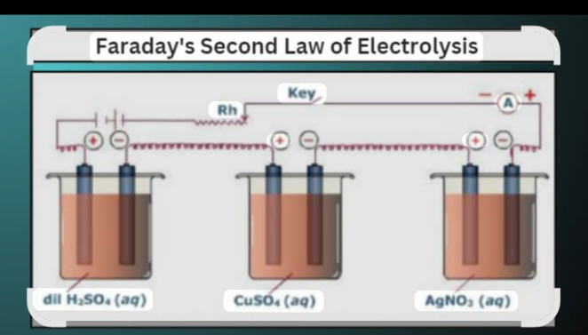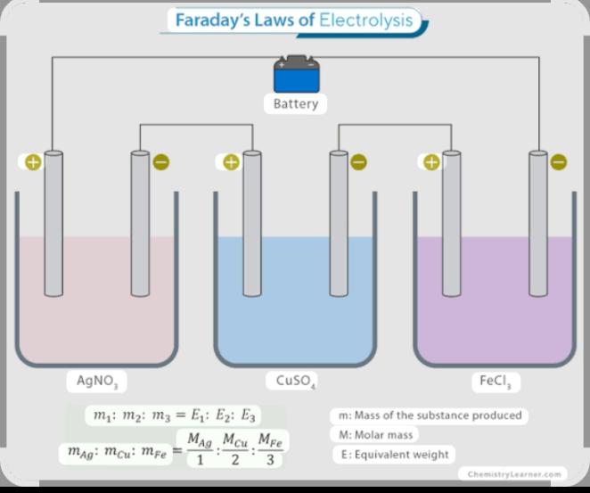
It represents one mole of electrons, which is the same as the quantity of electrons required to discharge one mole of Ag⁺ ions to give one mole of silver atom. The validity of Faraday’s Second Law of Electrolysis is evident from the following observations:
One faraday (IF) discharges one mole of H⁺, Na⁺, Ag⁺, Cl⁻ and OH⁻ ions.
Two Faradays (2F) discharges one mole of Cu²⁺, Pb²⁺, Mg²⁺, Ca²⁺, Fe²⁺, etc ions.
Three Faradays (3F) discharge one mole of Al³⁺, Fe³⁺, etc. ions.
Summarizing the two Laws of Electrolysis
-Chemical equivalent of element = 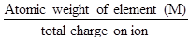
-Electrochemical equivalent of an element, Z = 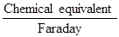
Therefore, electrochemical equivalent, Z = 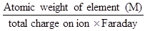

-Mass of substance liberated (m) = ZQ
m = Z × I × t
Since Z =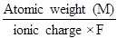, then m = 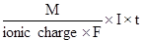

But F = 96500 C

Therefore m = 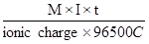

m = 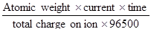
The relation summarizes the two Laws of Electrolysis.
Calculations in electrolysis
A steady current of 4 amperes is passed through aqueous copper (II) sulphate solution for 1800 seconds using platinum electrodes. Calculate:
mass of copper deposited
mass of oxygen liberated
Given: Atomic weight of copper = 63.5
Atomic weight of oxygen = 16
1 Faraday = 96500 C
Clue: Copper is deposited at the cathode and oxygen is liberated at the anode.
Solution
Cathode reaction: Cu²⁺ + 2e⁻ → Cu_{(s)}
In this case, 2 Faradays of electricity are required to deposit one mole of copper atom 63.5g.
This means 2 × 96500 C liberates 63.5g of copper.
Quantity of electricity passed = I×t = 4×1800C. So, if 2×96500 C liberates 63.5g, then 4×1800C will liberate 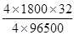= 2.4g of copper.
Therefore, mass of copper deposited = 2.4g

Anode reaction: 4OH⁻→2H₂O_{(l)} + O_{2(g)} + 4e⁻
Solution
The reaction shows that 4 moles of electrons (=4 Faradays) are lost during the reaction process.
Therefore, 4 × 96500 C are needed to liberate one mole (32g) of oxygen.
I.e. 4 × 96500 32g of oxygen gas

Quantity of electricity flowing = 4 × 1800 C
So if 4 × 96500 C = 32g, then
4 × 1800 C = = 0.6g
Therefore, mass of oxygen liberated = 0.6g
A current of 3.2 amperes was passed through fused aluminium oxide for 10 minutes. The volume of oxygen given out at the anode was 112cm³ measured at s.t.p. Calculate:
the mass of aluminium deposited
the charge of one mole of electrons (The Faraday)
(O=16, Al = 27, molar volume = 22.4 dm³ at s.t.p.)
Note:
1 mole (32g) of oxygen at s.t.p. occupies 22400cm³
Solution
(i) If 32 of oxygen occupies = 22400 cm³, then the weight of oxygen that would occupy 112cm³ = 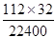= 0.16g
Let the weight of oxygen liberated be M₁ and that of aluminium be M₂ and their chemical equivalents be E₁ and E₂ respectively.
Then, by applying Faraday’s Second Law of Electrolysis, we have the relation
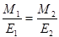
But chemical equivalent = 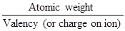
Therefore, E₁ = 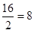

E₂ = 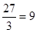
Data
M₁ = 016 E₁ = 8
M₂ = ? E₂ = 9

Substituting the relation in the formula
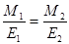, we have

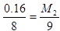

M₂ = 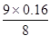
= 0.18g
\The mass of aluminium deposited = 0.18g

(ii) In this case, we can either use the mass of aluminium deposited or oxygen liberated to find the charge of one mole of electrons (the Faraday):
- The mass of oxygen liberated = 0.16g
- The mass of aluminium deposited = 0.18g
- The charge flow = amperes × seconds = (3.21 × 10 × 60)C

Alternative 1: using the mass of aluminium deposited.
3 moles of electrons are required to deposit 1 mole (27 g) of aluminium atoms
Al³⁺ + 3e⁻ → Al
If 3 moles of electrons deposit 27g, then 1 mole would deposit 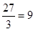g
But, what is the charge of this 1 mole of electrons?
Solution
If 0.18g of Al are deposited by (3.21 × 10 × 60)C, then 9g would require 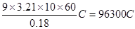

Alternative 2: using the mass of oxygen liberated
2 moles of electrons are required to deposit one mole (16g) of oxygen atoms
O²⁻ → 2e- + O
If 2 moles of electrons deposit 16g of oxygen atoms, 1 mole deposits 8g.

Solution
If 0.16g requires (3.21 × 10 × 60)C, then 8g would need 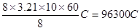
Therefore, you can see that both cases give a similar answer (96300C). However, remember that it is difficult to get the exact Faraday constant 996500C) under ordinary practical conditions.

EVALUATION
1.0.222g of a divalent metal is deposited when a current of 0.45A is passed through a solution of its salt for 25minutes.Calculate the relative atomic mass of the metal.
2. Calculate the mass of aluminium deposited when a current of 3.0 amperes is passed through an aluminium electrolyte for 2 hours.(Al=27,1 Faraday=96500c).

