LESSON NOTE 6
BASIC ECOLOGICAL CONCEPTS
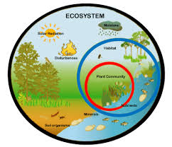
COMPONENTS OF AN ECOSYSTEM
Ecosystem refers to the basis functional unit in nature which consists of all living factors and their interaction with non-living factors of the environment. It can be natural or artificial. Ecosystem is made up of two main components; biotic (living) and abiotic (non-living) components.
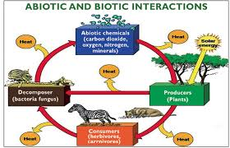
- Biotic components: all living things both plant and animals can be grouped into 3;
- Producers which are autotrophs and they manufacture their own foo from inorganic materials through photosynthesis and chemosynthesis (green plans and microorganism)
- Consumers are heterotrophs that feed on producers and or on one another.
- Decomposers are saprophytes that break down the remains of animals and release usable nutrients to the soil. These nutrients are in turn used by plants to make food
- Abiotic components: includes sunlight, inorganic nutrients (water, nitrogen, phosphorus) climatic factors (temperature, wind, humidity) edaphic factors like soils, rocks, topography, etc.
DEFINITION OF ECOLOGICAL CONCEPTS
- Environment: all factors in an organism’s surroundings, living or non-living.
- Habitat: the place where an organism lives that is suitable to their way of life.
- Ecological niche: the functional role and space/specific portion of habitat occupied by a particular organism or species.
- Population: the total number of all organisms of the same species or kinds living together in a given area
- Community: all populations of living organisms that exist together in a habitat
- Biosphere: all parts of the atmosphere, lithosphere and hydrosphere where life can be found.
BIOMES
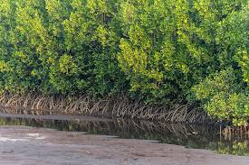
A biome is a major, geographically extensive ecosystem, characterized by its dominant life forms. Biomes are either terrestrial or aquatic. Biomes are also identified by their vegetation.
Local biomes in Nigeria
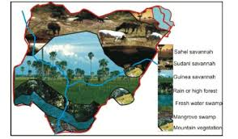
Local biomes are grouped into two major zones; the forest zone and the savannah zone
- Forest zone: made up of vegetation having mainly trees, they include mangrove swamp forest and Tropical rainforest
- Savanna zone: made up of mainly grasses and are further divided into 3 belts; Southern guinea savanna, Northern guinea savanna (Sudan savanna) and the Sahel savanna.
HOME FUN
Write short notes on the following;
- Mangrove, Swamp and Tropical rainforests. State notable features and identify their location in Nigeria
- Southern guinea, Northern guinea and the Sahel savanna. State notable features and their location.

LESSON NOTE 7
POPULATION STUDIES BY SAMPLING METHOD
Population is defined as the total number of organisms of the same species living together in a given area at a particular time. Characteristics of population include
- population size: total number of individuals of the same species in the habitat
- population density: the number of individual organisms per unit area or volume of the habitat. Mathematically it is represented as population density₌ Total population or Population size/Area of habitat
- population frequency: number of times an organism occurs within a given area of an habitat
- population growth rate: total and final effect of birthrate and death of organisms in the habitat
- percentage cover: area of ground covered (occupied) by a given specie in its habitat expressed in percentage
- distribution: the way in which individuals of a particular population are arranged in a given habitat.
METHODS OF STUDYING POPULATIONS
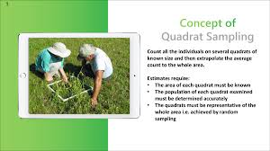
To conduct population studies, the following procedure is used;
-. Choose the habitat to be studied
- choose a sampling method
- identify species in the habitat
- collect, count and record the different types of organisms present
- repeat the population studies at different periods
For collecting plant sample two methods are used;
- Quadrat sampling
- Transect method
For collecting animal sample, the following methods are used
- Capture-Recapture method
- Collection of soil samples with quadrat
FACTORS THAT AFFECT POPULATION
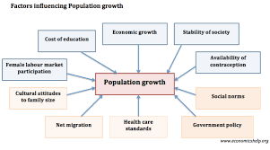
- Birth rate/Natality: rate of given birth to new organisms(both plants and animals)
- Mortality: rate of removal of individual from a population by death
- Immigration: movement of individual organism from different habitats into a new habitat
- Emigration: movement of organism out of a population o in a particular area
- Seasonal climatic changes
- Breeding periods: most organism move out of habitat during the breeding season hence reducing the population of that area
- Natural disasters like fire, drought etc. may lead to a decrease in population as many organism may die or move out to a new area.

LESSON NOTE
ECOLOGICAL FACTORS
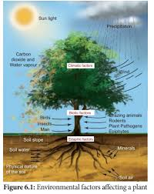
These are factors in the environment that influence life in the ecosystem. They are grouped into biotic and abiotic factors. The biotic factors are concerned with the effects of plants and animals on one another in a habitat e.g. competition, predation, parasitism etc. while the abiotic factors such as climate topographic and edaphic determine the type of biotic community organisms are found when there are variations in them
Ecological Factors Affecting terrestrial habitats
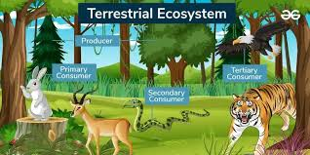
- Topographic factors are associated with the structure of the habitats and bring about variation in the vegetation and types of animals in an area. They include; altitude( height above sea level) slope and exposure ( the extent to which living creatures are not protected from climatic factors)
- Edaphic factors are related to the nature of soil particle, soil types ( loamy, sandy, clay etc.) soil texture, structure and soil pH
- Atmospheric factors (Relative Humidity) which affects the rate of transpiration from plants and evaporation from animals.
Ecological Factors Affecting Aquatic Habitats
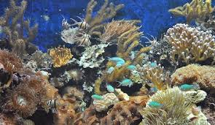
- Salinity which is the concentration of salts in water can affect the movement of water and salt across the body tissues of aquatic organisms.
- Depth of water as increased depth reduces the amount of light and dissolved oxygen.
- Turbidity which refers to cloudiness of water caused by presence of suspended materials in water and hinders light penetration
- Dissolved gases such as oxygen required by most aquatic animals for respiration can decrease with depth
- Tides and wave actions
- Speed of Flow (current)
- Density
Importance of Ecological Factors to Population of Plant and Animals
- They support metabolic activities (photosynthesis, nutrition and respiration
- Ensure that water supply is possible
- Provides conducive environment for survival.
RELATIONSHIP BETWEEN SOIL TYPES AND WATER HOLDING EFFECT OF SOIL ON VEGETATION
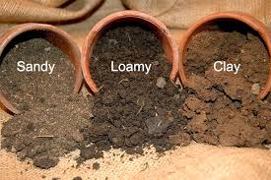
Soil is classified on the basis of the size of particle present in it and it varies in size and chemical composition. Soils with high proportion of sand are known as sandy soils, high proportion of slit and clay are called clayey soils and those with nearly equal amount of sand, clay and silt are known as loamy soil. Hence soil can be classified into 3 type: Sandy, Clay and Loamy soil. Soil is made up of, rock particles, humus (organic matter) air, water, mineral salt and living organisms.
WATER HOLDING CAPACITY OF SOIL
This is the amount of water that a given soil can hold for crop use. It also refers to the ability of soil to retain water. The amount of water retained by any soil depends on;
Size of particles, texture of soil, humus content, aeration, temperature and presence of microbes. Clay and humus retain higher amount of water than sand. Clay soil holds water firmly to the surface of the particle (hygroscopic water) which is not usually available to plants. Very little water is retained in sandy soil as most of it drains off. Loamy soil retains water within its particles (capillary water) and is available for plants use.
SIMPLE MEASUREMENT OF ECOLOGICAL FACTORS AND MEASURING INSTRUMENT
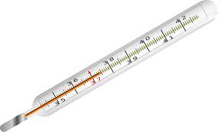thermometer 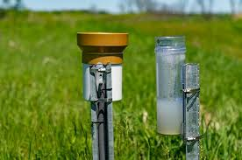 rain guage
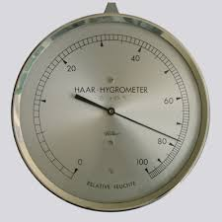hygrometer 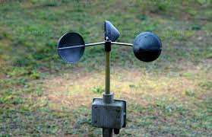anemometer
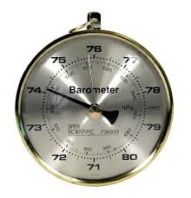barometer 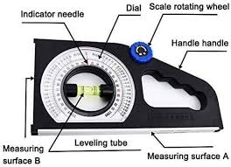slope guage
- Temperature- thermometer read in degrees
- Rainfall – rain gauge calculated in millimeters
- Relative humidity- wet and dry bulb Hygrometer
- Wind – direction is indicated by wind vane, while speed is measured with anemometer
- Light intensity –light meter or photometer
- Pressure - barometer
- Turbidity – measured by sinking a secchi disc into water and noting the depth at which it just cannot be seen anymore.
- Slope – slope guage
- Height – height of trees are measured tape
- PH- colorimeter to measure the acidity or alkalinity of soil population

