

**Subject: Physics**

**Class: SS 2**

**Week: One**

**Topic: Sound Waves**

**Introduction**

S

ound wave is a vibration propagated as an acoustical wave through a transmission medium which maybe solid liquid or gas. Sound travels best in air because it is a most efficient elastic medium for it. Sound excites the listening mechanism (the ear) which gives man’s brain a sensibility of the sound idea. Sound produced by a source is a longitudinal wave; that is, sound waves move such that its direction of motion is parallel to the direction of oscillation of the molecules of the medium. When an object fluctuates off its state of equilibrium, it causes small change in air pressure; this air pressure variation travels as waves and produces sound. The causes of sound can be both natural or artificial. Few natural causes of sounds include humans, flowing water, wind, animals, avalanches, volcanoes etc; while some artificial or man-made sources include airplanes, vehicles, trains, explosions, factories, vacuum cleaners etc.

Understanding and studying the concept of sound wave is so important to man that it is needed in almost all fields of life. It can be used in medicine for diagnosis (ultrasound) and for helping those with hearing defects, it can also be used in radar and sonar system especially under water to detect things, it is used in the creation of musical instruments etc.

**Transmission of Sound Wave**

Sound cannot travel without a medium, this is why we cannot listen to sound in a vacuum because it is a totally empty environment which includes the absence of air. Sound travel best through air because it is highly elastic, that is, it expands. This expansion can be noticed through diffusion, for example, when a content is puffed out of a spray-can, it tends to gradually expand until it becomes non visible and disappears into thin air, so also with sound as air through its elastic expansion carry sound energy from one medium to another. When air carrying this sound energy expands, in doing so it compresses the next layer of air to it. This state of compression is passed on rapidly, hence sound wave is a compressed wave.

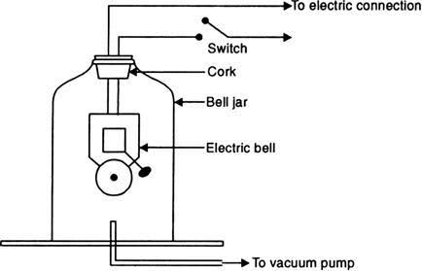

**Figure:** A Vacuum Bell Jar Experiment

**The Speed of Sound Wave**

The speed of sound wave varies, and they vary because of the variation in the density and elasticity of any medium which they are transported though be it solid, liquid or gas. At 0oC, the speed of sound in air is about 332ms-1, while for water is about 1500ms-1, while in a steel rod as high as 500ms-1. However, these speeds where noticed to vary with change in temperature, for example, in air there is an increase of about 0.6ms-1 for every 1oC rise in temperature.

**Characteristics of Sound**

**Figure:** General Representation of a Wave

1. **Wavelength (λ):** This is the distance the wave travels before it repeats itself. It is the combined length of a compression and the adjacent rarefaction, or the distance between the centers of two consecutive rarefaction or compressions.

2. **Amplitude (A):** This can be said to be the waves height with respect to its length. It is the maximum displacement of the particle the sound wave disturbs as it passes through such medium.

3. **Frequency (*f*):** This refers to the number of sound waves produced per second. It is measured in Hertz (HZ).

4. **Period (T):** This is the time required to produce a single complete wave, or cycle.

5. **Velocity (v):** This is the amount of distance the sound wave travel per second.

**Textbook reading reference: 226 - 227**

**Week: Two**

**Subtopic: Echoes and their Application**

All Waves have this characteristic called reflection. In the case of sound wave, its reflection is called an **ECHO**. Therefore, Echoes are the reflection of sound waves when they hit a plane surface. This effect makes one hear a particular sound the second time. Echoes can sometimes be a nuisance and they also have very important benefit by its application. For example, it can cause nuisance especially when sound is propagated in a large auditorium, and because of the reflection of the sound waves from the walls and ceiling of the building, especially when they are made of hard smooth materials. This causes the sound wave to be reflected back and forth many times which makes the room reverberate for a long time. In other to reduce this effect, the building walls and ceilings should either be constructed or padded with perforated materials through which the sound waves can refract into to get absorbed by.

**Application of Echoes**

1. **Determination of speed of sound (v) in air**: The speed of sound can be determined by directing sound to a barrier or maybe a wall, and the time it takes to echo is calculated using a stopwatch. This speed can be calculated using this mathematical equation: *v* = .

2. **Determination of distance or depth (*x*):** Sonar is an echo sounding device that can be used to measure depth. This involves sending sound wave to the sea bed which in turn reflects as an echo after striking the sea bed. By knowing the speed of the wave sent and the time taken, we can determine the depth of the sea using this mathematical equation: *x* = $\frac{vt}{2}$.

**Example:** A geologist sends down a sound wave using his sonar system with an unknown depth *x* to the sea bed, he receives an echo after 2.4 seconds. If the speed of the sound in water is 340ms-1, calculate *x*.

**Solution**

t = 2.4 s; v = 340ms-1; x =?

*x* =

*x* =

*x* = 408m

3. **Exploration for Gas**: Echoes can be used to determine the locations of oil and gas by geologist setting up small explosions into the earth surface, the reflecting waves is then used to determine the underground layer of rocks of which interpretation can be possible locations of minerals or oil-bearing rock formation.

4**. Reverberation**: This is most times observed in large halls because it takes time for the sound to die off after being made. This causes echoes in the building and too much of it can cause nuisance. However, some of it is needed otherwise the music sound becomes much weaker, hence acoustically dead.

**Music Instruments**

Most musical instruments can be classified into the following: Strings instruments, wind instruments, percussion instruments:

1. **String Instruments**: This are types of instruments that produce sounds at different frequencies when a string is vibrated. Typical examples of string instruments include: sonometer, the guitar, the piano and the violin. Each strong on each of these instruments produce their sound at a certain pitch due to their various frequencies. These frequencies of the emitted sound depend on the equation: *f = $\frac{1}{2l}\sqrt{\frac{T}{m}}$* , where *l* is the vibrating length of the string, T is the tension in the string and m is the mass per unit length of the string. All of these parameters on a string determines the kinds of sound they will produce, for example, vibrating length of a thick and loose guitar string produces musical notes at a lower frequency, while the thin and, short and taunt strings produces musical notes at a high frequency.



2. **Wind Instruments:** This are instruments that make use of air columns to produce sounds at different frequencies. The length of each vibrating column determines the frequency at which each note is produced and is mathematically related as f α $1/l$. This means that the longer the length of the vibrating column, the lower the frequency at which that vibrating column will produce a sound and vice versa. In other words, short column of air produces a high-pitched note, but a long column of air produces a low-pitched note. Typical examples of these instruments include the flutes, saxophone, trumpets etc.

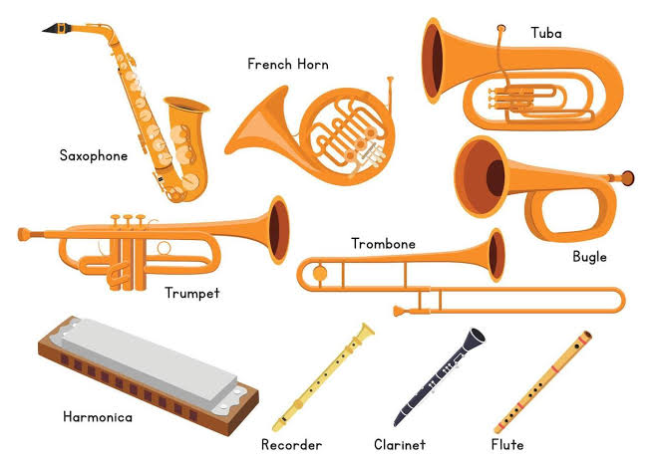

3. **Percussion Instruments**: These produce sounds when they are struck or hit. The perturbations of the air pressure around these instruments causes us to hear the sounds from these instruments. Examples include bells, drums and tuning forks.

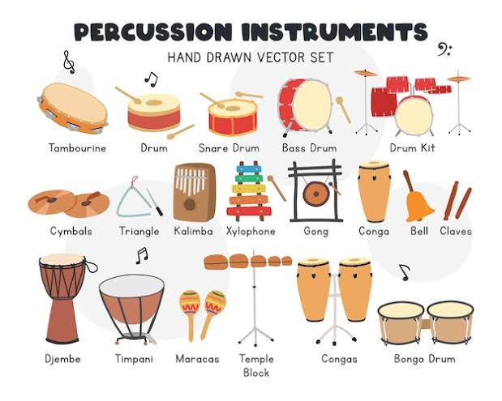

**Hearing Aids**

One of the medical applications of studying sound waves is the technology called a hearing aid. A hearing aid is a small electronic device that one wears in or behind the ear which makes sounds louder so that a person with hearing loss can listen and communicate. A hearing aid has three basic parts: a microphone, amplifier, and speaker. How it works is that the technology receives sound waves signal in the atmosphere caused by the perturbation of air pressure through the microphone, which converts the sound wave into electrical signals and then sends it to the amplifier which increases the power of the signal and then send it to the ear through the speaker.

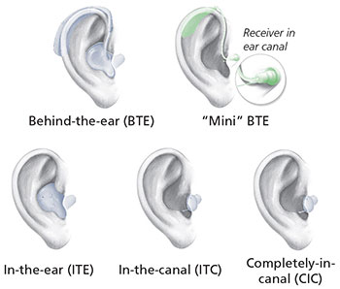

**Figure:** Different Types of Hearing Aids

**Textbook reading reference: 227 - 229**

**Week: Three**

**Subtopic: Music Sound and their Characteristics**

A music note is a sound produced from a source that is vibrating at certain set of frequencies. Noise on the other hand is a sound produced from a source vibrating with unfixed frequency, or is a sound produced from different sources at different frequencies of which its mixture produces unpleasant sounds. Musical notes have three basic characteristics, these characteristics are what gives the ear the sensation of what the musical note sound like and they include:

* **Characteristics of Sounds**

1. **Pitch:** This is the characteristics of sounds that enables us differentiate that a music note is a high note or a low note. This pitch becomes higher as the frequency increases and becomes lower as the frequency reduces. For example, on a stringed instrument, a tight string is at high frequency which produces high pitch, but a lose string which is at low frequency produces low pitch.

2. **Quality**: This is a characteristic that enables us differentiate a note from another although played with the same loudness and pitch when played on different musical instruments. For example, there is a difference playing on the C major scale on the piano and playing the same on a guitar. What makes us differentiate the sound is the quality of the sound produced.

3. **Intensity and Loudness**: The intensity of a sound at a certain place is the rate of flow of energy per unit area perpendicular to the direction of the sound wave, while loudness is a sensation in the mind of the observer, depending on the intensity of the sound. The greater the intensity, the louder the sound. By creating large air vibration, larger sound wave energy is being transferred and louder sound produced.

**Resonance**

Resonance is an effect caused by a vibrating body, which causes another body to vibrate at a larger amplitude provided both have the same frequency. A body set into vibration vibrates at its natural frequency, but it can be made to vibrate at other frequencies if an external frequency is imposed on it. However, if the imposed frequency is the same as the natural frequency, a larger vibration builds us, this is what we call resonance and it finds it application in various fields. For example, in receiving radio signals from a radio station, the radio box receiver is tuned, and when the current in the aerial circuit is in resonance with the incoming radio wave, you get tuned in. This also finds it application when studying sound; a vibrating tuning fork is placed over a column of air and the volume of air is gradually varies. When the natural frequency of the air is equal to the natural frequency of the tuning fork, a large sound is heard.

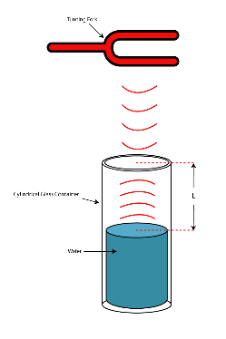

**Figure:** Tuning fork Cylinder Resonance Experiment

**Textbook reading reference: 229 - 237**

**Week: Four**

**Topic: Pressure in Fluids**

**Introduction**

P

ressure can be defined as the force acting or exerted perpendicularly to a unit area of a surface. Pressure is more or less a compelling force exerted on a body which may influence the body on which it is exerted. The SI unit of pressure is the pascal (Pa) or the newton per square metre (Nm-2). It is mathematically given as $P=F/A$, where F = Force (in Newton) and A = Area (in metre square). This equation shows an inverse variation between the area and the pressure exerted which implies that when the area is small, the pressure is large and when area (A) is large, the pressure is small. Therefore, the pressure exerted by a person wearing a narrow heel is more than that exerted by a person wearing flat heels.

**Example:**

1. If a force of 40N acts on an area of 5m2, what is the pressure exerted on the surface?

**Solution**

F = 40N; A = 5m2

=

2. What weight of water would exert a pressure of 2000Pa on the base of a rectangle water tank with dimension 20cm by 30cm?

**Solution**

P = 2000Pa; A= 20cm X 30cm; F = ?

Area = () = 0.6m2

*F = P X A* = 2000 X 0.6 = 120 N

Weight of water = 120N

**Pressure in a Liquid**

A property of liquid which does not vary is it density which is the mass of one cubic metre of the liquid substance measured in kilogram (kgm-3). Through the variations in density of different liquids, although if they are placed in the same conditions, their pressure will vary. Density greatly influences pressure in a liquid. Other characteristics of pressure in liquids include:

1. The pressure increases in a liquid with increase in the depth of the liquid (For example, a dam station).

2. The pressure at any point in a liquid act equally in all directions.

3. The pressure at all point at the same level within a liquid is the same (For example, a water tank and tap network within a house).

*Let's consider the figure below with a column of liquid h (height) metres above the level PQ of liquid in a cylinder.*

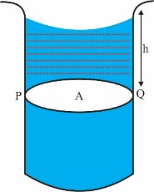

Where A = area of the cylinder

h = height of the liquid column in the cylinder

**Note:** Since liquids have no definite volume, their volume is determined by their containers.

**⸫ Volume of liquid = *h x A = hA***

However, **Mass = density x volume**

Let density of liquid be denoted as ρ

**Mass of liquid (m) = *ρ x hA = ρhA***

**Weight (W) = mg**

**W = *ρhA* X *g = ρhAg***

Where g is the conversion factor of which masses are converted into weight and is measured as 9.8 or 10 Nkg -1

However,

**Example:**

1. What is the pressure due to water at the bottom of a tank which is 10m deep and is half full of water? (Density of water= 10³kgm–3, g = 10Nkg–1).

**Solution**

h = 10m; $ρ=$ 10³kgm–3

P = 103 X 10 X 10 = 105 Pa

**Pascal's principle**

Pascal's principle deals with the transmission of pressure in fluids. *Pascal's principle states that the pressure applied to an enclosed fluid is transmitted undiminished to every portion of the fluid and the walls of the containing vessel.* The principle holds for liquids and gases. The operation of the hydraulic press and the car brake system is based on Pascal's principle.

1. **Hydraulic Press:** This is a device whereby small force is used to produce a large force which is basically used to lift things. It is basically constructed by connecting two cylinders using a tube, whereby the bore of one cylinder is smaller than the other. A tight piston is fitted in each cylinder with liquid between the piston.

The pressure exerted by the small pistol can be calculated using P = $\frac{f}{a}$ while that of the large piston using P = $\frac{F}{A}.$

$$\frac{f}{a}= \frac{F}{A}$$

$$aF=Af$$

$F= \frac{A}{a}f$ (N)

The large force used to lift load in a hydraulic Press can therefore be determined using the mathematical equation F above. This force (F) produced by a hydraulic Press has one of its basic application in the hydraulic jack used in lifting cars

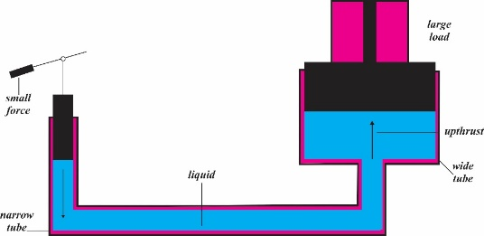

2. **Car brakes:** they also work with the principles found to operate the hydraulic Press. Pressure is transmitted from the brake pedal through a piston to transmit the pressure to slave cylinders which operate the brakes at each wheel.

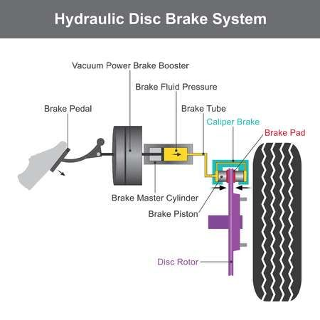

**Example:**

1. A mass of 20kg is placed on the small cylinder of a hydraulic press. Find the useful force produced at the large cylinder, the area of small and large cylinders being 10cm² and 10 000cm² respectively (g =10ms–2).

**Solution**

**Parameters:** m = 20kg; a = 10cm2; A = 10 000cm2; g = 10ms-2

⸫ F = 2000 000 = 2 X 105N

**Atmospheric Pressure**

Atmospheric pressure is the pressure exerted by the environment from the atmosphere at about 80km to ground or sea level. Therefore, atmospheric pressure can be taken as the air pressure exerted upon all objects on the surface of the earth. At sea level, the atmospheric pressure is at 10⁵Pa but we aren't conscious of this because our blood pressure is greater than the atmospheric pressure. Since the atmospheric pressure is due to the weight of air on the earth, this means that atmospheric pressure decreases with increase in altitude (height).

* **Unit of Atmospheric Pressure**

The average pressure of the atmosphere has been calculated to be 760 mmHg which is approximately 10⁵ Pa.

**Application of Atmospheric Pressure**

1. **Siphon:** This is used for transferring liquids that cannot be easily emptied out conveniently for example, from petrol tanks. The air pressure of the vessel that contains the liquid must be greater than that of which the liquid is to be emptied into else the siphoning process will not occur.

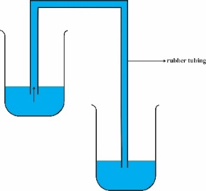

2. **The Lift Pump:** This is used in raising water from wells. It operates such that atmospheric pressure is pumped into the water which raises the water level, application of this is found in the pump borehole mechanism.

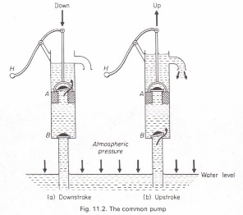

3. **The syringe:** When the piston of a syringe is drawn out, atmospheric pressure pushes into the tube of it the liquid. The liquid can also be pushed out in opposite directions.



**Week: Five**

**Topic: Electromagnetic Wave**

E

lectromagnetic waves are waves that have electric origin, and has the ability to travel in a vacuum. Therefore, electromagnetic waves require no material medium for their propagation. Electromagnetic waves are regarded as a combination of travelling electric and magnetic force, an example of this wave is light rays from the sun to the earth. All electromagnetic waves travel at the same velocity calculated to be 3 108ms-1, however, their wavelengths may vary. All electromagnetic waves result from electrons suffering some kind of change, for example. When electrons accelerate in an aerial, radio waves are emitted.

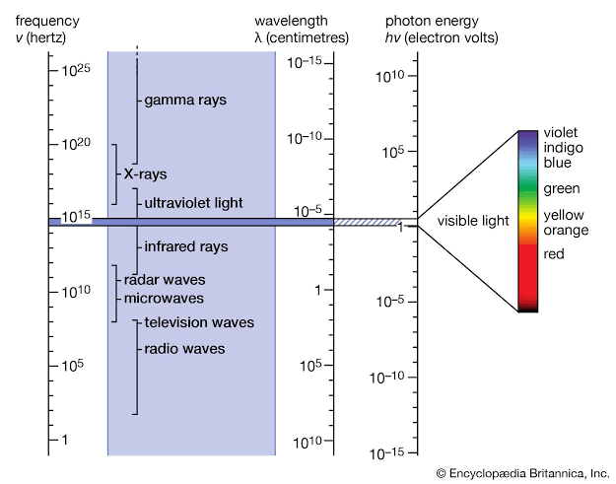

**Types of Electromagnetic Waves**

The following electromagnetic waves are arranged in order of decreasing wavelength:

1. **Radio wave:** This wave has the longest wavelength; hence they can be projected to large distances. Its wavelength can vary from 10-3m to 1000m. This wave is used to carry radio signals to radio sets. The shortest radio wave is called microwave which is used for heating, cooking, and in radar, while the longest radio waves travels through the ionosphere which consists of electrical charged gases.

2. **Infrared (I.R. Waves):** Infrared is found beyond the red end of the visible spectrum. Infrared have wavelength of about 10-6m. Infrared can be found in the radiation emitted from the sun which gives man a sensation of hotness. A non-glowing hot body below 500 $℃$ emits infrared. Infrared can be reflected by polished surface just as with light. Infrared are used in manufacturing industries to dry paint on painted items, they are used to for treatment of muscular complaint, and can be used to see things in the dark.

3. **Light wave (visible spectrum):** This is made up of the colours of the rainbow red, orange, yellow, green, blue, indigo, violet. Its wave length is at about 7 10 -7m. When these are combined, they form white light. The main source of heat is the sun, therefore, when object are heated to a very high temperature, such object becomes white hot and gives out white light.

4. **Ultraviolet rays:** Their wavelength is at about 10-8m. They are produced by quarts, mercury filament, or the sun. They can be detected by how they cause materials to fluoresce (i.e. glow). They also cause sunburn on human skin. They are used for exposure of contents on photographic plates.

5. **X-rays:** The wavelength of x-rays is in the order of 10-10m. They are produced when fast-moving electrons strike a metal target, which reduces their velocity. X-rays are used in the hospital to destroy cancerous growths in the body, to produce photographs of fractures etc. However, too much x-ray in the body can be harmful and can lead to sterility and adverse change in the blood.

6. **Gamma – rays:** These are similar to the x-rays, but their wavelength is of the other of 10-11m. Gamma-rays are emitted by radioactive substances such as cobalt-60 and they can be detected using Geiger Muller tube. Gamma rays have a greater penetrating power than x-rays. Gamma-rays cause fluorescence. The use of gamma-rays is similar to those of X-rays.

**Week: Six**

**Topic: Gravitational Field**

G

ravitational field is a force field influenced by gravity. This force always attracts objects on the earth or close to the earth surface. Without gravity, man will not be able to walk, without gravity, buildings cannot be constructed, without gravity, man would not have a civilization on the earth. Understanding the concept of gravity has helped man to apply it usefully in a lot of fields, some of which includes space travel etc. As long as 1666, Isaac Newton discovered this universal law now known as the law of gravity which helped to further explain the concept of gravitation:

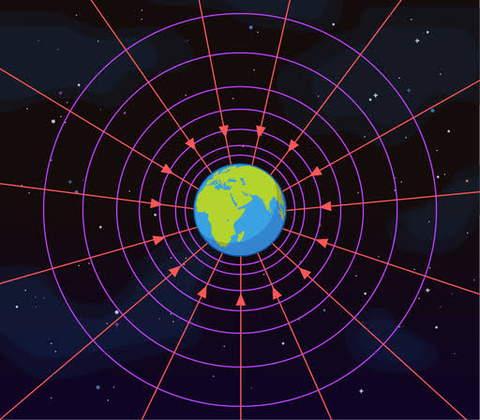

**Newton’s Law of Gravity**

This law state that every particle of matter in the universe attracts every other particle with a force that is directly proportional to the product of the masses of the particle and inversely proportional to the square of the distance between them. It is mathematically related as

$$F= \frac{Gm_{1}m_{2}}{r^{2}}$$

Where F = gravitational force

m1 and m2 = masses of the bodies involved

r = distance between the particles

G is the universal gravitational constant = 6.67 10-11Nm2kg-2

**Example**

1. Calculate the gravitational force of attraction between two planets of masses 1024kg and 1027kg separated by a distance of 1020 metres.

**Solution**

$F= \frac{Gm_{1}m_{2}}{r^{2}}$ = $\frac{6.67 × {10}^{-11}×{10}^{24}×{10}^{27}}{{\left({10}^{20}\right)}^{2}}$

F = 6.67N

**Velocity of Escape**

One of the greatest applications of why we study gravitation is space travel seen in the concept of velocity escape whereby a rocket fired from the earth is able to escape the gravitational influence of the earth so as to go into space. Therefore, the workdone by the rocket which is equals to the product of the mass of the rocket and the potential difference between infinity (space) and the surface of the earth (X).

$⸫$ Workdone = m $×\frac{GM}{R}$---------------(1)

Since the rocket moves with velocity v, then it’s kinetic energy

Workdone = ½ mv2 -------------------(2)

Equating equation 1 and 2

½ mv2 = m

Take off m from both side and then cross multiply, we have that

v2 =

v = = velocity of escape ---- (3)

but g = $\frac{GM}{R^{2}}$

put “g” into equation 3, we have

v = $\sqrt{\left(2gR\right)}$

**Week: Seven**

**Topic: Gravitational Field**

* **The Solar System**

The solar system is a group of planetary bodies which consist of our sun, and every other planet bounded to it by gravity. These planets include: Mercury, Venus, Earth, Mars, Jupiter, Saturn, Uranus and Neptune. Other dwarf planets around the solar system includes Pluto, Ceres, Makemake, Haumea and Eris. The solar system also contains hundreds of moons; and millions of asteroids, comets and meteoroids. The first four planets which are Mercury, Venus, Earth and Mars are the smallest planets known as terrestrial planets because they are made up of rock and metals while the others are massive in size and called the gas giants.

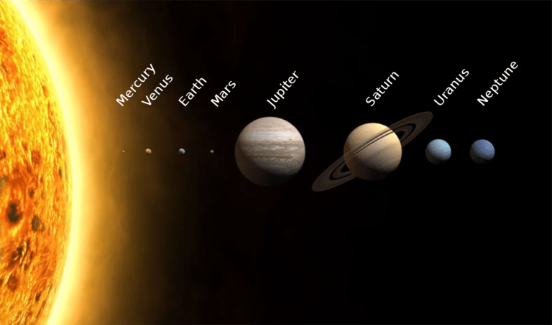

Gravitational field is what holds all of these planets in their orbits and makes them revolved round. Therefore, we can say that gravitational attraction between them influences the centripetal force of these planets revolving round the sun.

**Kepler’s Laws**

There are three basic laws of Kepler which describes the planetary motion of objects around the sun and they are:

1. The planets each travel around an ellipse with the sun as the focus.

2. The line joining the sun and other planets sweep out equal area at equal time.

3. The square of the period of revolution of the planet are proportional to the cubes of their means distance from the sun T2α r3.

**Natural and Artificial Satellites**

A natural satellite is an astronomical body that revolves round a planet, dwarf planet, or small solar system body. The Earth’s natural satellite is called the moon, with a diameter of 0.273 that of the Earth, and $1/{80}$ of its mass. Other planets also have their own satellite, for example, Jupiter has 12 satellites.

Artificial satellites are a manmade object placed in an orbital space to revolve around a celestial body which can be for the purpose of communication, weather forecasting, navigation, Earth’s observation/surveillance, scientific research etc. Nigeria has also sent some satellites into space, and their names are: NigeriaSat – X, NigeriaSat 1, NigeriaSat 2, NigComSat – 1.

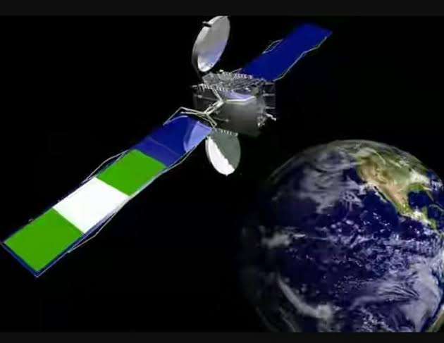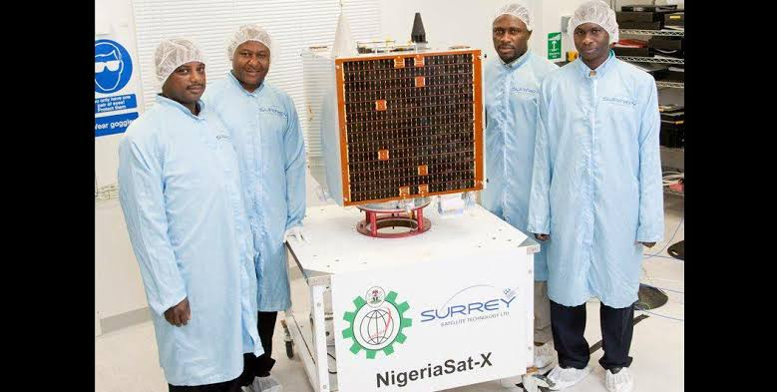

* **Launching A Satellite**

In launching a satellite, rockets are needed. These rockets are juiced up with a lot of fuel known as propellant which helps the rocket escape the gravitational pull of the Earth. These rockets are divided in four main parts, which are the nose cone, fins, rocket body and engine. The nose cone carries the payload or cargo which may include astronauts, satellites, scientific instruments or even explosives. After the rocket is launched into space, these rockets separate and the part containing the payload or cargo becomes functional while the other experiences what is called a burn out.

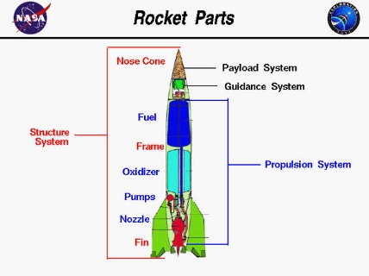

**Week: Eight**

**Topic: Electric Field**

* **Production of Continuous Charges**

A

steady current is produced through a continuous flow of charge. This continuous flow can be generated from chemicals, mechanical energy, heat energy, solar power. For example, electricity can be produced from chemical energy through the use of electric cells, electricity can also be produced through mechanical energy with examples which includes a bicycle dynamo, turbines in hydropower plant etc., electricity can also be produced when sunlight fall on a photosensitive surface such as a potassium or silicon surface whose electron are produced and movement constitute a current.

* **Electric Cells**

A cell is a device for converting chemical energy to electrical energy. A cell contains what is called an electrode and an electrolyte. The electrodes are two dissimilar metals with, one called the **anode** because of its positive electrostatic charges, and **cathode** because of its negative electrostatic charges, some examples of electrodes are copper, iron, zinc, lead etc. The electrolytes are the solution of acid or salt in the container of the entire cell formation, some examples of electrolytes include dilute tetraoxosulphate (VI) acid or a strong solution of ammonium chloride in water. There are two main types of cells – primary and secondary cells.

**Primary Cells**

This cell consists of a copper rod and a zinc plate immersed in a container filled with dilute sulphuric acid which is the electrolyte. The copper is the anode (Positive electrode), while the zinc is the anode (Negative electrode). The zinc plate and copper rode are connected by a wire, and the reaction between the electrolyte and the zinc causes electron to flow from the zinc plate to the copper rod. This can be varied by connecting a bulb between the terminals, as it lights up indicating current flow. A very important example of the primary cell is the Leclanche Cell which are of two types, the wet and dry Leclanche cell.

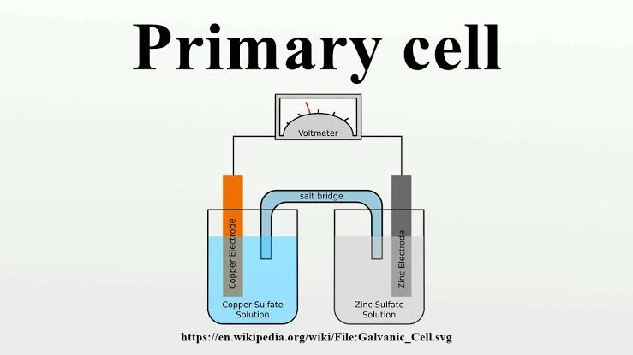

**The Wet Leclanche Cell**

This consist of a Carbon rod and Zinc rod immersed in solution of ammonium chloride. The zinc is the cathode while the carbon rod is the anode. The zinc, carbon and the electrolyte set up an e.m.f which drives the current from the zinc to the copper.

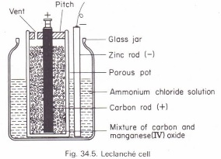

**The Dry Leclanche Cell**

In the dry cell, the electrolyte is a jelly-like material containing ammonium chloride instead of a liquid solution. The positive electrode is a carbon rod surrounded by a packed mixture of manganese dioxide and powdered carbon, inside a zinc container which is the negative electrode. The working principle is similar to that of the wet Leclanche cell. Examples of this cell torch batteries, transistor radio batteries etc.

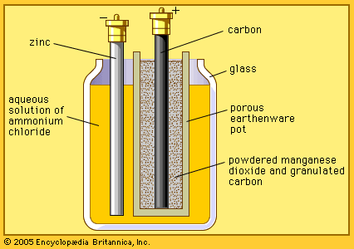

**Secondary Cell**

A secondary cell or accumulator is a type of cell that receives current through a source of electricity and is being charged but when delivering current, it is being discharged. There are two main kinds of secondary cell: The lead-acid accumulator and the Nife or alkaline accumulator.

**The Lead-acid accumulator**

This consist of lead oxide as the positive electrode, lead as the negative electrode and tetraoxosulphate (VI) acid as the electrolyte. During discharge, that is, when current is going out of the cell, both electrodes gradually changes into lead tetraoxosulphate (VI) while the acid become more dilute and denser. Therefore, density variation in the electrolyte determines if the cell is charged or discharged. This type of cell are the ones used to power cars up.

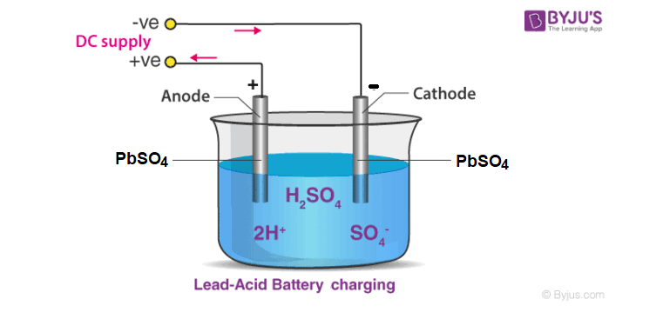

**The Alkaline or Nife Accumulator**

Nife come from the abbreviation of the two elements Nickel (Ni) and Iron (Fe). The positive electrode is made of nickel hydroxide while the negative plate is iron or cadmium. The electrolyte of this cell is the potassium hydroxide dissolved in water. This cells last longer than the lead-acid cell accumulator, keep their charges longer and they require lesser maintenance, however, they are more expensive.

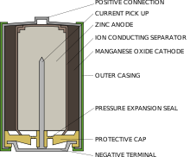

**Arrangement of Cells**

1. **Cells in series:** A group of cells connected together is called a battery. When they are connected in series, the positive terminal of one is connected to the negative terminal of the other and the following is observed:

i. Total e.m.f. between terminals A and B equals the sum of individual e.m.fs

ii. Total internal resistance equals the sum of internal resistances.

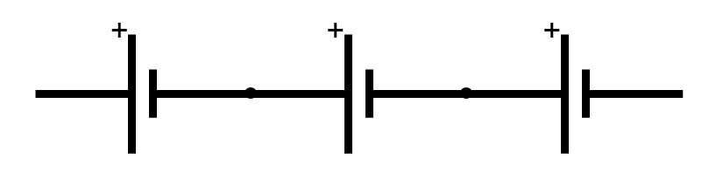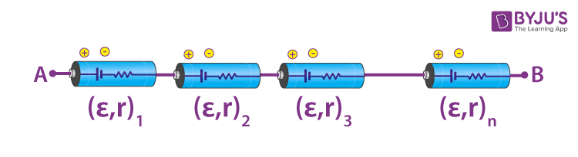

2. **Cells in parallel:** When identical cells are connected in parallel, all the positive terminals of the cells are connected together and the negative terminals also connected together. The following are observed:

i. Total e.m.f. is the e.m.f of only one cell.

ii. Total internal resistance is the combined resistances of the resistor in parallel.

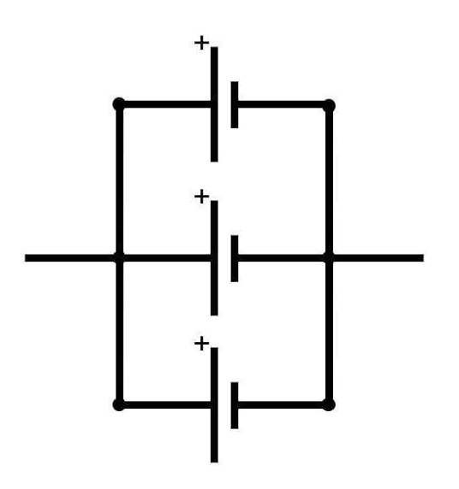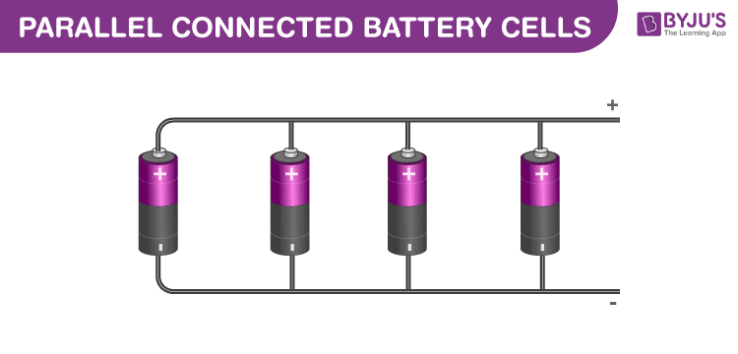

**Week: Nine**

**Topic: Electric Field**

* **The E.M.F of a Cell**

The electromotive force or EMF of a cell is the maximum potential difference between two electrodes of a cell. A cell is a device that converts chemical energy into electrical energy through the chemical reaction that involves the electrolyte and the negative electrode. This chemical reaction that involves the exchange of electron is called redox reactions. The emf of a cell is used to determine whether an electrochemical cell is Galvanic or not.

**Note:** A cell is characterized by its voltage. This means that a particular type of cell generates the same voltage irrespective of the size of the cell. This is because the voltage of a cell depends on the chemical composition of the cell if operated at ideal condition.

**Types of Cell**

1. **Galvanic cell:** named after Luigi Galvani an Italian Scientist is a cell that constitute of two different metallic conductor called electrodes immersed in their own ionic solutions. Each of these arrangements is a half cell. Alone, a half-cell is not able to generate a potential difference, but combined, they generate a potential difference. A salt bridge is used to combine the two cells chemically. A Galvani cell consists of a zinc Electrode soaked in a zinc sulphate solution and a copper electrode-soaked copper sulphate solution. The zinc electrode acts as the anode and copper acts as the cathode.

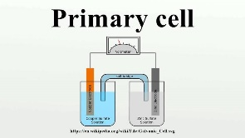

2. **Daniel Cell:** This cell and the Galvanic cell operate the same way. The only difference between the Daniel cell and the Galvanic cell is that Daniel cell can only use zinc and copper as Electrodes whereas Galvanic cells is not limited to zinc and copper Electrodes only, it can use a variety of metals as Electrodes.

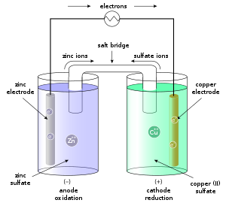

* **Internal Resistance of a Cell**

The internal resistance of a cell is the opposing force in the flow of current which a circuit experiences due to the electrolyte and electrodes present in the battery/cell.

**Characteristics of Internal Resistance**

1. It is present within the cell or battery

2. It is measured in ohms.

3. Fresh/new cell has low internal resistance but increases with continuous use.

4. Potential drops across the terminal as the current flows.

**Internal Resistance of a Cell Depends on the following:**

1. Nature of the electrolyte of the cell

2. Direct proportional to the concentration of electrolyte

3. Inversely proportional to the area of the electrodes in an electrolyte

4. Inversely proportional to the temperature

5. Directly proportional to the distance between the cathode and anode.

* **Resistors and Rheostat**

A resistor is a circuitry component used to resist the flow of current to a certain level of resistivity. A resistor can be constructed by cutting measured lengths of wire such as manganin or constantan and winding them non-inductively round a wooden block or cardboard rolled in cylindrical form and providing terminals of connection. Carbon resistors are marked with 3 or 4 colour codes to know their resistance.

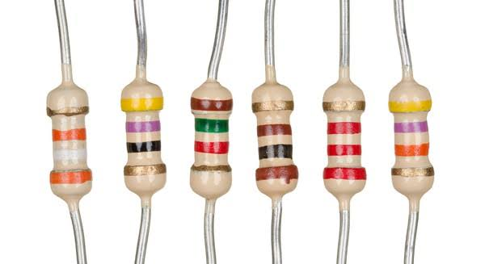

The **first two** colour bands are digits, the **third band** is a multiplier, that is, it is to the power of ten, the **fourth band** indicates precision or tolerance. The value for different colour bands is shown in the table below:

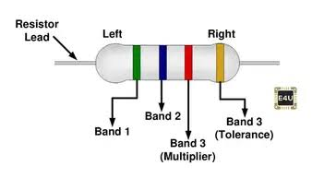

|  |  |  |
| --- | --- | --- |
| **Colour** | **Value of digit** | **Multiplier Value** |
| Black | 0 | 1 |
| Brown | 1 | 10 |
| Red | 2 | 102 |
| Orange | 3 | 103 |
| Yellow | 4 | 104 |
| Green | 5 | 105 |
| Blue | 6 | 106 |
| Violet | 7 | 107 |
| Grey | 8 | 108 |
| White | 9 | 109 |
| Silver | 10% |  |
| Gold | $±$ 5% |  |
| No band | 20% |  |

**Example:**

1. What is the value of the resistors below:

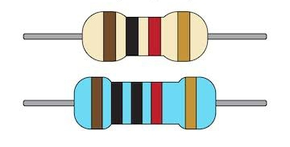

**Solution**

First resistor

Brown = 1; Black = 0; Red = 102 = 100; Gold $±$ 5%

10 $×$ 100 $±$ 5% = 1000Ω $±$ 5%

A **Rheostat** is a variable resistor used to adjust current flowing in the circuit. It consists of a long resistance wire coiled round an insulator. The resistance introduced in the circuit depends on the length of the coil as determined by the slide position.

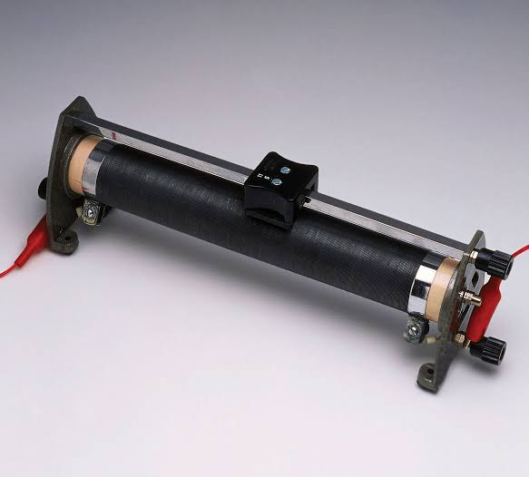

**Week: Ten**

**Topic: Electric Field**

* **Resistors in Series**

In a circuit, when two or more resistors are connected end to end, they are said to be connected in series. When three resistors are connected in series, R1, R2, R3, their combined resistance R can be measured using a voltmeter. The combined resistance of these resistors in the circuit can be ascertained using the formula below derived from ohms law:

Combined resistance **R** = $\frac{V}{I}$

Where V = voltage

I = Current

So, through the measurement of currents and voltage passing through the circuit, one can use the formula above to know the combined resistivity of the resistors connected in series in the circuit. The combined resistance is also equal to

**R = R1 +R2 +R3**

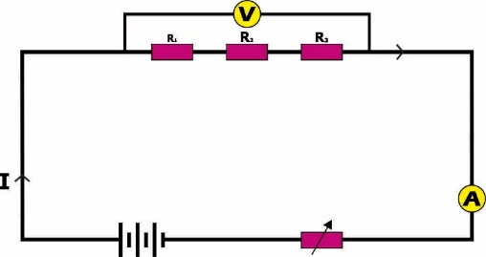

* **Resistors in Parallel**

In household wiring, lamps are connected in parallel. This is why when one lamp is turned off, it does not affect the other. This is because each lamp has electrical individual connectivity to the source of emf. This parallel connection is also applicable in resistor connections because when they are connected in parallel, they still maintain their respective resistivity as current passes through the circuit. A large current will pass through the resistors with small current. If R is the equivalent resistance, then it can be obtained using this formula:

$$\frac{1}{R}= \frac{1}{R_{1}}+ \frac{1}{R_{2}}+ \frac{1}{R_{3}}$$

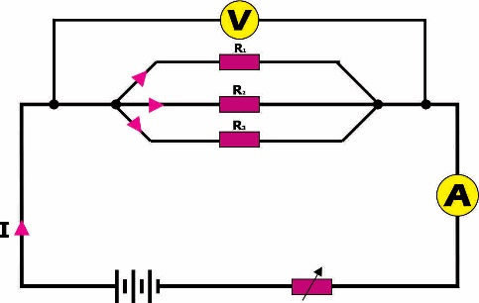

**Example:** In the diagram shown below, determine

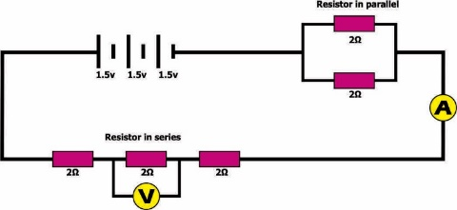

i. The current flowing through the ammeter, A;

ii. The voltage flowing through the voltmeter, V.

**Solution**

i. R = 2 + 2 + 2 + $\frac{2 ×2}{2+2}$ = 7Ω

Total e.m.f = 1.5 + 1.5 + 1.5 = 4.5v

From Ohms law, we know that **V = IR**

$⸫ I= \frac{V}{R}$ = $\frac{4.5}{7}$ = 0.643 A

ii. P.d across 2Ω

v = $\frac{2 ×4.5}{7}$ = $\frac{9}{7}=1.29v$