SUBJECT: CIVIC EDUCATION

TOPIC: DEMOCRACY

WEEK: ONE

CLASS: SS 1

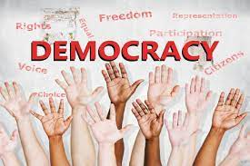 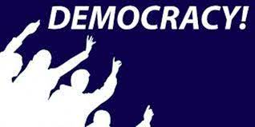

The word democracy is derived from the Greek word "demos" meaning people and "kratia" which means authority or rule. Therefore, democracy may be said to be the rule or authority of the people. According to Abraham Lincoln, democracy can be defined as "Government of the people, by the people, for the people". It is also a form of government where the people have and exercise the supreme power directly or indirectly through a system of representation usually involving free and fair elections held at specific dates by the electoral body in the country.

There are two types of democracy, they are: Direct Democracy and Indirect Democracy or Representative Democracy.

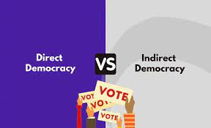 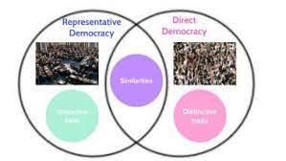

**Direct democracy**: Direct democracy places all power in the hands of the individual. When political decisions must be made, all members of a polity gather together and individuals cast a vote. In theory, this sounds like the ideal form of government. There are no intermediaries. Each person is treated as an equal, and each person is given a chance to directly influence the policymaking process.

**Indirect/representative democracy**: Representative democracy is a form of government whereby eligible citizens elect their leaders through periodic election to represent them at all levels of government for a fixed tenure. This is a political arrangement that establishes an intermediary political actor between the individual and the policy outputs of the state. In other words, representative democracy is a process in which the people through election elect those who will represent or govern the state on their behalf for a fixed period.

**Characteristics of representative democracy**

1. Respect for Minority rights

2. The supremacy of the constitution

3. Existence of fundamental human rights

4. Periodic election, Free and fair election and independent electoral body

5. Existence of political parties

6. Majority rule/Popular sovereignty

7. Multi Party system

8. Presence of opposition

9. Separation of powers between the arms and levels of government

10. Freedom of association and groups, Equal political rights

WEEK: TWO

SUBJECT: CIVIC EDUCATION

TOPIC: RULE OF LAW

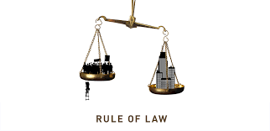 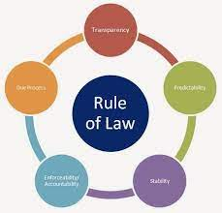

**MEANING OF LAW**: Laws can also be defined as a body of official rules and regulations generally found in the constitutions, legislation, and judicial opinion and so on that is used to govern a society and control the conducts of its members.

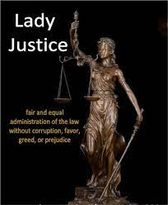 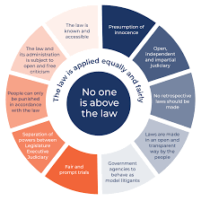

**MEANING OF RULE OF LAW**: Rule of law is a concept that emphasizes the supremacy of the law, legal equality, impartiality and individual liberty. Rule of law is a principle of governance in which all persons, institutions and entities, public and private, including the State itself, are accountable to laws that are publicly promulgated, equally enforced and independently adjudicated, and which are consistent with international human rights norms and standards.

**MAXIMUM BENEFITS OF THE RULE OF LAW TO THE CITIZENS:**

1. It makes everyone equal in a political system

2. It brings about obedience to the law of the land.

3. It guarantees the supremacy of law over citizens.

4. It guarantees peace and order in society.

5. It enhances the protection of citizens' rights.

6. It ensures freedom of press and association.

7. It prevents tyrannical rule, arbitrariness and dictatorship

8. It guards against illegal or unlawful detention.

9. It guarantees the inalienable rights of the citizens.

10. It promotes separation of powers and guarantees good governance.

11. Promotes the freedom of the judiciary and preserves the constitution

12. Promotes qualitative life

WEEK: THREE

SUBJECT: CIVIC EDUCATION

TOPIC: RULE OF THE MAJORITY



**MEANING OF MAJORITY RULE**: The concept of majority rule means that after an election, which ever political party wins the election, there should be no discrimination against the people that voted against the winning party. Those in minority groups still have the right to express their views on issues. It is a principle that postulates that the decision selected is the one majority of people endorses. Numerically and politically, the major ethnic groups in Nigeria are the composite Hausa-Fulani, the Yoruba, and the Igbo. These three 'hegemonic' ethnic groups are popularly referred to by the generic term 'wazobia'. All the rest constitute different degrees of 'minority' status.

There are 'large minorities' with millions of members, such as the Ijaw, Kanuri, Fulani, Edo, Ibibio, Nupe and the Tiv. However, since minority status is both a numerical and a political category, often underlined by administrative and economic factors, the bulk of the minority groups shade into different degrees of 'minorities'. It is on this basis the struggles for the recognition of the right of the minority ensued.

**Reasons for protecting minority interest**

1. To avoid war

2. To promote the stability of the country

3. To enhance mutual relation and trust among the otherwise diverse society

4. To ensure rapid socio-economic development

5. To promote equal treatment and enhance democratic principles in a country

6. To ensure equal distribution of national resources

**Ways of protecting/safeguarding minority interest**

1. Creation of state

2. Establishment of federal character commission

3. Legislation

4. Equal treatment

5. Equal distribution of national resources

**WEEK: FOUR**

**TOPIC: PILLARS OF DEMOCRACY**

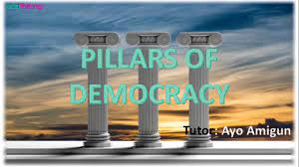 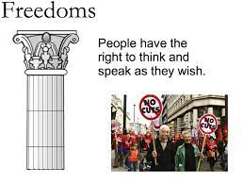

**MEANING OF PILLAR**

Pillar means a tall upright object used as support. It could also mean a very important part of a system. The pillars of democracy are those institutions and conditions that promotes an enduring democracy. They are regarded as pillars because the success of democracy depends on them.

**PILLARS OF DEMOCRACY**

1. **Constitution-** This refers to the fundamental rules and principles that guides the affairs of the state.
2. **People** – The first and sole pillar of democracy are the people who operate democracy. Without the people, there cannot be any democracy. Democracy is the government of the people by the people and for the people.
3. **Democratic Institutions** – These are also other pillars of democracy. Getting good and God-fearing leaders depend on how effective INEC is in doing their work.
4. **The Pressure Groups** – These are groups that put pressure on the government to influence decision in favour of the masses and this goes a long way to make democracy stand firm.
5. **The arms of government** – The legislative, judiciary and executive are other pillars of democracy. The separation of power among them makes things to work out well.
6. **Rule of Law** – This is a process that is bound up with the law and that the law is supreme. This makes everybody to be equal before the law. And there will be no impartiality
7. **Transparency** – True democracy does not permit any secrecy. All that is done is done in the open. This transparency is a strong pillar that makes democracy one of the best systems of government.

**WEEK: FIVE**

**TOPIC: FEDERALISM**

**MEANING OF FEDERALISM**

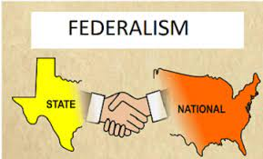 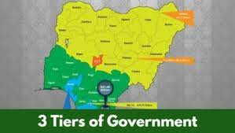

A federal system of government can be defined as one in which governmental powers that exist in the country are shared between a central government and the component regions or states, so that each government is legally and constitutionally independent and autonomous. This does not mean that powers are shared equally between the central and the component regions. Countries that practice federalism adopt federal constitution. Examples of such countries include; U.S.A., Nigeria, Federal Republic of Germany, Brazil, Switzerland, Australia, Yugoslavia, India among others.

Powers are assigned constitutionally among the states and central government and these powers are usually referred to as ***legislative lists***. Under the federal exclusive legislative lists, only the central government can legislate on matters in this list. Matters in this list includes; federal civil service, mining, defense, foreign policy, currency and banking, aviation, immigration, police, customs, and prisons. Concurrent list of power are areas where powers are shared jointly by both the central and state government and in case there is conflict of laws made by both governments, the central government laws will supersede that of the state. Subject matters on concurrent list include health, education, agriculture, roads, housing etc. Residual powers are powers not included in either the exclusive list or the concurrent lists, and this rest in the states. Matters in the residual lists include chieftaincy matters, local governments, markets, etc.

**REASONS FOR FEDERATING**

The following are the reasons for the adoption of federal system of government

1. **The Size of the Country:** A federal system is suitable for a state with large geographical area and large population.
2. **Tribal Differences:** Differences in culture, religion, language, custom, tradition, etc among different groups of a country may lead to the adoption of federalism.
3. **Protection of the Interest of Minority Groups**: In order to protect the interest of the minority group in a country where there is sharp demarcation between majority and minority group, it will be necessary to establish federalism.
4. **Desire for Union**: The fear of internal aggression and threat to their independence always encourages states to come together to form a federation.
5. **Fear of domination**: The fear of one ethnic group dominating others gave rise to the adoption of federalism, because of the country’s multi-ethnic background.

**Characteristics or Features of Federal System of [Government](https://stoplearn.com/category/government/)**

The following are the basic characteristics of the federal system of [government](https://stoplearn.com/category/government/):

1. The constitutional powers are shared among the levels or tiers of [government](https://stoplearn.com/category/government/); that is, the federal, state and local governments.
2. Each component unit or [government](https://stoplearn.com/category/government/) has sole control over the area under its authority.
3. The constitution of a federal state is usually rigid. It cannot be amended by any one level of [government](https://stoplearn.com/category/government/), but by all the governments together.
4. Supreme Court settles constitutional conflicts.
5. Federal system of [government](https://stoplearn.com/category/government/) adopts written constitution.
6. There is duplication of organs of [government](https://stoplearn.com/category/government/) In all levels or tiers of [government](https://stoplearn.com/category/government/).
7. The constitution is supreme in federalism.
8. The constitution of federalism forbids secession.
9. The constitution specifies the areas of responsibility of each level of [government](https://stoplearn.com/category/government/).
10. All the levels of [government](https://stoplearn.com/category/government/) derive their powers from the constitution.

**Resource Control in a Federal System [Government](https://stoplearn.com/category/government/)**

In a federal system of [government](https://stoplearn.com/category/government/), the state or local [government](https://stoplearn.com/category/government/) would manage the resources from their territories under federal guidelines, and then remit taxes to the federal [government](https://stoplearn.com/category/government/).

**Advantages of Federalism**

1. **Encouragement of Healthy Competition:** Federalism encourages healthy competition among the component states or regions which goes a long way in leading to rapid development.
2. **Prevention of Emergence of Dictator:** This is as a result of the fact that powers are not concentrated in a single authority as is done in unitary system of government.
3. **It Allays Fear of Domination:**Fear of domination of one ethnic group on others are reduced by federalism since each ethnic group is given the opportunity to rule itself in its own way.
4. **Economic Advantages:**Federalism brings about rational utilization of the material and human resources in all levels of government.

**Disadvantages of Federalism**

1. **It is Expensive to Operate:** It cost a lot in terms of material and human resources required to operate a federal system of government due to duplication of positions and offices.
2. **Problem of Wealth Sharing:**Federalism creates the problem of sharing the wealth of the country among different component states and the central government.
3. **Difficulty in Amending the Constitution:** This is as a result of lack of flexibility and rigid nature of the federal constitution adopted in a federation.
4. **It Leads to Dual Loyalty:** The citizens tend to have two different governments to demonstrate their loyalty, which is the state and central government.

**WEEK: SIX**

**TOPIC: CITIZENS RESPONSIBILITIES**

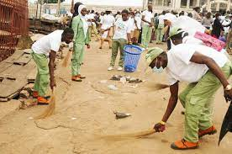 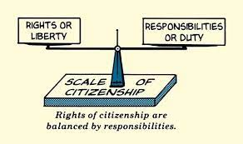

Citizen responsibilities means active participation in the public life of a community in an informed, committed and constructive manner, with a focus on the common good. The rights of a citizen go with responsibilities that is where there is right, there is corresponding duty. Duties are responsibilities a citizen is expected to perform for the effective functioning of a state. Duties and obligations of Nigeria citizens are;

1. Loyalty to the state. All citizen must be loyal to the state. As a sign of loyalty to the state, every citizen should respect the state’s National anthem and flag and other symbol of statehood
2. Obedience of law and order. The citizens of a state are expected to obey the laws of the state for orderliness in the state.
3. Payment of taxes and rates. Every citizens is expected to pay his/her taxes at the appropriate time. Thus payment is necessary so that the state can discharge her functions effectively.
4. Voting during election, Reporting of criminals and Promotion of peace.
5. Environmental sanitation, Taking care of government properties and Dignity of labour.

**WEEK: EIGHT**

**TOPIC: UNIVERSAL DECLARATION OF HUMAN RIGHTS**

 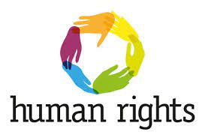

**MEANING OF UNIVERSAL DECLARATION OF HUMAN RIGHT UDHR**

UDHR means universal declaration of human rights. It was a declaration adopted by the United Nations General Assembly in 1948. Drafted by a committee chaired by Eleanor Roosevelt, it was adopted without dissent but with eight abstentions. Among its 30 articles are definitions of civil and political rights (including the rights to life, liberty and a fair trial) as well as definitions of economic, social and cultural rights (including the rights to social security and to participate in the cultural life of one’s community), all of which are adopted by UN member state. All countries of the world are members of the United Nations General Assembly. They sit together to take decisions on behalf of the people as regards what is good for the people.

**BRIEF HISTORY OF UNIVERSAL DECLARATION OF HUMAN RIGHTS UDHR**

The work of some early writers and philosophers on human right contributed greatly to the environment of the concept of human right. Philosophers came up with the belief that human beings been bestowed by nature with certain inalienable rights, like right to life, personal liberty and freedom. These writings, influenced philosophical and legal thinking at that time. Therefore, revolutionary, like concerted struggles to overthrow feudalism, autocracy and dictatorship gained much grounds in the western world and elsewhere, this brought about mass action across the globe like England, America, France and Russia .After world war II, the western world apprehensive of the dangers of absolutism and dictatorship had posed to the very existence of mankind itself formed the United Nations in 1945 to replace the league of Nations In 1948, the United Nations promulgated the United Nations Charter on human rights on the need for respect for human rights. The charter harped on the need for respect for human rights and fundamental freedom for all without distinction as to race, sex, language or religion. This declaration had a great influence on Africa that African Heads of States met under the defunct organization of African Unity (OAU) on Human and people’s rights. Many African countries including Nigeria are signatories to the international treaty and also enacted the provision of UDHR and charter into local laws

WEEK: NINE & TEN

TOPIC: CORE- FREEDOM OF UNIVERSAL DECLARATION OF HUMAN RIGHTS

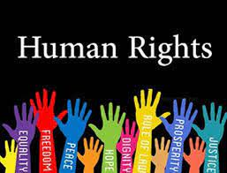

THE MEANING

The seven core freedoms of the UDHR are those major rights that all members of the United Nations organization must entrench in their constitution and must be benefited by their citizens. The seven core freedoms are freedoms that cannot be taken away from any individual even in emergency situations. The seven core freedom of UDHR are;

1. Right to life, liberty and dignity of human person. Everyone has the right to live and to live in freedom. Everyone has the right to be free from unlawful or arbitrary arrest, detention or deprivation of his or her liberty. Everyone is entitled to protection against violence, physical injury, threats and intimidation by state officials or private individuals, groups or institutions.
2. Freedom from discrimination by gender, race, ethnicity, national origin or religion. All persons are equal before the law and are entitled to the equal protection of the law, including protection against discrimination on the grounds of gender, race, citizenship, sexual orientation, etc.
3. Right to freedom of movement and to choose a residence within the borders of each state. Everyone has the right to come and go as he or she wishes within his or her country. Everyone has the right to leave and return to his or her country.
4. Right to freedom from forced labour, slavery, slavery-like practices and servitude. Everyone has the right to be free from forced labour, unless it is a lawfully imposed punishment for a crime. Everybody has the right to be free from slavery, slavery-like practices, including debt bondage and forced or servile marriage, and servitude.
5. Right to freedom of association and peaceful assembly. Everyone has the right to form a true union or join one that already exist. Everyone has the right to organize and to attend peaceful meetings. No one should be forced to belong to a group.
6. Right to expression, thought, conscience or religion. Everyone has the right to practice his or her religion freely, to change it and to practice it either individually or with other people.
7. Right to freedom of opinion and expression. Everyone has the right to speak his or her mind, provided it is done in full respect of the rights and reputations of others. This includes the freedom to seek, receive and impart information

**WEEK: ELEVEN**

**TOPIC: RESPONSIBILITIES OF INDIVIDUALS AND GROUPS IN THE UNIVERSAL DECLARATION OF HUMAN RIGHTS**

 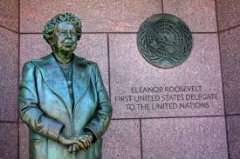

The following are the roles of individuals in promoting UDHR

1. Giving financial support to human rights abuse victims and To ensure that victims of human right violation have access to justice.

1. Individuals are expected to become conscious of their rights as citizens and be ready to claim it.
2. Have respect for the right of their fellow beings. Individuals should not abuse the right of others.
3. Willingness to report cases of human right abuse to necessary authorities.
4. Joining human rights group to promote respect for all human rights.
5. To advocate human rights through awareness campaign.
6. To advocate knowledge of human rights through print and electronic media.

**ROLES OF INDIVIDUAL ADVOCACY THROUGH PRINT AND ELECTRONIC MEDIA AWARENESS CAMPAIGN IN UDHR**

1. Raising the level of awareness on issues which impact the livelihoods of individuals.
2. Involvement in right discourse due to serious human right violations taking place in the context of armed conflicts.
3. To investigates and reveal violation of human rights

**WEEK: TWELVE**

**TOPIC: RESPONSIBILITY OF GOVERNMENT IN THE UNIVERSAL DECLARATION OF HUMAN RIGHTS**

**THE ROLE OF GOVERNMENT IN UNIVERSAL DECLARATION OF HUMAN RIGHTS**

1. Government is the watchdog of the society
2. Government must ensure that all persons under it are able to enjoy all social, economic and political freedom.
3. Government must adopt legislation, administration and other steps as may be necessary to ensure effective implementation of rights and freedom.
4. Government has a role to provide an effective remedy for person who claim to have been victims of human rights violation.
5. Government has the role of enacting laws for establishment of agencies to protect human right victims e.g National Agency for Prohibition of Traffic in Person (NAPTIP), Legal aid Council, for victims of human rights violation without the means to engage the service of lawyers for the defence.
6. Government has the role of giving prompt information of it policies to its citizens.
7. Government has the role ensuring the effective elimination of all forms of violations of human rights of it citizens including all forms of discrimination's on the basis of sex, tribe, religion, political or other opinion, birth or status.