JSS 3 THIRD TERM

COMPLETE LESSON NOTE

**WEEK 1: DATABASE MANAGEMENT SYSTEM (DBMS)**

**Topic**: Database Management System (DBMS)

**Lesson Objectives**: By the end of the lesson, students should be able to:

* Define what a DBMS is.
* Identify and explain common database terminologies.

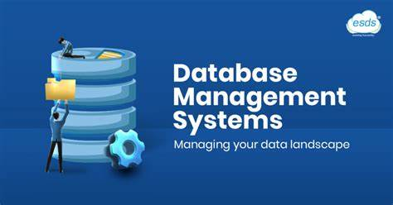

**Content**:

**Definition of DBMS**: A Database Management System (DBMS) is software that is used to create, manage, and manipulate databases/data.

It helps users to store, retrieve, and manage data efficiently.

**Importance of DBMS**:

1. Helps in data storage and retrieval.
2. Allows for easy updating and deletion of records.
3. Improves data accuracy and reduces redundancy.
4. Secures data and allows for controlled access.

**Terminologies in DBMS**:

1. **Database**: A collection of organized data.
2. **Table**: A set of data arranged in rows and columns.
   * 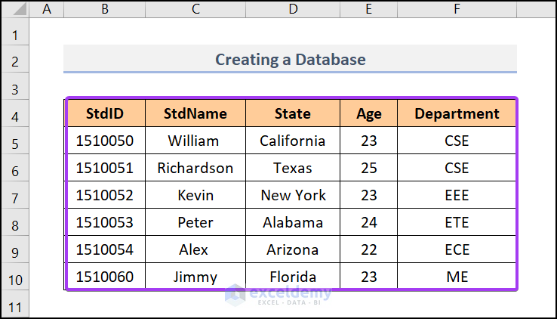
3. **Field**: A single piece of data; a column in a table.
   * 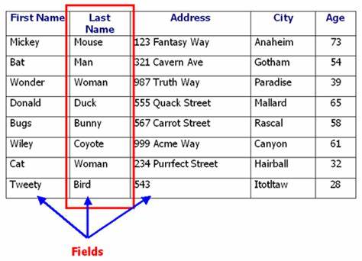
4. **Record**: A complete set of related data; a row in a table.

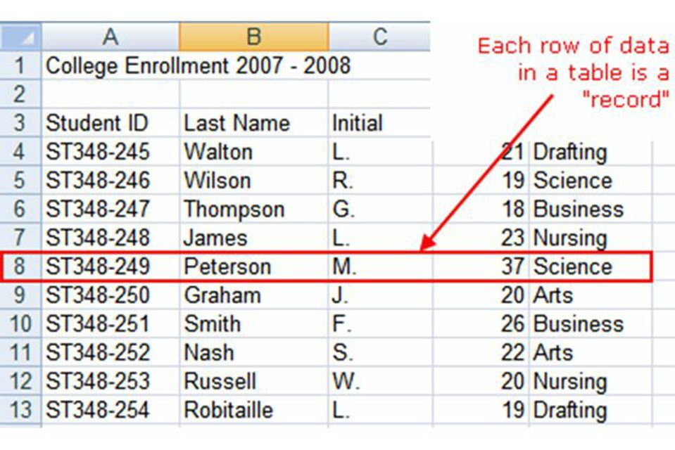

1. **Primary Key**: A unique identifier for each record.

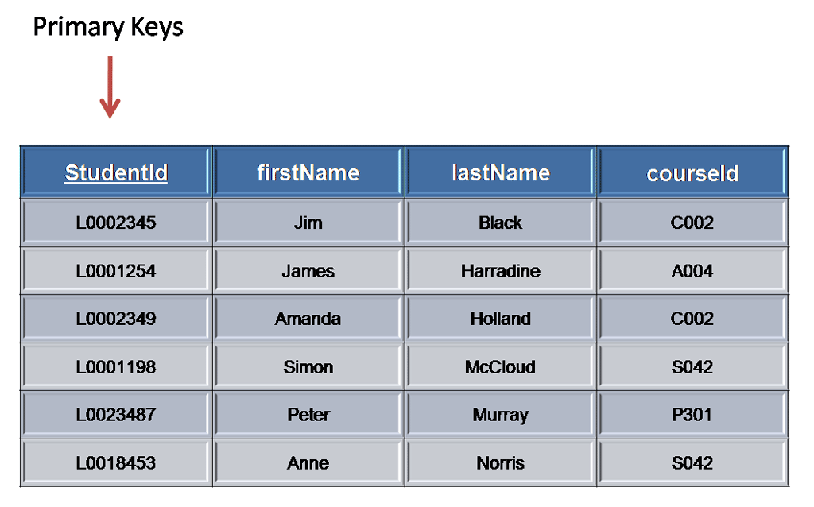

1. **Query**: A request for information from the database.
2. **Form**: An interface used for entering and editing data.
3. **Report**: A formatted output of data.

**WEEK 2: FORMS OF DATABASE**

**Topic**: Forms of Database

**Lesson Objectives**:

* Identify and explain the various forms of databases.
* Distinguish between flat file, hierarchical, relational, and network databases.

**Content**:

1. **Flat File Database**:

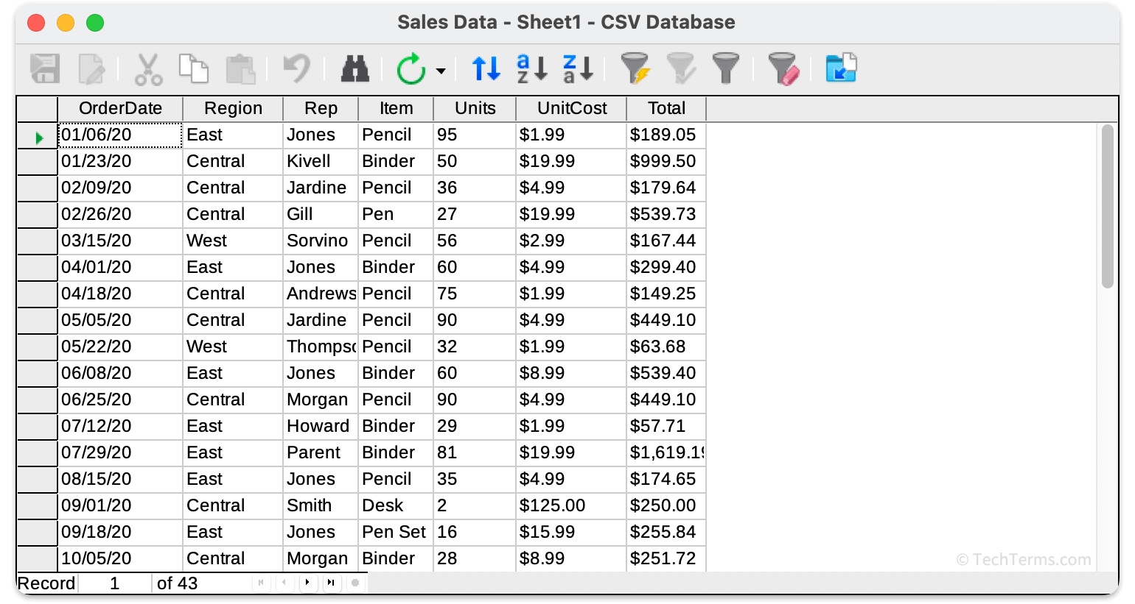

A simple database that stores data in a single table.

Example: A contact list with names and phone numbers.

1. **Hierarchical Database**:

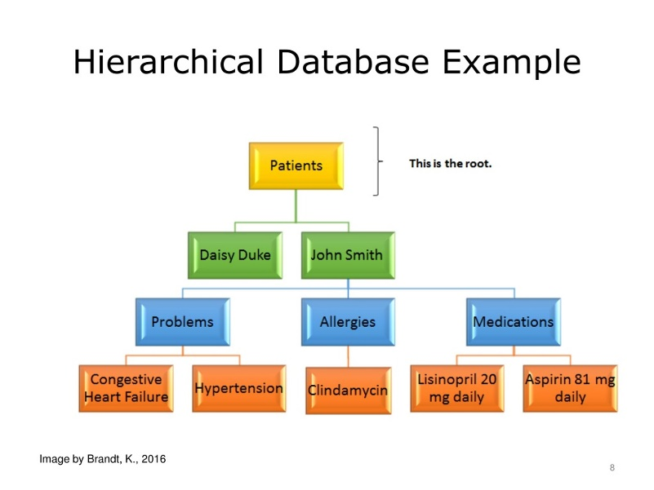

Organizes data in a tree-like structure. A Parent-child relationships; each child has one parent.

Used in early mainframe computers.

1. **Relational Database**:

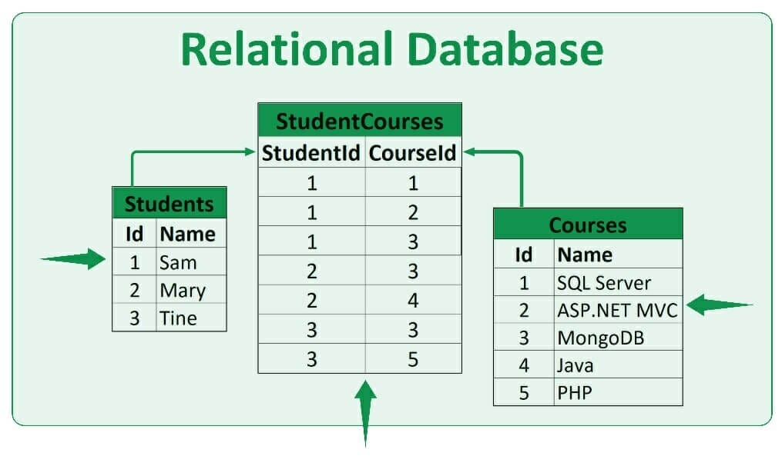

Data is stored in multiple related tables.

Example: Microsoft Access, MySQL.

1. **Network Database**:

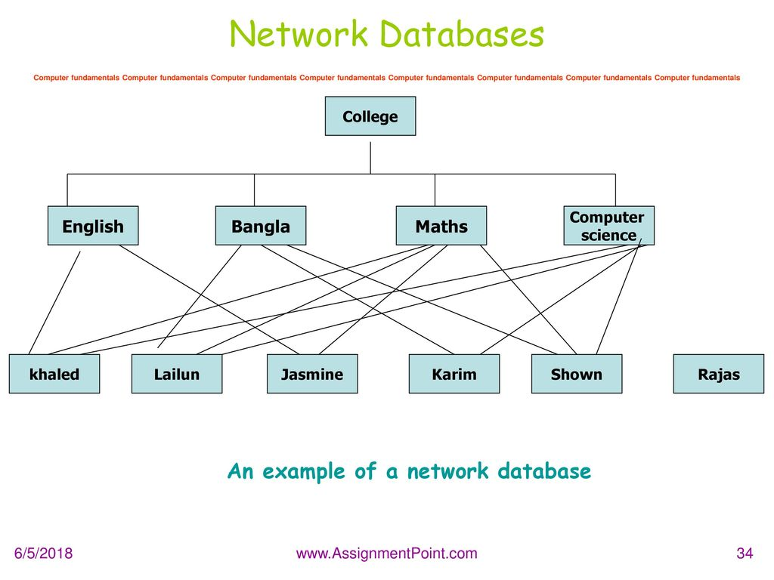

Similar to hierarchical, but a child can have more than one parent. More flexible but complex.

**WEEK 3: SPREADSHEET – I**

**Topic**: Introduction to Spreadsheet

**Lesson Objectives**:

* Define a spreadsheet.
* Identify examples of spreadsheet software.
* State the uses of spreadsheets.

**Content**:

**Definition**: A spreadsheet is a digital worksheet that organizes data in rows and columns and is used for calculations, data analysis, and visualization.

**Examples**:

* Microsoft Excel
* Google Sheets
* LibreOffice Calc

**Uses**:

1. Budgeting and accounting
2. Recording student scores
3. Data analysis and graph plotting
4. Business inventory management

**WEEK 4: SPREADSHEET – II**

**Topic**: Features and Terminologies of Spreadsheet

**Features**:

1. Grid layout (cells, rows, and columns)

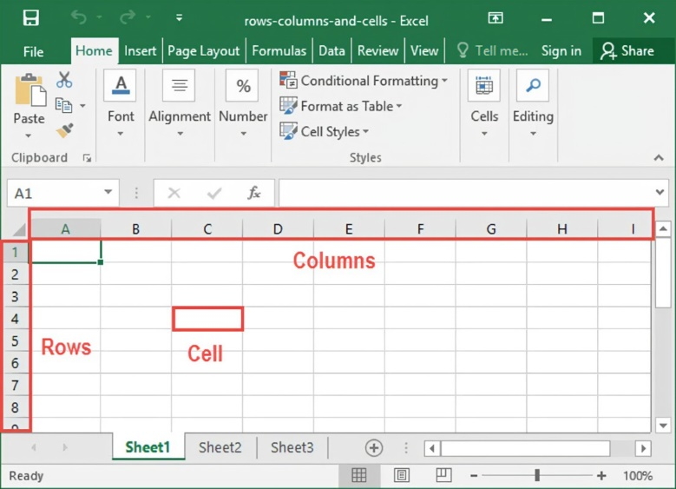

1. Formula bar

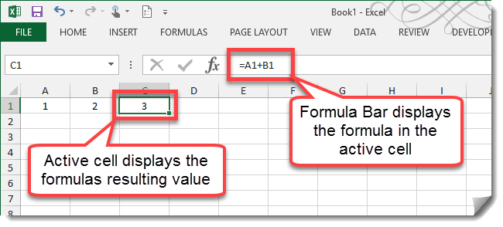

1. Charts and graphs

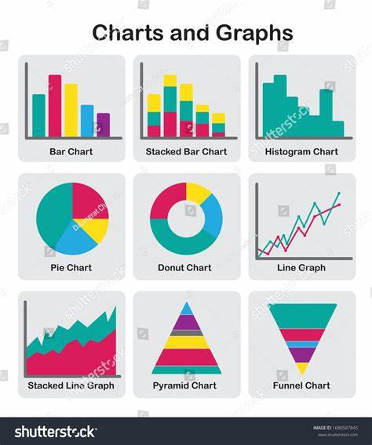

1. Formatting tools

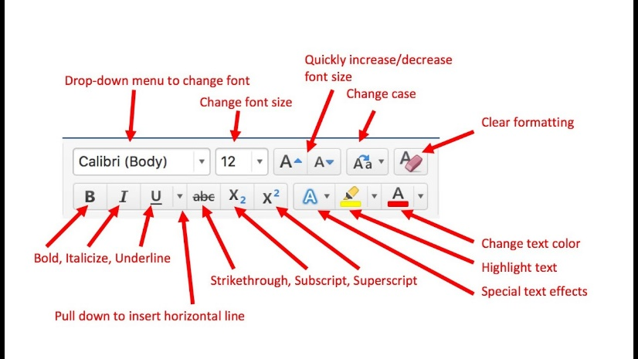

1. Auto-fill and sorting tools

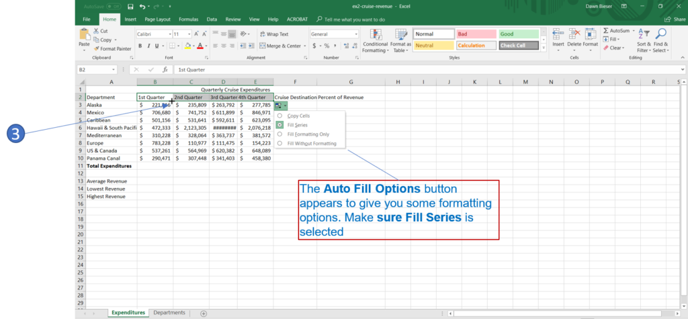

**Terminologies**:

* **Cell**: Intersection of a row and column (e.g., A1).
* **Row**: Horizontal line of cells.
* **Column**: Vertical line of cells.
* **Formula**: Mathematical expression (e.g., =A1+B1).
* **Function**: Predefined formulas (e.g., =SUM(A1:A5)).

**WEEK 5: WORKSHEET**

**Topic**: Worksheet

**Lesson Objectives**:

* Define what a worksheet is.
* Identify components of a worksheet.

**Definition**: A worksheet is a single page in a spreadsheet file (also called a workbook) that contains cells organized in rows and columns.

**Components**:

1. Worksheet tab

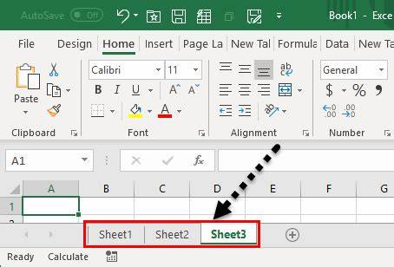

1. Grid of cells
2. Active cell

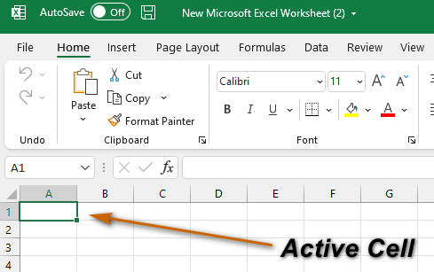

1. Name box

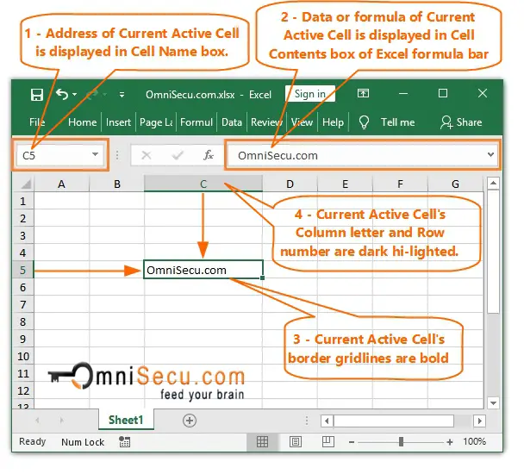

1. Formula bar

**WEEK 6: CALCULATIONS AND PRINTING OF WORKSHEET**

**Topic**: Performing Calculations and Printing

**Lesson Objectives**:

* Perform basic calculations in a worksheet.
* Learn how to preview and print a worksheet.

**Calculations**:

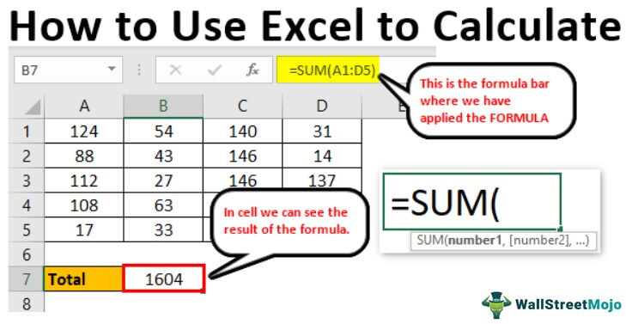

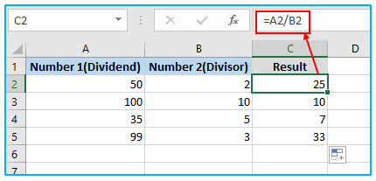

* Addition: =A1+B1
* Subtraction: =A1-B1
* Multiplication: =A1*B1
* Division: =A1/B1
* Average: =AVERAGE(A1:A5)

**Printing**:

* Go to File > Print.
* Choose printer settings and page layout.
* Print Preview to check formatting.