THIRD TERM JSS1 AGRICULTERAL SCEINCE

**DEFINITION AND CHARACTERISTICS OF WEEDS**

**WEEDS**

A weed is a plant that grows in a place where it is not wanted e.g. a vegetable plant growing on a cassava plot is a weed. Weeds are plants growing where they are not wanted or cultivated. A plant may be weed in one farm but crop in another farm. For instance, a cowpea plant growing in a cassava plot is a weed. They are unwanted plants. Examples   
Guinea grass, bahama grass, carpet grass, spear grass, wire grass, centrosema, calopogonium, stubborn grass , elephant grass, giant star grass, stubborn weed, goat weed, pigweed, waterleaf, tridax, sida acuta, bush green, etc.

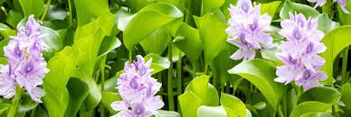

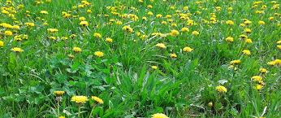

**CHARACTERISTICS OF WEEDS**

**Weeds have the following characteristics**

1. Weeds produce many seeds
2. They can survive in adverse soil condition
3. They grow very fast.
4. They have the ability to survive adverse soil and climate conditions.
5. The seeds can remain dormant in a soil for a long time.
6. They are easily dispersed e:g by man, animals, birds, wind etc.
7. Seeds of weeds are highly viable.
8. They are resistant to trampling
9. They produce large quantities of pollen grains/ high productive capacity.
10. Most seeds are wind-pollinated

**IDENTIFICATION OF COMMON WEEDS IN THE LOCALITIES**

**SOME COMMON WEEDS**

|  |  |  |
| --- | --- | --- |
| S/N | NAMES OF COMMON WEEDS | BOTANICAL NAMES |
| 1 | Guines grass | Panicum maximum |
| 2 | Bahama grass | Cynodon Dactylon |
| 3 | Carpet grass | Axonopus compressus |
| 4 | Elephant grass | Pennisetum purpureum |
| 5 | Spear grass | Imperate cylindrical |
| 6 | Giant star grass | Cynodont plactostachyum |
| 7 | Northern gamba | Andropogon gayanus |
| 8 | Stubborn grass | Eleusine indica |
| 9 | Southern gamba | Andropogon tectorum |
| 10 | Aspilla Africana | African marigold |
| 11 | Centro | Centosema pubescens |
| 12 | Calopo | Calopogonium mucunoides |
| 13 | Kuzu orpuero | Pueraria phaseolaides |
| 14 | Stylo | Stylosanthes |
| 15 | Sun hemp | Crotolaria juncea |
| 16 | Mucuna | Mucuna utilis |
| 17 | Goat weed | *Ageratum conozoides* |
| 18 | Stubborn weed | *Arctium minus* |
| 19 | Sensitive plant | *Mimosa pudica* |
| 20 | Blue feather | *Commelina nudiflora* |
| 21 | Pig weed | *Amaranthus spp* |
| 22 | Bush green | *Amaranthus spinosus* |
| 23 | Water leaf | *Talinum triangulare* |
| 24 | Sedge plant | *Cyperus rotundus* |
| 25 | Tridax PWD weed | *Tridax procumbens* |

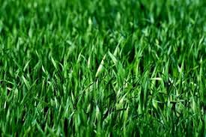 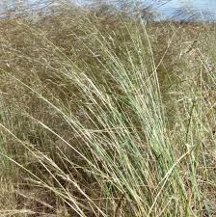 **spear grass Goat weed**

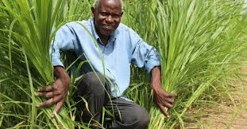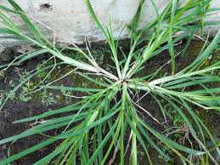

**Elephant weed Stubborn weed**



**Carpet grass**

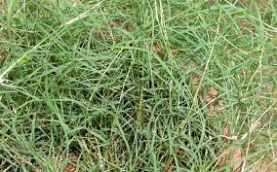

**Bahama grass**

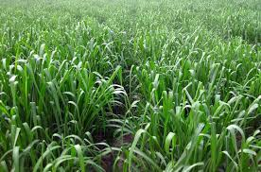

**Guinea grass**

**USES OF WEEDS**

Many herbs are called weeds. Some of these herbs have medicinal properties and are used for commonly in the rural areas for treating human ailments (diseases)

Some of these weeds are used for

1. **MEDICINE**: Most weeds are medicine. Drug can be extracted from such weeds e.g. lemon grass. milk weed, thorny pigweed, goat weed etc.
2. **EROSION CONTROL**: Weeds are used to control tiny erosion e.g. Bahama grass.
3. **SOURCE OF ORNAMENTAL**: Weeds are the major source of ornamental crops e.g. pride of Barbados, carno lily, rose, croton and hibiscus, are used for decorations.
4. **SOURCE OF FOOD**: many weeds are eaten by human beings as part of their food, some vegetable such as Tete elegun, water leaf, lemon grass etc serves as food items and medicine.

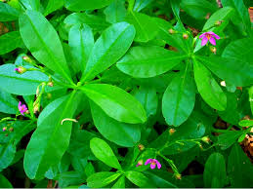

Water leaf

1. They serve as mulching materials: they are used to cover yam from burning after planting
2. They are used for feeding livestock.
3. Weed protect the soil from wind and soil erosion

WEEK 5

**EFFECTS OF WEEDS AND CONTROL MEASURES**

**METHODS OF WEEDS CONTROL**

Weed control refers to any deliberate effort made by man to eliminate weed seeds and stop them from growing or stop weed growth. Weeds can be controlled by the following methods:  
1. **Mechanical weed control**. It involves the uses of tools, implements and machines to remove weeds from medium and large sized farms. It may be in the following forms:  
i. **Hand pulling**: The use of hand to remove weeds.  
ii. **Hoeing:** It entails using hoes to remove weeds.  
iii. **Mowing**: The use of mower to clear weeds.  
Other methods include flooding, smothering, heat treatment. They are used when the crops are young.  
2. **Chemical weed control:** is the method of using chemical to kill weeds. Special chemical called herbicides have been produced which are poisonous to weeds and are used to kill them. Examples of such chemicals include, grammoxone, arsenicals, chlorate, Paraquat, Atrazine, etc. herbicide can be applied before the planted crops germinate, these are known as pre-emergence weed killers, some other herbicides are applied after the planted crops have grown well in the filed, these are called post-emergency herbicides.   
3. **Cultural weed control:** it is a routine farm Practices without the use of tools/implements. These Practices are burning, mulching, tillage, cover cropping, close spacing crop rotation, use of clean seeds, etc to kill weeds.  
4. **Biological weed control**: This method involves the use of living organisms, (plants and animals) to controlled weeds eg. Cover crops, animal grazing.  
5 **Burning:** burning can be used to control harmful weeds during the peak of the dry season, though it is becoming unpopular and is therefore not recommended.

**EFFECTS OF WEEDS CONTROL METHODS ON VEGETATION AND SOIL**.

Effects of weed control methods on vegetation and soil  
• Herbicides can be poisonous to human beings.  
• pollution of water and soil; Herbicides can pollute soil and ground water.  
• Contamination of livestock pasture thereby killing the animals that feed on  
Them, Some herbicides, when used can kill both good and unwanted plants and animals.

* It destroys aquatic life or contamination of pond/ water
* Bush burning kill beneficial insects
* Fire destroys organic matter in soil

**WEEK 7**

**TOPIC; AGRICULTURAL PEST**

**Meaning of pest.**Introduction: Pest can be defined as any living organism, plant or animal, which can cause damage to cultivated crops, animals and human beings. Human beings can also be called pests if they cause damage to crops or livestock. Pests can carry organisms that cause diseases. Majority of crop pests are invertebrates e,g insects an aeelworms while some vertebrate are birds and mammals.

**TYPES OF PEST**

The most common pests include:  
1. Insects eg. Grasshoppers, beetles, aphids, mealy bugs, scale insects, whiteflies. etc,  
2. Mammals (rodents) eg rats, monkey, grass cutters, squirrels, etc  
3. Birds eg. Weaver birds.  
4. Nematodes are worms that live in the soil.

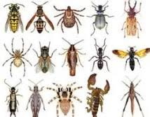

**WEEK 9**

**CLASSIFICATION OF INSECTS PEST BASED ON MOUTH PARTS**

Classification of insects pest based on mouth parts can be divided in to three groups.  
i. Piercing and sucking insect   
ii. Biting and chewing insect   
iii. Boring insect

I. **Piercing and sucking insects**  
These insects have mouth parts with which they pierce and suck juice from leaves, stems and fruits of plants. they sap from tissue of tender crop plants, In the process, transmitting diseases to them and reducing the growth of the plants. This group of insects includes white flies, aphids, mealy bug, cotton stainer, butter flies, moth, Scale insects, butterflies, moths, capsids etc. this type of mouth-part is called proboscis.

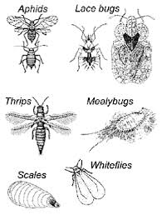

Piercing and sucking insects

ii. **Biting and chewing insect**   
These insects’ pests include locusts, grasshoppers, crickets, termites, mantis, cockroaches beetles and nymphs. They feed on the leaves and young stems of plants by biting and chewing them, especially vegetable.

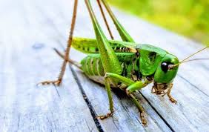  
biting and chewing insect



iii. **Boring insects pest**  
These are insects that bore holes into plant tissues and seeds. The grains that are kept in the  
store are damaged by weevils. They use their long mouth part to bore holes into the grains  
Examples are weevils, stem borers, beetles, etc  
The damage done by these boring pests reduce crop quality and their market  
  
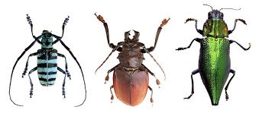

**boring insects**

**WEEK 11**

**TOPIC: NATURE OF DAMAGES CAUSED BY CROP PEST**

**Description of the damage done by pests**

Crop pests do a lot of damage to crops either on the farm or in the store. The damages done by pests include:  
• Some insect pests are carriers of diseases which they transmit to healthy plants.  
Examples of diseases transmitted by insect are: ground nut rosette, cassava mosaic,  
swollen shoot of cocoa, etc  
• Mammals (rodents) e.g rats, grass-cutter eat up the tubers of yam, cassava and  
potato.  
• The birds destroy rice, sorghum, beans, maize and fruits at various stages of their  
growth on the farm.

* The piercing and sucking insects cause damage to crops by removing juice from plants, they reduce the food inside the attacked plans, thus, making them weak.
* some of the sucking insects inject poisons into the plants after piercing through them. E.g (bugs)
* biting insects such as grasshoppers, feeds on vegetables, i.e all leaves are eaten up.

**Effects of pests on crop**

1. Heavy attack by pests may result in total crop failure.
2. Reduction in value of produce: Infected seeds, crops, and vegetables have low market value.
3. Pests reduce the quality of crops
4. Pests eat up leaves of crops, thereby reducing the photosynthetic activity of  
   the plant.
5. Insect pests control takes time and labour.
6. Infected seeds usually have low viability (germination) capacity
7. Some insects like aphids transmit diseases to crops.
8. Insect infestation increases cost of production.
9. Reduction in quality of produce: Pests reduce the quantity of crop.

**METHODS OF CROP PEST CONTROL**

There are different methods used for controlling the various pests of crops.

1. **CHEMICAL CONTROL**: This is the process of using chemical like insecticides or pesticides to kill insects. Spraying pumps are used to apply insecticides
2. **CULTURAL CONTROL:** is the application of farming activities to control pests such as early planting and harvesting of crops, crop rotation, appropriate tillage operation, regular weeding, use of resistant varieties, following, close season practices, and burning of crop residues.
3. **PYSCICAL CONTROL**: this involves the following, use of scare crow, setting trap to catch rodents, handpick of insects and larvae, shooting birds and rodents with gun or catapult, fencing around the farm with wire nets and use of poisonous baits.
4. .**BIOLOGICAL CONTROL**: is the use of natural enemies (parasites, predators or disease) to control pest. Or when some insects feed on other insects. An insect feeding on another insect is called a predator. While the insect on which the predator feeds is called the prey. E.g cat can be use to control mice and rat in the store.