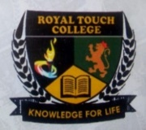**Class: Js 2**

**Subject: Physical and Health Education**

**Week: One**

**Topic: Rescue Operation**

* **Introduction**

R

escue operation is an organised effort aimed at retrieving people from life-threatening situations such as natural disasters, accidents, medical emergencies etc. The main goal of rescue operation is to safely evacuate people in danger and to take care of them after such rescue.

* **Situations that Requires Rescue Operations**

i. **Natural disaster:** a rescue team is needed to search for, evacuate and provide medical attention to people involved in natural disasters such as earthquakes, hurricane, floods, wildfires etc.

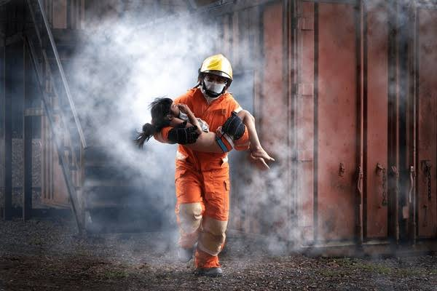

ii. **Accidents and collapse:** rescue operation needs to be carried out for people involved in car crash, plane crash, building collapse etc., some of who are still trapped.

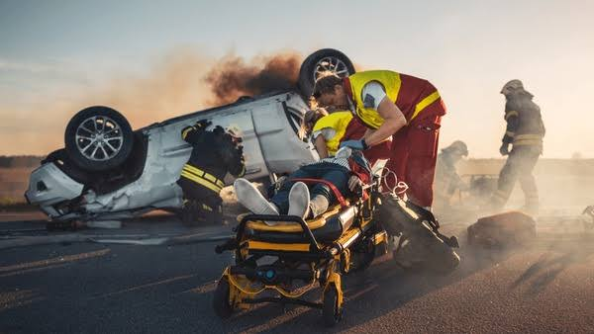 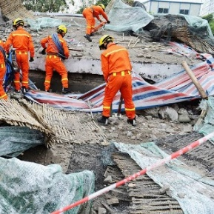

iii. **Environmental hazard:** this hazard such as chemical spill, nuclear accident etc., needs a rescue team to quickly evacuate people and provide instant medical attention to them.

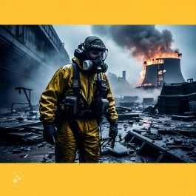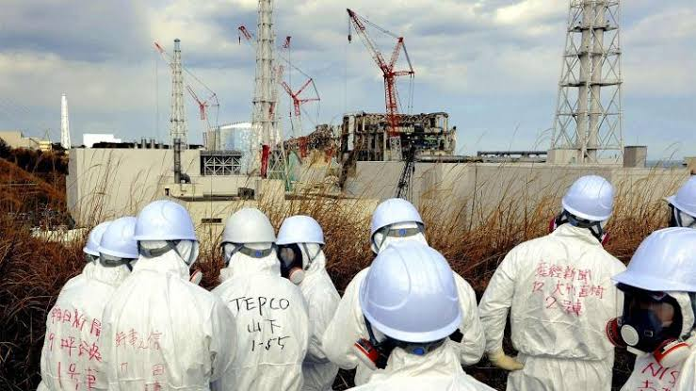

iv. **Hostage situation:** this is needed to ensure the safe release of hostages in the case of terrorist attack or armed robbery.



* **Different Aspect of Rescue Operation**

i. **Search and rescue:** this involves searching for missing persons, stranded people or even survivals of natural disasters.

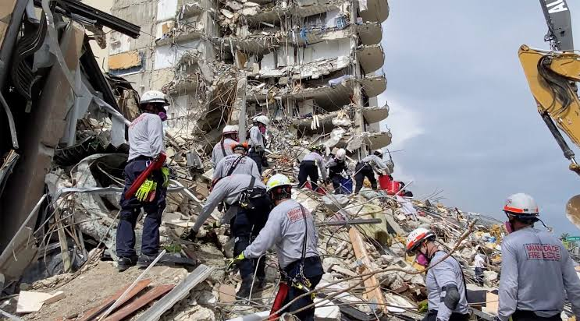 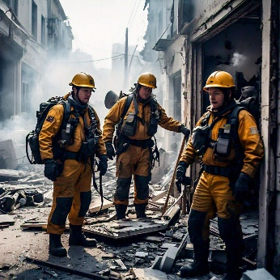

ii. **Water rescue:** this involves saving people from drowning, those stranded on water or those involved in a boat accident.

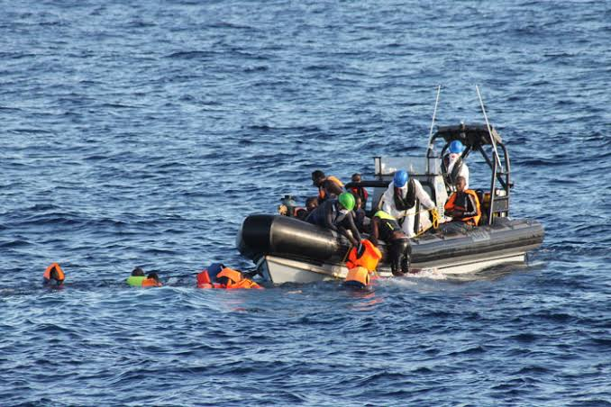

iii. **Aerial Rescue:** this involves using a helicopter or planes to rescue people from inaccessible areas.

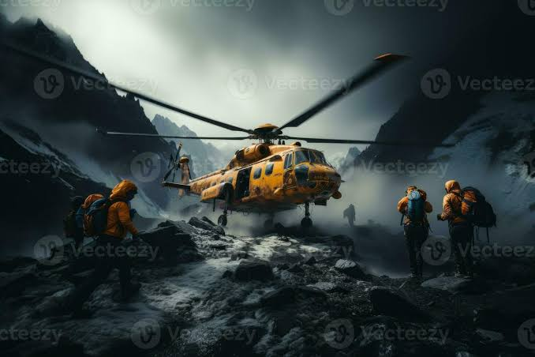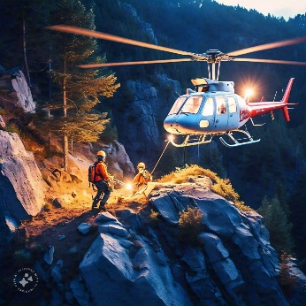

iv. **Medical rescue:** this focuses on providing medical assistant to people in need or who have no access to it.

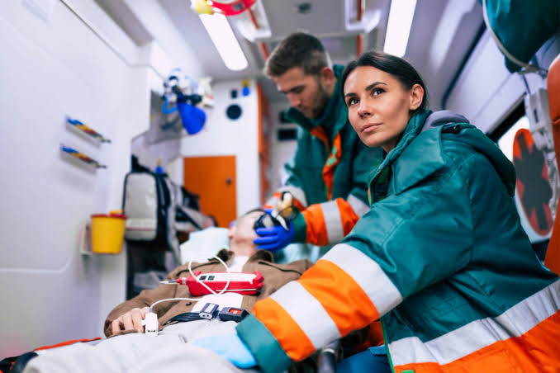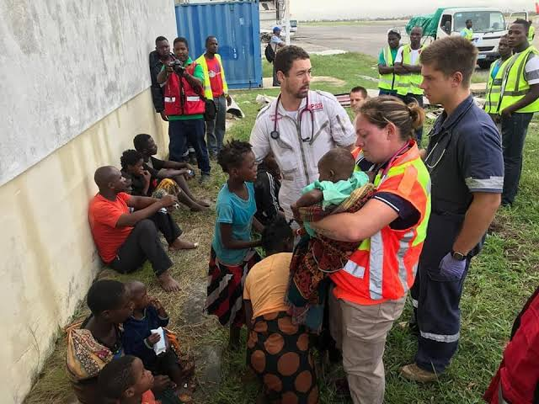

**Week: Two**

**Subtopic: Tools Used in Rescue Operation**

i. **Rescue Vehicles:** These are special vehicles such as ambulances, fire trucks, rescue helicopter etc., used by rescue teams.

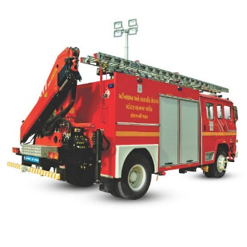

ii. **Rescue Gear:** These are equipment such as ropes, ladder, axe, chain saw etc., used to access and rescue people.



iii. **Communication Devices:** These are phones or radios used to communicate with and to coordinate rescue teams.

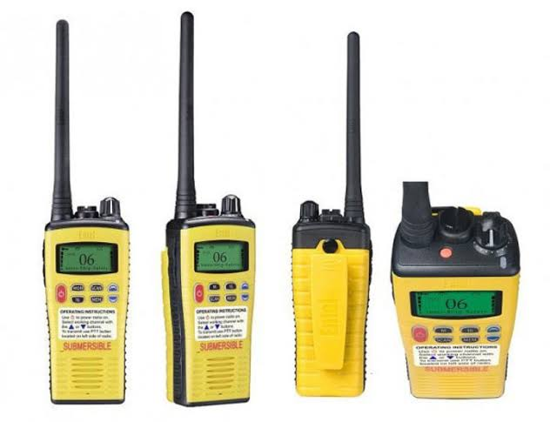

iv. **Medical Equipment:** These are equipment such as oxygen tank, stretchers etc., used to provide medical attention to people in distress.

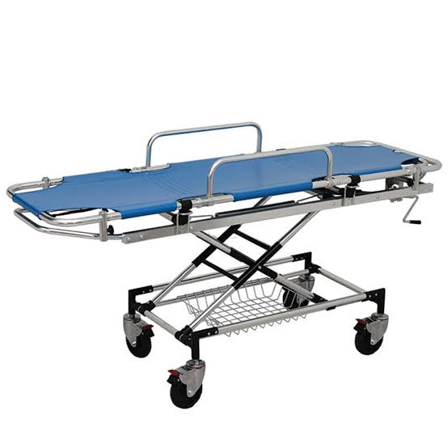

* **Importance of Rescue Operation**

i. **To save lives:** It is an operation targeted at saving lives and to prevent further harm by taking people away from danger areas.

ii. **Medical assistant:** It is an operation targeted at providing medical assistance such as first aid, emergency treatments and transportation to medical facilities.

iii. **Restoring Order and Stability:** It is an operation aimed at providing aids such as food, water, clothing and shelter to victims of disasters or those affected by an emergency.

**Week: Three**

**Subtopic: Agencies involved in Rescue Operations**

i. **Federal Road Safety Commission (FRSC):** They focus on rescuing accident victims on the road.

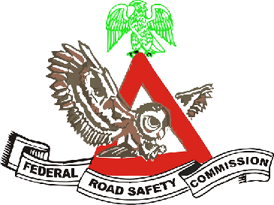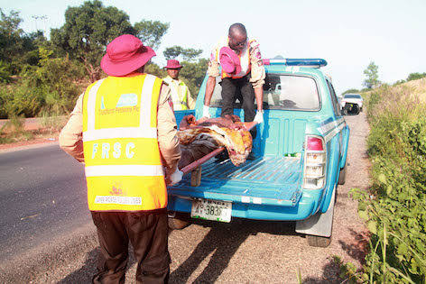

ii. **Federal Fire Service:** They focus on rescuing victims involved in fire accidents.

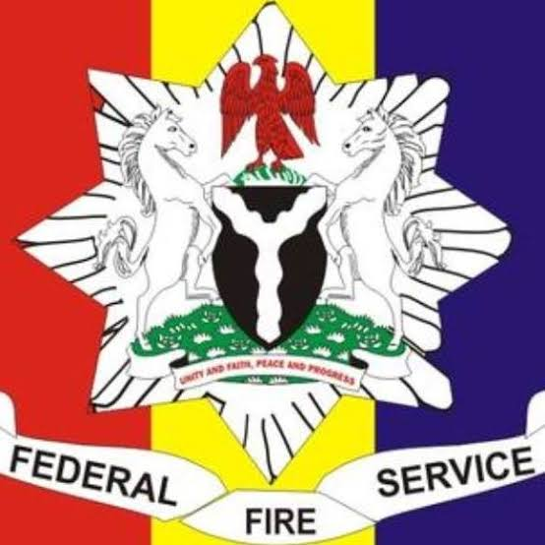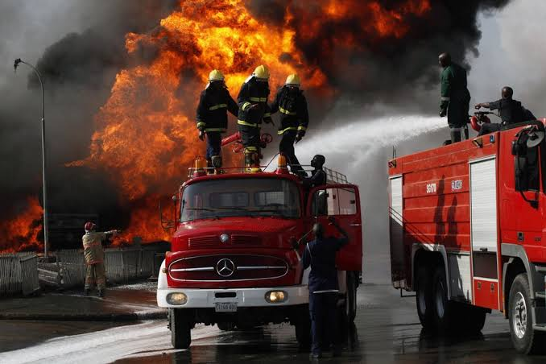

iii. **Nigerian** **Red Cross Society:** They focus on providing first aid to people involved in disasters and other emergencies.

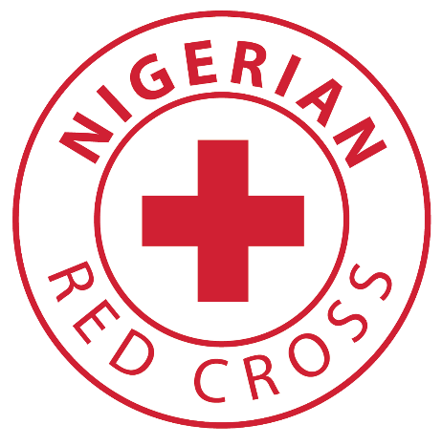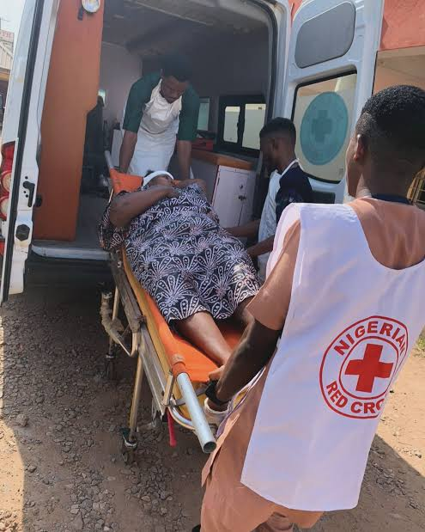 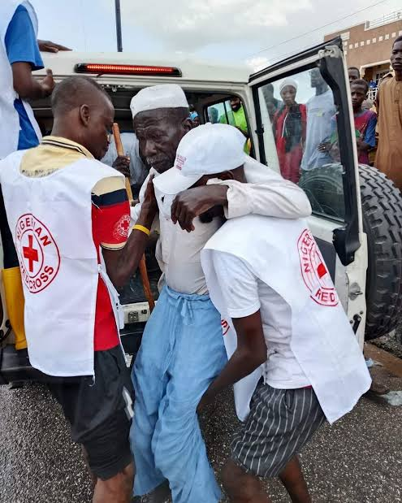

iv. **Salvation Army:** They provide relief, food, shelter to people involved in disasters.

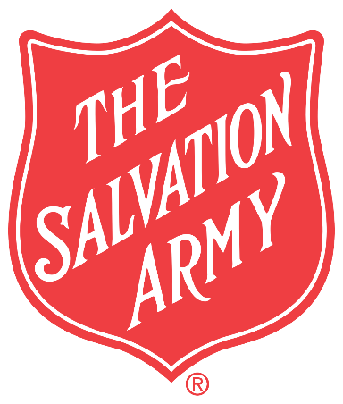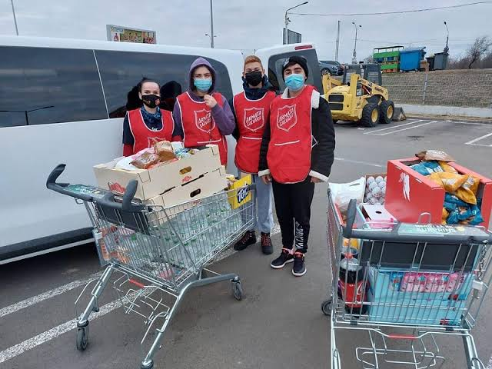

v. **International Rescue Committee (IRC):** They provide humanitarian aid and rescue services.

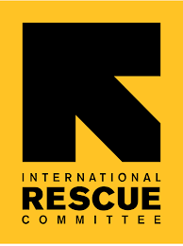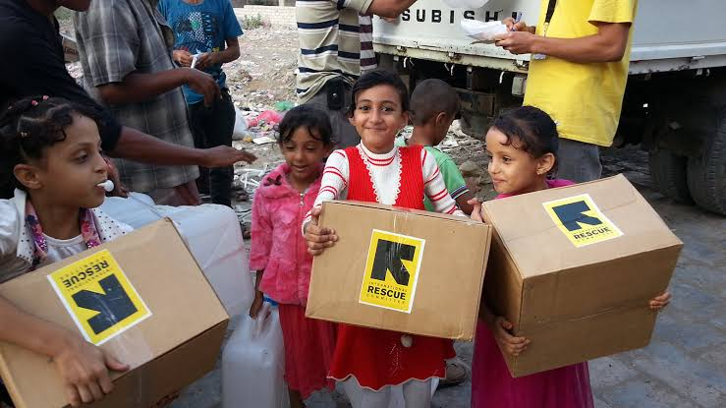

* **Steps in Rescue Operations**

i. **Alert and Notification:** This involves getting a distress call for a potential rescue operation, and alerting immediately the rescue team and other relevant authorities.

ii. **Assessment and Planning:** This involves assessing the situation and developing a rescue plan, and also getting all resources and personnel needed for the rescue operation.

iii. **Deployment and Execution:** This involve deploying the rescue team and all resources to the scene and carrying out all laid down plans.

iv. **Evacuation and Transportation:** This involves transporting those saved to a safe location and ultimately to the hospital.

**Week: Four**

**Topic: School Health Programme**

S

chool health is the health care given to everybody within and around a school environment to ensure their well being and quality state of life. **School health programme** refers to all the activities and planning carried out to ensure school health within a learning environment.

* **Component of School Health Programme**

i. **School Feeding Services:** This is to ensure that students in a school are given adequate balanced diet especially for the boarding school.

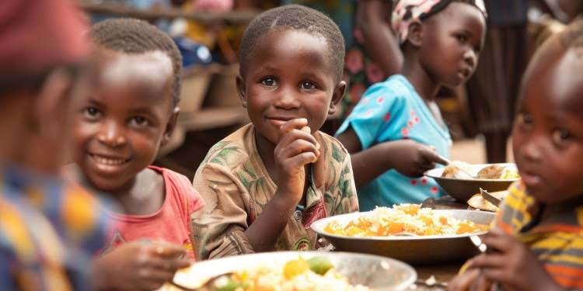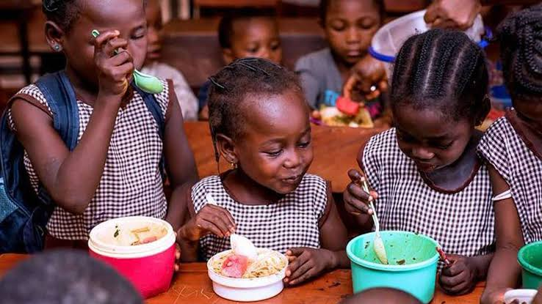

ii. **Healthy School Environment:** This is to ensure the promotion and maintenance of a safe and wholesome school environment through the provision of clean water supply, good ventilation, electricity, effective sewage etc.

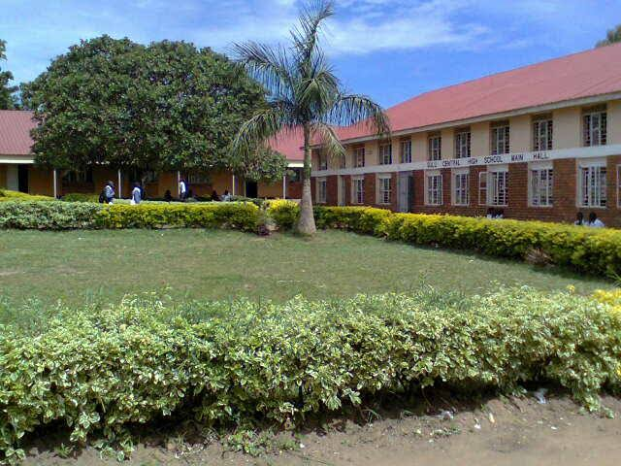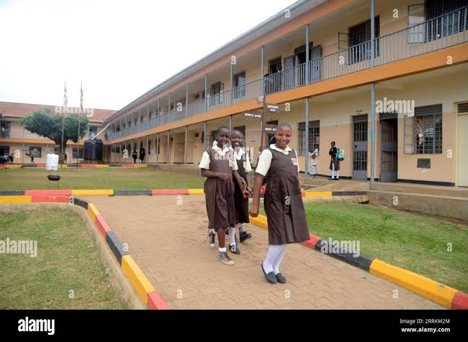

iii. **School Health Instructions:** This is an organised teaching procedure aimed at educating students on health-related matters for their wellbeing.

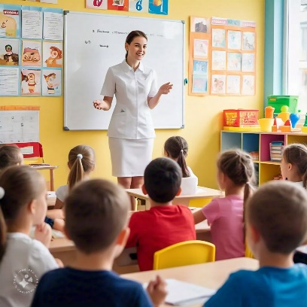

* **FRESH Approach to School Health Programme**

FRESH is an acronym given thus:

**F** – Focusing

**R** – Resources

**E** – Effective

**S** – School

**H** – Health

It therefore stands for **Focusing Resources on Effective School Health**, with the aim to encourage stakeholders such as educational and health officials to divert resources into school health programmes. It has four basic components which are:

i. Health-related school policies,

ii. Provision of safe water and sanitation,

iii. Skilled-based health and nutrition services,

iv. School-based health and nutrition services.

**Week: Five**

**Topic: Personal Health**

P

ersonal health can be defined as an individual’s ability to maintain and practise healthy habits that brings about healthy living. These healthy habits include general cleanliness of the body, adequate sleep and rest, consumption of balanced diet and nutritious food, exercises etc.

* **Effect of Personal Health**

i. **Good body posture and fitness:** A person who regularly exercises will have a good body physic and endure in labour for longer hours.

ii. **A clean living environment:** A person with good personal healthy habit always love their environment tidy and neat.

iii. **Long lasting health:** A person with good healthy habit seldom fall sick because they avoid doing or taking in things that results into sicknesses.

iv. **Good looking skin:** people who take care of their bodies are always adorable to look at.

**Week: Six**

**Topic: Non-communicable Diseases**

N

on-communicable diseases are diseases that are not infectious, that is, they cannot be transmitted from one person to another or from animals to man. Some examples include stroke, sickle cell, anaemia, kwashiorkor, obesity, cancer etc.

* **Difference Between Communicable and Non-communicable Diseases**

|  |  |
| --- | --- |
| **Communicable Diseases** | **Non-communicable Diseases** |
| i. Disease can spread from one person to another | Disease cannot be transmitted from one person to another |
| ii. They are caused by viruses and bacterial | They are caused by environmental factor such as transmittance through air and water. |
| iii. They cannot be inherited from one generation to another. | They can be inherited from one generation to another. |
| iv. Communicable disease can be prevented through vaccinations, hygiene practices and vector control. | Non-communicable disease can be prevented through lifestyle modification, such a healthy living and regular exercise. |

**Week: Seven**

**Topic: Non-communicable Diseases**

* **Sickle Cell Anaemia**

This is an inherited blood condition or disease of which the victim has a genetic blood disorder whereby the blood cell of the individual takes up the shape of a sickle, hence the reason it is called sickle cell and anaemia because it relates to the blood. The picture of a normal red blood cell and a crescent shaped blood cell also known as sickle cell is shown below:

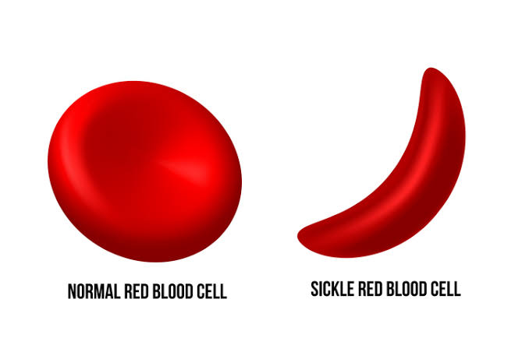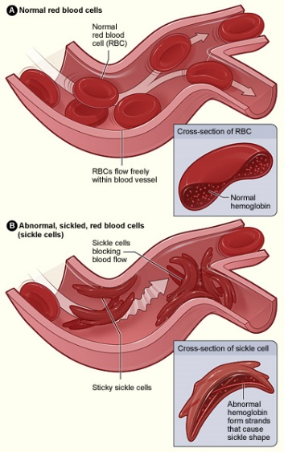

Symptoms of Sickle cell includes: general body weakness, pain in the joints, blood clots, fever etc.

**Preventive Measure Against Sickle Cell**

i. An SS or SC individual should never marry another person with such condition for the sake of their offspring.

ii. Blood transfusion can help to reduce the negative health condition.

iii. If unhealthy bone marrows can be completely replaced, then blood with normal cell can be produced.

**Week: Eight**

**Topic: Non-communicable Diseases**

* **Obesity**

This refers to being overweight caused by excessive accumulation of fat in the body. This is caused by too much intake of food. The body fats are mainly in the stomach, intestine and tissues beneath the skin. The picture below shows what obsessed people look like:

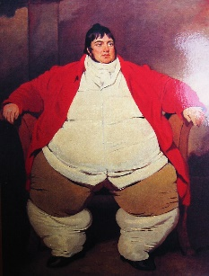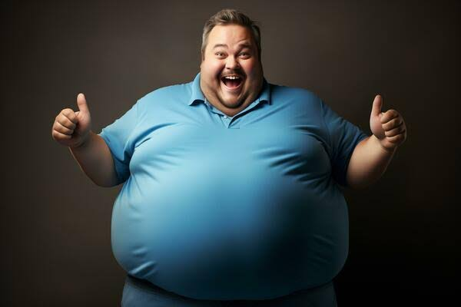



Obesity can lead to cardiac arrest by blockage of the arteries pumping blood to the heart, it also makes the individual get tired easily.

**Preventive Measure Against Obesity**

i. Regular exercises helps those with this tendency to stay in shape and fit.

ii. Avoid overeating and eating of junk and other fatty foods.

iii. Avoid late eating and then going straight to bed.

**Week: Nine**

**Topic: Non-communicable Diseases**

* **Asthma**

Asthma is a disease caused by the chronic inflammation of the airways. It is a chest and lung condition associated with difficulty in breathing. This inflammation spasm the airway thus narrowing it. Asthma is mostly aggravated by allergens like dust, chemicals, fumes etc. Below is a diagram showing asthma.

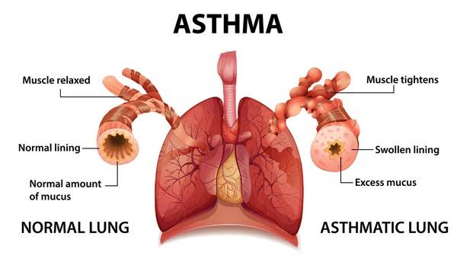

**Preventive Measure Against Asthma**

i. Medical check-up should be conducted for early discovery.

ii. Drugs and medications should be prescribed by professionals.

iii. Asthma patients should stay far from allergens.

iv. They must avoid unnecessary stress, emotional tension and getting upset quickly.

**Week: Ten**

**Topic: Non-communicable Diseases**

* **Kwashiorkor**

This is a malnutrition disease caused by severe deficiency in protein. Symptoms of this includes: diarrhoea, change in air and skin colour to rust colour, oedema (swelling of the ankles, feet and belly), flaky rash etc. Pictures below shows people with kwashiorkor:

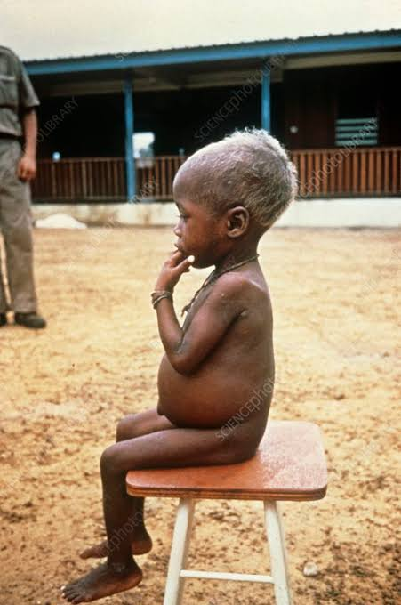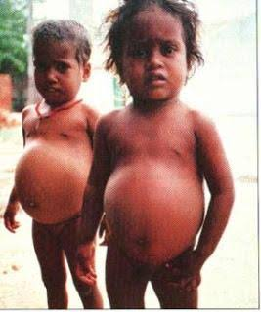

**Preventive Measure Against Kwashiorkor**

i. Eat adequate balanced diet.

ii. Take food supplements.