**Week 1: Topic: Christian Association of Nigeria (CAN)**

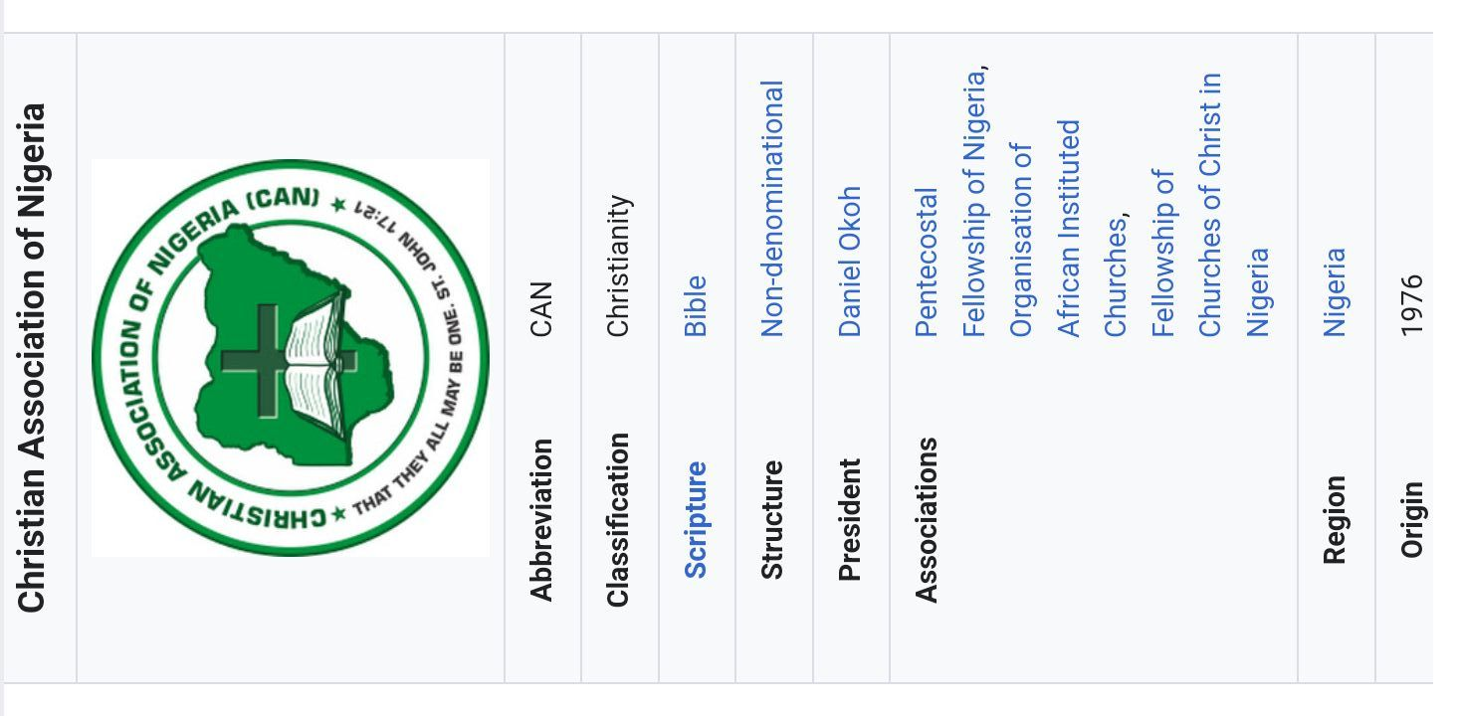Christian association of Nigeria can be said to be the mother body that supervises the activities of all denominational churches in Nigeria. They are also the voice that speaks on behalf of Christians and churches to government and international bodies.

CAN was established in 1976 in Lagos as a joint decision making body in matters that affects and concerns Christians in Nigeria.

CAN motor is taken from John 17:21 that says " That they may be one". Members of CAN include all registered denomination from the Catholic, Protestants and Pentecostal Christian churches.

**AIMS AND OBJECTIVES OF CAN**

1. To act as an organ of liason for the common action and consultations.

2. To serve in response to the clamour for the unity of the church of Christ.

3. To strive to promote cooperation in Nigeria in order to propagate the gospel of Christ.

4. To serve as a body that monitors and ensures that the spiritual and welfare content of the gospel to the nations is adequate.

5. To act as the first and strongest voice of the Christian faith before the government within and outside Nigeria.

6. To promote peace and unity and understanding among different religious groups and Christian denominations in the country.

**Home fun**

**M**ention 15 churches that are registered under CAN

**Week 2: Topic: Nigeria Fellowship Of Christian Evangelical Students ( NIFES)**

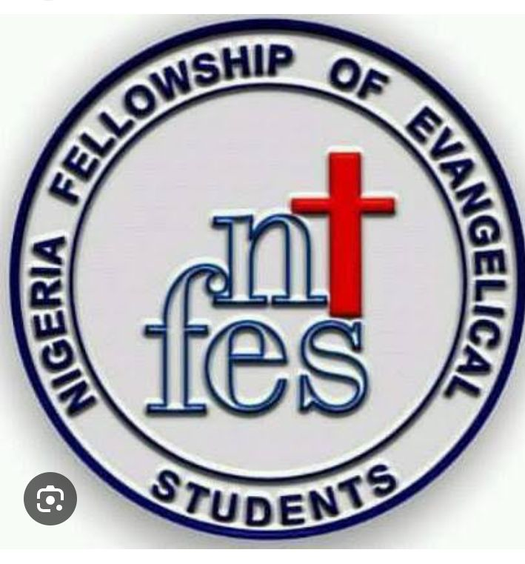**The** Nigeria Fellowship of Evangelical Students NIFES was established on August 1968. As an indigenous, non-governmental and inter denominational Christian campus movement, she has the sole duty to promote and encourage evangelism, discipleship and mission activities among Christian students. NIFES is the largest Christian campus fellowship in Africa with bases in most territory institutions in Nigeria.

**AIMS AND OBJECTIVES OF NIFES**

The major Aim of NIFES is to win and disciple students in Nigeria schools for Christ.

Objectives include ;

1. To equip Christian students for evangelism, especially amongst fellow students on campuses.

2. To nurture Christian students through personal discipleship to enable them grow into maturity in Christ.

3. To train Christian students in biblical leadership for godly roles in the church and society at large.

4. To promote and support Christians literary works and library services through writing and sponsoring publications of Christian books

5. To mobilize Christian students for mission work and in creating mission awareness among students, staffs and associations.

**Home fun :** Research and write on the origin and history of NIFES in Nigeria.