**Week 3: Reasons for drug trafficking**

**Peer pressure:** friends and the company we keep have a lot of impact on our daily decisions and action. Some drug traffickers go into the business due to the deceit or the strong opinion of the friends who are into it. Enticing them with the financial benefits accruing from the illegal business of drug trafficking.

**Poverty: as** a key driver of drug trafficking ,Individuals living in impoverished conditions may see drug trade as a means of escaping financial hardship. Lack of alternative means of economic survival can lead people to view drug trafficking as a quick way to generate income, even if it involves high level of risks.

**Ignorance**: Lack of awareness and education about the consequences of drug trafficking can contribute to its perpetuation. In some cases, individuals may be unaware of the devastating impact drugs have on communities, families, and individuals, but may not fully understand the harm it causes.

**Greed**: The desire for wealth and a luxurious lifestyle is a powerful motivator for drug trafficking. Individuals, especially youths may be enticed by the prospect of making substantial profits quickly. The allure of financial gain can overshadow the potential harm caused by the trade.

**Lack of Education:** Limited access to education or lack of skills and knowledge needed to pursue lgitimate jobs and lack of educational opportunities can trap people in a cycle of poverty, making drug trafficking seem like a more viable option for financial stability.

**Weak legal laws:** the problems with most country laws especially the third world countries like Nigeria is not lack of law, there are indeed some many laws enshrine in our constitution. However, the low level of enforcement of this laws tend to render them useless, most top government officials engage in drug trafficking and the law protect their interest instead of fighting them.

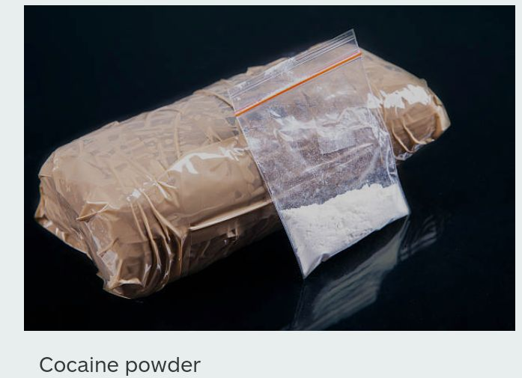

**Week 4: Dangers of drug trafficking**

There are many dangers associated with drug trafficking. Some of the dangers are;

**1. Physical Danger:** Drug trafficking can cause physical injury to drug traffickers. For instance, injection of hard drugs by drug traffickers could cause damage to the organs of the victims. In some cases, it could lead to the death of the victims.

**2. Crime-Related Issues:** Drug trafficking has been directly linked to violent crimes worldwide. The nature of the job requires a certain degree of involvement in criminal activities like murder, kidnapping, armed robbery, etc.

**3. Imprisonment:** Since drug trafficking is an illegal act, drug traffickers are criminals. And when caught in the act, they are taken to the court of law for prosecution. If they are found guilty, they are jailed, depending on the gravity of the offence committed.

**4. Death Penalty:** When drug traffickers are arrested, as they are taken to a court of law for prosecution. If the offence committed is very grievous, they are likely to be given the death penalty. When Nigeria was under the military regime, drug traffickers caught were made to face firing squad.

**5. National Insecurity:** Drug trafficking has negative effects on national security. The effects of hard drugs on the human mind pose a great threat to the security of the nation. These drugs alter the state of the mind negatively, leading to increased violence and crime. Drug traffickers also deal on sells of arms and ammunition. Therefore, national well-being is affected by the activities of these drug traffickers.

**6. Negative Impact on the Economy:** In every country, government spend a lot of money to maintain law enforcement agents and to acquire equipments to fight drug trafficking, which affects the economy of the country, in addition to the activities of drug traffickers. The illegal trade in drugs brings about loss of revenue to the country,

**7. Bad Image for an individual and the Country:** Countries where drug trafficking is rampant do not have a cordial relationship with the international community, sanctions could even be imposed on such countries with serious drug trafficking cases. The sanctions include severing their economic ties or relationships and closing their borders to citizens from drug-infiltrated countries. In fact, innocent citizens from drug trafficking countries can be embarrassed by officials of other countries who subject them to thorough searches before they are allowed into their countries.

