**Class: Js 1**

**Subject: Physical and Health Education**

|  |  |
| --- | --- |
| Third Term Scheme of Work | |
| Week 1 | **Contact Sport**   * Meaning of Contact Sport * Types of Contact Sport * Benefits of Contact Sport * General Safety Measures in Contact sport |
| Week 2 | **Contact Sports: Basketball**   * Definition of Basketball * Facilities/equipment in Basketball * Basic Skills in Basketball * Rules in Basketball * Officials in Basketball |
| Week 3 | **Contact Sports: Wrestling**   * Definition of Wrestling * Facilities/equipment in Wrestling * Basic Skills in Wrestling * Rules in Wrestling * Officials in Wrestling |
| Week 4 | **Non-contact Sport**   * Meaning of Non-contact Sport * Types of Non-contact Sport * Benefits of Non-contact Sport * General Safety Measures in Non-contact sport |
| Week 5 | **Non-contact Sports: Tennis**   * Definition of Tennis * Facilities/equipment in Tennis * Basic Skills in Tennis * Rules in Tennis * Officials in Tennis |
| Week 6 | **Non-contact Sports: Swimming**   * Definition of Swimming * Facilities/equipment in Swimming * Basic Skills in Swimming * Rules in Swimming * Officials in Swimming |
| Week 7 | **Midterm Break** |
| Week 8 | **Recreational Activities:**   * Definition of Recreational Activities * Types of Recreational Activities * Venues for Recreational Activities |
| Week 9 | **Leisure Activities:**   * Definition of Leisure Activities * Types of Leisure Activities * Venues for Leisure Activities |
| Week 10 | **Dance Activities:**   * Definition of Dance Activities * Types of Dance Activities and their Skills |

**Week: One**

**Topic: Contact Sports**

* **Introduction**

C

ontact sports are generally sports that involves a contest between two or more persons involved in fighting or in no fighting. This kind of sport involves using physical strength to struggle so as to gain advantage over an opponent to have the victory. Examples of this sport includes: Wrestling, judo, boxing, tug-of-war, fencing etc.

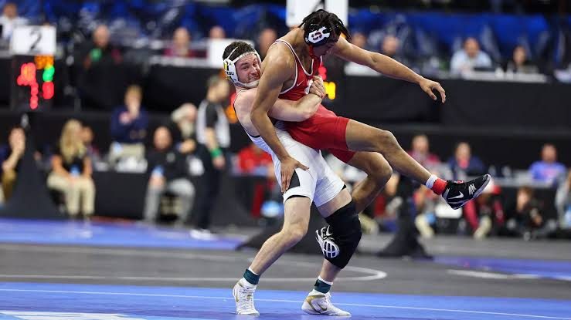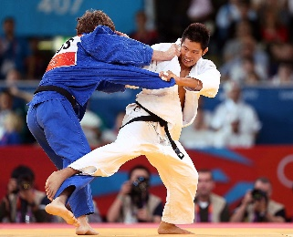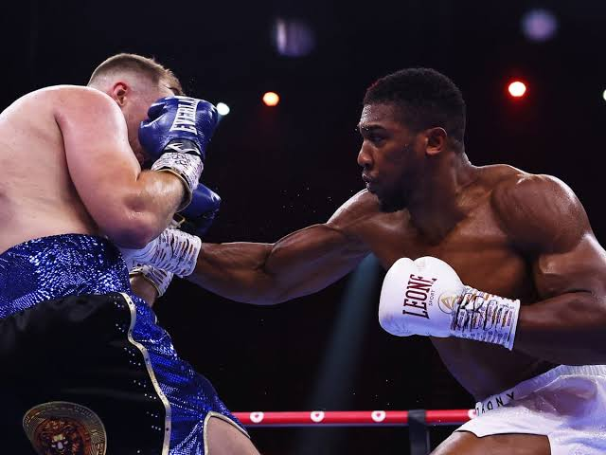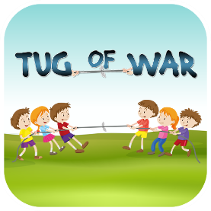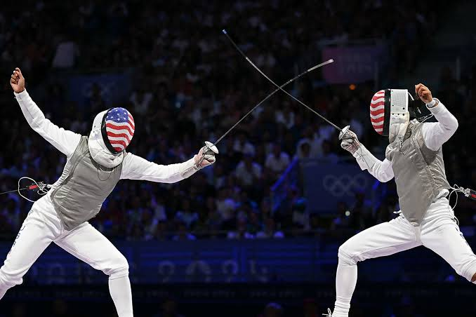

* **Benefits of Contact Sports**

i. To improve self-defence abilities;

ii. To train the mind and improve courage;

iii. To build strength and power;

iv. To develop overall physical fitness;

v. To entertain spectators;

vi. To generate income for practitioners etc.

* **General Safety Measures in Contact Sports**

i. Warm up adequately before any contest;

ii. Fight with opponents in your weight category;

iii. Avoid any rough moves that can hurt your opponent;

iv. Avoid the use of wristwatches, finger rings or any jewellery within contest;

v. If sick, do not fight because you can be easily injured etc.

**Week: Two**

**Topic: Basketball**

B

asketball can be defined as a game played by two teams of five players each, bouncing a ball and try to score points by throwing the ball through one of the raised nets at each end of a rectangular court. A large rubber ball is used in playing this game.

* **Facilities and Equipment in Basketball**

i. **Basketball Court:** This is a rectangular court with hardwood or synthetic surface divided into two halves.

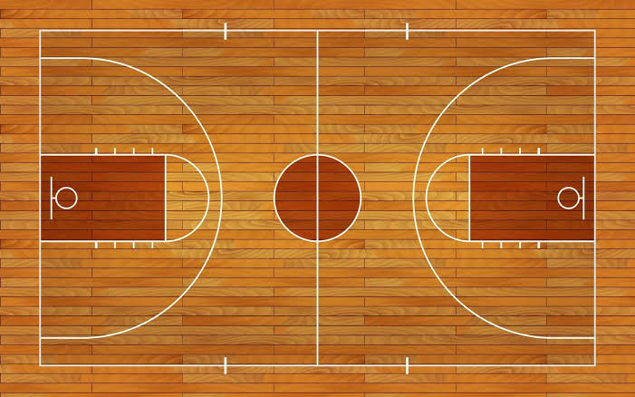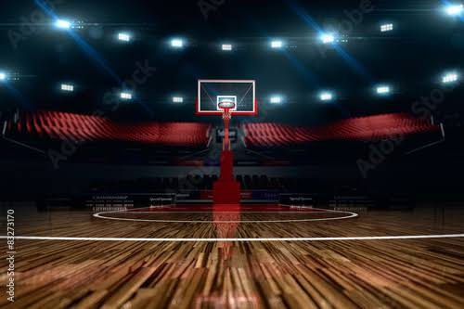

ii. **Basketball:** An inflatable ball made of leather, weighing 624 grams for men’s game and 567 grams for women’s game.

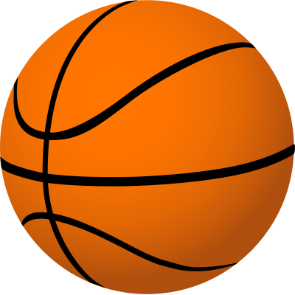

iii. **Hoops:** Two goals, each consisting of a rim, net and backboard placed at opposite ends of the court.

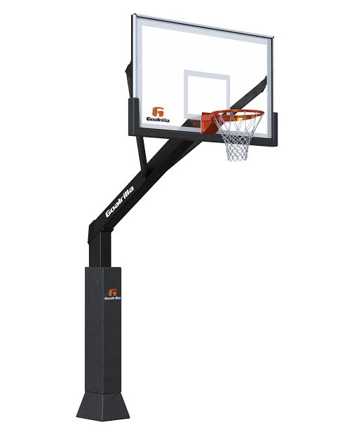

iv. **Scoreboard:** An electronic or manual display showing the score, time and other game-related information.

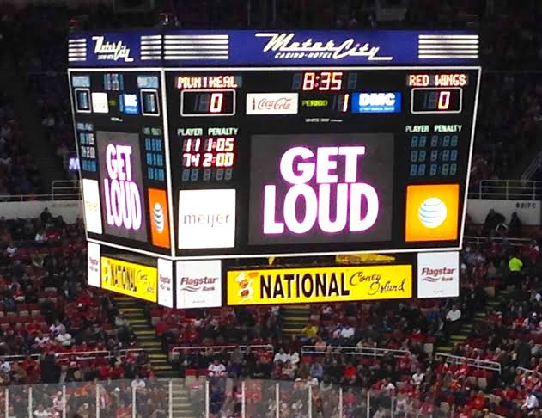

* **Basic Skills in Basketball**

i. **Dribbling:** This involves skilfully moving the ball around the opponent to get to the other side of the court while maintaining control.

ii. **Shooting:** This involves scoring by throwing the ball into the hoop.

iii. **Rebounding:** This involves grabbing the ball after a shot is missed

iv. **Defence:** This involves guarding an opponent to prevent scoring.

v. **Passing:** This involves moving the ball to a teammate.

* **Basic Rules in Basketball**

i. **Ball Possession:** The ball must be advanced by dribbling or passing not by carrying or throwing.

ii. **Scoring:** Point scored on field goal (2 or 3 point), while free-throws are 1 point.

iii. **Travelling:** Players can only take two steps without dribbling the ball.

iv. **Carrying:** Players cannot hold on to the ball for more than five seconds or carry it without dribbling.

* **Officials in Basketball**

i. **Referees:** Responsible for enforcing rule and making foul decisions within games.

ii. **Umpires:** Assist the referee in monitoring the game and making decisions.

iii. **Scorekeeper:** Responsible for keeping track of the score, timeouts and fouls.

**Week: Three**

**Topic: Wrestling**

W

restling can be defined as a sport whereby two contestants try to throw, force, or pin each other to the ground. In this sport, two unarmed individual struggle hand-to-hand to subdue or unbalance the other.



* **Facilities/Equipment in Wrestling**

i. **Wrestling room:** This is a space dedicated for wrestling practice and competition, often equipped with wrestling mats and score boards.

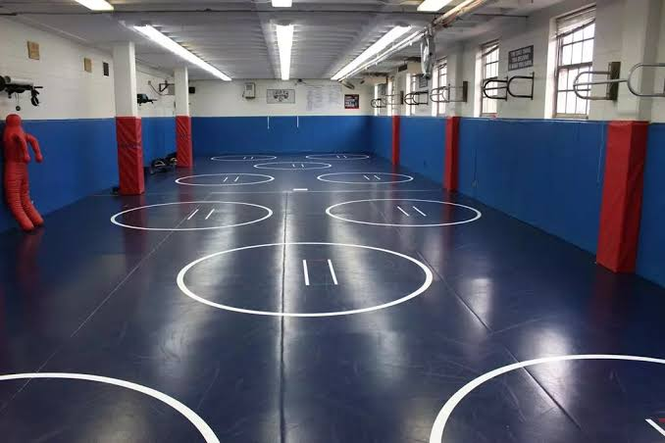

ii. **Wrestling mat:** A padded, shock-absorbing surface designed specifically for wrestling.

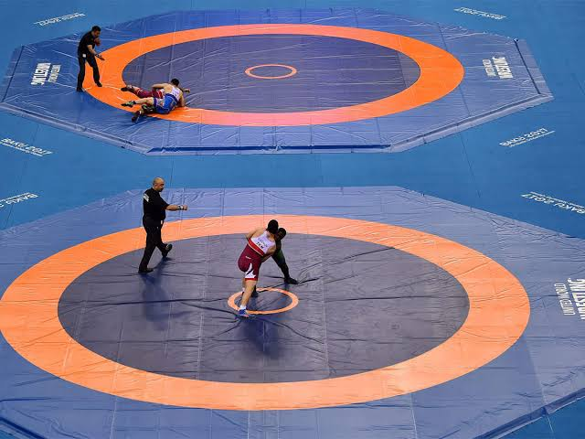

iii. **Headgear:** Protective gear worn on the head to prevent ear and head injuries.

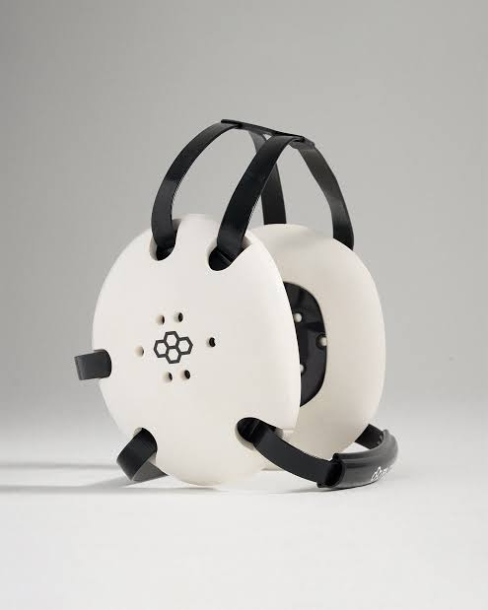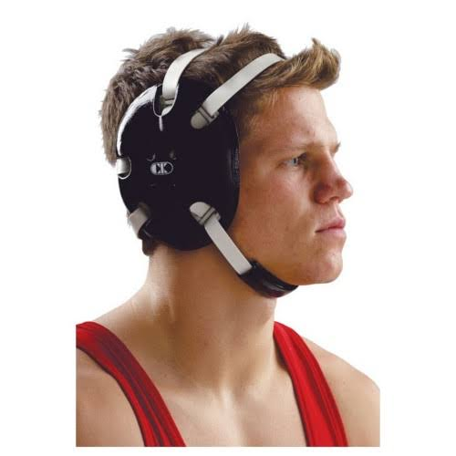

iv. **Mouthguard:** Protective gear worn in the mouth to prevent mouth and dental injuries.

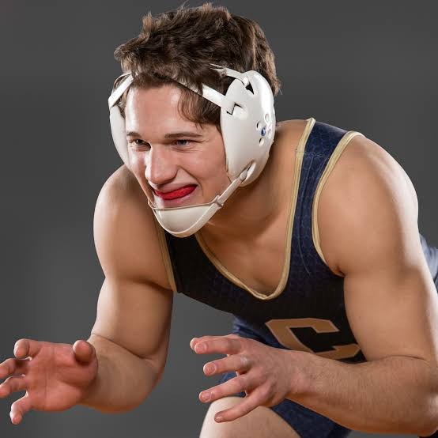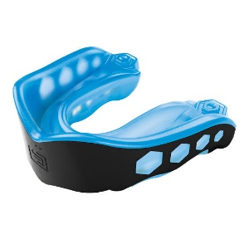

* **Basic Skills in Wrestling**

i. **Stance and Movement:** This involves the standing position with the feet and shoulders apart and hands up as a way of defence and also sliding or circling to create new positioning.

ii. **Takedowns:** This involves a single-leg, double-leg or high-crotch takedown. The first and second takedown involves attacking one leg or both to take down opponent, while the last involves attacking opponent’s upper thigh.

iii. **Throws:** This involves the hip-throw, shoulder-throw, and arm-throw. The all involve using the mentioned part of the body to throw the opponent down.

**iv. Escape:** A wrestler can escape from their opponent’s control by breaking free or reversing positions.

* **Rules in Wrestling**

i. A standard wrestling march consist of three periods, each one lasting for 2 to 3 minutes.

ii. Wrestlers compete in specific weight classes to ensure fair competition.

iii. Wrestlers are to begin in a neutral position facing each other.

iv. Wrestlers score points by takedowns, escapes and near-falls (that is, when the opponent shoulders are close to the mat).

* **Officials in Wrestling**

i. **Referee:** Responsible for enforcing the rules during the match and declaring the winner.

ii. **Mat Judge:** Assist the referee in monitoring and scoring points.

iii. **Table officials:** keep track of match time, scores, and penalties.

**Week: Four**

**Topic: Non-contact Sport**

N

on-contact Sport can be defined as sports in which players are physically separated and is nearly impossible for them to make physical contact with one another during the course of a game. Types of non-contact sport includes: Gymnastics, swimming, tennis, squash etc.

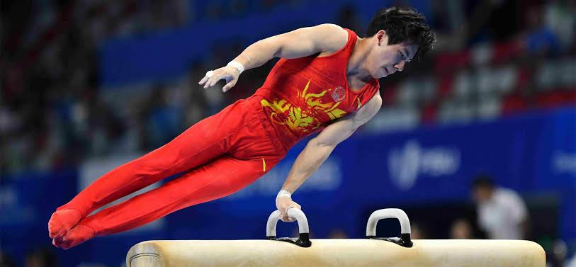 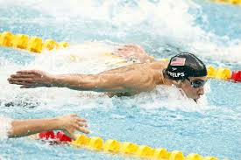 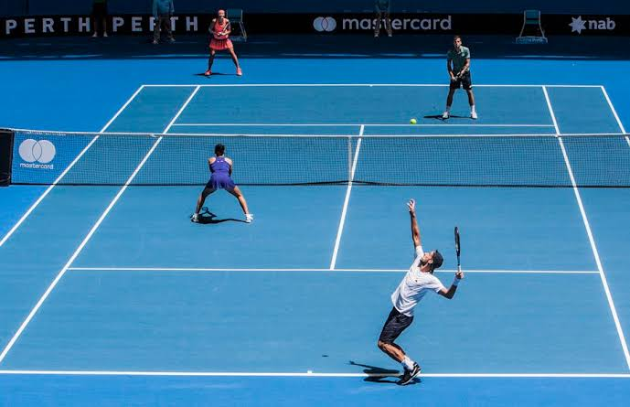

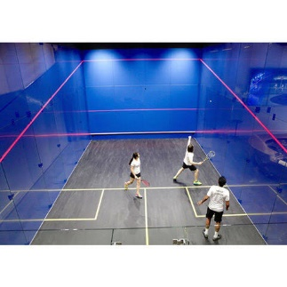

* **Benefits of Non-contact Sport**

i. They are lifetime sports, which means that one can partake of these sports as long as one desires.

ii. Assists people to develop positive attitude getting involved in exercises.

iii. To develop healthy and strong bodies with qualities such as strength, agility endurance etc.

* **General Safety Measures in Non-contact sport**

i. Warm-up properly before the game by bending, stretching and even jogging.

ii. Learn the correct skills and technique of the sport before venturing into any competition.

iii. Use standard equipment and materials for the particular sport you are engaged in.

**Week: Five**

**Topic: Tennis**

T

ennis can be defined as a game that is played by two players or two pairs of people on a special court called the tennis court, where they hit a small elastic ball back and forth over a low net using rackets.

* **Facilities/Equipment in Tennis**

i. **Tennis court:** This is a rectangular surface made of grass, clay, or even synthetic materials.

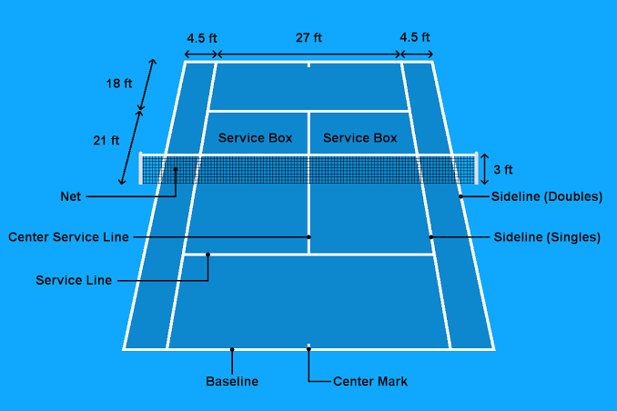

ii. **Tennis rackets:** This is a lightweight, oval-shaped frames with strings used for hitting the ball.

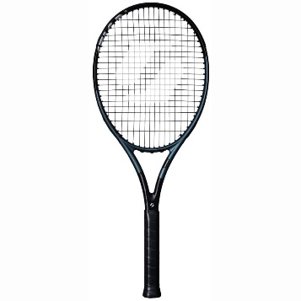

iii. **Tennis ball:** This is a small spherical ball usually light-greenish in colour with a rubber core.

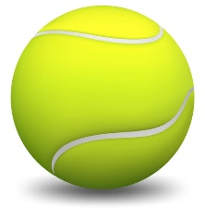

iv. **Ball machine:** This is an automated machine used for shooting balls for practice.

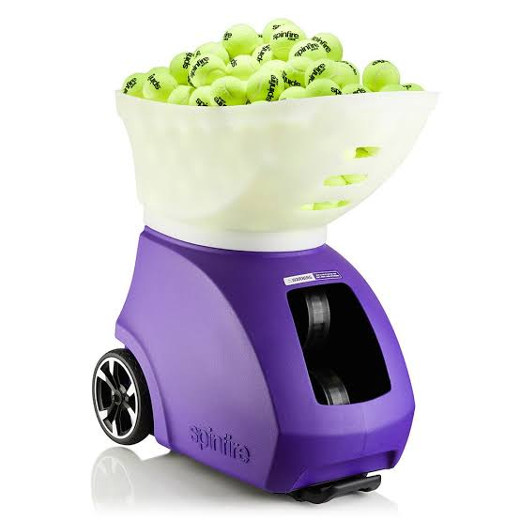

v. **Tennis net:** This is the net that divides the court and regulates play etc.

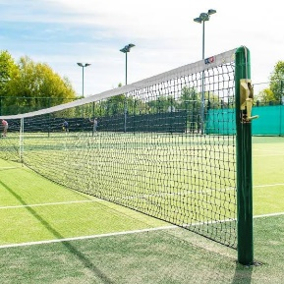

* **Basic Skills in Tennis**

i. **Serve:** This is a way to kickstart play whereby a player tosses the ball and hits it to go across opponent’s side of the court.

* A serve that land on the opposite side of the court without opponent touching it is called an ACE.

ii. **Volley:** This is a shot hit before the ball has the chance to bounce.

iii. **Lob:** This is a high-arching shot, usually hit to buy time or to clear the opponent at the net.

iv. **Groundstroke:** This is a shot hit after the ball has bounced etc.

* **Rules in Tennis**

i. **Fault:** A player is said to have committed a fault when he/she serves into the net, out of bound or fail to clear the net.

* **Note:** double fault gives a point to the opponent of the one who commits it.

ii. **Out of bound:** This is when the ball lands outside the court or in a non-playable region.

iii. **Foot fault:** A foot fault is said to be committed when a player’s foot touches the baseline before serving.

iv. **Scoring Term:** One point is represented by 15 while the second point is represented as 30 while the third point which wins the set is represented by 40. When the score is 40-40, it is called a deuce. To break this tie, one player must have two point above the opponent in an extended play.

* **Officials in Tennis**

i. **Chair Umpire:** Sits in a raised chair and makes judgemental decisions based on the rules of the game.

ii. **Linesmen/lineswomen:** Stands at the side-line to detect faults.

iii. **Net Judge:** Stands at the net and calls when the ball hits the net or when it is served into the net.

**Week: Six**

**Topic: Swimming**

S

wimming can be defined as a sport that involves one using the body to travel through water. This is a sport that requires one to be afloat on or below water and not to sink to the bottom. It is one of the numerous aquatic sports.

**Note:** The movements of the limbs and body used for locomotion in swimming is called **stroke**.



* **Facilities/Equipment in Swimming**

i. **Competition Pool:** This is a 50-metre pool used for competitive swimming.

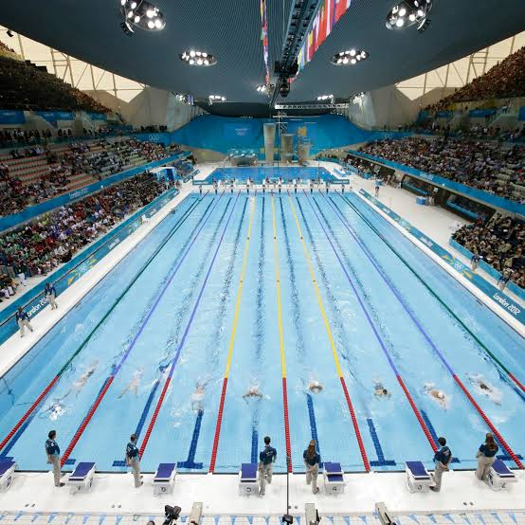

ii. **Starting blocks:** This is a platform used by swimmers to start race.

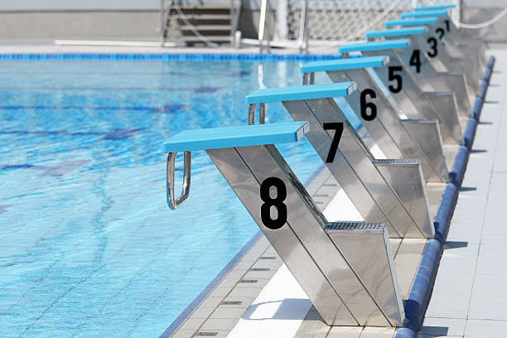

iii. **Lane lines:** This is a floating line that divides the pool into separate lanes

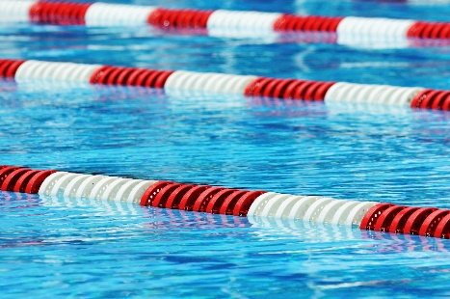

* **Basic Skills in Swimming**

i. **Front Crawl:** This is the fastest stroke in swimming. It is done with alternative legs and arms action.

ii. **Breast Stroke:** This is a frog-like movement. It is the only stoke in which you swim under water.

iii. **Back Stroke:** This is entirely done on the back. The shoulder roll in the stroke to aid movement.

* **Rules in Swimming**

i. Swimmers must start and finish in their own lane.

ii. Swimmers must swim in their designated stroke.

iii. Swimmers must not touch the lane line or pool bottom.

iv. Swimmers must not interfere with other swimmers.

* **Officials in Swimming**

i. **Meet referee:** He/she is the chief official responsible for overseeing the entire meet.

ii. **Stroke Judges:** Observes the swimmers’ strokes, turns and finishes.

iii. **Lifeguards:** Provides safety coverage during the meet.

**Week: Eight**

**Topic: Recreational Activities**

T

he word recreation is gotten from the Latin word “Recreatio” which means to refresh. Therefore, recreational activities can be defined as the activities carried out that rest one from work, by giving a person space to refresh the mind, body and spirit.

* **Types of Recreational Activities**

i. **Hiking:** This involves taking long walks or climbing mountains and hills.

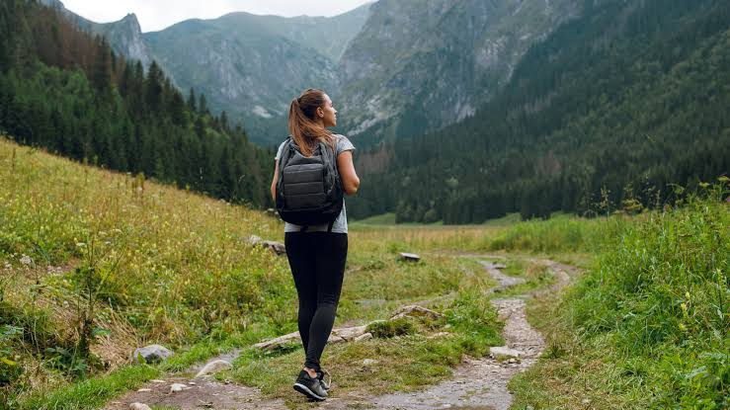

ii. **Camping:** This involves spending time outdoors often in a tent or RV.

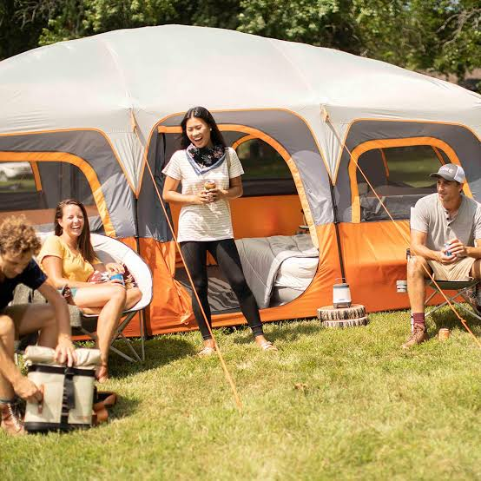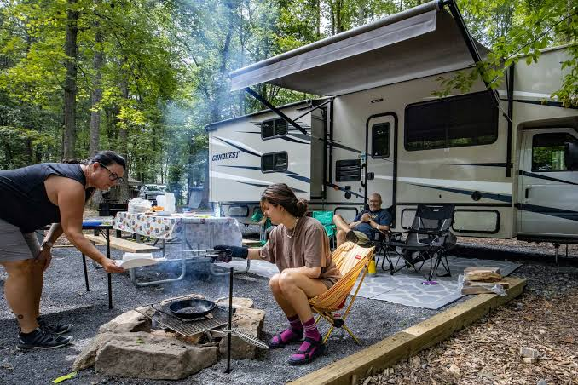

iii. **Sports:** This involves either playing indoor sports or going to watch a game.

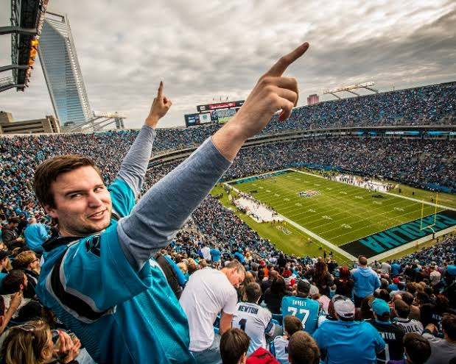

iv. **Reading:** This involves reading for fun, to get educated and entertained at the same time.



* **Venues for Recreational Activities**

i. **Stadiums:** These are large indoor and outdoor sport facilities where people go to watch games or attend other events.

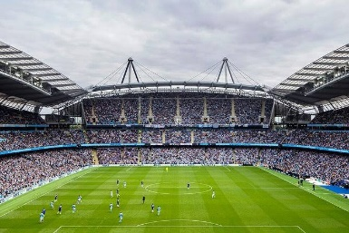

ii. **Parks:** This are large green areas preserved in its natural state used basically for recreational purposes.

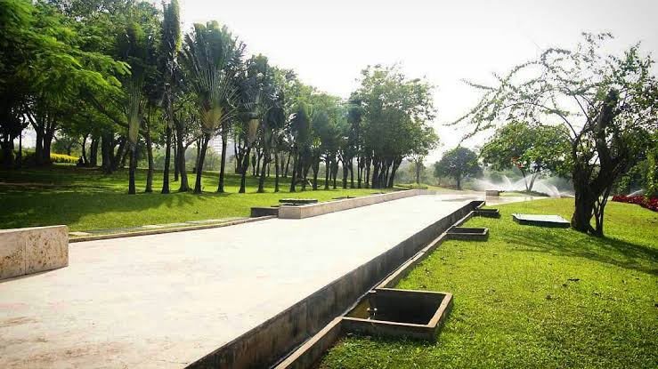

iii. **Movie Theatres:** These are indoor facilities with screens and sound systems used for showing movies.

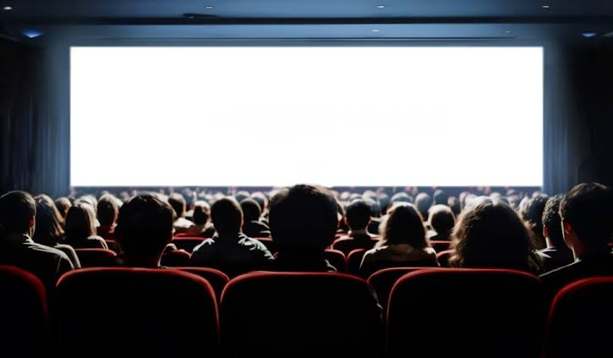

iv. **Gyms:** These are indoor facilities where people go to do exercises and lift weights for body building.

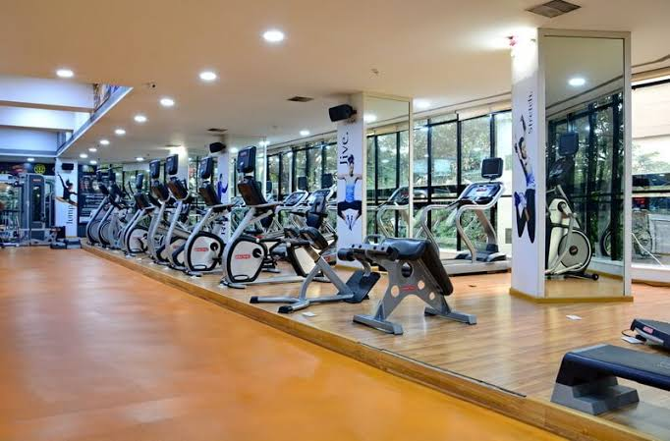

**Week: Nine**

**Topic: Leisure Activities**

L

eisure is a free time one has after the completion of work or the fulfilment of an obligation. This time in other words is called ‘free time’ whereby a person can do whatever he/she like with that time, things like listening t music, drawing, meditating etc.

* **Types of Leisure Activities**

i. **Cooking or baking:** This involve preparing meals or baking things for personal enjoyment.

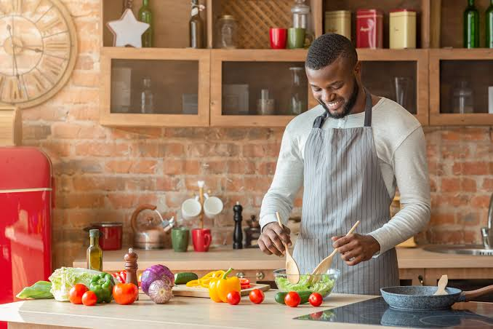

ii. **Painting:** This involves creating artwork using various mediums such as water colour or oil paint.

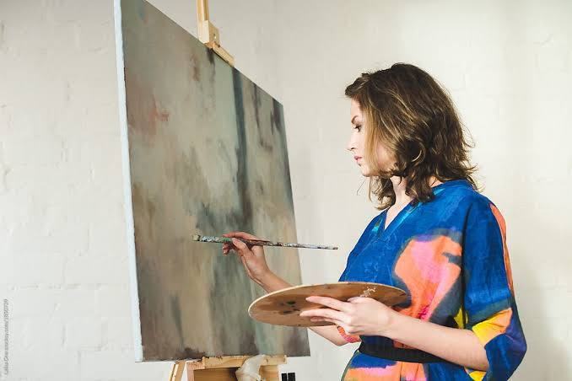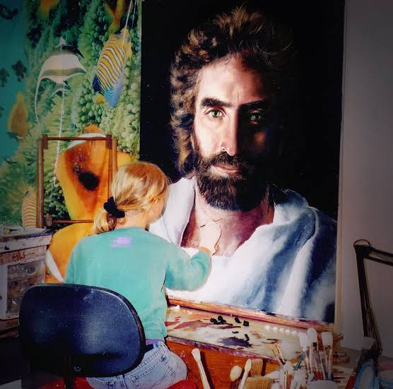

iii. **Photography:** This involves one capturing image using cameras or smartphones.

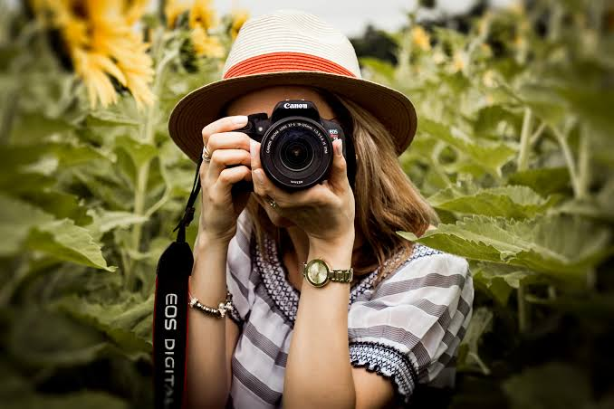

iv. **Travelling:** This involves one exploring other places whether domestically or internationally.

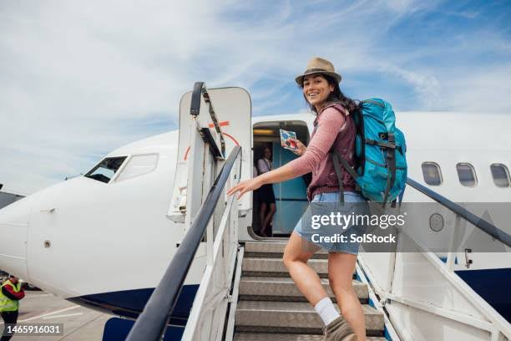

* **Venues for Leisure Activities**

i. **Libraries:** These are institutions offering books and other educational programs



ii. **Opera Houses:** These are specialised venues for opera and classic music performance.

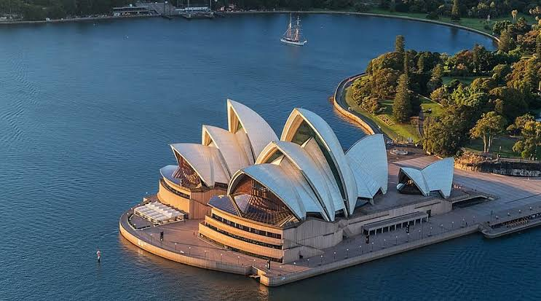

iii. **Art Galleries:** These are spaces exhibiting local, national and international artwork.

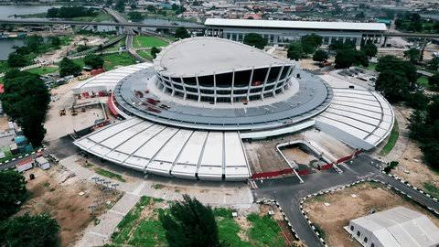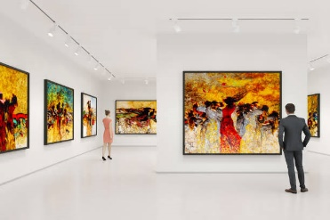

iv. **Beaches:** These are coastal areas for swimming, sunbathing and water sports.

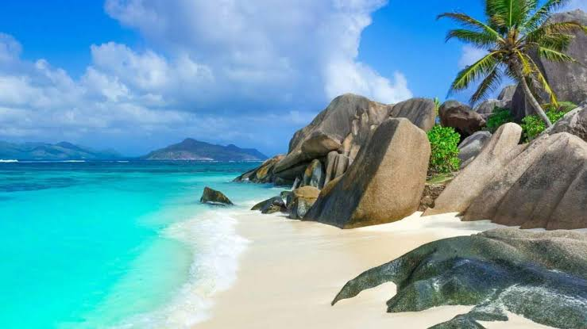

**Week: Ten**

**Topic: Dance Activities**

D

ance is a rhythmical pattern of moving the body according to the rhythm of a music, or the act of performing a dance. Dancing involves using correct foot pattern while keeping the muscles of the body under control and in a relaxed form.

* **Types of Dance**

i. **Ballet:** This is a classical dance formalized by movements of the body which requires flexibility.

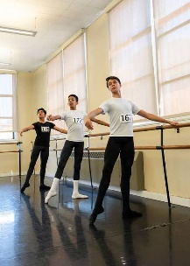

ii. **Hip-hop dance:** This is a high-energy dance style that includes breaking, popping and locking.

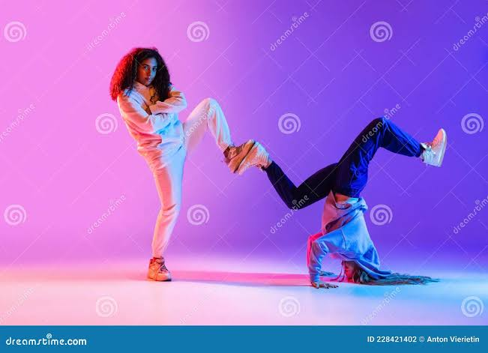

iii. **Tap dance:** This is a percussive dance that focuses on creating rhythms with the feet.

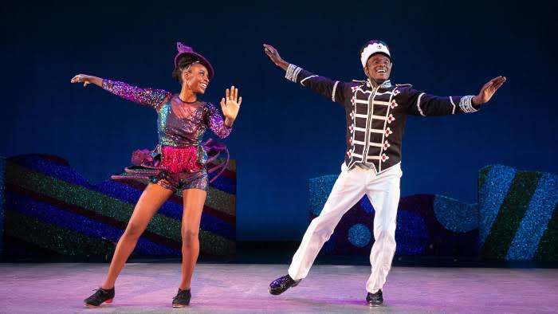

iv. **African waist dance:** This is a form of dance that involves shaking the waist common to the south-south people of Nigeria.

