

**Subject: Physics**

**Class: SS 2**

**Week: One**

**Topic: Electric Fields**

* **Electric Conduction through Fluids (Electrolysis)**

E

lectrolysis is defined as the process of decomposing certain liquids and solutions into their component parts by the passage of electricity through them. In other words, it is a process of separating the contents of compound mixture solutions by passing electricity through that solution. The liquid in which takes place is called the electrolyte, and in it is the negative electrode also known as cathode which is always either hydrogen or metal, while the positive electrode also known as anode is always oxygen or non-metal or the anode may dissolve in the solution. Note: Electrodes are in form of rods or plate.

Ions are charges particles which exist in the electrolytes and take part in the electrolysis. The ions which moves to the anode are called anions while those who move to the cathodes are called cations. A Voltameter is the vessel containing the electrolyte and electrodes.

**Ionic Theory: Conduction through Liquid**

Swedish scientist – Arrhenius developed the ionic theory. In his theory, he postulated that dissociation can occur irrespective of whether or not an electric field is applied into the electrolyte. For example, copper tetraoxosulphate (VI), (CuSO4) in solution will dissociates into copper ion and tetraoxosulphate (VI) ion:

CuSO4 Cu2+ + S

The copper ion has lost two electrons and is positively charged while the negative ion has gained two electrons hence negatively charged.

In an electrolyte, the negative and positive ions move randomly in it until the electrodes are introduced into the electrolyte. With this, the positive ion drift towards the cathode while the negative ion drift towards the anode. This is illustrated below:

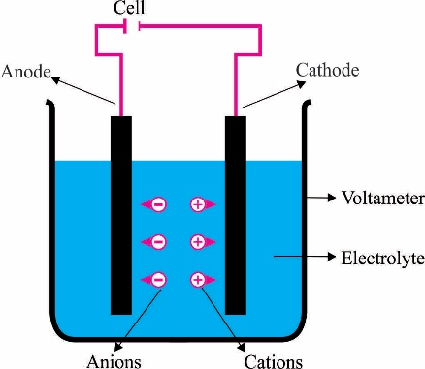

**Examples of Electrolysis**

1. Electrolysis of Acidulated Water

2. Electrolysis of Copper Tetraoxosulphate (VI) solution using Copper Electrodes

**Faraday’s Law of Electrolysis**

Based on experiments, Faraday was able to formulate two laws on electrolysis:

1. The mass (*m*), of a given element liberated during the process of electrolysis is directly proportional to the quantity of electricity (Q) that has passed during the electrolysis.

i.e **m Q**

**m = zQ**

but **Q = It**

⸫ ***m = zIt***

Where z = constant of proportionality known as the electrochemical equivalent (C-1)

I = current (A)

t = time (s)

2. The relative mass of substances liberated by the same quantity of electricity are proportional to their chemical equivalents C.

**Take Note:** We must also take note of this fact that the quantity of charge required to liberate or dissolve one mole of any singly charged ion in electrolysis is termed Faraday constant (F). It is estimated to be 9.65 104 Cmol-1.

**Examples:**

1. The electrochemical equivalent of a metal is 0.12 10-6kgC-1. Calculate the mass of the metal deposited in 2 hours after a current of 2.0 A flows through the electrolyte.

**Solution**

z = 0.12 10-6kgC-1

I = 2.0 A

t = 2 hours = (2 60 60) s

*m = zIt*

*m* = 0.12 10-6 2 (2 60 60)

*m =* 1.728 10-3kg

2. The masses of copper and silver deposited are 10.00g and 34.28g respectively when the same current flows through copper and silver voltameters for 30 minutes. If the chemical equivalent of silver is 108, calculate the chemical equivalent of copper.

**Solution**

m1 = 10.00g; m2 =34.28g; c2=108; c1 = ?

c = 31.5

**Application of Electrolysis**

1. **Electroplating:** This process is usually used in coating cutleries such as spoon, forks etc. They are basically used to improve the appurtenance of metals and prevent them from corroding. How is it done? The material to be plated is made the cathode, while the coating material is made the anode. The solution of salt of the plating material is made the electrolyte in the voltameter. For example, if a spoon is to be silver coated, the spoon is made the cathode, pure silver (Ag) is made the anode and silvertrioxonitrate (V) (AgNO3) solution is made the electrolyte. When electricity is passed through the solution, Ag+ drifted to the cathode where they are discharged and the spoon is coated with silver.

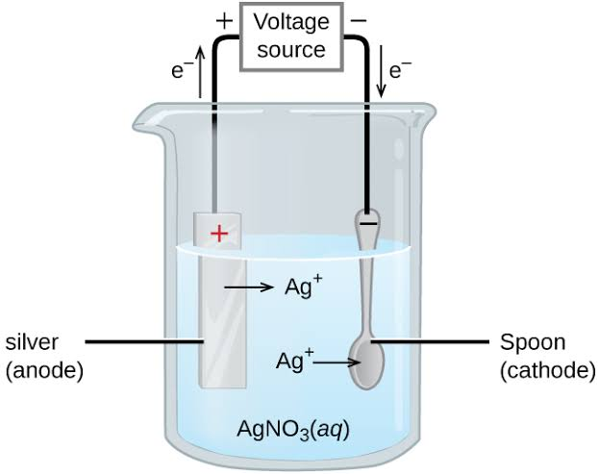

2. **Purification of Metals:** This is basically used in the purification of copper. Impure copper is made the anode, while pure copper is made the cathode. When electricity passes through the solution, the ions dissociates from the impure copper at the anode and gets deposited at the cathode, leaving the impurities in the solution.

3. **Preparation of metals from their compounds:** Electrolytic processes can be used to prepare metals such as aluminium, sodium and potassium from their molten chloride or hydroxide solutions.

**Week: Two**

**Topic: Electric Fields**

* **Conduction of Electricity through Gases**

Electrolytes don't have to be liquid solutions, they can also take up the form of gases. This is seen in electric sparks formed in the atmosphere also called lightening, in sodium vapour lamp which produces bright yellow light and helium gas lamp which produces white light.

*Sodium vapour lamp*



*Lightening*

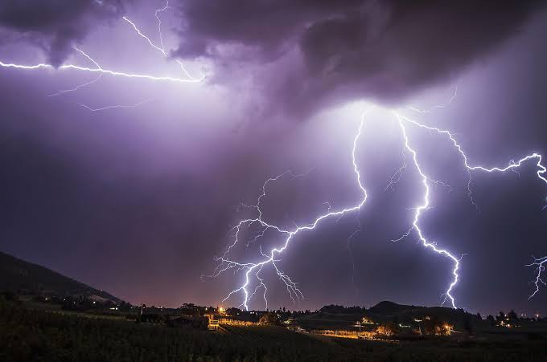

*Helium gas lamp*

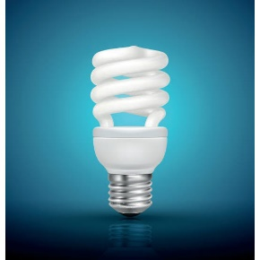

The different result seen by the type of light produced in the examples above are not just Influenced by the type of gas they are made up of, but also the pressure under which they take place. For instance, the pressure of sodium vapour lamp at low pressure is 7.10-⁶atm, while atmospheric pressure that conducts lightening is 760mmHg.

Gases serve as electrolytes, that is, a medium of transfer of liberated ions from the cathode to the anode. If the potential difference between the electrodes are small, the gas will act almost as a perfect insulator. Also, at lower pressure the potential difference needed to give a spark is reduced.

**Hot Cathode-Ray Tube**

A hot Cathode-Ray Tube is a glass tube containing air and pressure of whose air pressure can be varied with the electrodes at either end. When potential is applied, which forces ions to get liberated from the Cathode to move to the anode through the gas serving as the electrolyte, the atoms of the gas are charged up which causes it to glow. Experiments show that gases will conduct electricity to glow if under low pressure and high potential difference.

**Cathode Ray Oscilloscope (CRO)**

Cathode ray tubes are found in a device called an oscilloscope, so they are called Cathode Ray Oscilloscope (CRO). What is an oscilloscope? It is a device used to measure voltage (AC and DC), observation of wave forms, frequency and phase comparison and time measurement. CRO was developed in 1897 by Brown from cathode tubes.

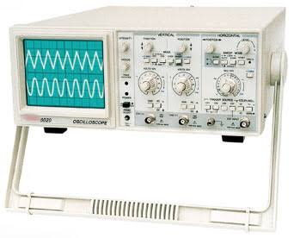

* **Working Principle of CRO**

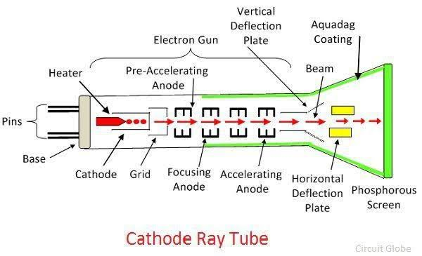

**Using the diagram above, the working principle of the CRO goes thus:**

1. The cathode is heated which produces beam of electrons;

2. A grid is used to control the brightness of beam;

3. The beam is deflected vertically and horizontally by two pairs of plates to the florescence screen;

4. The beam falls on the fluorescence screen coated with zinc sulphide which emits blue glow;

5. A graphite coating shields the beam from external electric fields.

**Week: Three**

**Topic: Electric Fields**

* **Capacitors and Capacitance**

A capacitor is a device that stores up electrical charges. In a capacitor is contained any two conductors separated or sandwiched by an insulator. The two conductors usually carry equal and opposite charges, and their net charge on the capacitor is zero.

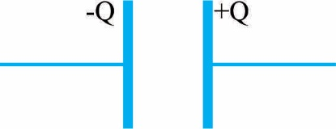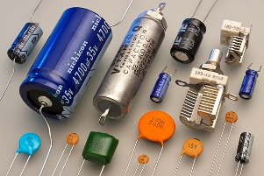

**Working Principle of Capacitor**

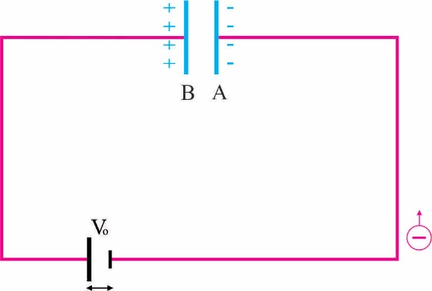

As seen in the diagram above, when a capacitor is connected to a battery, electrons flow from the negative terminal of the battery to the to the plate A of the capacitor. At the same rate, electrons flow from the B plate of the capacitor to the positive terminal of the battery. As this continues, the potential difference between plate A and B increases which allows the charge to accumulate in the capacitor, and the charging current reduces to zero when the potential difference between the plates equals that of the battery. When the battery is disconnected, the capacitor is seen to be fully charged.

* **Capacitance**

Capacitance is the ability for a capacitor to store charges. It is mathematically expressed as:

Capacitance (C) =

Therefore C = --------------------------- (1)

Or Q = CV -------------------------(2)

Capacitance of a capacitor is measured in farads (F).

**Take Note:** A capacitor has a capacitance of 1 Farad if the potential across it rises by 1 volt when a charge of 1 Coulomb is placed on it.

**Arrangements of Capacitors**

Capacitors can be connected in parallel or series for greater effect of capacitance:

1. **Capacitors in Parallel:**

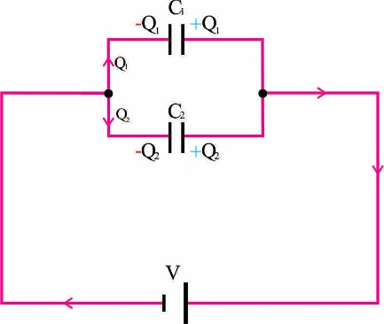

For the capacitors connected in parallel as seen above, the potential difference (V) across both capacitors is the same but the charges stored up are shared. So, let's call the charges Q1 and Q2 respectively.

From equation (2) Q = CV

Q1 = C1V and Q2 = C2V

but Q = Q1 + Q2

Q = C1V + C2V

Q = V (C1 + C2)

but Q = CV

CV = V (C1 + C2)

Divide both Side By “V"

C = C1 + C2

where C is the capacitance of combination

2. **Capacitors in series:**

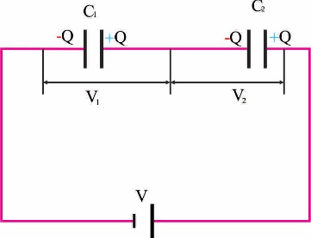

When two capacitors are connected in series as seen above, the charges stored up by each capacitor is the same but potential (V) are not the same. So, let the potential be V1 and V2 respectively.

From equation 1, C = which can be reformulated as v =

and

But V = V1 + V2

V = +

But V =

= +

Dividing through by “Q”

= +

**Examples**

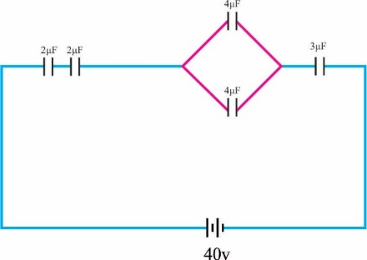

Calculate the:

a. Total capacitance in the circuit represented by the figure above.

b. Charge on the 3μF capacitor

**Solution**

**a.** For the capacitor in parallel, Cp = C1 + C2 = 4μF + 4μF = 8μF

All capacitors are now in series, we now make use of = +

**b.** From Q = CV

Where C = 0.686 and V = 40v

Q = 0.686 40

Q = 27.43

**Energy Stored in a Charged Capacitor**

This talks about the work done through a capacitor because it has the ability to store up charges, hence to be a source of electricity. The work done of capacitance is given by:

W = average potential difference charge

W = ½ Q V

But V =

⸫ W = ½ Q =

But Q = CV

W =

W= Cv2 or W =

**Example:**

Calculate the energy stored in and charged on the plates of the combined capacitor in the circuit below:

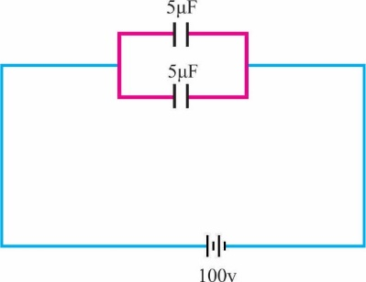

**Solution**

Using W= Cv2

Cp = C1 + C2 = 5μF + 5μF = 10μF = 10 10-6 F

V = 100v

W = 10 10-6  (102)2J

Energy (W) = 5 10-2J

From W = ½ Q V;

Q =

Q = 10-3C

**Application of Capacitors**

1. Tuning a radio circuit,

2. Elimination of sparking in switches,

3. Storing of large quantities of charge,

4. Blocking noise in ac amplifiers etc.

**Week: Four**

**Topic: Electric Fields**

* **Semiconductor Materials and Devices in Electronics**

Semiconductor are materials whose electrical conductivity intermediate between that of a metal and an insulator. We know that conductors allow electrical charges flow through them easily while insulators do not. For semiconductors, they can act both as conductors or as insulators based on the condition they are exposed to. For instance, electrical conductivity of semiconductors increases with increase in temperature or in the presence of impurities. Some examples of semiconductor materials including Silicon, Germanium Antimony, Cadmium, Gallium etc.

* **Electronic Configuration of Semiconductors**

Semiconductors belong to group IV in the periodic table, and their valence (outermost) shell have four electrons. The valence electrons of the semiconductor acts as insulators at room temperature as they are held together in the atom by a covalent bond. However, when its temperature begins to rise and it begins to lose its electron, it starts to act as a conductor. Therefore, the characteristic of the semiconductors is alterable.

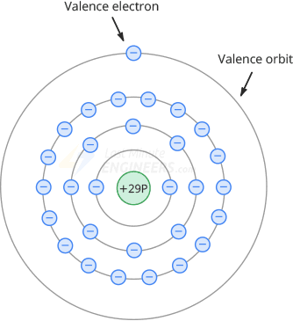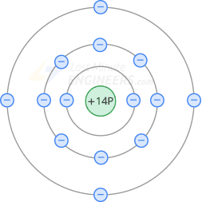

* **Energy Band Model**

In the energy band model, every solid material has three bands which are the filled valency band, empty conduction band which is separated by an energy gap band. For conductors, insulators and semiconductors, there are different energy band models:

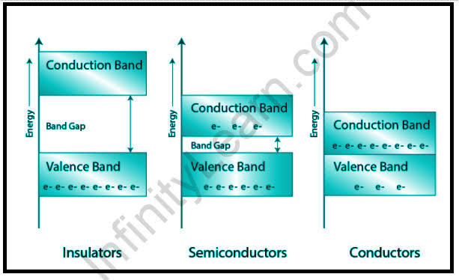

**1. Conductor:** In conductors such as metals, the valency band contains the electrons to be released and the conduction band is waiting to receive electrons. Conductors have no energy gap band in-between them, hence they overlap. So, when the electric field is applied, there is easy conduction of this field through them because there is no energy gap hindrance. This overlap can also allow for conduction in the metal even without the application of external energy.

**2. Insulators:** For insulators, they have a very wide energy gap in-between the valency band and the conduction band. So, even at temperature up to a hundred Kelvin, there cannot be a flow of electrons from the valency band to the conduction band even by the application of electric field.

**3. Semiconductor:** There is a narrow energy gap in the energy band model of the semiconductor. Therefore, with the excitation of electrons through vibration by the application of external energy, electrons may have a chance to cross from the valency band to the conduction band, but there will be a high resistivity of the flow of electrons due to the narrow energy gap. However, with more electric field applied, the semiconductor will act more as a conductor which practically closes up the energy gap.

**Semiconductor Devices**

These are devices made out of semiconductor materials. Examples include, photovoltaic cell system (a.k.a solar panel), diodes, transistors etc. For the purpose of this class, we shall focus on diodes and transistors.

**1. Diodes:** This is a device used in electronic circuit which makes current flow in one direction. Its electrical circuity symbol and pictures are given below:

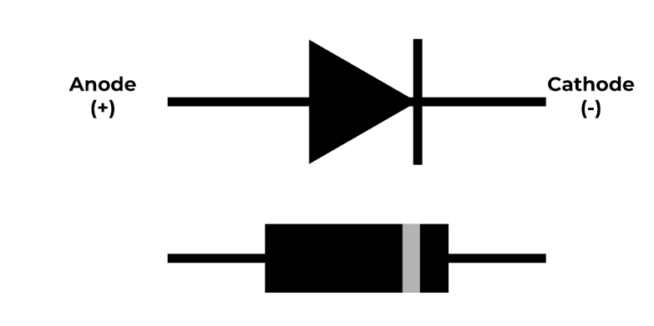 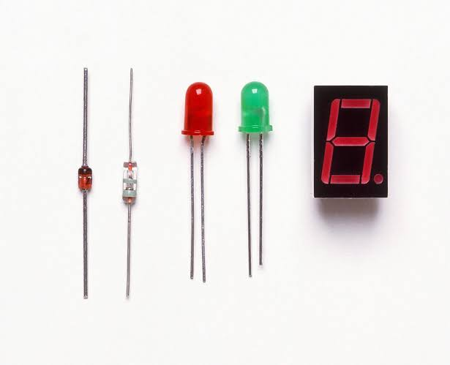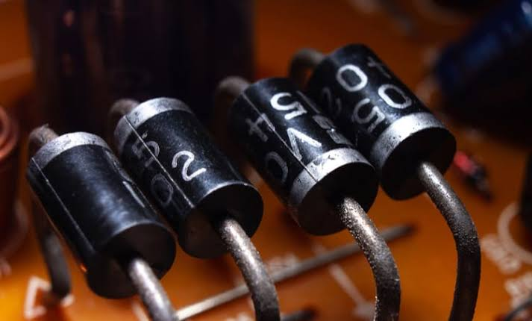

* **Working Principle of a Diode**

Using the energy band theory, we shall explain the working principle of a diode. This device contains semiconductor materials doped in two regions by different impurities and has a depletion layer at the center as shown below:

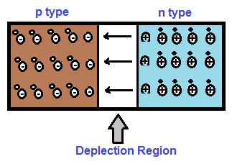

The p-region part of the device is doped with impurities that makes it behave like a complete insulator while the n-region part is doped with impurities that makes it behave like a conductor, how? Since they both have four electrons in their valence shell, the p-region part of the device is doped with impurities that makes it lose its valence electrons to leave vacant spaces called holes, while the n-region part of the device is doped with impurities that makes it contains more electrons in its valence shell. The holes from the p-region tends to diffuse to the n-region while the electrons from the n-region also diffuses to the p-region of the devices, hence a region called the P-N junction is created.

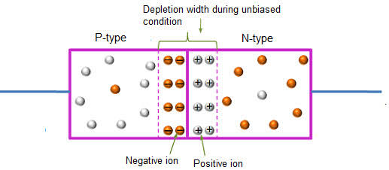

At the P-N junction, the layer formed as seen above acts as a potential barrier against any further diffusion in the device which stops the flow of charges, that is, the holes from p-region and electrons from n-region.

**Other Types and Uses of Diodes**

i. **Light Emitting Diode (LED):** Use to generate light and coloured illumination,

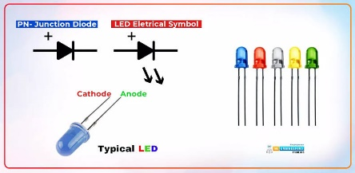

ii. **Photodiode:** used as smoke and fire detector,

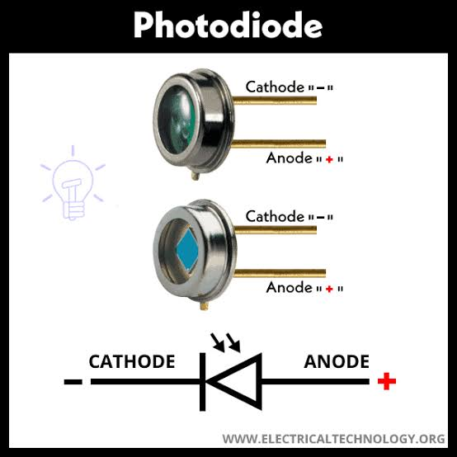

iii. **Zener diode:** used in voltage regulation,

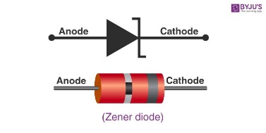

iv. **Laser diode:** used in fibre optic communication, barcode readers, laser pointers, CD/DVD reader etc.

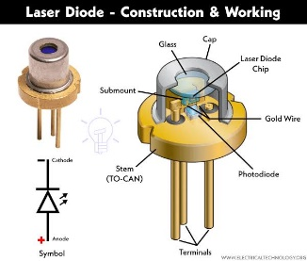

**2. Transistors:** This is a semiconductor device basically used for amplification. They belong to the group of two families, the bipolar Junction Transistor (BJT) and the Field Effect Transistors (FET). Amplifiers designed using BJTs are current controlled while those designed using FETs are voltage controlled. For the purpose of this class, we shall focus on the BJT transistor. The electronic symbol of transistors is given below:

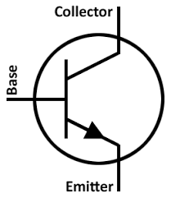

* **Working Principle of the BJT**

Transistors are a three-terminal device with two P-N junctions formed back to back. There are two types of BJTs, one is the n-p-n with a p-type region sandwiched between the n-type region, and the second is the p-n-p with a n-type region sandwiched between the p-type region as shown below:

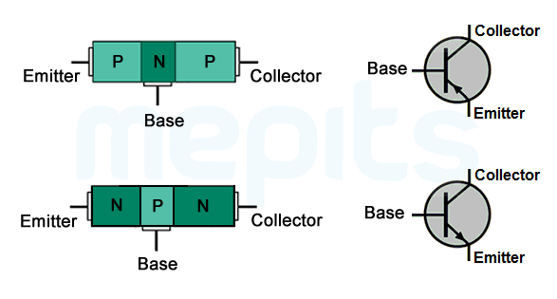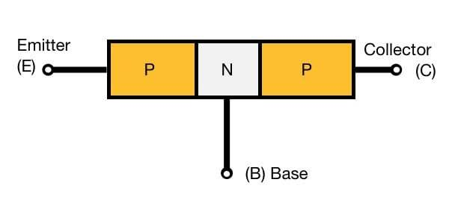

The BJT transistor has three terminals which are the **emitter (E), base (B) and collector (C)** as seen above. The base region is thin and lightly doped while the emitter and collector region are heavily doped.

Using n-p-n BJT under the biasing condition pushes a lot of electrons from the emitter region into the lightly doped base region. Some electrons from the emitter region connects with the hole in the base region. However, 95% of the electron goes to the collector region to form collector current which introduces a surge inflow of new electrons into the collector region.

* **Other Types of Transistors**

i. Dual gate MOSFET

ii. JFET

iii. Metal Oxide Semiconductor Field Effect Transistors (MOSFET)

I v. Phototransistor etc.

**Week: Five**

**Topic: Magnetic Fields**

* **Introduction**

M

agnetic Field is the region around a magnetic material or a moving electric charge within which the force of magnetism acts. Magnetism deals with the attraction of metals. However, not all metals are attractable by magnets or a moving electric field. Metals such as iron, cobalt, nickel and certain alloys are attracted to magnets while substances such as brass, wood, copper and glass are not attracted to magnets. Any substance is generally said to be magnetic if it is attracted by a magnet. Magnets are gotten from iron ores called magnetite or Lodestone.

Magnetic field is produced by moving electric charges and intrinsic magnetic moments of elementary particles associated with a fundamental quantum property known as spin. The Symbol of magnetic field is B or H, unit is Tesla and Base Unit (Newton.Second)/Coulomb

* **Properties of Magnets**

1. The ends of magnets are regions where the attracting power is greatest. These ends are called **poles**.

2. A freely suspended magnet always comes to rest with its axis pointing approximately North-south. The poles attracted to the North is called the North pole while that attracted to the south is called the south pole.

3. This property is also called the **Basic Law of Magnetism** which states that like poles of a magnet repel each other while unlike poles attract.

**Magnetic Field Lines (Flux) and Density**

Magnetic field lines are a visual tool used to represent magnetic fields. They describe the direction of the magnetic force on a north monopole at any given position. They are imaginary lines used to describe magnetic field. The density of the lines indicates the magnitude of the field. Taking an instance, the magnetic field is stronger and crowded near the poles of a magnet. As we move away from the poles, it is weak, and the lines become less dense.

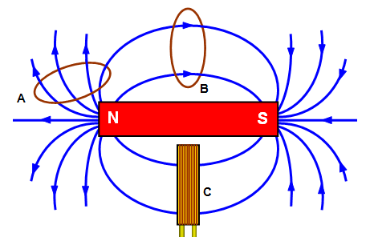

* **Properties of Magnetic Field Lines**

1. Magnetic field lines never cross each other

2. The density of the field lines indicates the strength of the field

3. Magnetic field lines always make closed loops

4. Magnetic field lines always emerge or start from the north pole and terminate at the south pole

**Magnetic Field Intensity**

Magnetic field strength is also magnetic field intensity or magnetic intensity. Magnetic field intensity is measured in units of amperes/metre. The SI unit of magnetic field intensity is Tesla. It is given by the formula:

H =

**Where:** B is the magnetic flux density

M is the magnetization

μ is the magnetic permeability

**How does a Magnetic Field Originate?**

The magnetic field arises when a charge is in motion. There are two basic ways to arrange for a charge to be in motion and generate a useful magnetic field. Following are the two ways:

1. **Magnetic Field created by a Current-Carrying Conductor:** Ampere suggested that a magnetic field is produced whenever an electrical charge is in motion. Let’s consider a wire through which the current is made to flow by connecting it to a battery. As the current through the conductor increases, the magnetic field increases proportionally. When we move further away from the wire, the magnetic field decreases with the distance. Ampere’s law describes this. According to the law, the equation gives the magnetic field at a distance r from a long current-carrying conductor I.

In the equation, µo is a special constant known as the permeability of free space (µo=4π×10-7 T⋅m/A).

2. **Motion of Electrons around the Nuclei of Atoms**: Permanent magnets work based on the motion of electrons around the nuclei. We have observed that only some materials can be made into magnets, and some much stronger than others. To attain this state, some specific conditions should be met:

Atoms have many electrons, and they are paired in such a way that the overall magnetic field cancels out. Two electrons paired this way are said to have opposite spins. From this, we understand that if we want a material to be magnetic, we need to have atoms that have one or more unpaired electrons with the same spin. Iron is a material that has four such electrons and therefore is good for making magnets out of it. A tiny piece of material consists of billions of atoms. If they are oriented randomly, the overall field cancels out, regardless of how many unpaired electrons the material has. The material has to be stable enough at room temperature to allow an overall preferred orientation to be established. If established permanently, then we have a permanent magnet, also known as a ferromagnet.

**Method of Magnetization**

This can be done in two ways:

1. **Electrical Method:** This is done by inserting a conductor into a solenoid (a coil of wire with many turns) through which a steady direct current flow. After a while, the material is removed and it is found to be a magnet.

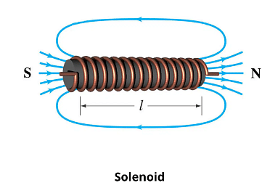

2. **Single or Double Touch Method:** For single touch method, the material is stroked from one end to the other end several times in the same direction with one pole of the magnet. For double touch, the material is stroked with two magnets, using unlike poles from the centre outward.

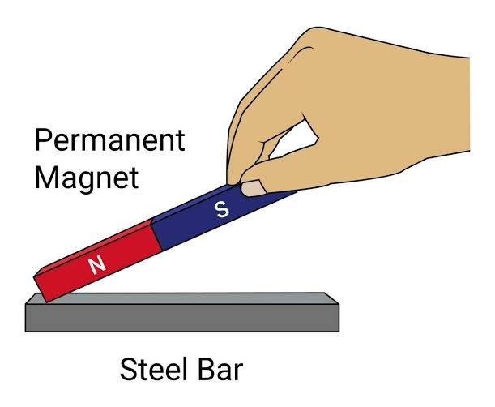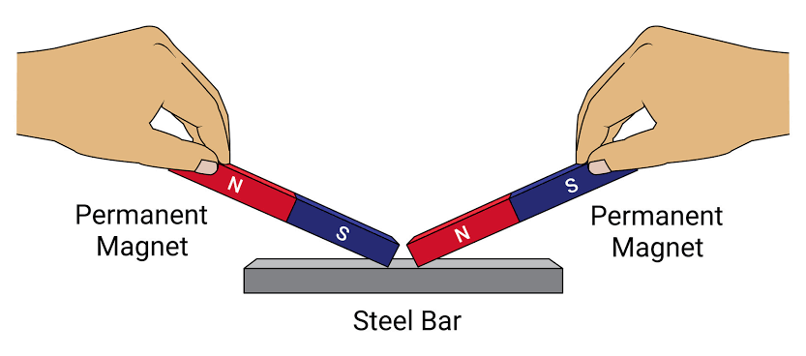

**Method of Demagnetization**

Demagnetization is the process by which a magnet loses it magnetism, that is, its ability to attract metals. This can be done in two ways:

1. **Electrical Method**: This is done by placing the magnet into a solenoid through which an alternating current flow. This solenoid is placed with is axis pointing east to west. After some seconds, the magnet is slowly withdrawn from the solenoid and taken a long distance away.

2. **Heating Method**: This is done by heating up the magnet until it is red hot and then allowed to cool while lying in the East west direction. The molecules are shaken up by thermal agitation.

**Week: Six**

**Topic: Magnetic Field**

* **Magnetic Properties of Iron and Steel**

Iron is an element, while steel is an alloy of iron and carbon. Steel is harder than iron which makes it harder for steel to be magnetized, but when they do, they maintain such magnetism for a long period. On the other hand, iron is a soft magnetic material which easily gets magnetised but will not retain its magnetism for very long. The magnetic properties of both iron and steel have their unique applications: For example, hard magnetic material such as steel are used in making permanent magnets, electrical metre and loudspeaker, while soft magnetic material such as iron are used in the cores of transformers, electromagnets, magnetic shield, electric bell etc.

Further properties and comparison between the magnetic properties of iron and steel are given below:

|  |  |
| --- | --- |
| **Magnetic Properties of Iron** | **Magnetic Properties of Steel** |
| 1. Can easily be magnetised and demagnetised | Hard to magnetise and demagnetise |
| 2. Can be magnetised by weak magnetic field | Requires a strong magnetic field to magnetise |
| 3. Retains its magnetism temporarily | Retains it magnetism permanently |

* **Magnetic Shielding**

This is a protection against magnetic waves which allows to attenuate the ambient magnetic field in a defined volume. In other words, it is a system of protection designed to protect another system against the interference of magnetic field while it is in operation in order to ensure optimal operation of that system, or to protect an environment from the influence of magnetic field emitted by an instrument.

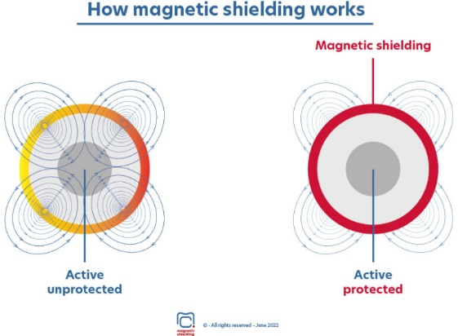

There are two types of magnetic shielding, we have the passive and active shielding:

1. **Passive Shielding**: In this case, magnetic field can be absorbed by a metal shield. This shield can also be referred to as Faraday’s Cage to shield a system from continuous or low frequency magnetic field. This shield is most time made from sheet metal part such as iron, nickel etc.

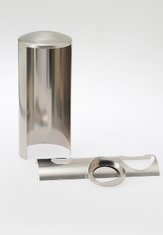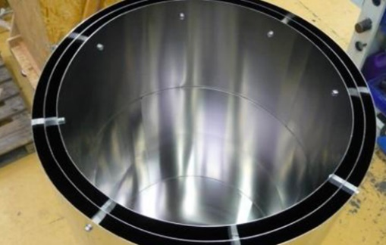

2. **Active Shielding**: In this case, magnetic field is neutralised by another instrument which emits an opposite magnetic field of equivalent value to cancel out the effect of the former.

* **Electromagnets and their Application**

An electromagnet is a temporary magnet which is constructed by winding solenoids in opposite directions round soft bar bent into a U-shape. The end of the U-shape of the magnet where the current enters the iron is the south pole, while the other end where the current leaves the system is the north pole.

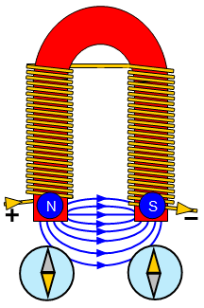

**Application of Electromagnets**

1. **Electric Bell**: The electric bell consists of two solenoids wound in opposite in directions on two of the iron cores connected with a soft iron bar. One end of the windings is connected to a terminal T, and the other to a metal bracket which supports a spring mounted soft iron armature. The armature carries a light spring which is soldered to a disc which acts as a contact taken to second terminal T2. The circuit is completed through a battery of cells and a push switch connected to terminals, T1 and T2.

**Working principle of electric bell**

When the push switch is pressed, current flows and the iron cores become magnetized. The iron bar B is now attracted to the electromagnet. The circuit is then broken and B is released. It falls back again to make contact with X and T, once more. Thus, contact is remade and the process is repeated, consequently, the armature vibrates to-and-fro and the hammer attached to the armature strikes the gong repeatedly.

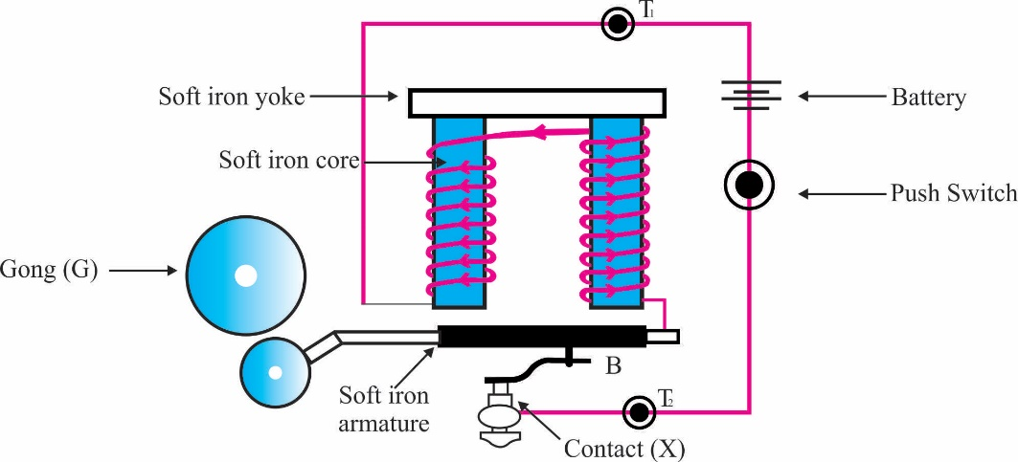

2. **Telephone Receiver**: A telephone receiver consists of an electromagnet formed by placing a short permanent bar magnet across the ends of two iron bars as seen in the diagram below. This is placed so that it exerts a pull on the magnetic diaphragm constructed from a soft alloy. Two solenoids are wound in opposite directions on the soft-iron bars. When one speaks into the microphone at the other end of the line, a varying electric current is set up having the same frequency as the sound waves. The same current is made to pass through the solenoids of the earpiece. This causes the strength of the magnetic flux to vary in sympathy with the pull of the diaphragm and therefore vibrates as the sound waves which entered the microphone.

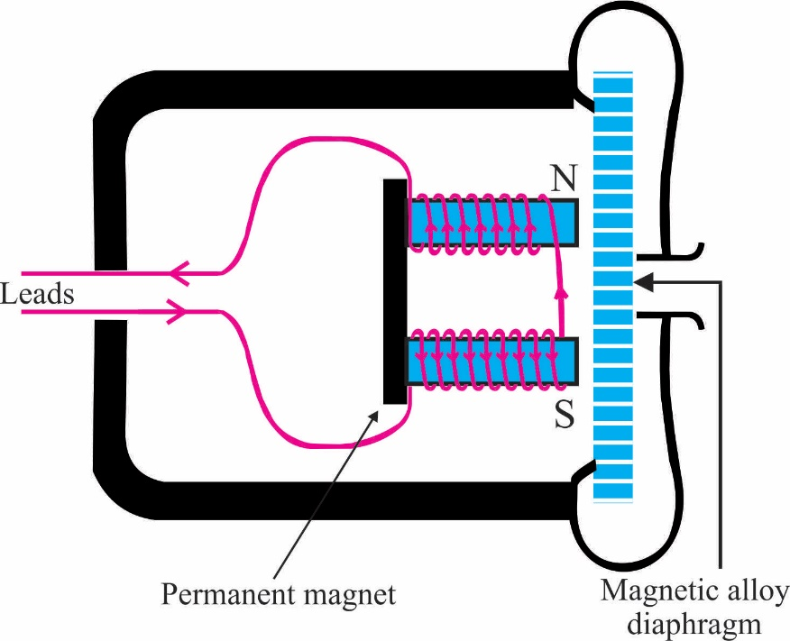

Other applications of electromagnet include lifting and transporting pieces of iron and steel, separating iron from non-magnetic elements to produce strong magnetic fields required in generators and electric motors etc.

**Week: Seven**

**Topic: Magnetic Field**

* **The Earth’s Magnetic Field**

When a needle or a bar magnet is freely suspended, it will always point in north-south direction. This is because of the earth’s magnetic field. The earth behaves as though it contains short magnet inclined at a small angle to the axis of rotation of the earth. This imaginary magnet has its south pole in the northern hemisphere and its north pole in the southern hemisphere as shown below:

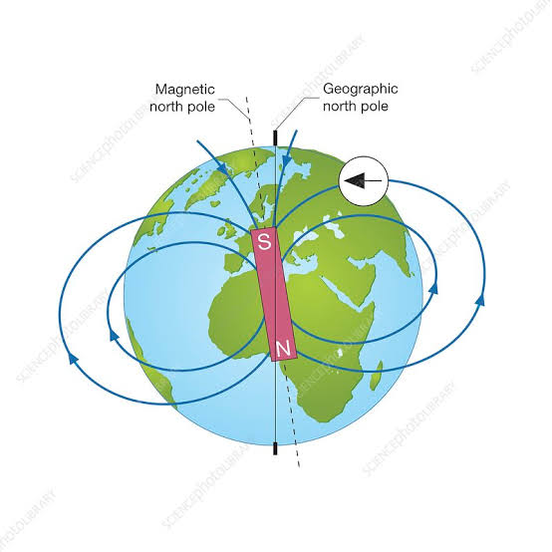

* **Magnetic Element of a Place**

The magnetic elements are the factors responsible to determining the magnetic field at a place, and they include:

1. **Angle of Dip/Inclination**: This is the angle between the direction of the earth’s resultant magnetic field and the horizontal. When a uniform copper bar which is non-magnetic is suspended at its middle, it will stay horizontal. However, when a magnetic needle is suspended in its centre of gravity, the needle will point downwards at an angle to the horizontal. This angle is what we call the angle of dip which is influenced by the earth’s magnetic field. Angle of dip varies all over the earth’s surface from 90 near the geographic pole to 0 near the equator. This is because, the properties and flux density of a magnet are stronger at the polar region.

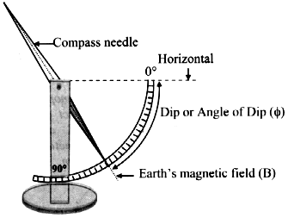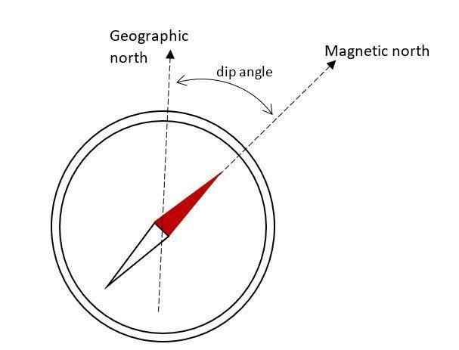

2. **Angle of Declination or Variation**: The magnetic north and geographical north at a particular place on the earth are not usually the same. The magnetic meridian at any place is a vertical plane passing through the magnetic axis of a magnet suspended freely under the influence of the earth’s magnetic field. The geographical meridian at any place is a vertical plane containing the north and south pole of the earth. So, the angle of declination is the angle formed between the magnetic north and the geographic north. Mariners calls the declination the variation of the compass, and can be calculated by adding the reading of the compass bearing to the declination at that place.

**Week: Eight**

**Topic: Electromagnetic Flux Induction**

I

nduction is an electrical phenomenon whereby an electromotive force (EMF) is generated in a closed circuit by a change in the flow of current. As learnt, electromagnetic force can be generated through the means of a solenoid. If the magnetic flux through the coil of this solenoid is altered, then an electromotive force (EMF) will be generated in the coil. Faraday discovered that this emf could be generated in two ways, either by:

a. Moving the coil or source of the flux relative to each other, or

b. Changing the magnitude of the source of flux in some way.

**Experimental Process to Understand Electromagnetic Induction**

Faraday must have carried out an experiment to discover what induction is by using the apparatus shown in the diagram below:

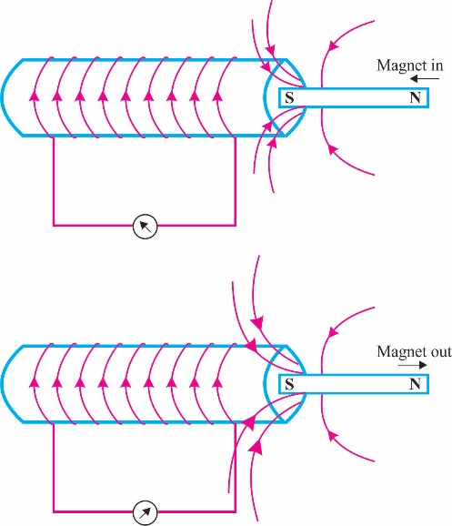

Making use of a coil wound around a conductor, bar magnet and a galvanometer, when magnet was plunged into the coil, the galvanometer needle gave a momentary deflection showing that a current has been induced (that is, current is introduced) in the coil. On withdrawing the magnet from the coil, another deflection from the galvanometer needle is observed. The introduction of electric current into the coil due to variation in the magnetic flux through the coil is what is called electromagnetic induction. It was also noted that no current was induced in the coil when the magnet remained stationary inside or outside the coil.

Faraday also found out that the strength of the induced current depends on:

a. The number of turns in the coil;

b. The strength of the magnet; and

c. The speed with which the magnet moved relative to the coil.

* **Faraday’s Law of Electromagnetic Induction**

**It states that:** *Wherever there is a change in the magnetic flux linked with a circuit, an electromotive force (E) is induced, the strength of which is proportional to the rate of change of the flux (Φ) linked with the circuit.*

It is mathematically given as:

**E =**

Where E = electromotive force

Φ = rate of change of flux

t = time taken

This means that the faster the flux is changed, the greater is the emf produced.

* **Lenz’s Law of Electromagnetic Induction**

**It states that:** *The direction of the induced emf is such that it tends to oppose the change that produces it.*

Work is done in an electromagnet when the magnet moves with respect to the coil, and it experiences an opposing force to it source of magnetic flux

* **Fleming’s** **Right-Hand Rule**

Fleming proposed a simple rule to know the direction of induced current, and it states that:

*If the thumb and the first two fingers of the right hand are held at right angle to each other and the first finger is pointed in the direction of the magnetic field and the thumb in the direction of motion, the second finger gives direction of the induced current.*

**Application of Electromagnetic Induction**

* **The A.C. Generator**

If a coil rotates in a magnetic field, then an emf is induced in the coil. This is the basic of how generators produced current.

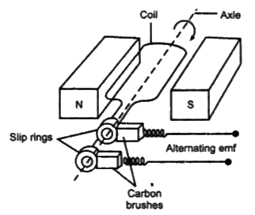

When a coil (The Rotor) is rotated between poles of a d.c. electromagnet, the emf generated is taken from the ends of the coil. The ends of the coil are connected to a sliding contact known as slip rings and further to two carbon brushes. As the coil rotate, it cuts through the lines of magnetic flux, thus producing an induced emf, but may produce a variation in current. A much smoother output is obtained by having a number of coils wound on an iron core which is laminated.

**Week: Nine**

**Topic: Electromagnetic Flux Induction**

* **Eddy Currents**

These are induced current in metal objects larger than pieces of wire. Induced e.m.f. is not generally great, but because the resistance in a lump of metal is very small, induced current in it can be large. Therefore, eddy currents can serve as a very good electromagnetic brake. Eddy currents becomes a problem in the cores of transformer where they could cause large energy losses.

* **Transformers**

This is an electrical device by which alternating current of one voltage is changed to another voltage. This device uses property of mutual inductance to change voltage of supplied alternating current. It is made use of in homes to give a low voltage output from power supply mains of home devices such as cassette recorder, televisions etc., or to produce high voltage for the national grid.

**Working Principle of Transformers**

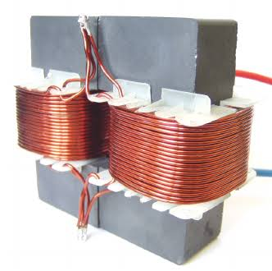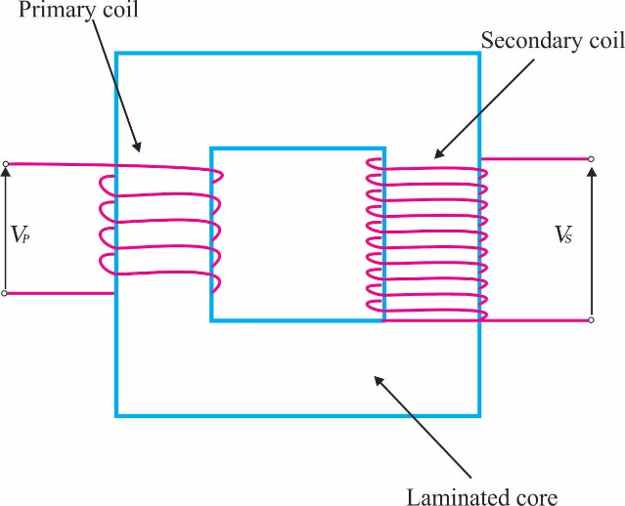

This device consists of two coils wound around a laminated iron core, and they are known as the primary coil and secondary coil. The core of transformers is laminated so as to avoid large Eddy current, that is, for induce current in the coil not to be discharged by the iron core due to it permeating into it. The a.c. voltage is applied to the primary coil and this produces a changing magnetic field within it. The changing magnetic field linked with the secondary coil induces an emf in it. The magnitude of the induced emf in the secondary coil (Vs) is related to the applied emf in the primary coil (Vp) by the equation:

**Where** Ns is the number of turns on the secondary coil

Np is the number of turns on the primary coil.

The number of turns on either the primary and secondary coil relative to each other is what determines if a transformer will increase or reduce voltage in any given system. A transformer is known as a **step-up transformer** if the output voltage is greater than the input voltage, and this happens when the number of turns on the secondary coil (Ns) is greater than the number of turns on the primary coil (Np), that is, Ns Np.

So also, a transformer will be known as a **step-down transformer** when the input voltage is greater than the output voltage, and this happens when the number of turns on primary coil (Np) is greater than the number of turns on the secondary coil (Ns), that is, Np Ns.

For an ideal transformer, that is, one with no flux leakage of current, the following equation holds.

Where Ip and Is are current flowing in the primary and secondary coil.

**Example:**

1. A transformer which can produced 12V from a 220v supply has an efficiency of 80%. If the current in the secondary coil is 10A, calculate the current in the primary coil.

**Solution**

Vs = 12v; Vp = 220v; Is = 10A; Ip = ?

**To get the efficiency, we focus on the number of turns in the coils.**

⸫

⸫ Ns = 4 and Np = 5

**From equation (*i*), cross multiplying**

Ns Vp Ip = Np Vs Is

4 220v Ip = 5 12 10

⸫ Ip = = 0.68A

**Applicational Use of Transformers**

* **The Transmission of Electricity**

Transformer are very effective devices to distribute power through the national grid around the country. How does this apply?

When electrical energy is generated in a power station like the hydropower electric station, a potential of about 11.5 – 16kv is generated. Then this voltage is transmitted to a step-up transformer which steps up the current to about 330kv, which is then transmitted across the country in aluminium cables roughly 2cm in diameter.

After this, the high voltage is stepped down in a transmission substation by a step-down transformer to about 132kv, which is further transmitted to an injection substation and stepped down there to about 33kv. At this point, distribution of this electrical power to homes, offices and industries take place but not until it is further stepped down by a distribution transformer to 11kv which is in turn stepped down to 0.415kv and further to 240v.

**Week: Ten**

**Topic: Practical**

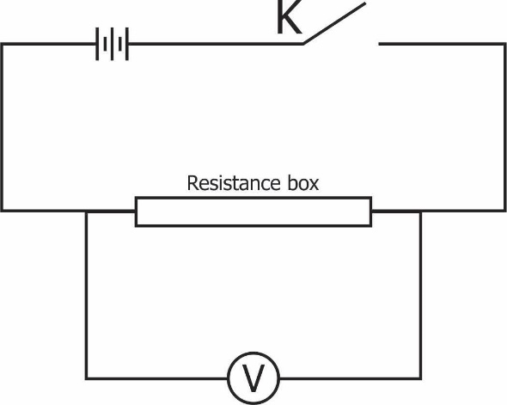

**You have been provided with a resistance box, a voltmeter, a key, a battery and other necessary materials.**

1. Connect the circuit as shown in the diagram above.

2. With the key K closed, read and record the voltmeter reading Vo.

3. Set the resistance R in the resistance box equal to 1.

4. Close the key, read and record the potential difference V on the voltmeter.

5. Evaluate R and V,

6. Repeat the procedure for five other values of R=2,3, 4,5 and 6.

7. Tabulate your readings.

8. Plot a graph with V on the vertical axis and R on the horizontal axis.

9. Determine the slope, s, of the graph and the intercept, c, on the vertical axis.

10. Evaluate c,

11. State two precautions taken to obtain accurate results.