**MICRO-ORGANISMS CONTINUED**

CONCEPT OF CULTURING

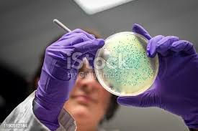

A pre-requisite to studying microbes is their cultivation under laboratory conditions. Hence it is important to know the nutrients and physical conditions needed by the organisms. The material on or which microbes grow in the laboratory is called culture. Culturing is the process of growing micro-organisms (bacteria or viruses) or cells in a controlled environment (laboratory) to study them, identify them, or produce substances.

*A culture is the population of organisms cultivated in a medium.*

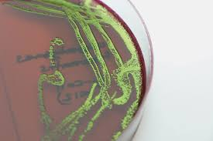pure culture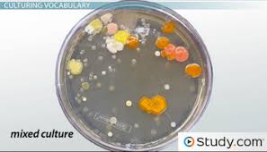 mixed culture

If a culture contains only a living species of organism regardless of the number of individuals, it is said to be a **pure or axenic culture**. While a culture with two or more species in it is called **mixed culture.**

An important medium used for growing microbes is **agar** (dried extract of red algae) used as a solidifying agent and not broken down by microbes.

BENEFICAL AND HARMFUL EFFECTS OF MICRO-ORGANISM

*Beneficial effects*

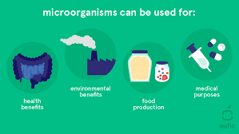

1. Bacterial help to digest cellulose
2. In man, they synthesize vitamin K and B12
3. They are used to manufacture amino acids and vinegar
4. They are used to decompose sewage into harmless inorganic compounds
5. Bacteria are used to process milk into different tastes and flavours.
6. Microbial cultures are used to produce enzymes
7. Yeast is used as leavening agent in baking industries.
8. Bacteria are used to produce single-cells proteins

*Harmful effects*

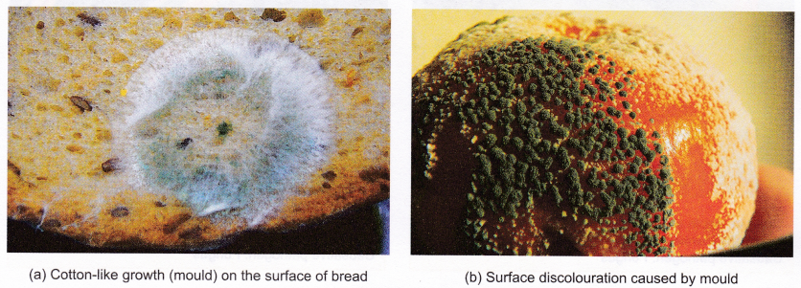

1. Bacteria cause decay and spoilage of food items.
2. Materials like woo, paper, textiles, rubber and metals are destroyed by microbes
3. They cause diseases of different types.

DISEASES CAUSED BY MICRO-ORANISMS

|  |  |  |  |  |
| --- | --- | --- | --- | --- |
| DISEASE | CAUSATIVE AGENT | SYMPTOMS | TRANSMISSION | CONTROL |
| Chicken pox | *Varicella virus* | Fever, tiredness, itchy blistery rash | Contact | Isolate patient and use appropriate drugs |
| Dengue | *Dengue virus* | Severe headache, eye, joint and muscle pain, rash etc. | Aedes Mosquito | Drain the water and clear the bushes around |
| Leprosy | *Mycobacterium leprae* | Disfiguring skin sores, lumps or bumps loss of feeling in the arms and legs. Etc. | Long and close contact | Use antibiotics and avoid contacts. Isolate patients |
| Poliomyelitis | *Polio virus or Enterovirus* | Fever, sore throat, headache, vomiting, back and neck pain, etc. | Houseflies, food and water | Good hygiene and appropriate medication |
| Rabies | *Rhabdovirus* | Fever, cough, sore throat,, etc. | Mad dog bites | Treat dogs and seek urgent medical attention in cases of bites |
| Tetanus | *Clostridum tetani* | Muscle spasms and breathing problems | Bacteria in soil and through wounds | Treat wounds urgently |
| Influenza Flu | *Orthomixovirus* | Fever an muscle aches, cold, runny nose, sore throat etc. | Contact | Take appropriate medication and avoid contact |

SEXUALLY TRANSMITTED INFECTIONS

STIs are diseases that are contacted through sexual intercourse, they include; syphilis, gonorrhoea, herpes, thrush, AIDS etc.

|  |  |  |  |
| --- | --- | --- | --- |
| DISEASE | CAUSATIVE ORGANISM | SYMPTOMS | PREVENTION/CONTROL |
| Gonorrhoea | Bacterium (Neisseria gonorrhoea) | Burning sensation during urination in males and females. Discharges in both male and female. Swelling of vulva and sterility at advanced stage | Discourage commercialized prostitution. Avoid multiple sexual partners. Get medical attention |
| Syphilis | Bacterium (Treponmapallidium) | Small and painless sore appear on the penis or vulva at initial stage. Fever, skin rash, mouth ulcer, nervous disorder, repeated abortion etc. | Same treatment as above |
| Genital warts | Human papillomavirus (HPV) | Painless, flesh coloured bumps/warts develop on the penis, around the vagina and the anus which may re-appear at different times. Cervical cancer | Vaccine available for women aged 9-24. Avoid sharing personal items including towels, razors, bars or soaps etc. |
|  |  |  |  |
|  |  |  |  |
|  |  |  |  |

**CONTROL OF HARMFUL MICRO-ORGANISMS**

1. Boiling and freezing: boiling or heating food, pasteurization of milk, freezing of food to reduce the activities of microbes to barest minimum
2. Covering of food to prevent vectors and pathogens in the air from coming in contact with the food.
3. Antibiotics such as amphiclox, ampicillin, pencillin, tetraclycline, are drugs used to kill many bacteria causing diseases.
4. Antiseptics such Dettol, Milton, chlorine water, medicated soap etc. destroy micro-organisms while other prevent the multiplication of the microorganisms.
5. Salting: salt applied to fresh food items (meat, fish) bacterial cells are plasmolysed due to the movement of water from the cells of the bacteria.
6. Drying/Dehydration: micro-organism such as bacteria need water to survive, so drying food items prevents their survival.
7. Sanitation, isolation of infected persons and balanced diet.

**ROLES OF HEALTH ORGANIZATIONS**

WHO

1. Provides and assists national governments at their request to strengthen their health services
2. Promotes and provides improved methods of training health, medical related professional experts for member countries
3. Produces medical publications
4. Provides drugs and vaccines in cases of emergency
5. Promotes material and children’s health care and welfare.

UNITED NATIONS CHILDRENS’S FUND (UNICEF)

1. Provides emergency needs for children in areas affected by diseases or famine.
2. Improves the nutritional condition of undernourished children.
3. Feeds and cares for disabled children
4. Ensure the provision of clothing and other needs for children.

INTERNATIONAL RED CROSS

1. Care for the injured
2. Provision of emergency aid
3. Negotiating for the exchange of prisoners of war
4. Evacuation of refugees
5. Welfare of war prisoners.