SUBJECT: CIVIC EDUCATION

TOPIC: DEMOCRACY

WEEK: ONE

CLASS: SS 1

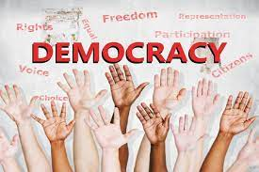 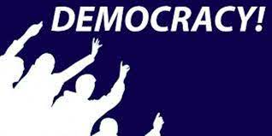

The word democracy is derived from the Greek word "demos" meaning people and "kratia" which means authority or rule. Therefore, democracy may be said to be the rule or authority of the people. According to Abraham Lincoln, democracy can be defined as "Government of the people, by the people, for the people". It is also a form of government where the people have and exercise the supreme power directly or indirectly through a system of representation usually involving free and fair elections held at specific dates by the electoral body in the country.

There are two types of democracy, they are: Direct Democracy and Indirect Democracy or Representative Democracy.

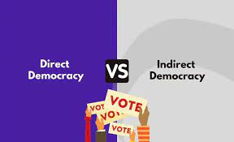 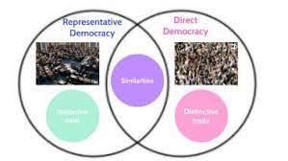

**Direct democracy**: Direct democracy places all power in the hands of the individual. When political decisions must be made, all members of a polity gather together and individuals cast a vote. In theory, this sounds like the ideal form of government. There are no intermediaries. Each person is treated as an equal, and each person is given a chance to directly influence the policymaking process.

**Indirect/representative democracy**: Representative democracy is a form of government whereby eligible citizens elect their leaders through periodic election to represent them at all levels of government for a fixed tenure. This is a political arrangement that establishes an intermediary political actor between the individual and the policy outputs of the state. In other words, representative democracy is a process in which the people through election elect those who will represent or govern the state on their behalf for a fixed period.

**Characteristics of representative democracy**

1. Respect for Minority rights

2. The supremacy of the constitution

3. Existence of fundamental human rights

4. Periodic election, Free and fair election and independent electoral body

5. Existence of political parties

6. Majority rule/Popular sovereignty

7. Multi Party system

8. Presence of opposition

9. Separation of powers between the arms and levels of government

10. Freedom of association and groups, Equal political rights

WEEK: TWO

SUBJECT: CIVIC EDUCATION

TOPIC: RULE OF LAW

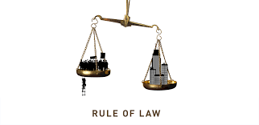 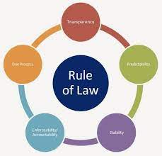

**MEANING OF LAW**: Laws can also be defined as a body of official rules and regulations generally found in the constitutions, legislation, and judicial opinion and so on that is used to govern a society and control the conducts of its members.

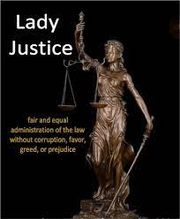 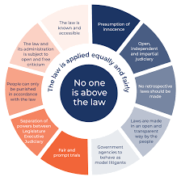

**MEANING OF RULE OF LAW**: Rule of law is a concept that emphasizes the supremacy of the law, legal equality, impartiality and individual liberty. Rule of law is a principle of governance in which all persons, institutions and entities, public and private, including the State itself, are accountable to laws that are publicly promulgated, equally enforced and independently adjudicated, and which are consistent with international human rights norms and standards.

**MAXIMUM BENEFITS OF THE RULE OF LAW TO THE CITIZENS:**

1. It makes everyone equal in a political system

2. It brings about obedience to the law of the land.

3. It guarantees the supremacy of law over citizens.

4. It guarantees peace and order in society.

5. It enhances the protection of citizens' rights.

6. It ensures freedom of press and association.

7. It prevents tyrannical rule, arbitrariness and dictatorship

8. It guards against illegal or unlawful detention.

9. It guarantees the inalienable rights of the citizens.

10. It promotes separation of powers and guarantees good governance.

11. Promotes the freedom of the judiciary and preserves the constitution

12. Promotes qualitative life

WEEK: THREE

SUBJECT: CIVIC EDUCATION

TOPIC: RULE OF THE MAJORITY



**MEANING OF MAJORITY RULE**: The concept of majority rule means that after an election, which ever political party wins the election, there should be no discrimination against the people that voted against the winning party. Those in minority groups still have the right to express their views on issues. It is a principle that postulates that the decision selected is the one majority of people endorses. Numerically and politically, the major ethnic groups in Nigeria are the composite Hausa-Fulani, the Yoruba, and the Igbo. These three 'hegemonic' ethnic groups are popularly referred to by the generic term 'wazobia'. All the rest constitute different degrees of 'minority' status.

There are 'large minorities' with millions of members, such as the Ijaw, Kanuri, Fulani, Edo, Ibibio, Nupe and the Tiv. However, since minority status is both a numerical and a political category, often underlined by administrative and economic factors, the bulk of the minority groups shade into different degrees of 'minorities'. It is on this basis the struggles for the recognition of the right of the minority ensued.

**Reasons for protecting minority interest**

1. To avoid war

2. To promote the stability of the country

3. To enhance mutual relation and trust among the otherwise diverse society

4. To ensure rapid socio-economic development

5. To promote equal treatment and enhance democratic principles in a country

6. To ensure equal distribution of national resources

**Ways of protecting/safeguarding minority interest**

1. Creation of state

2. Establishment of federal character commission

3. Legislation

4. Equal treatment

5. Equal distribution of national resources