**WEEK: 5**

**TOPIC: PRESSURE GROUPS**

**MEANING OF PRESSURE GROUPS**

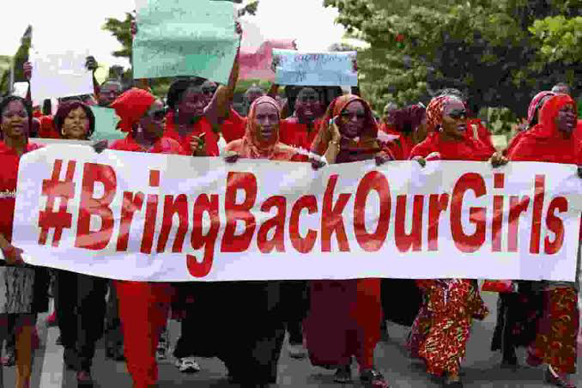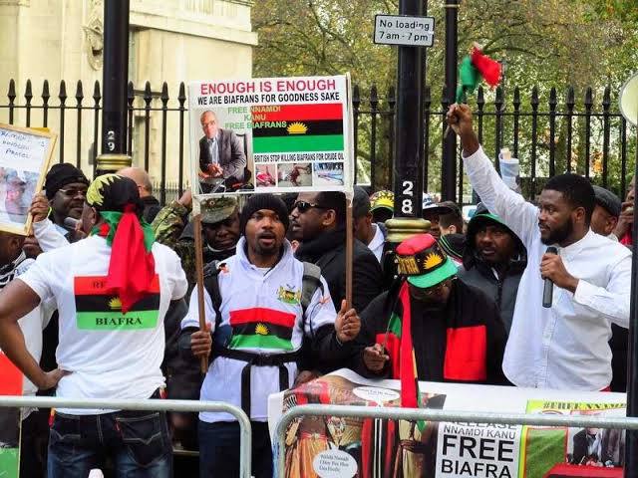

Pressure groups are organized associations which seek to influence government decisions and policies without attempting to contest elections to take over government. They put actual or potential pressure on the decision makers in other for the realization of group and collective interest. Pressure groups are also called interest groups. Examples of pressure groups include Bring Back our Girls (BBOG)

**TYPES OF PRESSURE GROUPS**

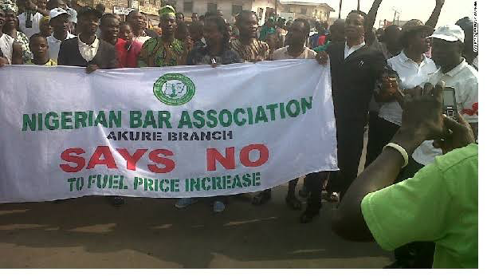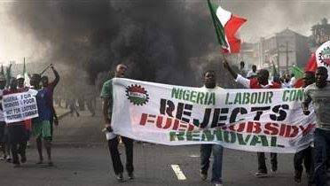

*1.* ***Economic pressure Groups****:* They comprise mostly of producers and manufacturers. Their main goal is to protect the interest of their members and the businesses they are involved in. Examples of Such include: manufacturers Association of Nigeria(MAN)

*2.* ***Professional Or Occupational Groups*** *:* These can also be called associational pressure groups and it comprises of workers of the same occupation or professional interest e.g. Nigerian Medical association (NMA), Nigerian union of Teachers (NUT), Academic staff union of secondary schools (ASUSS), Nigerian Union of Road Transport workers (NURTW).

3. **Religious Pressure Groups**: These are pressure groups of people that belong to the same religion and wish to influence government decisions in favour of their belief. E.g. Supreme council of Islamic Affairs (SCAN), and Christian Association of Nigeria (CAN).

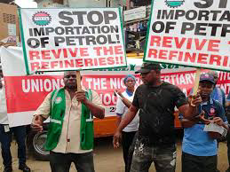

4. **Promotional Pressure Groups** :These groups promote some causes which may not directly benefit their Members e.g. Red Cross, and National Centres for Environmental Information (NCEI) Which is Involved in gathering weather data and advising on weather related issues.

5. **Anomic Pressure Groups** :This type of interest groups use violent demonstrations, arson, assassinations, strikes and the likes in expressing their aims and objectives. They are mob groups, street demonstrations and student riot groups not well organized but they may be interested in same common goals.

6. **Institutional Pressure Groups:** These exist in order to protect the interest of certain important institutions within the society E.g. Nigerian army, Nigerian police, Ministries and commissions etc.

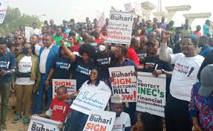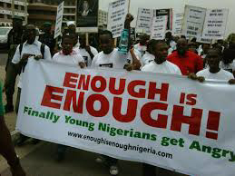

7. **Non Associational Pressure Groups** :These are tribal groups which people become members merely by accident of birth e.g. Hausa, Igbo, Efik, Yoruba e.t.c. However, in the inevitable struggle for resources of the nation, individuals behave consciously or unconsciously as members of such groups.