**WEEK: ONE**

**SUBJECT: CIVIC EDUCATION**

**TOPIC: NIGERIA AS A FEDERATION**

**CLASS: JS 2**

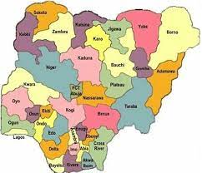 

**MEANING OF FEDERATION**: Federation is a system of government in which there is a constitutional division of powers between the central government and other component units forming a union (state and regional government). It is commonly referred to as a federal system of government or federalism.

**BRIEF HISTORY OF NIGERIA’S FEDERALISM**: Nigeria is one indivisible and indissoluble sovereign state known as Federal Republic of Nigeria. The name Nigeria was suggested by Miss Flora Shaw (later Mrs. Lugard) in her essay which first appeared in The Times of January 1897. The Nigerian nation came into existence in 1914 when the Southern and Northern protectorates were amalgamated. It became an independent nation and 99th member of UNO on October 1, 1960. Furthermore, it became a federation consisting of states and federal territory.

**THE THIRTY-SIX STATES IN NIGERIA**: The thirty-six states in Nigeria are Abia, Adamawa, Akwa lbom, Anambra, Bauchi, Bayelsa, Benue, Borno, Cross River, Delta, Ebonyi, Edo, Ekiti, Enugu, Gombe, Imo, Jigawa, Kaduna, Kano, Katsina, Kebbi, Kogi, Kwara, Lagos, Nasarawa, Niger, Ogun, Ondo, Osun, Oyo, Plateau, Rivers, Sokoto, Taraba, Yobe, Zamfara, and the Federal Capital Territory (FCT) Abuja.

**WEEK: TWO**

**SUBJECT: CIVIC EDUCATION**

**TOPIC: NIGERIA AS A FEDERATION**

**SUB TOPIC: NEED FOR A FEDERATION**

**CLASS: JS 2**

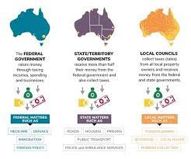 

Constitutional power is shared among the tiers as follow:

1. **Exclusive List**: Only the federal government can legislate on items on the exclusive list. These include defense, currency, foreign affairs, immigration and emigration, customs, mining, police force etc.

2. **Concurrent List**: This spells out the areas where the powers are jointly shared by the federal and state government. Items on which both the federal and state government can legislate are called concurrent lists. Such areas include agriculture, education, health, roads, information etc.

3. **Residual List**: This shows items on which only state government can legislate. This list includes minor roads, chieftaincy, markets etc.

**Need for Federation**

Nigeria adopted federation because of the following reasons:

1. **National integration**: The component units within Nigeria need to be brought together and ruled as one and not as a separate entity. The government at the center cares for everybody and coordinates the economic and political activities of other component units (state and local governments) . It makes policies which help in integrating the country. For instance, the establishment of National Youth service corps, the national flag, national anthem and common constitution are symbols which bring Nigerians together. The central government sees to the even development of all the states and local governments.

2**. Unity in Diversity**: Federation is a necessity in Nigeria due to the multi-ethnicity structure of the country. Nigeria has over 250 ethnic groups within its territory. The federal government has the major responsibility of ensuring that policies that will unify the entire people and give them the sense of belonging are initiated and implemented. Among such policies which had been made in the past we're the establishment of unity schools in various part of Nigeria which brings children from different parts of Nigeria together, the establishment of National Youth Service Corps (NYSC), the establishment of the Federal Character Commission and so on. Without the Federal structure, unifying the different ethnic groups in Nigeria would be a very difficult task.

3. **Geographical Size**: For easy administration, there is the need for a federation so that the activities of the state and local governments can be monitored to ensure that people at the grassroots are well cared for.

4. **Economic Factor**: The need to pool resources together to form a strong economy necessitated the adoption of the federal structure in Nigeria.

5. **Minorities**: The need to protect the interests and aspirations of the minorities called for the adoption of a federation in Nigeria.

**WEEK: THREE**

**SUBJECT: CIVIC EDUCATION**

**TOPIC: NIGERIA AS A FEDERATION**

**SUB TOPIC: CHARACTERISTICS OF FEDERATION**

**CLASS: JS 2**

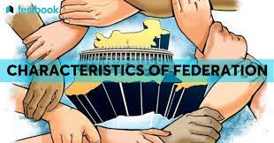

**CHARACTERISTICS OF FEDERATION**

The following are some of the characteristics of a federation

1. **Division of powers**: In a federation, governmental powers are shared among federal, state and local governments. This is normally entrenched in the constitution of the country. A federation is normally governed by a federal constitution.

2. **The supremacy of the constitution**: In the federal system of government, the constitution is the final authority in any matter. Both the federal and state governments derive their powers from the constitution.

3. **Written and Rigid Constitution**: A federation normally has a written and rigid constitution which are the features of a federal constitution.

4. **Existence of a Bicameral Legislature**: A federation through the provisions of the federal constitution has a bicameral legislature. This means that at the central level, there are two legislative houses/chambers. For instance, in Nigeria, the national assembly consists of the House of Senate and House of Representatives. But the component units (the state) have a unicameral legislature, that is, only one legislative house.

5. **Existence of Supreme Court**: There is a Supreme Court which settles disputes between the various levels of government (federal and state government).

In Nigeria, there are three tiers of government. These are; the federal government, the state government and the local governments.

**WEEK: FOUR**

**SUBJECT: CIVIC EDUCATION**

**TOPIC: NIGERIA AS A FEDERATION**

**SUB TOPIC: RELATIONSHIP BETWEEN FEDERAL, STATE AND LOCAL GOVERNMENT**

**CLASS: JS 2**

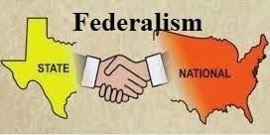 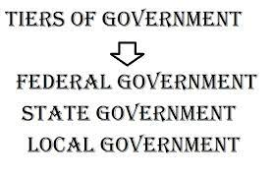

1. **The Federal Government**: The Federal Government is the central authority that represents the entire nation in external affairs and internal affairs of common interest. The constitution gives exclusive power to the federal government in matters relating to currency, foreign affairs, defence, immigration, customs, emigration etc. The federal government has greater constitutional power than the state and local governments.

2. **State Government**: The head of the state government is the governor. The state governor oversees the state council of chiefs, state civil service commission, the local government service commission and so on. The state government has its own legislative arm that makes law for the state called House of Assembly. The State Executive Council, headed by the governor makes major important decisions for the smooth running of the state.

3. **Local Government**: This is the third tier of government in Nigeria. It is headed by the Local Government Chairman. It also has its own legislative body which makes bye-laws for her. The local government brings government close to the people at the grassroots.

The relationship can be summarized as follows:

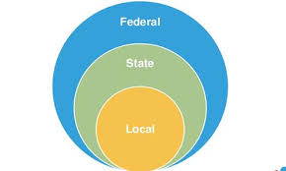 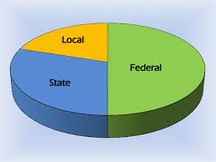

1. The federal government creates the state and local governments based on constitutional provisions.

2. The state and local governments help in implementing some of the federal government policies, for instance, educational policy, industrial policy etc

3. The federal government has power over the adjustment of the boundaries of state and local governments.

4. The state government looks into the account of the local government authorities.

5. They all get allocations from the federal account.

6. The annual budgetary estimates of local government are subject to the approval of the state government.

7. The state government has the power to dissolve local government executive council.

**WEEK: FIVE**

**SUBJECT: CIVIC EDUCATION**

**TOPIC: RULE OF LAW**

**CLASS: JS 2**

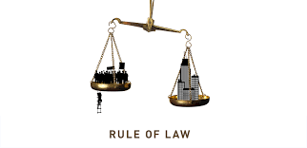 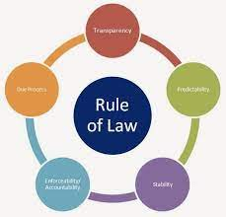

Law can be defined as a set of rules and regulations through which a society is governed to ensure peace and orderliness.

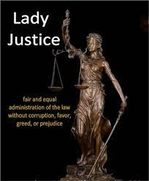

**MEANING OF RULE OF LAW:** Rule of law implies the supremacy of law over every citizen in a country or nation. It emphasizes the supremacy of law, equality before the law and presence of individual right.

According to A. V. Dicey who propounded the doctrine, all leaders should abide by the law and govern the people according to the provisions of the constitution of the country. He explained further that powers should not be centered in the hands of a few people.

**Principles/Fractures of the Rule of Law**

The following are the principles of the rule of law as explained by Prof. A. V. Dicey:

1. **Principle of Equality Before the Law:** This means that all citizens should be equal before the law. Law should apply to everyone irrespective of who they are. No citizen should be above the law.

2. **Principle of impartiality:** This means that the law should be impartial in dealing with those who break it. An offender should be deemed innocent until he is proved guilty by due process in the court. Furthermore, no suspect should be detained for more than twenty-four hours. Same punishment should be given to all offender irrespective of their status in society.

3. **Law is no respecter of person**: This means that anyone that breaches the law will be dealt with by the principles of the law whosoever he may be. The law does not punish the poor and excuses the rich. The same punishment will apply to every citizen in the court.

4. **Principle of Supremacy of Law**: The law is supreme over everyone, that nobody is above the law.

5. **Principle of Fair Hearing**: Anyone arrested for an offence should be given fair hearing through the normal legal process in the court of law before condemned or sent to jail.

6. **Right to Appeal**: When an individual is not satisfied with the judgment passes on him by a lower court, he should be able to appeal in a higher court.

7. **Fundamental Human Rights**: Rights of individuals should not only be entrenched in the constitution but should be enforced and guaranteed.

WEEK: SIX

TOPIC: BENEFITS OF RULE OF LAW



The Benefits of the Rule of Law as Against Arbitrary Rule:

1. The principle of rule of law guarantees equality before the law and therefore, nobody no matter how highly placed can use his position to bend the law in his favour.  
   2. The rule of law protects an individual from forfeiting his property without compensation.  
   3. The principle states that an individual is entitled to defend himself with the assistance of a lawyer and an individual cannot be arrested without being told of the offence he committed.  
   4. Under the rule of law, an accused person is assumed innocent until a court of law presided over by free and fair and impartial judge finds him guilty.
2. The principle makes it possible for all citizens of the country to enjoy equal access to law facilities, equal right to fair hearing, legal advice in the court of law, etc.

WEEK: NINE

**TOPIC: CONSUMER RIGHTS AND RESPONSIBILITIES**

WHO IS A CONSUMER?

A consumer is a person that buys and uses a commodity produced by another person. Most consumers do not produce and that is why they consume most of the goods they have. As a consumer,you have legal rights when you purchase goods and services. In Nigeria, the government set up Consumer Protection Council(CPC), in the year 1999 to provide speedy redress to consumers complaint about goods and services, thereby protecting their rights.

**CONSUMER PROTECTION**

Consumer protection is the various ways and methods that government and the private organizations ensure  that consumers are not cheated or exploited by the producers and middlemen and that they derive satisfaction from the consumption of goods and services they pay for.

**REASONS FOR CONSUMER PROTECTION**

1. Substandard goods or low quality goods.
2. Misleading or false advertisement.
3. To ensure maximum satisfaction.
4. Regular supply of goods.
5. Inadequate instructions or direction.

**SOME AGENCIES RESPONSIBLE FOR CONSUMER PROTECTION**

1. Consumer Association.
2. Standard Organization of Nigeria (SON).
3. Ministry of Trade and Industry.
4. Price Control Board (PCB).
5. Manufacturers Association (M.A).

WEEK: TEN

SUN TOPIC: UNIVERSAL RIGHTS OF A CONSUMER

1. Right to Basic Needs–which guarantees survival, adequate food, clothing, shelter, healthcare, education and sanitation. With this right, consumers can look forward to the availability of basic and prime commodities at affordable prices and good.
2. Right to Safety—the consumer should be protected against the marketing of goods or the provision of goods that are hazardous to health and life.
3. Right to Information—the consumer should be protected against dishonest or misleading advertising or labeling and has the right to be given the facts and information needed to make an informed choice.
4. Right to Choose—the consumer has the right to choose from among various products at competitive prices with an assurance of satisfactory quality.
5. Right to Representation—the right to express consumer interests in the making and execution of government  policies.
6. Right to Redress— the right to be compensated for misrepresentation, shoddy goods or unsatisfactory services.
7. Right to Consumer Education, which is the right to acquire knowledge and skills necessary to be an informed customer.
8. Right to a Healthy Environment—the right to live and work in an environment which is neither threatening nor dangerous and which permits a life of dignity and well-being.

WEEK: ELEVEN

TOPIC: THE RESPONSIBILITIES OF A CONSUMER

Consumer responsibilities are;

1. Think independently: The consumer should not be carried away by the advertisement on the product by the manufacturer. He should know the quantity of what he wants to purchase.
2. Beware : the consumer should check the product he wants to buy thoroughly to know if it is the original and at the right place.
3. Demand and keep proofs of transactions: Documents like receipts, invoice warranty, pay slip are proofs that transactions took place between the seller and the consumer. These documents should be kept for future purposes.
4. Respect the environment: The consumer must make sure that the environment is not littered with wastes of the products he has used.

TOPIC: GROUPS THAT ASSIST IN PROTECTING HUMAN RIGHTS OF CITIZENS

In some companies and professions and non governmental organizations, there are bodies that assist in protecting human rights. Examples are

Trade union – The umbrella that bind some workers together

NUT – Nigerian Union of Teachers. Teachers within the local, state [government](https://stoplearn.com/category/government/) and nation as a whole under this trade union. This union stands to protect all human rights violations against his members. Under the same union, a faction either in the local [government](https://stoplearn.com/category/government/) or the state can call out its people to protest.

Student union – Some institutions deliberately introduce policies and programmes that violate human rights in school. It could also have been denied some of their rights. The [government](https://stoplearn.com/category/government/) may introduce programmes and policies that affect the fundamental human rights of citizens.

Ethnic Associations – For the purpose of unity and cooperation, some ethnic groups form associations. This could be in locations outside their community. So anything that want to stand against such unity or rights in their community, the ethnic association would stand against violation of human rights.

Legal Aid council – Some lawyers have come together to form a legal aid council in order to defend people whose rights are being trampled upon but who have no means of seeking for legal justice. The legal aid council takes up cases and defend people to a logical conclusion for them to win and have assess to their fundamental human rights.

Civil Society Organisations – There are many civil organisations that assist in protecting human rights. E.g CLO, CDHR, CRP. They protect people from being molested and denied their fundamental human rights. They oppose [government](https://stoplearn.com/category/government/) policies and programmes that stand against peoples’ rights. They ensure that the rule of law is enforced in places where it is not in operation.