**WORLD POPULATION**

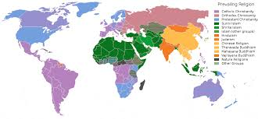

Population is defined as the number of people leaving in an area at a particular time.

The continents with the most population is Asia making up 60% of world population, Africa comes next with 17%, Europe makes up 11% while North America and Oceania are the least populated continents.

|  |  |  |  |  |
| --- | --- | --- | --- | --- |
| **CONTINENTS** | **Population (2020)** | **Area (Km²)** | **Den sity (P/**  **Km**  **²)** | **World Populati on Share** |
| ASIA | 4,641,054,775 | 31,033,131 | 150 | 59.54% |
| AFRICA | 1,340,598,147 | 29,648,481 | 45 | 17.20% |
| EUROPE | 747,636,026 | 22,134,900 | 34 | 9.59% |
| NORTH AMERICA | 592,072,212 | 21,330,000 | 28 | 7.60% |
| SOUTH AMERICA | 430,759,766 | 17,461,112 | 25 | 5.53% |
| AUSTRALIA/OCEANIA | 42,677,813 | 8,486,40 | 5 | 0.55% |
| ANTARCTICA | 0 | 13,720,000 | 0 | 0.00% |

World population distribution pattern

Population can be classified into 3 different density areas

- Areas of sparse population

- Areas of medium population

- Areas of Dense population

Calculation of population density

Population density is the number of persons per unit area of land or square kilometer of land.

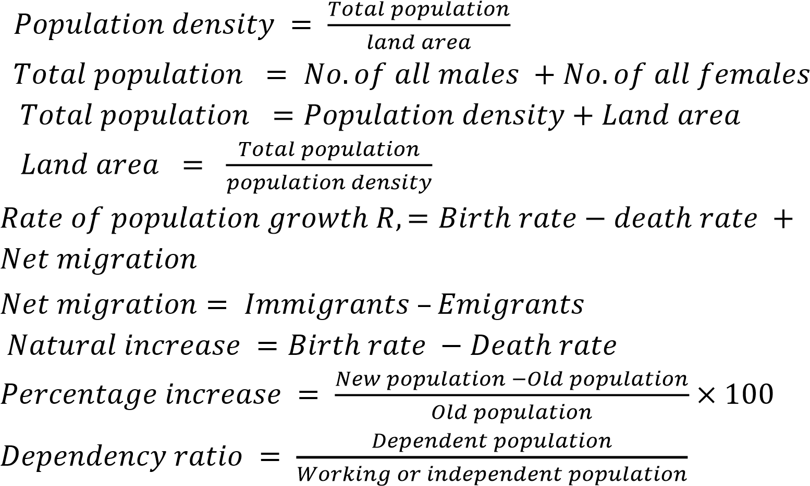Some population formulae

Merits of high population density

1. It will lead to effective planning which in turn results in development of the densely populated area
2. It provides large labour force for industries
3. It makes dissemination of information easy and quick

Demerits of high population density

1. Areas of high population density are likely to have high crime rate due to lack of jobs
2. It can result in traffic congestion most of the time
3. It creates pressure on social amenities like pipe borne water and electricity

Merits of low-density population

1. These areas have high standard of living as goods and agricultural products are cheap and easily available
2. There is no traffic congestion these areas
3. There is also little or no pressure on social amenities.

Demerits of low-density population

1. there is gross under-utilization of infrastructure
2. Areas of low density may experience difficulty in development
3. They also generate low revenue as a result of low labour force.

Factors affecting population distribution

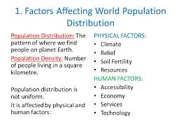

1. Climatic factors such as rainfall can affect population distribution as low rainfall in desert areas do not encourage agricultural hence will be sparsely populated unlike areas with high rainfall that encourages agriculture.
2. Economic factors such as industrial and commercial activities, transportation systems, mining or mineral resource e.t.c influence population distribution
3. Political instability or stability can affect population distribution around the world.

Home work

1. Itemize 5 ways of solving world population problems

A country X has a land area of 300,000km², population of 12,000,000. calculate the population density.