

**Subject: Physics**

**Class: SS 1**

**Week: One**

**Topic: Heat Energy**

* **Introduction**

U

nderstanding the concept of heat and temperature is of utmost importance to the life of man. Knowing about its advantages and disadvantages can help man utilize this energy safely. For instance, Africa is a continent with high solar radiation which means much heat, however, this energy is underutilized for the provision of tangible solutions to our pending crisis specially to provide the energy we need for our everyday productivity. As scientist, we study the concepts of heat energy to have a prerequisite knowledge needed to harness the power of heat available in our continent and covert it to meet our needs.

**Concept of Heat**

Heat is a form of energy which flows due to temperature difference. Heat makes us feel a sensation of hotness. Heat serves man in various ways; like cooking, drying our cloths, producing electricity through photovoltaic cells, for separating metals from ores, the heat produced due to the combustion of petrochemicals which makes vehicles and planes move etc.

* **Production of Heat**

Heat can be produced from different sources, some of which includes:

1. Heat can be produced from the sun, it is called solar heat.

2. Heat can be produced due to friction, that is, energy produced when the surfaces of two bodies are in contact with each other.

3. Heat can be produced due to chemical reaction, for example, when tetraoxosulphate (VI) acid is introduced into a test tube of water.

* **Effect of Heat on Matter**

It has been observed that when heat is applied to a body, various changes take place. Some of these changes include:

1. Chemical changes,

2. Change in physical property,

3. Change in the temperature of the body,

4. Expansion of the body,

5. Change in the pressure of the body

6. Change of state, that is, for solid to liquid or gas etc.

**Concept of Temperature**

Temperature is the degree of the hotness or coldness of a body. For example, when a beaker of water is placed on a burner, the temperature increases, but when refrigerated, the heat is drawn away and the water gets cold.

* **Measurement of Temperature**

Temperature is measured with an instrument called **thermometer**. There are different kinds of thermometer which makes use of different substances called the **thermometric substance**.These thermometric substances make each thermometer unique. Some type of thermometers includes:

1. Liquid in glass thermometer,

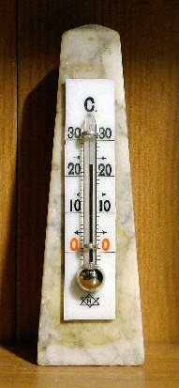

2. Gas thermometer,

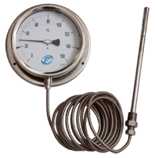

3. Bimetallic strip thermometer,

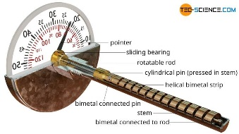

4. Thermoelectric thermometer etc.

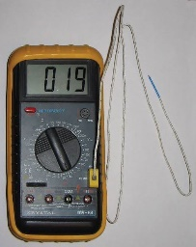

**Thermal Expansion of Solids**

Solids can expand when heated or contract when cooled. The rate of expansion or contraction differs from different solids by the type of material the solid is made up of. Some of the effect of expansion of solid in everyday life can be found in the following:

1. Railway lines and bridges,

2. Buildings galvanized iron sheets,

3. Wires etc.

* **Application of Expansion**

One of the applications of expansion in solid is the bimetallic strip, which is used in the construction of a bimetallic thermometer, and a thermostat a device for maintaining steady temperature (Thermostat is used in electric laundry iron, refrigerators and hot water storage).

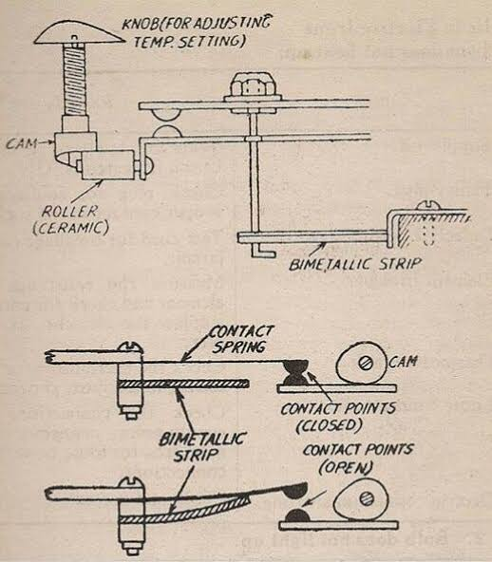

The bimetallic strip consists of two different metals (brass and iron) rivetted together. When heated, the bimetallic strip bends. This is because, brass expands more than iron at the same temperature.

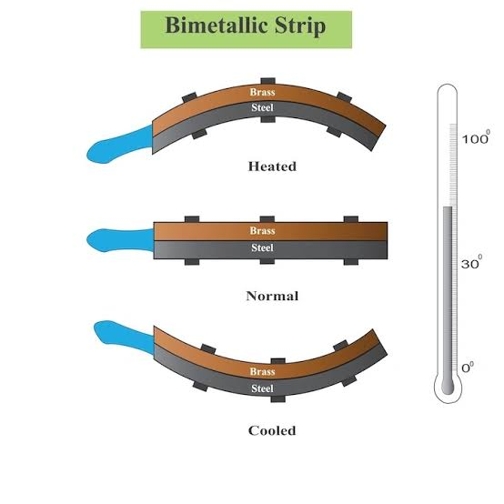

**Textbook reading reference: 48 – 52**

**Week: Two**

**Subtopic: Thermal Expansivity**

Under this, we shall discuss the linear, area and volume (cubic) expansivity of solid and liquid.

1. **Linear Expansivity of a Solid ($α$):** This is defined as increase in length per unit length of a solid (metal) for one degree rise of temperature. It is mathematically given as:

$$α =\frac{l_{2}-l_{1}}{l_{1}(θ_{2}-θ_{1)}}K^{-1}$$

Where ***l2*** = final length and ***l1*** = initial length

**θ2** = final temperature and **θ1** = initial temperature

**Take Note:** The increase per unit length of an iron multiplied by its temperature difference is **α =** 12 X 10-6 K-1. This is a standard measurement for linear expansivity in iron. Also, **θ = θ2** – **θ1.**

**Examples:**

a. A brass of length 100m increases to 100.5m, when heated from 50oC to 100oC. Calculate its linear expansivity (α).

**Solution**

**θ2** = 100oC; **θ1** = 50oC; ***l2*** = 100.5m; ***l1*** = 100m

= 10-4 K-1

b. An iron rod of α **=** 12 X 10-6 K-1 and ***l1*** = 60m, expands when heated through 100oC. Calculate:

a. Increase in length (*l2 – l1*)

b. Final length (*l2*)

**Solution**

α **=** 12 X 10-6 K-1; ***l1*** = 60m; θ = 100oC

**a.**

But θ = θ2 – θ1

**⸫**

*l2 – l1 = αl1θ*

*--l2 – l1 =* 12 X 10-6 X 60 X 100

= 0.072m.

**b**. *l2 – l1 = αl1θ*

**Make *l2* the subject of formula**

*l2 = l1 +αl1θ*

Factorise out *l1*

*l2 = l1(1+αθ)*

*l2 =* 60(1+12 X 10-6 X 100)

= 60.072m.

2. **Area and Volume (Cubic) Expansivity of Solid:** In this case of expansivity, the expansion in area and volume of the body is considered where A1 and A2 are the initial and final area of the solid body, while V1 and V2 are the initial and Final volume of the body being considered.

* The area expansivity (β) is given by:

$β =\frac{A_{2}-A_{1}}{A_{1}(θ_{2}-θ_{1)}}$**------------------------------------(1)**

Since θ = θ2 – θ1

**⸫**

**Cross Multiply**

A2 – A1 = A1βθ

**Making A2 subject of formula**

A2 = A1 + A1βθ

A2 = A1 (1 + βθ) -------------------------------------**(2)**

But β = 2β = 2 into equation 2

A2 = A1 (1 + 2θ) ------------------------------------(**3**)

* The Volume or Cubic Expansivity (γ) is given by:

$γ =\frac{V_{2}-V_{1}}{V_{1}(θ_{2}-θ_{1)}}$**------------------------------------(1)**

Since θ = θ2 – θ1

**⸫**

**Cross Multiply**

V2 – V1 = V1γθ

**Making A2 subject of formula**

V2 = V1 + V1γθ

V2 = V1 (1 + γθ) -------------------------------------**(2)**

But γ = 3γ = 3 into equation 2

V2 = V1 (1 + 3θ) ------------------------------------(**3**)

**Example:**

a. The linear expansivity of a material is 15 X 10-5K-1. If the initial area is 25m2, calculate:

i. The increase in area, if it is heated through 40oC

ii. Cubic expansivity.

**Solution**

α = 15 X 10-5K-1; θ = 40oC; A1 = 25m2

**i.** β = 2 α

= 2 (15 X 10-5)

= 30 X 10-5

From

A2 – A1 = A1βθ

A2 – A1 = 25 X (30 X 10-5) X 40

= 0.30 m2

**ii**. γ = 3

= 3 X 15 X 10-5

= 45 X 10-5

= 0.45 X 10-3K-1

**Textbook reading reference: 46 – 47**

**Week: Three**

**Subtopic: Thermal Expansivity**

3. **Expansion of Liquid:** Liquids change in volume with temperature difference. Liquids with the same volume as a solid can expand ten times more for the same amount of temperature change. Different liquids have their various and unique expansivity when heated at the same temperature as shown below:

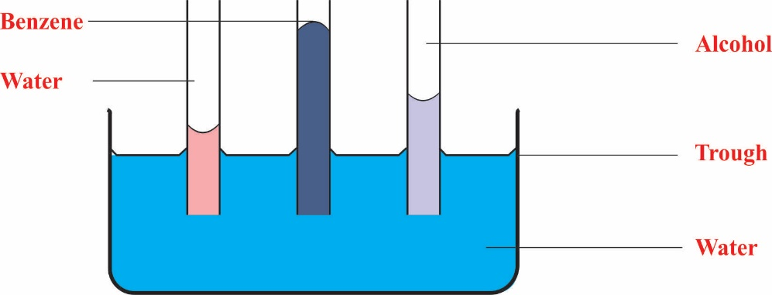

**Figure:** Expansion of three different types of Liquid

4. **Volume (cubic) expansivity of liquid:** Liquids have no volume of their own, they take up the volume of their containers. Since they do, we cannot talk about their cubic expansivity without taking into consideration their container and we know this by taking into consideration real (absolute) and apparent expansivity of liquids.

* Real (absolute) volume expansivity of liquid (γr): This is defined as the increase in volume per unit volume per unit rise in temperature.
* Apparent volume expansivity of liquid (γa): This is defined as the increase in volume per unit volume per unit rise in temperature when the liquid is heated in an expansive container.

It is mathematically given as: γr = γa + γ

Where γr = Real (absolute) cubic or volume expansivity of liquid

γa = Apparent cubic or volume expansivity of liquid

γ = cubic expansivity of liquid container

**Example:**

1a. Calculate the apparent expansivity of a liquid whose increase in volume is 0.05m3 and original volume is 10m3, if it is raised through a temperature of 100oC.

1b. Assuming the expansivity of the container is 0.001oC-1, calculate the real expansivity of the liquid.

**Solution**

V2 – V1 = 0.05m3; V1 = 10m3; θ = 100oC

a.

=

= 5 X 10-5 oC-1

b. γr = γa + γ

= 5 X 10-5 + 0.001

= 1.05 X 10-3 oC-1

**Transfer of Heat Energy**

Heat transfer happens through either conduction, convection or radiation.

1. **Conduction:** This is a process whereby heat is transferred along a metal from a particle of higher temperature to a particle of lower temperature. In this process, the particle does not appear to move. All metals are good conductors of heat, but their rate of conductivity varies by the type of material the metal is made up of.

2. **Convection:** This is the process by which energy is transferred in a fluid by the actual movement of the particle. For example, when you feel the heat of a boiling water around you, that’s convection because the vaporised water is transferred to you.

3. **Radiation:** This is a process by which heat is transferred from it source to another body without heating the medium of transfer. Convection and conduction need material medium for their propagation, but radiation doesn’t need it, because it is electromagnetic.

**Textbook reading reference: 47 - 48**

**Week: Four**

**Topic: Electrical Charges**

* **Introduction**

E

lectricity is gotten from the Greek word elektron. Elektron in this sense are electrons, and these are the subatomic particles that needs to move from one point to the other for the production of electricity. Every matter you see contains atom, and all atoms have electrons which means that all things have some form of electronic charges but may be static. What is a static electricity? Static charges are charges at rest, that is, they are in a state of equilibrium (a balanced undisturbed state), however, these charges (electron) can be perturbed out of their shell in their atom of which the following can be used to observe their behaviour when they do:

* A plastic comb rubbed with a cloth will make someone’s hair stand on if the comb is placed closed to it.
* The friction between silk and the amber causes the amber to become charged to stick to it.

**Types of Charges**

From experiments conducted by Benjamin Franklin (1706 - 1790), he was able to discover and confirm that there were two types of static charges; positive and negative charges which was ascertained via the following experiments: Plastic rods were rubbed on a piece of fur, and it was noticed that the rods did repel each other. Furthermore, glass rods were rubbed on a piece of silk and when the glass rod became charged, they repelled each other. However, it was found out that the charged particle from the plastic rod and fur did attract each other while the silk and the plastic rod also did attract each other. What happened was that when the glass was rubbed with silk, it became positively charged while the plastic rubbed with fur became negatively charged hence, they could attract each other. From this experiment it was concluded that:

***Like (similar) charges repel, while unlike charges attract each other***

From this, we can deduce the types of charges we have which are all embedded in an atom as follows:

**1. Nucleus:** This is made up of the protons which are positively charged and the neutrons which are uncharged or neutral. The nucleus is a very dense core of about 10-15m in dimension. The protons and the nucleus are held together in the nuclei by the nuclear force. The mass of the proton is mp = 1.6726231 X 10-27kg while that of the neutron is mn = 1.6749286 X 10-27kg.

**2. Electrons:** These are the negatively charged particles of the atom. They surround the nucleus and have a diameter of about 10-10m from the nucleus. These electrons are held within their atoms in their shells by the positively charged nucleus which is the proton. The mass of electron mc = 9.1093897 X 10-31kg.

In a neutral atom undoped, the number of electrons is equal to the number of protons. If one electron is pulled out of its shell, a hole which is positively charged is left vacant, hence the atom is a positive ion that attracts any stray electron. Furthermore, if an atom which has vacant positively charged atoms gain one or more electron to fill up the vacant space, such atom is a negative ion. This whole process of gaining or losing one or more electrons is called **ionization**.

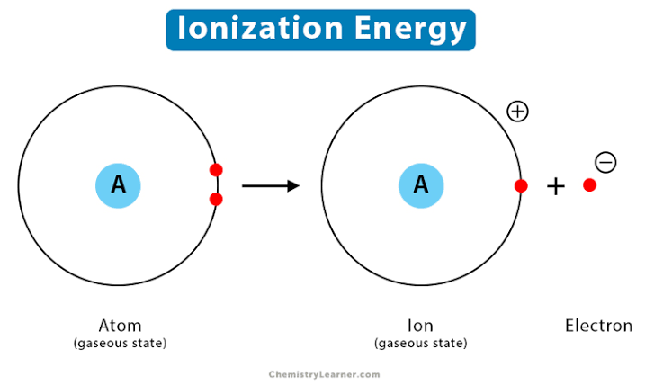

**Distribution of Charges on Conductor**

When charges flow over to the surface of a conductor, it is noticed that the charges are unevenly distributed except if the surface of the conductor is spherical. Therefore, charges will only concentrate at points where the shape of the conductor is sharply curved.

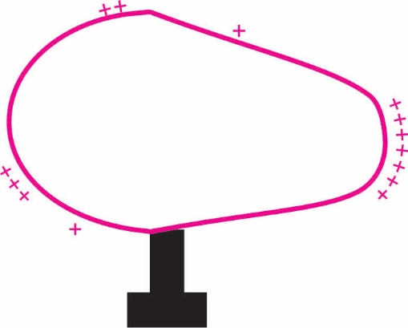

**Figure:** Distribution of Charges on a Conductor

**Lightning and Lighting Conductors**

The atmosphere contains ions which store up. These ions get trapped in the atmosphere as they have been produced by UV rays, radiation from the sun, cosmic radiation etc. The lightning we see is a sudden discharge of these stored-up charges in the atmosphere and is most times released when the charges build up in the cloud. In this atmosphere of stored up charges, there contains in it both positive ions and negative ions of which they attract and interact with each other. Take note of this that when electrons interact with protons, they either generate heat or they generate light. In the case of potentials stored up in the sky, light is generated by the attraction of these ions towards each other, hence the reason why we see a sudden flash of light. The sudden flash of light usually occurs due to a heavy spark of light as the charges attract each other, and they may be dangerous to man, building, wildlife reserves and properties if they strike any of them.

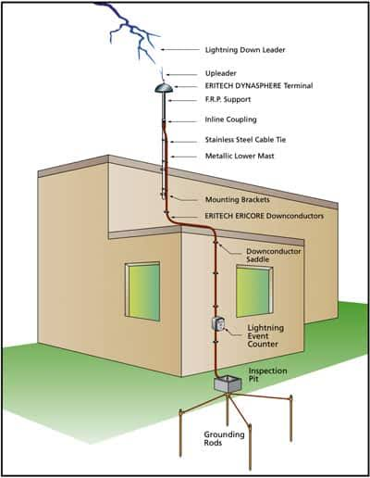

The lightning conductor was created to solve this problem of lightning destroying lives and properties and it works with a simple principle. Lightning conductors are made up of thick metals capable of holding heavy current without melting. At the upper part of this lightning conductor, it has a spike (sharp point) which extends above the roof. The lower end of the conductor is buried beneath the soil attached to a large piece of copper plate to ensure good contact. The spike attracts the charged ion and send it down beneath the soil where it becomes neutralized.

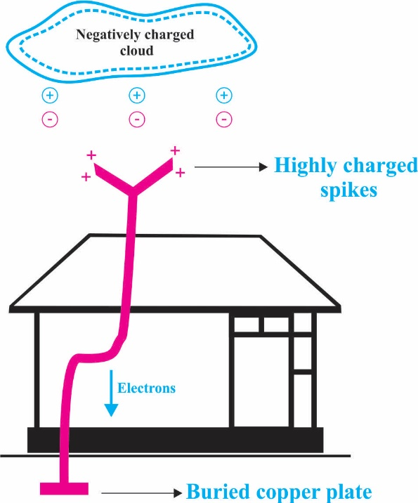

**Figure:** Action of a lighting conductor

**Textbook reading reference: 58 - 63**

**Week: Five**

**Topic: Description and Properties of Fields**

* **Introduction**

A

field can be described as a region under the influence of some physical agency such as gravitation, electricity, magnetism, heat etc. There are two kinds of fields which are vector and scaler fields. Example of scalar field are fields influenced by scaler quantities such as temperature, density, electric potential etc., while vector fields include field influenced by vector quantities such as the gravitational force field, magnetic and electric fields. The magnitude of scalar field is usually mapped out by lines but that of vector fields are mapped out by lines of flux or lines of force as indicated below:

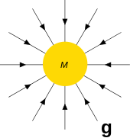

**Types of Fields**

1. **Gravitational field:** This field is a field created and influenced by gravitational force. It was discovered around 1666 by Isaac Newton and he propounded a law on it now known as the law of gravitation, and it states that: *The force of attraction between two given particles of masses M and m is inversely proportional to the square of their distance, r, and directly proportional to the product of their masses.* It was mathematically related to the equation below:

$$F_{g}= \frac{GMm}{r^{2}}$$

The knowledge of gravitation has been applied in so many fields, some of which includes space travel: The concept of gravitational field has been used widely in space travel especially through engaging what is called escape velocity.

2. **Electric force and fields:** Electric force which deals with the study of the magnitude of attraction or repulsion between two charged bodies was carried out by Coulombs in 1875, and He formulated what is called the Coulomb’s law which states that: *In a given medium, the force of attraction or repulsion Fe between two charged bodies of Q and q is directly proportional to the charges and inversely proportional to the square of their separation.* It is mathematically related as

$$F_{e}= \frac{1}{{4πε}_{o}}. \frac{Qq}{r^{2}}$$

Where $\frac{1}{{4πε}_{o}}$ is a constant of proportionality = 9.05 109mF-1

Electric field is the field that is influenced by the presence of electric force due to the attraction or repulsion of charges between two charged bodies. It is mathematically given as:

**E = $\frac{F_{e}}{q}$**

Where E = electric field

Fe = Electric force

q = charges

but

**⸫** E =

E =

3. **Magnetic field:** This field is created due to materials that have magnetic properties, for example, magnetites. The study of magnetism grew through the observation of magnetites, that is, certain stones that attract bits of some metals such as iron. Through the study of this materials, modern permanent magnets were eventually produced. The earth is also known to have magnetic properties, and this magnetic property is responsible for our compasses working and it also helps to redirect meteorites trying to penetrate the earth’s atmosphere. Through the study of magnets, electromagnetism also came to be. Some of the general application of the study of magnetism includes: telecommunication, loud speakers, motors etc.

**Properties of Electric Lines of Force**

Lines of force were created by Faraday as a way to visualize electric, magnetic and gravitation fields. They are imaginary lines for representing field patterns, and some of its properties includes:

1. The direction of the line at any point is the same as the direction of the field at that point.

2. The number of the lines of force represented is equal to the magnitude of the field at that point, that is, the density of the line shows the magnitude of the field.

3. Field lines may be parallel, radial or curved depending on the nature of the electric or magnetic field.

**Week: Six**

**Topic: Gravitational Field**

G

ravitational field has been introduced last class which deals with the force of attraction F between two bodies with masses M and m. Today we shall further discuss about another parameter that is involved in the study of gravitation field which has a strong influence on the filed and it is called acceleration due to gravity (g).

**Acceleration Due to Gravity (*g*)**

The force that will make a coconut or an apple firmly hanging on a tree to fall is a force called the force of gravity. This is because there is an interaction for attraction between the particles of the mass of the earth and the particle of the mass of the apple or coconut. Therefore, the force of gravity is a force that attracts all object to the surface of the earth.

Because all common objects around us are too small to cause a force of attraction large enough to be measured, but the earth itself, having a large mass pulls any object with a measurable force known as the force of gravity, this force is the weight of the object. The force of gravity of an object on the earth was given by Newton to be $F= \frac{GMm}{R^{2}}$ where G is the Universal gravitational constant which holds the moon in its orbit and makes the earth and fellow planet revolve round the sun and is equal to 6.67 10-11Nm2kg-2, M is the mass of the earth and is equal to 5.98 1024kg, R is the radius of the earth estimated to be 6.38 106km. However, the Force of the object on the earth is ***F = mg***. Equating this two we have that:

F = F

**⸫**

*g* **=**  = = 9.8 ms-2

**Variation of g at Different Places on the Earth’s Surface**

If the Earth is perfectly spherical, and G and M are constant, then g will be constant at all point on the surface of the earth but this is not so. The earth is not a perfect sphere; hence its radius R which is the distance between the centre of the earth and any point on the earth surface will vary. For this reason, g varies from place to place along the earth’s surface. Therefore, the value of g is larger where the value of R is small and the value of g decreases where the value of R is large. This is why for example, the value of g is greater at the poles than at the equator because the diameter of the equator is greater than the diameter of the poles. It should also be known that g varies with increase in altitude, that is, the higher you go, the lesser g will have an effect on you.

**Week: Seven**

**Topic: Electric Field**

* **Introduction**

A

n electric field also known as E-fields is a region where electric force is experienced. Charged particle when they are oppositely charged to each other exert attractive force on each other because unlike charges attract, and repulsion when charges are the same. The force exerted in an electric field is described by Coulombs, which says that the greater the magnitude of the charges attracting or repelling each other, the greater the force, and the greater the distance between these two charges, the weaker the force. The interaction in the electric field between atoms is the force responsible for chemical bonding that results in molecules, and these forces are also what holds electron in an atom. This field can be described by the lines of force which represents the direction of motion of positively charged particle interacting with another in the field as shown below:

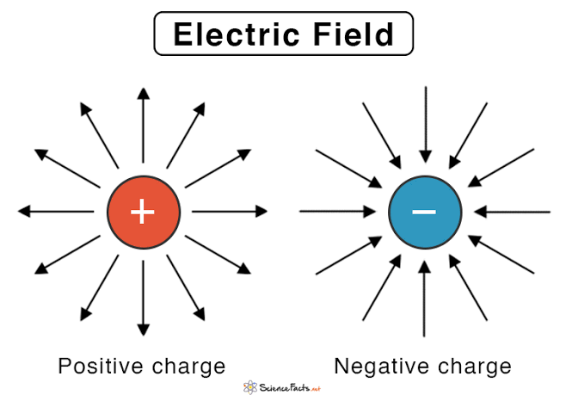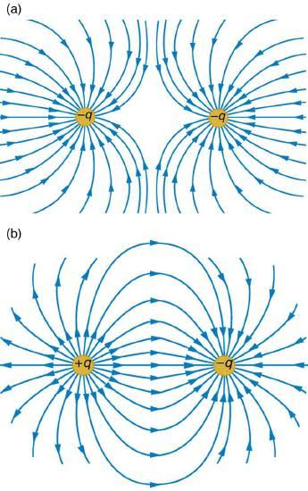

**The Electric Potential**

Electric potential at a point is defined as the work done in bringing a unit positive charge from infinity to that point against the action of the field. The potential difference is therefore the work done (energy expended) when that unit positive charge is moved from one point to another in that field.

The potential, V, due to a charge, Q is given as **V = $\frac{Q}{4πεr}$**

While the potential difference V*ab* which is the work done in taking a unit positive charge from b to against the force is given as V = $\frac{Q}{4πε}\left[\frac{1}{r_{a}}-\frac{1}{r_{b}}\right]$

If b $≫$ a

V = $\frac{Q}{4πεr}$

**Example:**

1. Calculate the potential associated with a point charge of 5.0 $μ$ c. If it is placed 6cm from a point A.

**Solution**

9.05 109mF-1;

Q = 5.0c = 5.0 10-9c

r = 6cm = 6 10-2mm

V = = 7.5

**Electric Current**

An electric current (*I*) is the time rate of flow of charge (*Q*) round a circuit. An electric current consists of charges in motion from one region to another in an electric circuit. The quantity of electricity (*Q*) is measured in Coulombs (C) and the unit of current one Coulomb per second is called an ampere (A).

**⸫ I = $\frac{Q}{t}$**

**Example:** A current of 4.5A flows through a car headlight. How many coulombs of charge flow through it in 1.0hr?

**Solution**

I = 4.5A; t = 1hr = 60 $×$ 60 = 360s

I = $\frac{Q}{t}$

Q = I $×$ t = 4.5 $×$ 360 = 16200C

**Current Measuring Instruments**

The instrument used to measure current is the ammeter. Other types of ammeter are the micrometre, milliammeter, and Galvanometer. The ammeter is used for measuring large current, while the micrometre and milliammeter are used for measuring small current but the galvanometer is used especially in potentiometer and metre bridge experiments to measure or detect small currents a thousand times smaller than the milliammeter. The symbol representation of these instruments on an electric circuit is shown below:

**Week: Eight**

**Topic: Electric Circuits**

An electric circuit is a path that forms a closed loop through which current passes through. These circuits are a means to convey energy from one place to another in an appliance. They are made use of in radios, television transmitter and receiver, computers etc. An electric current will only flow only if there is a complete circuit of conductors by which current can leave from one terminal of the cell and flow round to the other terminal. The following are the symbolic representations of different instruments/materials used in a circuitry connection:

**1. Resistor:** Used to resist to a level some current passing through the circuit

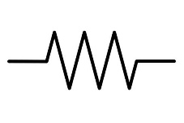 or 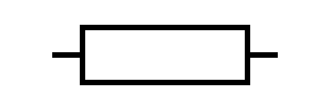

**2. Rheostat:** a variable resistor

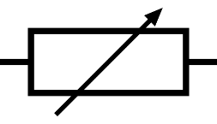

**3. Voltmeter:** used for measuring voltage in a circuit

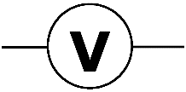

**4. Ammeter:** used for measuring current in a circuit

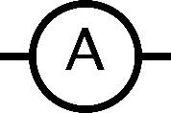

**5. Galvanometer:** used to measure small currents

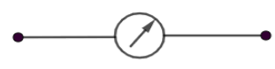 or 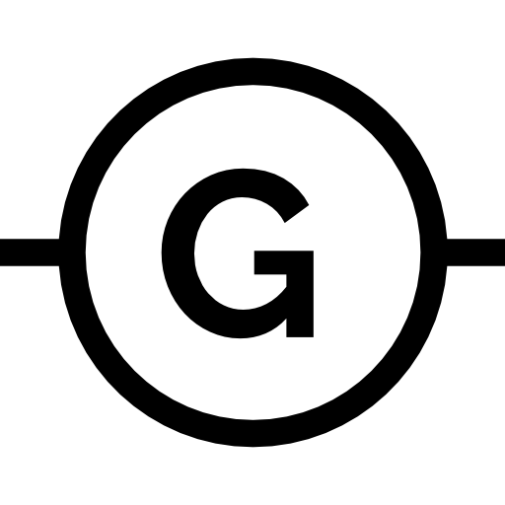

**6. Lamp:** Used to indicate the flow of current through the circuit

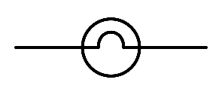

**7. Key:** Acts as the switch of the circuits

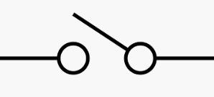

**8. Source of e.m.f:** can be a battery or a cell

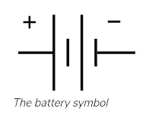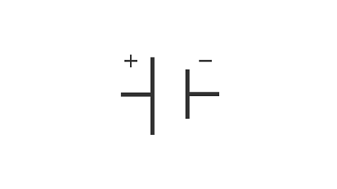

**Electric Conduction Through Materials**

All materials have their own level of resistance to the flow of current through them, some materials allow current flow through them more readily than others. Materials which allow electricity easily flow through them are called conductors. Examples of some conductors includes: almost all metals, impure water, inorganic acid solutions. The best metallic conductor is silver followed by copper. Most connecting wires in circuits make use of copper because it is less expensive than silver.

**The Ohm’s Law**

George Simon Ohm a German Physicist in 1826 discovered that there is a good relationship between current flowing through a conductor and its potential difference. Through this, he propounded what is now known as the Ohm’s law which states that:

***The Electric current (I) passing through a metallic conductor (wire) at constant temperature is directly proportional to the potential difference (V) applied between its ends.***

That is: V α I

V = IR

Where R is the constant of proportionality which depends on the nature of the conductor identified as the resistance of the conductor. The Greek letter-omega (Ω) is the unit for measuring this resistivity.

**Week: Nine**

**Topic: Crystals**

A

Crystal can be defined as a solid formed by the solidification of a substance, having a regular repeating internal structure. Examples of some crystalline structure are cubic structure, prismatic crystal Octahedral crystal etc. Some types of crystals we have are indicated in the image given below:



**Facts about Crystals**

1. Crystals have a definite melting point;

2. A crystalline compound takes up a definite shape, peculiar to that compound;

3. Crystals of the same compound take up the same shape;

4. Substances of the same crystalline shape are referred to as Isomorphous;

5. Crystals are distinguished from each other simply by their shapes;

6. Crystals are made up of atom, ions or molecules arranged in a regular repeating pattern which is responsible for the definite shape taken up by the crystal.

**Arrangement of Atomic Elements in a Crystal**

Since we already know that the atoms, molecules or ions of a crystal structure are usually arranged in an orderly repeating manner, it is further expedient we understand why they take up that definite crystalline shape through this arrangement. The arrangement of molecules in crystal is referred to as crystal lattice. These molecules are held together in the crystal through different forces of attraction especially the electrostatic force of attraction which is the strongest of all the forces. So, due to this force of attraction the crystal structure takes up its definite strengthen shape which can only be altered with a lot of heat energy to break this strong force binding the ions together. For example, in Sodium chloride, it forms a crystal that takes up a cubic structure. The ions from the sodium and that of the chloride which are oppositely charged to each other attract each other to form a strong bond which repeat in regular patterns. Each ion of chlorine is being surrounded by six ions of sodium, and each ion of the sodium is surrounded by six ions of chlorine. This forms a very strong bond because there is no free movement in the crystal, hence the lattice is strong.

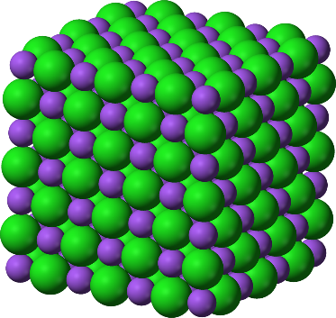

**Amorphous Substances**

When you see a water cooled to freezing point, it takes up the shape of a crystal, when you see a piece of glass, they can take up the shape of a crystal but they are not. This is because unlike crystals, they do not have a definite shape and melting point. The molecules of amorphous substances turned into solids do not take up a regular repeating pattern, instead, they are made up of long chain-like molecules which were intertwined in their liquid state. Crystallization of melted materials can never happen with amorphous materials, that is, unlike crystals, when they are melted and cooled, they will not go back to take up their definite shapes.

