**Class: Js 1**

**Subject: Physical and Health Education**

**Week: One**

**Topic: Sports and Games (Volleyball)**

* **Volleyball**

V

olleyball is a game played with a ball by two teams of six players each of which they are separated by a high net. It can either be played as an indoor or outdoor game. Each team tries to score points by grounding the ball on the opponent’s court under organized rules.

* **Rules and Regulations in Volleyball**

i. The server must serve from the right-hand side of his/her court from the baseline.

ii. The server must serve the ball over the net. If the ball hits the net or it get obstructed by a fellow team mate, the pole or ceiling, it is considered as a fault.

iii. The server must toss the ball before hitting it.

iv. A team must not touch the ball three times before it goes to the opponent side.

v. It is a fault for a player to catch, carry or throw the ball etc.

* **Facilities and Equipment Used in Volleyball**

i. **Volleyball court:** This is a rectangular court which is not too rough or slippery, and has a centre line dividing the court into two.

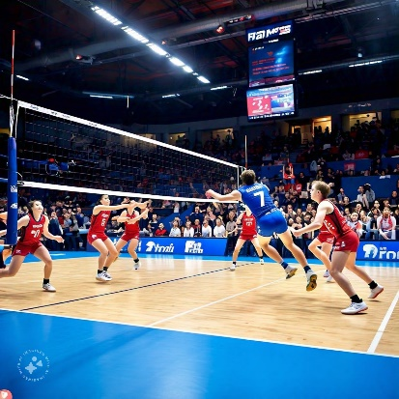

ii. **Volleyball net:** This is a net above the centre line. For women it is 2.24 metres high while for men it is 2.43 metres high.

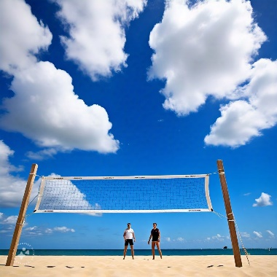

iii. **Volleyball:** This is a soft ball weighing about 260 to 280 grams, with a circumference of 65 to 67cm.

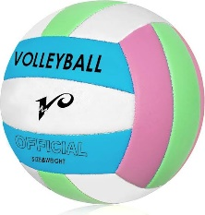

**Week: Two**

**Subtopic: Basic Skills in Volleyball**

i. **Serve:** This is the act of putting the ball to play. It involves a player serving to put the ball in the opponent’s part of the court.

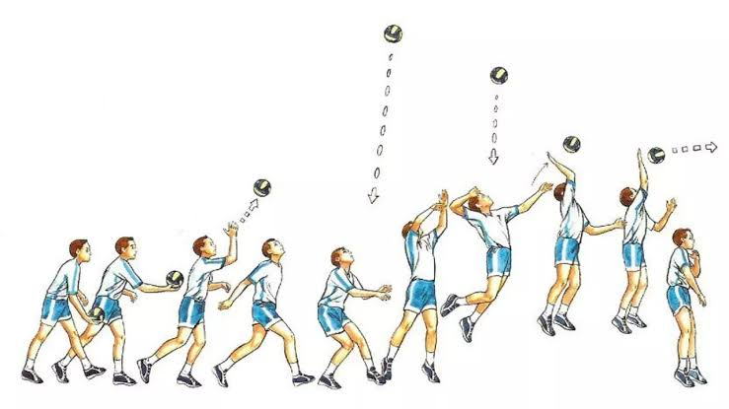

ii. **Pass:** This is also called reception, and it is an attempt to move the ball to a team mate or to properly serve, or to engage in any form of attack.

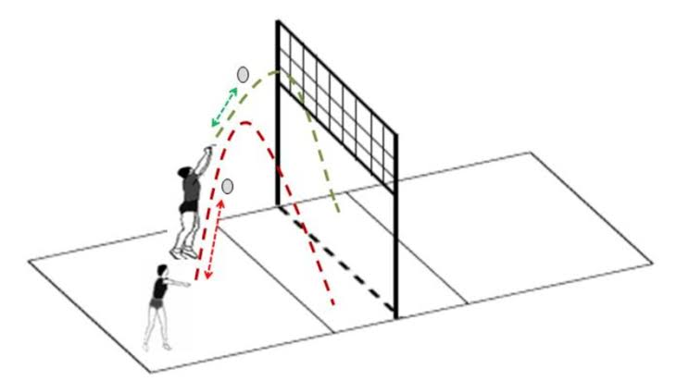

iii. **Attack:** This is also called spike and it is to forcefully strike the ball over the net to land on the opponent’s side of the court.

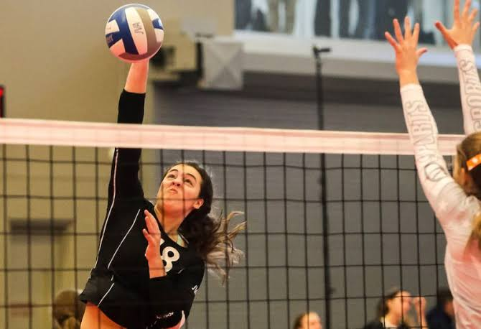

iv. **Set:** This is an act of putting the ball in the air, so that it can be spiked into the opponent’s side of the court.

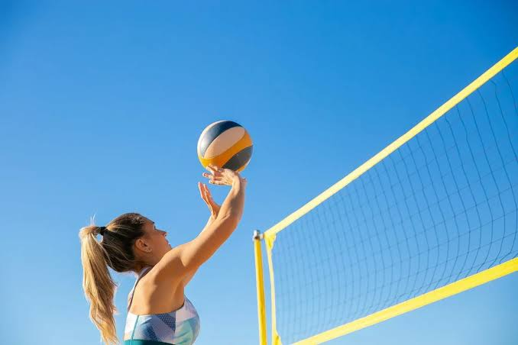

v. **Block:** This is an act of stopping an attack by jumping using both hands to stop the ball at the net.

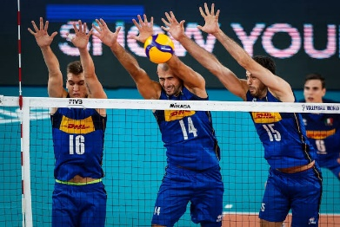

vi. **Dig:** This is an act of preventing the ball from touching one’s side of the court after a spike.

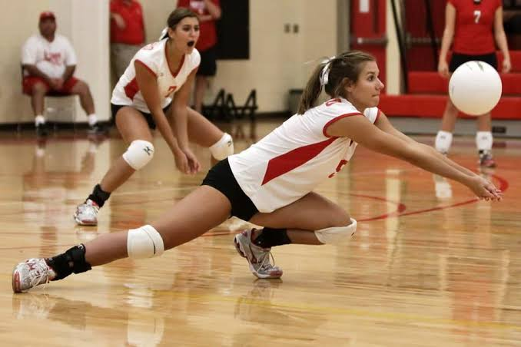

* **Volley Ball Officials and their Duties**

i. **The Scorer:** He or she records the score on the score board, records the final result, records all sanctions and any other important information from the match.

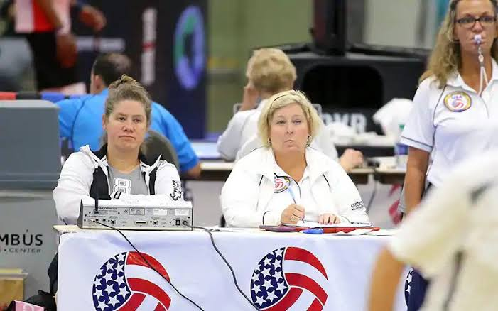

ii. **Lines Judges:** They can be two or four. Four is needed for international competitions. They are positioned diagonally to each other. They raise the flag above their heads to indicate when pall is out of play, they also signal the referee when there are foot faults, service faults etc.

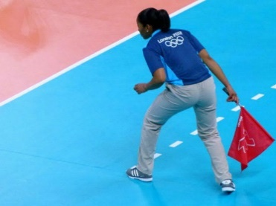

**Week: Three**

**Topic: Sports and Games (Football)**

* **Soccer (Football)**

S

occer or football is a game that originated from England. It is the most popular sport in the world. It involves two teams of eleven players each struggling to get a ball into a goal area (the goal post), thereby to score a goal.

* **Rules and Regulations of Football**

i. **Playing time:** The whole game takes 90 minutes, 45 minutes for each half and 15 minutes at halftime.

ii. **Kick-off:** The game starts with a kick off at the centre of the field and is also used after a goal is scored.

iii. **Free kick:** This is awarded whenever a foul such as handball, kicking the opponent, hitting, pushing etc is committed.

iv. **Goal:** A goal is said to be scored when the ball fully crosses the goal line between the post and below the cross bar.

* **Facilities and Equipment in Soccer**

i. **Football Pitch:** This is a rectangular green grassed field with a dimension of 90 metre by 45 metre. There is also a centre circle of 9.15 metre radius.

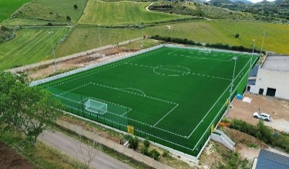

ii. **Football:** This is a leather ball played with the foot which weighs between 396 to 453 grams. It has a diameter between 68cm and 71 cm.



**Week: Four**

**Subtopic: Basic Skills in Soccer (Football)**

i. **Kicking:** This is a basic skill that involve using the foot to send the ball in in a given direction. This is mostly used for goal scoring or to move ball away from the goal area as a means of defence.

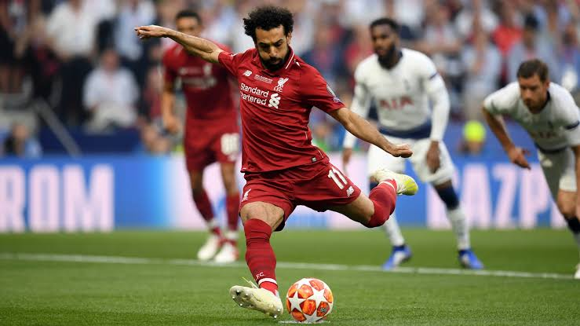

ii. **Passing:** This involves moving the ball around the field among team mates.

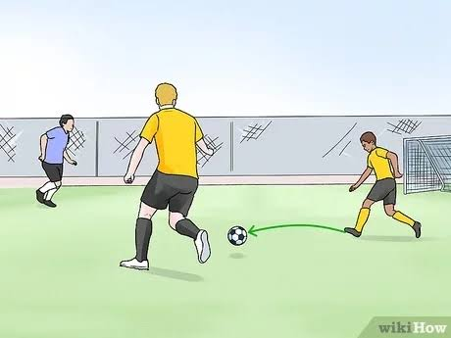

iii. **Trapping:** This is also known as ball control which involves stopping or bringing under control a bouncing, rolling or flying ball.

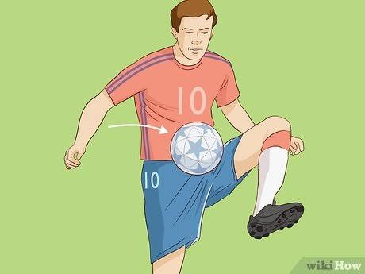

iv. **Dribbling:** This is a skilled way of playing ball to get ball away from the opponent.

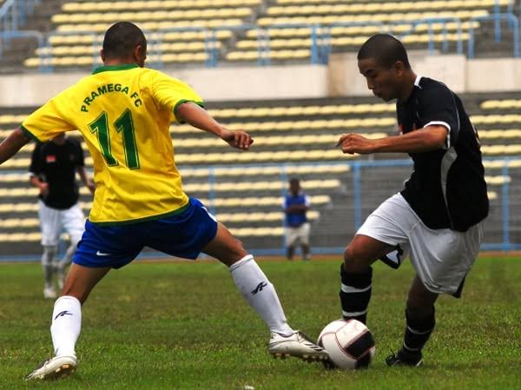

v. **Heading:** This is the act of controlling the ball in the air with the head which can be used to pass or even shoot to score a goal.

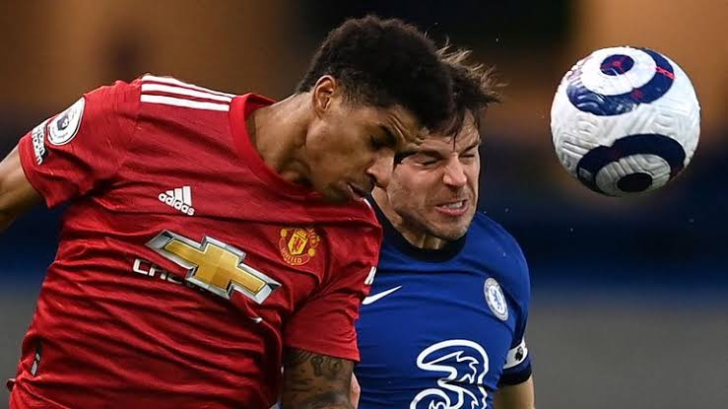

* **Football Officials and their Duties**

i. **The Referee:** Acts as the sole time keeper of the match, rejects unsuitable match equipment, caution players with yellow and red cards in case of fouls etc.

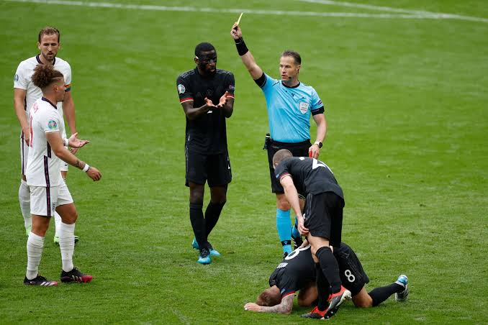

ii. **Substitute Referee:** Takes over the functions of the referee in case he or she is unable to continue.

iii. **Assistant Referee:** These are the two referees always on the side lines. They signal the referee by raising a flag in case of a foul, offside or when the ball is out of play.

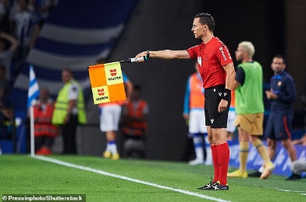

**Week: Five**

**Topic: Environmental Pollution**

* **Introduction**

T

he environment is a natural habitable space where living things such as plants and animals, and non-living things such as air, water, sand etc., naturally occur and reside. Pollution is the process of making air, water and soil dirty through the introduction of harmful substances called pollutant into it. Types of pollution includes air, soil and water pollution.

* **Soil Pollution**

Soil pollution also known as soil contamination is said to occur when pollutant such as industrial waste dumping, mineral exploitation, refuse dumping are released into the soil thereby causing potential harm to the environment, human’s health and at large the ecosystem.

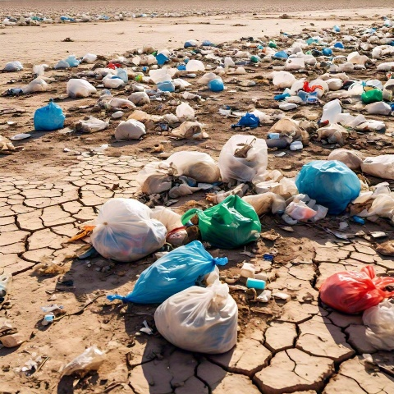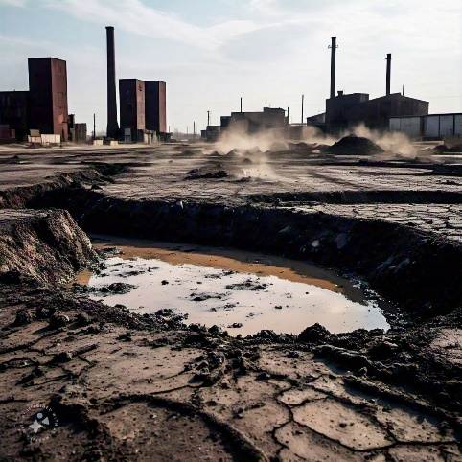

* **Causes of Soil Pollution**

i. **Agricultural activities:** In a bid to prepare the land for a good harvest, pesticides, herbicide and fertilizers can leach into the soil affecting its quality.

ii. **Urbanization:** Constructions and demolition can lead to soil pollution.

iii. **Waste disposal:** Improper disposal of hazardous waste such as batteries and electronics can contaminate the soil.

iv. **Accidental Spill:** chemical spillage either during transportation or storage can pollute the soil.

* **Effect of Soil Pollution**

i. Soil pollution can contaminate groundwater, surface water and even the air.

ii. Exposure to polluted soil can cause a great risk to human health.

iii. Soil pollution can harm plants, animals and even microorganisms.

iv. Soil pollution can reduce the rate of agricultural yield by affecting plant growth and also contaminate food.

* **Control of Soil Pollution**

i. **Proper waste disposal:** it must be ensured that all hazardous wastes are properly disposed through a regulated means.

ii. **Government Policies:** the government must establish and enforce laws to limit the release of pollutant into the soil.

iii. **Use of eco-friendly products:** Individuals can play their part by making use of only eco-friendly products that causes less damage to the soil.

iv. **Organised community sanitation:** Communities can organise clean-up events.

**Week: Six**

**Subtopic: Water Pollution**

This is the introduction of pollutants into water bodies such as lakes, rivers and even the sea. These pollutants can include substances such as pesticides, fertilizers, oil spill, refuse etc.

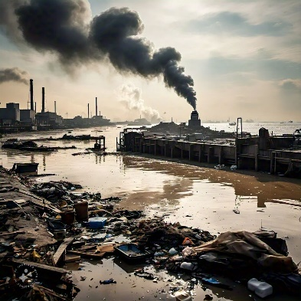

* **Causes of Water Pollution**

i. **Industrial waste:** pollutants from industries which has its sewage disposal pipeline directed towards the river.

ii. **Flooding:** floods can carry pollutants from the land into water bodies.

iii. **Refuse disposal:** human disposal of trash such as plastic bags, bottles etc., into the water bodies.

* **Effect of Water Pollution**

i. It can cause sicknesses such as typhoid, cholera and dysentery.

ii. It threatens the survival of aquatic animals.

iii. It renders water unsafe for domestic and industrial uses.

* **Control of Water Pollution**

i. People should be educated by the government and NGO’s on the effect of water pollution.

ii. Industries should be mandated to never throw off untreated sewage into the river.

iii. Water should be tested and treated by appropriate governmental agencies and NGO’s.

**Week: Seven**

**Subtopic: Water Pollution**

* **Purification of Water**

Water purification can be defined as the process of removing contaminants and other impurities from water thereby making it safe for drinking, cooking and other use.

* **Purpose of Water Purification**

1. To reduce bacterial such as E. coli and Salmonella and other pathogens which causes waterborne diseases.

ii. To reduce heavy metals content such as lead, mercury in water.

iii. To take away taste and odour from water etc.

* **Methods of Water Purification**

i. **Sedimentation:** This involves allowing water to sit for a period of time, allowing the heavy particles to settle to the bottom, hence the clearer water is removed and further treated.

ii. **Filtration:** This involves passing water through a filter such as sand or membrane filter.

iii. **Disinfection:** This method involves adding disinfectant such as chlorine or ozone into water to kill the bacterial in it.

iv. **Distillation:** This involves boiling water and collecting the condensed steam which is free from many contaminants.

**Week: Eight**

**Subtopic: Air Pollution**

Air pollution is said to occur when poisonous substances are released into the air. These substances include smoke or fumes, sulphur dioxide, carbon monoxide, chemicals from factories etc.

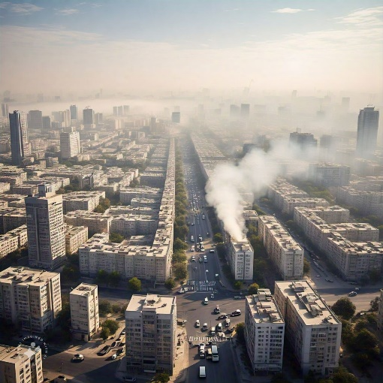

* **Cause of Air Pollution**

i. **Fossil fuel combustion:** burning of fossil fuel such as coal and natural gases.

ii. **Vehicle emission:** smoke emissions from cars, buses, trucks releases pollutants such as carbon monoxide, nitrogen oxide etc.

iii. **Improper waste management:** Opening burning of waste releases harmful substances into the environment.

* **Effect of Air Pollution**

i. Can lead to the irritation of the eyes, nose and even the mouth.

ii. Can cause asthma attack, headache or even dizziness.

iii. Can cause cancer or even cardiovascular problems.

* **Control of Air Pollution**

i. With the creation of hybrid vehicles such as electric cars, we can reduce the emission of air pollutants.

ii. Use of public transport systems, walking or using a bike can help reduce air pollution.

iii. Implementation of pollution taxes for anyone found releasing harmful substances into the air.

**Week: Nine**

**Topic: Safety**

* **Introduction**

S

afety can be defined as the protection of people, properties and the environment from hazard. It involves taking measures to minimize risk and accidents. Safety is needed in various areas such as product safety, workplace safety, personal safety etc. However, for the purpose of this class we shall focus on road safety which includes pedestrians, cyclist and motorist.

* **Importance of Safety**

i. For the prevention of injuries and even death.

ii. For the protection of people’s health and wellbeing.

iii. In order to avoid financial burdens that comes with accidents.

iv. For the protection of our properties.

* **Safety Guidelines for Pedestrians**

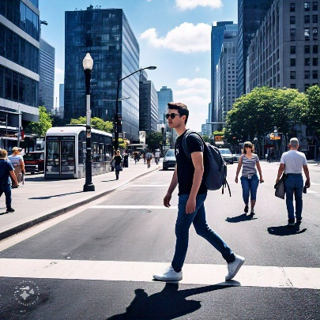

A pedestrian is one who travels on foot. Pedestrians need to understand the rules to keep save as they walk, and they include:

i. **Wear visible cloths:** It is important to wear bright coloured cloth or reflective clothing especially at night so you are visible to drivers.

ii. **Use Pedestrians friendly routes:** These routes have walkways, crosswalks and pedestrian bridges and signals.

iii. **Look left, right and left again:** Check for the traffic before crossing.

iv. **Walk in opposite flow to the traffic:** This enables you to see the condition of forth coming vehicular movements, and also to maintain eye contact with the driver.

**Week: Ten**

**Subtopic: Safety Guidelines**

* **Safety Guidelines for Cyclist**

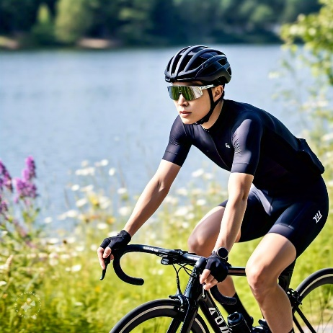

A cyclist is one who rides a bicycle. Cyclist also need to understand rules they must follow for their safety as they travel on their bicycles, they include:

i. **Wear a helmet:** This is a most important safety gear for cyclist as it helps to protect the head in case of an accident.

ii. **Use hand signals:** Always use your hand to indicate your intentions to drivers and to other cyclists.

iii. **Be aware of your surrounding:** Keep a sharp eye out for potholes, speed bump and other things that can cause you to lose control of your bike.

iv. **Check your Bike:** Ensure your bike is in a good condition before using it.

* **Safety Guidelines for Motorist**

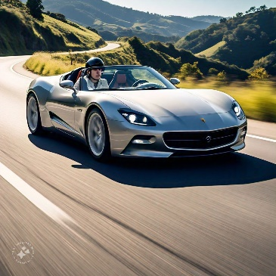

A motorist is one who travels in an automobile. They also have guidelines to follow in other to keep safe as they drive, they include:

i. **Check your vehicle:** The vehicle must be in a good working condition before use. The brakes, tires and fluids must be checked.

ii. **Wear your seatbelt:** This will help to protect you in case of an accident.

iii. **Avoid distractions:** While driving, ensure you don’t use your phones or any other gadget.

iv. **Obey all traffic rules:** These rules include speeding limits, traffic lights and other stop signs.