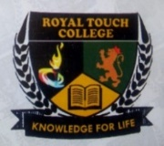**Class: Js 2**

**Subject: Physical and Health Education**

|  |  |
| --- | --- |
| Third Term Scheme of Work | |
| Week 1 | **Communicable Disease**   * Meaning of Communicable Disease * Types of Communicable Disease * Factors that Causes Communicable Disease * General Preventive Measures Against Communicable Disease |
| Week 2 | **Communicable Disease: COVID - 19**   * Definition of COVID - 19 * Causes of COVID - 19 * Symptoms of COVID - 19 * Preventive measure against COVID - 19 |
| Week 3 | **Communicable Disease: HIV/AIDS**   * Definition of HIV/AIDS * Causes of HIV/AIDS * Symptoms of HIV/AIDS * Preventive measure against HIV/AIDS |
| Week 4 | **Communicable Disease: Malaria**   * Definition of Malaria * Causes of Malaria * Symptoms of Malaria * Preventive measure against Malaria |
| Week 5 | **Posture and Postural Defect**   * Meaning of posture * Kinds of Posture |
| Week 6 | **Posture and Postural Defect**   * Characteristics of good posture * Advantages of good posture |
| Week 7 | **Midterm Break** |
| Week 8 | **Posture and Postural Defect**   * Meaning of Posture Defect * Causes of Posture Defect |
| Week 9 | **Posture and Postural Defect: Types of postural defect**   * Kyphosis * Lordosis * Scoliosis |
| Week 10 | **Posture and Postural Defect: Factors that affect correct posture**   * Nutrition * Heredity * Occupation |

**Week: One**

**Topic: Communicable Disease**

* **Introduction**

C

ommunicable disease can be defined as diseases or illnesses that from spread from one person to another or from animals to humans through various means such as touching, through contaminated food, vectors, blood/bodily fluid transfer etc. Types of communicable diseases includes: tuberculosis, HIV/AIDS, hepatitis, measles, malaria, meningitis etc.

* **Factors that Cause Communicable Disease**

i. **Microorganisms:** Bacterial, viruses, fungi, parasites etc., can cause communicable diseases.

ii. **Poor Hygiene:** Poor environmental sanitation, contaminated food and inadequate handwashing can cause communicable diseases.

iii. **Human Behaviour:** Sharing of sharp objects like needles and blades can spread diseases.

iv. **Human-animal Interface:** Direct contact with infected animals or their product can spread disease.

* **General Preventive Measures Against Communicable Disease**

i. **Use Hand Sanitizer:** Always use alcohol-based sanitizers to disinfect your hands from germs and bacterial that can spread disease to you.

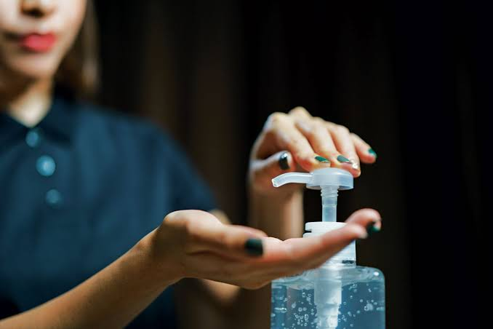

ii. **Vaccination:** Take appropriate vaccination to help immune your system against any wild spreading disease.

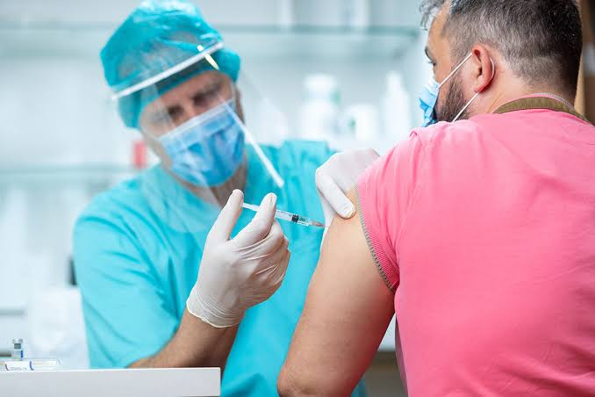

iii. **Use Insect Repellent:** Use this to kill insects and ticks that spread diseases such as mosquitoes.

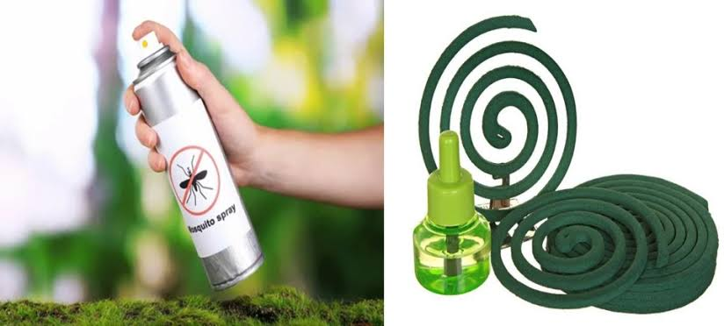

iv. **Maintain Physical Distances:** Do not stay too close to people who have contacted communicable diseases.

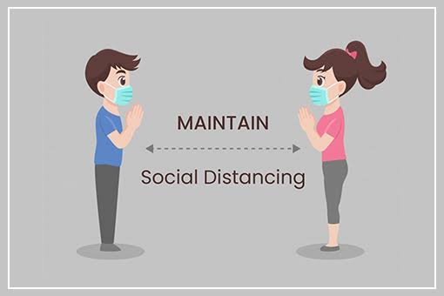

**Week: Two**

**Topic: Communicable Disease: COVID-19**

C

ovid-19 also known as **Corona Virus Disease 2019** is a respiratory illness caused by a virus called the SARS-coV-2 which is an acronym for Severe Acute Respiratory Syndrome Coronavirus 2. This was a virus first identified in China but later spreading across the world causing a pandemic and a total world lock down.

* **Causes of COVID – 19**

i. **Viral Mutation:** This virus is thought to have evolved from bats.

ii. **Animal-Human Transmission:** This virus then transferred to humans through contact with infected animals.

iii. **Human-to-Human Transmission:** This virus then spread rapidly among humans through respiratory droplets and contact with contaminated surfaces.

* **Symptoms of COVID – 19**

i. **Fever:** Infected people normally have raised temperatures up to 38 $℃$.

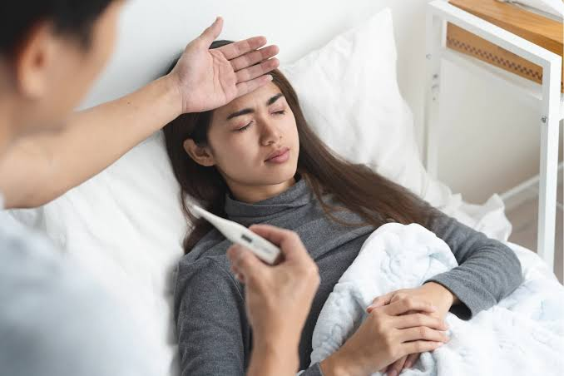

ii. **Cough:** Infected people always have a dry or wet cough which can be mild or severe.

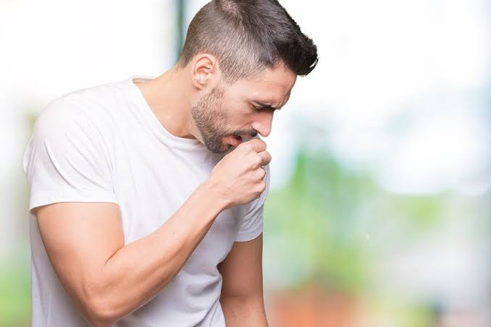

iii. **Runny nose:** Infected people usually have a runny or stuffy nose.

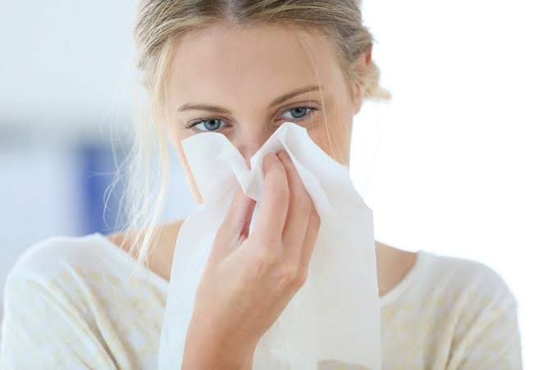

iv. **Diarrhoea:** Infected people usually experience loose or watery stooling.

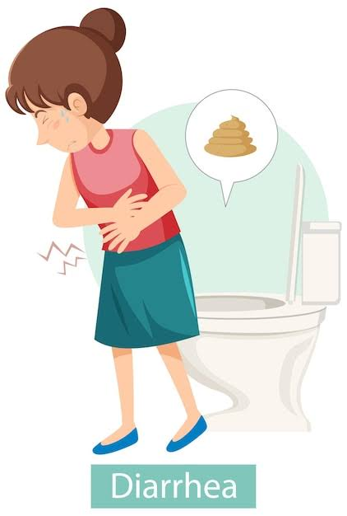

* **Preventive measure against COVID – 19**

i. **Clean and disinfect surfaces:** Using disinfectant, clean surfaces such as the door knob, light switches and other frequently touched places.

ii. **Improve Ventilation:** In workplace or at home, improve ventilation to reduce the transmission of respiratory droplet to another person.

iii. **Avoid travelling to some places:** Places with high records of COVID-19 victims should be avoided.

**Week: Three**

**Topic: Communicable Disease: HIV/AIDS**

H

IV is an acronym for Human Immunodeficiency Virus while AIDS is an acronym for Acquired Immunodeficiency Syndrome. HIV is a virus that specifically attacks cells in the body’s immune system called the CD4, which is a cell that helps the immune system fight off infections. AIDS is just a most advanced stage of HIV.

* **Causes of HIV/AIDS**

i. **Viral Transmission:** HIV is primarily spread through unprotected sex, sharing of sharp objects etc.

ii. **Mother to child transmission:** Offspring of mothers carrying HIV can carry this virus from their mother if the maternal process is not well monitored.

iii. **Blood Transfusion:** Receiving the blood transfusion of unscreened donors who carry the virus can lead to transfer.

* **Symptoms of HIV/AIDS**

i. **Weight loss:** HIV leads to unintentional weight loss.

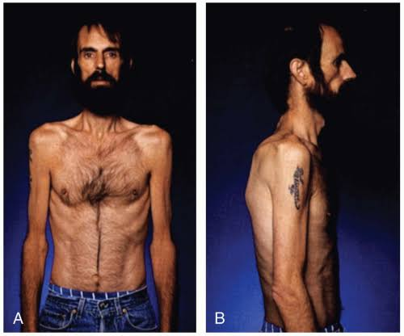

ii. **Skin Problems:** Skin rashes, lesions or infections begins to appear on the skin.

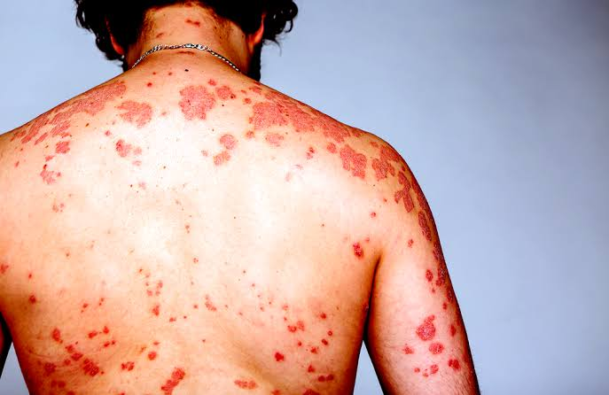

iii. **Neurological problems:** HIV patients experience memory loss and confusion

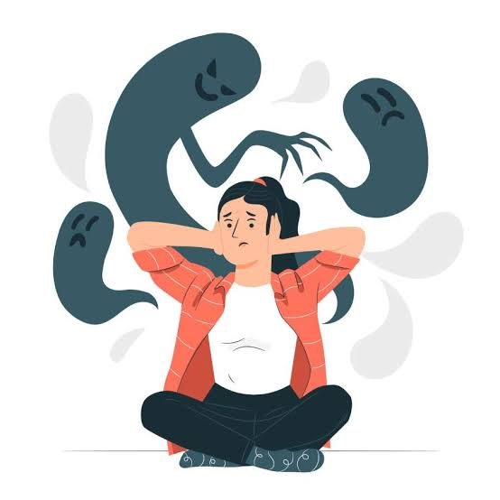

iv. **Fever:** HIV patients experience recurring fever and difficulty in breathing.



* **Preventive measure against HIV/AIDS**

i. **Safe Sex Practices:** Ensure you get married before having sex and know the HIV status of the person you want to get married to.

ii. **Practice Monogamy:** Limit the number of your sexual partner to one to reduce the risk of transmission.

iii. **Get tested:** Go for test regularly to know your HIV status.

**Week: Four**

**Topic: Communicable Disease: Malaria**

M

alaria is a life-threatening disease caused by the transmission of parasites to humans through mosquito bites. **Take note:** Mosquitoes are just vectors that transmit parasite that causes malaria from one human to the other.

* **Causes of Malaria**

i. **Parasite transmission:** This is caused by mosquito bites which transmit the parasite into the human bloodstream.

ii. **Poor Sanitation:** This can contribute to the spread of malaria because mosquitoes breed and multiply in unhygienic surroundings.

iii. **Climate change:** this can alter the habitat and behaviour of mosquitoes making it easy for them to spread malaria.

* **Symptoms of Malaria**

i. **Fever:** Infected people normally have raised temperature up to 38 $℃$.



ii. **Diarrhoea:** Infected people usually experience a loose or watery stooling.



iii. **Chills:** malaria can cause shaking or chills which can be very severe.

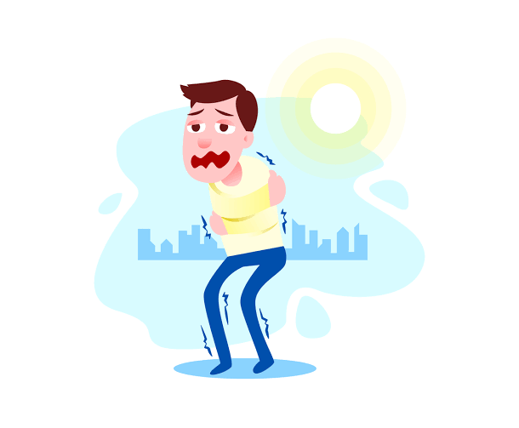

* **Preventive measure against Malaria**

i. **Use treated bed nets:** sleep under insecticide-treated net to prevent mosquito bites.

ii. **Apply insect repellent:** When you want to stay outdoors, apply insect repellent over your body.

iii. **Eliminate standing water:** Remove any stagnant water around your environment to prevent mosquitoes from breeding.

**Week: Five**

**Topic: Posture and Postural Defect**

P

osture can be defined as the position or alignment of the body, particularly the spine while sitting, standing or engaging in various activities. Your posture says a lot about your personality. How you look or feel is directly related to your posture. Posture can either be described as good or bad posture.

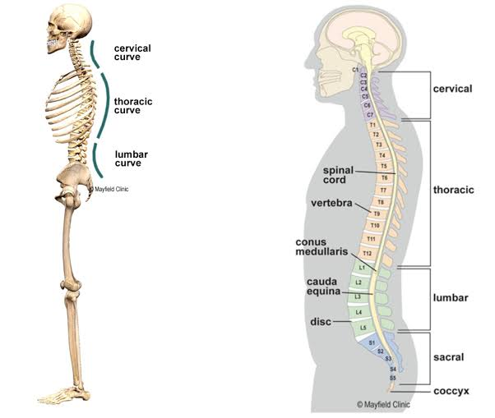

* **Kinds of Posture**

i. **Standing Postures:** This includes the **upright posture** which involves standing with shoulders back, chest out, and head held high; **slouching posture** which involves standing with shoulders slumped, chest caved, and head down, and the **leaning posture** which involves standing with weight shifted onto one leg or leaning on an object.

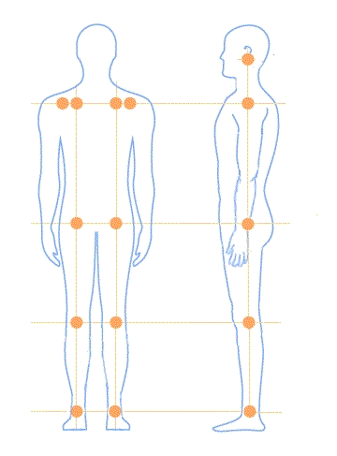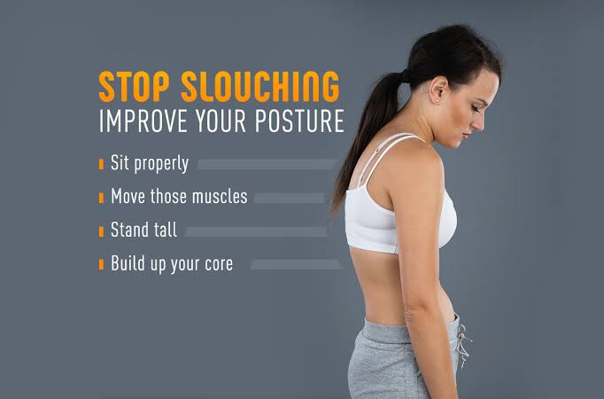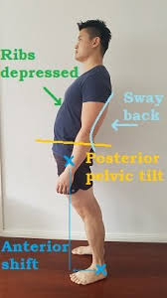

ii. **Sitting Postures:** This includes the **Good sitting posture** which involves sitting with back straight, shoulders relaxed, and feet on floor; **Slouching posture** which involves sitting with back curved, shoulders slumped, and head down, and the **Cross-legged posture** which involves sitting with legs crossed, often used for meditation or relaxation.

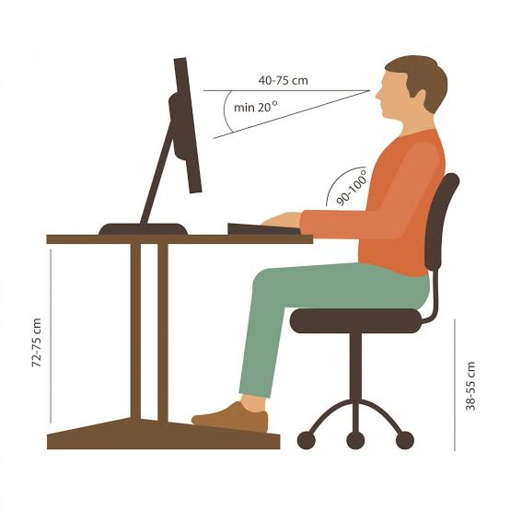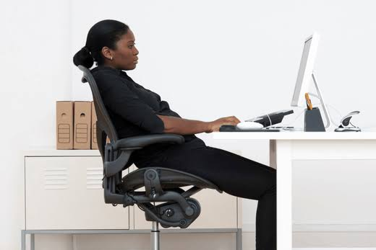

iii. **Lying Postures:** This includes the **supine posture** which involves lying on back with arms and legs relaxed, **prone posture** which involves lying on stomach with arms and legs relaxed, and the **fetal posture** which involves lying on side with knees drawn up to chest.

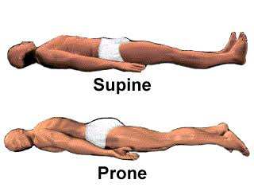

**Week: Six**

**Topic: Posture and Postural Defect**

* **Characteristics of good posture**

Below are some of the characteristics are person must possess which shows they have a good body posture:

i. **Natural Spine Alignment:** This involves a person maintaining the natural curvature of the spine by the alignment of the ears, shoulder, hips and ankles region.

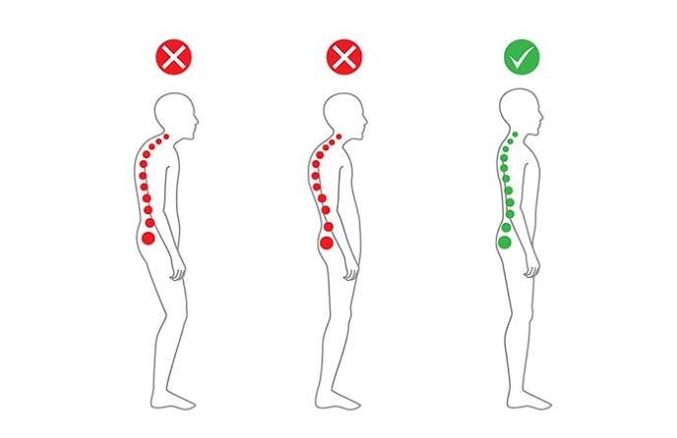

ii. **Relaxed shoulder:** The shoulders should always be relaxed and down.

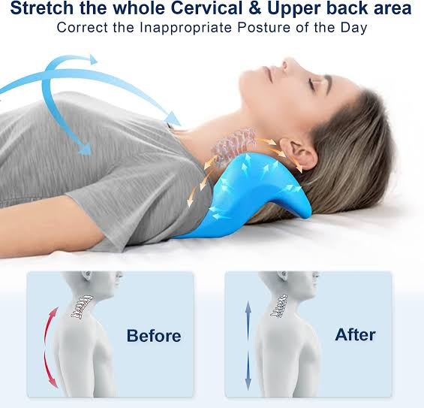

iii. **Good Head Position:** The head should always be held high, one must avoid leaning or tilting forward.

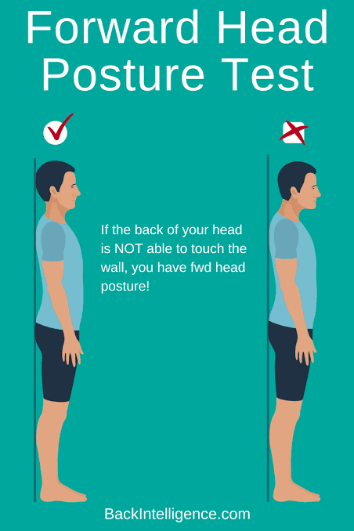

iv. **Open Chest:** The chest should always be opened and expanded, one must avoid slouching or hunching.

* **Advantages of good posture**

i. **Increases Confidence:** When you hold an upright confident posture, you are likely to have more confidence in your thinking.

ii. **More Energy:** Poor body alignment can affect your energy level resulting into quick fatigue. Practicing correct posture helps to reduce your stress level greatly.

iii. **Less Frequent Headaches:** Bad posture creates tension in the upper back, neck and shoulders headaches. So, maintaining good posture can help you avoid unnecessary headaches.

iv. **Easy Breathing:** Slouching reduce the lung capacity, leading to shortness of breath. You need to breath in and out well to maintain maximum productivity in the usage of your brain, and a good posture can help with that.

**Week: Eight**

**Topic: Posture and Postural Defect**

* **Postural Defect**

P

ostural defect also known as postural deformity can be defined as the irregular alignment of the body, particularly the spine which affects an individual’s overall posture. Types of postural defect includes kyphosis, lordosis, scoliosis etc.

* **Causes of Posture Defect**

i. **Injuries or trauma:** Sometimes, injuries and trauma affect the spine which causes a misalignment from their natural arrangement.

ii. **Poor posture habit:** Prolonged period of poor postural habit such as slouching can affect the spine permanently.

iii. **Genetic condition:** Some genetic conditions such as scoliosis and autism can affect the spine leading to postural defect.

iv. **Improper child delivery:** Sometimes, when women are not delivered of their babies through professionals and the babies are mishandled, they carry postural defect.

**Week: Nine**

**Topic: Posture and Postural Defect**

* **Types of postural defect**

i. **Kyphosis:** This is an excessive outward curve of the upper back region also known as the thoracic spine. Symptoms of kyphosis includes back pain, breathing difficulties, fatigues etc. This can be corrected through physical therapy to correct the posture, surgery or exercise that helps one stretch to improve good posture.

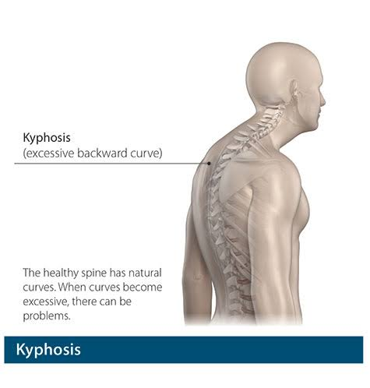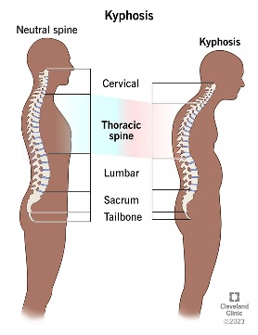

ii. **Lordosis:** This is an excessive inward curve of the lower back region also known as the lumbar spine. Lordosis can be caused by one maintaining a poor posture, muscle imbalance etc. Symptoms of Lordosis also include breathing difficulties, back pain etc. Lordosis can be corrected through bracing, surgery, physical therapy etc.

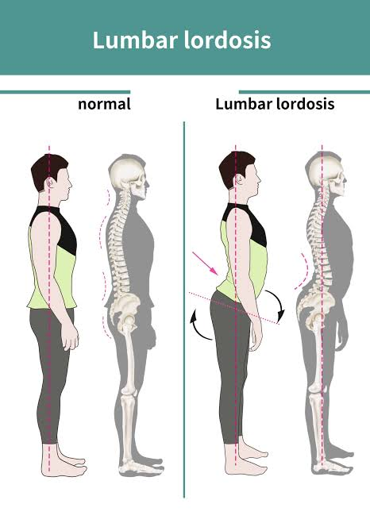

iii. **Scoliosis:** This is the abnormal sideways curve of the spine. The curve can be C-shaped or S-shaped, and can occur in any part of the spine. Symptoms of Scoliosis also include breathing difficulties, back pain, fatigue etc. This can also be corrected by bracing, physical therapy, surgery etc.

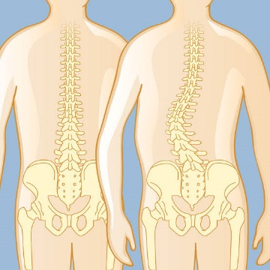

**Week: Ten**

**Topic: Posture and Postural Defect**

* **Factors That Affect Correct Posture**

i. **Nutrition:** The food we eat matters if we must maintain good posture. We need to feed on diets that gives to us strong bones, diets that contain iron and calcium.

ii. **Heredity:** Due to genetic issues, some children might become prone to certain postural issues. This is one of the things marital partners must take into consideration before marriage. Also, offspring still in the womb should be well monitor to correct any imbalance while forming in the womb.

iii. **Occupation:** Some occupations can greatly influence good posture while others don’t. For example, sport like occupations can aid you to have good posture because it demands consistent exercising and stretching.

iv. **Sleep:** Always sleep on a supportive mattress and use a comfortable pillow to help improve your posture. Poor sleeping habits affect posture.

v. **Weight:** Excess weight canput strain on the body hence to affect posture.