### **Lesson Note for SS2: Concept of Computer Files**

#### **Topic: Concept of Computer Files**

#### **Objectives**

By the end of the lesson, students should be able to:

1. Define a computer file.
2. Identify and describe types of data items.
3. Explain file structure organization.

#### 



**Definition**

A computer file is a collection of related data or information stored on a storage medium, such as a hard drive or a flash dri ve.

**Example**: .txt, .jpg, .mp3, .mp4, .doc, .exe, etc.

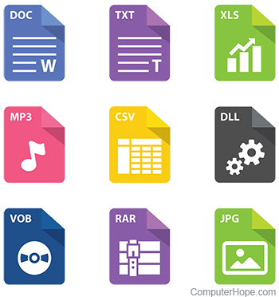 File Formats

**Types of Data Items**

Data items are the smallest units of information in a file. Types of data items include:

* **Numeric Data**: Consists of numbers only (e.g., 123, 45.67).
* **Alphabetic Data**: Consists of letters of the alphabet (e.g., A, John).
* **Alphanumeric Data**: Consists of a combination of letters, numbers, and special characters (e.g., A123, John-56).
* **Binary Data**: Images, audio, video.

**File Structure Organization**

File structure refers to how data is organized within a file.

* **Sequential File Organization**: Data is stored in a specific order. Eg. Payroll Processing.

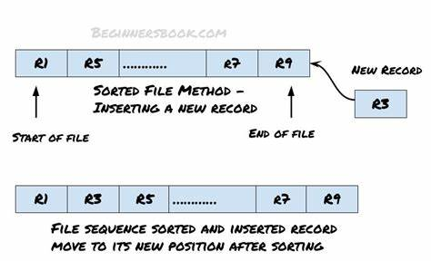

* **Indexed File Organization**: Data is stored with an index to allow faster access. Eg. Library Management System.

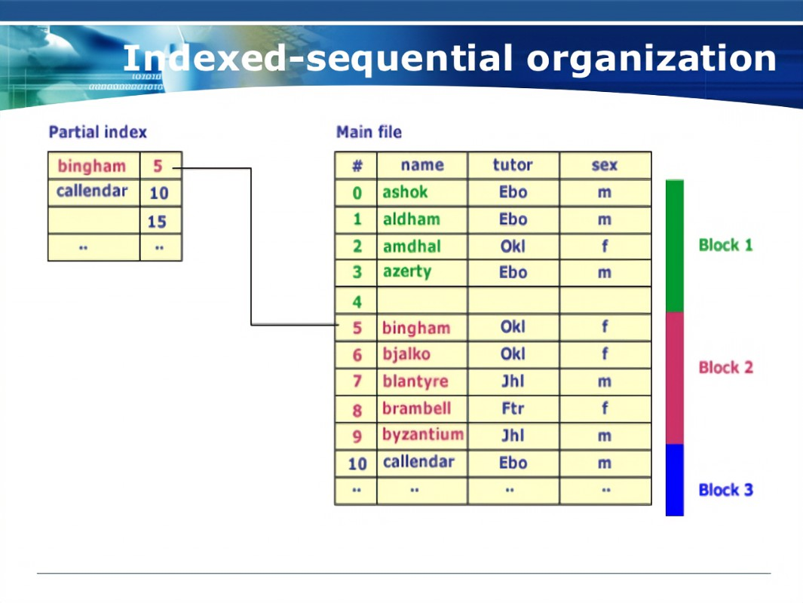

* **Direct/Random Access File Organization**: Data can be accessed directly without reading through other data. Eg. Database Records, Playing a music playlists stored on a CD

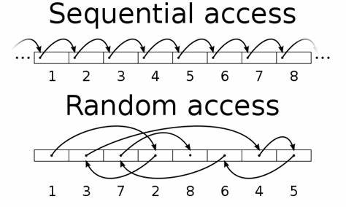

#### **Classification of Computer Files**

Computer files can be classified into the following categories:

1. **Based on Content:**
   * **Text Files:** Contain plain text, readable by text editors (e.g., .txt).
   * **Binary Files:** Contain data in a format only readable by specific programs (e.g., .exe, .bin).
   * **Image Files**: Store graphical data (e.g., .jpg, .png, .gif).
   * **Audio Files:** Store sound data (eg. .mp3, .wav, .aac, .flac)
   * **Video Files:** Store video data (eg. .mp4, .avi, .mkv, .mov
2. **Based on Purpose:**
   * **System Files**: Essential for the operating system's functioning (e.g., .sys, .dll).
   * **Application Files:** Store information used by specific programs (e.g., .docx, .xlsx, .pptx).
   * **Configuration Files**: Store settings and preferences (e.g., .ini, .cfg).
3. **Based on Storage:**
   * **Master Files:** Store permanent data used for long-term records (eg. data stored secondary memory)
   * **Transaction Files:** Contain data for short-term processing (eg. Cache files, temporary internet files, session files.
   * **Backup Files:** Copies of important data for recovery purposes (eg. system restore points)

**File Hierarchy**

The hierarchy from smallest to largest unit is:

* **Data Item**: The smallest unit of data, representing a single value.
* **Field**: A collection of related data items that represent one attribute of a record.
* **Record**: A collection of fields that represent a complete set of information about an entity.
* **File**: A collection of related records.

**Handling Computer Files**

### 

### **Introduction**

Managing computer files efficiently requires knowledge of basic operations and the steps involved in creating and accessing files.

#### **Basic Operations on Computer Files**

Computer files are subject to several basic operations, including:

1. **Creating Files:** Establishing a new file on a storage medium to store data.
2. **Opening Files:** Accessing a file to read, write, or modify its contents.
3. **Reading from Files:** Retrieving data stored in a file. Eg. copying or moving files
4. **Writing to Files:** Adding or modifying data within a file.
5. **Closing Files:** Ending the current access session to free system resources.
6. **Deleting Files:** Removing files permanently from storage.

#### 

#### **Steps Involved in Creating a Sequential File**

A sequential file is a file where data is stored in a linear, ordered manner. The process for creating a sequential file includes:

1. **Open a Text Editor**: Use any text editor you prefer, such as Notepad (Windows), TextEdit (macOS), or Gedit (Linux).
2. **Write Data**: Type the data you want to store in the file. For example:  
    Hello, World!

This is a sequential file.

Each line is written one after the other.

1. **Save the File**: Save the file with a .txt extension. For example, example.txt.

#### 

#### **Steps Involved in Accessing a Sequential File**

Accessing a sequential file involves reading its content from the beginning to the end:

1. **Open the Text Edito**r: Open the same text editor you used to create the file.
2. **Open the File**: Use the text editor’s “Open” function to open the example.txt file.
3. **Read Data**: The text editor will display the contents of the file sequentially, just as you wrote them.
4. **Close the file**

**WEEK 4, 5 & 10**

**Topic:** File Security

**Instructional Objectives:** By the end of the lesson, students should be able to:

1. Explain the effects of file insecurity.
2. Describe methods of ensuring file security.
3. Differentiate between computerized files and manual files.
4. List the advantages of computerized files.
5. State the limitations of computerized files.

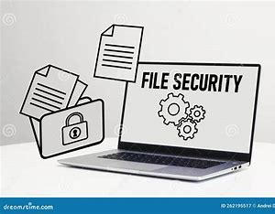

#### **Introduction**

**File Security** is the process of protecting files from unauthorized access, corruption, or loss.

#### **Effects of File Insecurity**

1. **Loss of Data** – Important files can be deleted or corrupted.
2. **Unauthorized Access** – Sensitive information can be stolen.
3. **Financial and Legal Implications** – Breaches can result in fines or financial losses.
4. **Reduced Productivity** – Time is lost recovering compromised data.

#### **Methods of File Security**

1. **Password Protection** – Securing files with strong passwords.
2. **Encryption** – Converting data into unreadable formats.
3. **Regular Backups** – Creating copies of files to restore data.
4. **Access Control** – Restricting who can read or modify files.
5. **Antivirus Software** – Protecting against malware.

**Types of Files**

There are two types of files:

1. **Computerized File:** Data is stored electronically on computers, servers, or cloud storage.

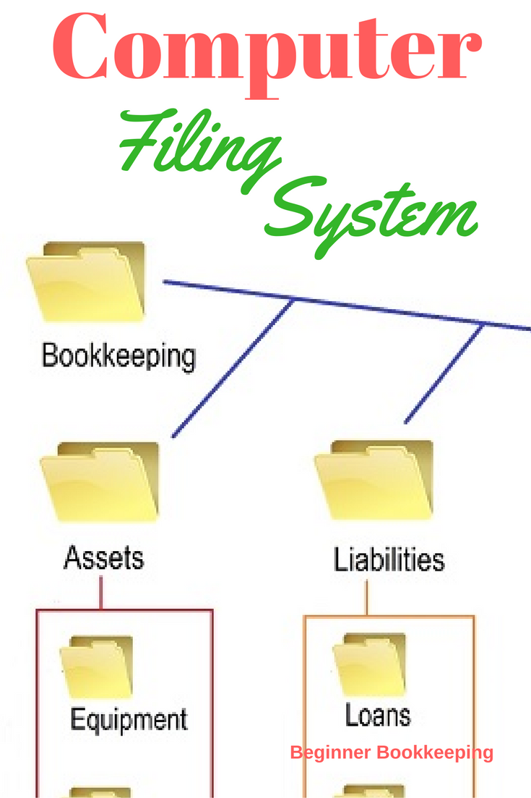

1. **Manual Files:** Data is stored physically in paper files, folders, or cabinets.

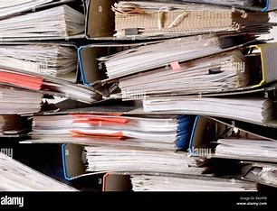

#### **Differences Between Computerized and Manual Files**

|  |  |  |
| --- | --- | --- |
| **Aspect** | Computerized Files | Manual Files |
| **Storage** | Electronic storage (hard drives, cloud) | Paper-based storage |
| **Access Speed** | Fast | Slow |
| **Data Security** | Uses encryption and passwords | Vulnerable to physical theft |
| **Editing** | Easily Modified | Time Consuming |

#### **Advantages of Computerized Files**

1. Faster data access and processing.
2. Improved data accuracy and editing.
3. Easier data sharing and management.
4. Space-saving and reduced clutter.

#### 

#### **Limitations of Computerized Files**

1. Risk of data loss due to system failure.
2. Vulnerability to cyber threats and hacking.
3. Dependence on electricity and technology.
4. High initial setup costs.

**Assignment:** Explain how encryption ensures file security works

**WEEK 10**

**TOPIC: Alternative Logic Gates – XOR Gate**

**Definition of XOR Gate**

An Exclusive OR (XOR) gate is a digital logic gate that outputs true (1) if and only if the inputs are different (i.e., one is 1 and the other is 0). If both inputs are the same (both 0 or both 1), the output is false (0).

**Symbol of XOR Gate**

The standard logic symbol for the XOR gate is:

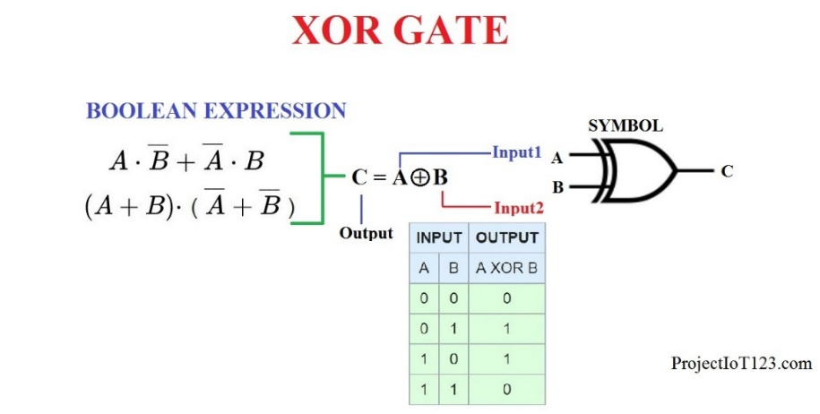

**XOR Gate Truth Table**

| Input A | Input B | Output (A ⊕ B) |
| --- | --- | --- |
| 0 | 0 | 0 |
| 0 | 1 | 1 |
| 1 | 0 | 1 |
| 1 | 1 | 0 |