WEEK ONE-FOUR

**Igbo-Ukwu Culture**

**1. Meaning and Location** Historical sites are places that have **important events**, **artifacts**, or **structures** from the past. They help us understand the history, culture, and lifestyle of people who lived long ago.

**2. What is Igbo-Ukwu?** \***Igbo-Ukwu** is a **town in Anambra State**, in the **southeastern** part of Nigeria. *It is famous for its **ancient artifacts** made of **bronze**, **beads**, and **terracotta**. *These items were **discovered in 1938** by a man named **Isaiah Anozie**, a local farmer.

### ****3. The Discovery \*****While digging a well, Isaiah Anozie found **unusual metal objects**. *Later, archaeologists (people who study ancient objects) examined the site. *They found many **artworks and tools** that were about **1,000 years old**.

### ****4. What Makes Igbo-Ukwu Special? \*****The bronze works found there are **very advanced**, even **older** than those from Benin. *The objects show that the people of Igbo-Ukwu had: \***Good knowledge of metalworking *Trade links** with other parts of Africa and beyond *A rich **religious and cultural life**

### ****5. Some Artifacts Found** Bronze pots, Ornaments and jewelry, Beaded necklaces, Sacrificial bowls, Terracotta (clay) sculptures**

### ****6. Importance of Igbo-Ukwu \*****It shows that **African societies** were **advanced** before contact with Europeans. *It helps us understand **Igbo history and culture**. *It is an important site for **tourism and education** in Nigeria

### ****7. Preservation \*****The artifacts are preserved in **museums**, including the **National Museum in Lagos** and the **British Museum in London**. *Efforts are being made to protect the site for **future generations**.

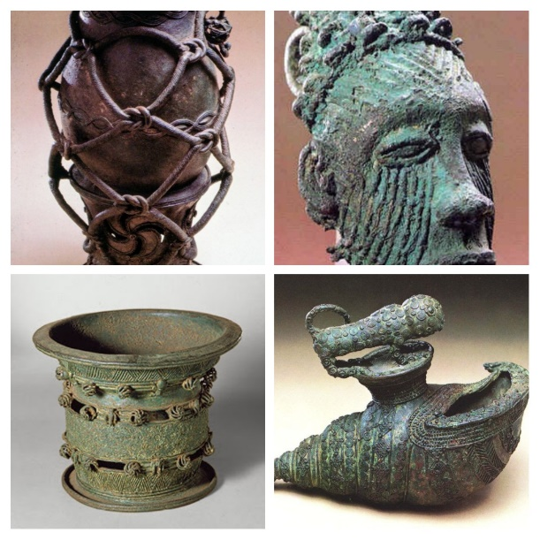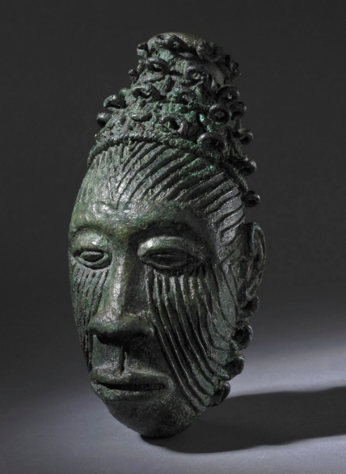 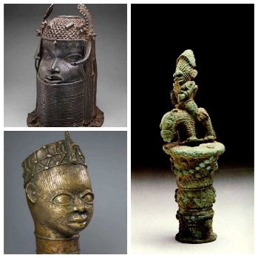

WEEK FIVE

IGBO UKWU OCCUPATIONAL ACTIVITIES

1. **Metalworking (Bronze Casting and Blacksmithing)**
   * Igbo-Ukwu is best known for its **advanced bronze work**, which was discovered by archaeologists in the 20th century.
   * The people created beautiful **bronze artifacts**, including **pots, jewelry, staffs, and ritual vessels**.
   * These items showed a high level of **artistic skill and technology**, even before contact with Europeans.
2. **Farming (Agriculture)**
   * Farming was a major occupation among the Igbo-Ukwu people.
   * They grew crops such as **yam, cassava, maize, cocoyam, and vegetables**.
   * They practiced **subsistence farming**, meaning they mostly produced food for their own use.
3. **Hunting**
   * Hunting was another important occupation.
   * Hunters provided **meat and animal skins** used for food, clothing, or trade.
   * They used **traps, spears, and bows and arrows** to catch animals.
4. **Fishing**
   * For communities near rivers or streams, fishing was common.
   * Fish served as a major source of **protein** for the people.
   * They used **nets, hooks, and baskets** to catch fish.
5. **Pottery Making**
   * Women were mainly involved in making **clay pots and other utensils**.
   * These items were used for **cooking, storing food, and rituals**.
   * Pottery was also a trade item in local markets.
6. **Weaving and Cloth Making**
   * The Igbo-Ukwu people made **cloths and mats** from local materials.
   * They wove **baskets, mats, and other items** used in daily life and ceremonies.
7. **Trading**
   * Trade was an important occupation in Igbo-Ukwu.
   * They traded **bronze items, farm produce, pots, and cloths** with neighboring communities.
   * This shows that the people had an early form of **local and long-distance trade**.

**Importance of Occupational Activities in Igbo-Ukwu**

* Helped in the development of **early civilization** in Nigeria.
* Supported **community growth** and interaction with neighbors.
* Encouraged the development of **skills and technology**.
* Helped preserve **Igbo cultural heritage** through artifacts.
* Promoted **economic and social life** in ancient times.

**WEEK SIX** **SIGNIFICANCE OF IGBO UKWU CULTURE IN NIGERIA HISTORY**

1. Evidence of Early Civilization
2. Advanced Metal Technology
3. Cultural and Artistic Achievement
4. Trade and Economic Development
5. Religious and Political Organization
6. Pride in Nigerian Heritage
7. Contribution to Archaeology and African Studies