**WEEK 10**

**TOPIC; CALL OF MOSES FOR THE FREEDOM OF ISREAL ; Exodus 3: 1- 15**

**BIRTH AND EARLY LIFE OF MOSES**

After the death of Joseph in Egypt. Another leader (pharaoh) emerged. This new pharaoh did not know Joseph and his accomplishments in Egypt. He saw how the Israelites were enlarging and feared that ISREAL would take over Egypt and dis-inherit them of their father's land.

He therefore made laws against the birth of a male child among the Israelites in order to reduce the number of their military force.

Moses was born to a Levites parents; Amram and Jochebed at the time of this abnormal law by pharaoh. His mother hid him for three months, and then put him in a water proof basket and kept him by the river bank. She instructed his sister Mariam to watching over him.

Pharaoh's daughter discovers him , took him and through Miriam's intervention got him back to his mother to nurse him (without knowing she was his biological parents), she at this point freely and openly cared for him, and return him back to her after he was weaned.

When Moses was grown , one day he noticed an Egyptian fighting an isrealites, He killed the Egyptian, the next day when he saw two lsrealiites fighting and tried to separate them. He was surprised when he was confronted by his action of the previous day.

At this revelation, Moses feared that he would be killed by pharaoh, hence he excaped to Midian where he found and got married to ZIPPORAH the daughter of Jethro ,priest of Midian, and had two sons ; Gershom and Ephraim.

**CALL OF MOSES**

One day while Moses was taking care of his father in-law sheeps in the bush , God appeared to him in form of a fire (a burning bush that is not burnt). And told him to go back to Egypt and deliver the isrealites from pharaoh.

Accompanied by Aaron his brother , Moses met with pharaoh and negotiated the freedom of the Hebrews. When pharaoh proved stubborn , God sent ten different plagues (disease and affliction) to force pharaoh into submission. Pharaoh submitted to the will of God after the tenth plague which was the killing of all the first born of the Egyptians. Passing so many test in the wilderness, Moses lead the Isrealites half way to their promised land , Joshua took over and lead the survivals to the promised land of Canaan.

Moses crusade as a freedom fighter is a good example of a leader who had faith in God's direction and guidance.

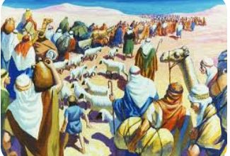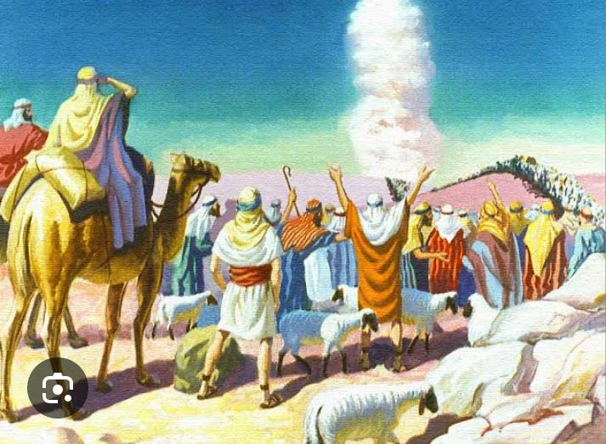

**Home fun**

Write the Ten Commandment in sequence.

**Class Activities:** Story of Deborah and Barak leading the people Of ISREAL to freedom ; Judges 4