

**Subject: Physics**

**Class: SS 1**

**Week: One**

**Topic: Elastic Properties of Solid**

T

he elasticity of a body can be defined as the ability of that body to regain its original shape and size after undergoing a stretch or compression. This elasticity is well explained and demonstrated by **Hooke’s Law**.

***Hooke’s law states that provided the elastic limit is not exceeded, the extension (e), in an elastic material is directly proportional to the load of the body or the force applied (F).*** It is mathematically related as:

***F* α *e***

***F* = *ke***

**⸫ *k* = (Nm-1)**

Where ***k*** is the elastic constant of the material of whose elasticity must not be exceeded.

From Hooke’s law, when a stretching force (*F*) was applied to a wire, the extension (*e*) of the wire was equal to the weight of the load exerting the force on the string being stretched. When this load is taken away from the sting, the wire regains it original shape. However, this process of elasticity may not continue indefinitely if the load causing the extension on the wire is too much for the wire to bear, hence the extension is no longer directly proportional to the applied force. At this stage, the wire is said to have lost its elasticity or have reached elastic limit.

**The graph below shows the properties of a strained elastic wire:**

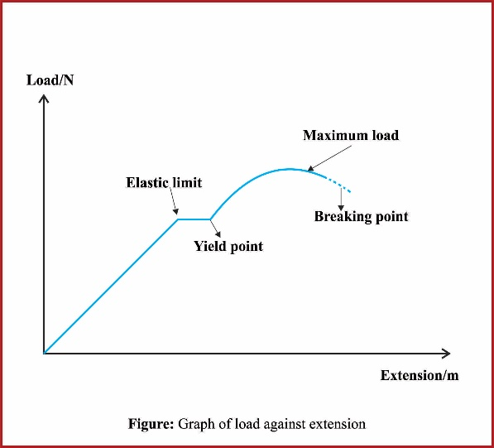

**What to take note of in the graph above:**

1. Up to the elastic limit, Hooke’s law still applies;

2. Beyond the elastic limit, the wire stretches permanently and if the load is removed, it will not return to the original length;

3. From the yield point, small increase in load will produce large extension;

4. The breaking point is the pointed reached where the wire can no longer stand any further increase in load, and the wire breaks.

Hooke’s law has found it application in many areas of life especially in ascertaining the weights of material. Other applications of Hooke’s law are found in: manometers, spring scales etc.

**Examples:**

1. A spring of natural length 3 m is extended by 0.01 m by a force of 4N, what will be its length when the applied force is 12N.

**Solution**

When *F* = 4N and *e* = 0.01 m

*k = $\frac{F}{e}$*

***k =***  = 400 Nm-1

When *F* = 12N and *k* = 400 Nm-1

*F = ke*

12 = 400 *e*

*e* = = 0.03m

Length = 3m + 0.03m = 3.03 m

2. An elastic wire extends by 1.0cm when a load of 20g hangs from it, what additional load will be required to cause a further extension of 2.0cm?

**Solution**

F = 20 grams (converting to Newton where 100g = 1 N); ⸫ F = $\frac{20}{100}=0.2 N$

$e_{1}$ = 1.0 cm = 0.01 m

$e_{2}$ = 2.0 cm = 0.02 m

*For the initial load of 0.2 N*

*k =*

=

= 20 Nm-1

*To get the weight of the additional load which caused a string extension of 0.02m, let weight be M (kg)*

F = Ke

(0.02 + M) 10 = K $×$ ($e_{1}+ e_{2}$)

0.2 + 10M = 20 $×$ (0.01 + 0.02)

0.2 + 10M = 20 $×$ 0.03

10M + 0.2 = 0.6

10 M = 0.6 – 0.2

10M = 0.4

M = $\frac{0.4}{10}$ = 0.04kg

= 40g

* **Young Modulus**

Suppose a force of F (in Newton) applied to a wire of original length lo (in meters) and a cross-sectional area A (in m2) extends in length by e (m), we can state Hooke’s law as:

$$\frac{F}{A}∝\frac{e}{l_{o}}$$

$$\frac{F}{A}=E\frac{e}{l_{o}}$$

Where **E** is a constant known as the young modulus

***Cross Multiplying***

F $×$ lo= E $×$ e $×$ A

***Dividing both side by e $×$ A***

E = $\frac{F × l_{o} }{e × A}$

E = $\frac{F}{A}$ $×$ $\frac{l_{o}}{e}$

E = $\frac{F}{A}$ $÷$ $\frac{e}{l_{o}}$

But $\frac{F}{A}$ = tensile stress and $\frac{e}{l_{o}}$ = tensile strain

⸫ E = $\frac{tensile stress}{tensile strain}$

* **Work Done in Springs and Elastic String**

Work is done when an elastic material is stretched or compressed. If the force stretching the material is F and the extension of material is e, work done is given by:

Workdone = average force $×$ extension

= $\left(\frac{0+F}{2}\right) ×e$

= $\frac{1}{2}$*Fe*

But F = Ke

$⸫ \frac{1}{2}$*ke $×$ e*

*Work done = $\frac{1}{2}$*  *k $e^{2}$*

**Examples:**

1. If a spring has a stiffness of 950 Nm-1, what work will be done in extending the spring by 60mm.

**Solution**

K = 950 Nm-1; e = 60mm = = 0.06 m

*Work done =*   *950*

= 1.71 J

2. A spring is stretched 40mm by a force of 15N, what is the work done by the force?

**Solution**

F = 15N; e = 40mm = $\frac{40}{1000}$ = 0.04m

Workdone = $\frac{1}{2}$*Fe*

*= $\frac{1}{2}$ $×15×0.04$*

= 0.3 J

**Assignment**

1. A spring 20cm long is stretched to 25cm by a load of 50N, what will be its length when stretched by 100 N assuming that the elastic limit is not reached?

2. If a force of 100N stretches a spring by 0.1cm, find:

a. the elastic constant

b. The work done in stretching the spring 0.3cm if the elastic limit is not exceeded.

**Week: Two**

**Topic: Fluids at Rest and in Motion**

U

nder fluids at rest, we shall discuss phenomena such as the surface tension and capillarity while for fluid in motion, viscosity, and also know their relevant applications.

* **Surface Tension**

Surface tension is the tension or force acting along the surface of a liquid. The surface of a liquid behaves as if it were covered by an elastic skin, the surface thus appears to be under some force or tension. For example, if a steel needle with density greater than a liquid were to be placed gently on the surface of the liquid, it rests there as though being supported by the surface of that liquid, and the liquid behaves as though it has an elastic skin. Also, some insects can walk on the surface of water, their feet make some marks in the surface but do not penetrate it. All these are examples of surface tension. Intermolecular force such as Van der Waals force is responsible for surface tension.

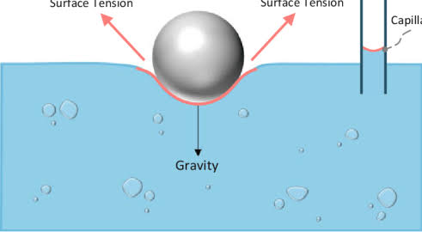

**Figure: Needle on the Surface of Water**

The coefficient of surface tension T is defined as the force (N) acting on a metre length drawn on the surface. It is mathematically related as: T = (Nm-1) Where F is force and L is length.

**Surface tension can be decreased by:**

1. Increase in the temperature of the liquid;

2. Adding detergent to the liquid.

**Some Application of Surface Tension**

1. Medicine: by measuring the tension of saliva, it can be used to diagnose dehydration, diabetes and other conditions,

2. Rainproof materials: They are used to create materials such as umbrellas and tents where surface tension will bridge the pores in the tent or umbrella material,

3. Cleaning cloths: Washing cloths by detergent or soap lowers surface tension of the water.

* **Capillarity**

Capillarity is defined as the tendency of liquids to rise or fall in narrow capillary tubes. If a very narrow glass tube is inserted in a beaker of water, it rises up the tube and its surface is concave. If an identical tube is placed in a beaker of mercury, the surface is convex to the air and is depressed below the outside level. This is brought about by a phenomenon called **cohesive** and **adhesive** forces.

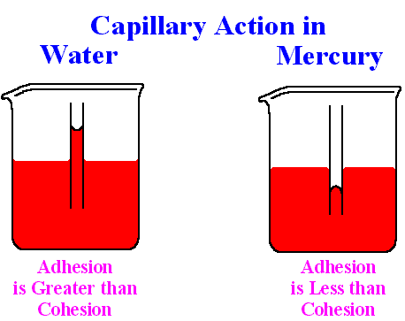

**Figure: Action in Capillarity**

**Adhesion and Cohesion**

The force of attraction between molecules of the same substance is called **Cohesion**, while the force of attraction between molecules of different substances is called **Adhesion**. Adhesion of water to glass is stronger than the cohesion of water, hence, when water is spilled on a clean glass surface, it wets the glass. On the other hand, cohesion of mercury is greater than its adhesion to glass, thus when mercury spills on a glass surface, it forms small spherical droplets and does not wet the glass.

Water which wets glass will rise in a capillary tube because the force of adhesion between the water and the glass is greater than the force of cohesion between the water molecules. On the other hand, the cohesion of mercury molecule is greater than their adhesion to glass, hence the meniscus curves downwards and the mercury becomes depressed in the tube.

**Examples of Capillary Actions**

1. Water rising up the stem of a plant,

2. Ink held on the nib of a pen,

3. Blood spreading through the fine capillary channels in the body,

4. Rise of mercury in thermometer;

5. Rise of kerosene through the wool of a stove or lantern etc.

**Viscosity – Friction in Fluid**

Viscosity is the name given to internal friction which exists between layers of a liquid or gas in motion. Liquids that flows and pour slowly are called viscous liquids, for example, engine oil. Other liquids such as water and kerosene are said to be less viscous. The viscosity of a liquid are also great factors that influences surface tension and capillarity of that liquid.

**Application of Viscosity**

One of the greatest applications of viscosity is to reduce friction between two surfaces in contact with each other. For example, lubricating the surfaces of moving parts in machine sliding against each other with oil helps these moving parts slide off each other with less friction.

**Week: Three**

**Topic: Physics in Technology**

* **Units in Industry**

U

nits are used to measure a physical quantity such as mass or length. Units are references we use to measure an object’s properties. Units are important because they allow us reproduce measurement. Units provide a standardised reference that can be reproduced everywhere. If one uses an arbitrary reference, the same value could not be accurately measured twice. Measuring units is important when manufacturing or building objects, as it allows us to reproduce the work. Units are widely used in industry and everyday life, without them, modern life will not be possible.

**What are the SI Units?**

SI is derived as an acronym from the phrase *Système International* which means international system of units and is a unified measurement system. SI units are basically seven used to measure seven elemental physical quantities. The SI system of measurement is the one with the most global recognition and has official status in almost all countries. What are they?

1. **Metre:** used to measure length; its symbol is m.

2. **Second:** used to measure time; its symbol is s.

3. **Kilogram:** used to measure mass; its symbol is kg.

4. **Candela:** used to measure luminosity; its symbol is cd.

5. **Ampere:** used to measure electrical current; its symbol is A.

6. **Kelvin:** used to measure temperature; its symbol is k.

7. **Mole:** used to measure the number of particles contained in a sample of a substance; its symbol is mol.

**What are Derived Units?**

Derived units are those that have been created by the combination of the basic units. Derived units measure more complex physical quantities. The list below features some SI units derived:

|  |  |  |  |
| --- | --- | --- | --- |
| Derived Unit | Symbol | Measures | Unit |
| pascal | Pa | Pressure | Kg/m.s2 |
| Joules | J | Energy | Kg.m2/s2 |
| Newton | N | Force | Kg.m/s2 |
| Hertz | Hz | Frequency | S-1 |
| Volt | V | Electric Potential | Kg.m2/s3.A |
| Lux | Lx | Amount of luminosity | Cd/m2 |
| Ohm | Ω | Resistance to electric flow | m2/kg/s3.A2 |

* **Electrical Continuity Testing**

Continuity is he availability of a complete path for current flow. A closed switch on a circuit for example has continuity. As long as current can flow from the source input to the output because there is no bridge on its path, there is said to be a continuity.

A continuity test is a check to see if a circuit is open or closed. Only a closed circuit has continuity. During this test, a multimeter sends a small current through the circuit to measure resistance in the circuit. A multimeter with a beeper sounds off when it detects a closed circuit.

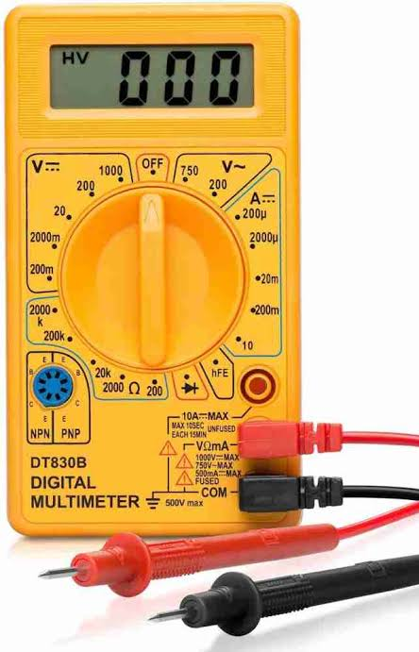

**Continuity Testing Determines:**

1. If a fuse is good or blown;

2. If conductors are open or shorted;

3. If switches are operating properly

4. If circuit paths are clear.

**Note:** Continuity testing should be attempted only when voltage is NOT present in the circuit tested.

* **Solar Energy**

Solar energy is the energy gotten from the sun that generates both light and heat. This energy can be harnessed and converted into electricity, heating water etc., based on what was used to collect the energy can transform is into other types of energy needed for man’s use. The study of solar energy and its used have become too important for man’s use as it is a very abundant energy available in the nation Nigeria and can help tackle a lot of energy crisis issues we face. The Earth receive 174 petawatts (PW) of incoming solar radiation, if this energy can be trapped down, and converted, it will help to tackle a lot of man’s energy crisis.

The pending crisis of global warming also poses as a treat to man’s survival on the earth. However, what causes Global warming? Global warming is basically caused because most of the solar irradiation which hits the earth gets reflected back to the atmosphere which stores up there and warms the earth also resulting in the depletion of the ozone layer. So, by harnessing adequate means to trap down energy from the sun using it for man’s daily need instead of allowing it to reflect back, we can in a great way curtail the effect of global warming. This can be possible by studying and understanding the creation and use of different mechanism needed to trap down this energy, what are they?

**Solar Collectors**

1. **Photovoltaic Cells:** This is generally referred to as solar panel. It is basically made from the semiconductor called silicon.



2. **Parabolic Troughs:** This is basically used to redirect sun light to a focal point to generate greater intensity of heat there so as to heat up water.

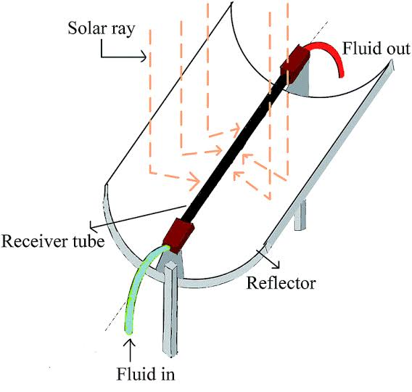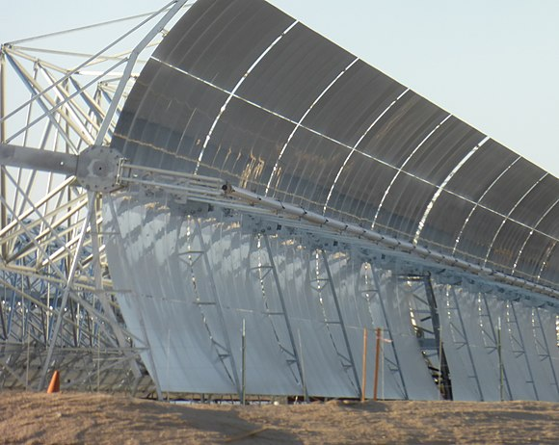

3. **Solar Tower:** This is more of a large solar field containing a lot of sun trackable mirrors called heliostats used to reflect sunlight to a collector at the top of a tower.

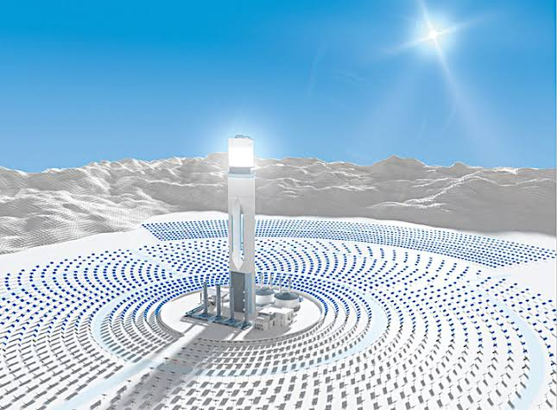

4. **Solar cooker:** This is used to reflect sunlight for greater intensity at a spot so as to cook food or heat water

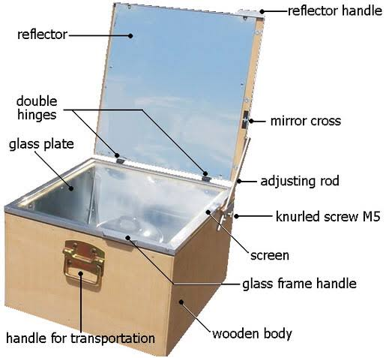

**Week: Four**

**Topic: Equilibrium of Forces**

E

quilibrium can be defined as a stable situation in which forces cancel each other. An object acted upon by several forces is said to be in equilibrium if it does not move or rotate. Equilibrium is a state of balance caused by one force cancelling out the effort of another force exerted on a body. This means that the resultant force and resultant moment acting on a body are separately zero. The study of equilibrium is applied in the construction of bridges, weigh balances, designing towering skyscrapers etc.

**Important Factors Involved in Equilibrium**

1. **Moment of a Force**: Turning effect is what is called moment. The moment of a force about a point is defined as the product of the force and the perpendicular distance from the point to the line of action of the force. The point at which the body turns is called the fulcrum.

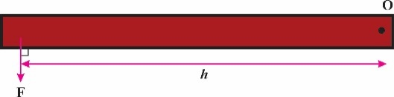

**Moment** = Fh (Nm)

**Where** F = force

h = perpendicular distance of F from O

A very large moment can be produced with a small force provided the distance is large. This is why it is easier to loosen a tight nut with a long spanner than with a short one.

2. **Couples:** A couple is a system of two parallel and equal but opposite forces not acting along the same line. This system can only allow a body undergo rotation and produce no linear motion. Examples of such a system are seen in the action of a corkscrew or turning a water tap off and on. In this system, equal and opposite forces are applied to each end of the system to produce this turning effect. The resultant force is zero, but the resultant moment is not zero, it is equal to:

**Moment** = Fh (Nm)

**Where** F = force

h = perpendicular distance between the lines of action of the two forces

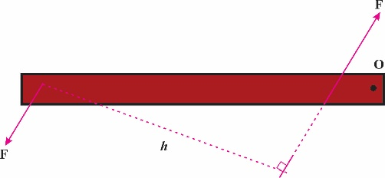

3. **Equilibrium under parallel forces**: A body is said to be in equilibrium if it does not accelerate or rotate. This means that the forces acting parallel along a body cancels out each other thereby making the resultant force equal to zero. So, if a body is in equilibrium, the total force acting upwards must be equal to the total force acting downwards or the body would move vertically. The principle of moment also states that if a body is in equilibrium, then the sum of the clockwise turning moments acting upon it about any point equals the sum of the anticlockwise turning moments about the same point.

**Week: Five**

**Subtopic: Centre of Gravity**

The centre of gravity of a body can be defined as the point through which its resultant weight acts. A stone has large number of particles whose masses can be denoted as m, each mass is pulled downed to the centre of the earth by a force mg where g is gravity. Therefore, the earth’s pull on this stone consist of large number of parallel forces acting on it. The parallel resultant force can be given as = (mg + mg + …) = Mg where M = (m + m + …). This resultant force acts through a point called the centre of gravity.

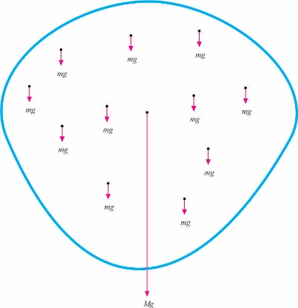

* **Centre of Gravity for Different Objects**

1. A metre rule’s centre of gravity is at 50cm if the rule is of uniform cross-section.

2. A circular object’s centre of gravity is at the centre of the circle.

3. A spherical object’s centre of gravity is at the centre of the sphere.

4. A rectangular, square or parallelogram object’s center of gravity is at the intersection of its diagonal.

5. A cylindrical object has it centre of gravity at the centre of the cylinder.

* **Methods of Determining Centre of Gravity**

1. **By a balancing method:** The centre of gravity of a thin object like a metre rule or rod can be determined by balancing it on a knife edge. The centre of gravity is vertically above the knife edge.

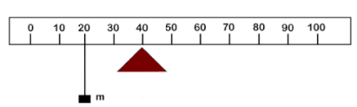

2. **By means of a Plumbline:** A plumbline consist of a small lead bob supported by a thin cord. To get the centre of gravity of a non-orthodox shape, a plumbline may be suspended to interact with two diagonal lines on the workpiece as shown below:

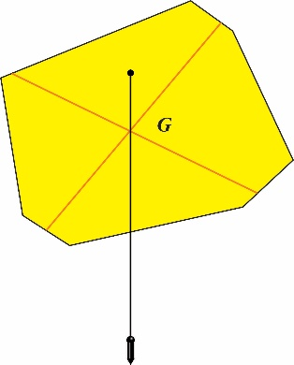

**Types of Equilibrium**

1. **Stable Equilibrium:** A body is said to be in stable equilibrium if when it is displaced off its state of rest, it tends to return back to it original position. This happens to body with large base but low center of gravity. Examples include a pendulum, a cone resting on its base etc,

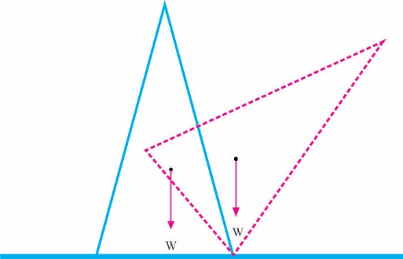

2. **Unstable Equilibrium:** A body is said to be in position of unstable equilibrium if when displaced from its original position, it tends to move on, farther from that position. This happens because a body has a small base and a high centre of gravity. Examples include a cone resting on its vertex, or egg standing on its pointed end.

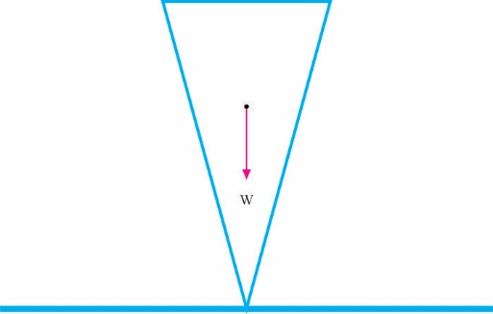

3. **Neutral Equilibrium:** A body is in a neutral equilibrium if when it receives a slight displacement, it tends to rest in its new position. Examples include a cone resting on curved surface, a ball rolling on horizontal surface etc.

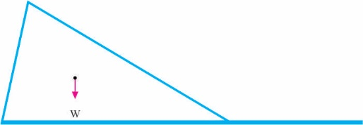

**Week: Six**

**Subtopic: Equilibrium of Bodies in Liquids**

* **Archimedes Principle**

*Archimedes' principle states that when an object is wholly or partially immersed in a fluid, it experiences a loss in weight or an upthrust which is equal to the weight of the fluid displaced by the object.*

When a heavy object is completely immersed in water, common experience shows that the object appears to become lighter. This is experienced when a bucket of water is being drawn out from a well. The bucket appears very light when it is still under water and can be drawn out very easily with one hand, but it becomes very heavy as soon as it is out of water, so that you need to use two hands to draw it out.

This puzzle was first explained by a Greek scientist called Archimedes. He showed that while it is in water, an upward force is exerted by the water on the body. This force is called the upthrust U of water on the object. Hence, the resultant pull experienced as tension in the rope when the object is under water is T = W-U where W is weight of the object when it is out of water. From the above equation, the upthrust U can be written as:

**U= W-T= loss in weight.**

**Principle of Flotation**

*The principle of Flotation states that: A floating body displaces its own weight of the liquid in which it floats or a body floats when the upthrust exerted upon it by the fluid is equal to the weight of the body.*

When the weight W, of a body is greater than the upthrust U, of a liquid, the body will sink into the liquid. When the weight W, of a body is lesser than the upthrust U, of a liquid, the body will rise into the liquid. However, if weight is equal to upthrust, the body will float. When the body float, it is said to be in equilibrium.

**Some Applications of Flotation**

1. **Ships:** Although ships are made of denser materials such as steel which has the ability to sink in water, they don’t because they are vessels that are constructed to contain a great deal of air. Because air is less dense than water, therefore, the ship will float. The upthrust of the water is large enough to support the weight of the ship, so, a large amount of it is displace but the ship will still float.

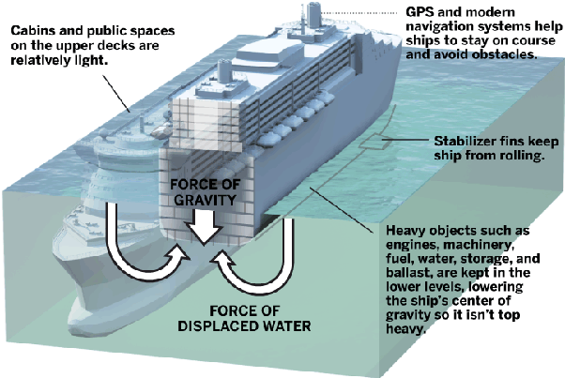

2. **Submarines:** This vessel is submergible because they are built to be able to absorb water and release water while at sea. By absorbing water, the weight of the submarine increases which makes it denser to overcome the upthrust force of the water hence will sink, but by releasing water, it loses its weight and gets filled with air which makes it float.

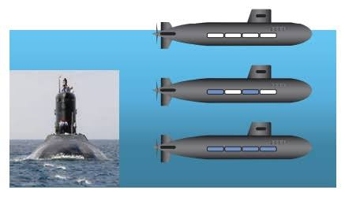

3. **Hot-air Balloon:** This floats in the air because the air in the balloon is heated up by a burner to make it less dense than the air outside, which makes the balloon as a whole less light than air, hence to float upwards.

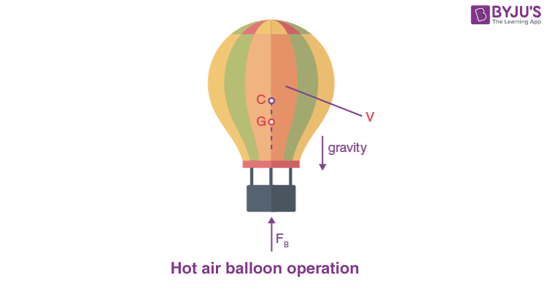

**Density and Relative Density**

* **Density**

The density of a substance is its mass per unit volume. It is mathematically given as:

Density (ρ) = $\frac{mass (m)}{volume (v)}$

The SI unit of density is kgm-3 or gcm-3. However, the conversion between this unit is given as 1gcm-3 = 1000kgm-3.

The density of two materials like iron and wood are said to be different because of each unit of the volume of iron is thicker, hence heavier than that of water. So, even if the same volume of iron and water is given, their weight will vary as that of the iron will be heavier. Below is the list of densities of some important substances in descending order of magnitude:

|  |  |
| --- | --- |
| **Substance** | **Density ( 103) kgm-3** |
| Gold | 19.3 |
| Mercury | 13.6 |
| Lead | 11.3 |
| Brass | 8.9 |
| Iron | 7.9 |
| Aluminum | 2.7 |
| Glass (Varies) | 2.6 |
| Water | 1.0 |
| Ice | 0.92 |
| Paraffin Oil | 0.80 |
| Wood (varies) | 0.75 |
| Petrol | 0.70 |
| Air | 0.0013 |

* **Relative Density (R.d)**

Since water is the most common substance and its density is 1000kgm-3 or 1gcm-3, then it is convenient to use it as a standard for comparing the densities of other substance. Therefore, the R.d of a substance is given as:

R.d = $\frac{density of the substance}{density of water}= \frac{mass of substance}{mass of equal volume of water}=\frac{weight of sunstance}{weight of equal volume of water}$

**Examples:**

**1.** Find the density of the material of a cylinder of base radius = 0.1m and height = 0.5m, if the mass of the cylinder is 44kg. What kind of material is this drum likely made of?

**Solution**

Density = $\frac{mass }{volume }$

But the volume of a cylinder = πr2h = (0.10)2 0.50m3

=

= 2800kgm-3

From the table, the density is very close to aluminum. Therefore, the material is most likely aluminum.

* **The Hydrometer**

A hydrometer is an instrument for measuring the density of liquids. Its operation is based on the fact that, the depth the tube sinks depends on the density of the liquid in which it is floating. A simple hydrometer can be constructed by putting small pebbles or lead shot in a graduated scale test tube so it can float vertically in water. Through this graduated scale, one is able to read how much depth the test tube sank in the liquid to determine its density.

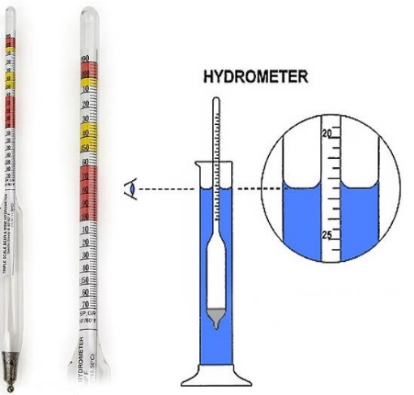

The work in principles is as follows:

Volume of liquid displaced (*Al*) = $\frac{mass (W)}{density (gρ)}$

⸫ *Al* = $\frac{W}{gρ}$

*l* = $\frac{W}{Agρ}$

Where W, A, g are constants

Then *l $α$ $\frac{1}{ρ}$*

From this inverse proportion given above, we can deduce that the length of the tube submerged shows it density. The higher the density of the liquid, the shorter the length of the tube immersed.

**Week: Seven**

**Topic: Newtons Law of Motion**

* **Introduction**

I

saac Newton was able to propound three laws as relating to motion. These laws have helped in different ways to shape life and encourage technological advancement and even is applicable in the study of the movement of subatomic particles in Quantum Mechanics. We are going to study these laws and understand how they apply to everyday life in our environment today.

* **Newton’s First Law of Motion**

It states that: *A body will continue at its state of rest or uniform speed in a straight line unless acted upon by a force*.

This state of a body remaining at its state of rest or uniform speed is what we call **inertia**, hence newton’s first law can also be referred to as the law of inertial.

We need to understand that once a body is in motion on a straight line, it needs no force to keep it in motion. Although a lot have considered this law invalid because of phenomena such as friction, air resistance and gravitation that tends to make a moving body on a straight line come to rest, however, this law still remains valid especially in space science. For example, when an object such as a rocket is fired into space, air resistance and gravity tend to pull it back to the centre of the earth, but via escape velocity, this rocket is able to escape the gravitational pull of the earth into space. However, when this rocket gets into space, it will carry on to its destination without any further force because the Newton’s first law applies in space where there is no or little frictional force and gravitational pull. So, the true environment of inertial such that an object at rest or in motion will remain at that state is attainable in space.

* **Newton’s Second Law of Motion**

It states that: *The rate of the change of* ***momentum*** *of a body is directly proportional to the applied force and takes place in the direction of which the force acts.*

The key word from this law is “Momentum”. So, we need to understand what momentum is to understand what Newton meant in his second law.

* **Momentum**

The momentum of a body is defined as the product of the mass (m) of that body and its velocity (v).

**Momentum = mv**

The way a body moves is greatly influenced by momentum. For example, let’s say a Lamborghini which is small in size moves very swiftly across the asphalt, but not a lorry because it moves slower. So, the mass of these two bodies influences their velocities, that is, how fast or slow they move. The more mass a body has, the more gravity has influence on them, hence the slower they move. The mass of a body influences the velocity rate of that body. Therefore, we can say that momentum is the rate of acceleration of a body.

* **Back to the second Law**

F α $\frac{change in momentum}{time}= \frac{mv}{t}$-------------- (1)

With the condition of the body accelerating from an initial velocity (u) to a final velocity (v), we have:

F α $\frac{mv-mu}{t}$-------------- (2)

F α $\frac{m(v-u)}{t}$-------------- (3)

But a = $\frac{v-u}{t}$--------------(4)

F α $ma$------------------ (5)

F = k $ma$---------------- (6)

For k $≫$ 1

F = $ma$----------------- (7)

Equation 7 is recognized as a fundamental equation of dynamics and is one of the most important equations of physics.

**Examples**

1. A body of mass 2kg undergoes a constant horizontal acceleration of 5ms-1. Calculate the resultant horizontal force acting on the body. What will be the resultant force on the body when it moves with a uniform velocity of 10ms-1.

**Solution**

a = 5ms-2; m = 2kg

F = ma = 2 $×$ 5 = 10N

If it moves with a uniform velocity, it means it is not accelerating, hence a = 0

F = ma

= m $×$ 0 = 0

The resultant force of the body is zero.

**Further Deductions from Newton’s Second Law**

* **Impulse of a Force**

Impulse is the product of a large force at a very short time during which it acts.

From equation (7); **F = ma**

a = $\frac{v-u}{t}$

F = $\frac{m(v-u)}{t}$

**Cross multiplying, we have that**

**Ft = m (v-u)**

Ft is called impulse (I) of a force. Ft is also called change in momentum.

**Example**

2. A force of 10N acts for 20s. What is the change in momentum of the body?

**Solution**

10N; t = 20s

Impulse = Ft

= 10 $×$ 20 = 200Ns

3. A body of mass 5kg moving with a speed of 30ms-1 is suddenly hit by another body moving in the same direction, thereby changing the speed of the former body to 60ms-2. What is the impulse received by the first body?

**Solution**

Impulse = change in momentum

= mv – mu = m (v-u)

5(60 - 30) = 150Ns

* **Newtons Third Law of Motion**

It states that: *To every action there is an equal and opposite reaction.*

Every action will generate a reaction. For example, when you ride a bike, it seems the wind is against you. That’s because that action of riding a bike generates a reaction of air resistance for friction. The reactions of some actions may not be seen due to an equilibrium effect. For example, when you place a cup on a table, you see no reaction because the action on the table and the reaction from the table are equal to each other.

When a bullet is fired, the person who fires experiences the backward recoil force of the gun (a reaction) and this is equal to the propulsive force acting on the bullet.

Newton’s third law has a very useful application in the operations of jet-airplanes and rockets. This is because their operation is based on the application using the mass and velocity of a gas to impart large momentum (action) to the stream of gas which creates an equal and opposite momentum (reaction) to the rocket or jet which undergoes a forward thrust.

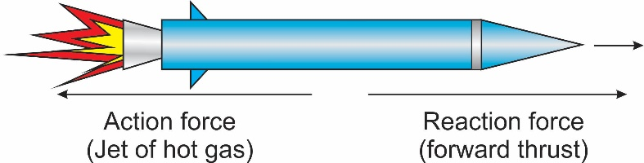

* **Linear Conservation of Momentum**

Through Newton’s third and second law, we are able to formulate the law of conservation of momentum which states that:

**In a system of colliding objects, the total momentum is conserved, provided there is no net external force acting on the system.**

It can also be stated as follows:

**With no external force applied in an isolated or closed system, when two bodies collide, the total momentum before collision is equal to the total momentum after collision.**

This law follows from the fact that the total action of body 1 on body 2 is equal to the reaction of body 2 on body 1.

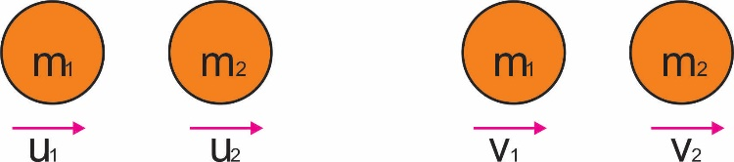

**It is mathematically related as:**

m1u1 + m2u2 = m1v1 + m2v2

**where** m1 = mass of first body; m2 = mass of second body

u1 = initial velocity of first body; u2 = initial velocity of second body

v1 = final velocity of first body; v2 = final velocity of second body

This law also applies to elastic body which rebound from each other after collision, and also inelastic bodies which join together after collision, hence to move with a common velocity (v). Therefore v1=v2=v.

**Examples**

4. A body of mass 4kg moving with a velocity of 10ms-1 collides with a stationary body of mass 6kg. If the two bodies move together after collision, calculate their common velocity.

**Solution**

m1= 4kg; u1 = 10ms-1; m2 = 6kg; u2 = 0

v = common velocity =?

m1u1 + m2u2 = v (m1 + m2)

410 + 6 0 = v (4 + 6)

40 + 0 = 10v

V = 4 ms-2

**Week: Eight**

**Topic: Projectiles**

A

projectile is an object if when thrown into the air or launched into space follows a parabolic path under the influence of gravity and air resistance. If a ball is thrown, the falling ball traces a curved path; if a stone is fired from a catapult, the stone also traces a parabolic path. The slightest departure from the parabolic path is due to air friction.

Other application of projectile is found when a football is kicked into the air, when javelins are thrown, when bombs are thrown, when bullets are fired, when arrows are shot, the landing coordinates for rocket capsule etc.

**Any projectile carries out two independent motion:**

a. A constant horizontal motion

b. A vertically downward acceleration of freefall due to gravity as seen below:

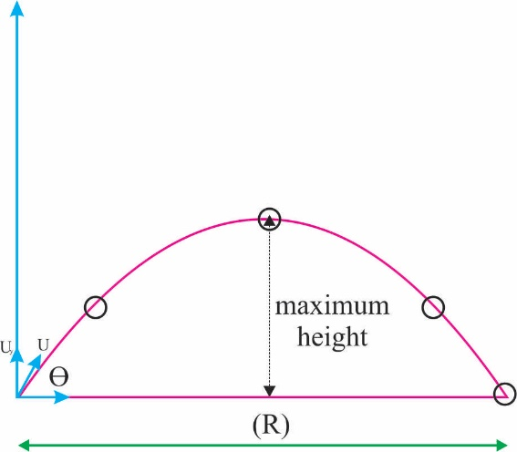

**Factors Involved in Projectiles**

1. **Time of Flight (t):** This is the time required for a projectile to return to the same level from which it was projected. To find the Time of Flight (t):

t = $\frac{Usinθ}{g}$

To find the total time of flight (T):

T = $\frac{2Usinθ}{g}$

**Where** u = initial velocity

g = acceleration of free fall

ϴ = angle of projection

2. **Maximum Height (H)**: This is defined as the highest vertical distance reached as measured from the horizontal projection plane. To find maximum height H, we apply this equation:

H = $\frac{U^{2\sin^{2}θ}}{2g}$ or

H = $\frac{U^{2}}{2g}$ when ϴ = 45 $°$ for maximum height attainable

3. **Range (R)**: This is defined as the horizontal distance from the point of projection to the point where the projectile hits the projection plane again. It is given as:

R = $\frac{U^{2}sin2θ}{g}$

To get maximum range, then ϴ = 45 $°$

Rmax = =

Rmax =

**Examples**

1. A tennis ball is hit with a velocity of 3ms-1 at an angle of 60 $°$ to the horizontal. Calculate the:

a. time of flight;

b. maximum height;

c. range.

**Solution**

a. T = $\frac{2Usinθ}{g}$ = $\frac{2×3sin60°}{10}= \frac{2×3×0.866}{10}$ = 0.52s

b. H = $\frac{U^{2\sin^{2}θ}}{2g}= \frac{3^{2×\sin^{2}60}}{2×10}= \frac{9 × {0.866}^{2}}{2×10}=0.3375m$

c. R = $\frac{U^{2}sin2θ}{g}= \frac{3^{2}×sin2(60)}{10}= \frac{3^{2}×sin120}{10}= \frac{9 ×sin120}{10}= \frac{9 ×0.866}{10}=0.779m$

**Week: Nine**

**Topic: Machines**

A

machine is a device that can be used to do work more conveniently. In physics, a machine does not have to be a complicated system, it might just be a simple system used to do work. A machine is a contrivance by which means force called Effort (E) is used to overcome another force called Load (L) at some other point. Most of the time but not all, little efforts in machines are used to overcome large load.

**Mechanical Advantage (M.A) and Velocity Ratio (V.R)**

1. Mechanical advantage (M.A) also referred to as Force Ratio (F.R) is defined as the ratio of the load (L) to the effort (E).

⸫ M.A = $\frac{L}{E}$------------------------ (1)

**Note:** i. If the Load (L) is bigger than the effort (E), the M.A is greater than one.

ii. The smaller the friction, the smaller the effort will be, hence the larger the mechanical advantage.

2. Velocity Ratio is defined as the ratio of the distance moved by the effort (*x*) to the distance moved by the load (*y*).

⸫ V.R = $\frac{x}{y}$----------------------- (2)

Note: i. When small applied effort moved through a distance *x*, while the large load overcome moves through a distance *y*, then V.R is greater than 1.

ii. Since V.R depends only on the geometry of moving part, it is independent of friction.

**Efficiency (ꜫ) of a Machine**

The efficiency of a machine is the ratio of the work output of that machine based on the work put into it. It is usually expressed as percentages and is defined as follows:

ꜫ = $\frac{work output}{work input} ×100\%$--------------------------- (3)

Remember that Workdone = Force $×$ Distance

And Force = Load (L) = Effort (E)

⸫ $\frac{work output}{work input}$ = $\frac{load \left(l\right) ×distance moved by load (y)}{Effort \left(E\right) ×distance moved by effort (x)}= \frac{L×y}{E×x}$

= $\frac{L}{E}×\frac{y}{x}$

Reciprocating

= $\frac{L}{E}×\frac{x}{y}$

But M.A = $\frac{L}{E}$ and V.R = $\frac{x}{y}$

⸫ ꜫ = $\frac{M.A}{V.R}×100\%$--------------------------------- (4)

**Example:**

A machine with *V.R.* 5 requires 1000J of work to raise a load of 500N through a vertical distance of 1.5m. Find the efficiency and M.A of the machine.

**Solution**

V.R = 5; Work input = 1000J; Load (L) = 500N; Distance moved by load (y) = 1.5m

Efficiency (ꜫ) =?; M.A = ?

To get the efficiency, we make use of equation 3

ꜫ = $\frac{work output}{work input} ×100\%$

but work output = load (L) $×$ distance moved by load (y)

**⸫** ꜫ = $\frac{load (L) × distance moved by load (y)}{work input} ×100\%$

ꜫ = $\frac{500 ×1.5}{1000} ×100\%$ = 75 $\%$

To get the Mechanical Advantage (M.A), we know from equation for that:

ꜫ = $\frac{M.A}{V.R}×100\%$

⸫ 75 = $\frac{M.A}{5}×100\%$

M.A = 3.75

**Classification of Machines**

1. **Lever:** A lever is a machine pivoted about a point called a fulcrum (f). Effort (E) is applied at one point on the lever to overcome a Load (L) at some other point. Lever are in three different classes based on the arrangement of the f, E, L as indicated below:

i. **First Class Lever:** This lever is one which the fulcrum is between the load (L) and the Effort (E). Examples include claw hammer, crow bar, pliers etc.

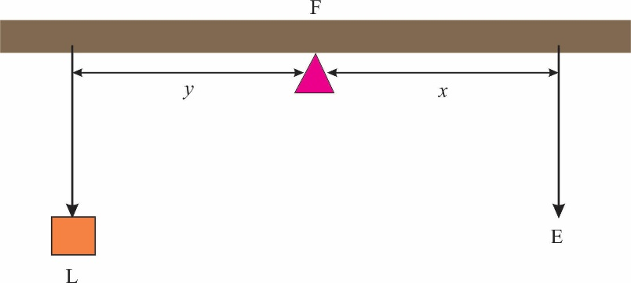

ii. **Second Class Lever:** This lever is one which the load (L) is between the fulcrum and the Effort (E). Examples include nut cracker, wheelbarrow etc.

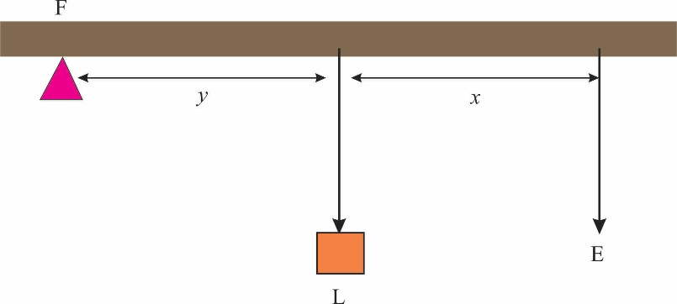

iii. **Third Class Lever:** This lever is one which the Effort (E) is between the fulcrum and the load (L). Examples include human forearm, a pair of laboratory tong etc.

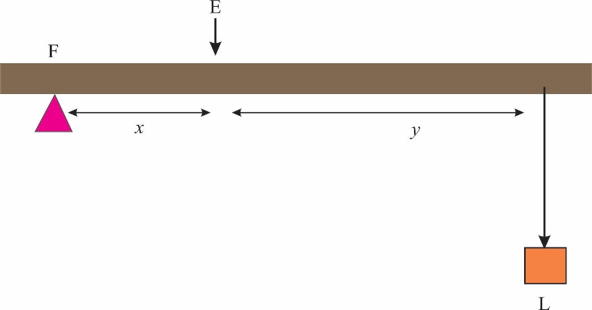

The lever works on a principle of moment. If *y* and *x* represent the distance of load (L) and effort (E) from the fulcrum (F) in each lever above, then taking the moment about f gives:

**y $×$ L = *x $×$* E** ----------------------- (6)

Dividing Both side by Ey

$\frac{L}{E}= \frac{x}{y}$

⸫ M.A = V.R

Which means that M.A increases with ratio increase

**Example:**

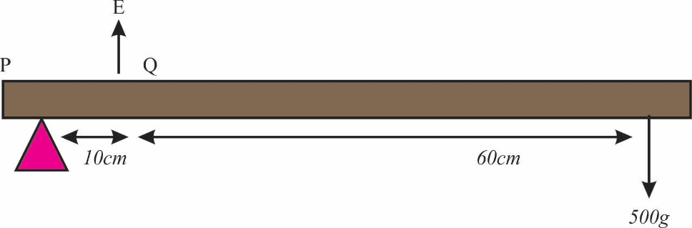

From the figure above, PQ = 10cm and QR = 60cm; calculate the effort.

**Solution**

Load = 500g = 5N; Distance moved by load (y) = 60cm + 10 cm = 70cm; Distance moved by effort (x) = 10cm

Taking the moment about p. From equation 6, we know that: y $×$ L = *x $×$* E

5 $×$ 70 = E $×$*10*

⸫ E = 35N

2. **Pulley:** A simple pulley is a system that contains a fixed wheel with a rope passing through the groove of its rim. Load (L) is attached to one end of the rope, while effort (E) is applied at the other end. If friction is neglected at the wheel and the weight of the rope is ignored, then tension (T) in the rope will be the same at all points. Therefore, L = T = E.

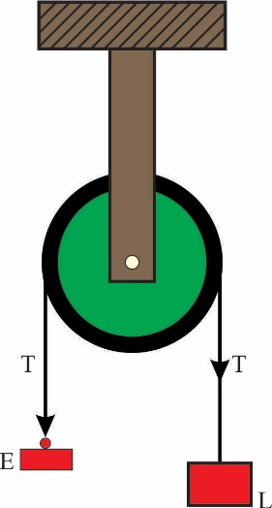

Pulley system is basically used to lift things upwards or downwards. For example, it is used for hauling heavy loads to high floors or in loading and unloading ships. Pulleys can be combined if a greater load needs to be lifted, and the aim of this combination is to achieve a larger velocity ratio to gain higher mechanical advantage.

3. **The Inclined Plane:** When a heavy load such as a drum of oil or an engine block needs to be raised to the back of say a lorry, this can be made possible through the aid of a sloping plank with little applied effort. This arrangement is also said to be a machine called the inclined plane.

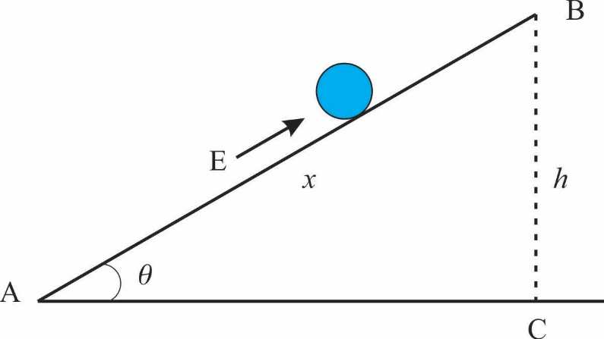

Suppose a load (L) is moved by an effort (E) which moves a distance AB = *x*, the angle of inclination of the plane being ϴ, the effort move by a distance *x* = AB, while load (L) moves a vertical distance h= BC. The velocity ratio will therefore be:

V.R = $\frac{distance moved by Effort (E)}{distance moved by Load (L)}$

V.R = $\frac{AB}{BC}= \frac{x}{h}$

V.R = $\frac{1}{Sin θ}$

**Example:**

What is the velocity ratio of an inclined plane of length 6m, if the higher end is 2m above the ground? If the efficiency of this plane used as a machine is 60%. Calculate the M.A.

**Solution**

V.R = $\frac{Length of Plane}{height}= \frac{6}{2}=3$

ꜫ = $\frac{M.A}{V.R}×100\%$

⸫ 60 =

M.A = = 1.8

4. **The Hydraulic Press:** This is another system where small effort could lift a large load through pressure in liquids.

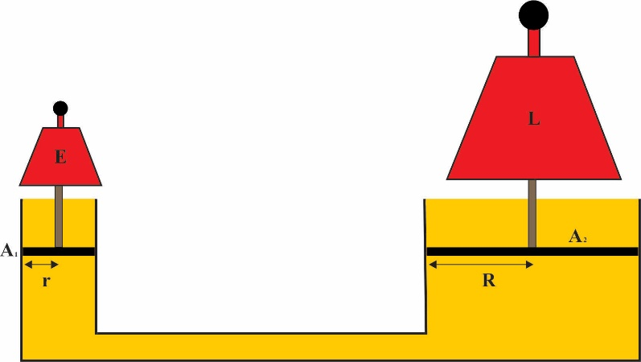

If A1 is the area of the small piston and P is the pressure in liquid inside the press, E = P A1

If A2 is the area of the large piston, the load is large, therefore, L = P A2

But M.A = = =

Where R and r are the radii of the large and small piston.

Also, if x and y are the distances moved by E and L respectively, we have that

A1x = A2y

Dividing both side by A1y

⸫

But V.R = $\frac{x}{y}$ $= \frac{A_{2}}{A_{1}}= \frac{R^{2}}{r^{2}}$

**Week: Ten**

**Topic: Practical**

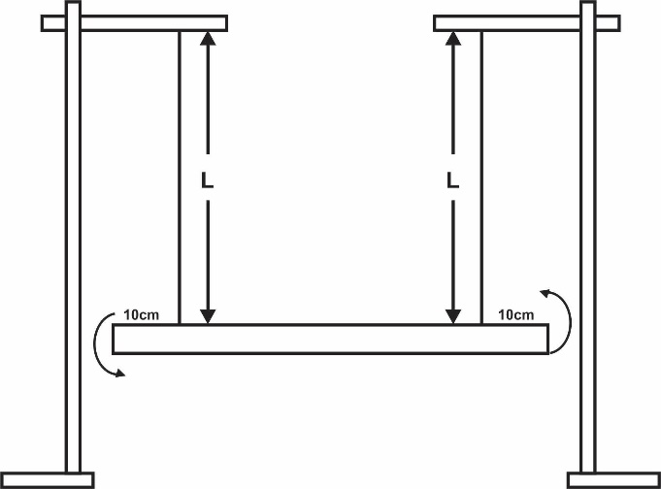

You are provided with two retort stand, two metre rules, pieces of thread and other necessary apparatus.

i. Set up the apparatus as illustrated above ensuring that the strings are permanent 10cm from either end of the rule.

ii. Measure and record the length L = 80cm of the two strings.

iii. Hold bath end of the rule and displace the rule slightly, then release so that it oscillates about a vertical axis through its centre.

iv. Determine and record the time t for 10 complete oscillations.

v. Determine the period T of oscillations.

vi. Evaluate log T and L

vii. Repeat the procedure for four other value of L = 70cm, 60cm, 50cm, 40cm.

viii. Tabulate your readings

ix. Plot a graph with log T on the vertical axis and log L on the horizontal axis.

x. Determine the slope, s and the intercept, c on the vertical axis.

xi. State two precautions taken to ensure accurate results.

Bi. Define simple harmonic motion

ii. Determine the value of L corresponding to t = 12s from the graph in 1 (a).