**PROJECT**

**Design/Package (write) any program/Jingles/ Advert that can be used as a public enlightenment programs to sensitize the public especially the youths of Nigeria on "THE DANGER OF DRUG TRAFFICKING", usable on any national Media outfit.**

**Week 7: Meaning and types of peace.**

Peace can be defined as the absence of war and social crises or violence. It is the state of affair where there is no physical violence or conflict or war. Peace is characterized by a sense of balance, harmony, and well-being among individuals and communities.

**Types of Peace**There are two types of peace namely positive peace and negative peace:

**1. Positive peace** occurs when things that bring conflict and misunderstanding have been removed. It is high degree of social justice, no violence or conflict or war.**2. Negative peace** occurs when people are forced to maintain peace without setting the cause of the conflict. This method might prevent violence in the short term, however the peace might not last..

**IMPORTANCE OF PEACE**

**1. For Individual Well-being:** Peace allows individuals to focus on building positive relationships, pursuing their goals, and enjoying life.

**2. For Societal Development**: Peace fosters economic development, harmony, progress, and unity, removing fear, tension, and insecurity.

**3. Cooperation and Stability:** Peace enables cooperation between individuals, groups, and governments, allowing for effective functioning and stability.

**4. Sustainable Development**: Peace is essential for sustainable development, as it creates an environment where progress and prosperity can flourish.

**5. Human Rights:** Peace is intrinsically linked to the protection of human rights, ensuring freedom from persecution and discrimination.

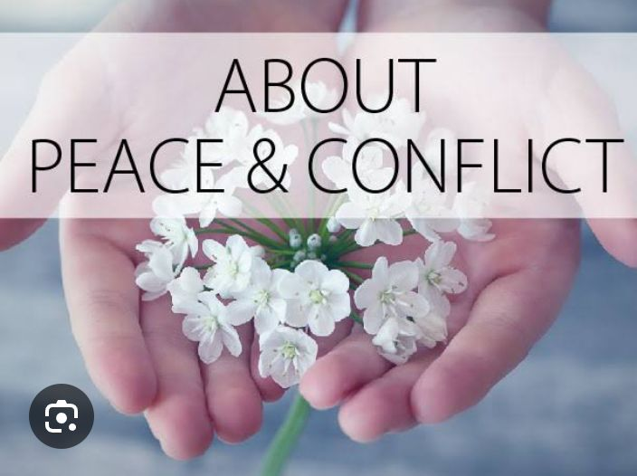

**Week 8: WAYS OF PROMPTING PEACE IN THE SOCIETY**

**1. Promote Education and Awareness:** Support educational initiatives that teach about different cultures, religions, and perspectives, fostering understanding and empathy.

Promote critical thinking and media literacy, by encouraging individuals to analyze information critically and be aware of biases and misinformation, which can fuel conflict.

**2. Foster Dialogue and Communication:**

a. Encourage open and respectful dialogue, by creating spaces where people from different backgrounds can come together to discuss issues and find common ground.

b. Promote active listening and empathy: Encourage individuals to listen to others' perspectives, even if they differ from their own, and to try to understand their experiences.

**3. Build Community and Relationships:** a. Organize community events and initiatives: Support activities that bring people together, such as festivals, sports events, and volunteer projects.

b. Promote intergenerational and intercultural interactions: Encourage older and younger generations, as well as people from different cultural backgrounds, to interact and learn from one another.

**4. Advocate for Justice and Equality**: By Speaking out against injustice and discrimination , standing up for human rights and equality, regardless of race, religion, gender, or any other characteristic. And also supporting organizations that promote peace and justice through donating to or volunteering to work with them to address the root causes of conflict and promote peace.

**5. Promote Non-Violence and Conflict Resolution**: Teach and practice non-violent conflict resolution: Learn and promote techniques for de-escalating conflicts and finding peaceful solutions. And be an example of peaceful and respectful behavior in your interactions with others.

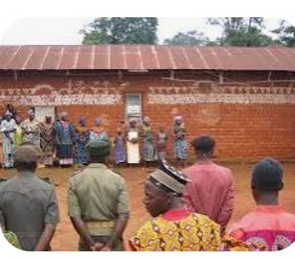

**Week 9: Meaning and types of conflict**

Conflict can be broadly defined as a disagreement or clash of interests, opinions, or principles, which can manifest in various forms, including interpersonal, intrapersonal, intergroup, and intragroup conflicts.

Meaning of Conflict: Conflict essentially means a situation where there's a disagreement, a struggle, or a clash between two or more parties (individuals or groups). Which often arises from differing goals, values, beliefs, or needs.

Types of conflicts are basically two, namely; positive and negative conflicts

1. Negative conflicts are defined as a conflict situation characterized by a lack of communication and unwillingness to compromise.

2. Positive conflicts: conflicts are termed positive if differences are communicated and respected and issues are openly addressed amicably between both parties , thus finding a lasting solution to the term of conflict.

**Week 10: basic causes of conflict in the society**

Conflicts are caused by various factors including differing values, beliefs, and goals, as well as competition for resources, power struggles, and communication breakdowns.

**A. . Differing Values, Beliefs, and Goals:**

**1. Cultural Differences:** Divergent cultural backgrounds and traditions can lead to misunderstandings and tensions.

**2. Religious Differences:** Disagreements over religious beliefs and practices can spark conflict either among people of same religion or among different reglious groups.

**3. Incompatible Goals:** When individuals or groups pursue conflicting objectives, it can lead to disagreements and conflict.

**4. Personal Values:** Differences in personal values and priorities can create friction and conflict. This happens among siblings, friends, classmates, individuas within a group, spouses, colleagues at work place etc. our Do's and don'ts , likes and dislikes can trigger conflicts

**B. Competition for Resources:**

**1. Scarcity of Resources:** Competition for limited resources, such as land, water, food, mineral resources or economic opportunities, can lead to conflict. This is very pronounced in Nigeria today.

**2. Unequal Distribution:** Perceived or real inequity in the distribution of resources can fuel conflict. This conflicts arises from scarcity of resources for a group, country or society.

**C. Power Struggles:**

**1. Struggles for Power and Control:** Conflicts often arise from individuals or groups vying for power, influence, or control over resources or decision-making.

**2. Perceived Injustice:** A sense of being treated unfairly or unjustly as a result of one holding and using his leadership position (powers) against the other, this can lead to conflict and unrest.

**D. Communication Breakdown:**

**1. Misunderstandings:** Poor communication, misinterpretations, and lack of open dialogue can lead to conflict, this is rampant within family circles and groups.

**2. Lack of Common Understanding:** When individuals or groups lack a shared understanding of issues or situations, it can lead to disagreements and conflict. When people find it difficult to accept other people's opinions or views.

**E. Other Factors are;**

**1. Personality Differences:** Disagreements can arise from clashes in personalities and communication styles.

**2. Stress and Frustration:** High levels of stress or frustration can make individuals more prone to conflict.

**3. Unclear Expectations:** When expectations are unclear or unmet, it can lead to conflict.

**4. Greed and Desire for Power:** Greed and the desire for power can fuel conflicts and violence and political instability in a country, as it has being the case in Nigeria.

**5. Unjust Social Structures:** Unjust social structures and institutions can create and perpetuate social conflict

**Week 11: Examples of conflict**; there are four major categories of conflicts

**1. Intrapersonal Conflict:** This type of conflict arises within an individual, often involving internal struggles or dilemmas, such as conflicting values, goals, or beliefs.

**2. Interpersonal Conflict:** This occurs between two or more individuals, stemming from disagreements, misunderstandings, or personality clashes.

**3. Intragroup Conflict:** This type of conflict occurs within a group or team, involving disagreements or tensions among members.

**4. Intergroup Conflict:** This type of conflict arises between different groups or teams, often involving competition, power struggles, or differing value



**(ii) CONSEQUENCES OF CONFLICTS**

Conflict consequences include societal breakdown, loss of lives and property, fear, and hinderances in development, leading to disunity, insecurity, and economic hardship.

**A. Immediate Consequences:**

1. Loss of Life and Injury: Conflicts often result in deaths and injuries, both for combatants and civilians.

2. Destruction of Property: Infrastructure, homes, and businesses can be damaged or destroyed during conflicts.

3. Displacement and Migration: People may be forced to leave their homes due to conflict, leading to displacement and migration.

4. Disruption of Social and Economic Systems: Conflicts can disrupt essential services like education, healthcare, and economic activities.

**B. Long-Term Consequences:**

1. Societal Breakdown: Conflicts can lead to a breakdown of social structures, institutions, and norms.

**2. Disunity and Hatred**: Conflicts can foster division and hatred among individuals, different groups or communities.

3. Economic Hardship: Conflicts can lead to economic downturns, poverty, and reduced productivity.

4. Psychological Trauma: Individuals can experience psychological trauma, fear, and insecurity as a result of conflict.

5. Hindered Development: Conflicts can significantly impede social, economic, and political development in a community and nation at large.

6. Erosion of Relationships: Conflicts can damage relationships and create lasting tensions between individuals and groups.

7. Increased Crime: Conflicts can lead to an increase in crime and violence.

8. Environmental Damage: Conflicts can have significant environmental consequences, such as pollution and deforestation, there by affecting crop yield and causing food scarcity.

