**REPRESENTATION OF RELIEF FORMS**

**Hill Shading (**levels of gray**)**is a method ofrepresenting relief on a map by depicting the shadows that would be cast by elevated areas if light were shining from a certain direction.

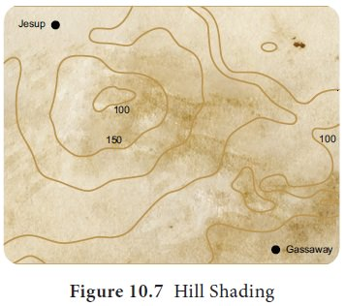

**Layer Colouring**is a method showingrelief in layers and each layer is given a different colour. Physical maps in atlas and wall maps use this method to show relief features. Ocean depth is also shown in various shades of blue. There is an international recognition for colours used in these maps. Accordingly, blue represents water bodies, green for plains, various shades of brown for highlands and white for snow covered peaks.

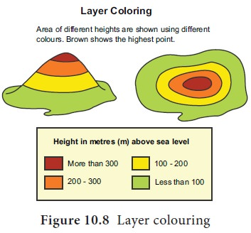

**Bench marks**represent the actual heightof a tall structure like a tall building, pillar, bridges or any other object of permanent nature. They are marked with the letters BM with the respective height. They are represented by ꙟBM and the height is written beside it.

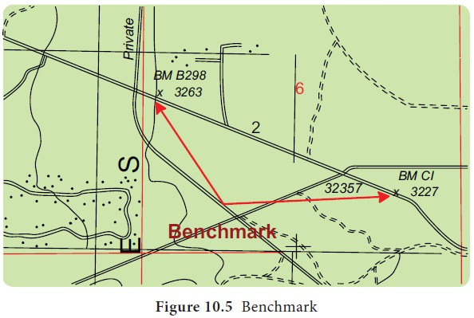

Home work

Explain the following methods of representing relief form with diagrams

1. Trigonometric station
2. Spot height