**THIRD TERM JSS 2 SECURITY**

**WEEK 1**

**TOPIC: DISASTERS**

**Definition:**

**A disaster** is a significant event that causes serious harm, including loss of life, property damage, and disruption to normal life, often leaving communities unable to cope without external help.

**Disasters** are serious disruptions to the functioning of a community that exceed its capacity to cope using its own resources. Disasters can be caused by natural, man-made and technologicalhazards, as well as various factors that influence the exposure and vulnerability of a community.

**A disaster** is defined as a sudden and calamitous event, whether natural or man-made, that causes widespread damage, loss, or destruction, particularly to human life and the environment. A disaster is a sudden accident or a natural catastrophe that causes great damage to humans and the environment.

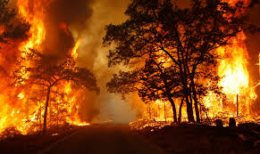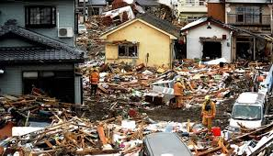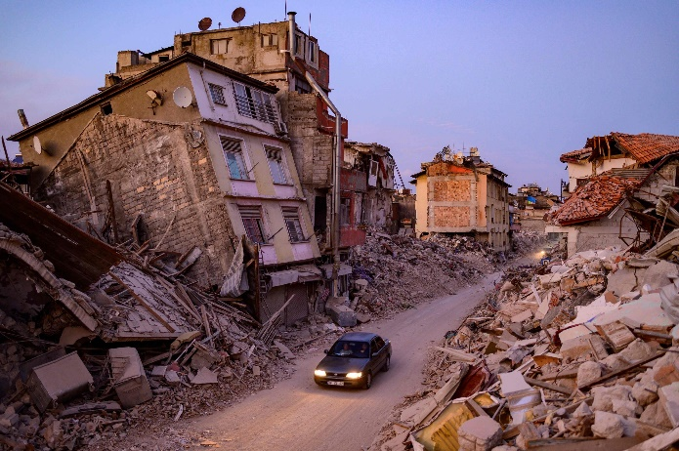

**Types of disaster**

1. Natural disaster
2. Man-made disaster

**Natural Disaster**: are those disasters that occur by natural factors.  
Some of the types of natural disasters includes: earthquake, landslides, thunderstorms, floods, wildfires. tornadoes famine, global warming, etc.  
 **causes of natural disaster**  
1. Soil erosion  
2. Air pressure from rushing wind  
3. Tectonic movement  
4. Earthquake  
5. Famine

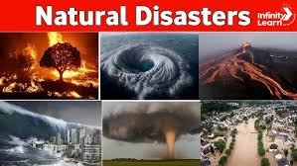

**WEEK 2**

**TOPIC: EFFECTS OF NATURAL DISASTER**  
Natural disaster has serious effects on both humans and the environment, some  
of these effects are;  
1. **Hunger**: When natural disaster occurs farm land are destroyed and at the  
end it will lead to hunger  
2. **It leads to destruction of properties** like buildings  
3. **Natural disaster also leads to loss of financial resources** like business  
damage  
4. **It renders animals homeless** when natural disaster like flood occurs  
5. **Natural disaster leads to loss of human lives**  
6. **It contributes to the spread of epidemic**7. **It causes personal injury**

**WEEK 3**

**TOPIC: PREVENTION OF NATURAL DISASTER**Natural disaster can be prevented in the following ways:  
1.  **emergency Preparedness kit**: This will help the people avoid disaster  
2. **Awareness**: The people should be aware of their environment and the dangers of natural  
disaster.  
3. **Climate monitoring:** Natural disaster can be prevented by monitoring of the climate to know which certain disaster are to occur.  
4. **Education:** Educating The people in an area prone with natural disaster on how to prevent certain natural disasters.  
5. **The use of prediction and warning systems**

6. **restore and maintain river.**

**WEEK 4**

**TOPIC: MEANING OF MAN-MADE DISASTER**Man-made disaster are those disasters that are caused by human negligence or error in our  
environment.

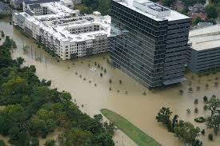

**TYPES OF MAN-MADE DISASTERS**Types of man-made disasters are;  
1. Nuclear accidents (as a result of negligence)  
2. Road accidents (negligence and error)  
3. Terrorism  
4. Chemical disasters  
5. Fire accidents

6. industrial disaster.

**WEEK 5**

**TOPIC: Effects of man-made disaster**

Man-made disasters can have severe and long-lasting effects on

individuals, communities, and the environment. Some of the effects of

man-made disasters include:

i. **Loss of life:** Man-made disasters can result in the loss of many lives, whether due to direct physical harm or long-term health effects from exposure to hazardous materials.

ii. **Injuries**: Many people can sustain injuries during man-made disasters, including burns, respiratory problems, and trauma from violence.

iii. **Displacement:** Man-made disasters can force people to leave their homes and communities, often resulting in displacement, homelessness, and loss of personal possessions.

iv. **Economic impact**: Man-made disasters can have a significant impact on local and regional economies. For example, businesses may be damaged or destroyed, and supply chains disrupted, leading to job losses and reduced economic activity.

v. **Environmental damage:** Man-made disasters can cause significant environmental damage, including soil and water pollution, deforestation, and habitat destruction.

vi. **Psychological impact:** Man-made disasters can have a significant psychological impact on individuals and communities, resulting in stress, anxiety, and post-traumatic stress disorder (PTSD).

vii. **Infrastructure damage:** Man-made disasters can damage or destroy infrastructure such as roads, bridges, and buildings, making it difficult for communities to recover and rebuild. The effects of man-made disasters can be devastating and long-lasting, requiring significant resources and support to mitigate their impact and aid in recovery efforts. Prevention and preparedness measures, such as risk reduction, disaster response planning, and emergency drills, can help reduce the impact of man-made disasters.

**WEEK 6:**

**Topic: PREVENTION OF MAN-MADE DISASTERS**

Preventing man-made disasters entirely is not always possible, but many measures can be taken to reduce the risk of man-made disasters and their impact. Here are some strategies for preventing man-made disasters:

i. **Risk assessment and management**: Conducting regular assessments of potential hazards and risks, and implementing measures to manage and mitigate them, can help prevent man-made disasters. This includes measures such as enforcing building codes and regulations, conducting safety inspections, and providing adequate training for workers.

ii. **Education and awareness:** Educating the public and workers about potential hazards and how to prevent them can help reduce the risk of man-made disasters. This includes providing safety training and promoting a culture of safety in the work place.

iii. **Technology and innovation:** Technology can be used to prevent man-made disasters, such as sensors that can detect leaks and other potential hazards. Innovation can also help reduce the environmental impact of human activities, such as developing renewable energy sources and reducing greenhouse gas emissions.

iv. **Emergency response planning:** Developing and implementing emergency response plans can help minimize the impact of man-made disasters. This includes identifying potential risks, developing contingency plans, and ensuring that emergency response teams are properly trained and equipped to respond quickly and effectively.

v. **Regulations and enforcement:** Regulations and enforcement can help prevent man-made disasters by ensuring that companies follow safety guidelines and standards. This includes enforcing environmental regulations, occupational health and safety standards, and other laws and regulations.

vi. **Conflict resolution:** Resolving conflicts through peaceful means can prevent the escalation of violence and the potential for man-made disasters caused by war or civil unrest. Overall, preventing man-made disasters requires a multi-faceted approach that includes risk assessment and management, education and awareness, technology and innovation, emergency response planning, regulations and enforcement, and conflict resolution.

**WEEK 7:**

**Topic: MEANING OF FLOODING**

Flooding is the overflowing of water onto land that is normally dry. It occurs when there is an excessive amount of water in a river, lake, or other body of water, or when heavy rainfall or snowmelt overwhelms the drainage system, causing water to accumulate in low-lying areas. Flooding can also occur due to other factors, such as storm surge caused by

hurricanes, tsunamis, or dam or levee failures. Floods can be slow or fast-rising, and the severity of the flooding can vary depending on the amount of water and the speed of the flow. Floods can have significant impacts on individuals, communities, and infrastructure.

They can cause property damage, disrupt transportation, and interrupt critical services, such as water and power supply. Flooding can also cause loss of life and result in long-term health impacts from exposure to contaminated water and mold.

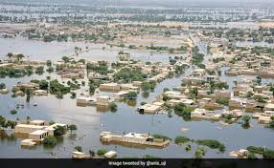

**WEEK 8**

**CAUSES OF FLOODING**

There are many different causes of flooding, and here are the prominent ones.

1. Heavy Rainfall
2. Overflowing Rivers
3. Collapsed Dams
4. Snowmelt
5. Climate Change
6. poor drainage,
7. blocked drainage

1) **Heavy Rainfall**

Heavy rainfall can occur due to various weather conditions. A great example is tropical cyclones, which can transform into hurricanes and produce large amounts of rain that can cause flash floods and deaths. For instance, Hurricane Katrina, a tropical cyclone that hit the southeastern U.S. in 2005, caused a coastal flood and over 1,800 deaths.

2) **Overflowing Rivers**

Areas near rivers have a higher flood risk during an overflow. If you live in such a place, you need to protect your property against a river flood. You can build a string of dams and manage it properly. However, installing an [**Aqua-Barrier® inflatable water dam**](https://aquabarrier.com/aqua-barrier-cofferdam/) is the simplest and affordable way to protect your property from flooding.

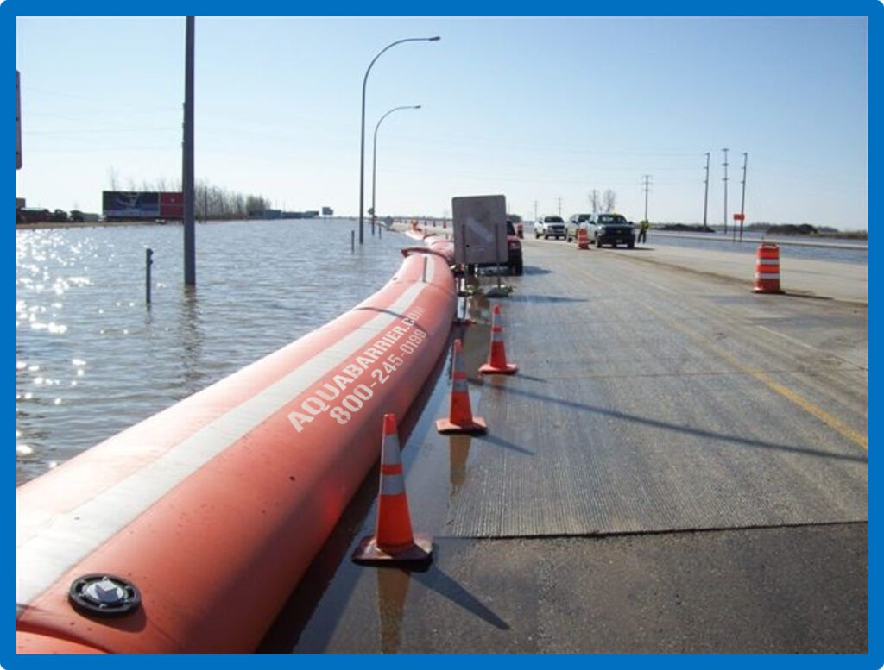An example of Aqua-Barrier® cofferdam preventing flooding on a roadway.

3) **Collapsed Dams**

Dams are designed to hold water upstream. If the dams begin to collapse, they will discharge more water downstream, resulting in flooding. That can cause more problems for people living in the low-lying areas around the dams. It may also result in deaths.

4) **Snowmelt**

Much of the springtime streamflow or runoff in rivers is accountable for melting snow or ice in colder climates. When there’s heavy precipitation, flooding will most likely occur during the subsequent warm seasons. Snowpack will begin to melt and release water.

5) **Climate Change**

Uncontrolled human activities can contribute to climatic changes, which are responsible for flooding in most regions. Through extensive deforestation, the atmosphere’s carbon dioxide levels will increase, causing climatic changes attributable to flooding risks.

**WEEK9**

**EFFECTS OF FLOOD ON COMMUNITIES**

Flooding can have severe consequences for communities, impacting their security in multiple ways. These impacts include

**Economic Losses:**

Floods can destroy homes, businesses, and infrastructure, leading to significant financial losses for individuals and the community.

**Health Risks:**

Floodwaters can be contaminated with sewage, bacteria, and other harmful substances, increasing the risk of waterborne diseases and illnesses like cholera, typhoid, and dysentery.

**Food Security:**

Flooding can damage crops and livestock, leading to food shortages and increased prices, impacting the ability of communities to feed themselves.

**Social Disruption:**

Floods can displace people from their homes, leading to overcrowding in shelters, increased social tensions, and potential conflict over resources.

**Environmental Damage:**

Floods can damage the environment, such as eroding soil and destroying wetlands, which are important habitats for various species.

**Disrupted Livelihoods:**

Flooding can disrupt fishing, farming, and other traditional livelihoods, impacting people's ability to earn a living.

**Infrastructure Damage:**

Floods can damage roads, bridges, and other infrastructure, making it difficult for people to access essential services like healthcare and education.

**WEEK 10:**

**TOPIC: EFFECTS OF FLOOD ON THE ECONOMIC GROWTH OF A NATION**

Floods can have significant economic impacts on a nation, including:

i. **Infrastructure damage:** Floods can cause damage to critical infrastructure, including roads, bridges, and buildings, resulting in costly repairs and disruptions to transportation and other services.

ii. **Business disruption:** Floods can disrupt business operations, leading to reduced productivity and revenue loss.

iii. **Agriculture impacts**: Floods can damage crops and farmland, leading to reduced agricultural output and increased food prices.

iv. **Insurance costs:** Floods can lead to increased insurance costs for individuals and businesses.

v. **Government spending:** Governments often have to spend significant resources on disaster response and recovery efforts, which can strain budgets and divert funds from other priorities.

vi. **Reduced investment**: Flood-prone areas may become less attractive for investment, leading to reduced economic growth in those areas.

vii. **Tourism impacts:** Floods can lead to decreased tourism, which can have significant economic impacts on areas that rely on tourism for revenue.

**WEEK 11**

**PREVENTIVE MEASURES TO FLOOD**

**.** Improving Drainage:

* **Clear Debris:**

Regularly remove debris, leaves, and other obstructions from gutters, downspouts, and storm drains to prevent blockages that can lead to flooding.

**Maintain Drainage Systems:**

Ensure that drainage ditches and canals are free of debris and properly maintained to allow for efficient water flow.

**Deepen or Create Drainage Channels:**

In areas prone to flooding, consider deepening existing drainage channels or creating new ones to improve water runoff.

2.Reinforcing Structures:

* **Elevate Structures:**

Elevate buildings, particularly in flood-prone areas, to minimize the impact of floodwater.

* **Strengthen Foundations:**

Reinforce building foundations with strong materials to withstand the pressure of floodwaters.

* **Implement Waterproofing Measures:**

Seal basements and walls with waterproofing compounds to prevent water seepage.

3. Raising Awareness and Community Preparedness:

* **Public Education:**

Educate communities about flood risks, early warning systems, and safe evacuation procedures.

* **Flood-Proofing Information:**

Share information about how to flood-proof homes and businesses, including measures like elevating appliances and storing valuable items away from flood zones.

* **Early Warning Systems:**

Implement early warning systems to alert residents of impending floods, allowing them to take necessary precautions.