**COMPUTER SCIENCE**

**SS1 THIRD TERM COMPLETE NOTE**

**Week 1: Communication System – Meaning and Types of ICT**

**Definition of ICT**

ICT stands for **Information and Communication Technology**. It refers to the use of digital technology to store, retrieve, transmit, and manipulate data or information.

**Types of ICT**

ICT is classified into the following categories:

1. **Broadcasting**: Includes radio, television, and satellite TV systems.
2. **Telecommunications**: Use of telephones and mobile networks.
3. **Data Networks**: Computer networks including the internet.
4. **Information Systems**: Structured systems for data collection and analysis.
5. **Satellite Communication**: Use of satellites to transmit data over long distances.

**Broadcasting**

Broadcasting is the distribution of audio and video content to a dispersed audience via any electronic mass communication medium.

* **Radio Broadcasting**: Transmits sound.
* **Television Broadcasting**: Transmits both audio and visual content.
* **Satellite TV Systems**: Uses satellites to transmit content to receivers.

**Week 2: Communication Systems**

**Topic: Telecommunications and Data Networks**

**Telecommunications**

Telecommunications refers to the transmission of information over significant distances by electronic means.

Examples of telecommunications device include telephone systems, televisions, radios etc.

**Types of Telephone Systems:**

1. **Public Switched Telephone Network (PSTN)**: Traditional landline telephone systems.



1. **Mobile Phone Systems (GSM)**: Cellular communication used in mobile phones.

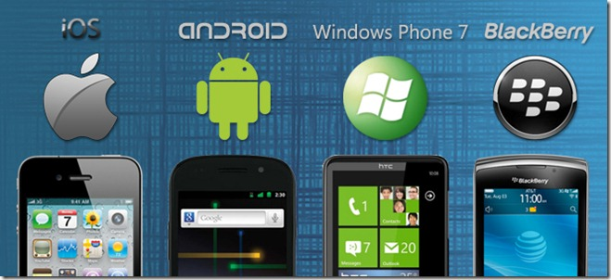

1. **Circuit Switched Packet Telephone System**: Mixes voice and data over circuit-switched networks.
2. **Satellite Telephone System**: Uses satellites to enable voice communication in remote areas.

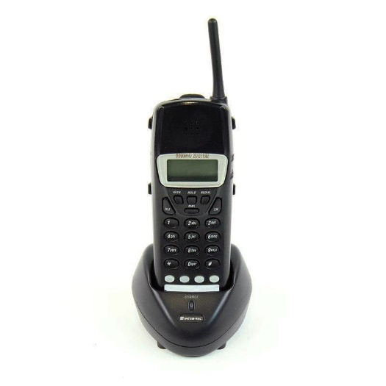

1. **Fixed Wireless Telephone System**: Uses wireless links for fixed-line connectivity.

**Data Networks**

Data networks are systems that allow computers to share resources and information.

**Types of Data Networks:**

1. **Personal Area Network (PAN)**: Very small network, e.g., Bluetooth between phone and computer.

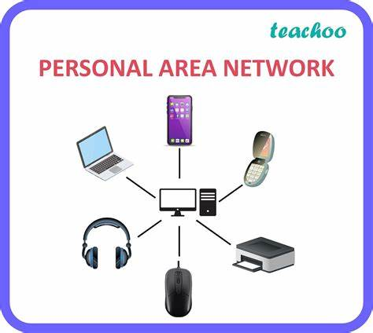

1. **Local Area Network (LAN)**: Network within a building (e.g., school or office).

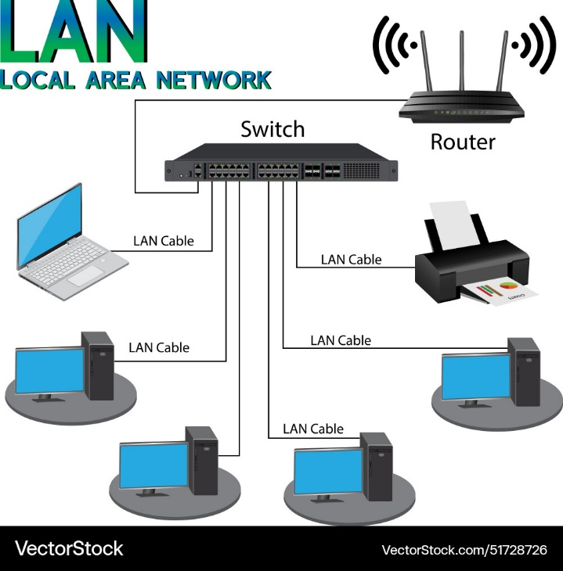

1. **Wide Area Network (WAN)**: Connects networks across cities or countries.

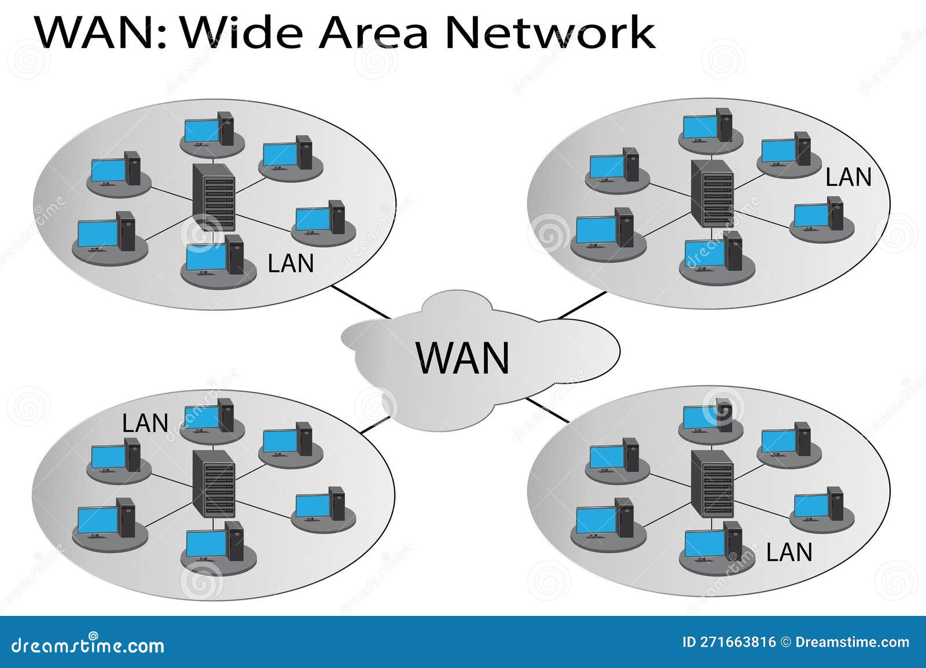

1. **Internet**: The global system of interconnected networks.

**Week 3: COMMUNICATION SYSTEMS 1**

**Topic**: *Information Systems and Applications of ICT*

**Information Systems**  
An Information System (IS) refers to a coordinated set of components and resources designed to collect, process, store, and disseminate data and information.

The **key components** of an IS include:

* 1. Hardware (computers, routers, servers)
  2. Software (applications, operating systems)
  3. Data (input, storage, output)
  4. People (users, IT professionals)
  5. Processes (communication and operations)

**Global Positioning System (GPS)**  
GPS is a system of satellites and receivers that allow users to determine their exact location (latitude, longitude, and altitude) anywhere on Earth.

**ICT Applications**

* + **Teleconferencing**: This is the use of communication technology to hold discussions or meetings remotely.
  + **Video Conferencing**: It allows users to conduct live video meetings over the internet, enhancing visual communication.



* + **Tele-presence**: A more advanced form of video conferencing that creates an immersive experience for participants.
  + **Networking**: The connection of computers and other devices to share resources and information.

**Week 4: APPLICATION AREA OF ICT**

**Topic**: *ICT-based Gadgets and Their Operations*

**ICT-based Gadgets**

* 1. **Mobile Phones**: Used for communication, internet access, and multimedia purposes.

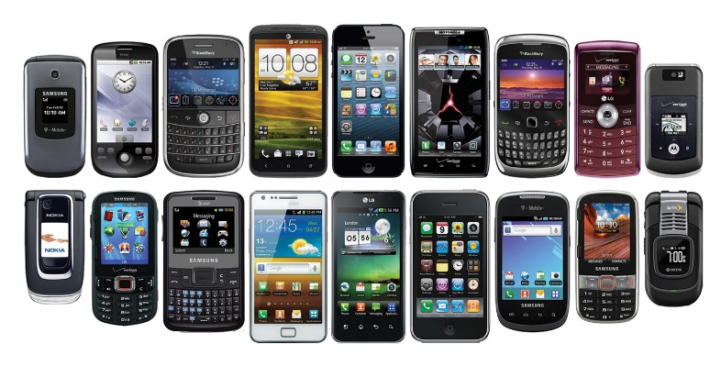

* 1. **Automated Teller Machines (ATM)**: Used for banking transactions such as withdrawals, deposits, and balance checks.

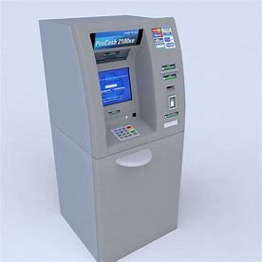

* 1. **Point of Sale (POS) Machines**: Used in retail stores for payment transactions.

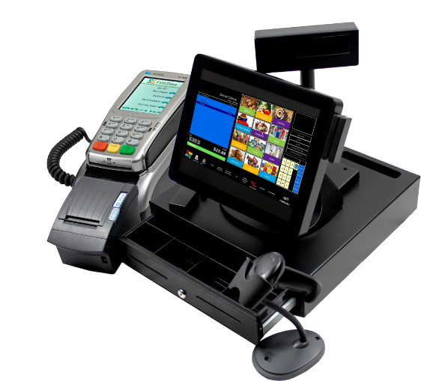

* 1. **Dispensing Machines**: Vending machines that dispense food, drinks, or tickets.

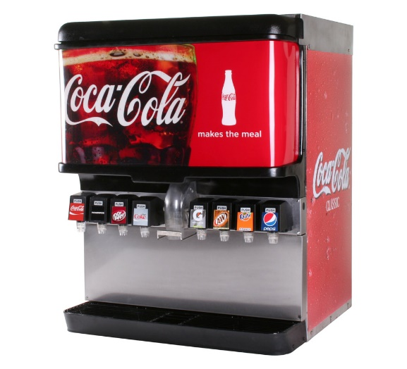

* 1. **Fax Machines**: Used for sending scanned documents over a telephone line.

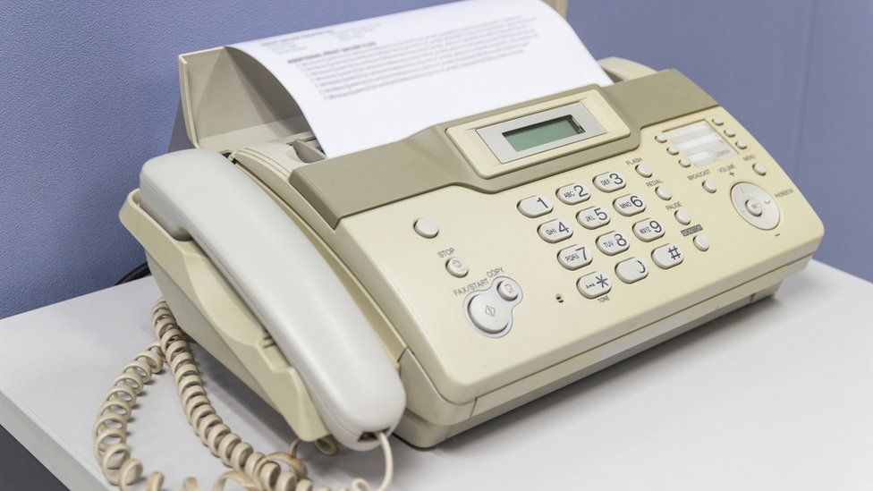

How to use a fax machine

https://youtube.com/shorts/llgS0-ZH9t8?si=4XxpqkoB31-cjHrp

**Operating ICT Gadgets**

1. **Mobile Phones**: Turning on, making calls, sending messages, using apps.
2. **ATM**: Inserting a card, entering a PIN, selecting options, and withdrawing cash.
3. **POS Machine**: Scanning items, making payments via card, and generating receipts.

**Week 5: BASIC COMPUTER OPERATIONS 1**

**Topic**: *Booting Process and Types of Booting*

**Booting Process**  
Booting is the process of starting up a computer, which involves loading the operating system into the computer's memory. It occurs in two stages:

* 1. **Cold Booting (Cold Start)**: This occurs when the computer is powered on from a completely off state.
  2. **Warm Booting (Restarting)**: This occurs when the computer is restarted without being completely turned off.

**Components of the Desktop Environment**

After booting, the computer system will boot to the desktop environment. The components include the following:

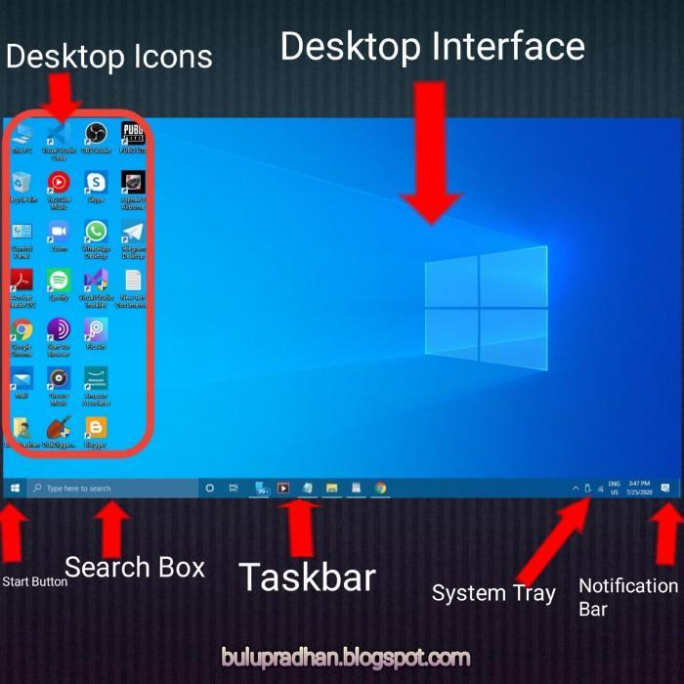

* 1. **Icons**: Small images that represent programs, files, or folders on the desktop.
  2. **Taskbar**: The bar usually located at the bottom of the screen, displaying open applications and the Start menu.
  3. **Background**: The area behind the icons that can be customized with wallpapers or other designs.

**WEEK 6: BASIC COMPUTER OPERATIONS II**

**Topic:** Running an Application Program and Shutting Down the Computer

**Introduction:** Once the computer is booted, users can access different programs (applications) to carry out tasks like typing, browsing, playing music, etc. Proper shutdown of the system is also important to avoid data loss and software/hardware damage.

**Running an Application Program**

A software designed to help users perform specific tasks on the computer.

Examples: Microsoft Word, Excel, Paint, Media Player.

**How to Run an Application Program**:

1. Click the "Start" menu.
2. Scroll to the desired program or use the search bar.
3. Click to open.

**Shutting Down the Computer**:

1. Click on the "Start" menu.
2. Select “Shut down”.
3. Wait for the system to go off completely.

**WEEK 7: WORD PROCESSING I**

**Topic:** Introduction to Word Processing

**Introduction:** Word processing is one of the most used applications of computers today, especially in offices, schools, and homes.

**Definition**:

*Word Processing*: The act of creating, editing, formatting, and printing textual documents using a computer.

*Word Processor*: A software used for word processing.

**Examples of Word Processors**:

1. Microsoft Word
2. Google docs
3. WordStar
4. WordPerfect

**Features of a Word Processor**:

1. Text formatting (bold, italics, underline)
2. Paragraph alignment
3. Spell check
4. Insert images and tables
5. Save and print documents

**WEEK 8: WORD PROCESSING II**

**Topic:** The Word Processing Environment

**Word Processing Environment**:

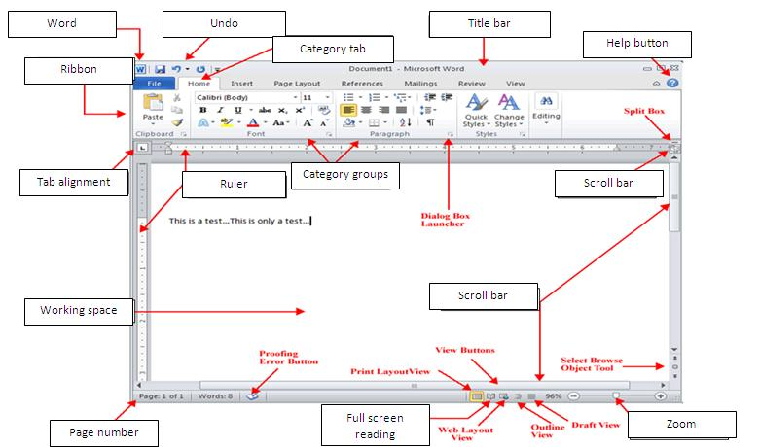

Title bar, Ribbon, Menu, Toolbar, Workspace, Status bar.

**Basic Operations**:

* + Create new document: File > New
  + Edit: Use backspace, delete, insert tools
  + Format: Font size, color, bold, align text
  + Save: File > Save As
  + Retrieve: File > Open
  + Print: File > Print
  + Close: File > Exit

**WEEK 9: PRESENTATION PACKAGES I**

**Topic:** Introduction to Presentation Packages

**Introduction:** Presentation packages are essential tools for creating visual and interactive presentations used in business meetings, classrooms, and public speaking.

**Definition**:

A software application used to create slide-based presentations.

**Examples**:

* + Microsoft PowerPoint
  + Google Slides

**Features**:

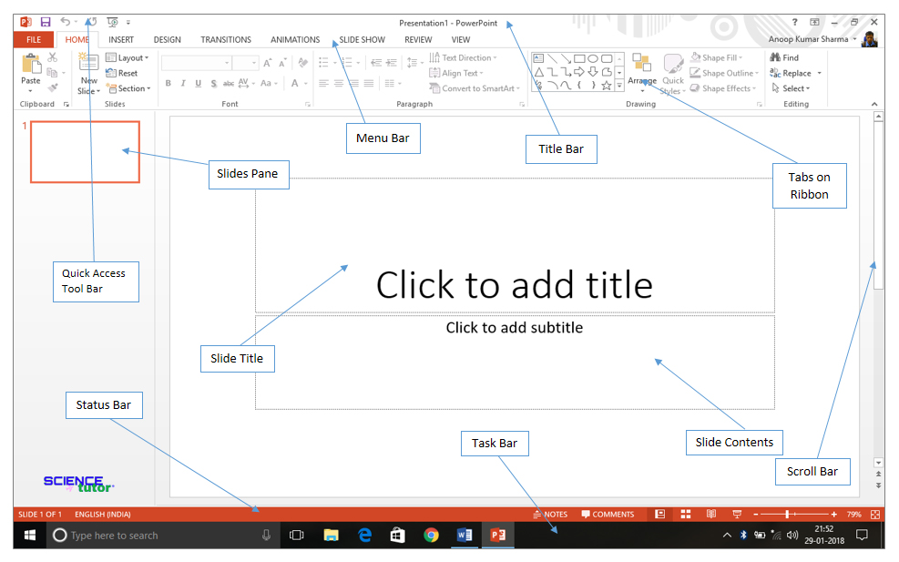

* + Slide creation
  + Text and multimedia insertion
  + Animation and transition effects
  + Slide show presentation

**WEEK 10: USING PRESENTATION PACKAGE I**

**Topic:** Creating Simple Presentations

**Introduction:** Microsoft PowerPoint allows users to create attractive and informative presentations for various purposes.

1. **Starting MS PowerPoint**:
   * File > New Presentation
2. **Inserting Content**:
   * Click in text box to type
   * Insert > Pictures/Shapes/Text Box
   * Resize and reposition elements
3. **Slide Navigation**:
   * Use “New Slide” to add slides
   * Rearrange slides using the slide pane

Watch video resource below

https://youtu.be/gkNGtBlZOwo?si=oo89D4R2E_RyhVA7

**WEEK 11: USING PRESENTATION PACKAGE II**

**Topic:** Animations and Saving Presentations

**Lesson Content:**

1. **Animations**:
   * Animations tab: Entrance, Emphasis, Exit effects
   * Applying to text and images
2. **Slide Management**:
   * Add, delete, rearrange slides
3. **Saving and Exiting**:
   * File > Save/Save As
   * File > Exit