**📘 COMPUTER STUDIES – JSS 1 – THIRD TERM**

**LESSON NOTES**

**WEEK 1: DATA PROCESSING**

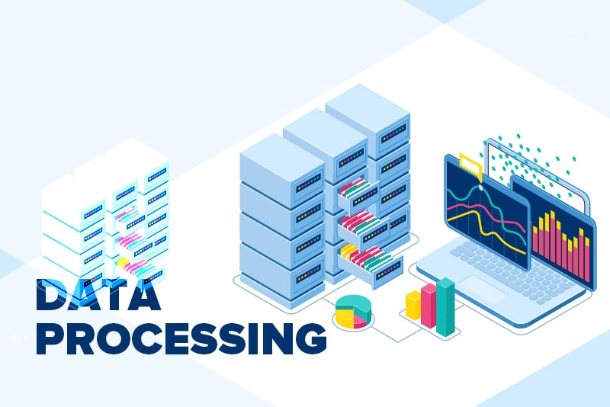

**Definition**:  
Data processing is the series of actions taken to collect, organize, manipulate, and output data into useful information. It is an essential part of communication and decision-making.

**Data Processing Cycle:**

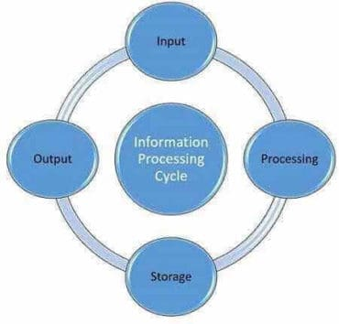

* 1. **Input**: Entering raw data into the computer (e.g., typing exam scores).
  2. **Processing**: The computer works on the data according to instructions (e.g., calculating average marks).
  3. **Output**: Processed data is displayed as information (e.g., report card).
  4. **Storage**: Information is stored for future use (e.g., saving students' results).

**Importance of Computer in Data Processing**:

1. Reduces human error
2. Saves time
3. Allows multitasking
4. Enhances storage and retrieval of large volumes of data
5. Improves decision-making by providing fast access to information

**WEEK 2: INFORMATION TRANSMISSION I**

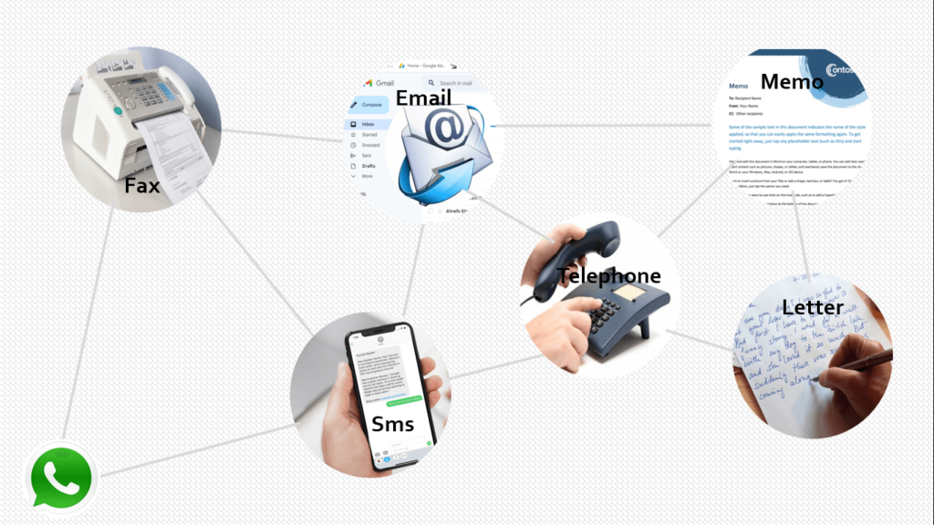

**Definition**:  
Information transmission refers to the act of sending information from one person, device, or location to another.

**Methods of Information Transmission**:

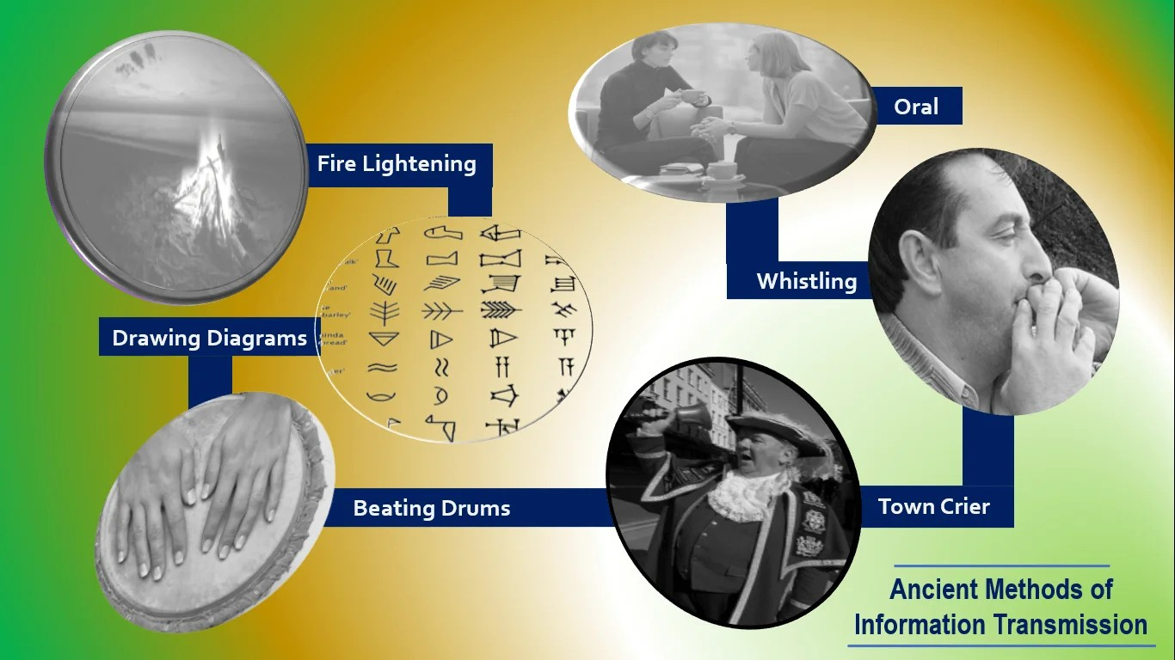

* 1. **Oral**: Spoken communication (e.g., phone call, face-to-face talk).
  2. **Written**: Letters, books, emails.
  3. **Visual**: Pictures, drawings, charts, and traffic lights.

**Importance of Information Transmission**:

* 1. Helps in sharing knowledge
  2. Promotes business activities
  3. Helps in emergency situations (e.g., calling for help)

**WEEK 3: INFORMATION TRANSMISSION II**

**Classification of Information Transmission**:

* 1. **Electronic Means**: Electronic means make information faster and accessible globally.

Examples include:

* + 1. Telephone
    2. Internet
    3. Television
    4. Radio
  1. **Non-Electronic Means**: Non-electronic means are useful in areas with no electricity or internet.

**Examples include:**

* + 1. Newspaper
    2. Hand-delivered letters
    3. Town crier announcements
    4. Verbal communication

**WEEK 4: MODES OF RECEIVING INFORMATION**

**These are the different means through which we receive information**

Different modes ensure information reaches all types of people, including those with disabilities.

These modes are:

* 1. **Auditory Mode**: Through hearing (e.g., listening to the radio or an announcement).
  2. **Visual Mode**: Through sight (e.g., reading a newspaper, looking at a signboard).
  3. **Audio-Visual Mode**: Through hearing and seeing at the same time (e.g., watching a movie).
  4. **Tactile Mode**: Through touch (e.g., reading braille).

**WEEK 5: INFORMATION EVALUATION I**

**Definition**:  
Information evaluation is the process of checking whether information is accurate, reliable, and useful before using it.

**Stages of Information Evaluation**:

* 1. **Identifying the source**: Who gave the information?
  2. **Checking for accuracy**: Is it correct and true?
  3. **Assessing relevance**: Is it related to what you need?
  4. **Confirming reliability**: Is the source trustworthy?

**Example**: Before using news from social media, verify it from official news websites.

**WEEK 6: INFORMATION EVALUATION II**

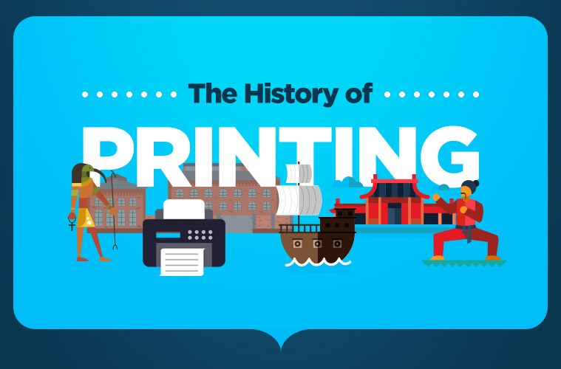

**Invention of Printing**:

**Printing** wasInvented by **Johannes Gutenberg** around 1440. It was the first movable type printing made to create hard copies.

It made books affordable and knowledge more accessible.

**Invention of Computers**:

Early computers like the **Analytical Engine** was designed by **Charles Babbage** as a means to make complex calculations easier and faster.

Computers have evolved to perform fast processing and storage.

**The Link between Computers and ICT**:

Computers combined with internet and telecommunications form **Information and Communication Technology (ICT)**.

ICT has revolutionized how we send, store, and access information today.

**WEEK 7: WORD PROCESSING**

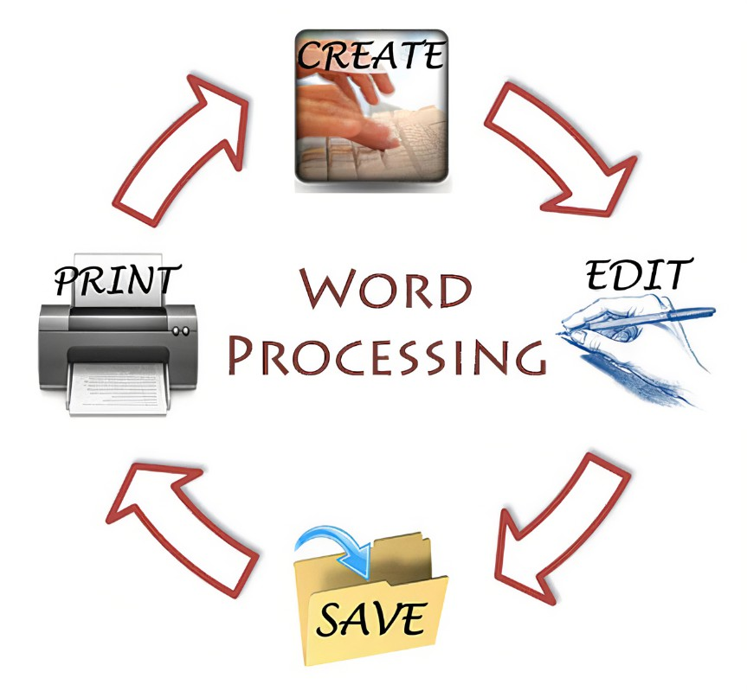

**Definition**:  
Word processing is the act of using a computer program to create, edit, format, and print documents like letters, essays, and reports.

**Examples of Word Processing Software**:

* + Microsoft Word
  + Google Docs
  + WPS Office

**Loading a Word Processor**:

Step 1: Turn on the computer.

Step 2: Click the application icon or search for it in the start menu.

**Exiting a Word Processor**:

Step1: Save your document.

Step2: Click 'File' → 'Exit' or close the window.

**WEEK 8: OPENING AND EXITING FILE**

**Opening a File**:

After starting the word processor, go to 'File' → 'Open' → Select the file.

**Exiting a File**:

* + Save changes (Ctrl + S).
  + Go to 'File' → 'Close' OR click on 'X'.

**WEEK 9: CREATING AND SAVING A FILE**

**Creating a New File**:

* 1. Open the word processor.
  2. Click 'File' → 'New' → A blank page appears.

**Saving a File**:

* 1. Click 'File' → 'Save As'.
  2. Type a file name.
  3. Choose where to save (desktop, documents).
  4. Click 'Save'.

**Importance**:

* 1. Helps you keep a copy of your work for future use.
  2. Files can be edited later without starting again.