**📚 COMPUTER STUDIES**

**JSS 2 – THIRD TERM** **(Weeks 1–10)**

**LESSON NOTE**

**WEEK 1: UNIT OF STORAGE IN THE COMPUTER**

**Topic:** Storage and Units of Storage

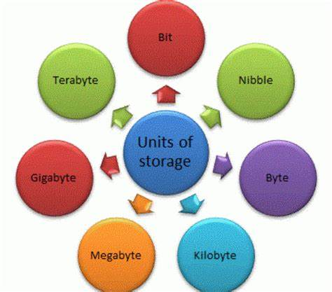

**Definition:**

**Computer Storage** is the part of a computer where data is held either temporarily or permanently. It allows users to save information and retrieve it later.

Computers store everything (text, images, sounds) as binary digits (0s and 1s).

**Units of Storage**:

1. **Bit (Binary Digit)**: The smallest piece of data, either 0 or 1.
2. **Nibble**: 4 bits (e.g., 1010).
3. **Byte**: 8 bits (e.g., 11001010). A byte can store one character like 'A' or '3'.

**Examples**:

* The letter 'A' is stored as 01000001 in 8-bit binary.

**WEEK 2: UNIT OF STORAGE II**

**Topic:** Higher Units of Storage and Conversions

**Storage Units**:

* + 1 Byte = 8 bits
  + 1 Kilobyte (KB) = 1024 Bytes
  + 1 Megabyte (MB) = 1024 KB
  + 1 Gigabyte (GB) = 1024 MB
  + 1 Terabyte (TB) = 1024 GB (optional info)

**Conversions**:

* To convert from KB to Bytes: Multiply by 1024.
* To convert from MB to KB: Multiply by 1024.
* Example: 2 MB = 2 × 1024 KB = 2048 KB.

**NOTE:**

To covert from higher unit to lower unit, you divide

Multiply to convert from lower to higher

**Differences**:

* KB is smaller than MB.
* GB can store larger files like movies.

**WEEK 3: PROGRAMMING LANGUAGE**

**Topic:** Definition and Examples



**Programming Language**:

Is a set of instructions written in a specific format for a computer to execute tasks.

**Why We Need Programming Languages**:

* + To control computers.
  + To develop applications (games, websites, banking systems).

**Examples**:

* + **Python**: Easy for beginners.
  + **Java**: Used for Android apps.
  + **C++**: Used for gaming and simulations.
  + **Scratch**: A visual programming language for children.

**Categories of Programing Languages**

Programing languages are classified into two major categories:

1. Low Level Programing Language and
2. High Level Programming Languages

**WEEK 4: LOW LEVEL LANGUAGE**

**Topic:** Machine Language and Assembly Language

**Low Level Language**: A programming language that interacts directly with the computer’s hardware.

**Types**:

* + **Machine Language**: Instructions are in binary code (e.g., 10101001).
    - Pros: Fast execution.
    - Cons: Hard to understand, bulky and hard to fix errors
  + **Assembly Language**: Uses short words (mnemonics) like MOV, ADD, SUB. Needs an assembler to convert it into machine language.

**Examples**:

* Machine: 00011010
* Assembly: MOV A, B

**WEEK 5: HIGH LEVEL LANGUAGE**

**Topic:** Definition and Translators

**High Level Language**: Are programing languages designed to be easy for humans to read and write.

Examples: Python, Java, BASIC.

**Translators**: Are System softwares that help computers read and understand programing languages

**Types of Translators:**

1. **Interpreter**: Translates and runs code line by line (e.g., Python interpreter).
2. **Compiler**: Translates the whole code at once, then executes (e.g., Java compiler).
3. **Assembler**: Converts assembly to machine language.

**Comparison**:

* High Level: Easy to read.
* Low Level: Harder to read but faster for the machine.

**WEEK 6: INTERNET I**

**Topic:** Definition and Benefits

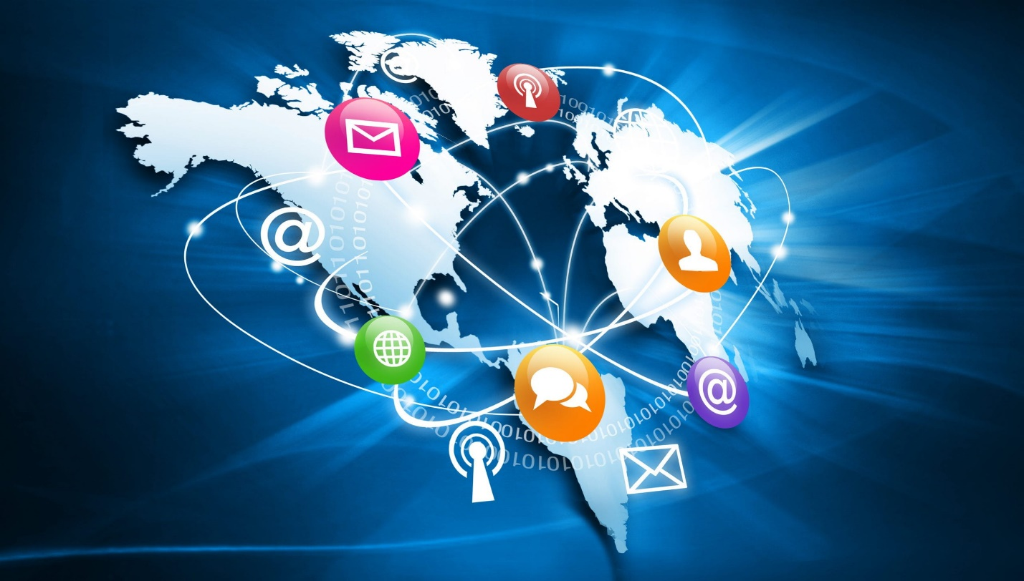

**Definition:**

**The Internet**: Is a worldwide connection of millions of computers for sharing information.

**Benefits**:

* 1. Email communication.
  2. Research and education.
  3. Online shopping and banking.
  4. Social media interaction (Facebook, WhatsApp).

**Real Life Application**:

* Using Google to do homework research.
* Chatting with friends over email or WhatsApp.
* Doing businesses
* School management
* E-commerce etc.

**WEEK 7: INTERNET II**

**Topic:** Abuse of the Internet

**Types of Internet Abuse**:

* 1. **Cyberbullying**: Sending hurtful messages online.
  2. **Hacking**: Unauthorized access to computers.
  3. **Fraud**: Scamming people online.
  4. **Exposure to Inappropriate Content**: Viewing harmful materials.

**Safety Tips**:

* Do not share personal information online.
* Report suspicious activities to adults.

**WEEK 8: INTERNET III**

**Topic:** Creating, Sending, Receiving E-mails

**E-mail** stands for electronic mail, it’s a means of sending and receiving information via the internet.

**Practical:**

**Creating an Email Account**:

* + Go to Gmail, Yahoo, or Outlook.
  + Fill in details (username, password, phone number).

**Sending an Email**:

* + Click "Compose."
  + Enter recipient’s address.
  + Write the subject and message.
  + Click "Send."

**Receiving an Email**:

* Check your inbox.
* Open and read the message.

**WEEK 9: INTERNET IV**

**Topic:** Searching for Educational Information

**Search Engines** are application softwares that enable us search for information on the internet.

**Popular Search Engines**:

* + Google
  + Bing
  + Yahoo

**Effective Searching Tips**:

* + Use specific keywords ("History of Computers" instead of "history").
  + Use quotation marks for exact phrases.
  + Evaluate if the site is reliable (e.g., sites ending with .edu or .gov).

**WEEK 10: INTERNET V**

**Topic:** Practical Session – Creating Email Accounts

**Practical Steps**:

* + Choose a unique username.
  + Set a strong password (use letters, numbers, and symbols).
  + Confirm email through mobile verification if required.
* **First Task**: Compose a “Thank You” email to the teacher.