**SOCIO POLITICAL STRUCTURE OF THE ANCIENT MAIL EMPIRE;**

The ancient Mali Empire operated monarchical system of government and was ruled by by a supreme ruler who bore the title, Mansa. The administration of the empire was decentralized, each territory retained some of their culture; control and privileges but they were under one authority. The society was class based by political and economic status. The Mansa and his officials were the most important people followed by the religious leaders and storytellers.

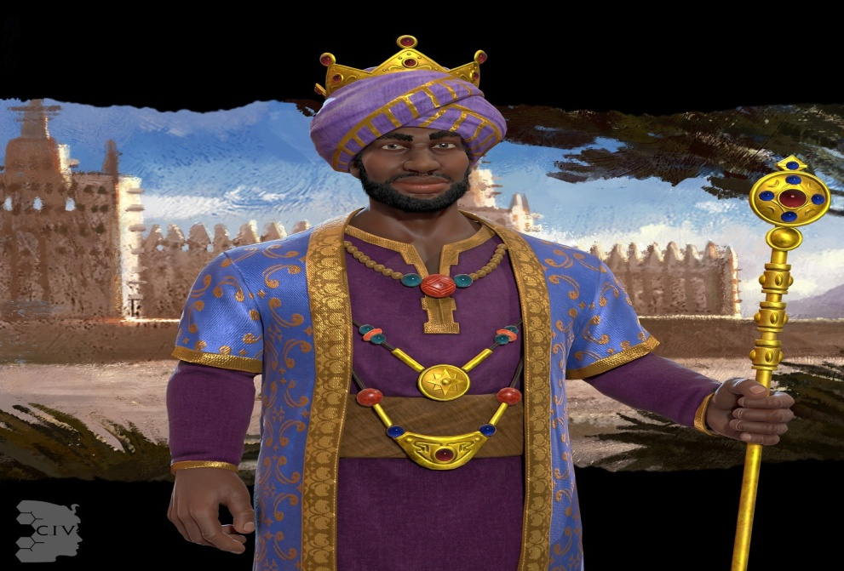

ACHIEVEMENT OF SUNDIATA KEITA (1235 C.E. to 1255 C.E.) Sundiata Keita was the first ruler of the Mali Empire from 1235 C.E. to 1255 C.E. Sundiata Keita, whose name means Lion Prince, was born early in the 13th century to a noble family within the Malinke people. The Malinke kingdom, Kangaba, was part of the Ghana Empire of West Africa. Oral stories about Keita say that he was a sickly child or suffered from some sort of physical impairment. This explains why, when his brothers were killed by the rulers of Ghana, he was spared. Eventually, he became a local leader of the kingdom of Kangaba. When the Ghana Empire tried to impose trade restrictions on the Malinke, Keita began a revolt. He managed to unite several peoples of West Africa to fight against Ghana's king, Sumanguru; he defeated Sumanguru at the battle of Kirina in 1235 C.E. After that, Keita’s generals began to conquer other territories in West Africa. He called his new kingdom the Mali Empire, which would become one of the richest empires in the world. Keita’s victory over Sumanguru marked the beginning of the Mali Empire. Keita decided to rebuild the then-destroyed city of Niani near the Sankarini River as his new capital. This area soon became a hub for African and Arab traders. The Mali Empire grew wealthy due to its control of trade routes as well as its significant gold and copper resources. The Mali Empire, under Sundiata Keita, created one of the very first charters of human rights, the Manden Charter, also known as the Kouroukan Fouga. This is an oral, rather than written, charter, which has been passed down by generations of Malinke. The Manden Charter speaks about peace within a diverse nation, the abolition of slavery, education, and food security, among other things. Keita died in 1255 from an unclear cause, though some believe he was killed in an accident. As founder of the Mali Empire, he is the subject of a large oral storytelling tradition that describes him as a near-legendary figure. The empire he founded became one of the richest in the world, and his descendants included one of the richest individuals to ever live, Mansa Musa. His administration and military work allowed the empire to survive through the 16th century, solidifying him, his empire, and his family into the imaginations of storytellers around the world.

**DESCRIPTION OF SUNDIATA KEITA THE EMPEROR OF THE ANCIENT MAIL EMPIRE.**

Description of Sundiata keita the emperor of the ancient Mali Empire. Sundiata Keita was the first ruler of the Mali Empire from 1235 C.E. to 1255 C.E. Sundiata Keita, whose name means Lion Prince, was born early in the 13th century to a noble family within the Malinke people. The Malinke kingdom, Kangaba, was part of the Ghana Empire of West Africa. Oral stories about Keita say that he was a sickly child or suffered from some sort of physical impairment. This explains why, when his brothers were killed by the rulers of Ghana, he was spared. Eventually, he became a local leader of the kingdom of Kangaba.

**HOW WOULD YOU DESCRIBE SUNDIATA KEITA?**

1. Sundiata keita was a west African political leader who became the founder and first ruler of the mail empire.
2. Sundiata was known to be a prudent ruler because he approached situation in a wise manner.

PICTURE OF SUNDIATA KEITA

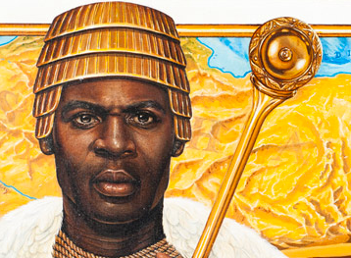

Keita was the founder and ruler of the [Mali Empire](https://aaregistry.org/story/the-mali-empire-a-brief-story/) in West Africa. Keita was the son of Nare Maghan, the ruler of Kangaba, a small state located on an offshoot of the upper Niger River. Sundiata left Kangaba, but the reason is unknown: he may have gone into voluntary exile to avoid a jealous half-brother, or he may have been exiled by Sumanguru Kante, king of the Soso, who killed Keita's father and took over his kingdom.

Keita responded to the requests of his people to return to Kangaba to help them regain their independence.

**He regain their independence in the following ways.**

1. **H**e assembled a coalition of Malinke chiefdoms and, in 1235, led them to victory in the Battle of Kirina. According to popular tradition, he triumphed because he was a stronger magician than his opponent. This victory marked the beginning of the Mali Empire.
2. After defeating the Soso, Keita merged his authority among the Malinke people and established a strong centralized monarchy. Ibn Khaldun and other fourteenth-century North African historians indicate that Sundiata Keita ruled Mali for 25 years.
3. He expanded the state by incorporating the [Ghana Empire](https://aaregistry.org/story/the-ghana-empire-a-brief-story/) and the West African goldfields. Keita built his capital at Niani, which was in his home region.
4. Mali gained economic strength by controlling the region's trade routes and goldfields. Although he was Muslim, he allowed the people to practice their religions. When Keita died, his son Uli became Mali's Mansa or king. The Malinke people of West Africa continue to regard Sundiata Keita as a national hero. His death is estimated to have taken place around 1260.

JSS 2 HISTORY NOTE WEEK 3-11

TOPIC: REGAINING THE INDEPENDENCE OF KANGABA

The Kangaba Kingdom had certain geographical advantages which was an assess in its becoming an empire. Unlike Ghana Empire its situated right in the center of the savannah lands of the western Sudan. This meant that the People of Kangaba practice agriculture and produce food to feed a large population, including its large fighting forces. Its position also gave its control of trans-Saharan commerce and a monopoly of the gold trade, especially as the gold – producing region of

Wangara. Sundiata Keita was once a [dugu -tigi], headman of one the villages of Kangaba. Sundiata Keita responded to the requests of his People to return to kangaba to help them regain their independent. He assembled a coalition of Malinke chiefdom’s [He brought together a small army of malinke ] and in 1235 led them to victory, he triumphed because he was a stronger Magician than his opponent.After the death of sundiata, his son mansawali succeeded him . He was one of the powerful leaders of the empire. Mansa wali was succeeded by his brothermansawati who was succeeded by mansakhalifa, khalifa was regarded to be a bad ruler during his reign. He drive pleasure in killing people unnecessarily.

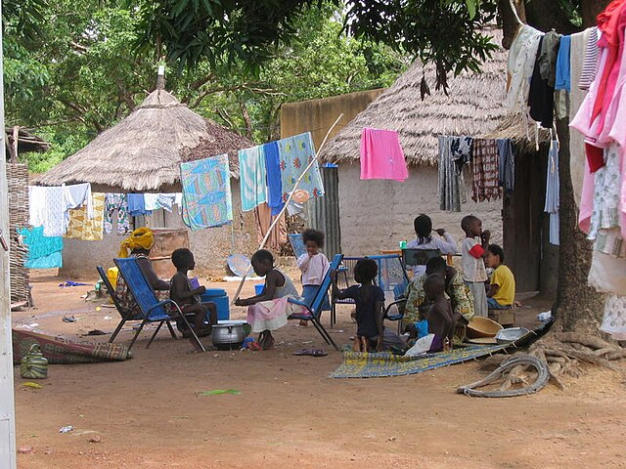

Kangabamali.

**TOPIC: PoliticalContributionofSundiatakeitatoMaliEmpire**

Politicsisthewaythatpeoplelivingingroups,makingdecisions.

Politicsisallaboutmakingagreementsbetweenpeoplesothatthey

Livetogetheringroups suchastribes,citiesorcountries.

**THECONTRIBUTIONOFSUNDIATAKEITATOMALIEMPIRE**

1. **S**undiatakeitatookcontroloftheGoldandSalttrade,helpingMalito becoming

Richandpowerful.

2.HislavishpilgrimagetoMeccamadetheEmpireofMaliand its wealth widely known.

3.HeestablishedthecityofNianiasthecapitaloftheEmpire.

4.From Niani, heruledfor20years,keepingpeaceintheregionandexpandingtheEmpire.

5.Hecreatednewarchitecturalmethodsthatarestillusedtilltoday.

TOPIC; **CREATION OF MALI EMPIRE BY SUNDIATA KEITA**

1230: Sundiata Keita, establishes the Mali Empire after defeating the Sosso Empire in the Battle of Kirina. 1235-1255: Sundiata Keita expands the Mali Empire through conquest, gaining control over the gold and salt trade routes and establishing a capital at Niani.13 Mar 2023

**THE STEPS USED BY SUNDITA TO TURN MAIL IN TO AN EMPIRE;**

1. He took power away from local chiefs, and took the authority of a mansa.
2. He took control of gold and salt trade routes.
3. He built a powerful army, conquered many neighboring kingdom.

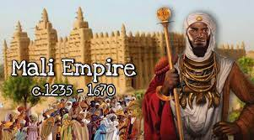

**ECONOMIC CONTIBUTION OF SUNDIATA KEITA IN MAIL EMPIRE**

1. He established economic stability in the Empire by taking control of the gold and salt trade in the region, thus making the Empire wealthier and more powerful.
2. Sundiata kept peace with his neighbors while expanding the territory of the Empire.

mails control of the trans-saharan trade routes boosted its economy. This made the north African merchants settle in mail empire and promoted trade links with sundan.

**GEOGRAFICIAL ADVANTAGE**

Geography was key to the Mali Empire's success. Mali was located on the Niger River, which facilitated fast travel and access to other regions, and was in the Sahel, the "shore" of the vast Sahara Desert. Camels, known as the "ships of the desert," carried salt from the northern mines in the desert to be traded for gold and other goods such as kola nuts and grain from the southern part of the Mali Empire

**FACTORS THAT LED TO THERISE OF MALI EMPIRE**

The political Factors that led to the rise of Mali Empire are thus:

1. **Capable leadership:** Mali Empire produced capable leaders, for example, Mansa

Musa who was reputed to be a very wise and efficient administrator.

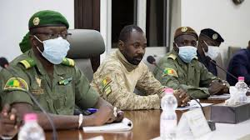

Mali leaders

2. **Conquest of some cities:** The conquest of some cities and its surrounding

areas led to the expansion of the empire. Some of the leaders, such as Mansa

Abubakar II, Mansa Musa, among others, launched successful military expeditions to

expand the empire.

1. **Organization of a formidable army or strong army:** Mali Empire established a strong military whichguarded its borders and citizens against conquests. Mali Empire at its peak couldboast of an army of more than 100,000 soldiers.

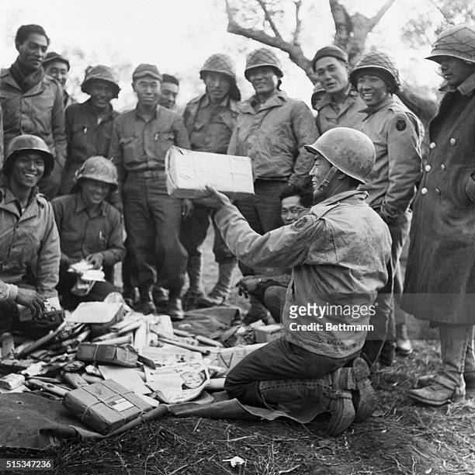

Mali soldiers

**4. Stable and political system;** there have council of nine clan elders and delegate advised the king in governance, economy and cultural matters. This made for stable government.

**ECONOMIC FACTORS THAT LED TO THE RISE OF MAIL EMPIRE.**

1. **Trading activities**: The empire traded in gold and other commodities withneighbouring states, North Africa and parts of Europe, this generated substantialrevenue.



Gold.

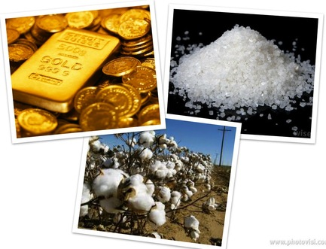Salt.

2. **Increase in tax revenue**: Taxes were collected from imported and exported goodswhich contributed to increase in government revenue.

3. **Control of the trans-Saharan trade routes:** Mali control of the trans-Saharan traderoutes boosted its economy. This made North African merchants settle in MaliEmpire and promoted trade links with Sudan.

4 **Collection of tributes;** Mail empire collected tributes from the vassal states which aided its economy.

**SOCIAL FACTORS THAT LED TO THE RISE OF MAIL EMPIRE**

1. Commission of great buildings like mosques in Timbuktu. This made the empire a famous centre of learning and spectacular architecture.
2. Building one of the centresof learning, the sankore university library, this institution produced great astronauts, scholars, and judges for the empire.
3. Her influence on the West African coast. This allowed for the spread of its language, law and customs along the West African coast.

**FACTORS THAT LED TO THE FALL OF MALI EMPIRE;**

Mali Empire due to some factors slowly declined until its final collapse in 1670AD. The

factors that contributed to the fall of Mali Empire are contained in the succeeding

paragraphs.

1. **Internal civil wars and rebellions:** Internal disputes resulted to wars within the

empire. The empire encountered external attacks which led to the capture of

Timbuktu and other major trading centres which affected it revenue supply.

**2. Incapable leadership:** There was political instability created by the emergence of

bad leaders whose reigns were usually short. This was after the reign of Mansa Musa.

3. **Rise of Songhai empire:** Songhai led the city of Gao to revolt against Mali empire. By

the 16th century, the rebels and invaders had reduced the empire to its original size

where the Malinke people lived before. The empire experienced gradual loss of its

northern and eastern vassal states to the rising Songhai Empire; this affected its

revenue and supply of slaves.

4. **Succession dispute after the death of Mahmud Keita:** There was power struggle

among the three sons of Mansa Mahmud IV after his death, which contributed to

the fall of the empire .Mansa Musa came to power in 1312 C.E., after the previous king, Abu Bakr II, disappeared at sea. Mansa Abu Bakr II had departed on a large fleet of ships to explore the Atlantic Ocean, and never returned. Mansa Musa inherited a kingdom that was already wealthy, but his work in expanding trade made Mali the wealthiest kingdom in Africa. His riches came from mining significant salt and gold deposits in the Mali kingdom. Elephant ivory was another major source of wealth.  
  
When Mansa Musa went on a pilgrimage (*hajj*) to Mecca in 1324 C.E., his journey through Egypt caused quite a stir. The kingdom of Mali was relatively unknown outside of West Africa until this event. Arab writers from the time said that he travelled with an entourage of tens of thousands of people and dozens of camels, each carrying 136 kilograms (300 pounds) of gold. While in Cairo, Mansa Musa met with the Sultan of Egypt, and his caravan spent and gave away so much gold that the overall value of gold decreased in Egypt for the next 12 years. Stories of his fabulous wealth even reached Europe. The Catalan Atlas, created in 1375 C.E. by Spanish cartographers, shows West Africa dominated by a depiction of Mansa Musa sitting on a throne, holding a nugget of gold in one hand and a golden staff in the other. After the publication of this atlas, Mansa Musa became cemented in the global imagination as a figure of stupendous wealth. After his return from Mecca, Mansa Musa began to revitalize cities in his kingdom. He built mosques and large public buildings in cities like Gao and, most famously, Timbuktu. Timbuktu became a major Islamic university center during the 14th century due to Mansa Musa’s developments. Mansa Musa brought architects and scholars from across the Islamic world into his kingdom, and the reputation of the Mali kingdom grew. The kingdom of Mali reached its greatest extent around the same time, a bustling, wealthy kingdom thanks to Mansa Musa’s expansion and administration. Mansa Musa died in 1337 and was succeeded by his sons. His skillful administration left his empire well-off at the time of his death, but eventually, the empire fell apart. Well after his death, Mansa Musa remained engrained in the imagination of the world as a symbol of fabulous wealth. However, his riches are only one part of his legacy, and he is also remembered for his Islamic faith, promotion of scholarship, and patronage of culture in Mali.

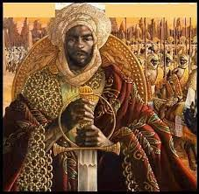

Mansa Musa

**ACHIEVEMENTS OF MANSA MUSA KANKAN**

Mansa Musa developed cities like Timbuktu and Gao into important cultural centers. He also brought architects from the Middle East and across Africa to design new buildings for his cities. Mansa Musa turned the kingdom of Mali into a sophisticated center of learning in the Islamic world.