Ερώτημα 1. Σχεδιασμός της ΒΔ

1. Εισάγετε τα παραπάνω δεδομένα σε μια κατάλληλα σχεδιασμένη ΒΔ σε σύστημα της επιλογής σας (PostgreSQL ή Oracle).

Δημιουργία πινάκων σύμφωνα με το σχεσιακό μοντέλο.

* Πίνακας customers:

CREATE TABLE customers

(

customerid integer NOT NULL,

firstname character(30),

lastname character(30),

address1 character(40),

address2 character(40),

city character(30),

state character(10),

zip integer,

country character(40),

region integer,

email character(40),

phone bigint,

creditcardtype integer,

creditcard bigint,

creditcardexpiration character(20),

username character(20),

"""password""" character(30),

age integer,

income real,

gender character(10),

CONSTRAINT pk_customers PRIMARY KEY (customerid)

)

WITH (

OIDS=FALSE

);

ALTER TABLE customers

OWNER TO postgres;

Γέμισμα πίνακα :

* 1o βήμα:

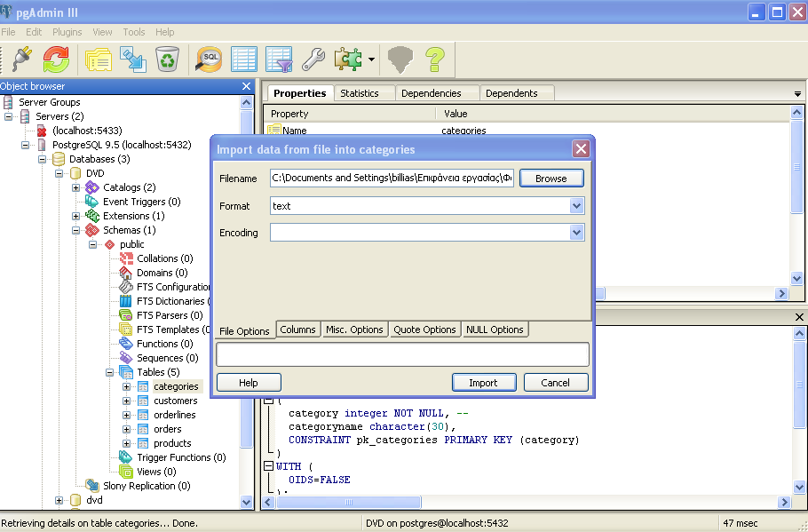

* 2o βήμα:

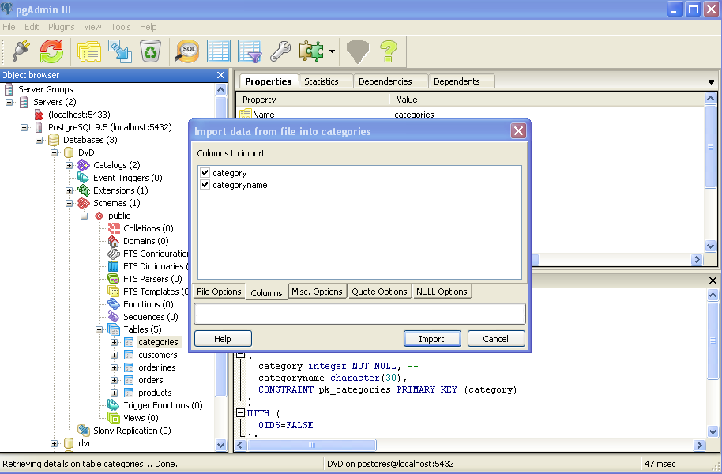

* 3o βήμα:

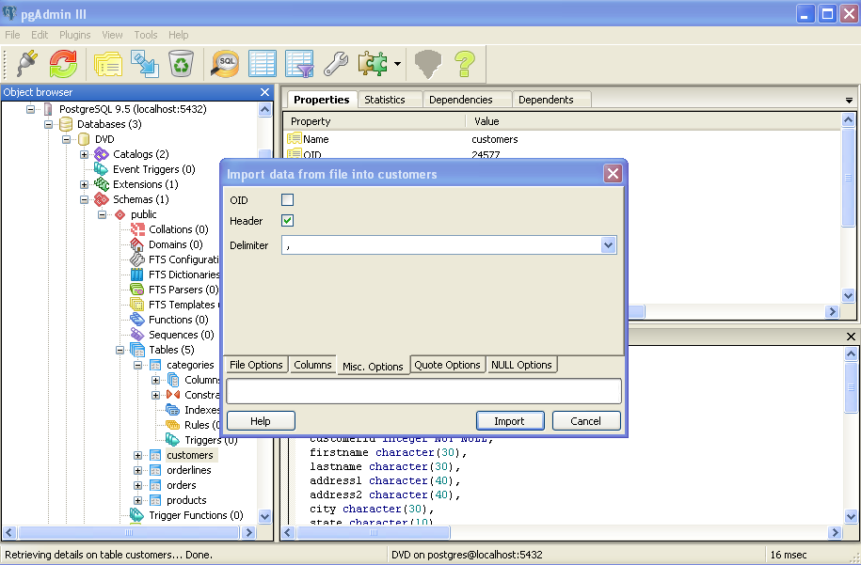

* 4o βήμα:

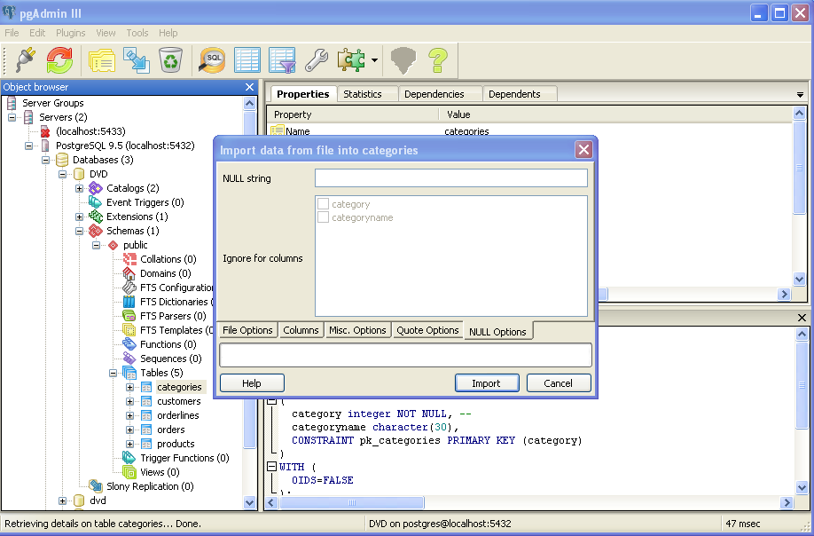

* 5o βήμα: 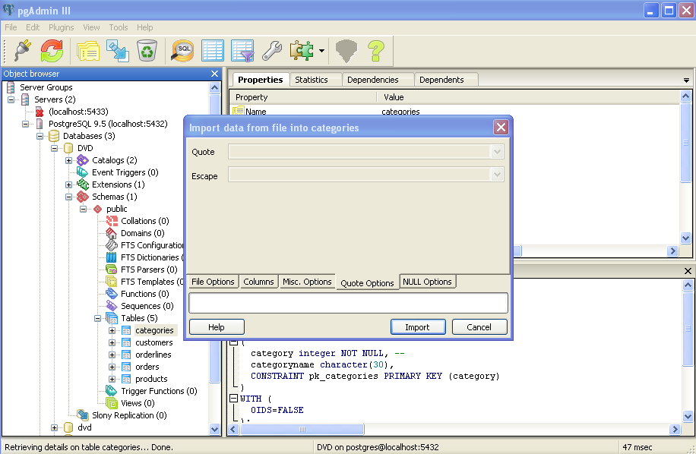
* **Πίνακας categories :**

CREATE TABLE categories

(

category integer NOT NULL,

categoryname character(30),

CONSTRAINT pk_categories PRIMARY KEY (category)

)

WITH (

OIDS=FALSE

);

ALTER TABLE categories

OWNER TO postgres;

COMMENT ON COLUMN categories.category IS '

';

* **Πίνακας orders:**

CREATE TABLE orders

(

orderid integer NOT NULL,

orderdate date,

customerid integer,

netamount real,

tax real,

totalamount real,

CONSTRAINT pk_orders PRIMARY KEY (orderid),

CONSTRAINT fk_orders FOREIGN KEY (customerid)

REFERENCES customers (customerid) MATCH SIMPLE

ON UPDATE NO ACTION ON DELETE NO ACTION

)

WITH (

OIDS=FALSE

);

ALTER TABLE orders

OWNER TO postgres;

* **Πίνακας products:**

CREATE TABLE products

(

prod_id integer NOT NULL,

category integer,

title character(40),

actor character(40),

price real,

CONSTRAINT pk_products PRIMARY KEY (prod_id),

CONSTRAINT fk_products FOREIGN KEY (category)

REFERENCES categories (category) MATCH SIMPLE

ON UPDATE NO ACTION ON DELETE NO ACTION

)

WITH (

OIDS=FALSE

);

ALTER TABLE products

OWNER TO postgres;

* **Πίνακας orderlines:**

CREATE TABLE orderlines

(orderlineid integer NOT NULL,

orderid integer NOT NULL,

prod_id integer,

quantity integer,

orderdate date,

CONSTRAINT pk_orderlines PRIMARY KEY (orderlineid, orderid),

CONSTRAINT fk1_orderlines FOREIGN KEY (orderid)

REFERENCES orders (orderid) MATCH SIMPLE

ON UPDATE NO ACTION ON DELETE NO ACTION,

CONSTRAINT fk2_orderlines FOREIGN KEY (prod_id)

REFERENCES products (prod_id) MATCH SIMPLE

ON UPDATE NO ACTION ON DELETE NO ACTION

)

WITH (

OIDS=FALSE

);

ALTER TABLE orderlines

OWNER TO postgres;

**Γεμισμένοι Πίνακες:**

**Customers:**

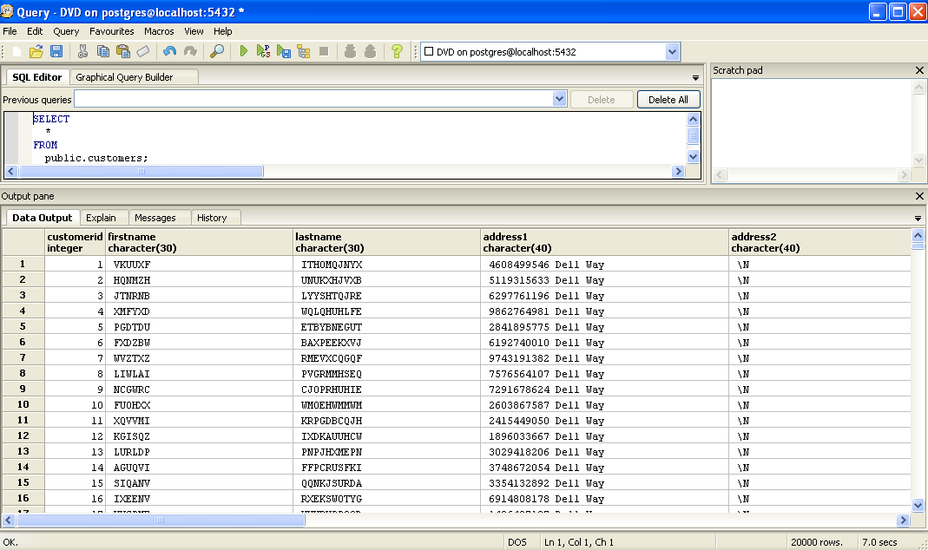

**Products:** 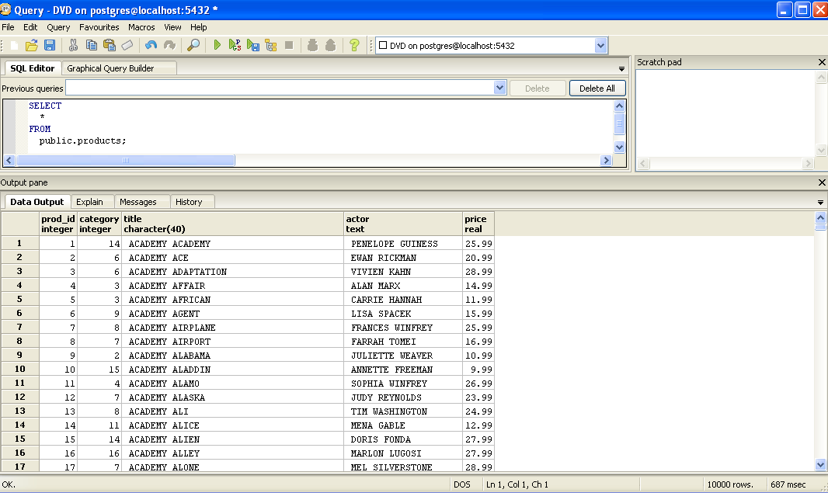

**Categories:**

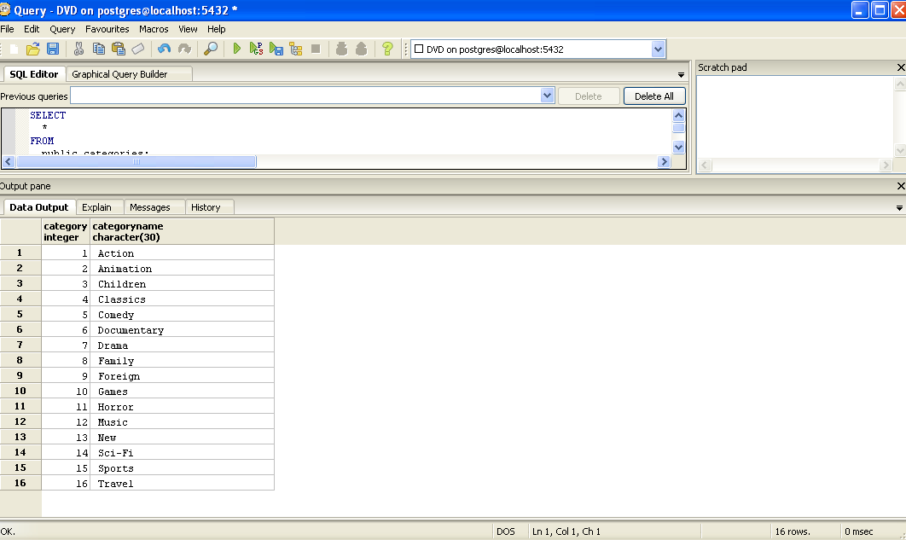

**Orders:** 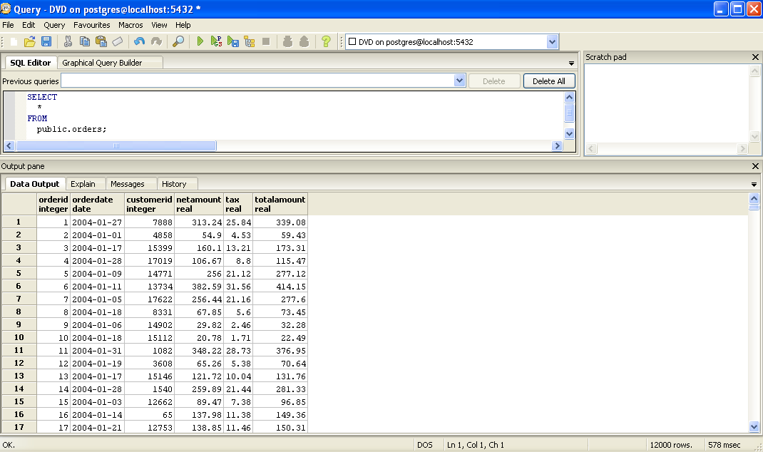

**Orderlines:**

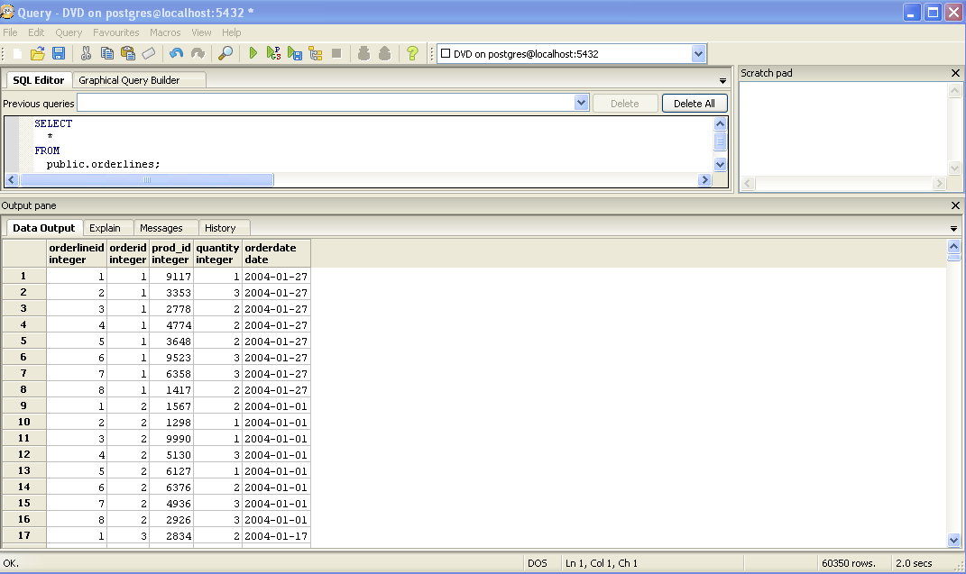

(b) Δημιουργία πινάκων σύμφωνα με το αντικειμενο-σχεσιακό μοντέλο.

**Δημιουργία Τύπων:**

CREATE TYPE address AS

(address1 character(40),

address2 character(40));

ALTER TYPE address

OWNER TO postgres;

CREATE TYPE category AS

(category integer,

categoryname character(30));

ALTER TYPE category

OWNER TO postgres;

CREATE TYPE credit_info AS

(creditcardtype integer,

creditcard bigint,

creditcardexpiration character(20));

ALTER TYPE credit_info

OWNER TO postgres;

CREATE TYPE location AS

(city character(30),

state character(10),

zip integer,

country character(40),

region integer);

ALTER TYPE location

OWNER TO postgres;

**Δημιουργία Πινάκων:**

CREATE TABLE products_objr

(

prod_id integer NOT NULL,

categoryinfo category,

title character(40),

actor character(40),

price real,

CONSTRAINT pk_products_objr PRIMARY KEY (prod_id)

)

WITH (

OIDS=FALSE

);

ALTER TABLE products_objr

OWNER TO postgres;

CREATE TABLE customers_objr

(

customerid integer NOT NULL,

firstname character(30),

lastname character(40),

addressinfo address,

locationinfo location,

email character(40),

phone bigint,

creditcardinfo credit_info,

username character(20),

password character(30),

age integer,

income real,

gender character(10),

CONSTRAINT pk_customers_objr PRIMARY KEY (customerid)

)

WITH (

OIDS=FALSE

);

ALTER TABLE customers_objr

OWNER TO postgres;

**Γέμισμα πινάκων:**

INSERT INTO customers_objr

(SELECT cu.customerid,cu.firstname,cu.lastname,(cu.address1,cu.address2)::address,

(cu.city,cu.state,cu.zip,cu.country,cu.region)::location,cu.email,cu.phone,

(cu.creditcardtype,cu.creditcard,cu.creditcardexpiration)::credit_info,cu.username,

cu.password,cu.age,cu.income,cu.gender FROM customers cu);

INSERT INTO products_objr

SELECT pr.prod_id, (c.category,c.categoryname)::category, pr.title, pr.actor, pr.price

FROM products pr, categories c

WHERE pr.category = c.category;