Lab 3: AWS Security and Server Infrastructure

Aim
The aim of this lab is to set up AWS server instances and understand the setup of key security aspects. It is preferable to use a Ubuntu server rather than an Amazon Linux instance.

Activities
A demo of the setup of the lab is here

Outline
In the previous lab, we have set up a range of architectures with GN3. This is a private cloud environment and creates infrastructure-as-a-service. Increasingly, we use the public cloud to build our information systems, which reduces data centre investment costs while providing the opportunity to quickly scale our server, network, and data infrastructure. It is generally a pay-as-you-go model, and we pay for CPU time, network bandwidth and data costs. The most popular public cloud provider is AWS (Amazon Web Services), and which provides EC2 (for compute), S3 (for data buckets), RDS (for databases) and AWS Network Firewall (for firewalls). Some of these services are outlined in Figure 1.
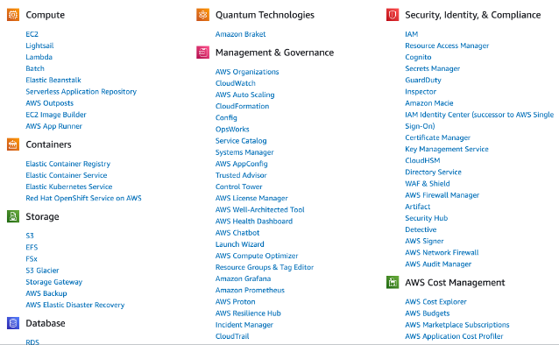
Figure 1: AWS Services

Enabling your lab
You should have an AWS Academy login, so go to: https://awsacademy.instructure.com/ and log into the system and select AWS Academy Learner Lab (Figure 2).
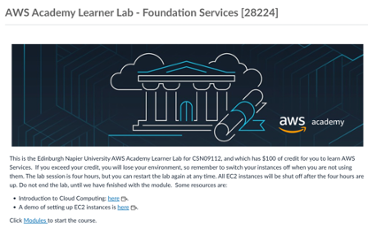
Figure 2: AWS Academy Learner Lab
Next, select “Modules”, and then “Learner Lab - Foundational Services”, and you should have the lab environment (Figure 3).
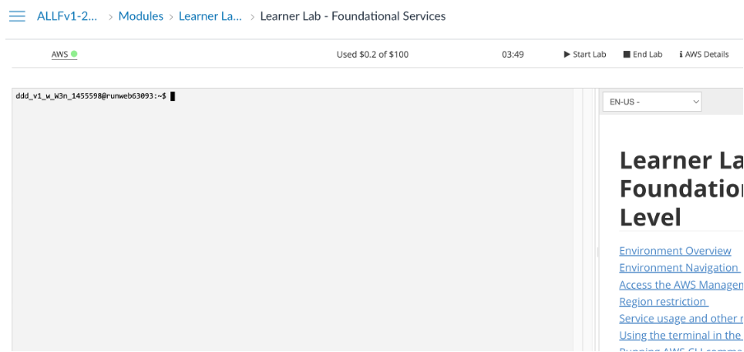
Figure 3: AWS Academy Learner Lab environment
In the console, you can interact with your AWS through the console (as you are already logged into AWS). Now, press the “Start Lab” button, and wait for the AWS light to go green. Once it turns green, you can click on it and open up your AWS Management console. After this, just select EC2, and you should see your EC2 environment.
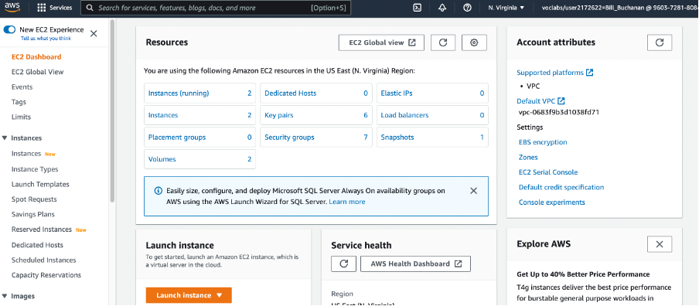
Figure 4: AWS Management Console (EC2)

Creating and Securing a Ubuntu Server
We will now create a Ubuntu Server, and which should be accessible from the Internet. For this, select “Launch Instance”, and then give it a name (such as “My Linux Server”) and select the Ubuntu instance for the AMI (Amazon Machine Image) – as shown in Figure 5.
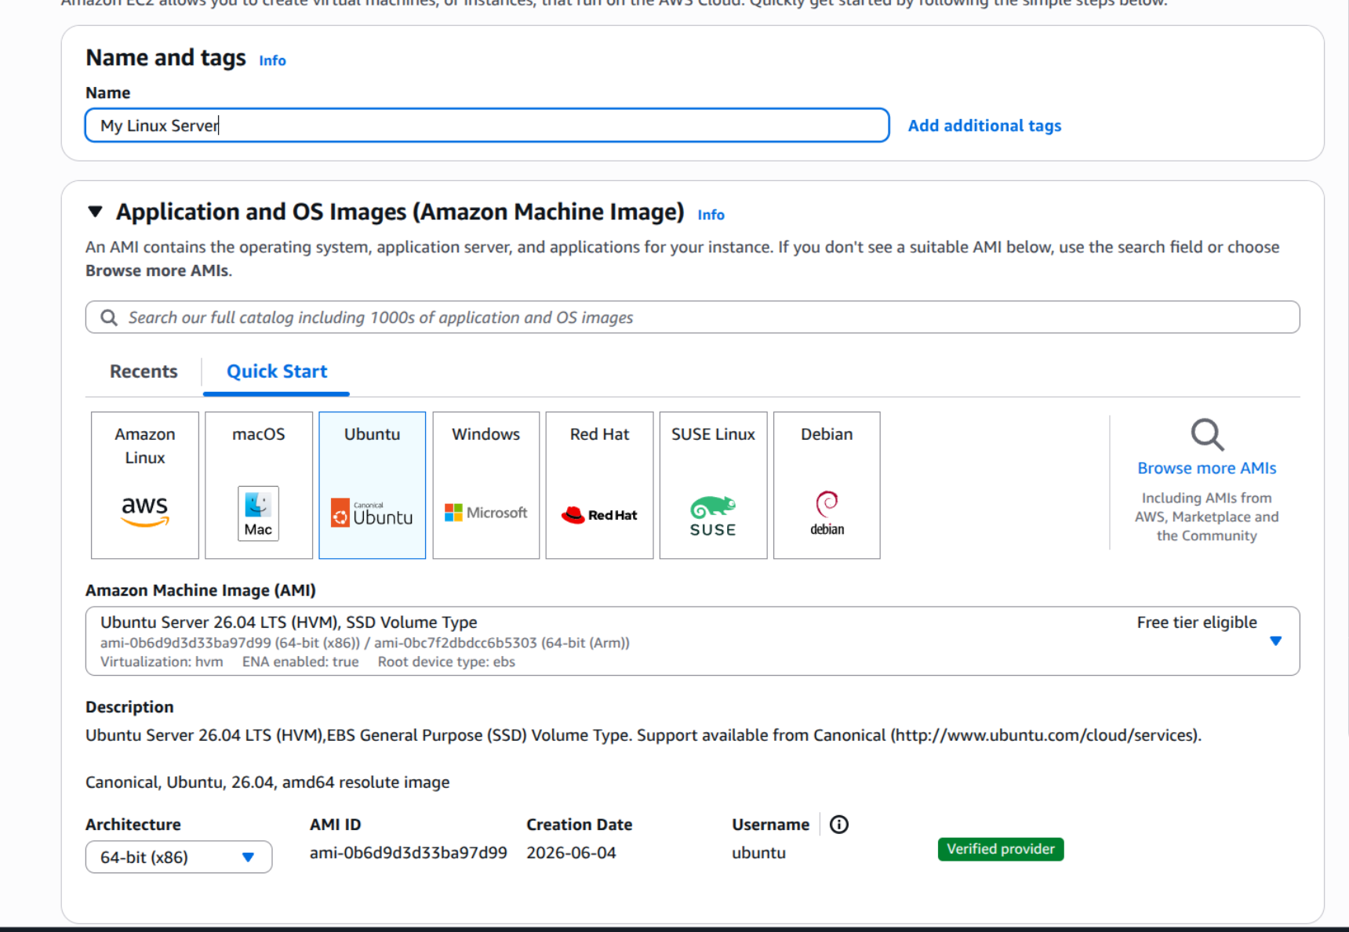
Figure 5: Creating Ubuntu instance
Now select t2.micro for the instance type.

How many vCPUs will the instance have?

How much memory will it have?

How much will it cost per day to run?

If you selected, t2.medium, how much would it cost per day?

If you selected, t2.large, how much would it cost per day?

Now create a new key pair and save it to your local drive. This file contains your private key, and which you will need to connect to your instance. Accept all the other defaults.

Observe the firewall group that will be applied.

Which firewall ports are open on the instance?

What do you think is the main issue with this firewall setting?

How would you change it, once you have created the instance?

Observe the disk storage setting for the instance.

What type of disk will be used? [HDD/SSD]

What do you think is the advantage of using SSD?

For disk storage, what is the default size of the disk that you will create?

What is the maximum storage size for a free tier storage of the AMI instance we are creating?

C.1 Creating the instance
Go ahead and create the instance. Then go back to the AWS Management Console, and find your instance. Wait for it to set its state to running.
Now we will connect to it. For this, we need to create an SSH connection and use the private key we have generated. The public key will be stored on the instance and will authenticate our access. We do not need a username or password to access the instance, as this is often insecure. Our PEM file will give us access (or you can use Putty for the connection).
Now, we will examine the details of our instance (Figure 6). On the instance summary, determine the following:
The public IP address:

The private IP address:

The instance type:

The public IPv4 DNS:

From your local host, can you ping the public IP address? [Yes/No]

Why can’t you successfully ping your instance?

Which region of the world is your instance running in?

C.2 Enabling ICMP on firewall
Now, we will enable ICMP on the instance. First, click on the Security tab of the instance summary, and then on the security group.
What is the firewall rule that is applied to the instance?

[SSH/Telnet/FTP/HTTP/HTTPs] for [0.0.0.0/0 or 0.0.0.0/8 or 0.0.0.0/16 or 0.0.0.0/32]

What does 0.0.0.0/0 represent?
Now go ahead and add an ICMP rule for all hosts (Figure 7).
Can you now successfully ping your instance? [Yes/No]

Now, lock your ICMP rule down to just your IP address (you need to use a /32 address for this). Can you still successfully ping the instance? [Yes/No]

Ask your neighbour or one of the lab tutors to ping your instance. Can they successfully ping it? [Yes/No]

What is the advantage of applying the firewall in AWS, rather than in the instance?
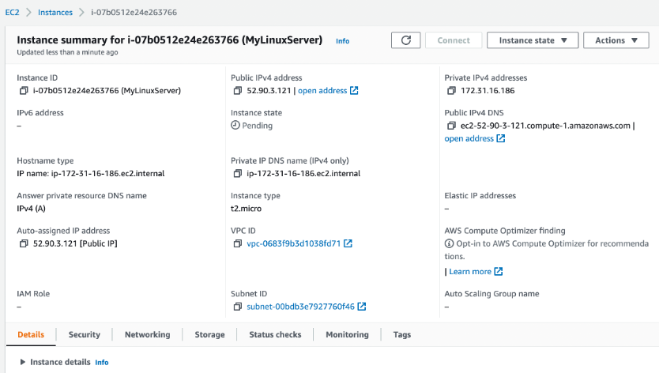
Figure 6: Details of instance
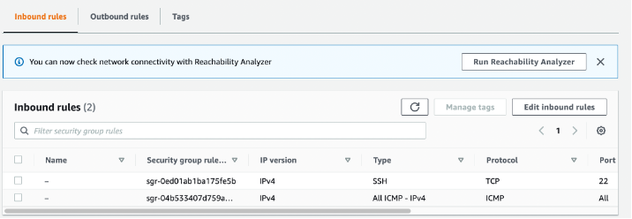
Figure 7: Enable ICMP

C.3 Accessing your instance
Now we will connect to our instance. For this you need SSH (such as provided by OpenSSH). This may be installed on the host you are using (such as in vSoC 2), or from Apps Anywhere. Once you have SSH, press Connect on the summary page, and you should then have tabs for Connect to instance (Figure 8). Next select the SSH client tab, and you will see the details of connecting to your instance with SSH.
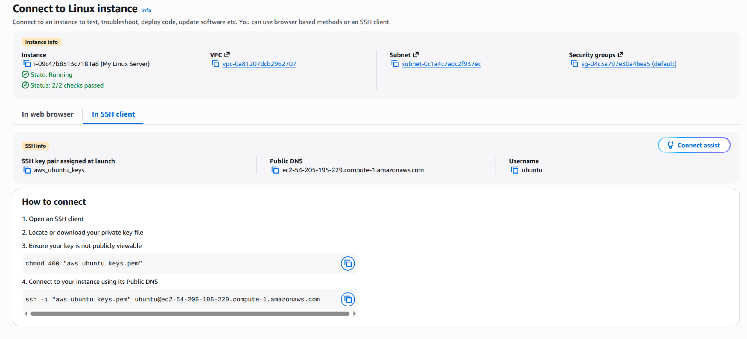
Figure 8: Connect to instance
Now find your PEM file on your local machine (from the command line), and protect it with:
chmod 400 "aws_ubuntu_keys.pem"
If you are using a Windows console, please see the note in Appendix A.
What protection does this put on your private key?
Next, use the SSH connection with the name of your PEM file and with the DNS (or IP address) for your instance. For example, in the case in Figure 8, we have:
ssh -i "aws_ubuntu_keys.pem" ubuntu@ec2-54-205-195-229.compute-1.amazonaws.com
What is the name of the user that logs in?
An example of connecting is (In this example it is Amazon Linux Instance, but your Ubuntu should display something similar):
% ssh -i "mynewkeypair.pem" ec2-user@ec2-52-90-3-121.compute-1.amazonaws.com
The authenticity of host 'ec2-52-90-3-121.compute-1.amazonaws.com (52.90.3.121)' can't be established.
ED25519 key fingerprint is SHA256:/c5UOK6gprKL19XCptNQ1brb9MpYR5wEeqhD/6t+/Wk.
This host key is known by the following other names/addresses:
~/.ssh/known_hosts:48: ec2-3-90-189-201.compute-1.amazonaws.com
Are you sure you want to continue connecting (yes/no/[fingerprint])? yes
Warning: Permanently added 'ec2-52-90-3-121.compute-1.amazonaws.com' (ED25519) to the list of known hosts.
Last login: Fri Sep 30 17:07:00 2022 from ec2-18-206-107-27.compute-1.amazonaws.com

__| __|_ )
_| ( / Amazon Linux 2 AMI
___|\___|___|

https://aws.amazon.com/amazon-linux-2/
[ec2-user@ip-172-31-16-186 ~]$
Have you managed to connect? [Yes/No]

By using “ip addr show” or “ifconfig” in your instance, what is the private IP address of it?

Can you ping 8.8.8.8 from your instance? [Yes/No]

Is there a folder named .ssh? [Yes/No]

What do you think is the purpose of the file contained in .ssh?

Now create a folder in the top level named “mytestfolder”, and put a new file in there named “mytext.txt” (and put some text in this file).

Now go to the EC2 Instance Connect (Figure 9), and press on the Connect button. You should now get a console terminal in the browser.

From your console (Figure 10), verify that your file has been created. Has it been created in the instance? [Yes/No]
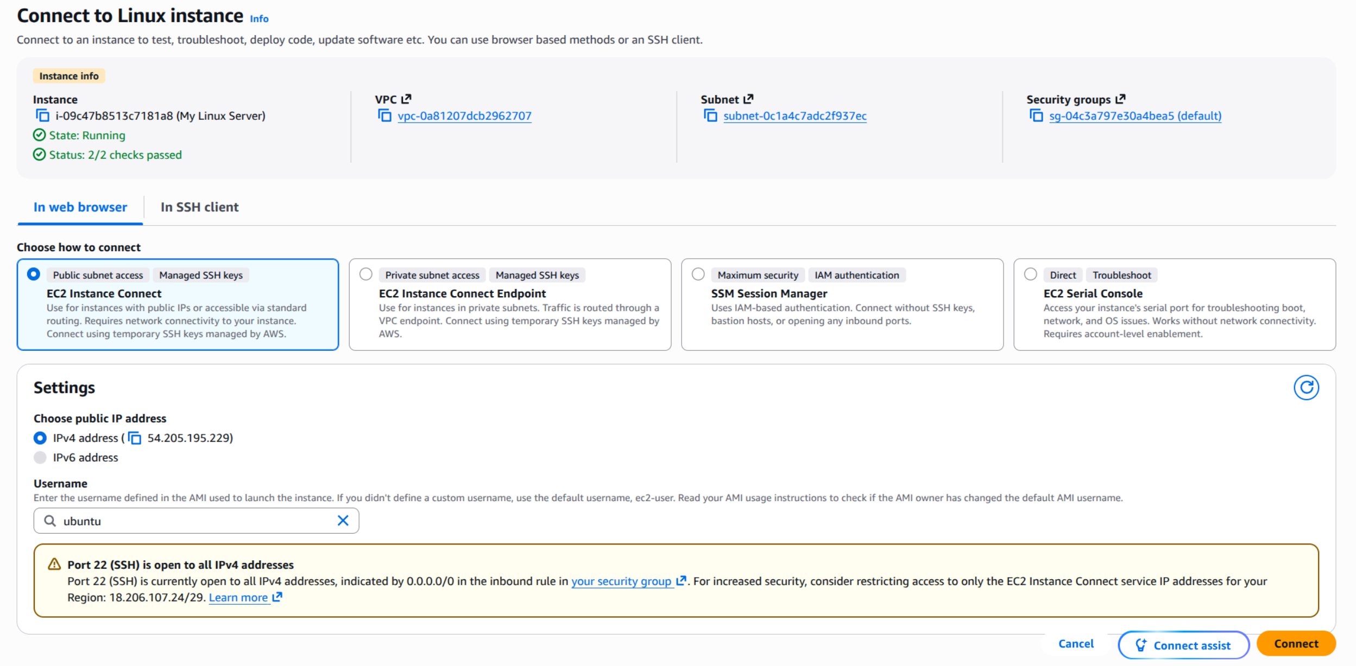
Figure 9: EC2 Instance Connect
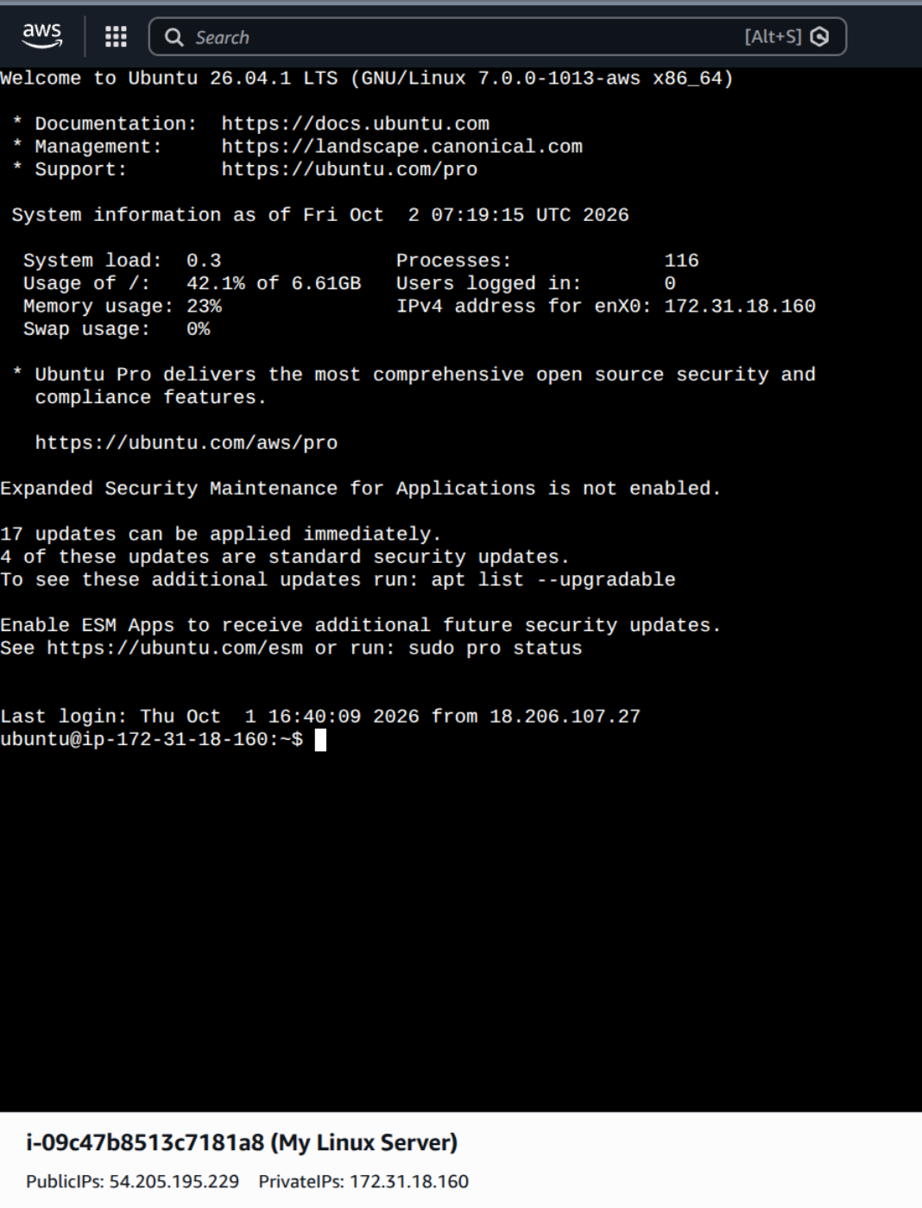
Figure 10: EC2 Instance Connect terminal
Now examine the running services on the instance with:
# First you need install the netstat tools
sudo apt install net-tools
# Then type
netstat -l | grep tcp
netstat -l | grep udp
Which of the main services are running:

C.4 Installing a Web server
Now we will install a Web server on the instance with:
Ubuntu Commands
sudo apt update -y
sudo apt upgrade -y
sudo apt install -y apache2
sudo systemctl start apache2
sudo systemctl enable apache2
Next open up a browser on your computer and access your instance for Web access.
Can you connect to it? [Yes/No]

Why can’t you connect to it?
Now enable firewall rules on Ports 80 and 443 to allow Web traffic (see Figure 11).
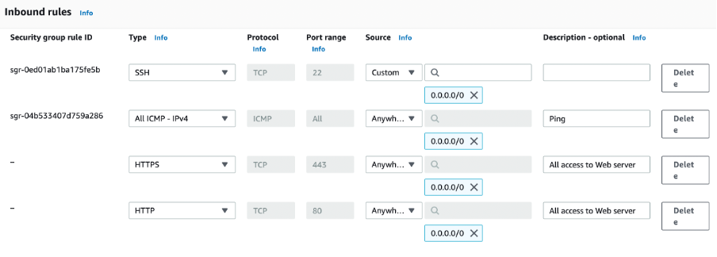
Figure 11: Enable HTTP and HTTPs rules
Can you now connect to your Web site? [Yes/No] (see Figure 12)
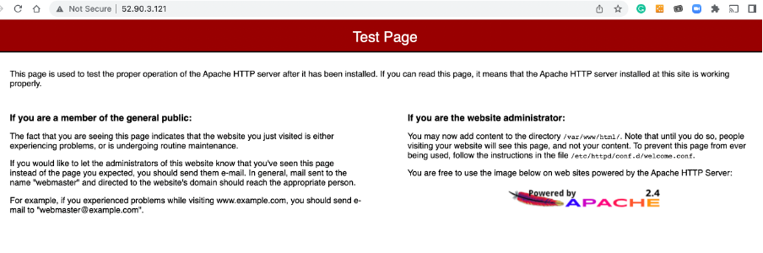
Figure 12: Sample access to the website
Now go into the /var/www/html folder, and create a file named “index.html”, and add:
<h1>Main Web site</h1>
<p>Hello to you</p>
And then save the file.
Has it changed the welcome? [Yes/No]

C.6 Auditing
The main logging output is in the /var/log folder. Go into this folder and observe some of the files in there. Identify the contents of the following files:
What are the likely contents of the "auth.log" file?

What are the likely contents of the "kern.log" file?

List the "/var/log/apache2/access.log" file in Ubuntu. What are its contents? Can you identify your browser access? (see Figure 13). Which browser type accessed your Web server?

Now try with another browser type (such as Firefox or Chrome) and re-examine the /var/log/apache2/access.log file. Did it detect the new browser type?

Now access a file that does not exist in your site (such as http://AWSIP/test.htm). Now re-examine the /var/log/apache2/access.log file in Ubuntu. What is the status code returned for the access?
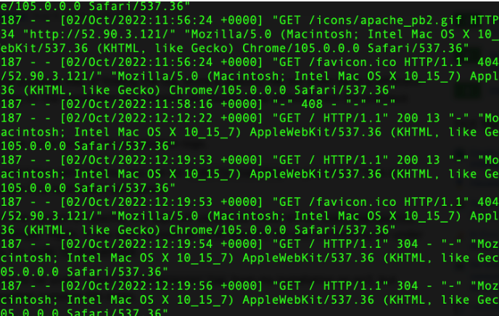
Figure 13: Sample list of log/httpd/access_log (you should have something similar and your ubuntu)

C.7 Adding a new user
The ubuntu username can be used to connect back into the server using access authenticated with the private key. We will now create a new user named “napier”, and which can connect to the instance with SSH. For this, we use adduser and passwd on the Linux instance:
[ubuntu@ip-172-31-16-186 ~]$ sudo adduser napier
Changing password for user napier.
New password: <yourpass>
Retype new password: <yourpass>
passwd: all authentication tokens updated successfully.
Now we will add the new user to the login. For this, we use:
Ubuntu
[ubuntu@ip-172-31-16-186 .ssh]$ sudo nano /etc/ssh/sshd_config
Add line of (similar to Figure 15):
AllowUsers ubuntu napier
Change the following to “yes” (see Figure 16):
PasswordAuthentication yes
Comment out the following:
#KbdInteractiveAuthentication no
Now restart the SSH service with:
[ubuntu@ip-172-31-16-186 .ssh]$ sudo systemctl restart ssh
Can you now connect to your instance with the new user and password (but change for the IP address of your instance):
ssh napier@54.209.145.85
Can you connect with the new user? [Yes/No]
Figure 14: Accessing instances
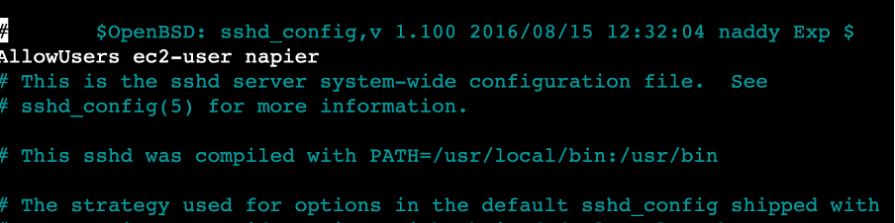
Figure 15: Accessing instances
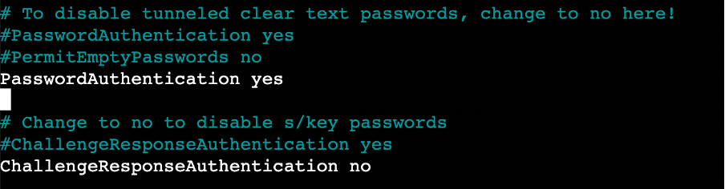
Figure 16: Accessing instances

C.8 Accessing from AWS prompt
We can also access our instance from the AWS terminal prompt. For this return to your AWS Academy console, and enter the command (Figure 17):
$ aws ec2 describe-instances
From the results, can you identify the following:
Instance type:
Public IP address:
Private IP address:
State:
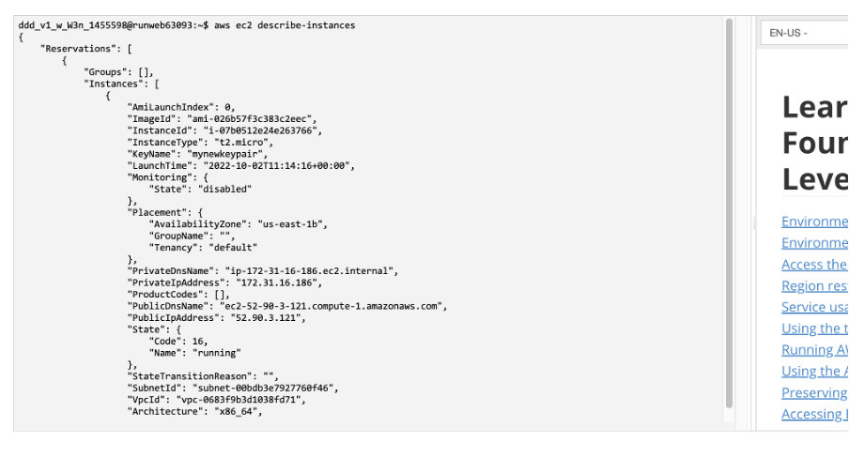
Figure 17: Describe instances
Now we will stop our instance using an AWS EC2 command. Run the following with your instance ID (see Figure 18):
aws ec2 stop-instances --instance-ids [My-instance-ID]
From the AWS Management Console, has your instance stopped? [Yes/No]
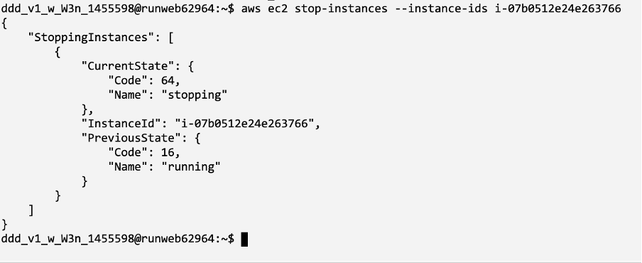
Figure 18: Stopping an instance
Now we will restart the instance with:
aws ec2 start-instances --instance-ids [My-instance-ID]
Has the instance re-started? [Yes/No]
Now we will change the instance type from t3.micro to t3.small. To do this, run the following commands:
aws ec2 stop-instances --instance-ids [My-instance-ID]
aws ec2 wait instance-stopped --instance-ids [My-instance-ID]
aws ec2 modify-instance-attribute --instance-id [My-instance-ID] --instance-type "{\"Value\": \"t3.small\"}"
aws ec2 start-instances --instance-ids [My-instance-ID]
Did it change the instance type? [Yes/No]
Can you still get access to your instance?
By observing the script and investigating what t3.micro and t3.small are, can you determine what has changed about your instance?
Now, revert the instance to t3.micro and suspend it.

D Creating and Securing a Windows 2022 Server
In this part of the lab, we will create a Windows 2022 server instance with t3.micro (note, that this is very low for vCPUs and memory, so the performance may be a little lacking). First create a new instance, and give it a name, such as “MyWindowsServer” (Figure 19).
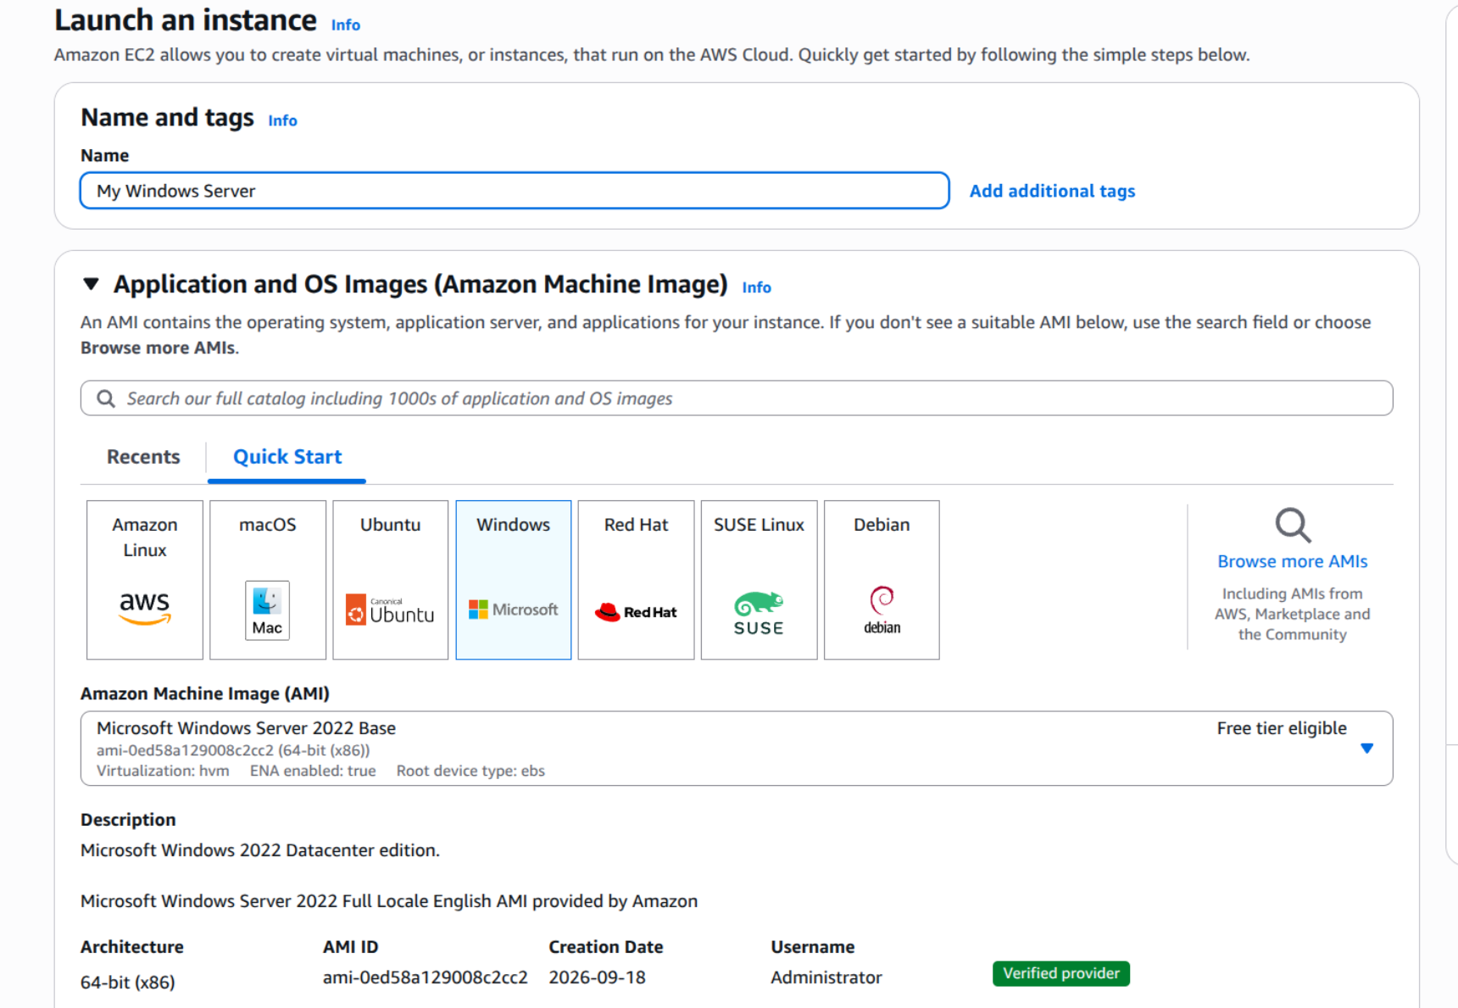
Figure 19: Creating Windows 2022 instance
Now select t2.micro for the instance type.
How many vCPUs will the instance have?
How much memory will it have?
How much will it cost per day to run?
If you selected, t2.medium, how much would it cost per day?
If you selected t2.large, how much would it cost per day?
Now create a new key pair and save it to your local drive. This file contains your private key, and which you will need to connect to your instance. Accept all the other defaults.
Observe the firewall group that will be applied.
Which firewall ports are open on the instance?
What is the main issue with this firewall setting?
How would you change it, once you have created the instance?
Observe the disk storage setting for the instance.
What type of disk will be used? [HDD/SSD]
What is the advantage of using SSD?
For disk storage, what is the size of the disk that you will create?
What is the maximum storage size for a free tier storage of the AMI instance we are creating?

D.1 Creating the instance
Go ahead and create the instance. Go back to the Management Console and find your instance. Wait for it to set its state to running. Now we will connect to it. For this, we need to create an RDP connection and use the private key we have generated to generate the initial password.
Now, we will examine the details of our instance (Figure 20). On the instance summary, determine the following:
The public IP address:
The private IP address:
The instance type:
The public IPv4 DNS:
From your local host, can you ping the public IP address? [Yes/No]
Why can’t you successfully ping your instance?
Which region of the world is your instance running in?

D.2 Enabling ICMP on firewall
Now we will enable ICMP on the instance. First click on the Security tab of the instance summary, and then on the security group.
What is the firewall rule that is applied to the instance?
[SSH/RDP/Telnet/FTP/HTTP/HTTPs] for [0.0.0.0/0 or 0.0.0.0/8 or 0.0.0.0/16 or 0.0.0.0/32]
What does 0.0.0.0/0 represent?
Now go ahead and add an ICMP rule for all hosts (Figure 121).
Can you now successfully ping your instance? [Yes/No]
We will not be able to ping the instance yet, as the firewall on Windows is disabling it.
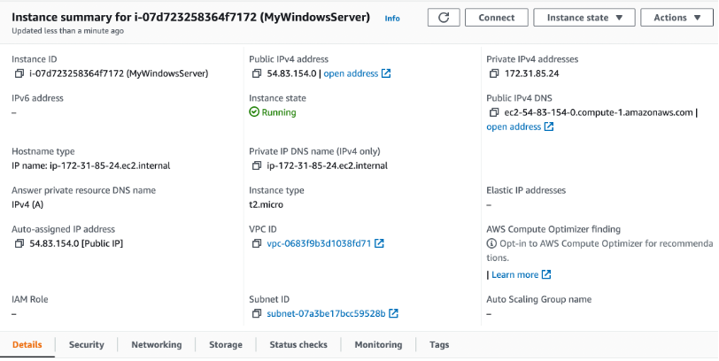
Figure 20: Details of instance
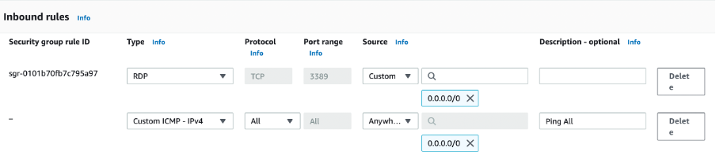
Figure 21: Enable ICMP

D.3 Accessing your instance
Now we will connect to our instance. For this, you need RDP. Next Connect to the instance (Figure 22). Click on “Get password” and present your PEM file, and it should reveal the password (Figure 23).
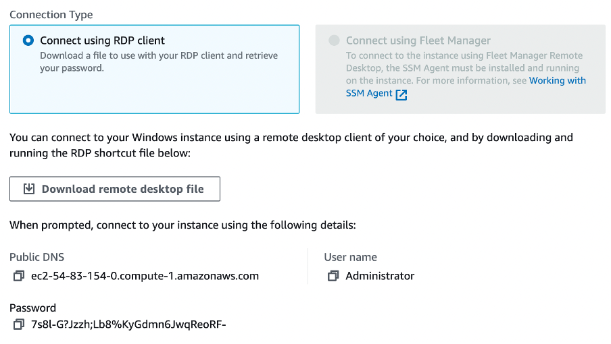
Figure 22: Connect to instance
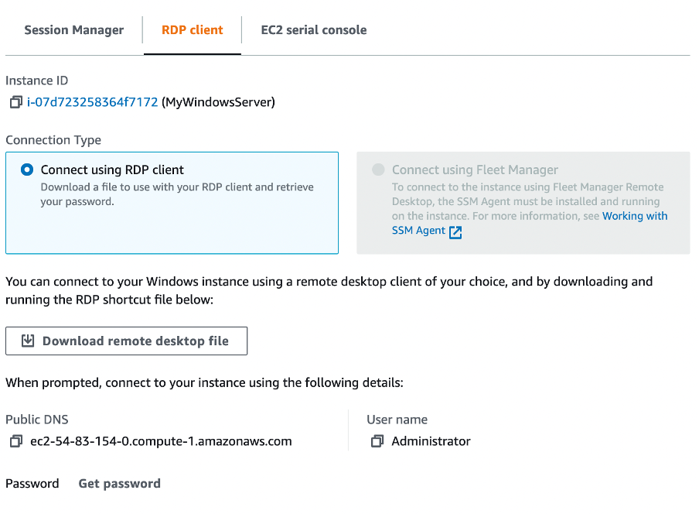
Figure 23: Reveal password
Have you managed to connect? [Yes/No] (Figure 24)
By using “ipconfig” in your instance, what is the private IP address of it?
Can you ping 8.8.8.8 from your instance? [Yes/No]
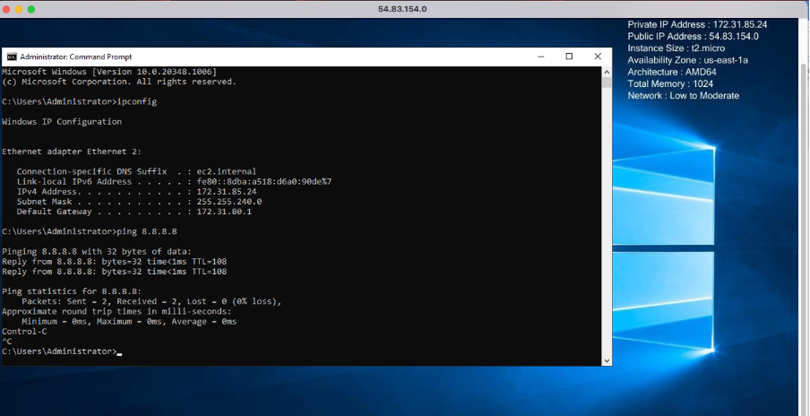
Figure 24: Windows 2022

D.4 Enable ICMP on instance
We have enabled the AWS firewall for ICMP. Now we will open up ICMP in the instance. For this open-up with Advanced Windows firewall, and enable the rule for “File and Printer Sharing (ICMP-in) – as shown in Figure 25.
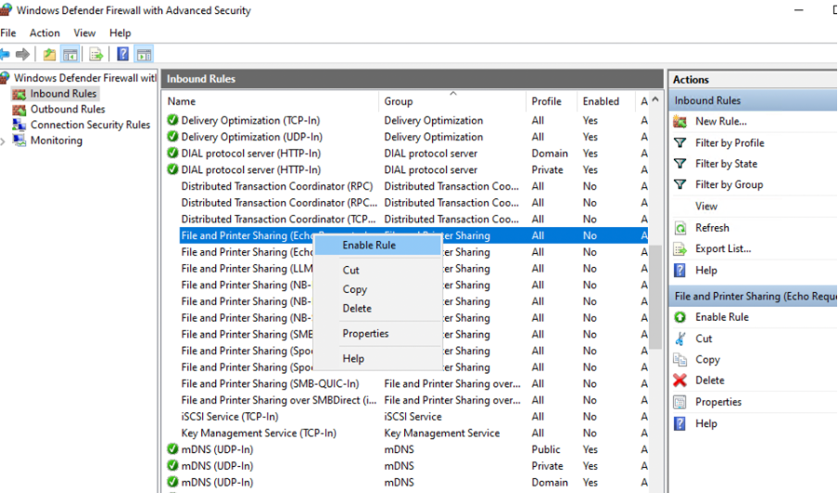
Figure 25: Enable ICMP
Can you successfully ping the instance from your instance? [Yes/No]

D.5 Show running services
Now examine the running services on the instance with:
$ netstat -i | grep tcp $ netstat -i | grep udp
Which of the main services are running:

D.6 Enable Web server
Now select Server Manage, and “Add a Role” for Web Server (IIS) (Figure 26).
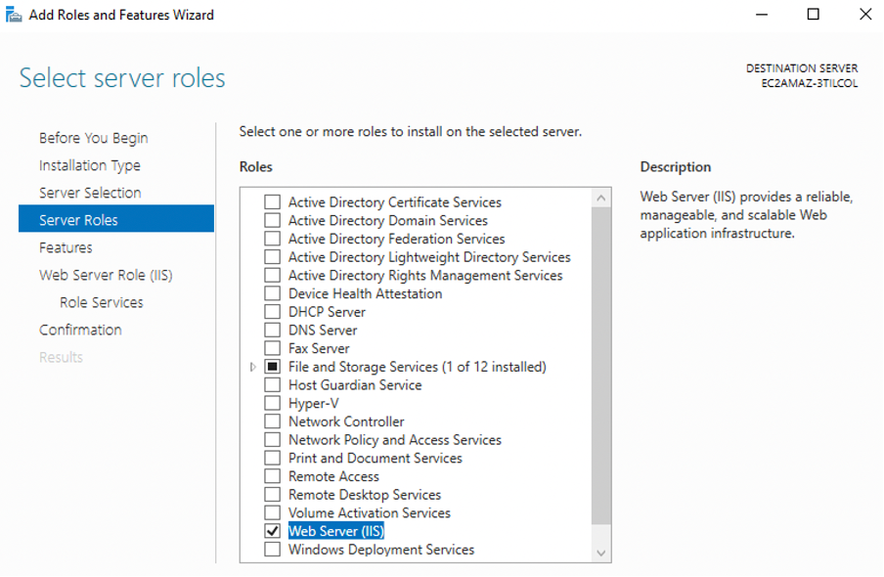
Figure 26: Enable ICMP
Now open a browser on the instance, and access http://localhost
Can you connect to the IIS Web server? [Yes/No] (see Figure 25)
Now open up your AWS firewall for Port 80 (Figure 27).
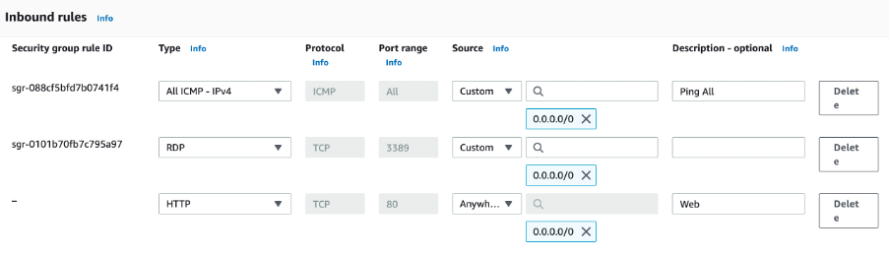
Figure 27: Enable HTTP
Now open a browser on the instance, and access http://[IP of AWS]
Can you connect to the IIS Web server? [Yes/No] (Figure 29)
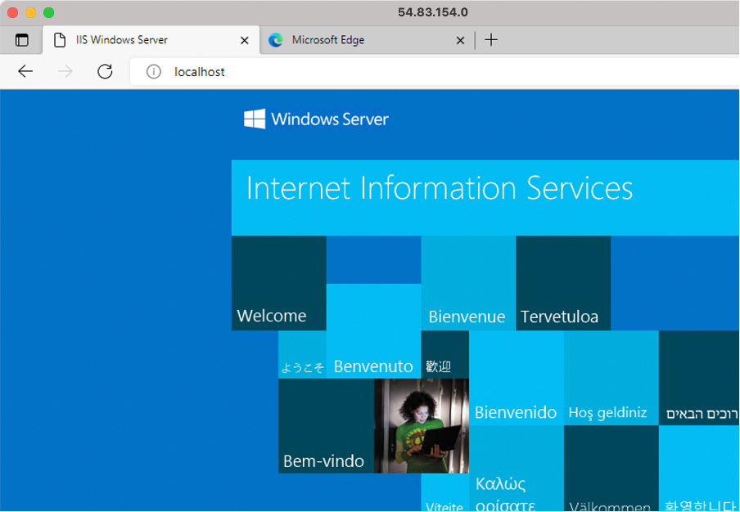
Figure 28: Local host
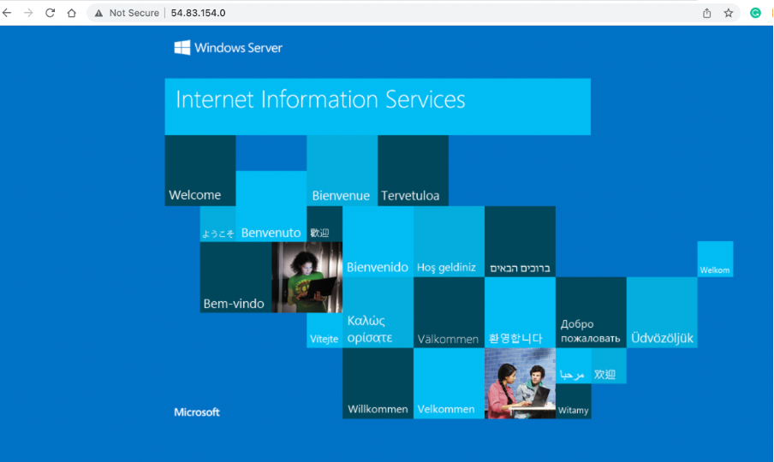
Figure 29: Remote access
Now go into the c:\inetpub\wwwroot folder, and create a file named “iisstart.html”, and add:
<h1>Main Web site</h1>
<p>Hello to you</p>
And then save the file.
Has it changed the welcome? [Yes/No]

D.7 Auditing
The main logging output is in the “C:\inetpub\logs\LogFiles\W3SVC1” folder. Identify the contents of the following files:
Go into the “C:\inetpub\logs\LogFiles\W3SVC1” folder, and list the file in there. What are its contents? Can you identify your browser access? Which browser type accessed your Web server?
Now try with another browser type, and re-examine the log/httpd/access_log file. Did it detect the new browser type?
Now access a file that does not exist in your site (such as http://AWSIP/test.htm). Now re-examine the file. What is the status code returned for the access?

D.8 Changing Administrator password
We can change the Administrator password, with something like:
net user administrator mynewpassword$$7k1
Or set up your own
net user administrator *

E Python Access
Your unique account will have been generated, and you can access it with aws_access_key_id and aws_secret_access_key (from AWS details). You will also find that your console has been set up with the details already set up for you. For this, there is a hidden folder named .aws, and there is a file named credentials in there:
(You need the CLI in the main AWS Academy Learner Lab to find this)
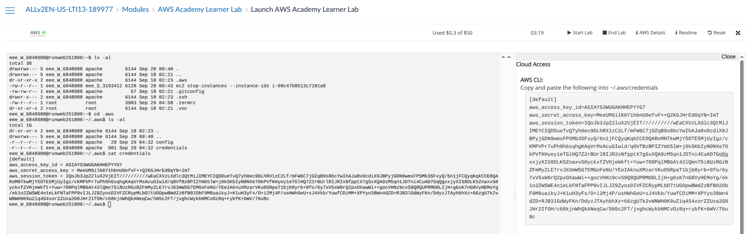
ddd_v1_w_W3n_1455598@runweb63277:~$ ls -al
drwxrwx--- 5 ddd_v1_w_W3n_1455598 apache 6144 Oct 2 10:13 .
drwxrwx--- 5 ddd_v1_w_W3n_1455598 apache 6144 Sep 29 10:32 ..
dr-xr-xr-x 2 ddd_v1_w_W3n_1455598 apache 6144 Sep 29 12:08 .aws
-rw-rw-r-- 1 ddd_v1_w_W3n_1455598 apache 51 Sep 29 10:32 .gitconfig
drwxr-x--- 2 ddd_v1_w_W3n_1455598 apache 6144 Sep 29 12:08 .ssh
-rw-r--r-- 1 root root 3851 Oct 4 02:44 .termrc
dr-xr-xr-x 2 root root 6144 Sep 29 10:32 .voc
ddd_v1_w_W3n_1455598@runweb63277:~$ cd .aws
ddd_v1_w_W3n_1455598@runweb63277:~/.aws$ ls -al
dr-xr-xr-x 2 ddd_v1_w_W3n_1455598 apache 6144 Sep 29 12:08 .
drwxrwx--- 5 ddd_v1_w_W3n_1455598 apache 6144 Oct 2 10:13 ..
-r--r--r-- 1 ddd_v1_w_W3n_1455598 apache 29 Oct 4 00:19 config
-r--r--r-- 1 ddd_v1_w_W3n_1455598 apache 501 Oct 4 00:19 credentials
ddd_v1_w_W3n_1455598@runweb63277:~/.aws$ cat credentials
List the contents of the credentials file, and verify that it contains the same credentials as from the AWS details button.
Are they the same? [Yes/No]
Now create a Python file which will show your instances in the terminal window (such as 1.py):
To create a file:
cd ~ # brings you back to home - no sudo needed here!
nano 1.py
Then type or paste the code below. (Remember to use Ctrl+Shift+V to paste anything in terminal or nano)
import boto3
ec2 = boto3.client('ec2', region_name='us-east-1')
print(ec2.describe_instances())
Then Ctrl+O, then enter to save, then Ctrl+X to exit.
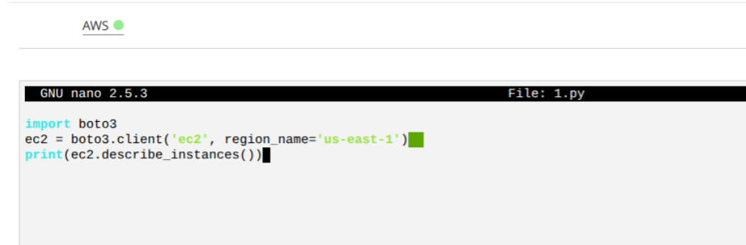Figure: Python file creation
Save the file, and then run the file with Python3 and prove that it shows your instances (Figure).
python3 1.py
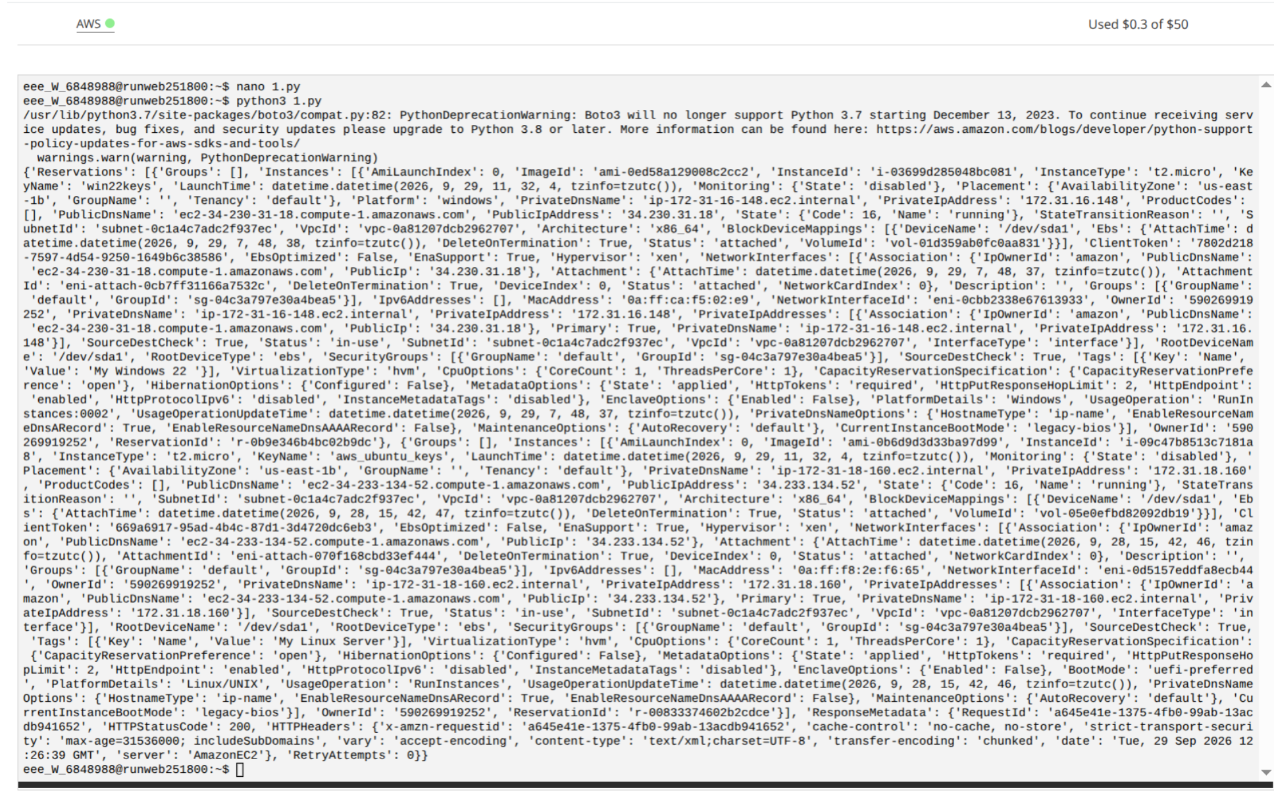Figure: Running the Python3 file
Does the Python3 program show your instances? [Yes/No]
Note, Boto3 has deprecated since Python 3.7, so just force Python to ignore any warnings with (assuming you have named the file 1.py):
python3 -W ignore 1.py
Now we will stop one of our instances. For this, get an instance ID, and add it to the following file:
nano 2.py
And paste
import boto3
ec2 = boto3.client('ec2', region_name='us-east-1')
ec2.stop_instances(InstanceIds=["i-07b0512e24xxxxxx"]) # where x's are replaced by your instance's ID
Now run the Python file, and prove that it has stopped your instance.
python3 -W ignore 2.py
Does the Python3 program stop your instance? [Yes/No]
Now we will restart one of our instances. For this, get an instance ID, and add it to the following file:
nano 3.py
And paste
import boto3
ec2 = boto3.client('ec2', region_name='us-east-1')
ec2.start_instances(InstanceIds=["i-07b0512e24xxxxxx"]) # where x's are replaced by your instance's ID
Now run the Python file, and prove that it has started your instance.
python3 -W ignore 3.py
Does the Python3 program start your instance? [Yes/No]
Finally, write a Python3 program which will start both of your instances, and another one to stop them both.
nano do it yourself ;-)
Do your Python3 programs work? [Yes/No]
You can also use the AWS prompt. Now try to start and stop your instances with:
aws ec2 stop-instances --instance-ids i-07b0512e24xxxxxx --no-cli-pager # remember to change the xxx's for your instance
and
aws ec2 start-instances --instance-ids i-07b0512e24xxxxxx --no-cli-pager # remember to change the xxx's for your instance
Do these command line programs work? [Yes/No]
Now we will create a keypair with Python, and then create a new Linux instance. First create the keypair with the Python file of:
nano 4.py
import boto3
ec2 = boto3.client('ec2', region_name='us-east-1')
key_pair = ec2.create_key_pair(KeyName='mykeypair2')
MyKeyPair = key_pair["KeyMaterial"]
outfile = open('mykeypair2.pem','w')

print(MyKeyPair)
outfile.write(MyKeyPair)
outfile.close()
Save, Exit, Run, Check
python3 -W ignore 4.py
cat mykeypair2.pem
What is the name of your key pair? Can you find it in your AWS Management console? [Yes/No]
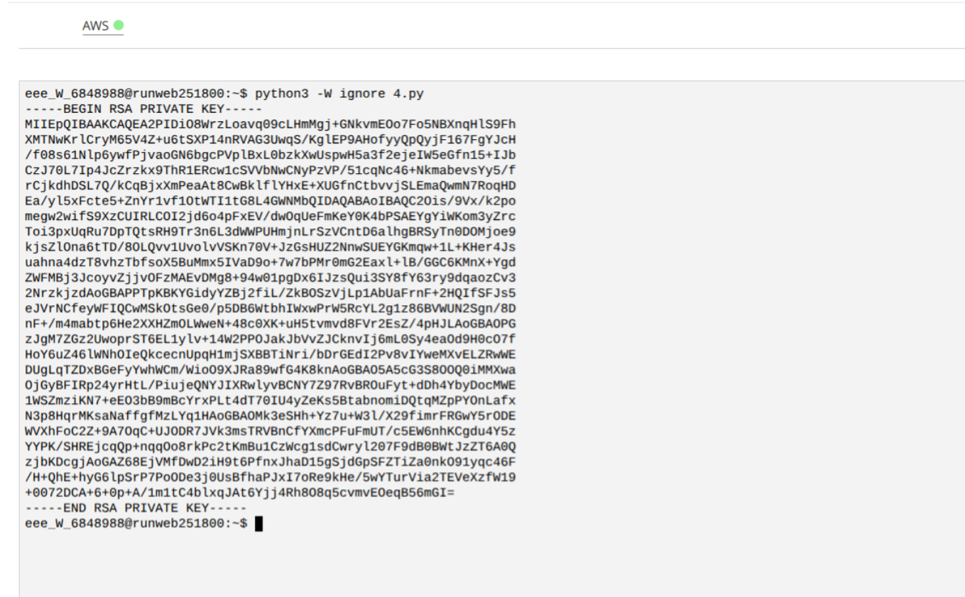Figure: Key Pair
Now we will create a Linux instance. Take a note of the AMI (not the instance ID!) for your Linux instance (see screenshot below)
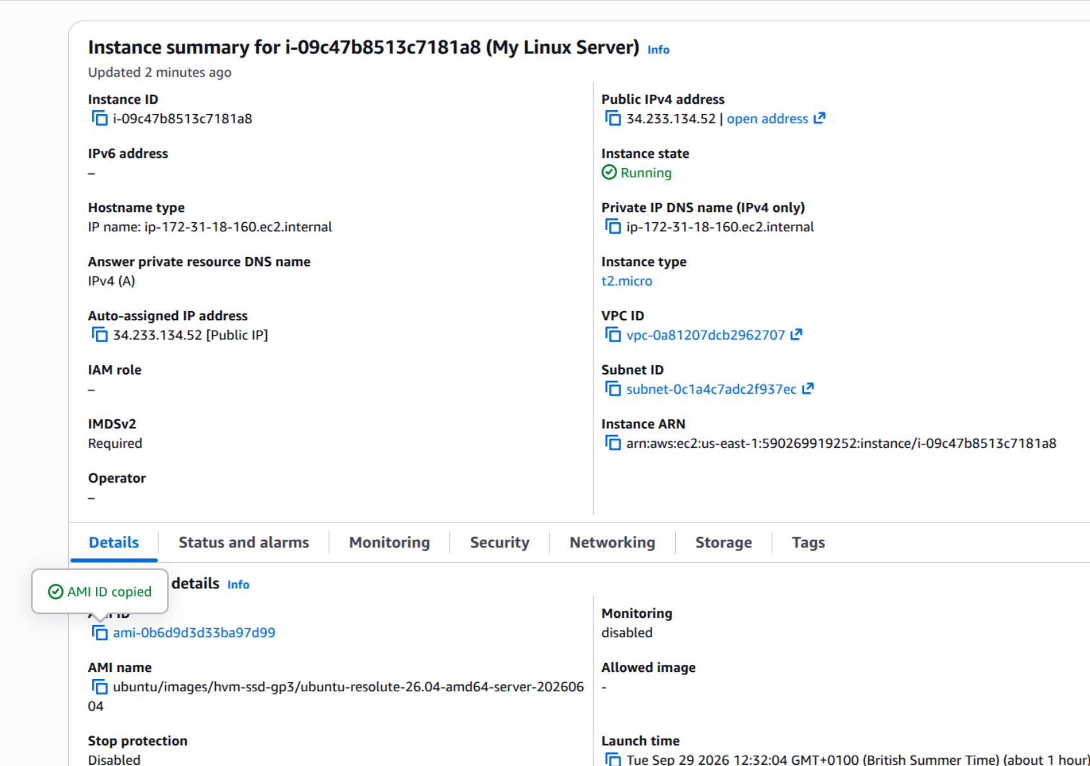Figure: Find the AMI
Now create
nano create.py
and save the file:
import boto3
ec2 = boto3.resource('ec2', region_name='us-east-1')

# create a new EC2 instance
instances = ec2.create_instances(
ImageId='ami-xxxxxxxxxxxxxxxxx', # replace with the AMI ID of your Ubuntu instance
MinCount=1,
MaxCount=1,
InstanceType='t2.micro',
KeyName='mykeypair2'
)

print(instances[0].id)
Finally run the script.
python3 -W ignore create.py
Check if it has created it, as in the screenshot below
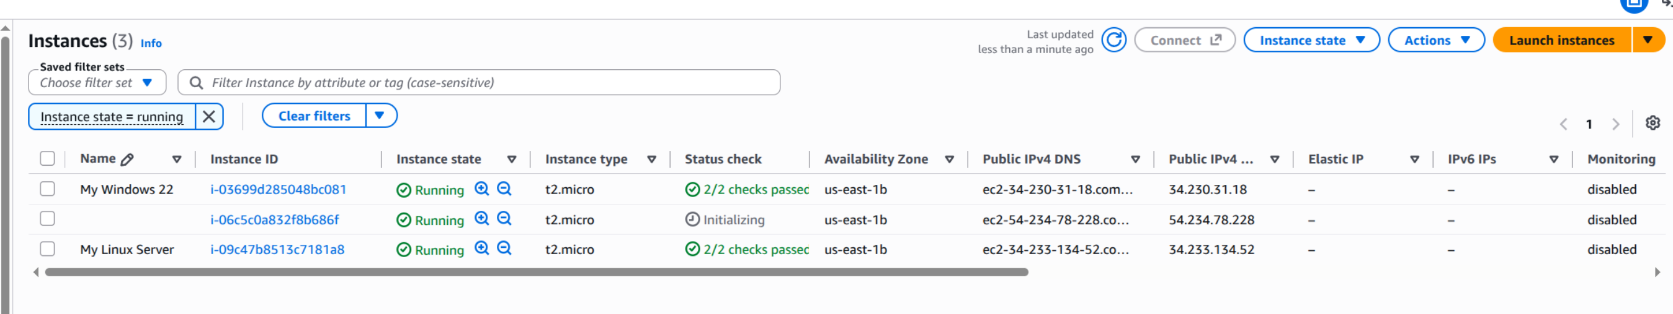Figure: New instance created (you may need to refresh the page)
Has it created the instance? [Yes/No]
Now terminate it.
aws ec2 terminate-instances --instance-ids i-xxxxxxxxxxxxxxxxx --no-cli-pager # replace xxx's with your instance
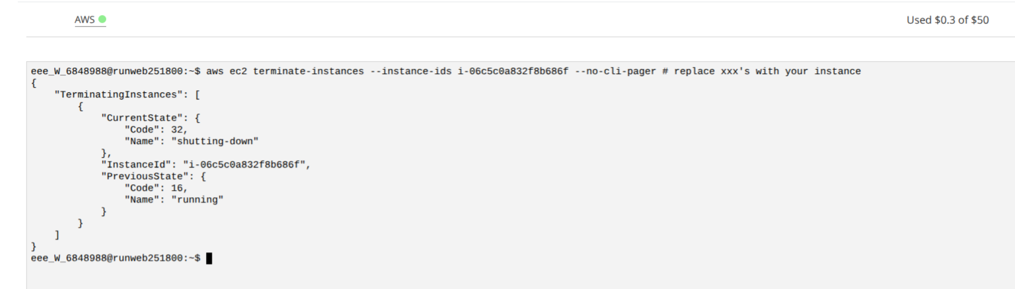Figure: Terminating your instance
Has it been terminated? [Yes/No]
NOW TERMINATE YOUR NEWLY CREATED INSTANCE (and any others you have created with Python)!
At the end of the lab, you should only have two instances. Please either terminate these, or stop them.

Appendix A
If working on your own Windows Machine, installing WSL is a convenient option. It installs Linux within your Windows operating system and gives you a Linux CLI:
Open PowerShell as Administrator Run
wsl --install
And restart your PC as prompted. And now you should have Ubuntu living inside your Windows! Convenient. Don't forget the always important updating:
sudo apt update && sudo apt upgrade -y
To use WSL for the SSH step, the PEM file has to live inside the Linux filesystem, not on /mnt/c/.... Permissions on Windows drives don't really apply, so chmod 400 appears to work but SSH still rejects the key as "unprotected". The fix:
cp /mnt/c/Users/<name>/Downloads/mykey.pem ~/ # Copies the key from the Windows Downloads folder into the Linux home directory, where permissions actually work
chmod 400 ~/mykey.pem
ssh -i ~/mykey.pem ubuntu@<instance-ip>
But if you are using the University's machine, then follow the next steps.
Note, if you are using a Microsoft Windows system, you will have to use icacls through the Command Terminal to make the file read-only. The following commands must be ran from the windows command prompt. Once you have opened the command prompt window, please ensure you are in the same directory that the PEM file is stored in. You can run the dir command to display the contents of the current directory.
If you are using a domain (such as with NAPIER-MAIL, you would define your domain name with your matriculation number, such as:
> icacls.exe mykey.pem /reset
> icacls.exe mykey.pem /grant:r NAPIER-MAIL\xxxxxxxx:(r)
> icacls.exe mykey.pem /inheritance:r
If you are using your own Windows device, you will first need to run the whoami command to determine your domain and username:
> whoami
Which will display you user's domain and username. For example the output of the whoami command could look like:
test-domain\test-user
Using this information, you will alter the icalcs commands to be specfic to your user details. For example:
> icacls.exe mykey.pem /reset
> icacls.exe mykey.pem /grant:r test-domain\test-user:(r)
> icacls.exe mykey.pem /inheritance:r
You can copy the PEM file from the JKCC machines to a USB or OneDrive folder so you can use the same PEM file at home, but the permissions must be updated whenever you move it to another machine. It is also important to store the PEM file on the device itself when calling it in the SSH command, rather than keeping it stored in OneDrive.

