Lab 1: Virtualised Infrastructures

A Challenge
Our challenge is to set up MyBank Incorp, where each of you will be allocated a network and hosts to configure and get online (Figure 1). You have a pfSense firewall, a Ubuntu (Private) host, a Windows (DMZ) host, a Metasploitable (DMZ) host, a Kali (DMZ) host and a Kali (Public) host to achieve your objectives.
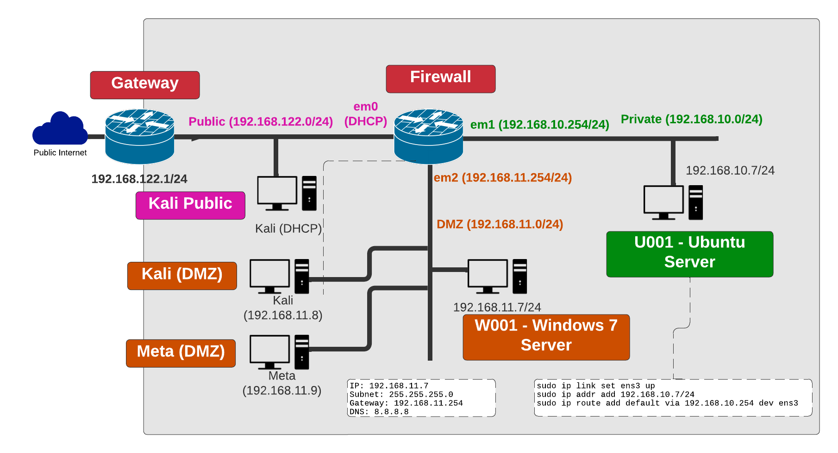

Figure 1: My Bank architecture

In Moodle, click on Virtual Labs (CSN09112) and open up:

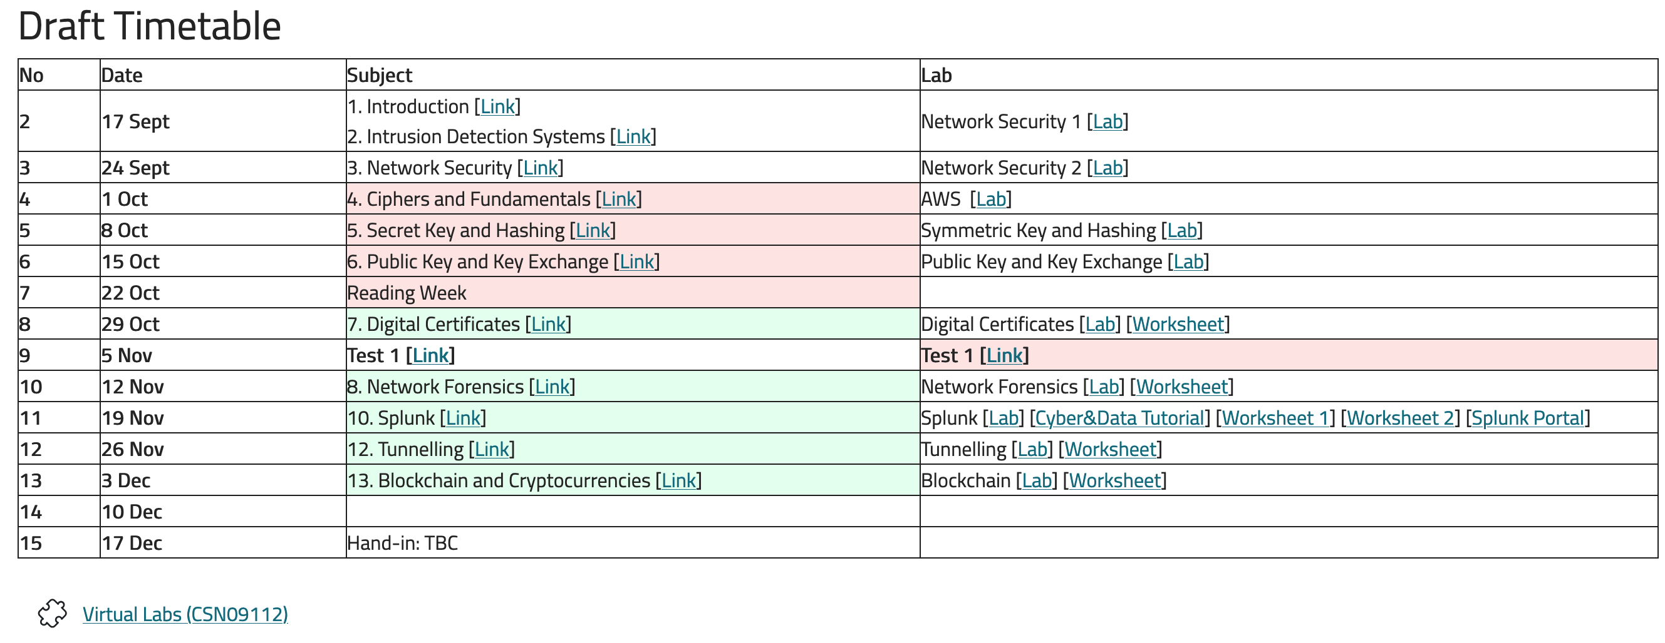
Select “Cyber Modular Labs”, and then select the project “bill_csn09112.gns”:
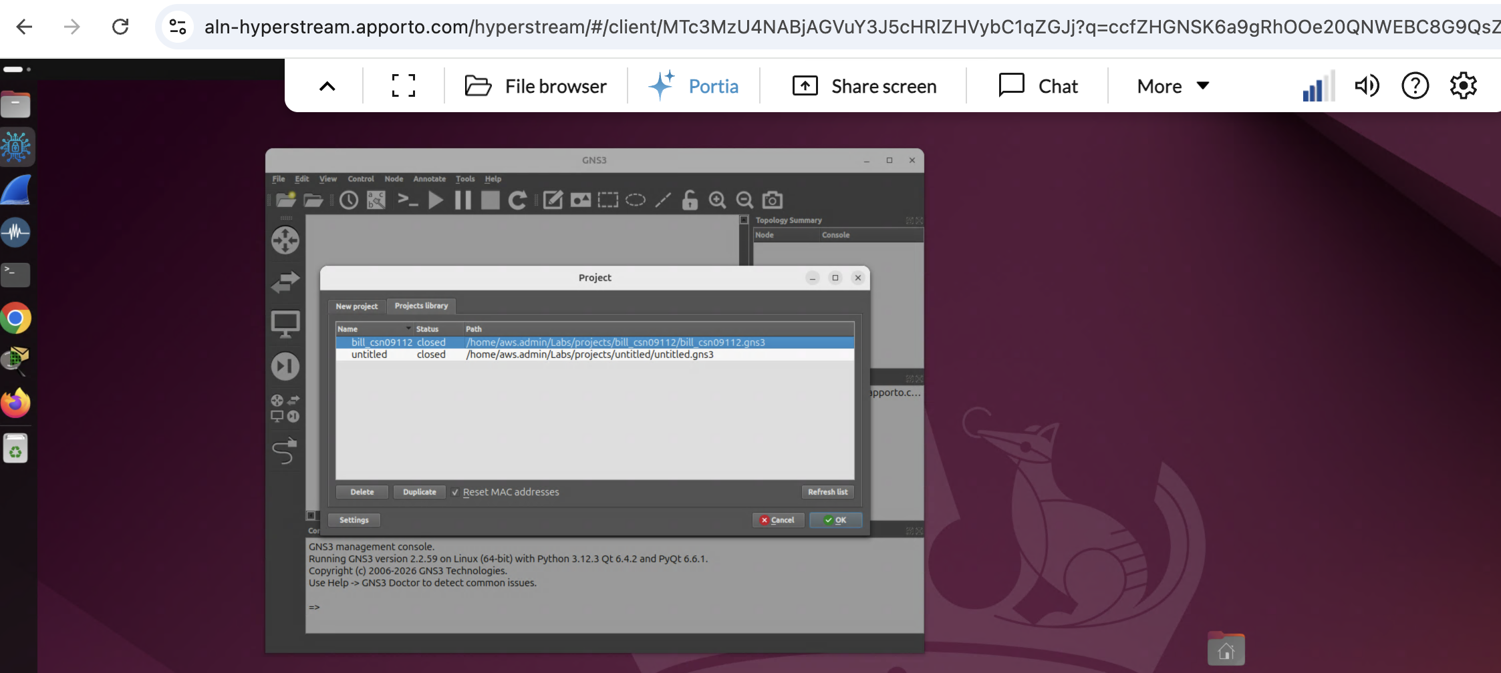

The setup for GNS3 is:

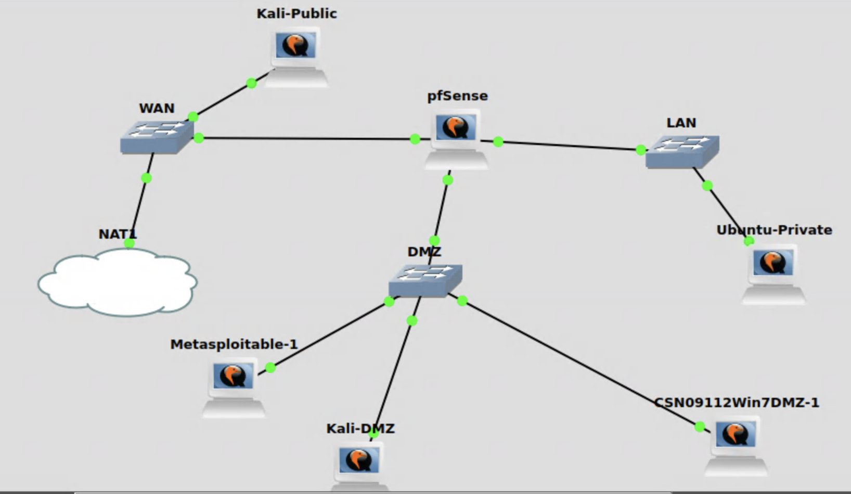

B Setting up the network
In this lab, we will connect our firewall to the main gateway.

Demo: https://www.youtube.com/watch?v=-7KuYsMNgeI

C Ubuntu setup
For Ubuntu configuration, we set up an address of 192.168.10.7/24:

sudo ip link set ens3 up
sudo ip addr add 192.168.10.7/24 dev ens3
sudo ip route add default via 192.168.10.254/24 dev ens3
sudo nano /etc/resolv.conf and confirm you have "nameserver 8.8.8.8"; otherwise, add it.

D Initial Firewall Creation
Power up your pfSense firewall. The interfaces are:

- em0. WAN.
- em1. Private.
- em2. DMZ

Let the firewall boot up, and then select (2) Setup IP Interface(s), and set the LAN interface to have an IP address of 192.168..10.254/24.

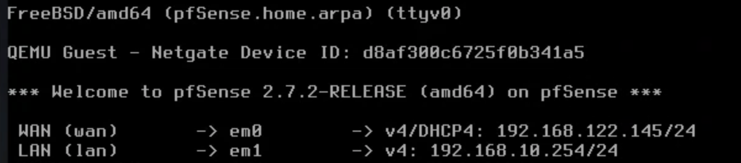

Answer no through the rest of the prompts.

Now we will configure the hosts to sit on the Private and DMZ networks.

E Ubuntu setup
Set up the Ubuntu host to have an IP address of 192.168.10.7/24 (for the ens160 network adaptor) with a default gateway of your firewall port (192.168.10.254/24).

sudo ip link set ens3 up
sudo ip addr add 192.168.10.7/24 dev ens3
sudo ip route add default via 192.168.10.254 dev ens3

Next, set up the nameserver on the Ubuntu host by editing the /etc/resolv.config and adding a nameserver of 8.8.8.8:

sudo nano /etc/resolv.conf

then add:

nameserver 8.8.8.8

F Firewall setup
We can test our connectivity to the Web service on the firewall. For this, on Ubuntu, run:
nmap 192.168.10.254
You should then see that the http service is enabled (see below).
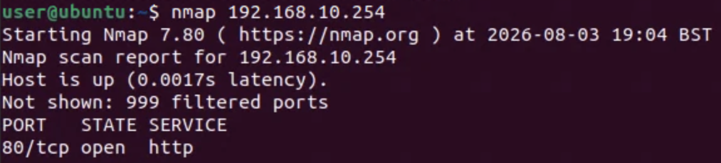
If not, reboot the firewall. To reboot the firewall, use Option 5 from the pfSense console:
Try the connectivity again once the firewall has rebooted. If this doesn't work, try restarting the Webconfigurator service (Option 11 from the pfSense console).

G Connecting to the firewall
We will now configure the firewall. For this, log into the firewall from the Ubuntu host on the Private network by opening a browser and entering:
http://192.168.10.254
The username for pfSense is admin and the password is pfsense.
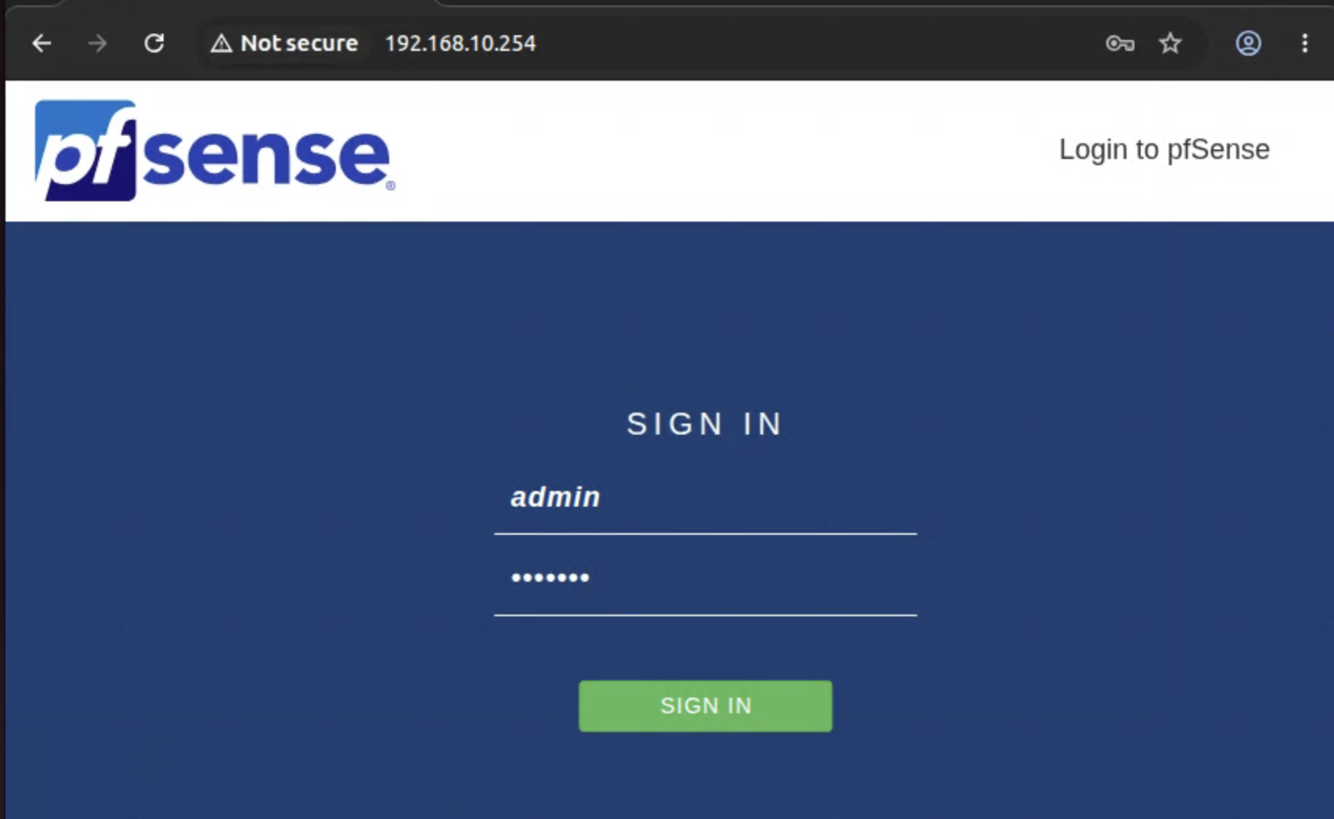

H Disable bogon from the public interface
The firewall will disable private IP addresses on the public network, we thus need to enable this. For this, go to Ubuntu, and make sure you have connectivity to the firewall:
ping 192.168.10.7
ping 192.168.10.254

I Testing connectivity
Now, from the Ubuntu terminal, test the following:
1. Can you ping the default gateway (192.168.10.254)? | Yes/No
2. Can you ping the main gateway (192.168.122.1)? | Yes/No
3. Can you ping 8.8.8.8? | Yes/No
4. Can you ping google.com? | Yes/No
5. Run "nslookup google.com". What IP address does it give?
6. Open a browser and navigate to google.com. Can you access the site? | Yes/No
If any of these answers is No, you need to debug your network and find the problem. By default, all traffic is allowed to flow from the Private network to the other network, so we do not have to enable any firewall rules. If (1) does not ping, you have a basic connectivity problem and need to check your network adaptor on Ubuntu for its IP address and subnet mask. If (2) doesn't work, you have a problem with your default gateway on Ubuntu, so check that the default gateway of Ubuntu is set of the LAN port of the firewall. If (3) doesn't work, you have a general problem with your firewall, so check the details on the pfSense firewall. If (4) doesn't work, but (3) does, you have a problem with your DNS service, so check the DNS details on the Ubuntu host.
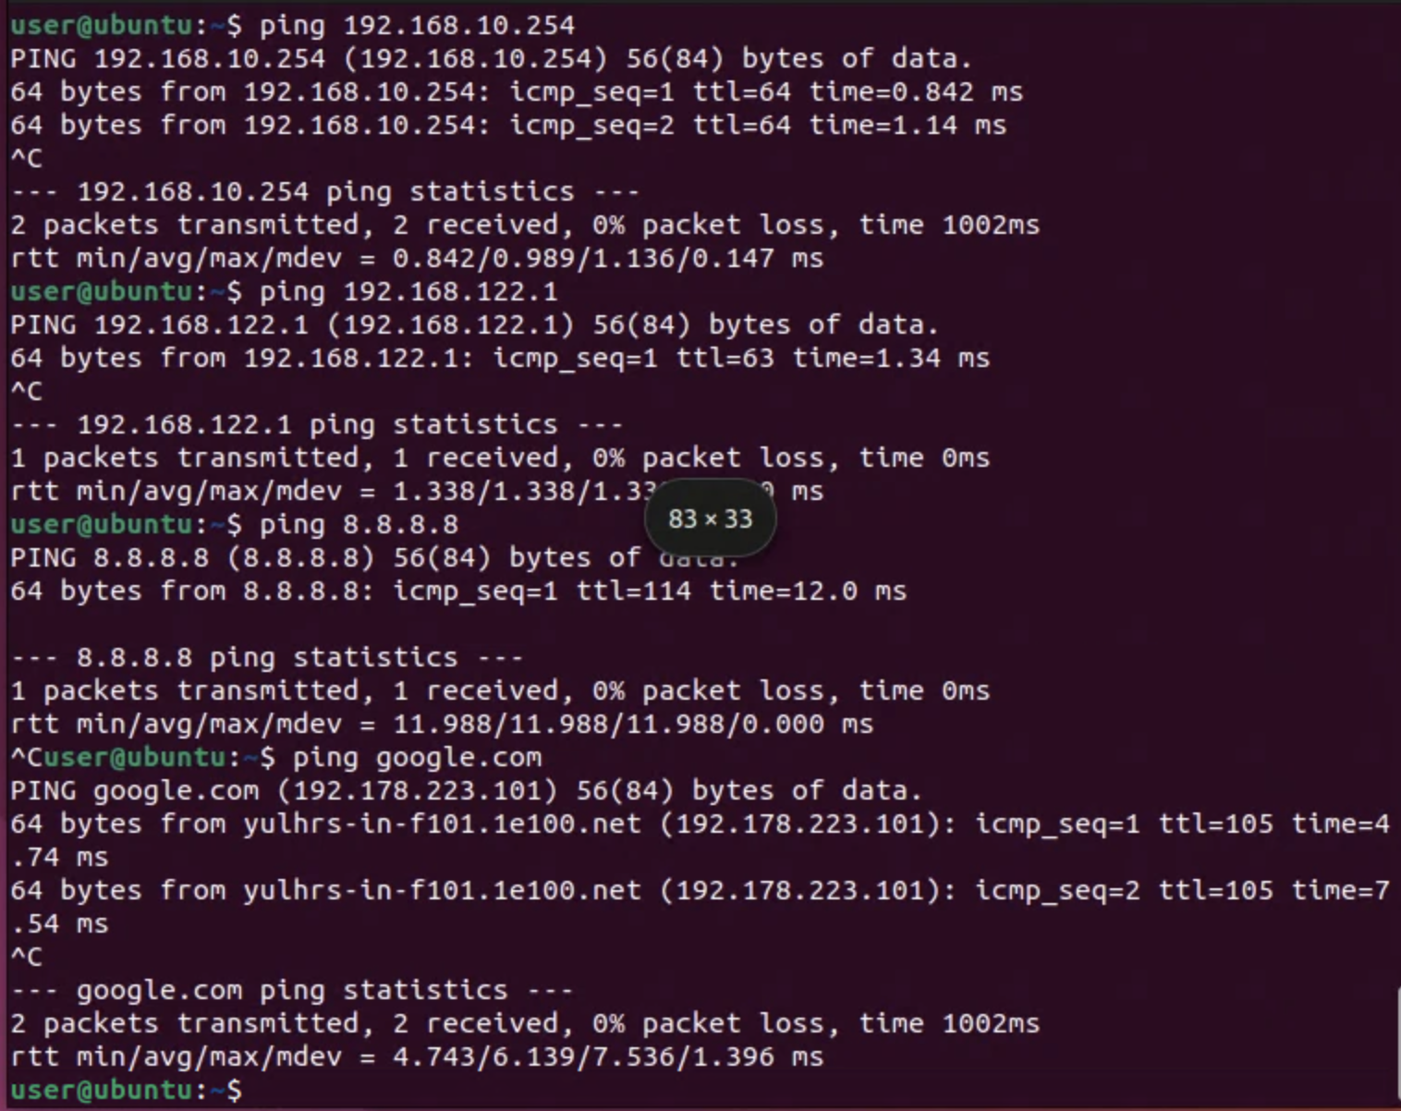
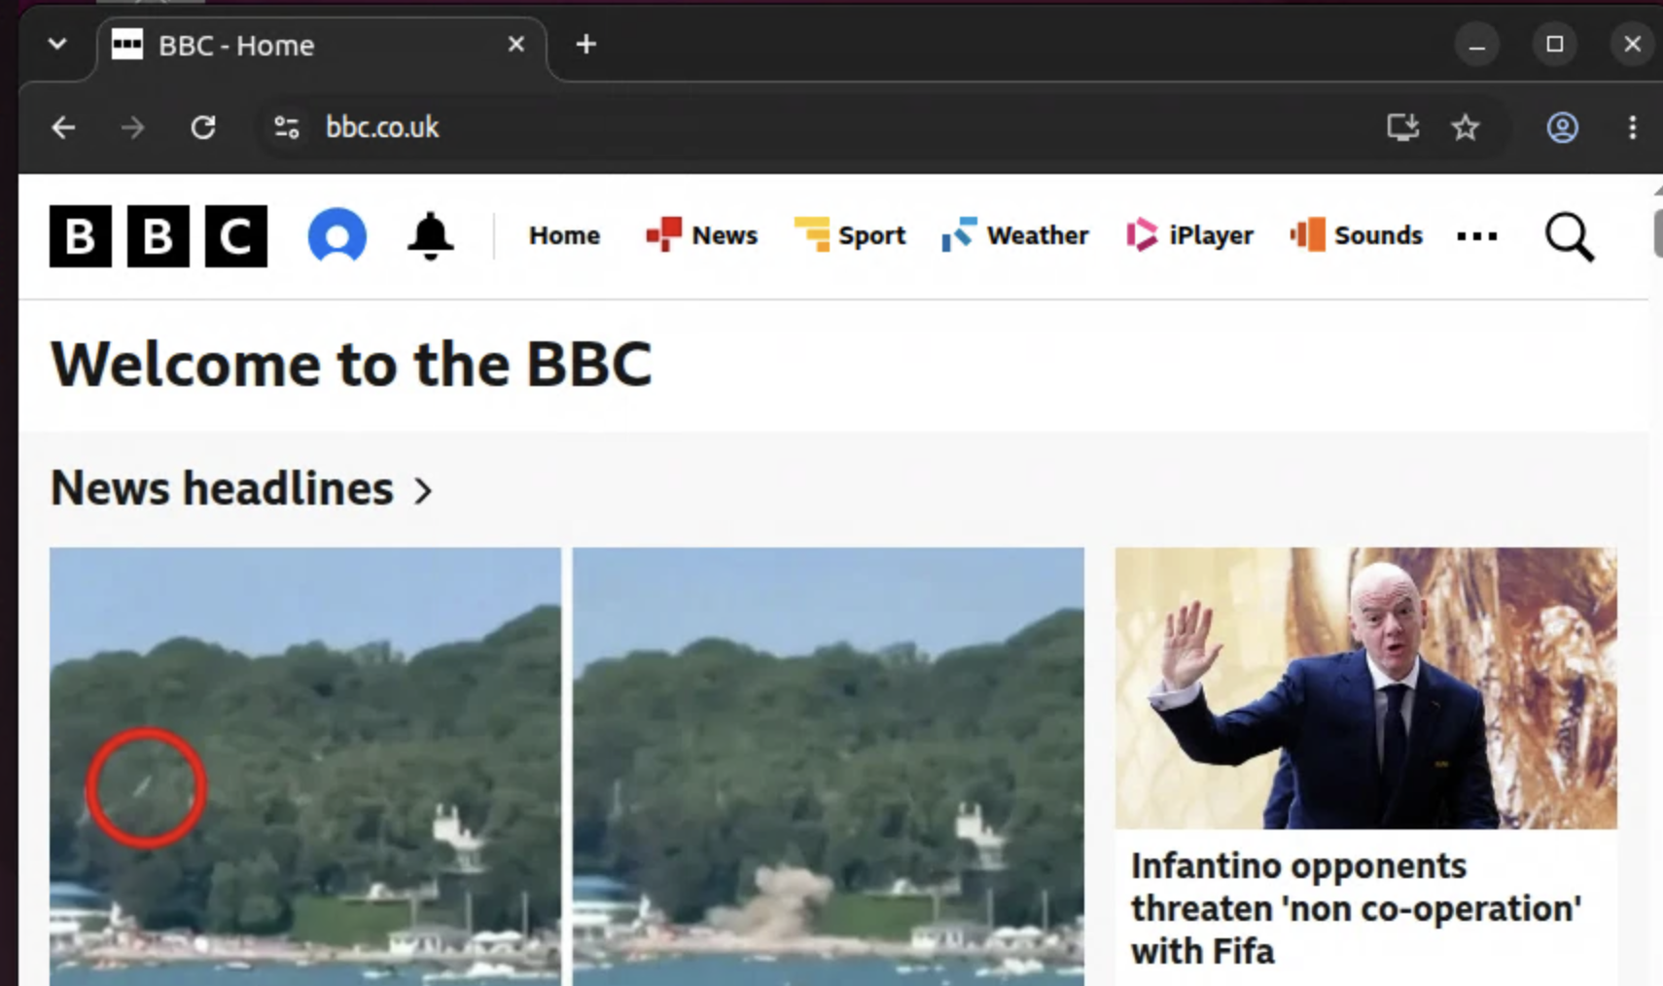

J Enable DMZ port
Next, navigate to the Interfaces menu item and then set up the required IP on the DMZ (192.168.11.254/24) and subnet mask (24-bit subnet mask). Note that by default the DMZ is named with the OPT1 network name.
1. Go to the pfSense terminal, and check that the right address is set for OPT1 (192.168.11.254/24). Is it correct? | Yes/No
2. Go to the Windows 7 server. Can you ping the default gateway (192.168.11.254/24)? | Yes/No
The answer to this should still be No, as the firewall will block the traffic by default until we enable it with firewall rules.
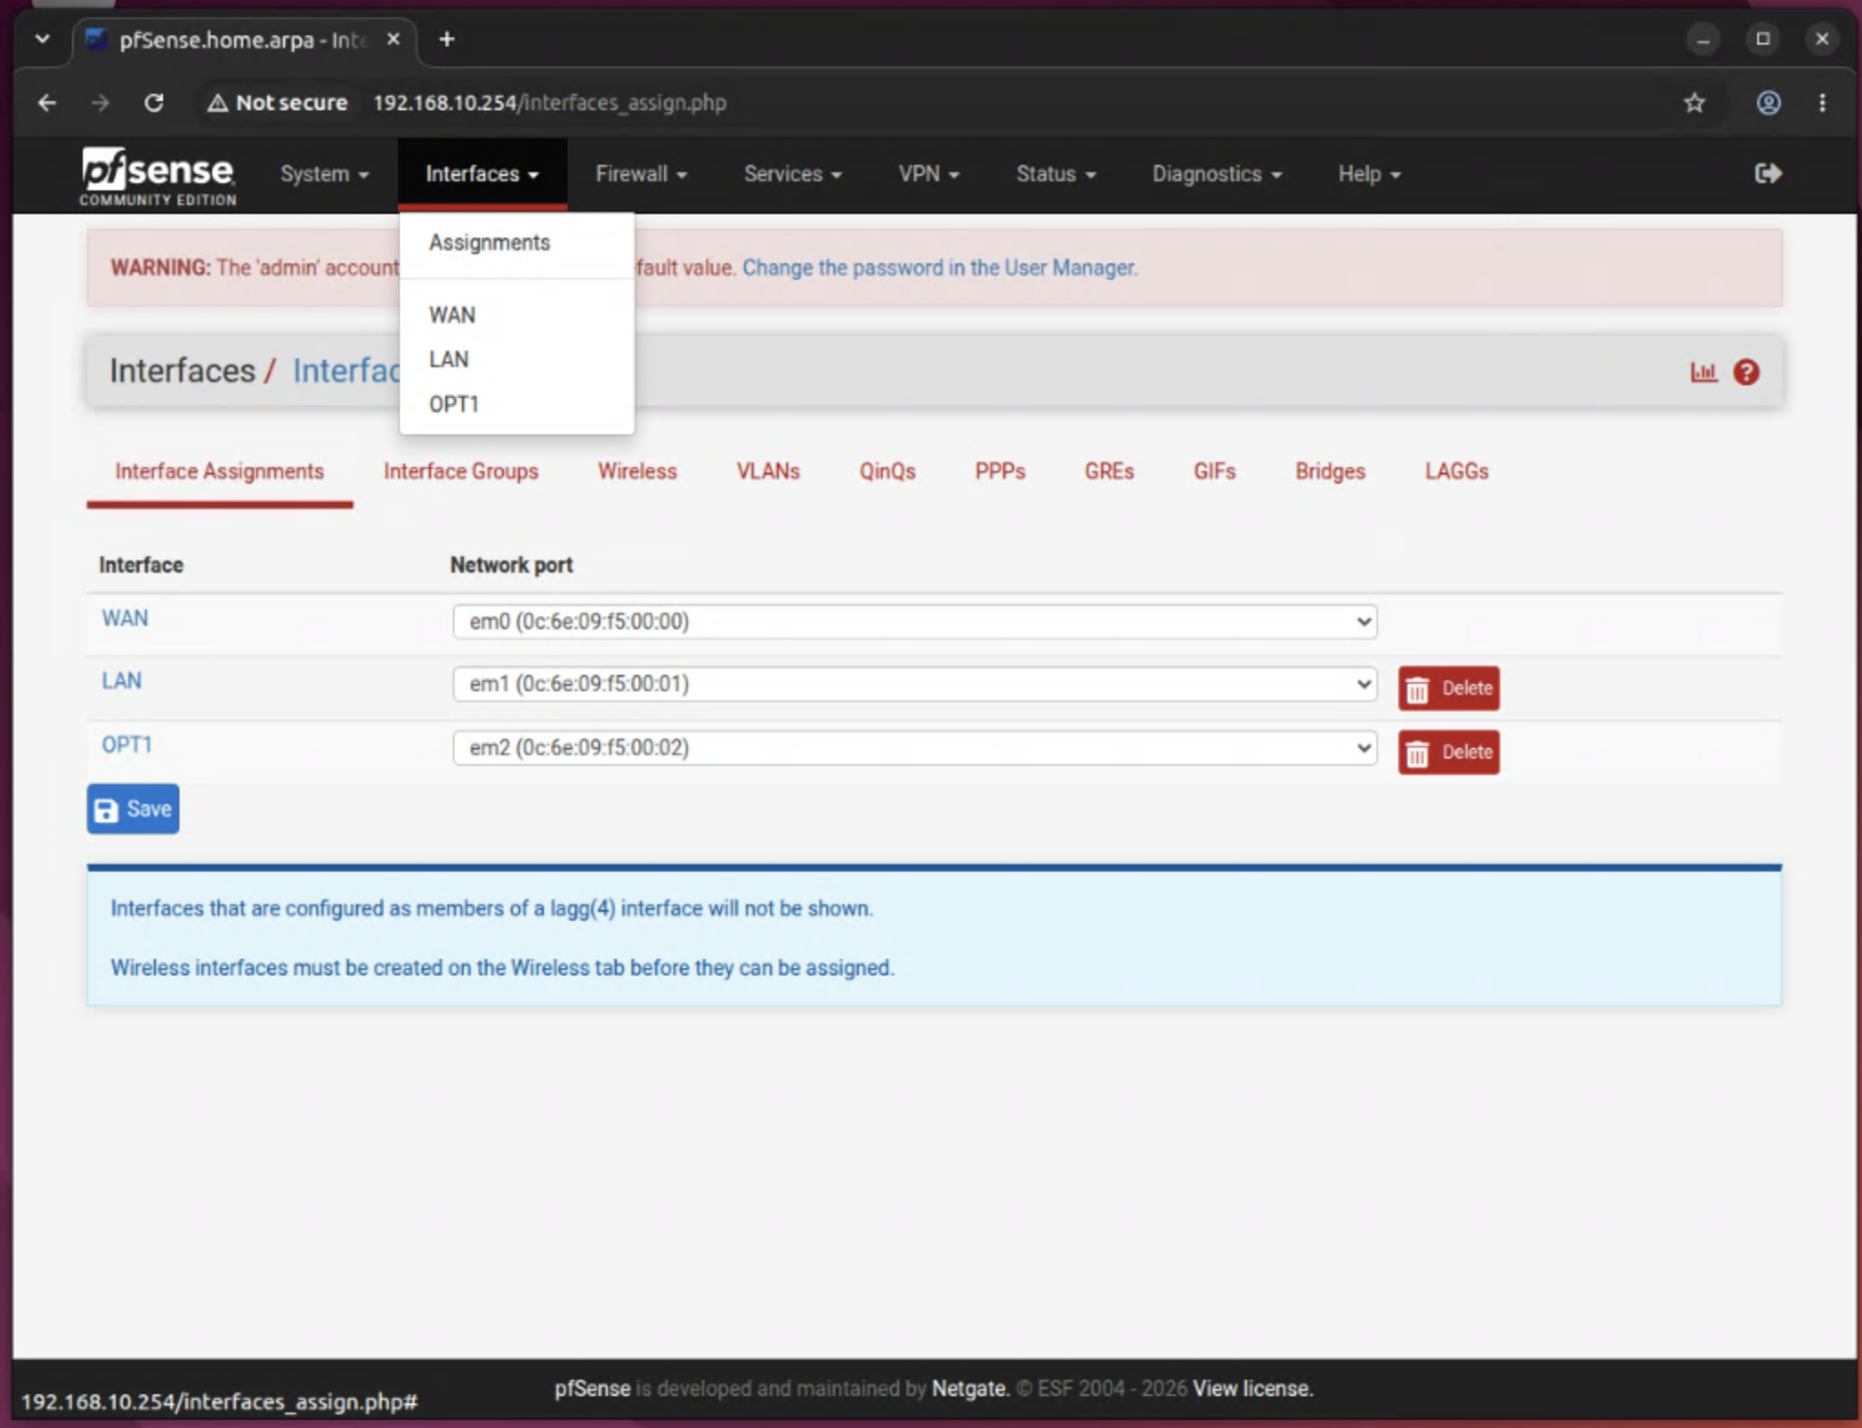
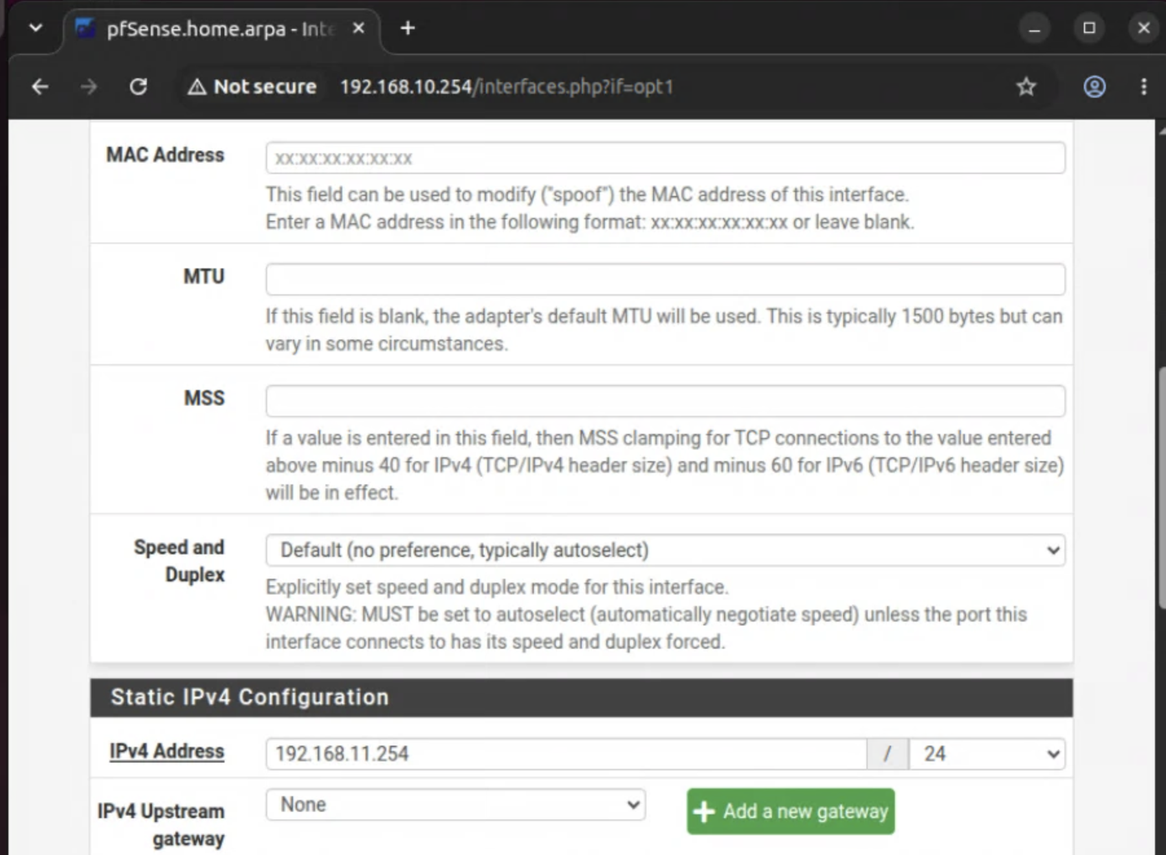
On the firewall console, we should see the new interface:
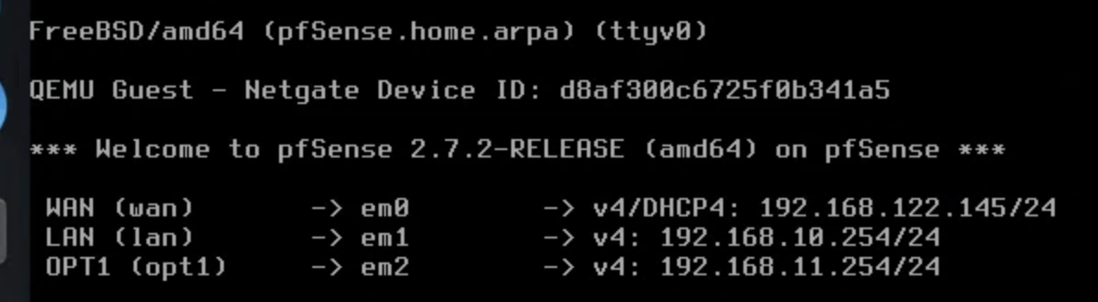

K Windows 7 host setup
On the Windows 7 server, modify the static address on the network interface with:
IP: 192.168.11.7
Subnet mask: 255.255.255.0
Gateway: 192.168.11.254
DNS: 8.8.8.8
1. Can you ping the default gateway? | Yes/No
The answer to this should be No, as we have not set up the firewall yet for this network port. Also, the firewall will block the traffic by default until we enable it with firewall rules.
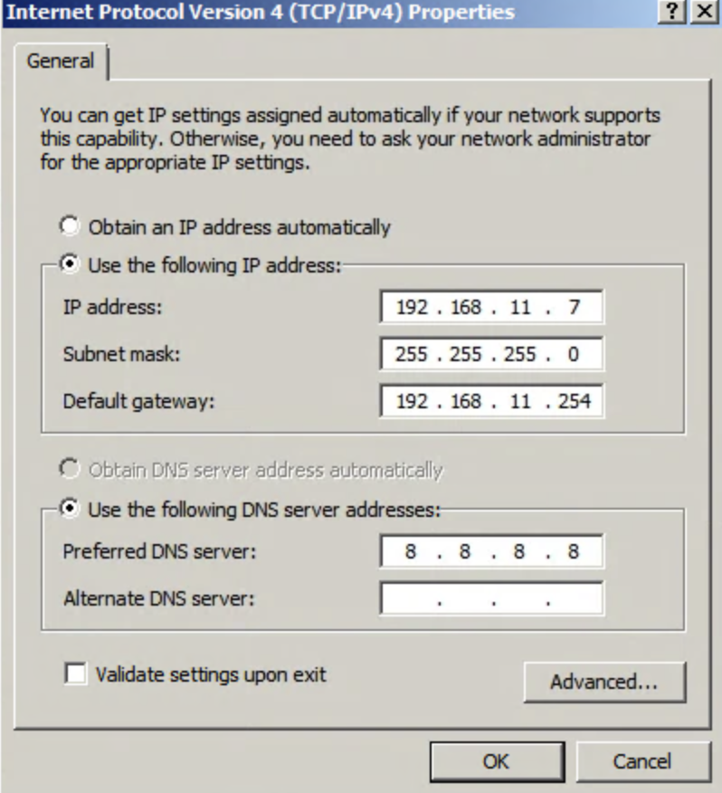

L Enable ICMP on DMZ
Now go to the Rules menu option on the firewall and add a rule that will allow ICMP traffic on the DMZ network.
1. Can you ping the default gateway (192.168.11.254)? | Yes/No
2. Can you ping the main gateway (192.168.122.1)? | Yes/No
3. Can you ping 8.8.8.8? | Yes/No
3. Can you ping google.com | Yes/No
The answer to the first three should now be Yes, but the last one should be No, as the firewall will be blocking DNS traffic from the DMZ network (OPT1). For this, we need to enable Port 53 UDP traffic from the DMZ. As we did before, go and enable this rule on the firewall, and commit it.
1. Can you ping the default gateway? | Yes/No
2. Can you ping the main gateway (192.168.122.1)? | Yes/No
3. Can you ping 8.8.8.8? | Yes/No
4. Can you ping google.com? | Yes/No
5. Run "nslookup google.com". What IP address does it give?
6. Open a browser and navigate to google.com. Can you access the site? | Yes/No
The answers to the first five should be Yes, but the last one will be No, as we have not enabled HTTPS (Port 443) on the DMZ.
Now, set a rule to allow traffic from Port 443 on the DMZ.
1. Can you ping the default gateway (192.168.11.254)? | Yes/No
2. Can you ping the main gateway (192.168.122.1)? | Yes/No
3. Can you ping 8.8.8.8? | Yes/No
4. Can you ping google.com? | Yes/No
5. Run "nslookup google.com". What IP address does it give?
6. Open a browser and navigate to google.com. Can you access the site? | Yes/No
The answer to each of these should be Yes.
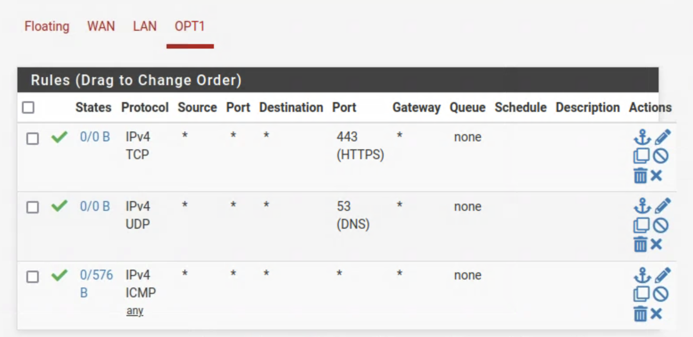

M Kali host set up
Now we will set up the Kali host on the DMZ. Set up the Kali host to connect to 192.168.11.8/24 with a default gateway of your firewall port (192.168.11.254/24).
sudo ip link set eth0 up
sudo ip addr add 192.168.11.8/24 dev eth0
sudo ip route add default via 192.168.11.254 dev eth0
Next, set up the nameserver on the Kali host by editing /etc/resolv.config and adding a nameserver:
sudo nano /etc/resolv.conf
then add:
nameserver 8.8.8.8
1. Can you ping the default gateway (192.168.11.254)? | Yes/No
2. Can you ping Windows 7 (192.168.11.7)? | Yes/No
3. Can you ping the main gateway (192.168.122.1)? | Yes/No
4. Can you ping 8.8.8.8? | Yes/No
5. Can you ping google.com? | Yes/No
6. Run "nslookup google.com". What IP address does it give?
7. Open a browser and navigate to google.com. Can you access the site? | Yes/No
The answer to these should be Yes. If not, you will have to check your configuration.

Metasploitable host setup
Next, set up your Metasploitable host on the DMZ (User: msfadmin, Password: napier123). Set up the Metasploitable host to connect to 192.168.11.9/24 with a default gateway of your firewall port (192.168.11.254/24).
sudo ip addr add 192.168.11.9/24 dev eth0
sudo ip route add default via 192.168.11.254 dev eth0
1. Can you ping the default gateway (192.168.11.254)? | Yes/No
2. Can you ping Windows 7 (192.168.11.7)? | Yes/No
3. Can you ping Kali DMZ (192.168.11.8)? | Yes/No
4. Can you ping the main gateway (192.168.122.1)? | Yes/No
5. Can you ping 8.8.8.8? | Yes/No
6. Can you ping google.com? | Yes/No
The answer to these should be Yes. If not, you will have to check your configuration.

N Kali (Public) host setup
On the Kali public host, verify that it can ping the default gateway (192.168.122.1), 8.8.8.8 and also google.com?
1. What is the IP address of your Kali (Public) host?
2. Can you ping 192.168.122.1? | [Yes/No]
3. Can you ping 8.8.8.8? | [Yes/No]
4. Can you ping Google.com? | [Yes/No]
5. Can you access Google.com from a browser? | [Yes/No]
The answer to these should be Yes.
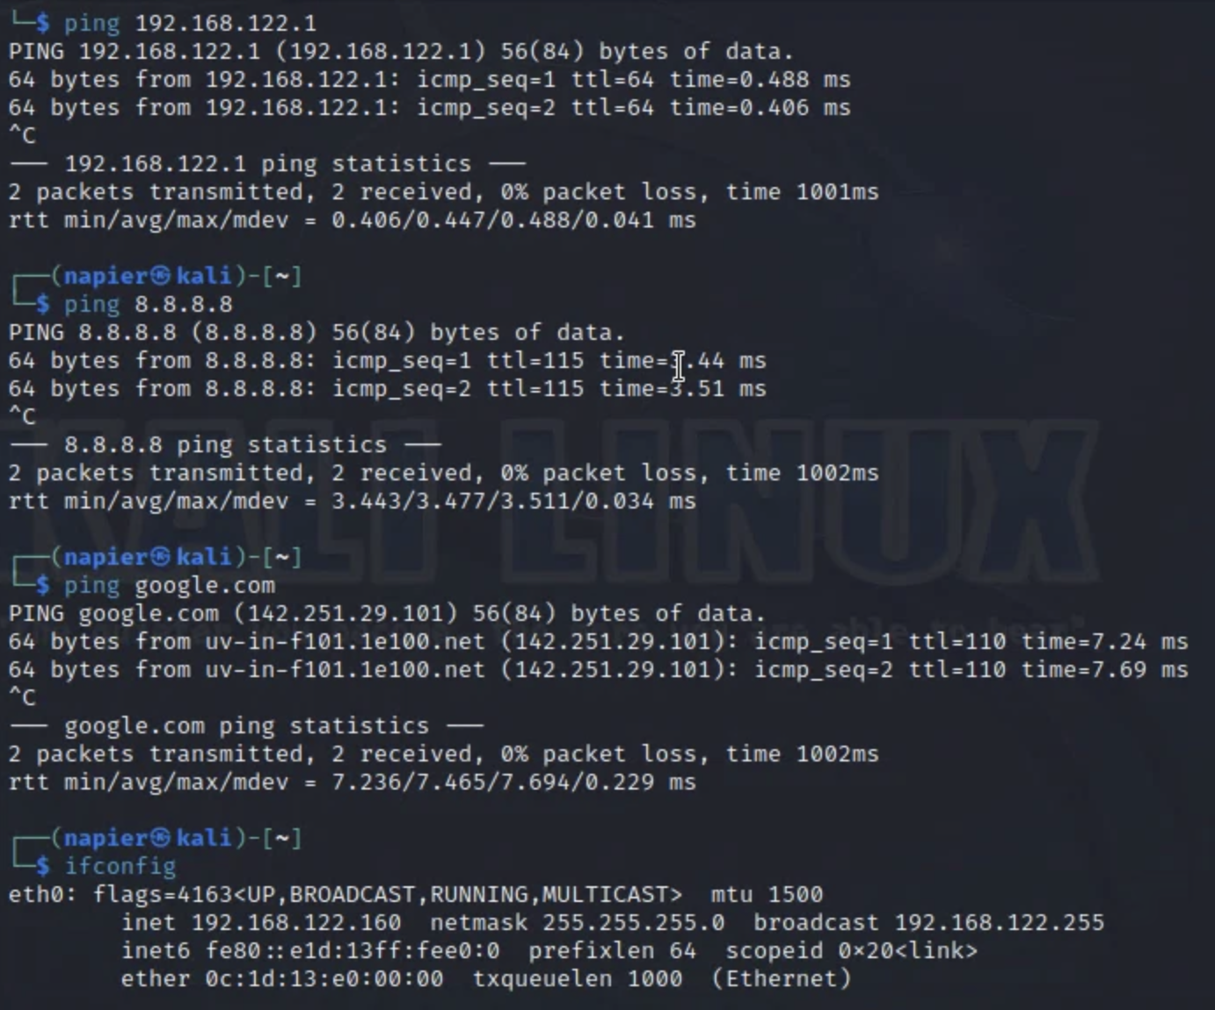

O Final check of connectivity
Go back to your Windows 7 host, and check that you can ping all of the hosts on the network.
1. Can you ping all the hosts and the firewall ports? | Yes/No
Go back to your Ubuntu host, and check that you can ping all of the hosts on the network.
1. Can you ping all the hosts and the firewall ports? | Yes/No

P Running NMAP to discover services
From Ubuntu, run nmap and discover the services that are running on Windows 7.
1. Do you get a range of services shown? | Yes/No
2. Name three services that are running on Windows 7?
You should get a range of services here, as the firewall will be open from the Private network to the DMZ.
From Windows 7, run nmap and discover the services that are running on Ubuntu.
1. Do you get a range of services shown? | Yes/No
You should not get a range of services here, as the firewall will be closed from the DMZ network to the Private network (apart from HTTPS - which we enabled earlier.
From Windows 7, run nmap and discover the services that are running on Ubuntu.
1. Do you get a range of services shown? | Yes/No
Go to the firewall, and enable all the TCP and UDP ports from the DMZ to the Private network.
From Windows 7, run nmap and discover the services that are running on Ubuntu.
1. Do you get a range of services shown? | Yes/No
2. Name three services that are running on Ubuntu?
You should now get a range of services shown.

Q Final connectivity
From Ubuntu, open up a browser, and connect to the Web server on Windows 7.
1. Can you view the Web server? | Yes/No
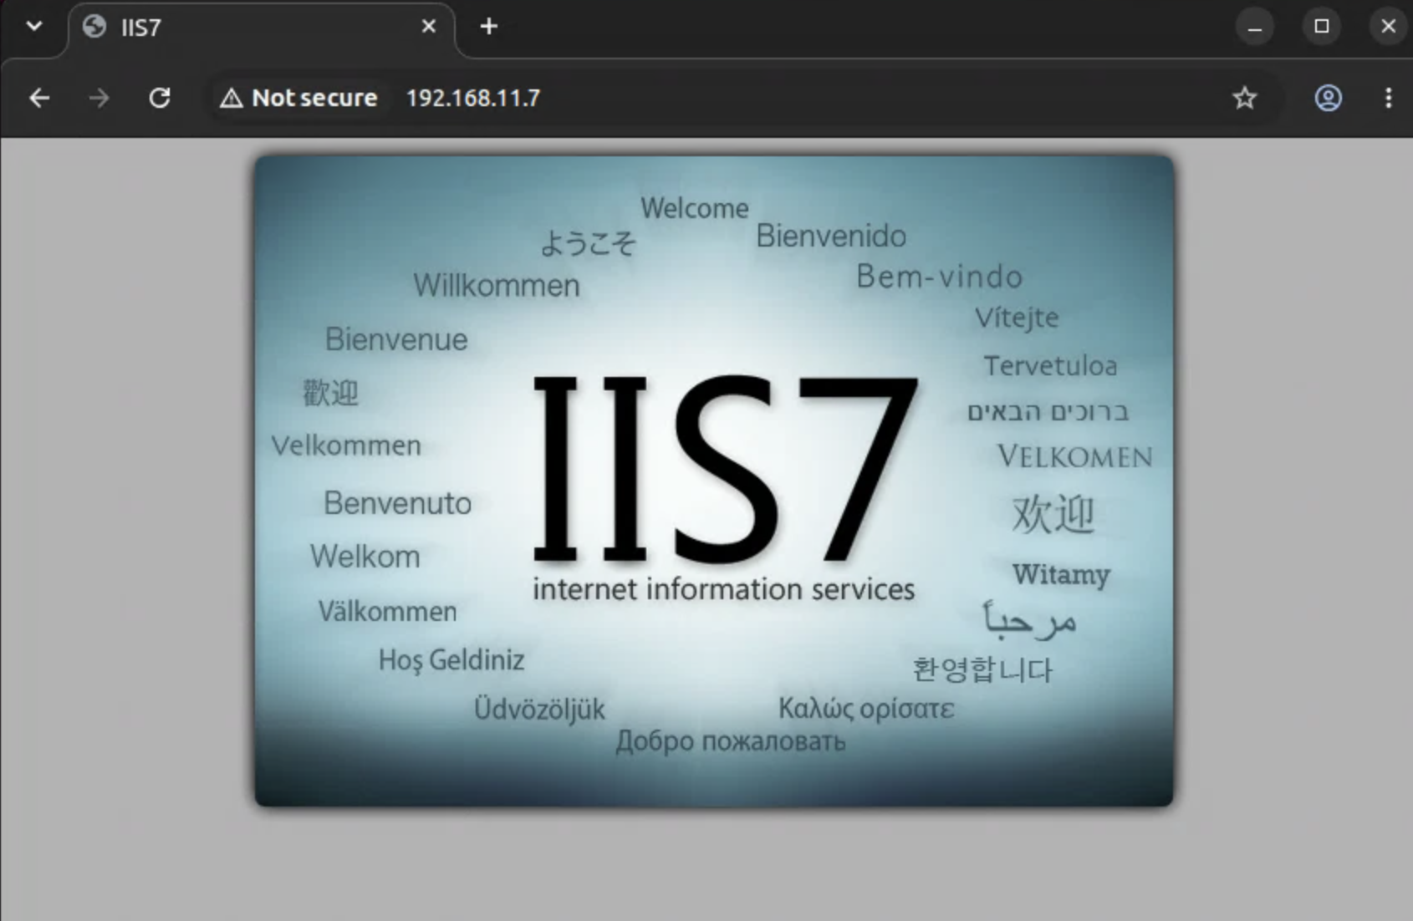
From Windows 7, open up a browser, and connect to the Web server on Ubuntu.
1. Can you view the Web server? | Yes/No
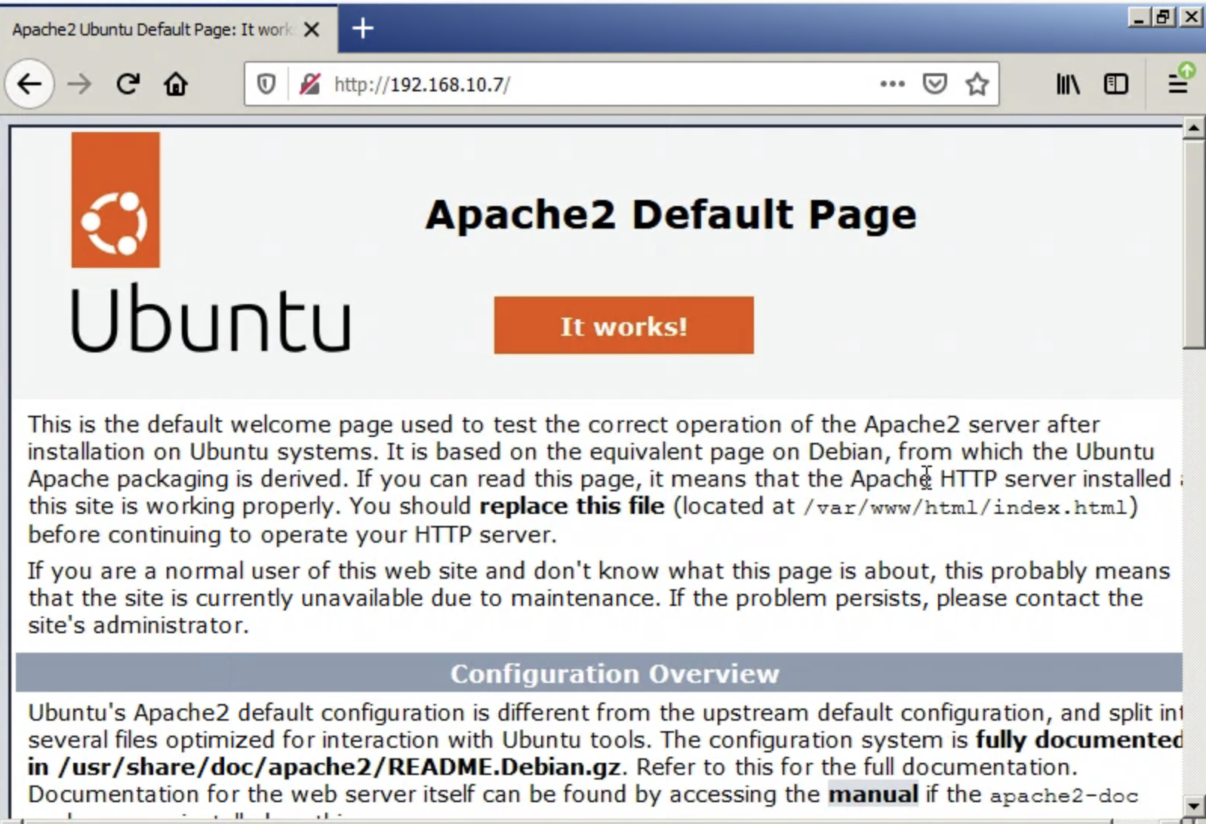

And finally ...
Share your instance with b.buchanan@napier.ac.uk
Now, power down your instances, or suspend them:
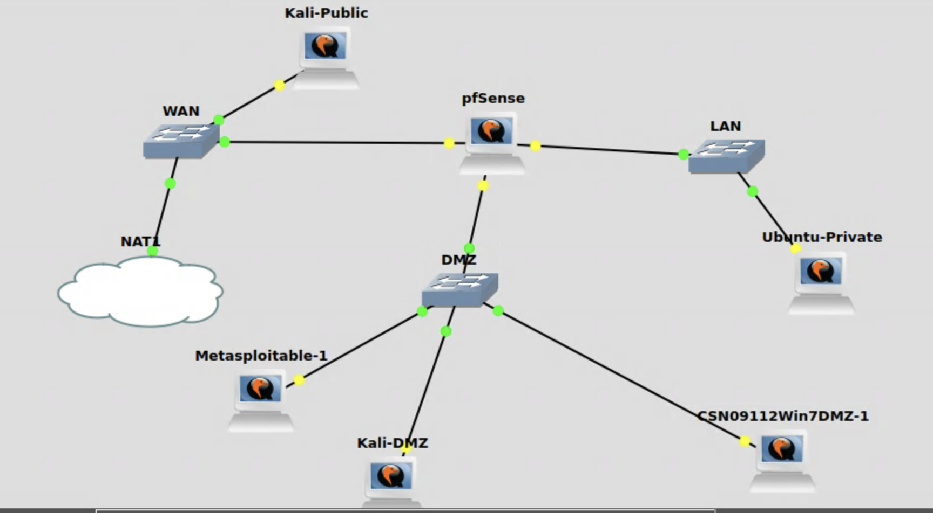

Appendix
User logins:

Ubuntu:- User: napier, Password: napier123
Kali:- User: napier, Password: napier123
Windows:- User: Administrator, Password: napier123
pfsense:- User: admin, Password: pfsense
Metasploitable:- User: msfadmin, Password: napier123

