OBJECTIVE | Determine what Cancelled or Completed projects are potentially errantly in that state, and remedy the situations
ROLES | - Developer: Staff running the report  - Manager: Project Manager  - PMO Manager: The Manager’s manager.
SCOPE | This SOP applies to all members of the Reporting Team who monitor Cancelled and Completed projects.
DEFINITIONS / TERMS | - Cancelled or Completed project: PPM Project indicating it is Cancelled or Completed with an end date beyond today.  - PM/Manager: Project manager of said project(s).
APPLICATIONS | - PPM Tool  - Outlook  - Teams
COMPLIANCE REQUIREMENTS | This SOP supports the proper management of projects, so that the Cancelled and Completed Work Status’ are not misused.

PROCEDURE
WHO | DOES WHAT
Developer | - Create a view in projects with the following filters:  - Finished date is after today’s date  - Active = Yes  - Work Status = Completed; Cancelled  - Template = No  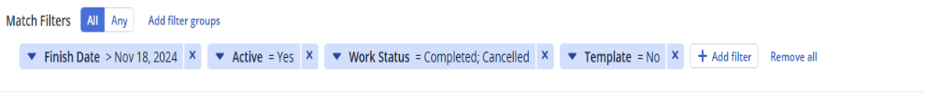  - Set up the following columns:  - Status Indicator  - Project ID  - Name  - Manager  - Start Date  - Finish Date  - Baseline Finish  - Work Status  - Project Category  - PMM Phase  - PMM Phase Exit Approval Request  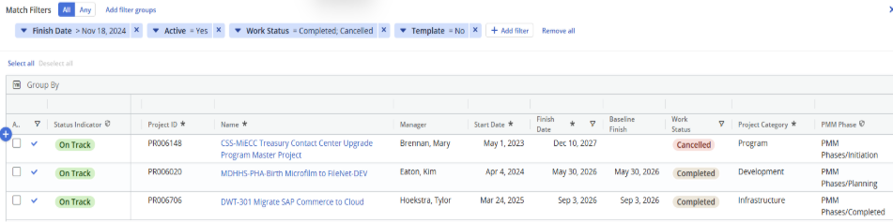  - Export to CSV, then format and email PM(s)/Manager(s)  E-mail to Project managers  Please review the attached list of projects. Currently, several projects are appearing as "Active" despite their work status being marked as "Complete."  Kindly verify that the PPM stage for these projects is set to "Closed" and ensure that your PMO Manager has provided the necessary approval.  If you require any assistance with this process, please feel free to reach out.  Best regards,  Link to how to close out a project (Clarity QRG)
Developer | Check the View frequently. If it becomes necessary, in order to right the status of a project, contact the Manager’s PMO Manager via Outlook and/or Teams.

Revision History

Revision No. | Date Revised | Summary of Changes | Author | Approval

