bambooBSC VM version

author: Chen Xin Nien / Bill Chen

mail: chen.xin.nien@gmail.com

VirtualBox download:
https://www.virtualbox.org/
https://www.virtualbox.org/wiki/Downloads

1. Create new VM and import bambooBSC vdi file to VirtualBox
1.1 Create operation system
OS-Type select BSD
Version select FreeBSD (32-bit)
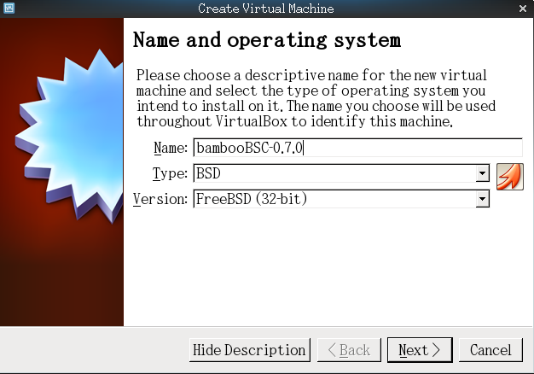

1.2 Memory settings
Please setting value min to 1680MB, If computer have enough resources, you can adjust to 2048MB

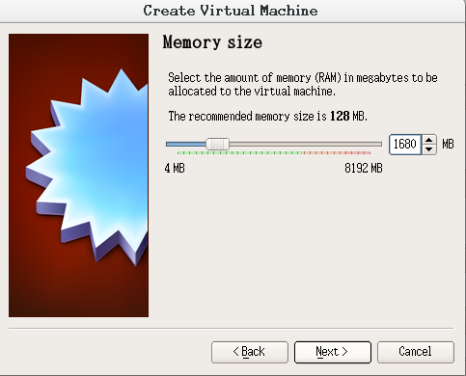

1.3 Select vdi file
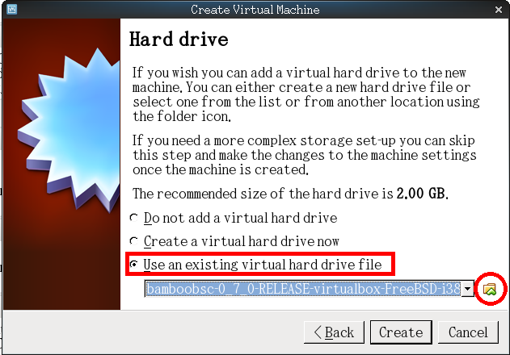

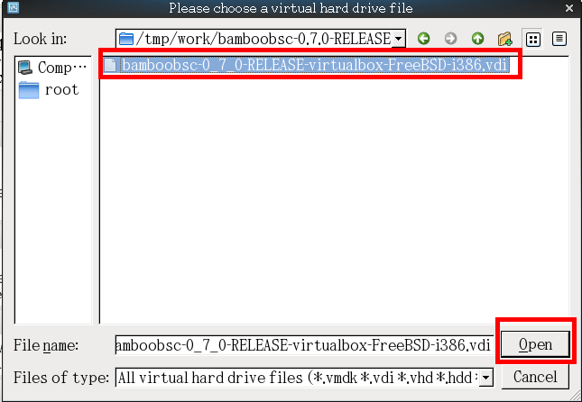

2. Settings VM
Chipset select ICH9 and Enable I/O APIC

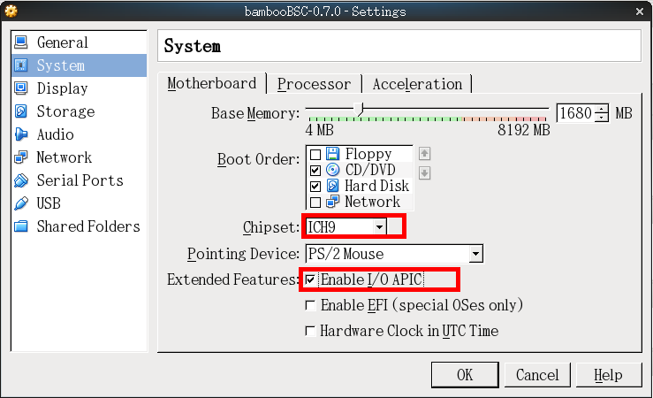

Enable Acceleration options.

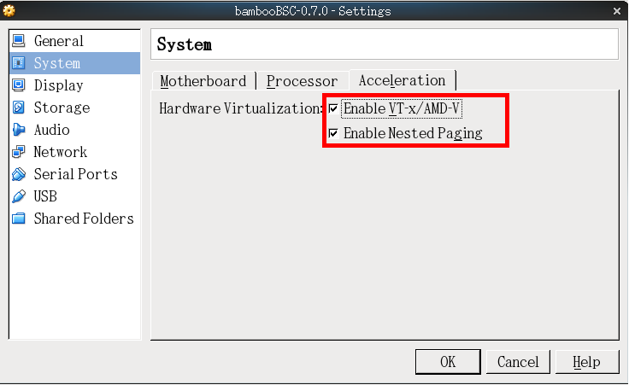

Adapter must attached to “Bridged Adapter” and Type select Intel PRO/1000 MT Desktop

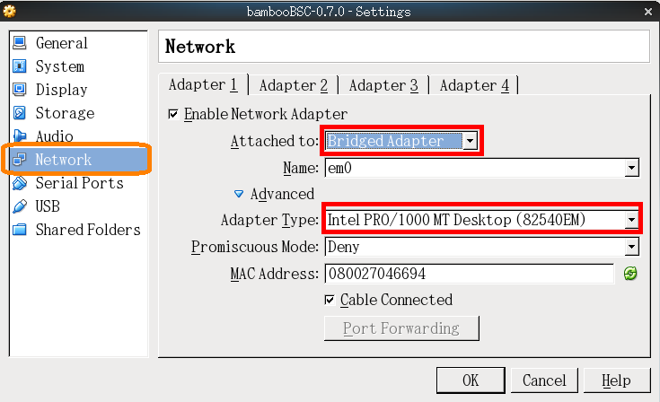

*** bambooBSC VM must be under the DHCP network environment to work. ***

*** bambooBSC VM must be under the DHCP network environment to work. ***

*** bambooBSC VM must be under the DHCP network environment to work. ***

3. Run VM
bambooBSC startup completion may have to wait more than 10 minutes.
and will show URL display on screen, the IP-Address ( 192.168.1.107 ) is request by DHCP.
So after each restart, IP address may be different
Open browser, input URL on Google-Chrome or FireFox.

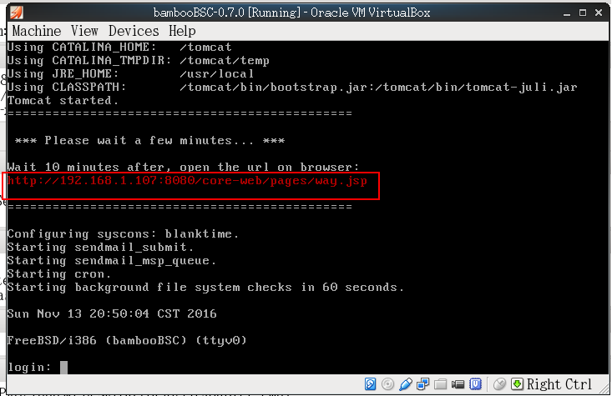
Open browser load bambooBSC login web page
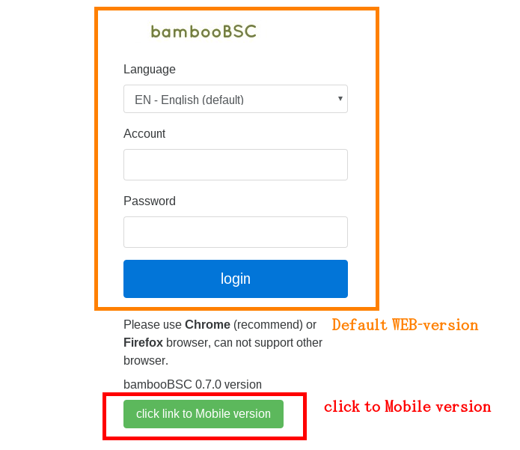

4. bambooBSC WEB account

administrator user
account: admin
password: admin99

hr manger ( same power user, but can delete account )
account: tiffany
password: tiffany

default user(power user)
account: tester
password: tester

sales ( only view , can input measure-data and enter 360 project score )
account: steven
password: steven

The freeBSD console account

root / bamboobscadmin123

Login success page. ( bambooBSC WEB )

