hillfog

hillfog is an KPI, OKR, PDCA, BSC web platform.

Version : 0.2

Author : Bill Chen / Chen Xin Nien

Modify date : 2021/06/02

Contact : [chen.xin.nien@gmail.com](mailto:chen.xin.nien@gmail.com)

Project source-code: <https://github.com/billchen198318/hillfog>

|  |  |
| --- | --- |
| **Current project status** | |
| OKR | in developing |
| KPI | in developing |
| BSC | Not yet in progress |
| PDCA | in developing |

內容

Check JAVA version 2

Run hillfog 3

Open the hillfog login page 3

TEST User account and password 4

# Check JAVA version

Use command java -version to check JDK version.

Hillfog need JDK11 version.

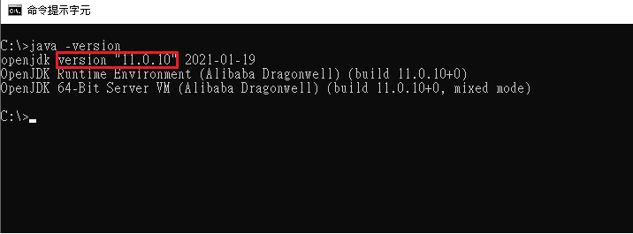

**JAVA11 download info:**

**Alibaba Dragonwell JDK**

<https://github.com/alibaba/dragonwell11/releases>

**Zulu JDK**

<https://www.azul.com/downloads/zulu-community/?version=java-11-lts&package=jdk>

# Run hillfog

Use command:

java -Xmx512M -jar hillfog-0.2.jar

# Open the hillfog login page

Use chrome or firefox open http://127.0.0.1:8088/

Input account and password to login.

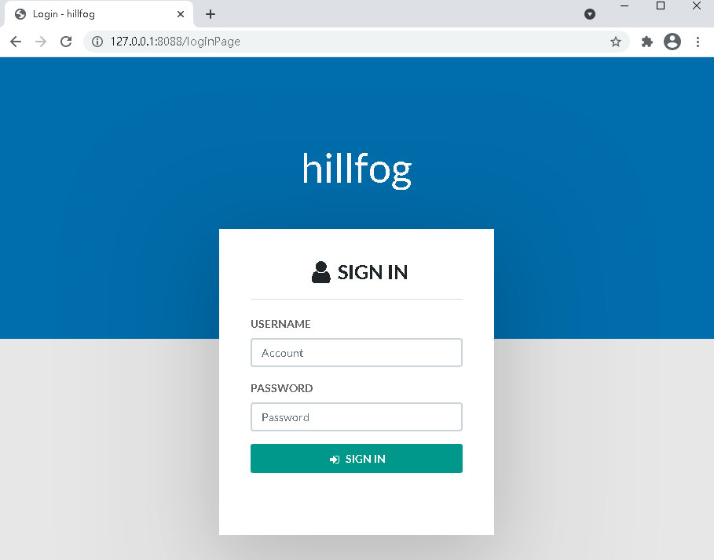

# TEST User account and password

|  |  |
| --- | --- |
| **Account** | **Password** |
| admin | admin99 |
| bill | 1234 |
| frank | 1234 |