hillfog

hillfog is an KPI, OKR, PDCA, BSC web platform.

Version : 0.4

Author : Bill Chen / Chen Xin Nien

Modify date : 2021/07/09

Contact : [chen.xin.nien@gmail.com](mailto:chen.xin.nien@gmail.com)

Project source-code: <https://github.com/billchen198318/hillfog>

|  |  |
| --- | --- |
| **Modify** | |
| 2021/04/09 | 0.1 |
| 2021/06/02 | 0.2 |
| 2021/06/14 | 0.3 |
| 2021/07/16 | 0.4 |

內容

1. Create Objective 3

1-1. Create Objective (input field) 4

2. OKR item management 5

3. Key Result measure data input 6

4. OKR report 8

4-1. OKR report (view detail) 9

5. KPI data management 10

6. KPI Create 11

7. KPI measure data input 12

8. KPI report 13

9. PDCA Create (for OKR) 15

10. PDCA Create (for KPI) 17

11. How to open PDCA Detail report page 18

12. PDCA Detail report 21

13. PDCA Edit 22

14. Personal board 23

15. Scorecard data 24

16. Scorecard create 25

17. Scorecard report 26

18. Employee hierarchy settings 27

19. OKR hierarchy view for employee. 28

20. OKR progress view for organization/department. 30

# Create Objective

First select “BA06 – OKR Base” , look (1_01) screenshots. Click  button to create program page.

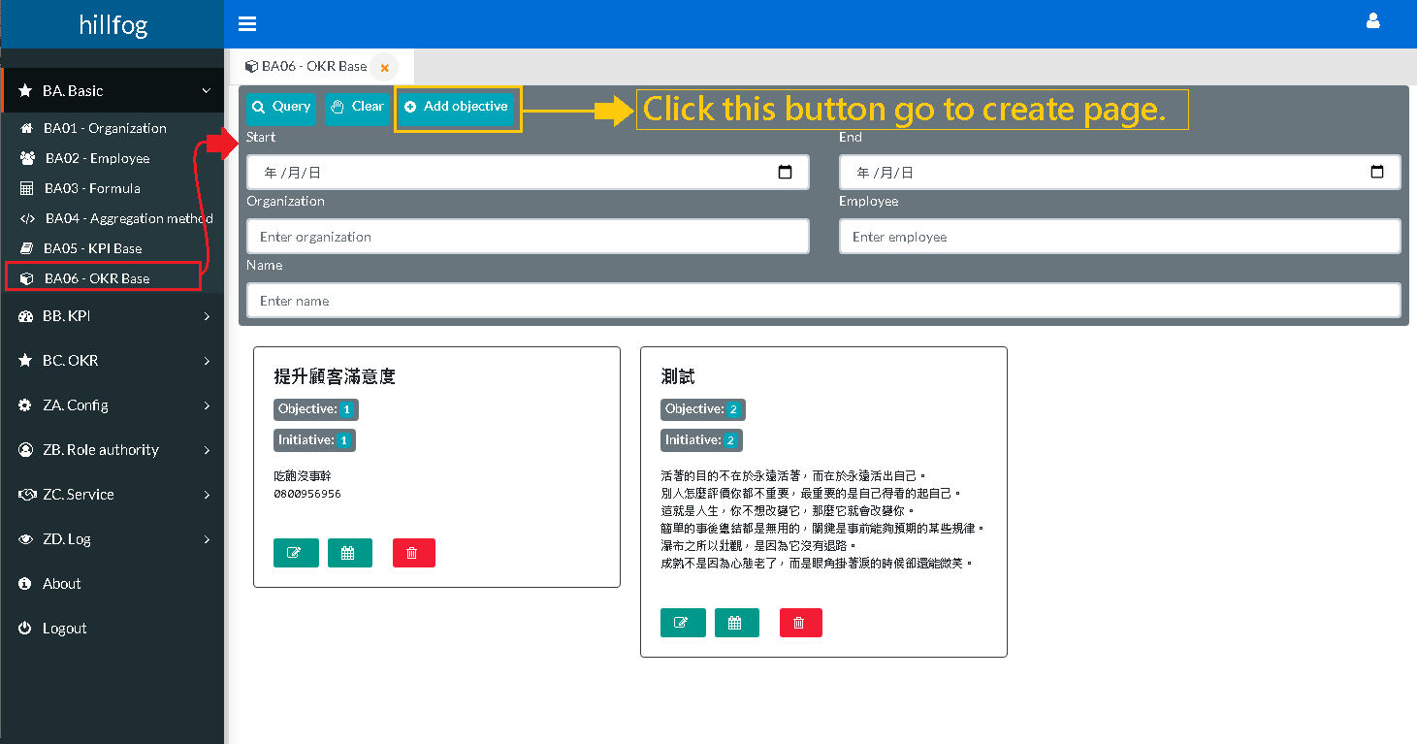

(1_01)

<< Please continue to the next page >>

## Create Objective (input field)

Look (1-1_01) screenshots. Input Objective content and Key Result content.

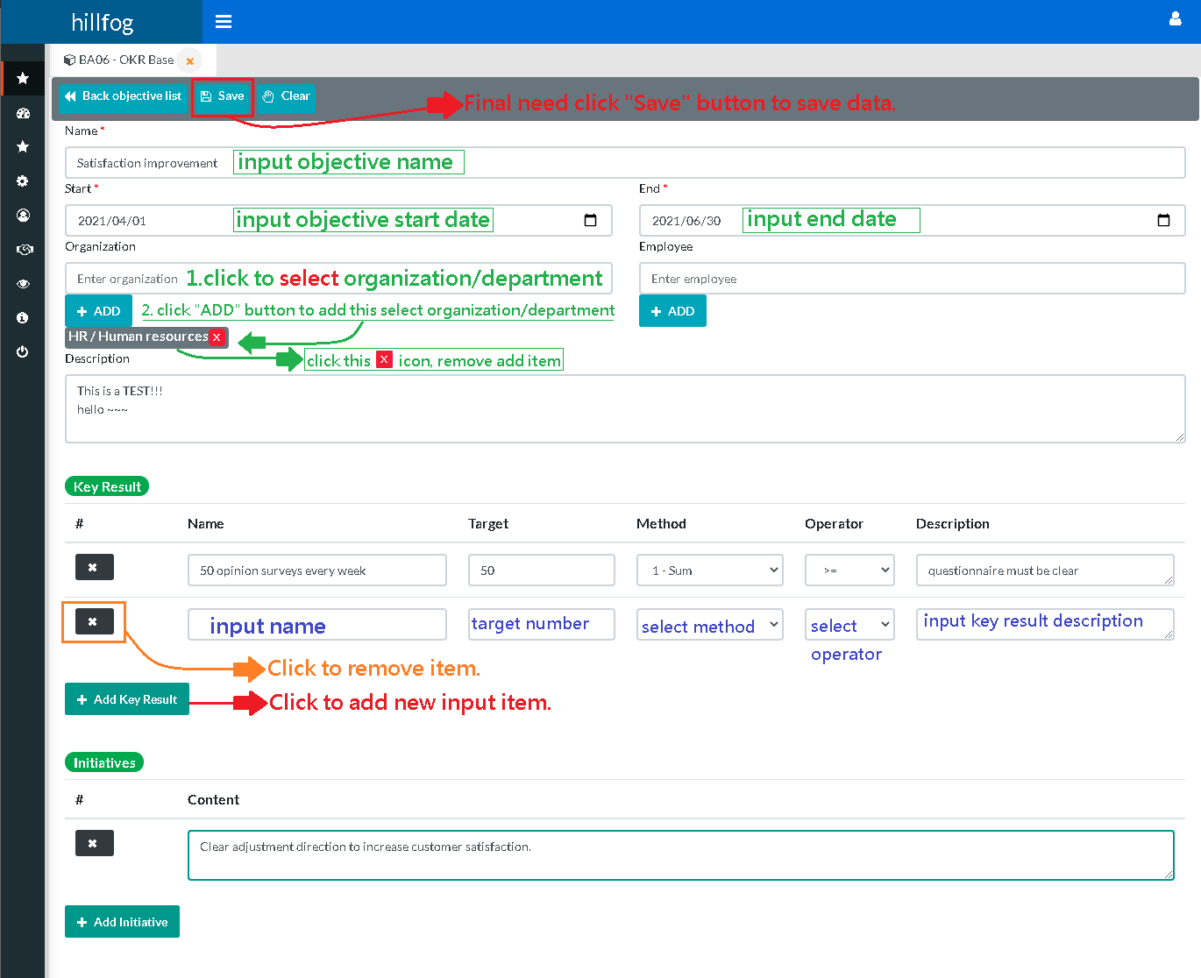

(1-1_01)

|  |  |
| --- | --- |
| **Key Result “Method” and “Operator” field description.** | |
| |  |  | | --- | --- | | **Method** | | | 1-SUM | Get period measure data value use sum. | | 2-AVG | Get period measure data value use avg. | | 3-MAX | Get period measure MAX data value. | | 4-MIN | Get period measure MIN data value. | | |  |  | | --- | --- | | **Operator** (Key Result progress is completed the rules.) | | | > | calculated value > target | | < | calculated value < target | | = | calculated value = target | | >= | calculated value >= target | | <= | calculated value <= target | |

# OKR item management

Click menu select “BA06 – OKR Base” , look (2_01) screenshots.

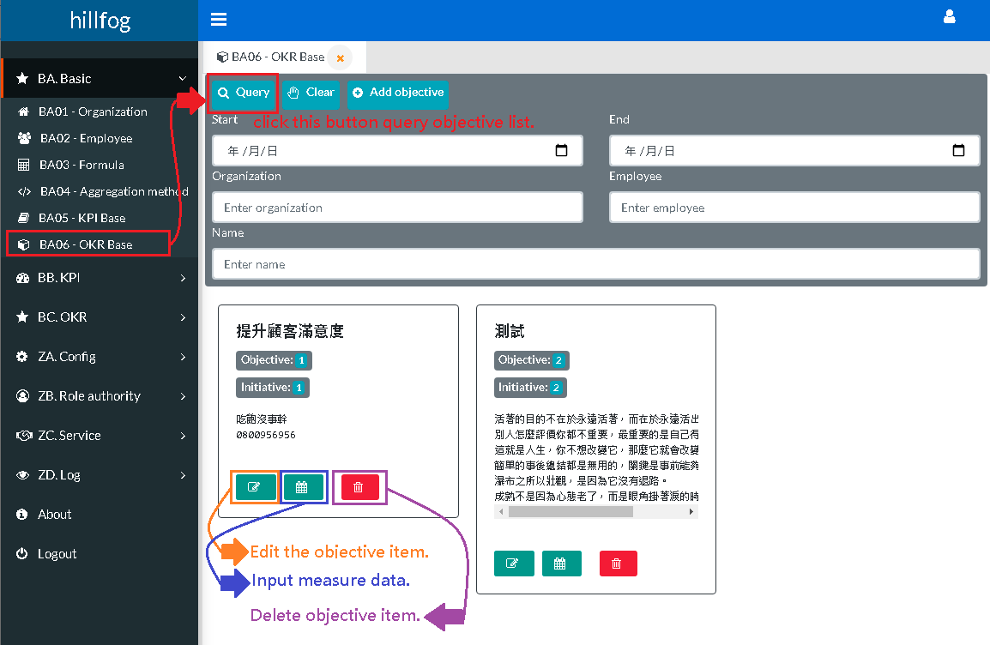

(2_01)

look (2_02) screenshots. Click button to Key Result measure data input page.

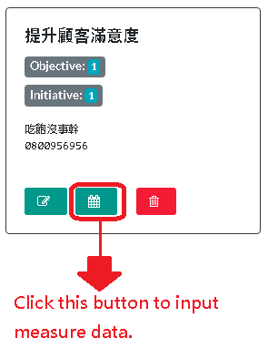

(2_02)

# Key Result measure data input

look (3_01) screenshots. Input Key Result measure data.

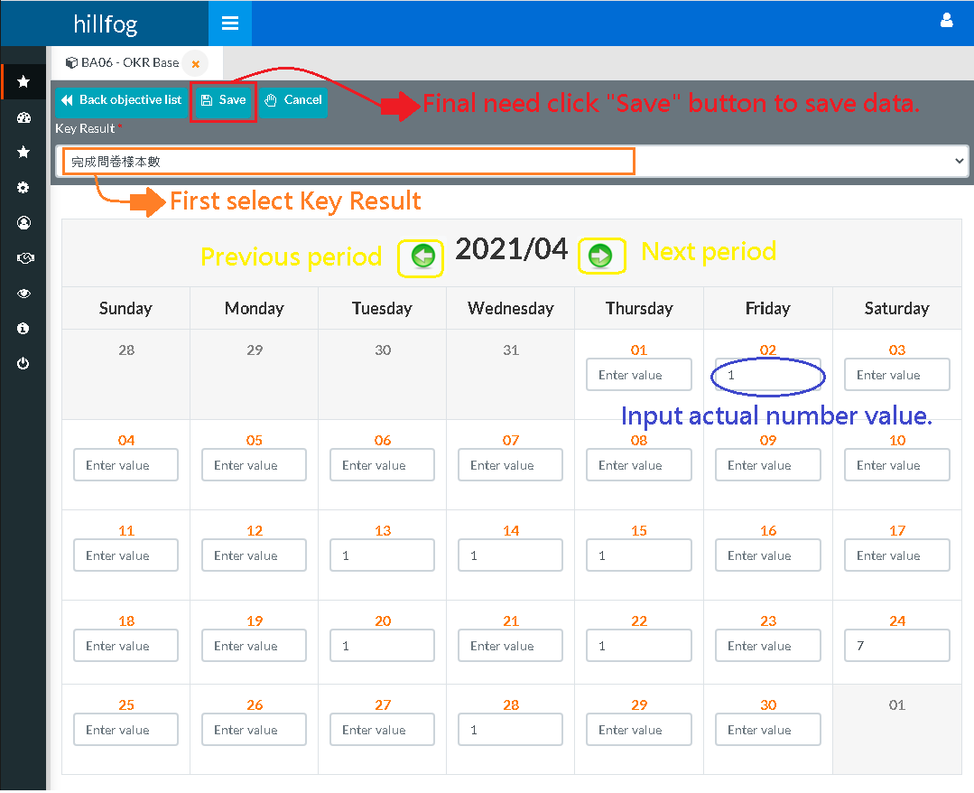

(3_01)

<< Please continue to the next page >>

# OKR report

look (4_01) screenshots. OKR completed progress query result.

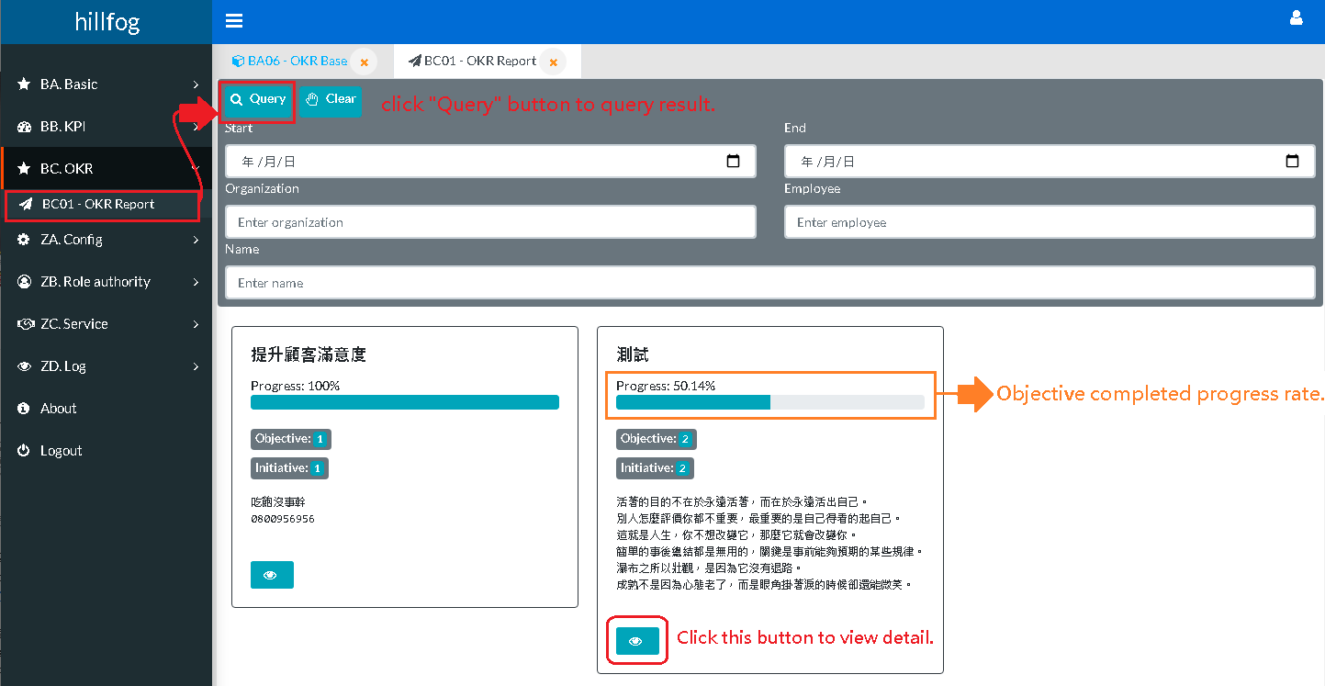

(4_01)

<< Please continue to the next page >>

## 4-1. OKR report (view detail)

look (4-1_01) screenshots. OKR detail report.

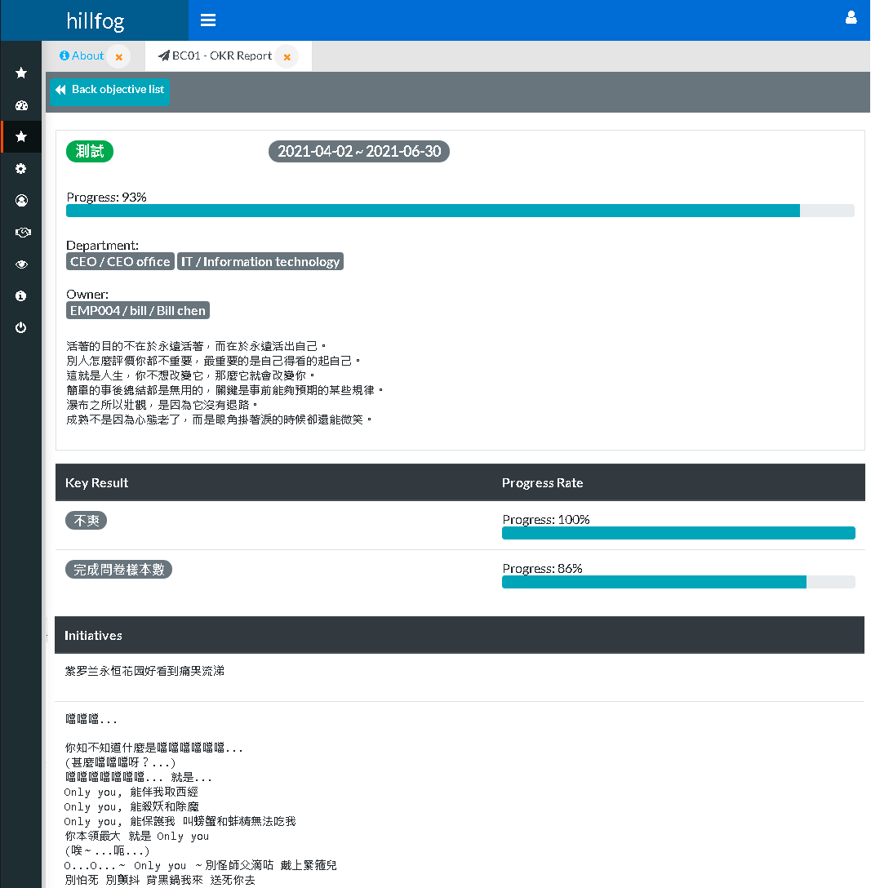

(4-1_01)

# KPI data management

Look (5_01) screenshots. KPI item data management.

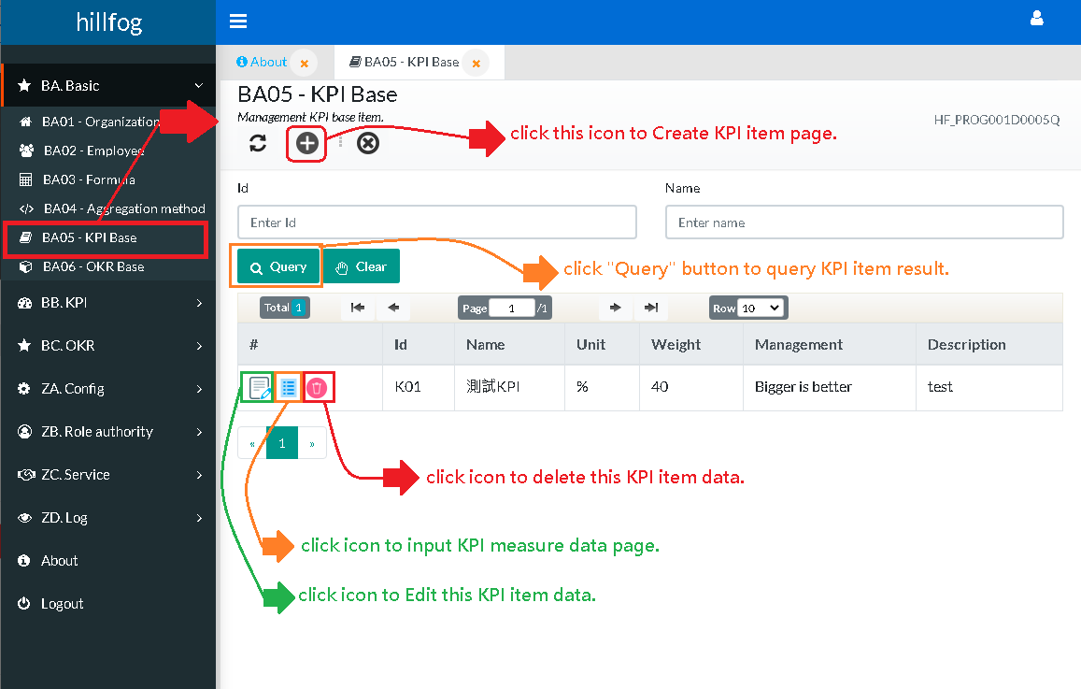

(5_01)

<< Please continue to the next page >>

# KPI Create

Look (6_01) screenshots. KPI create page.

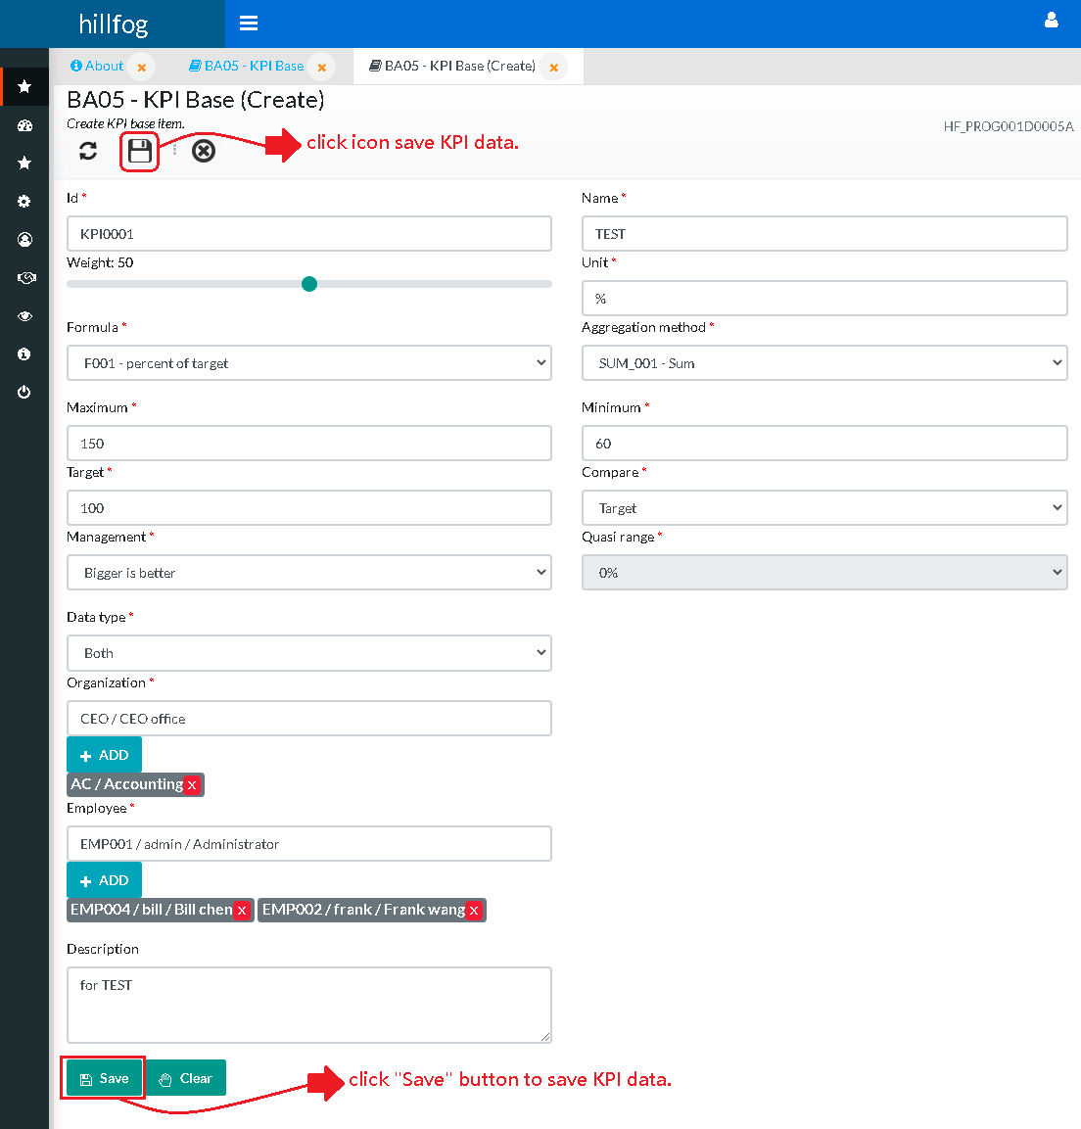

(6_01)

# KPI measure data input

Look (7_01) screenshots. Input KPI item ’s measure data.

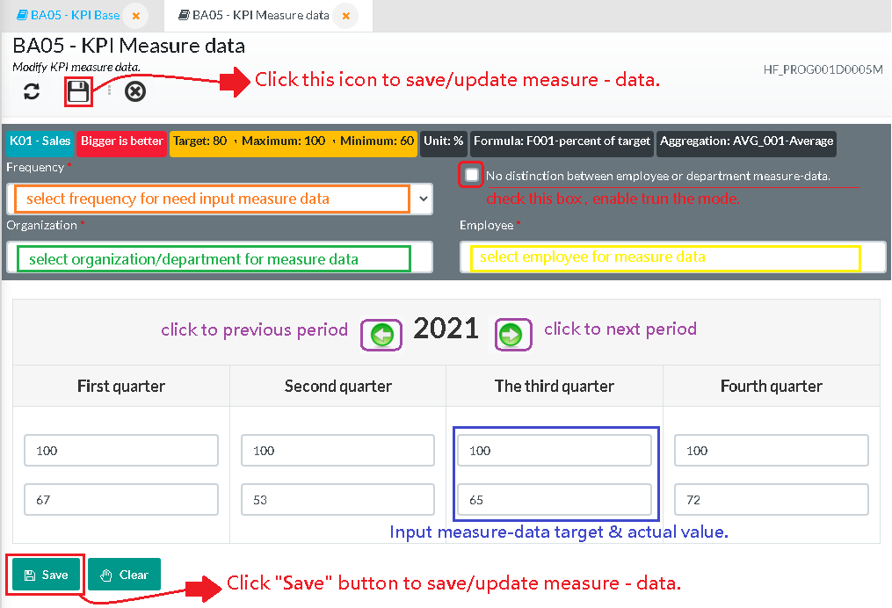

(7_01)

Three types of measure data for 1. For No distinction, 2. For Organization/department, 3. For Employee

E.g:

If you want to query KPI or Scorecard report for frequency is year, and want can show of the (1. For No distinction, 2. For Organization/department, 3. For Employee), These data need to be entered into measure-data, the KPI or Scorecard report to have a score.

# KPI report

Look (8_01) screenshots. Query KPI report, first input query field and click “Query” button.

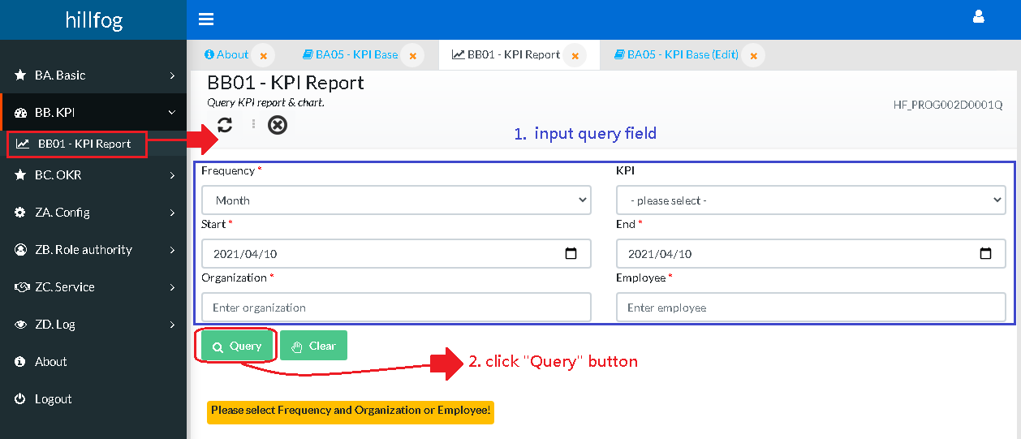

(8_01)

<< Please continue to the next page >>

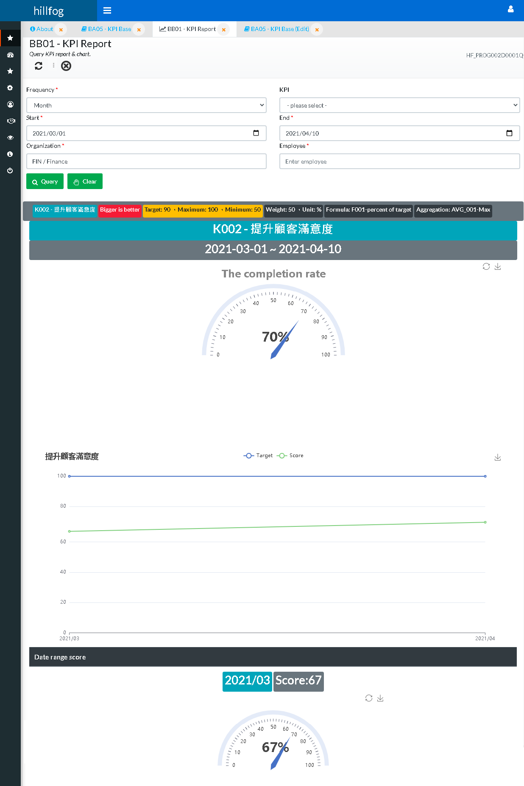

# PDCA Create (for OKR)

Look (9_01) screenshots. 1. Query OKR report and click any item to Report detail, 2. Click “Create PDCA” button to PDCA Create page (9_02) .

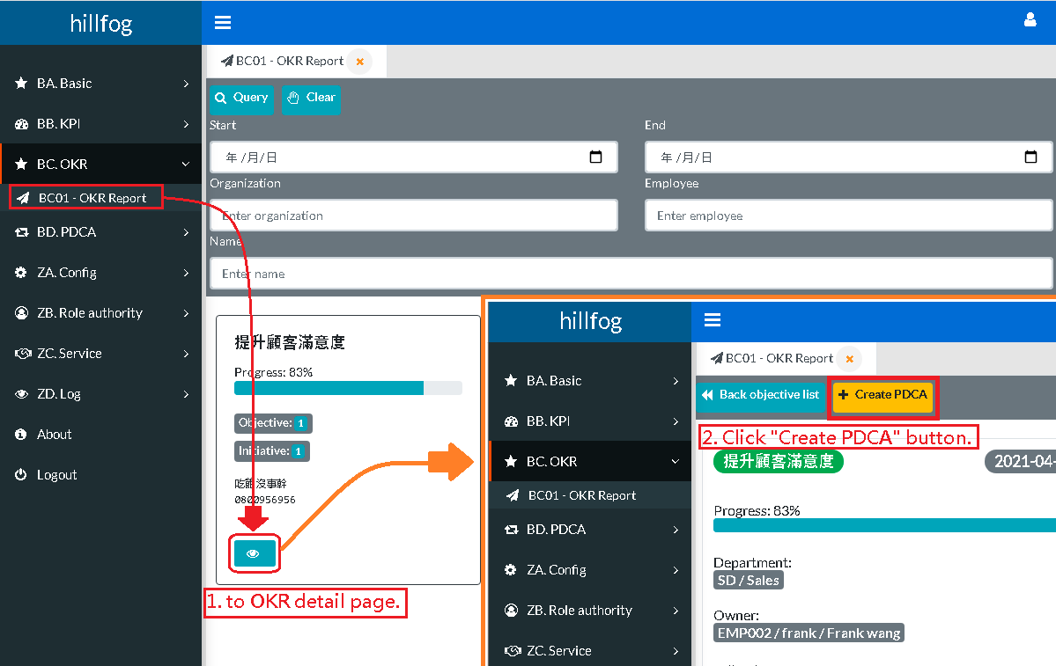

(9_01)

<< Please continue to the next page >>

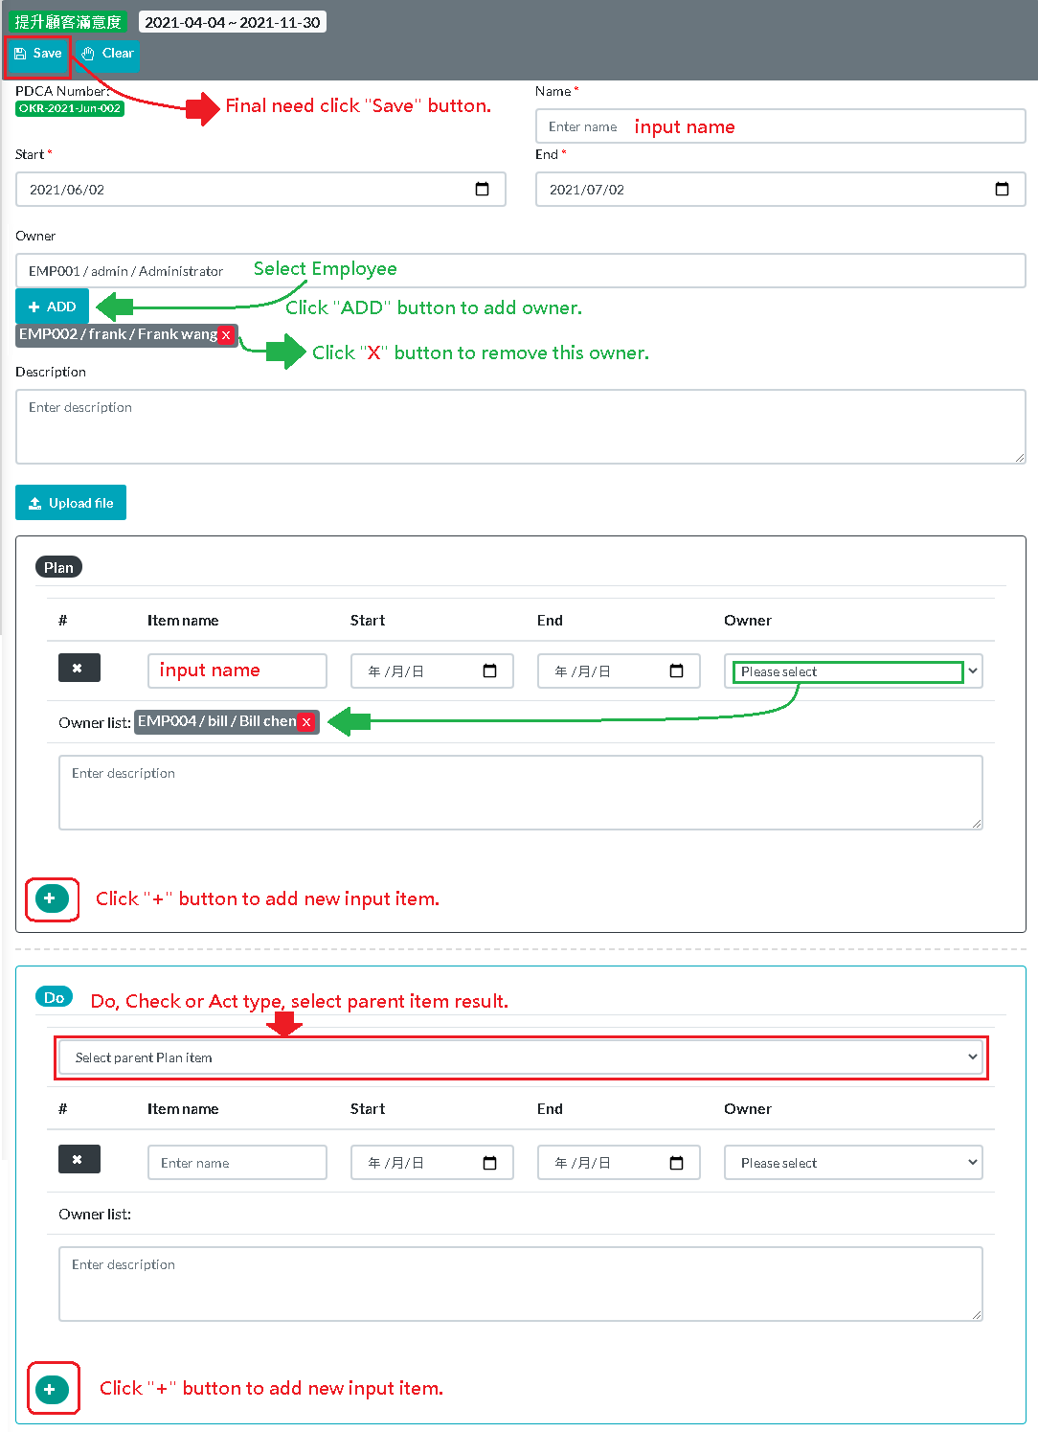

(9_02)

# PDCA Create (for KPI)

Look (10_01) screenshots. 1. Query KPI report result, 2. Click “Create PDCA” button to PDCA Create page, PDCA create input field please look previous page (9_02) screenshots.

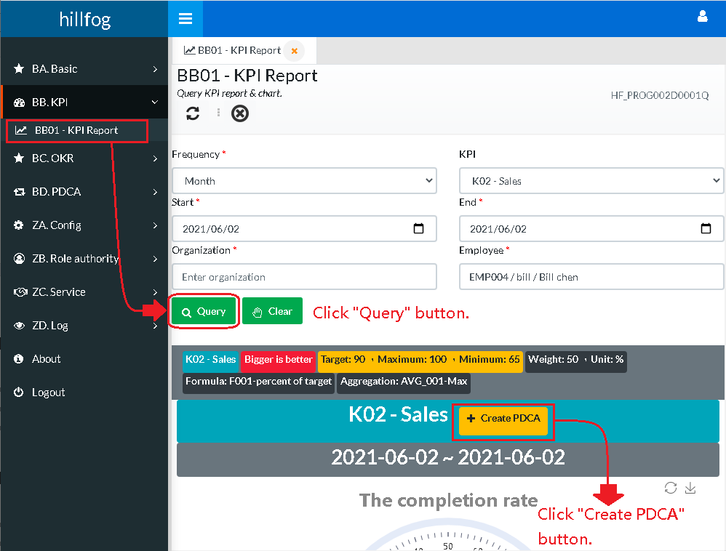

(10_01)

# How to open PDCA Detail report page

Look (11_01, 11_02 and 11_03) screenshots. Click “View detail” button to detail report page.

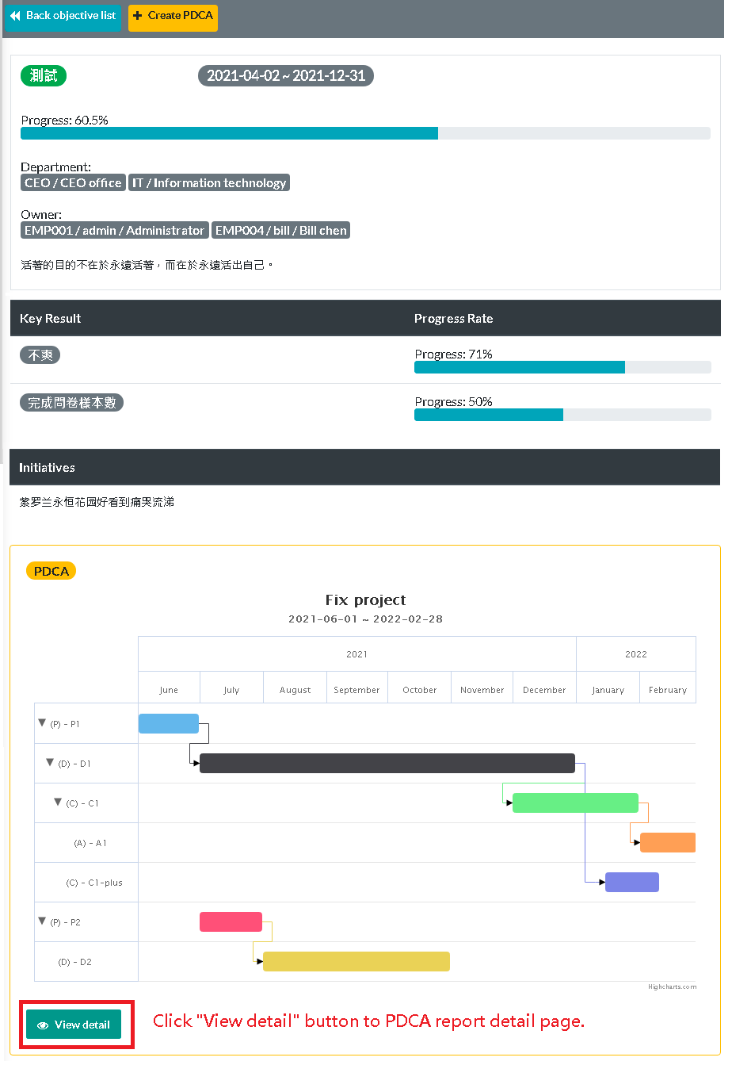

(11_01 – OKR report detail, if this OKR has any PDCA will show in the following area)

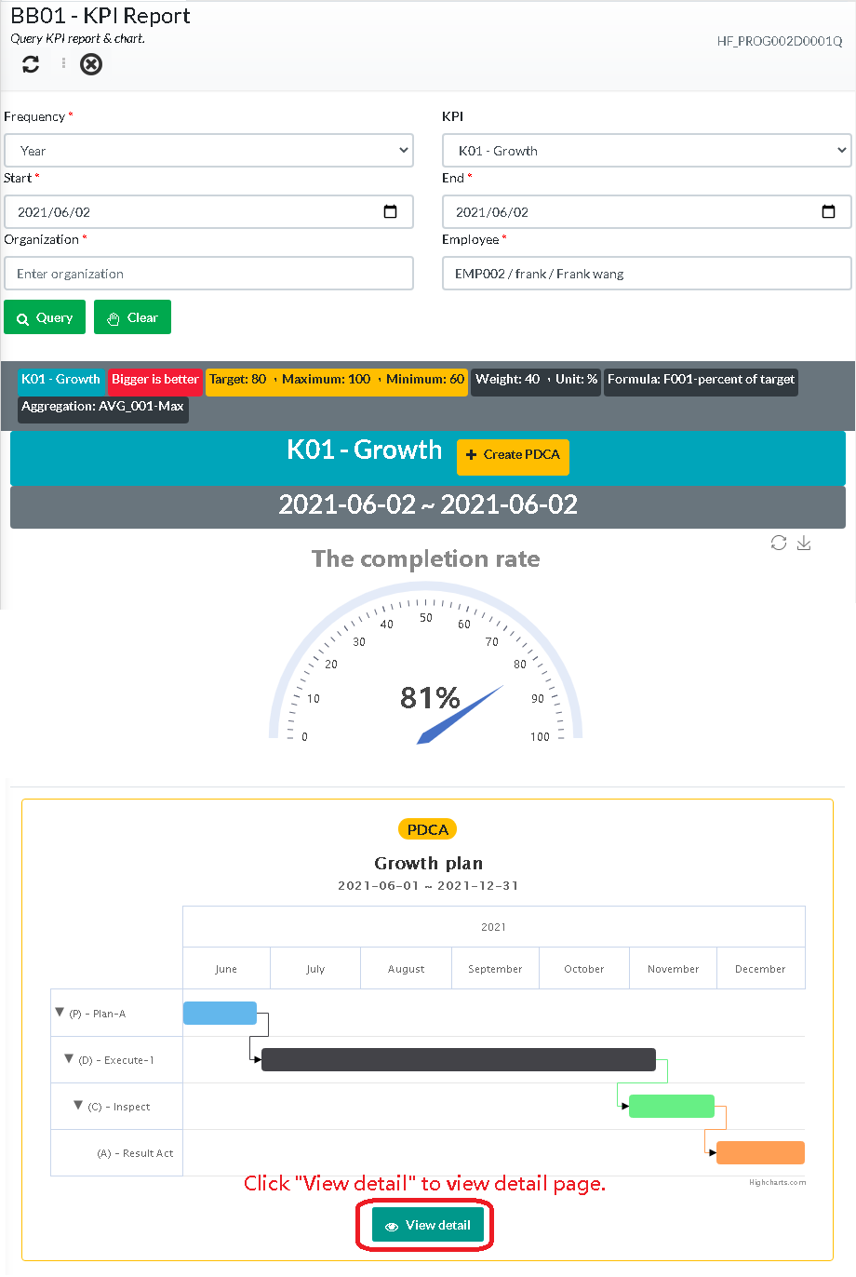

(11_02 – KPI report, if this KPI has any PDCA will show in the following area)

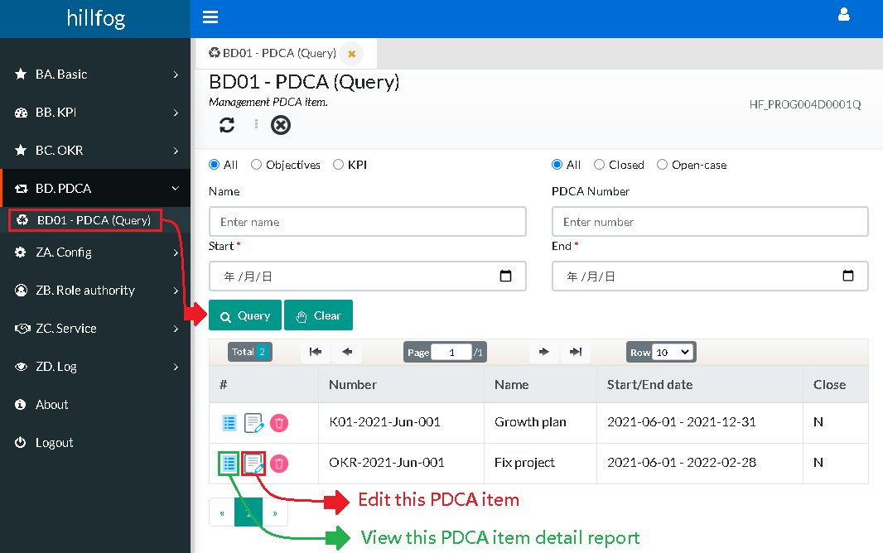

(11_03 – use B01 – PDCA query can click View detail icon to PDCA detail report)

<< Please continue to the next page >>

# PDCA Detail report

Look (12_01) screenshots. PDCA detail report.

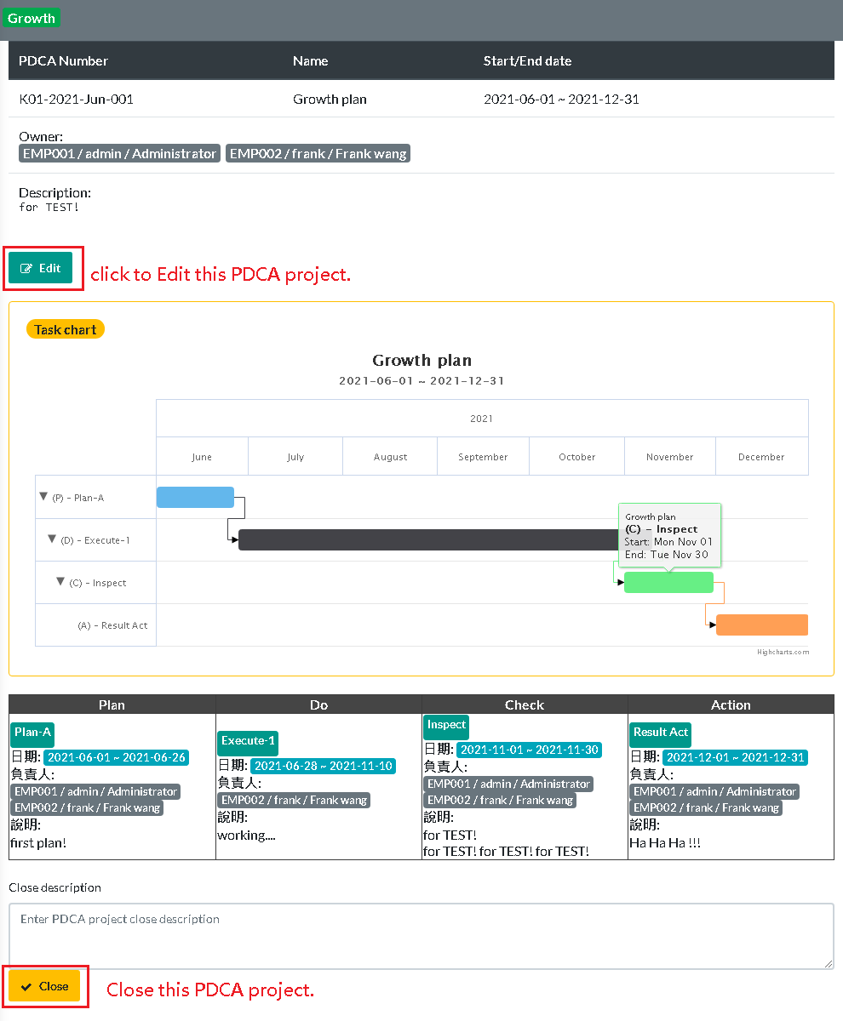

(12_01)

# PDCA Edit

Look (13_01) screenshots. Click “Edit” icon to PDCA edit page.



(13_01)

# Personal board

Look (14_01) screenshots. When login hillfog , first page will show personal-board.

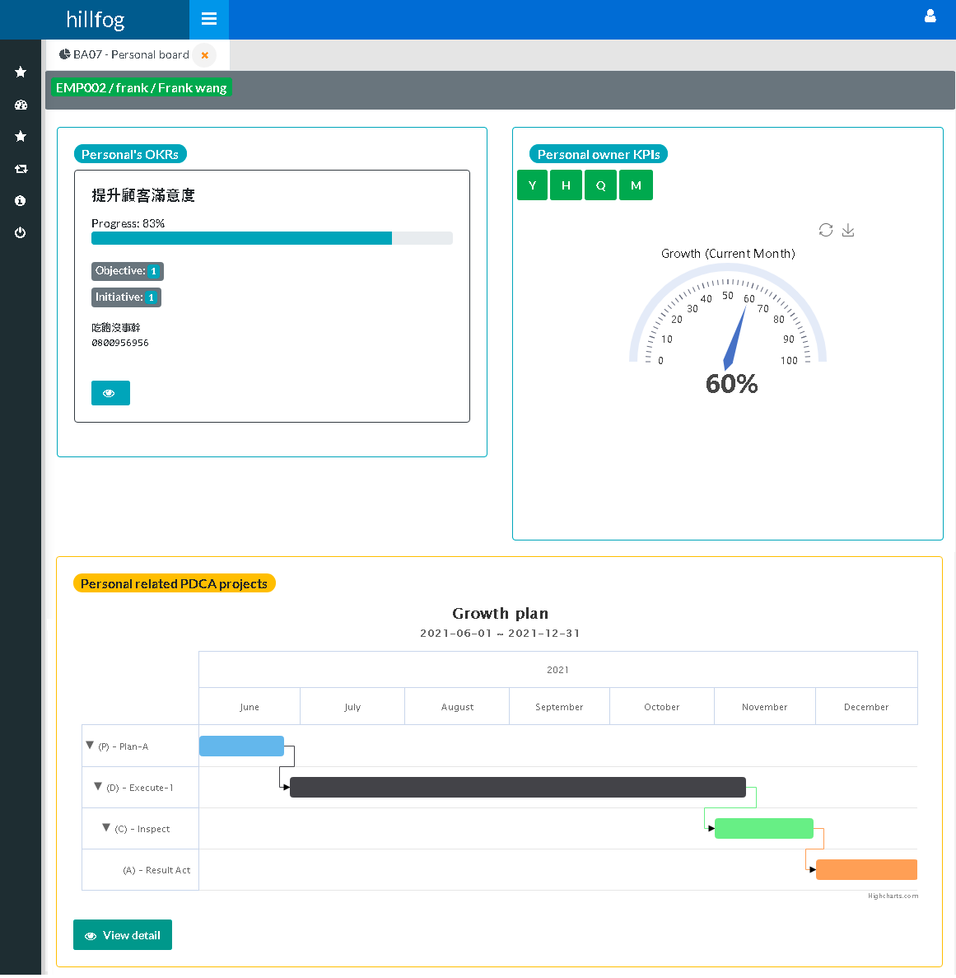

(14_01)

# Scorecard data

Look (15_01) screenshots.

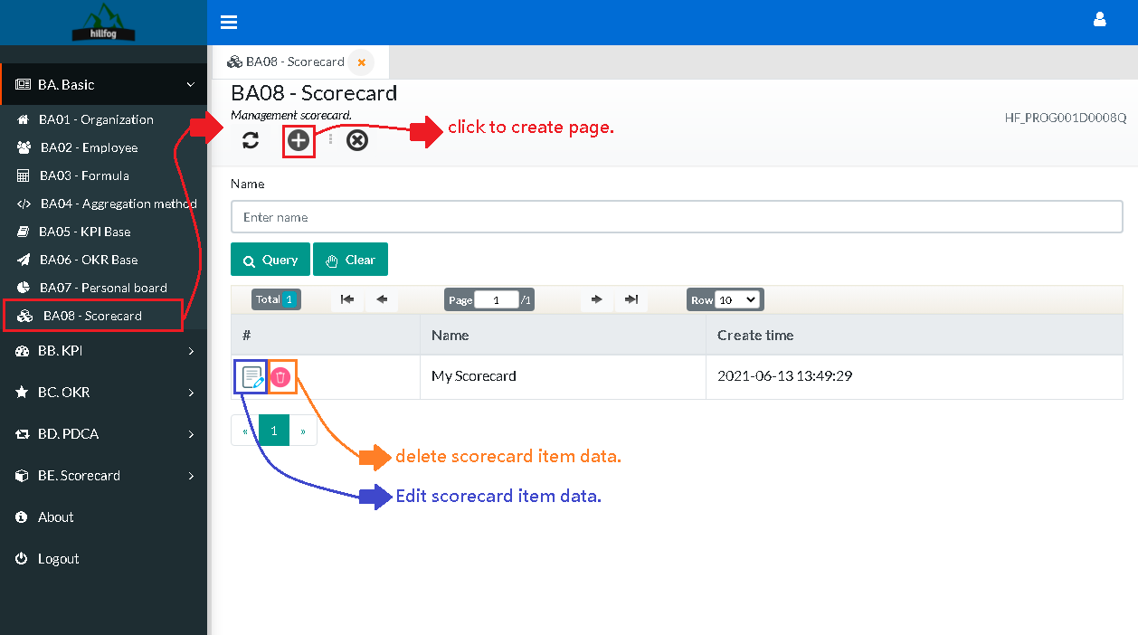

(15_01)

<< Please continue to the next page >>

# Scorecard create

Look (16_01) screenshots.

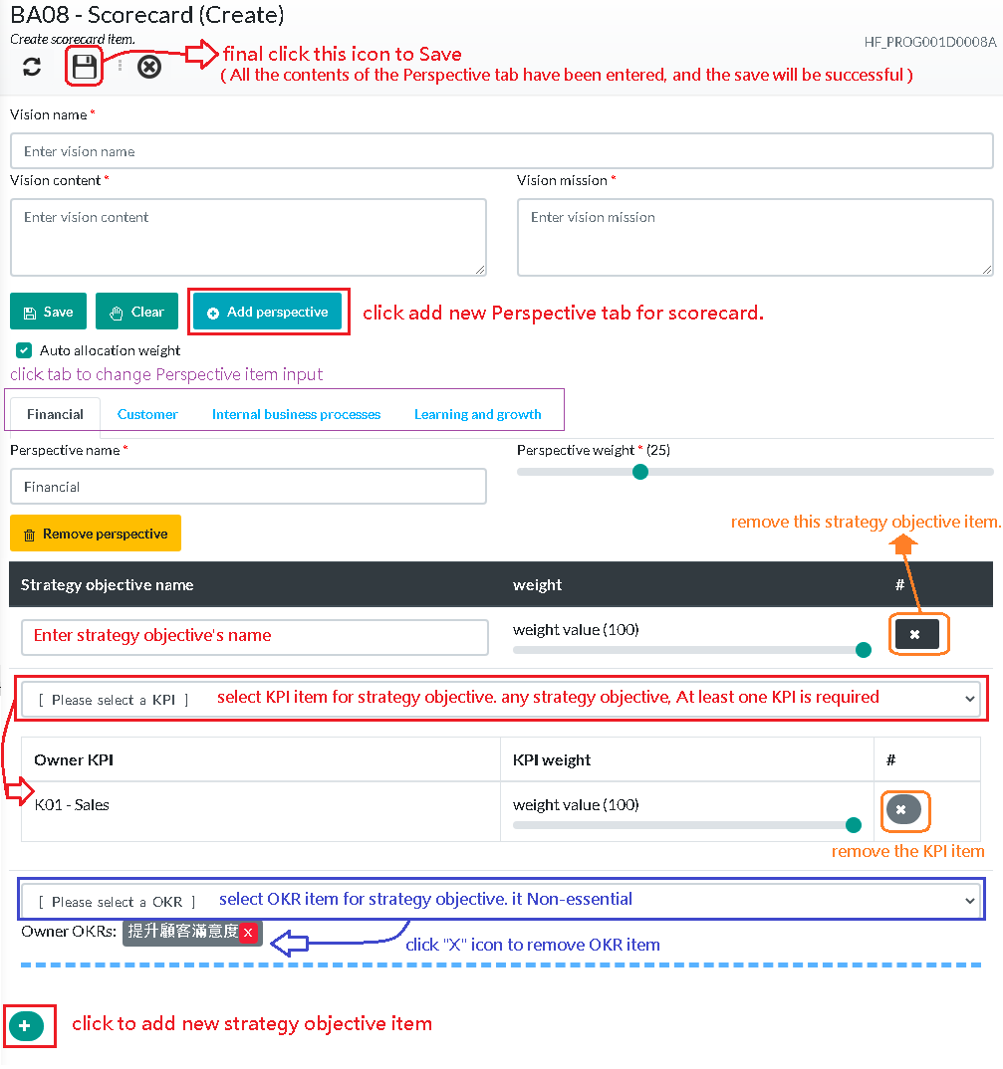

(16_01)

# Scorecard report

Look (17_01) screenshots.

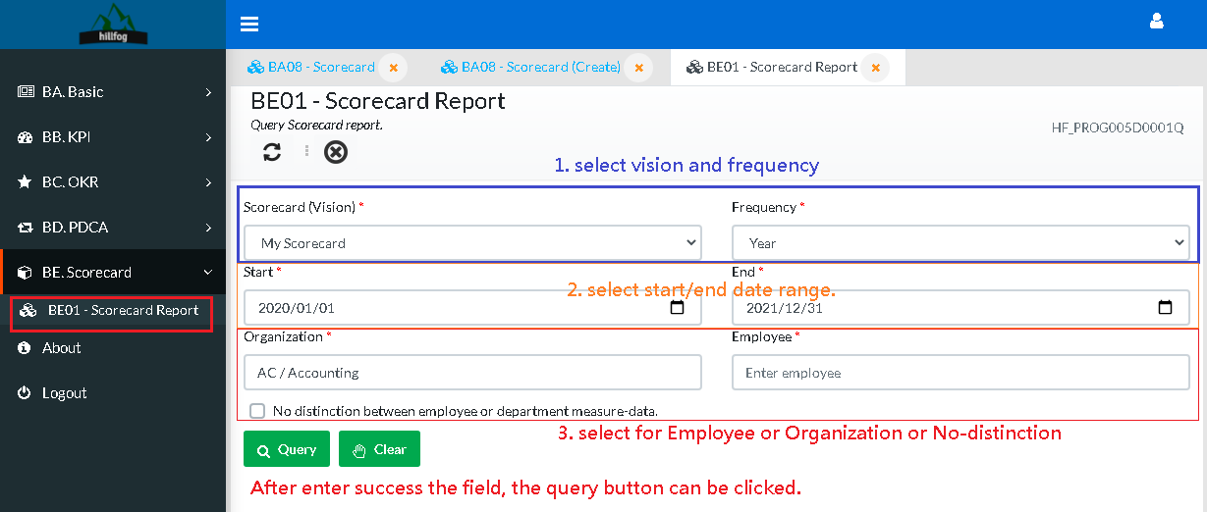

(17_01)

# Employee hierarchy settings

Look (18_01) screenshots. 1. open “BA02 - Employee”, 2. Click “Hierarchy” button to hierarchy settings page (18_02).

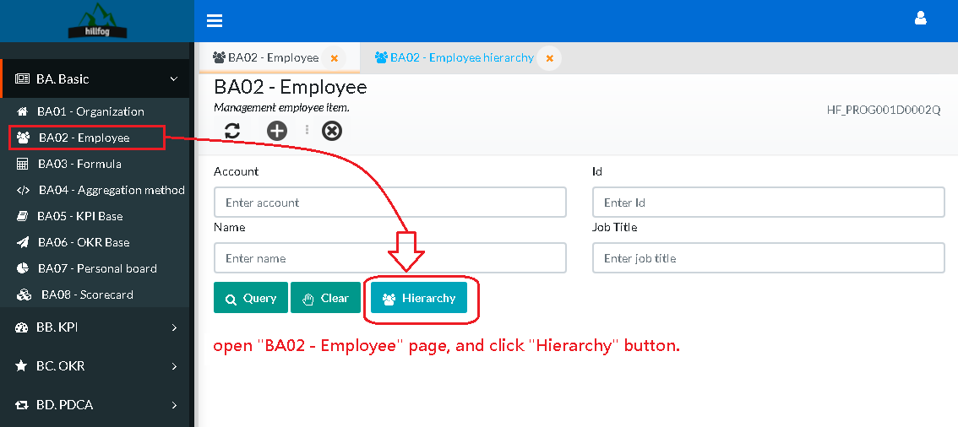

(18_01)

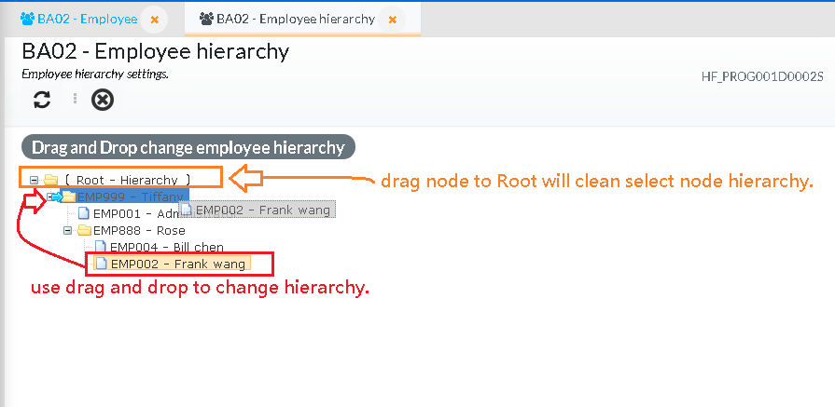

(18_02)

# OKR hierarchy view for employee.

Look (19_01) screenshots. 1. open “BC01 – OKR Report” page, 2. Click “Hierarchy” button to OKRs hierarchy view page (19_02).

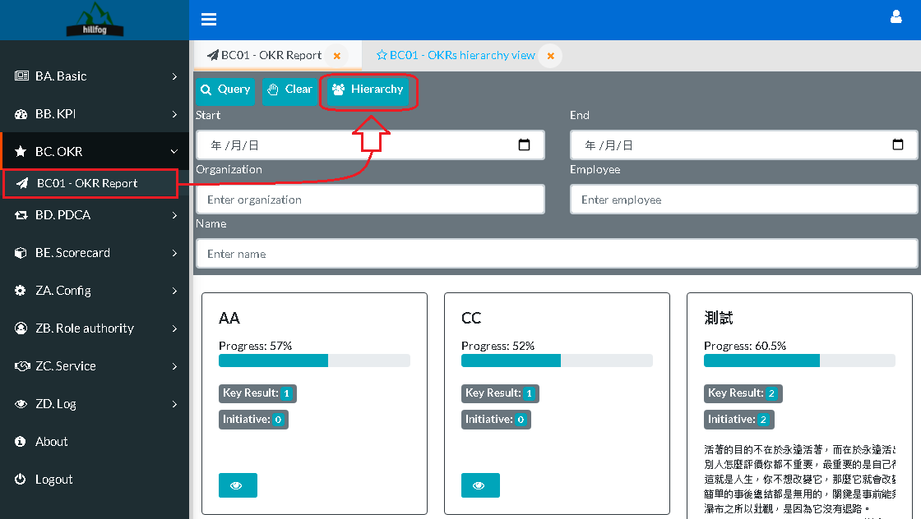

(19_01)

<< Please continue to the next page >>

*Example OKRs view for employee hierarchy.*

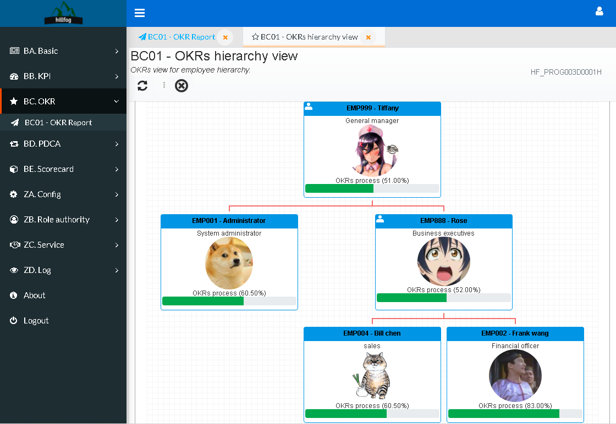

(19_02)

# OKR progress view for organization/department.

Look (20_01) screenshots. And click “Organization progress” button. screenshots (20_02) is progress result.

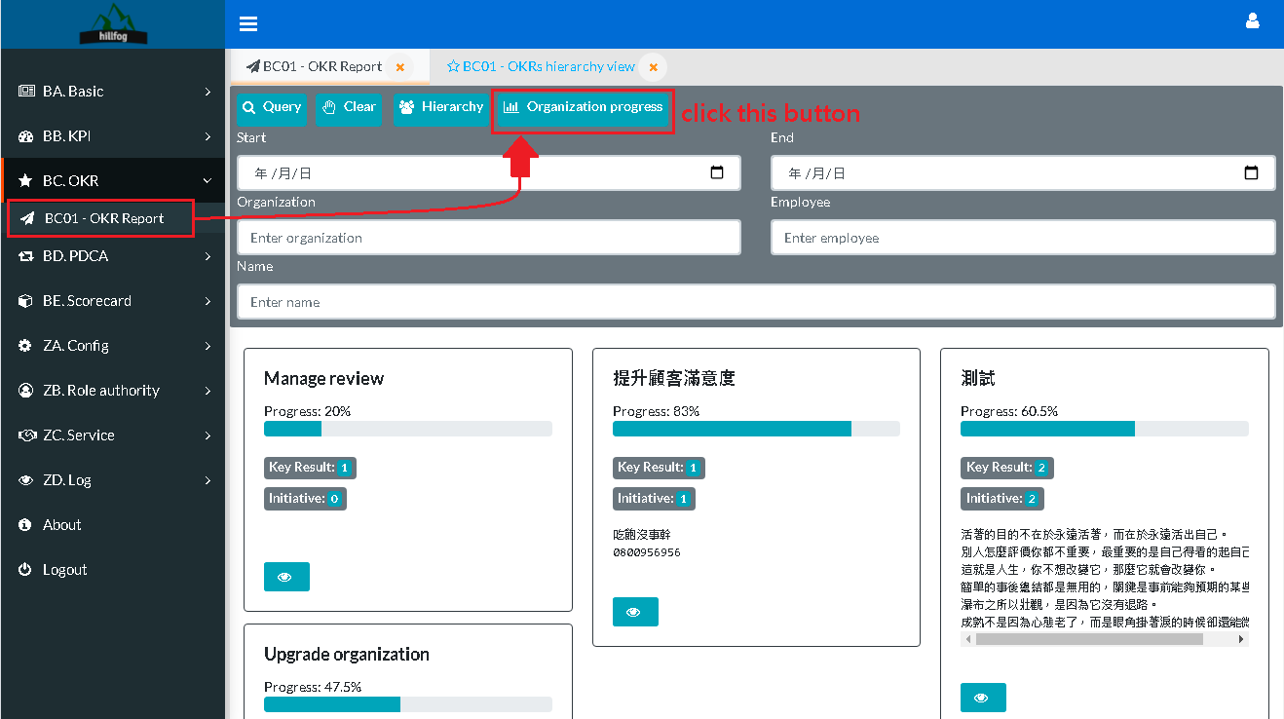

(20_01)

<< Please continue to the next page >>

*Example OKRs progress view for organization/department.*

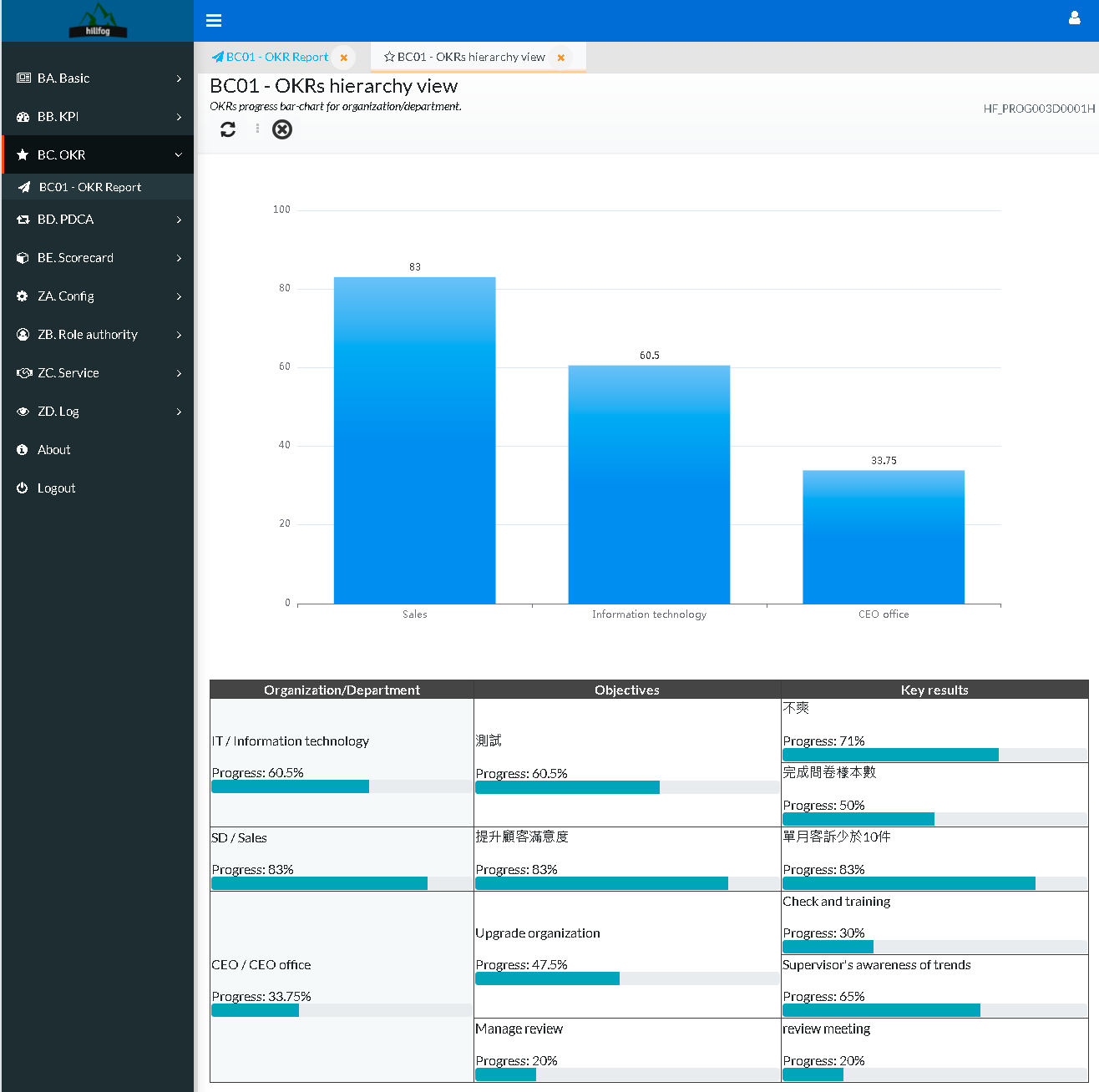

(20_02)