1. Explain the difference between preemptive and nonpreemptive scheduling.

  - 非抢占式（Nonpreemptive）：是让进程运行直到结束或阻塞的调度方式，容易实现，适合专用系统，不适合通用系统。
  - 抢占式（Preemptive）：允许将逻辑上可继续运行的程序，在运行过程能暂停的调度方式，可防止单一进程长时间独占CPU，系统开销大。

2. Suppose that the following processes arrive for execution at the times indicated. Each process will run for the amount of time listed. In answering the questions, use nonpreemptive scheduling, and base all decisions on the information you have at the time the decision must be made.
Process Arrival Time Burst Time
P1 0.0 8
P2 0.4 4
P3 1.0 1
a. What is the average turnaround time for these processes with the FCFS scheduling algorithm?
b. What is the average turnaround time for these processes with the SJF scheduling algorithm?
c. The SJF algorithm is supposed to improve performance, but notice that we chose to run process P1 at time 0 because we did not know that two shorter processes would arrive soon. Compute what the average turnaround time will be if the CPU is left idle for the first 1 unit and then SJF scheduling is used. Remember that processes P1 and P2 are waiting during this idle time, so their waiting time may increase. This algorithm could be known as future-knowledge scheduling.

- 10.53
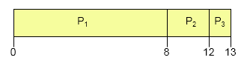
average turnaround time = ( (8-0) + (12-0.4) + (13-1.0) )/3 = 31.6/3 = 10.53
- 9.53
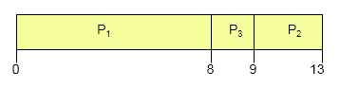
average turnaround time = ( (8-0) + (9-1.0) + (13-0.4) )/3 = 28.6/3 = 9.53
c. 6.86
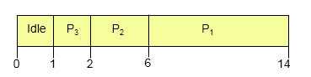
average turnaround time = ( (2-1.0) + (6-0.4) + (14-0) )/3 = 20.6/3 = 6.86

Remember that turnaround time is finishing time minus arrival time, so you have to subtract the arrival times to compute the turnaround times. FCFS is 11 if you forget to subtract arrival time.（周转时间是结束时间减去到达时间）

3.假设要在一台处理机上执行以下作业,且假定这些作业在时刻0以1,2,3,4,5的顺序到达。（题中时间单位均为s）.
表 作业执行时间和优先级
作业 | 执行时间（s） | 优先级
1 | 10 | 3
2 | 1 | 1
3 | 2 | 3
4 | 1 | 4
5 | 5 | 2
（1）给出分别使用FCFS（先来先服务）、RR（时间片轮转算法，时间片是1）、SJF（最短作业优先）以及非抢占优先调度算法（1的优先级最高），这些作业的执行顺序。画出甘特图。
- 针对上述每种调度算法，分别给出平均周转时间。

1.FCFS:
甘特图：
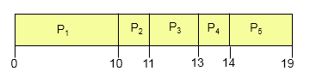
平均周转时间：
T =(10+11+13+14+19)/5 = 13.4

平均带权周转时间：
W = (1+11+6.5+14+3.8)/5 =7.26

2.RR:
甘特图：
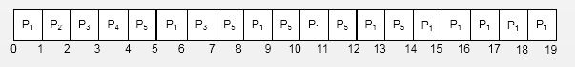
平均周转时间：
T =(19+2+7+4+14)/5 = 9.2

平均带权周转时间：
W = (1.9+2+3.5+4+2.8)/5 =2.84

3.SJF:
甘特图：
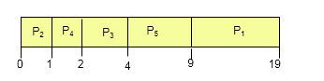
平均周转时间：
T =(19+1+4+2+9)/5 = 7

4.非抢占优先调度:
甘特图：
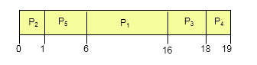
平均周转时间：
T =(16+1+18+19+6)/5 = 12

4. 在一个单道批处理系统中，一组作业的提交时间和运行时间如下表所示。试计算以下三种作业调度算法的平均周转时间T（时间单位s）
（1）FCFS（先来先服务）
（2）SJF（最短作业优先）
（3）响应比高者优先。

表 作业提交时间和运行时间表
作业 | 提交时间 | 运行时间
1 | 8.0 | 1.0
2 | 8.5 | 0.5
3 | 9.0 | 0.2
4 | 9.1 | 0.1

（1）FCFS（先来先服务）：
甘特图：
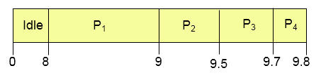
平均周转时间：
T =(1+1+0.7+0.7)/4 = 0.85

（2）SJF（最短作业优先）
甘特图：
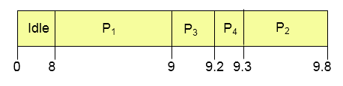
平均周转时间：
T =(1+1.3+0.2+0.2)/4 = 0.675

（3）响应比高者优先。
响应比计算：
作业1在时刻8.0到达，由于只有作业1，所以作业1得到CPU。
当时刻9.0时，作业1完成，作业2、3都已到达，计算响应比：
作业2：(0.5+0.5)/0.5 = 2
作业3：(0+0.2)/0.2 = 1
由于作业2响应比高，因此作业2得到CPU。
在时刻9.5时，作业2完成，此时有作业3、4.计算他们响应比：
作业3：(0.5+0.2)/0.2 = 3.5
作业4：(0.4+0.1)/0.1 = 5
因此作业4得到CPU
最后调度作业3

甘特图：
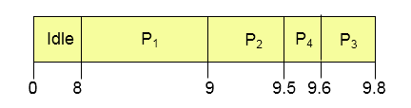
平均周转时间：
T =(1+1+0.8+0.5)/4 = 0.825

5.What advantage is there in having different time-quantum sizes at different levels of a multilevel queuing system?

  - 需要频繁服务的进程（诸如，编辑器这样交互式进程）可以在小时间量的队列中运行。
  - 而不需要频繁服务的进程可以在具有大时间量的队列运行，它要求较少的上下文切换来完成这个过程，从而有效的利用计算机资源。

6. Many CPU-scheduling algorithms are parameterized. For example, the RR algorithm requires a parameter to indicate the time slice. Multilevel feedback queues require parameters to define the number of queues, the scheduling algorithms for each queue, the criteria used to move processes between queues, and so on.
These algorithms are thus really sets of algorithms (for example, the set of RR algorithms for all time slices, and so on). One set of algorithms may include another (for example, the FCFS algorithm is the RR algorithm with an infinite time quantum).What (if any) relation holds between the following pairs of algorithm sets?
a. Priority and SJF
b. Multilevel feedback queues and FCFS
c. Priority and FCFS
d. RR and SJF

a. SJF也是一种Priority调度，作业越短，优先级越高, The shortest job has the highest priority.（短作业具有高优先级）
b. The lowest level of MLFQ is FCFS.
c. FCFS gives the highest priority to the job having been in existence the longest.(优先级:将作业在就绪队列中存在时间越长,确定为优先级别最高,这时FCFS就成为了Priority调度方法)
d. None.

7. 下面哪些算法会引起饥饿
a.先来先服务
b.最短工作优先调度
c.轮换法调度
d.优先级调度

最短工作优先调度和优先级调度算法会引起饥饿
8. Exercise：
6.2 Explain the difference between preemptive and nonpreemptive scheduling.

  - Non-preemptive（非抢占方式）: Once the processors is allocated to a process, let it perform some tasks ,until the process is completed or it is blocked by the occurrence of an event
  - preemptive （抢占方式）: Allows the scheduler stop a running process based on certain principles, reassigned processors to another process
6.4 What advantage is there in having different time-quantum sizes at different levels of a multilevel queueing system?

  - 需要频繁服务的进程（诸如，编辑器这样交互式进程）可以在小时间量的队列中运行。
  - 不需要频繁服务的进程可以在具有大时间量的队列运行，它要求较少的上下文切换来完成这个过程，从而有效的利用计算机资源。
  - 可以提高响应时间，降低系统开销。

6.7 Distinguish between PCS and SCS scheduling.
  - 进程竞争范围（process contention scope）：各个线程在同一进程范围内竞争“被调度的CPU时间”（但不直接和其他进程中的线程竞争）。
  - 系统竞争范围（system contention scope）：线程直接和“系统范围”内的所有线程(包括其它进程的线程)进行竞争.

6.8 Assume that an operating system maps user-level threads to the kernel using the many-to-many model and that the mapping is done through the use of LWPs. Furthermore, the system allows program developers to create real-time threads. Is it necessary to bind a real-time thread to an LWP?

有必要将实时运行线程邦定到LWP，即用户线程必须在实际调度之前竞争到可用的LWP,通过将用户线程绑定到LWP，在等待可用的LWP到达时没有延迟,这样可以实现实时用户线程进行调度。

6.10 Why is it important for the scheduler to distinguish I/O-bound programs from CPU-bound programs?

二者对CPU的使用有较大差别：
  - IO 操作只需少量的CPU时间片，大部分时间用于IO的等待，
  - 而CPU约束操作需要用整块时间，在CPU操作的后台可以同时运行IO等待操作，
  - 二者互不影响，通过区分两种操作，加上系统的调度，可以更好的利用系统资源，增加并发度，提高运行效率。
6.11 Discuss how the following pairs of scheduling criteria conflict in certain settings.
a. CPU utilization and response time
b. Average turnaround time and maximum waiting time
c. I/O device utilization and CPU utilization
- CPU利用率和响应时间：它们之间是相互作用的.如果提高CPU利用率, 调度的粒度越大越好,这样可以减少上下文切换的开销,然而, 调度的粒度的增大会降低响应时间,即每个粒度完成时间增加，下一个任务不能及时响应。
- 平均周转时间和最大等待时间：如果提高平均周转时间，可以通过先执行短作业来实现，而这样的策略可能会导致长作业产生饥饿现象，从而增加它们的等待时间。
- IO设备利用率和CPU利用率：如果提高CPU的利用率，可以通过运行占用CPU时间较长的任务来改进，这样IO设备利用率会降低；而运行短CPU任务，可以提高IO设备利用率，运行调度IO相关的作业，就会产生上下文切换的开销，从而IO设备利用率达到最大化，然而上下文切换会降低CPU的利用率。

6.12 One technique for implementing lottery scheduling works by assigning processes lottery tickets, which are used for allocating CPU time. Whenever a scheduling decision has to be made, a lottery ticket is chosen at random, and the process holding that ticket gets the CPU. The BTV operating system implements lottery scheduling by holding a lottery 50 times each second, with each lottery winner getting 20 milliseconds of CPU time (20 milliseconds × 50 = 1 second). Describe how the BTV scheduler can ensure that higher-priority threads receive more attention from the CPU than lower-priority threads.

为高优先级分配更多的lottery ticket。

6.13 In Chapter 5, we discussed possible race conditions on various kernel data structures. Most scheduling algorithms maintain a run queue, which lists processes eligible to run on a processor. On multicore systems, there are two general options: (1) each processing core has its own run queue, or (2) a single run queue is shared by all processing cores. What are the advantages and disadvantages of each of these approaches?
- 每个处理核心都有自己的运行队列的主要优点是：当调度程序运行在2个或者多个处理器上，调度程序只需要查看自己的运行队列，处理方便。
- 共享同一个运行队列缺点是必须使用锁机制来约束竞争条件，它必须获得锁来从单个队列中检索线程。
- 如果每个处理核心都有自己的运行队列，不同的运行队列之间存在负载均衡问题。如果是共享运行队列，不会带来负载均衡问题。

6.16 Consider the following set of processes, with the length of the CPU burst given in milliseconds:
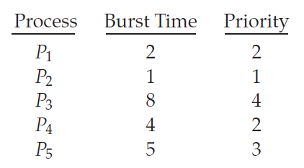
The processes are assumed to have arrived in the order P1, P2, P3, P4, P5,
all at time 0.
a. Draw four Gantt charts that illustrate the execution of these processes using the following scheduling algorithms: FCFS, SJF, nonpreemptive priority (a larger priority number implies a higher priority), and RR (quantum = 2).
b. What is the turnaround time of each process for each of the scheduling algorithms in part a?
c. What is the waiting time of each process for each of these scheduling algorithms?
d. Which of the algorithms results in the minimum average waiting time (over all processes)?

- The four Gantt charts are:
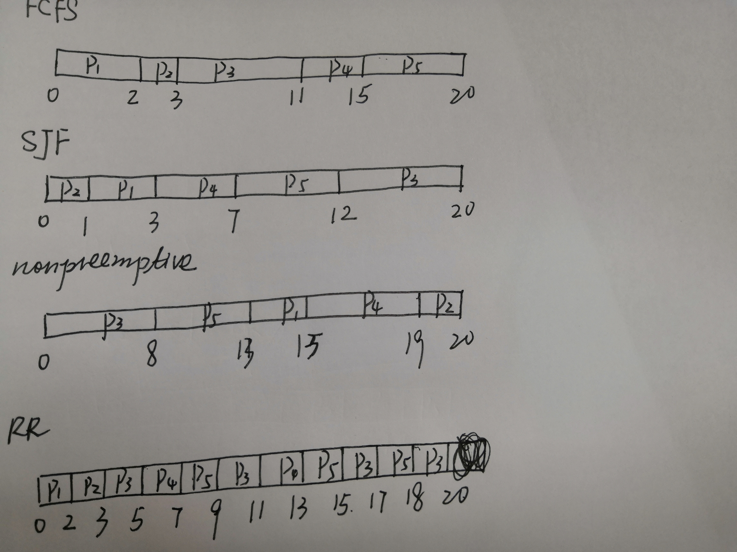
- Turnarroud time
 | FCFS | SJF | Priority | RR
P1 | 2 | 3 | 15 | 2
P2 | 3 | 1 | 20 | 3
P3 | 11 | 20 | 8 | 20
P4 | 15 | 7 | 19 | 13
P5 | 20 | 12 | 13 | 18

- Waiting time(turnaround time minus burst time)
 | FCFS | SJF | Priority | RR
P1 | 0 | 1 | 13 | 0
P2 | 2 | 0 | 19 | 1
P3 | 3 | 12 | 0 | 12
P4 | 11 | 3 | 15 | 9
P5 | 15 | 7 | 8 | 13

 | FCFS | SJF | Priority | RR
avg | 6.2 | 4.6 | 11 | 7
所以SJF的平均等待时间最短。

6.17 The following processes are being scheduled using a preemptive, round-robin scheduling algorithm. Each process is assigned a numerical priority, with a higher number indicating a higher relative priority. In addition to the processes listed below, the system also has an idle task (which consumes no CPU resources and is identified as Pidle ). This task has priority 0 and is scheduled whenever the system has no other available processes to run. The length of a time quantum is 10 units. If a process is preempted by a higher-priority process, the preempted process is placed at the end of the queue.
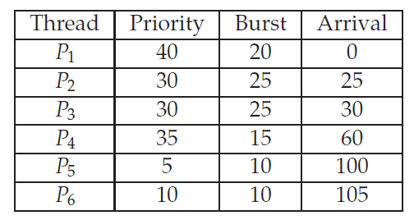
a. Show the scheduling order of the processes using a Gantt chart.
b. What is the turnaround time for each process?
c. What is the waiting time for each process?
d. What is the CPU utilization rate?

a. 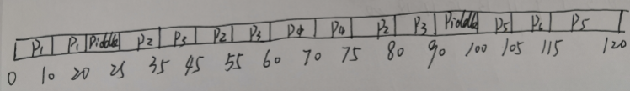
b.p1:20-0=20 p2:80-25=55 p3:90-30=60 p4:75-60=15 p5:120-110=20 p6:115-105=10
c.p1:0 p2:30 p3:35 p4:0 p5:10 p6:0
d.105/120=87.5%

6.19 Which of the following scheduling algorithms could result in starvation?
a. First-come, first-served
b. Shortest job first
c. Round robin
d. Priority

最短工作优先调度和优先级调度算法会引起饥饿

6.24 Explain the differences in how much the following scheduling algorithms
discriminate in favor of short processes:
a. FCFS
b. RR
c. Multilevel feedback queues
a. FCFS----不利于短作业，因为如果之前有长作业运行，短作业需要等待很长时间。
b. RR-----对所有的任务都是能够相同的（给它们相同的CPU时间区间），所以，短任务可以很快的离开系统，只要它们可以先完成。
c. 多级反馈队列和RR调度算法相似——它们不会先选择短任务。

