Please read chapter 9 and then do the following exercise.
- Exercise
9.1Under what circumstances do page faults occur? Describe the actions
taken by the operating system when a page fault occurs.
- 地址映射过程中，在页表中发现所要访问的页不在内存，则产生缺页中断。缺页中断是在指令执行期间，发现所要访问的指令或数据不在内存时所产生和处理的
- 操作系统接到此中断信号后，就调出缺页中断处理程序，根据页表中给出的外存地址，将该页调入内存，使作业继续运行下
缺页中断的过程：
1. 如果有对页面引用，第一次引用交给操作系统，产生缺页中断。
2. 检查该进程的内页表，看看该引用是否是合法的内存访问空间,如果不合法，终止该进程；
如果合法，但是没有调入到内存，需要将该进程放入该页中。
3. 查找一个空闲页框.
4. 将该页与空闲页框交换。调度磁盘操作来读取请求的页，将其放入新的分配的页框中。
5. 当磁盘读取操作完成时，重新设置该进程的页表，表明该页在内存中。validation bit = 1（重新设置页表，把位设为1）.
6. 重新启动中断的指令。该进程现在能够访问该页，因为它一直在内存中。
9.3Consider the page table shown in Figure 9.30 for a system with 12-bit
virtual and physical addresses and with 256-byte pages. The list of free
page frames is D, E, F (that is, D is at the head of the list, E is second,
and F is last).
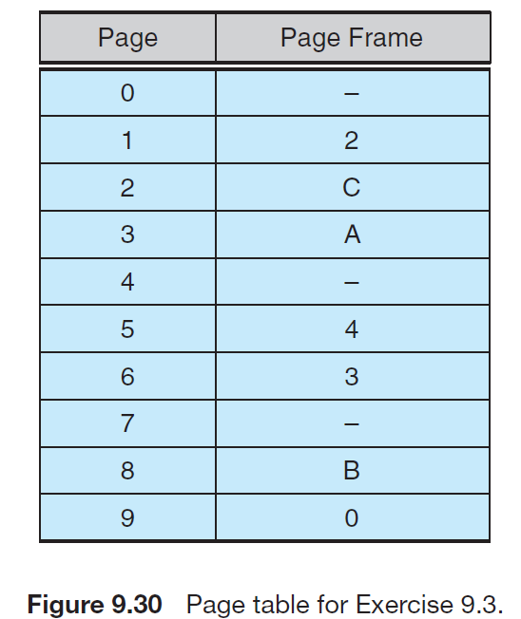
Convert the following virtual addresses to their equivalent physical
addresses in hexadecimal. All numbers are given in hexadecimal. (A
dash for a page frame indicates that the page is not in memory.)
• 9EF
- 9EF地址化为二进制： 9（1001）E（1110）F（1111）
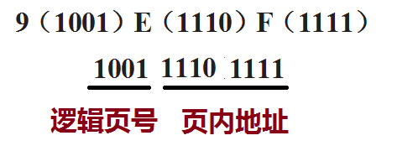
9号页面---查表，对应0号页框，页内地址不变，因此，物理地址为：
000011101111，即9EF的物理地址为 0EF
其它下面各个地址也类似变换，结果：
• 111 - 211
• 700 - D00
• 0F F - EF F

9.6An operating system supports a paged virtual memory. The central
processor has a cycle time of 1 microsecond. It costs an additional 1
microsecond to access a page other than the current one. Pages have 1,000 words, and the paging device is a drum that rotates at 3,000 revolutions per minute and transfers 1 million words per second. The following statistical measurements were obtained from the system:
• One percent of all instructions executed accessed a page other than
the current page.
• Of the instructions that accessed another page, 80 percent accessed
a page already in memory.
• When a new page was required, the replaced page was modified 50
percent of the time.
Calculate the effective instruction time on this system, assuming that the
system is running one process only and that the processor is idle during
drum transfers.
解答：
- 传输时间计算：
由已知条件，“Pages have 1,000 words, and the paging device is a drum that rotates at 3,000 revolutions per minute and transfers 1 million words per second”，得出：每页的1000个字中， 每页读取需要时间, 即1 个页面从外存传到内存的时间(传输时间)： 10^6/10^6*1000 =1000 us (读一页的传输时间)
- 旋转时间计算：
每分钟3000转，故一转需要60*10^6/3000=20000us

(c)条件概率方法计算有效时间：
访问当前页占99%,时间为：0.99*1us
访问其它页两种情况：
（a）其它页在内存： 0.01*80% *（1us+1us）
( b) 其它页不在内存: (又是条件概率事件: 不在内存，但被置换页面不需写回; 不在内存,需要写回磁盘的(50%修改后需要写回) )

条件概率方法：
0.99*1 + 0.01*[ 80% * (1us+1us)+ 20%* （50%*(20000+1000us)+*50%* (20000+1000us+1000us）] = 44us

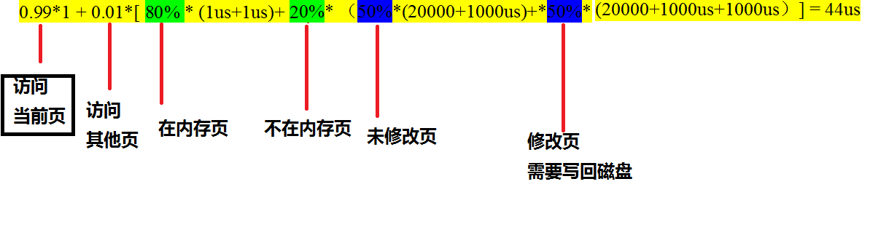
9.7Consider the two-dimensional array A:
int A[][] = new int[100][100];
where A[0][0] is at location 200 in a paged memory system with pages
of size 200. A small process that manipulates the matrix resides in page
0 (locations 0 to 199). Thus, every instruction fetch will be from page 0.
For three page frames, how many page faults are generated by the
following array-initialization loops? Use LRU replacement, and assume
that page frame 1 contains the process and the other two are initially
empty.
a.
for (int j = 0; j < 100; j++)
for (int i = 0; i < 100; i++)
A[i][j] = 0;

b. for (int i = 0; i < 100; i++)
for (int j = 0; j < 100; j++)
A[i][j] = 0;

a. 答案
- 一共分3个页框，“A small process that manipulates the matrix resides in page 0 (locations 0 to 199).”显然，数组初始化占两个页框。每个页框能容纳200个元素。
- 如果数组元素按行存放(A [0][0], A [0][1]……)，那么对于（a）问中按照元素列初始化，因为每次（换行）访问元素都缺页，并且能容纳200个元素，一共缺页100*100/2=5000
b. 答案，按照行初始化，每个页框能容纳200个元素，一次读入2行，缺页100/2=50次
a. 5000
b. 50
9.8Consider the following page reference string:
1, 2, 3, 4, 2, 1, 5, 6, 2, 1, 2, 3, 7, 6, 3, 2, 1, 2, 3, 6.
How many page faults would occur for the following replacement
algorithms, assuming one, two, three, four, five, six, and seven frames?
Remember that all frames are initially empty, so your first unique pages
will cost one fault each.
• LRU replacement
• FIFO replacement
• Optimal replacement
Number of frames | LRU | FIFO | Optimal
1  2  3  4  5  6  7 | 20  18  15  10  8  7  7 | 20  18  16  14  10  10  7 | 20  15  11  8  7  7  7

9.11Segmentation is similar to paging but uses variable-sized “pages.” Define two segment-replacement algorithms, one based on the FIFO page-replacement scheme and the other on the LRU page-replacement scheme. Remember that since segments are not the same size, the segment that is chosen for replacement may be too small to leave enough consecutive locations for the needed segment. Consider strategies for systems where segments cannot be relocated and strategies for systems where they can.
a.FIFO.为服务的段分配第一个足够大的段空间。如果无法进行重定位，且没有足够大的段空间，选择一个内存空间连续的段组合在一起，之后可以容纳新的段。如果可以重定位，则将内存空间重排以至于前N个段的空间能够容纳新的段。
b.LRU.选择一个最长时间未使用的段，且足够大，将剩余的地址空间添加到空闲空间列表中。如果没有一个足够大的段，选择内存中连续的且‘最长时间未使用’的段 （如果不能重定位），并且要足够大。如果可以进行重定位，将内存中连续的最长时间未使用的段重新排列，用新的段替换它们。

9.18 A certain computer provides its users with a virtual memory space of
232 bytes. The computer has 222 bytes of physical memory. The virtual
memory is implemented by paging, and the page size is 4,096 bytes.
A user process generates the virtual address 11123456. Explain how
the system establishes the corresponding physical location. Distinguish
between software and hardware operations
11123456H = 0001 0001 0001 0010 0011 0100 0101 0110(虚拟地址的二进制形式)------ 32位
4096 = 2¹²(页内地址) 因此页面大小为2¹² , 32-12 =20，页表大小为2²⁰,
0001 0001 0001 0010 0011 0100 0101 0110 (20bit+12bit)
0001 0001 0001 0010 0011 0100 0101 0110
因此前20bits用来表示在页表中的位置, 后12bits用来表示在页中的偏移量。
9.19Assume that we have a demand-paged memory. The page table is held in registers. It takes 8 milliseconds to service a page fault if an empty frame is available or if the replaced page is not modified and 20 milliseconds if the replaced page is modified. Memory-access time is 100 nanoseconds. Assume that the page to be replaced is modified 70 percent of the time. What is the maximum acceptable page-fault rate for an effective access time of no more than 200 nanoseconds?
(1 − P) × 0.1 ×10⁻⁶ +( 0.3P × 8 ×10⁻³+ 0.7P × 20×10⁻³ )<=0.2×10⁻⁶
(1 − P)+( 3P × 8 ×10³+ 7P × 20×10³ )<=2
(1 − P)+24000P+ 140000P<=2
约等于164000P<=1
P <= 0.000006
所以P=0.000006
9.21Consider the following page reference string:
7, 2, 3, 1, 2, 5, 3, 4, 6, 7, 7, 1, 0, 5, 4, 6, 2, 3, 0 , 1.
Assuming demand paging with three frames, how many page faults
would occur for the following replacement algorithms?
• LRU replacement
• FIFO replacement
• Optimal replacement
红色标注代表没有发生缺页中断。
7 2 3 1 2 5 3 4 6 7 7 1 0 5 4 6 2 3 0 1
7 7 7 1 1 1 3 3 3 7 7 7 7 5 5 5 2 2 2 1
2 2 2 2 2 2 4 4 4 4 1 1 1 4 4 4 3 3 3
3 3 3 5 5 5 6 6 6 6 0 0 0 6 6 6 0 0
LRU：缺页次数为18

7 2 3 1 2 5 3 4 6 7 7 1 0 5 4 6 2 3 0 1
7 7 1 1 1 1 1 1 6 6 6 6 0 0 0 6 6 6 0 0
2 2 2 2 5 5 5 5 7 7 7 7 5 5 5 2 2 2 1
3 3 3 3 3 4 4 4 4 1 1 1 4 4 4 3 3 3
FIFO：缺页次数为17

7 2 3 1 2 5 3 4 6 7 7 1 0 5 4 6 2 3 0 1
7 7 7 1 1 1 1 1 1 1 1 1 1 1 1 1 1 1 1 1
2 2 2 2 5 5 5 5 5 5 5 5 5 4 6 2 3 3 3
3 3 3 3 3 4 6 7 7 7 0 0 0 0 0 0 0 0
Optimal：缺页次数为13
9.22The page table shown in Figure 9.32 is for a system with 16-bit virtual and physical addresses and with 4,096-byte pages. The reference bit is set to 1 when the page has been referenced. Periodically, a thread zeroes out all values of the reference bit. A dash for a page frame indicates the page is not in memory. The page-replacement algorithm is localized LRU, and all numbers are provided in decimal.
a. Convert the following virtual addresses (in hexadecimal) to the
equivalent physical addresses. You may provide answers in either
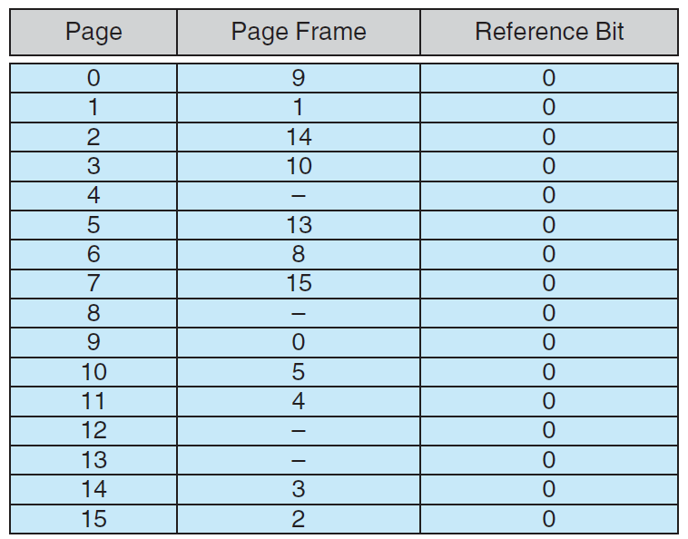
hexadecimal or decimal. Also set the reference bit for the appropriate
entry in the page table.
• 0xE12C
• 0x3A9D
• 0xA9D9
• 0x7001
• 0xACA1
b. Using the above addresses as a guide, provide an example of a
logical address (in hexadecimal) that results in a page fault.
c. From what set of page frames will the LRU page-replacement
algorithm choose in resolving a page fault?
0xE12C → 0x312C
二进制地址：1110 0001 0010 1100 根据逻辑页号1110（14）查页表，得到物理页框号3即0011，物理地址为0011 0001 0010 1100，即0x312C
0x3A9D → 0xAA9D
0xA9D9 → 0x59D9
0x7001 → 0xF001
0xACA1 → 0x5CA1
9.24Discuss situations in which the least frequently used (LFU) page replacement algorithm generates fewer page faults than the least recently
used (LRU) page-replacement algorithm. Also discuss under what circumstances the opposite holds.
最不经常使用法LFU（Least Frequently Used）： 选择到当前为止访问次数最少的那一页。
LRU是最近最少使用页面置换算法(Least Recently Used),也就是首先淘汰最长时间未被使用的页面
LFU是最近最不常用页面置换算法(Least Frequently Used),也就是淘汰一定时期内被访问次数最少的页
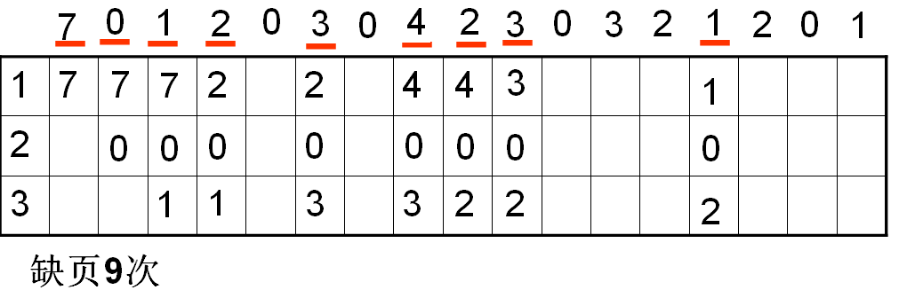
考虑如下顺序访问系统内存的序列，可在内存容纳4个页：1 1 2 3 4 5 1，当访问5 时，LFU 算法将会替换除了1 以外的任一其他页面，则在接下来读取1 时，就不会发生页错误。
而另一种情况是，如果序列为：1 1 2 3 4 5 2，显然LRU 算法性能更好.
9.27Consider a demand-paging system with the following time-measured
utilizations:
CPU utilization 20%
Paging disk 97.7%
Other I/O devices 5%
For each of the following, indicate whether it will (or is likely to) improve
CPU utilization. Explain your answers.
a. Install a faster CPU.
b. Install a bigger paging disk.
c. Increase the degree of multiprogramming.
d. Decrease the degree of multiprogramming.
e. Install more main memory.
f. Install a faster hard disk or multiple controllers with multiple hard
disks.
g. Add prepaging to the page-fetch algorithms.
h. Increase the page size.
a、b、c均不可以提高CPU利用率，d可以。
e．可能提高CPU的利用率，可以为保留更多的页面，而不需要分页或者磁盘。
f．可以提高CPU的利用率，通过更快的相应和更多的磁盘能消除磁盘的瓶颈，CPU将更快的获得数据。
g.CPU能够快速获取更多的数据，所以会频繁使用，可以提升CPU的利用率。
h.增加页面大小会减少缺页中断。如果访问数据的随机性大，会产生更多次的页面调度。因为保存在内存中的页面较少，每次缺页中断会产生更多数据转换。所以会降低CPU的利用率。
- 阅读下列LFU（最不经常使用）页面置换算法实例,完成Exercise 9.7.（同9.24）
最不经常使用法LFU（Least Frequently Used）： 选择到当前为止访问次数最少的那一页。
- 在分页虚拟存储管理系统中,假定系统为某个进程分配了4个主存块,页的访问顺序为 7,1,2,0,3,0,4,2,3,0,3,2,7,0,1若采用FIFO调度算法、OPT、LRU调度算法时，分别产生多少次缺页中断？写出过程。
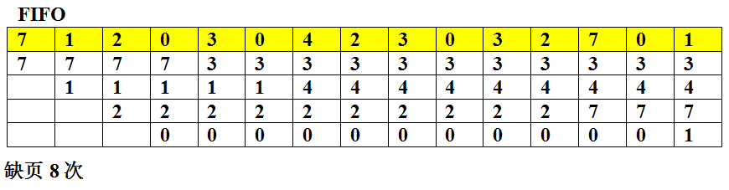
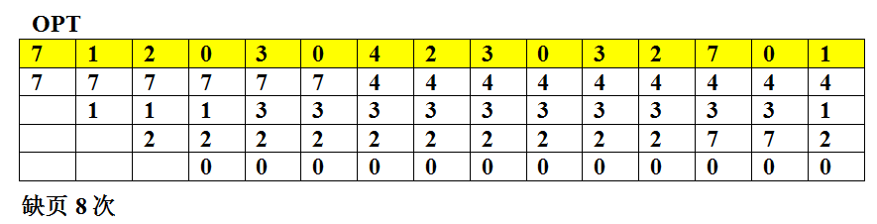
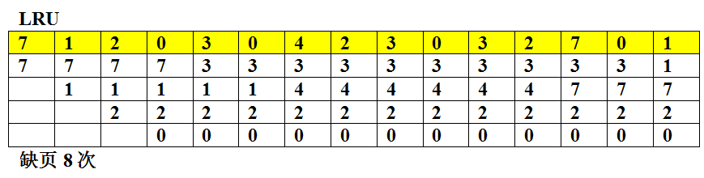
- 采用 B 不会产生内部碎片（internal fragmentation）。
A、分页式存储管理 B、分段式存储管理
C、固定分区式存储管理 D、段页式存储管理
- 内存加上外存容量之和与虚拟存储空间相比，其大小关系是__ _ D __。
A. 前者比后者大 B. 前者比后者小 C. 二者相等 D. 不一定
虚拟存储空间是通过硬件和软件的综合来扩大用户可存储空间，它在内存储器和外存储器（磁盘、光盘）之间增加一定的硬件和软件支持，使两者形成一个有机整体，支持运行比实际配置的内存容量大的多的大任务程序。程序预想放在外存储器中，在操作系统的统一管理和调度下，按照某种置换算法依次调入内存储器由CPU执行。这样，CPU看到的假想存储器成为虚拟存储器。具有保护模式的80286以上的CPU均支持虚拟存储空间。一般虚拟存储空间远大于实地址访存空间。

