ggPMX standing report

/home/matt/src/nlmixr.examples/vignettes

17 October, 2019

Table of Contents

# Key model diagnostics

## NPDE vs PRED

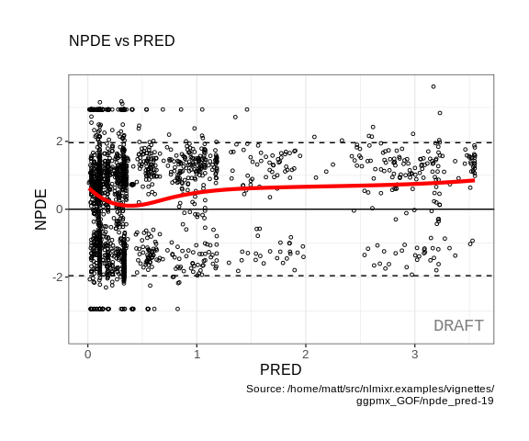

## NPDE vs TIME

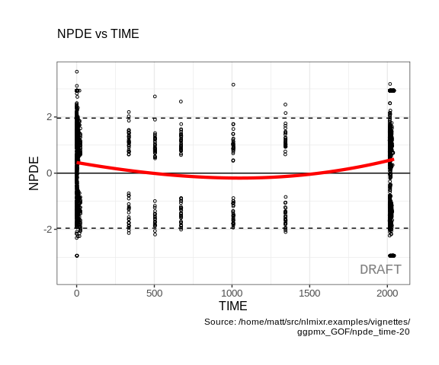

## IWRES vs IPRED

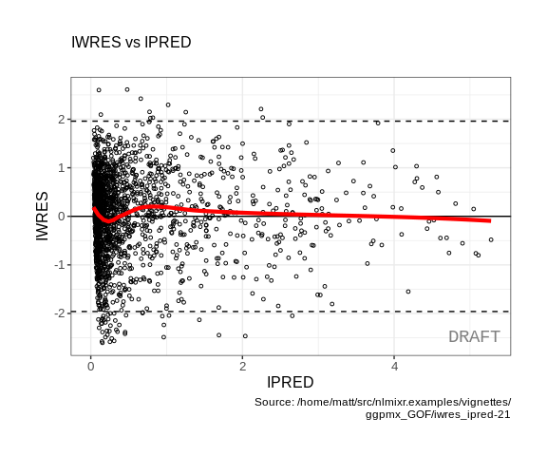

## IWRES vs TIME

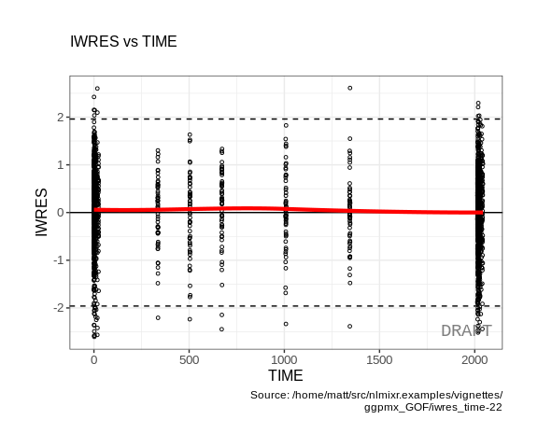

## Distribution of random effects

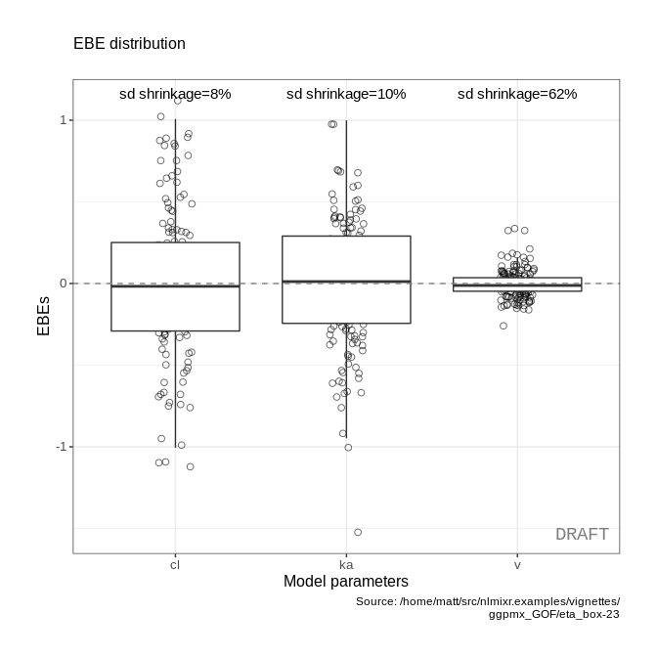

## VPC

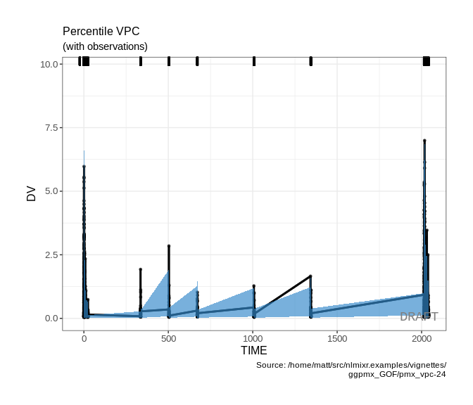

# Supplementary diagnostics

## Distribution of IWRES

### QQ plot of IWRES

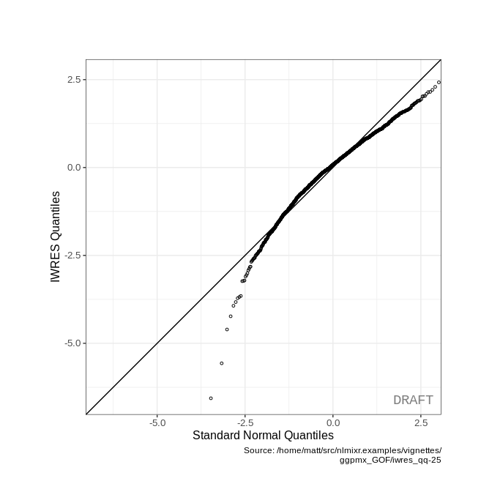

### Distribution of IWRES

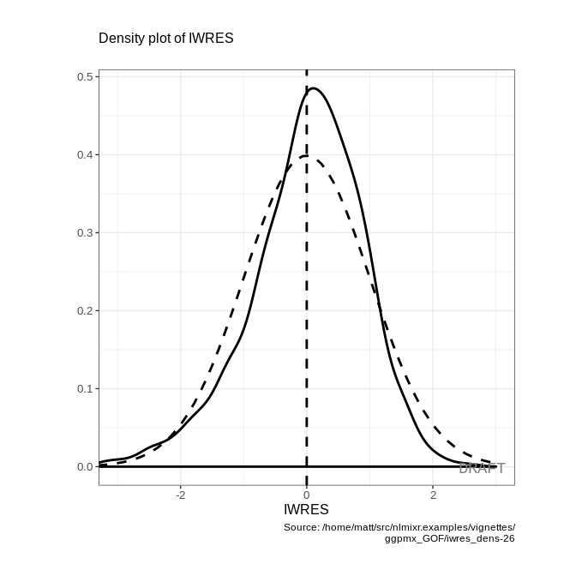

## EBE-based diagnostics

### Distribution and correlation of EBEs

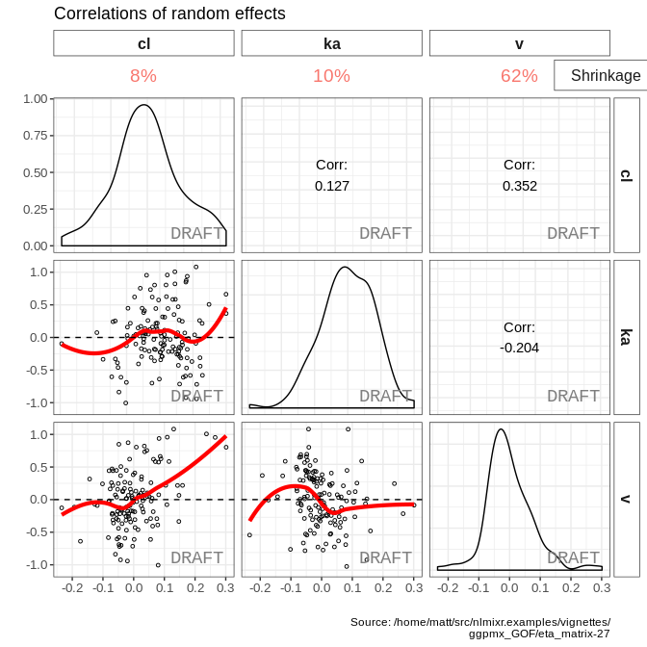

### EBE vs discrete covariates

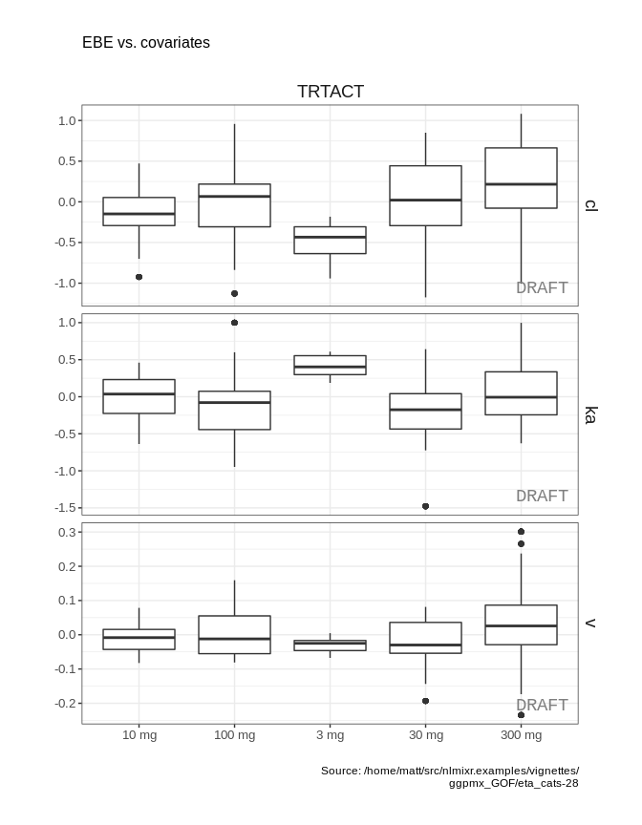

### EBE vs continuous covariates

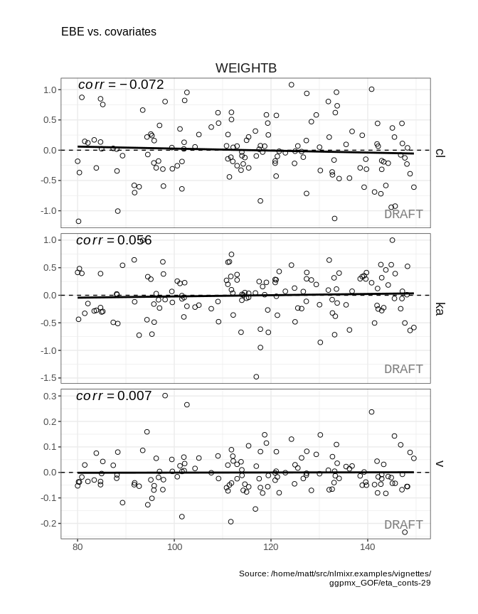

## Observations vs predictions

### DV vs PRED

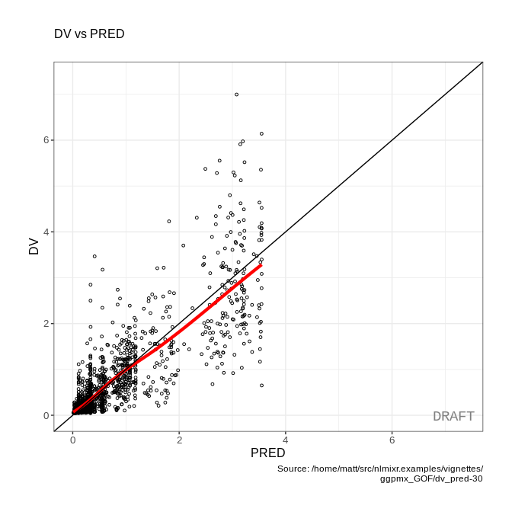

### DV vs IPRED

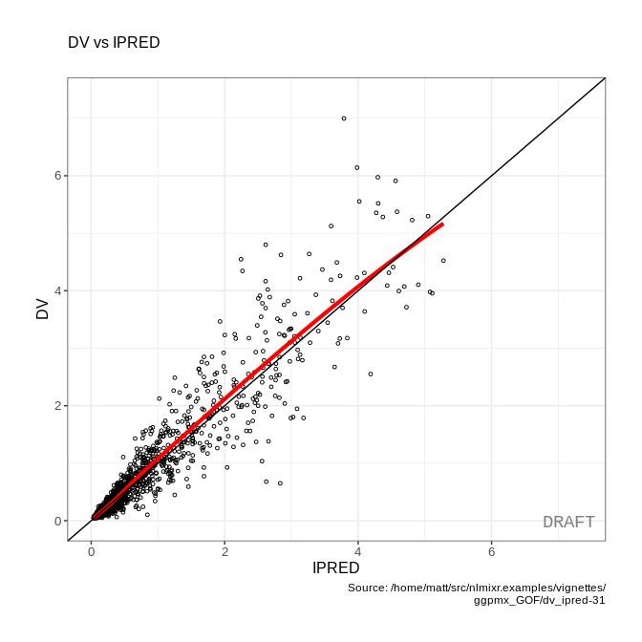

## Residual plots

### |IWRES| vs IPRED

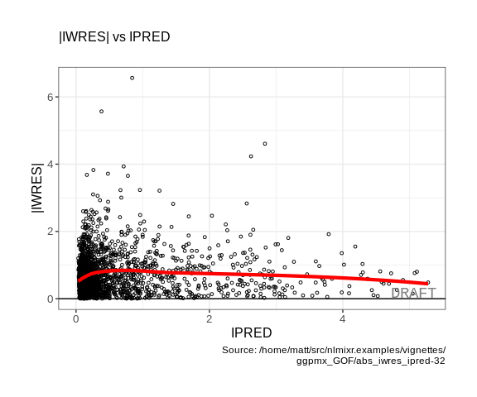

# Individual plots (selection)

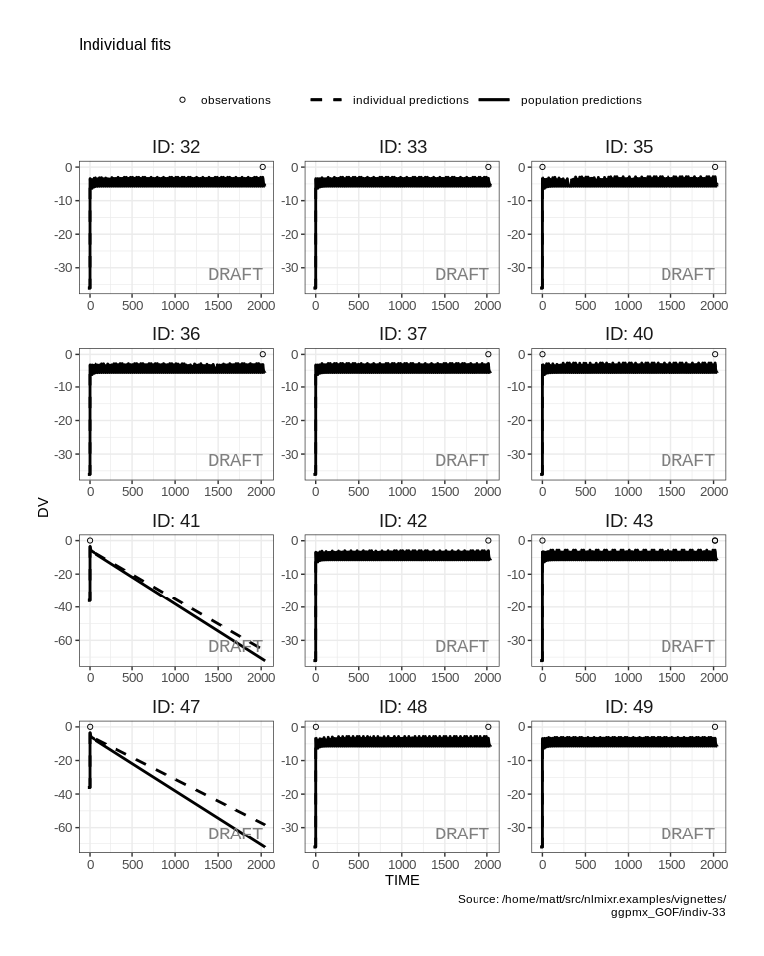

# Stratified key diagnostics

## NPDE vs TIME by categorical covariates

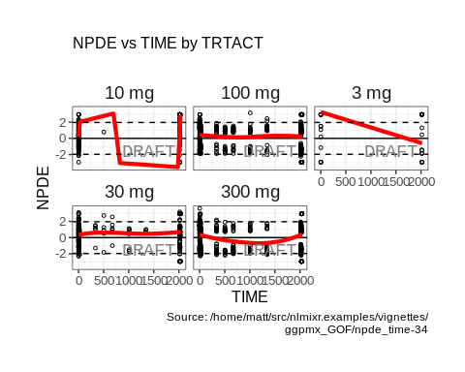

## IWRES vs TIME by categorical covariates

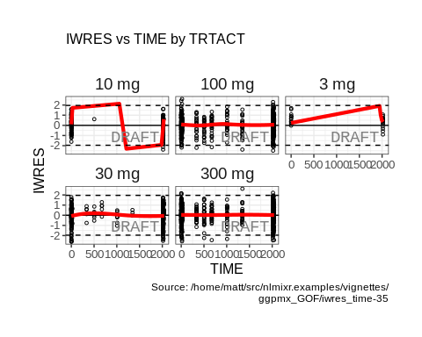

## VPC by categorical covariates

