**To Cloister, Colonial, Terrace, Quad, Tower, other big Frosh week clubs**

Hey {{officer.name}},

Hope you had a wonderful summer! Here on the ProspectAve Team we have been working hard maintaining the site and reflecting on successes and future goals. Here are a few highlights:

* Since going live, ProspectAve has accumulated over **6,800** page views and **2,300** unique users (nearly half of the undergrad population)
* Active monthly users peaked at 1,223 over LAWNPARTIES weekend
* 25% of users utilize the ProspectAve mobile page

Thanks for playing a part in making ProspectAve such a huge success!

With the upcoming semester and Frosh Week around the corner, we know this is a busy time of year for {{eating_club}}, and we want to make advertising for your events as easy and impactful as possible. I’d love to have a casual FaceTime/Google Hangouts call for roughly 5 minutes next week to talk about some new features and make sure we are on the same page. Please let me know what times work for you next Monday-Friday from 10am – 10pm.

Best,

Yang

**To other clubs**

Hey {{officer.name}},

Hope you had a wonderful summer! We here on the ProspectAve Team have been working hard maintaining the site and reflecting on successes and future goals. Here are a few highlights:

* Since going live, ProspectAve has accumulated over **6,800** page views and **2,300** unique users (nearly half of the undergrad population)
* Active monthly users peaked at 1,223 over Lawnparties weekend
* 25% of users utilize the ProspectAve mobile page

Thanks for playing a part in making ProspectAve such a huge success!

With the new semester and Frosh Week right around the corner, we know this is a busy time of year for {{eating_club}}, and we want to make event organization a little easier for you. I’d love to schedule a FaceTime/Google Hangouts call for roughly 5 minutes this week or early next week to talk about some new features and make sure we are on the same page. Please let me know what times work for your weekdays from 10am – 10pm EST.

Best,

Yang

|  |  |  |  |  |
| --- | --- | --- | --- | --- |
| **Clubs:** | **Contact** | **NetID** | **Contacted?** | **Call scheduled for:** |
| Colonial | Kimberly Peterson | kap3 | y | 8/29 7pm |
| TI | Charlotee Valentine | crv2 | y |  |
| Terrace | Madeleine Le Cesne  Elizabeth Yu | mlecesne  ecyu | y |  |
| Tower | Tim Thong | tthong | y | 8/30 10am |
| Cannon | Andrew Diehl | ad15 | fb message | – |
| Quad | Sarah Spergel | sspergel | y | 8/27 9pm |
| Ivy | Mimi Asom | masom | y |  |
| Cottage | cswezey | Casey Swezey | y |  |
| Cap | Estaban Aguas | eaguas | y |  |
| Cloister | Richard Swanton | rswanton | y | 8/27 12pm |
| Charter | Susanna Belt | sbelt | y |  |

**USG Newsletter Posting**

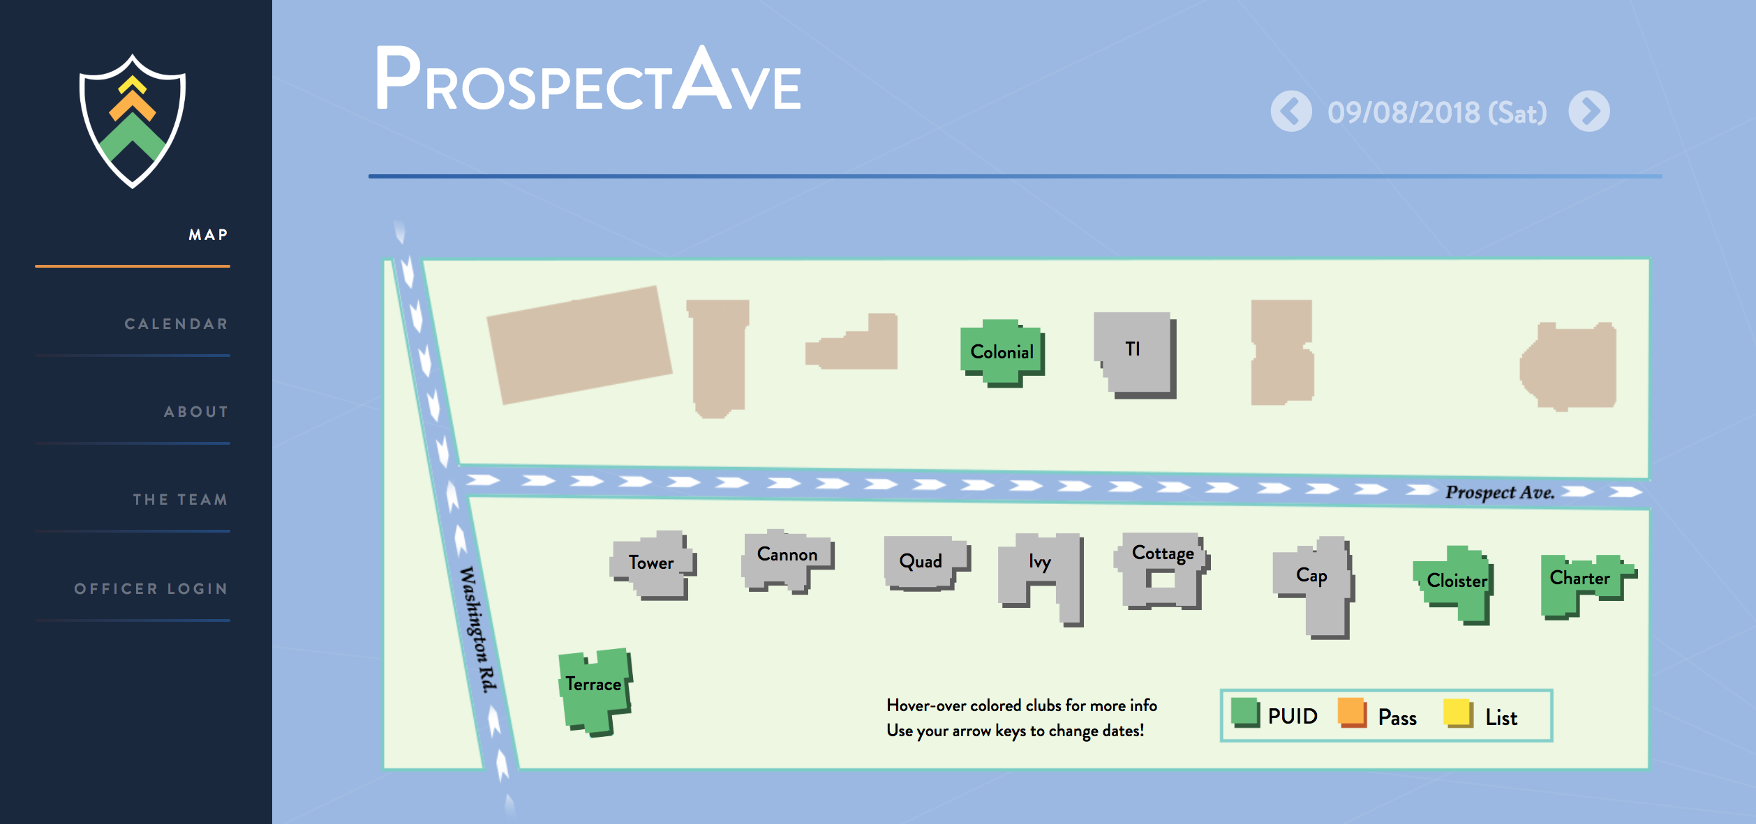

**Your Guide to the Street: ProspectAve.io**

Need a little help navigating the Street this first weekend back on campus? The ProspectAve team has your back! Head over to <https://prospectave.io> for the definitive guide to the Eating Clubs’ (~nighttime~) events. Frosh Week postings are live – be sure to check it out – and event information is always continuously being updated!